Report for Academic Skills Assignment 2 2018 – Reflective Report

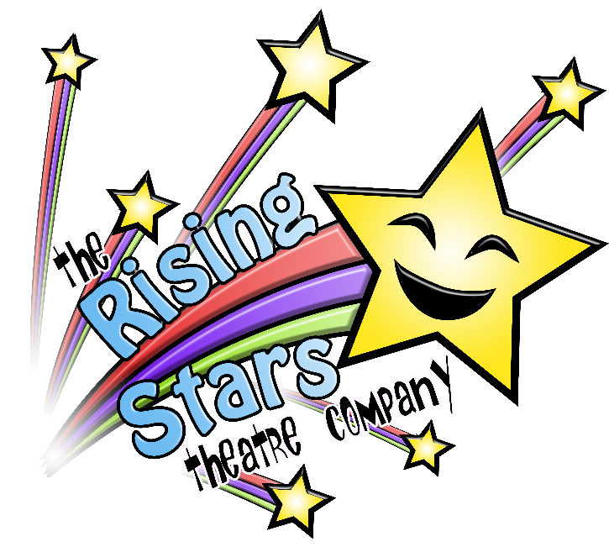

MARCH 2018

MODULE NAME: Academic Skills (M4XO1434)
Project Name: rEFLECTIVE REPORT
Name: Kate Oliver
Student Number: 1702582

Reflective Report
Contents
1. Executive Summary 3
2. Figures 4
3. Introduction 5
4. Report remit 5
5. Background of the business 5
6. Model of reflection 6
7. Masterclasses 7
7.1. Master class 1 Andy Rogers 7
7.2. Master class 2 Stifyn Parri 7
8. Influence of Masterclasses on the project 8
9. Influence of the Masterclasses on my personal Development and Learning 11
10. Conclusion 12
11. References 12

Executive Summary
I shall give an overview of Rising Stars and our project, followed by an explanation of Stella Cottrell’s model of reflection. Details on what the masterclasses contained will be followed by applying the model in order to reflect on the influence they had on our project and the team. The report will also provide an in-depth explanation of the impact the speakers had on me personally, how they helped me develop and improve throughout the entire project and what I would recommend for a similar task in the future.
The group was partnered with The Rising Stars Theatre Company, the aim of the charity, that was founded in 2007, is to provide individuals with learning difficulties a place to perform within an inclusive drama group. Their goal is to increase the confidence of each individual member, by providing them with a safe environment to express themselves. As a charity, they rely on donations from the public and ticket sales from their show to fund the work they do, which is why they asked the group for help promote the Company and their upcoming show.
While working on this project we participated in masterclasses from different business owners and entrepreneurs who gave us an insight into the business world, teaching us different skills that we can then put into practice both in our current and future project/s. we were taught the importance of self-confidence, understanding the importance of networking and how to identify the different types of people we may work with and how to cater to the fact each member of the team will be different.
Our groups communication became stronger due to this selection of masterclasses as well as learning how to read other people that we were working with. Pushing us to work better as a unit and perform to a high standard. I learnt about the importance of being genuine and letting myself sell why someone should work with me and believe in the things I create.

Figures

Figure 1 (The Core Model Diagram, Source: Stella Cottrell (2010))__________________________6
Figure 2 (The Rising Stars Flyer, Source: Our Group (2017))______________________________10

Introduction
According to Eva and Regehr as cited by (Devenny B, 2013) reflection is essential when it comes to professional development, commenting on its importance for ensuring safe and effective performances. In this case the reflection will help ensure that future projects can thrive, having learnt from this experience. The aim of this reflective report is to explain the different master classes we experienced and what we learnt from them. Then using Cottrell’s Core Model to reflect on how it affected us and our performance in both the project working with The Rising Stars Theatre Company and our own personal development for the future.

Report remit
I shall give an overview of Rising Stars and our project, followed by an explanation of Stella Cottrell’s model of reflection. Details on what the masterclasses contained will be followed by applying the model in order to reflect on the influence they had on our project and the team. The report will also provide an in-depth explanation of the impact the speakers had on me personally, how they helped me develop and improve throughout the entire project and what I would recommend for a similar task in the future.

Background of the business
The Rising Stars Theatre Company (TRSTC) is a drama group whose members all have learning difficulties and/or disabilities. It operates for children 12 and above and is open to those who live in Swansea, Neath and Port Talbot. It was set up in 2007 following the closure of the Spotlight Theatre Company when its government funding was withdrawn. So, the parents created Rising Stars in the belief that their children would benefit from what the Rising Stars Theatre Company would go on to produce. When it first began there was 15 members they now have more than double that to 34 aged 12 and above. Its main aims are, through drama, to provide an opportunity for young people to socialise and to promote a positive image of their disabilities. (The Rising Stars Theatre Company, 2018)
Our group includes myself as the team leader, Amy as the resource investigator, Rhodri was the finance manager, Jack, social media manager and Cai was in charge of our quality control. We worked with them from October 2017 to January 2018 and during this time we created a blog to help market the company and helped out with a couple of their sessions to help us develop research etc. for our end of semester Unit 19 presentation.

Model of reflection
A model provides a framework that can assist and structure the process of reflection. (Cottrell, 2011) To reflect on the masterclasses I have decided to use Cottrell’s Core Model. (As shown in Fig 1,) It consists of 5 stages;
- Evaluate
- Reconstruct
- Analyse
- Distill
- Apply
It helps to reflect and identify the key points that can help me to improve in the future. (Cottrell, 2010)
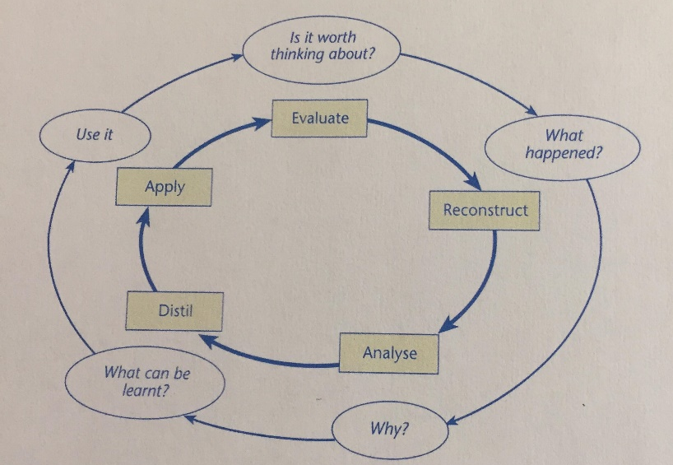
Figure 1 (The Core Model Diagram, Source: Stella Cottrell (2010))
Stage 1 is “Evaluate”, where I will examine the purpose of the masterclasses and what the results are of the experience. Stage 2 is “Reconstruct” where I will go over the classes and pick out the key aspects that I appreciated and would use in future projects. Stage 3 is “Analyse” where I shall truly lay out my opinion and how the project will motivate me in the future. Stage 4 is “Distil” where I will focus down on the specifics of what I have learned and what I will take forward. Finally, Stage 5 is “Apply” which is the way in which I will use the learning in Stage 4 to change and improve myself and my skills.

Masterclasses

Master class 1 Andy Rogers
Andy Rodgers conducted a masterclass on networking strategies for introverts. An introvert is someone who considers themselves shy and quiet lifestyle (Duffy, 2013). He discussed the need to move outside your comfort zone as people are more likely to find opportunities and he also suggested the more introverts push themselves to go out and network with those that may be able to help them and their career. He also explained how to socialise with introverts and how your body language can decide whether or not an introvert will feel able to come and talk to you. He also explained the difference between open and closed conversations. A closed conversation is where two people are talking and are standing parallel to each other, as this gives off an image that it is a private conversation and doesn’t invite people to join. Whereas an open conversation is when two people are talking and their body is slightly angled so they are still facing each other but leaving an open space so that others feel there are welcome to join the conversation.

Master class 2 Stifyn Parri
I participated in a masterclass on the 12th October 2017, conducted by Stifyn Parri. He focused on people and how they come across to others, whether they are potential employers, peers or in front of large audiences. He explained the importance of the four C’s;
- Calm
- Control
- Clear
- Confident
This helped me to fine tune the persona I wanted to create when leading my team and also when meeting the Rising Stars management. He also went over the different aspects to consider when it comes to interviews. Creating an equal status between you and those you’re talking to, leads to a relaxed environment. Another key point he suggested was planning. Having a good structure to plan how you will conduct yourself and ensuring you have back-up plans helps, not only in case something goes wrong, but also reduces the chance of worrying, as you know that strategies are already in place to help cater for any unexpected issues. I felt he focused a lot on emotions and how, having a passion for what I’m talking about, really impacts how I come across to other people. Mr Parri also addressed the issue of self-confidence and how my opinion of myself and my team’s opinion of me would affect both the strength of what we put together for The Rising Stars Theatre Company and its progress. By managing my own expectations, I can better understand that instead of wanting perfection, people just want the best we can give them.

Influence of Masterclasses on the project
Andy Roger’s class truly impacted my group and how we worked with The Rising Stars Theatre Company. As mentioned above, Andy discussed introverts and the different social struggles they face. Within our group, a couple of members struggled to open up and share with the rest of the team. This prevented them from expressing their ideas in a strong enough way to make sure they were properly considered. It also meant that, due to their lack of input, they were perceived as not caring or that they didn’t truly understand what it was they were a part of. However, after using the tools Mr Rogers showed us, the group became more aware of these actions and we worked out how we could change our behaviour to cater to those who struggled with open communication. By doing this we were all able, not just those who found it challenging, to take steps to become more involved.
Using Cottrell’s Core Model, I will now reflect on the impact and what it means for the future of the individuals in my group. Firstly, the masterclass taught us what introverts are and how to identify when someone is exhibiting introvert characteristics, as well as teaching those who are shy and reserved what they can do to put themselves out there. This awareness will result in increasing confidence in who they are working with and what they are creating. For example, when it comes to sharing your ideas with a group, he suggested writing out a list of the ideas so that you have it there with you in case you start to panic. In this way it provides you with something to hold and look at if you feel the room is slightly intimidating. This strategy allowed Jack, our social media manager, to actually put forward his ideas for the blog and how he felt it could reach a wider audience outside. As a result, he was given the title of social media manager because the team felt he was best suited for that job. The masterclass also helped the dynamics of our team as Andy Rogers explained that, even in social settings, the way people stand and talk to each other can affect whether someone feels comfortable joining the conversation. He explained the difference between open and closed conversations as explained in section 7.1 and, as a group, we used this in and out of meetings. We made sure
that we stood with an open posture spread out, thus allowing anyone to join our conversations. We also made a conscious decision that if anyone wasn’t originally involved in the conversation then they would be invited and welcome to join in.
I took a lot from this masterclass and I feel that if I were to lead a team again, I would ensure all communication was open and make sure to give plenty of opportunities for people to share their own ideas. Another key aspect of this masterclass was the constant discussion on peoples’ comfort zones and how they would rarely find new opportunities just sitting in their comfort zone. I feel this taught me not only to venture out and do things I wouldn’t normally consider but it also pushed me to think outside the box when it comes to marketing or designing something. It made me think that sometimes it’s good to do something that’s not normal or expected. I will definitely take this into future projects as it will enhance my chances of finding a USP (unique selling point) that other competitors may not have considered.
I personally feel that my group struggled to communicate and that due to the fact I was confident in myself I did overshadow some of those who had amazing ideas but were just unable to put their thoughts to the group. I feel the masterclass taught me and certain members of the group to consider that others will have good ideas even if they present them in an alternative way. It correspondingly compelled other members to stand by their ideas as they truly believed it would benefit not only the group but the theatre group we were supporting. For example, Rhodri suggested the use of flyers for Unit 19 in different places so it would attract a wider and perhaps alternative audience to those who already know of The Rising Stars Theatre Company. I then worked with him and suggested using RSTC’s logo colours in the flyer, giving it a type of uniformity to match all the other advertisements. (as seen in Fig 2.)
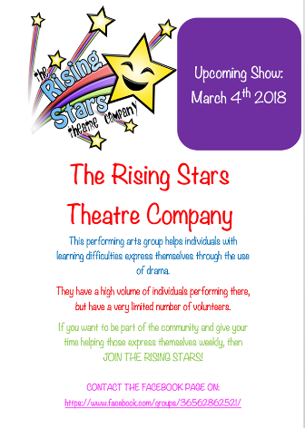
Figure 2 (The Rising Stars Flyer Source: Our Group (2017))
The skills I feel my team has learnt from is communicating not only within the team but also with the members of The Rising Stars Theatre Company. It also taught us about being self-aware of how we present ourselves to others and what we can do to make others more comfortable.
So overall, I feel that a lot was taken from the masterclass provided by Andy Rogers, my group definitely worked more dynamically as a result. In future projects I will certainly use these skills to enhance the team’s relationships.

Influence of the Masterclasses on my personal Development and Learning
I feel that Mr Parri’s masterclass had a great impact on me and I believe that I grew during the time of this project. He discussed how the way we feel can impact how we are perceived and this helped me tremendously when it came to meet with The Rising Stars Theatre group and its members. It taught me that being genuine and showing true passion for the project would give the charity confidence that I was the one leading the group whose main aim was to help them and project their image.
Using Stella Cottrell’s Model of reflection, I will go over the masterclass and how it impacted my learning and how it helped me develop for the future. Firstly, the masterclass focussed greatly on confidence and how to get the best out of yourself. I believe the point behind Mr Parri’s masterclass was to explain that I need to stop trying to provide people with perfection and instead, to give them the best I can offer. Once I start doing that, I will be able to grow and develop things as I see believe they should be instead of what I think others want. I feel the result of this experience has been that I’m more comfortable with myself and my ability to do a project to a good standard, in my own way rather than compromise to please others.
The key points I took from Stifyn Parri included managing my expectations; for example, when I first started the project I thought that we would be able to help The Rising Stars Theatre Company to grow and expand so they could take on more members. However, when I looked at the reality of the time and resources we had, I knew this was unattainable. I then re-evaluated and realised our time would be better spent spreading the word about what they were doing, as very few people know about organisations like RSTC and the impact they can have on the lives of their members. I also learned how to engage with people and present myself in a positive way as he explained the importance of eye contact and how to show confidence through body language and my tone of voice.
I feel my self-confidence has grown due to this masterclass as I have realised that the way I present myself is one of my biggest assets when it comes to selling an idea to people, whether it be an employer, peers or a group I wish to work with. It taught me that I am the face of whatever I’m working on and if people can see I believe in what I am talking about they are more likely to as well. This is something that I will definitely use in the future.
I will take the different skills and techniques and use them to develop myself in the future and it is also something I look to sharing with those I work with, as it will boost the confidence of my team members in themselves as well as pushing them to invest themselves into whatever we may be working on.

Conclusion
In conclusion, using Stella Cottrell’s core model to reflect on the masterclasses presented by Mr Andy Roger and Mr Stifyn Parri, has highlighted the different skills that have been learnt by those in my group as well as myself. In shows that the skills we learnt will be used in future projects to help us perform to the best of our ability.

References
Cottrell, S., 2010. Skills for success. Basingstoke: Palgrave Macmillan.
Cottrell, S., 2011. Critical thinking skills. 2nd ed. ed. Basingstoke: Palgrave Macmillan.
Devenny B, D. K., 2013. Nursing Standard, 18(7), pp. 28, 28, 37-43.
Duffy, B., 2013. Treating the recovering introvert. Addiction Professional, 11(5), pp. 27-29.
Eva, K. W. & Regehr, G., 2005. Self-assessment in the health professions: a formulation and research agenda. Academic medicine, 80(Supplement), pp. S46-S54.
Roger, A., 2018. Andy Roger's twitter. [Online]
Available at: https://twitter.com/andyrogersbiz
[Accessed 14 March 2018].
The Rising Stars Theatre Company, 2018. The Rising Stars Theatre Company. [Online]
Available at: http://www.facebook.com/groups/36562862521/about/
[Accessed 12 March 2018].

