Mohammed Abdul Farhan + Aidan Swan
Vito Construction Group Project
Civil Engineering Risk assessment
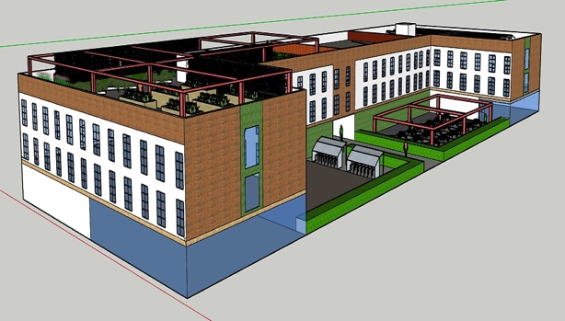
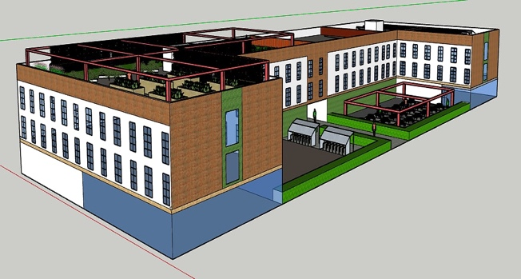

What are the hazards? | Who might be harmed and how? | What is being done to control the risks? | What further action do you need to take to control the risks? | Who needs to carry out the action?
Working at dangerous height. | Key workers, staff, managers and general public. | Using self-box ladder and hydraulic lift, instead of basic unsupported ladders, and extractor box lift. Keeping the area below clear and ensuring the area is cut off to allow no walking elderly, students or the general public for their own safety. | Using stability ladder boxes to raise up and down and locks in centre, using signage for public and also key workers. In addition HSE authority can provide extra support. | Site managers, site engineers, HSE authority
Nearby elderly, students and the general public. | Key workers, staff, managers and general public. | Using self-box ladder and hydraulic lift, instead of basic unsupported ladders, and extractor box lift. Keeping the area below clear and ensuring the area is cut off to allow no walking elderly, students or the general public for their own safety. | Using signage for public and also key workers. In addition HSE authority can provide extra support and safety for public and the site engineers. | Site managers, site engineers, HSE authority and local authority.
Pile head poorly constructed. |  | Ensure thorough inspection is done regularly, and look for quality at all times. | Ask site manager for help and guidance. HSE support. | Site engineers, site managers.
Electrical trip hazard and installation. | Key workers, staff, managers and inspectors and general public. | Look out for loose wiring and always maintain health and safety checks at all times. | Using visible signage will help the public and workers.  Always wearing correct PPE, and always being safe with the installation. | Electrical engineers, electrician or HSE authority.
Damaged material, slab or pre-cast. | Workers, managers. | Ensure control measures and quality checks are done with the producer. Look out for any form of damage before use and return back. | Purchase from the supplier who has good reputation, look for quality within the materials and pre cast. | Site engineers, site managers and distributors.

EMERGENCY AND RESCUE PROCEDURES:

In the event of an emergency, adequate arrangements have been made to ensure the safety of workers and other persons on site and the public near the site. The emergency may result from an accident or injury, landslip or other potentially dangerous occurrence. Natural disaster including electrical storms, floods, plant or machinery fire etc may also present hazards to the working operations. Plans have been setup for such matters and appropriate control measures are in place.

The risk assessment have taken the following factors into account:
- Nature of the hazard and possible emergencies.
- The size and location of the place of work.
- The number and mobility of persons at the workplace.
- The Location of nearest emergency services.

Control measures include:
- A tried and tested warning system.
- There are rapid evacuation procedures with a safe means communication of safe and including injured persons.
- Site Managers are trained to carry out the evacuation and rescue procedures and maintain the site safety until the emergency authorities arrive.
- All staff has been trained to shut down the site equipment.
Pump equipment on standby.
- Provisions of regularly inspected firefighting equipment have been made at the appropriate locations.
- Evacuation procedures have been displayed in appropriate locations for fire exit and other drill events.

WORK SYSTEMS AND CONTROL MEASURES:

Control measures have been put in place to prevent persons from being injured during the construction works. These measure are to be maintained as part of a safe system of work.
The system of work along with the control measures have been determined by individual job factors identified during the risk assessment process.
The following hazards have been identified are commonly associated with structural works and will be considered by the risk assessment process:
- Instability of the Excavation.
- Seepage of Water.
- Unplanned contact with Utility Services e.g. Electricity, Water.
- The placement of Excavated Material.
- Falls into Excavations / Falls from Height.
- Movement and positioning of heavy plant/equipment that may affect the excavation.
- Ground vibration affecting the stability of the structure/excavation.
- Excessive noise from the operation of machinery and plant.
- Chemical Burns.
- Manual Handling Injuries.
- Changes to environment conditions.

PREVENTION OF COLLAPSE OR FAILURE OF TRENCHES AND OPEN EXCAVATIONS:
A risk assessment has been produced by VITO Construction, which has controls implemented to prevent persons being injured by collapse or failure of all or part of a trench or open excavation. Additional attention has been given to adjacent properties that may be affected during the excavation process.
The following has been considered:
- Depth of the excavation.
- The nature of the Strata.
- The presence of Moisture or Water.
- Loads close to the edge or in the zone of influence to the excavation.
- Vibration.
- Exposure time.
- Previous disturbance of the ground, e.g. Previous Excavations.
- Adjoining buildings or structures.
- Structural propping of basement walls

Removal of soil from an excavation causes unbalanced soil stresses, which reduce the capacity of the excavation to support it. The risk assessment identifies an unstable condition, the following measures have therefore been implemented:

- Structural Engineer Design – Underpinning and structural propping.
- An experience Site Manager to supervise the progress of the excavation work.

INSPECTION OF SUPPORT SYSTEMS:
The risk assessment will be reviewed at all terms during the excavation works. The following conditions have been considered and will be monitored:
- Ensure shoring/formwork does not become unstable.
- Ensure formwork is not removed prematurely (only after 48hrs).
- Ensure no plant/machinery is operating within the zone of influence of excavations.
- Monitor ground water, possible seeping into excavations from its side walls or base.
- Monitor changes to soil and/or weather conditions.
- Ensure that surface water or run-off entering the excavations or accumulating on surface near the excavation.
- Monitor possible heaving or swelling of the ground at the bottom of the trench.
- Maintain safe access.
- Ensure no undercutting of the excavation.

