Title: Reflective Learning Log on Hotel Administration Placement at Marriott Cardiff City Centre
Module Code: BMIH6004
Module Title: Managing Hotel Administration
Student Name: Antonela Costiuc
Student ID: 2117337
Tutor Name: Kathryn Roberts
Placement Hotel: Marriott Cardiff City Centre

Declaration
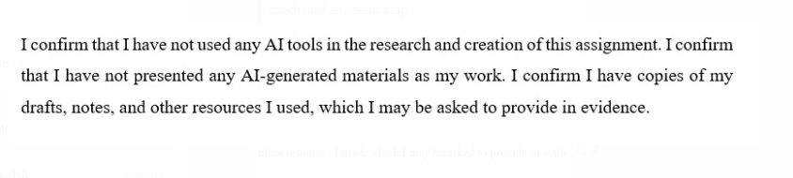

Table of Contents
1 Introduction 3
2 Role Reflection Using a Theoretical Model 4
2.1 Gibbs Reflective Model Explanation 4
2.2 Description of Role and Key Responsibilities 4
2.3 Observation of Leadership and Operational Efficiency in the Department 5
2.4 Examples and Application of Key Skills 5
2.5 Strengths, Weaknesses, and Action Plan 5
3 Key Hotel Administration Issues 5
3.1 Description of the Issue (training) at Marriott Cardiff 5
3.2 Critical Discussion Supported by Academic Literature 6
3.3 Module Link and Relevance 6
4 Future Trends in Hotel Administration 6
4.1 Identification of Emerging Trends (Use of AI in Front Desk Operations) 6
4.2 Impact on the Chosen Department at Marriott Cardiff 7
4.3 Supporting Academic Literature and Reflection 7
5 Conclusion 8
6 References 9

Introduction
I was placed in the Front Desk department at Marriott Cardiff City Centre, which connects first with guests and is crucial for their satisfaction. Check-in, check-out, processing reservations, responding to questions from guests, taking care of payments and working with housekeeping and maintenance are all managed by this department. At Marriott, Opera PMS is used at the front desk so that guest information and room statuses remain current in real time. Although I spent time observing all the departments, I chose the Front Desk since it’s very active and closely related to both customer service and the operational side of the hotel. My first step in the placement was to set the following three goals for learning. The first one is to build confidence when using the software that hotels use. Secondly, boost both your guest service and employee communication abilities. And learn the responsibilities of supervisors in the front office every day.

Role Reflection Using a Theoretical Model

Gibbs Reflective Model Explanation
I chose to use Gibbs’ Reflective Cycle (1988), which is a process divided into six steps: description, feelings, evaluation, analysis, conclusion and action plan. Hospitality schools and colleges find this model useful because students can put their skills to use in a realistic manner, guided by structure (Crawford et al., 2020). Using Gibbs’ model, I was able to explain my actions and also think about my mood, the results and how to improve it.
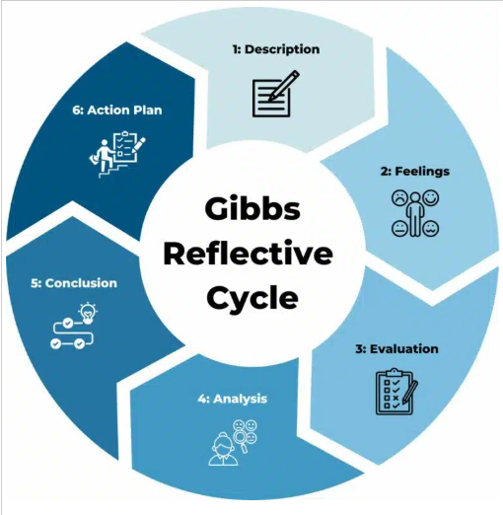
Figure 1 Gibbs Reflection model
Source: (Firth, 2020)

Description of Role and Key Responsibilities
I spent my placement working at the Front Desk of Marriott Cardiff City Centre. I was required to greet guests, register them using Opera PMS, manage reservations, receive and handle payments and answer questions about what was available at the hotel and what to do nearby. I answered calls and emails and worked with the housekeeping department to get rooms ready. I also took part in some of the shift supervisor’s work, which involved looking over shift duties and helping with guest issue management.

Observation of Leadership and Operational Efficiency in the Department
The leadership in the Front Desk team was mostly based on democratic systems. Staff were encouraged by supervisors to ask questions, make decisions independently and back up their colleagues. I noticed that being able to communicate well and making rapid decisions helped handle the rush better. If a big group of guests showed up at the same time, staff members immediately split up the jobs to ensure teamwork. Because of this, the hotel’s day-to-day operations ran efficiently, and guests were happy with their experience (Yadav and Raju, 2024).

Examples and Application of Key Skills
A guest was able to extend their reservation by updating it using Opera PMS. I had to change the reservation rate, confirm rooms were available and talk to housekeeping, this improved both my skills and coordination. At other times, guests may complain about rooms that are too noisy. I listened seriously, said sorry and changed their room. Calmness and empathy allowed me to deal with the issue well, showing how important strong communication and problem-solving skills are (Hussain et al., 2024).

Strengths, Weaknesses, and Action Plan
Strength: I was confident handling PMS, and it did not make me uncomfortable to speak with our guests.
Weaknesses: I realized I had to improve my time management skills and be calmer while facing a lot of tasks at once.
Action Plan:
- Register for online classes that teach how to operate an Opera PMS system.

- Split your own tasks into blocks and get advice from your supervisor.

- Explore tactics for leadership to deal with pressured situations more effectively.

Key Hotel Administration Issues

Description of the Issue (training) at Marriott Cardiff
A major administrative trouble I noticed at Marriott Cardiff was the regularity of training gaps for new and temporary front desk workers on the job. The beginning induction process was great, fully explaining the essential protocols and showing the systems, but there was no continued focus on training afterwards. The gap was seen as staff dealt with unique circumstances or started using the Property Management System (PMS) for activities that weren’t explained during induction in detail (Hazel, 2022). For these reasons, there were delays and staff confusion sometimes, which changed the way the hotel worked, and the experience guests had.

Critical Discussion Supported by Academic Literature
It is well known that good training, especially in hospitality management, straightaway affects the quality of service and how pleased guests are with their stay. Baum et al. (2020) pointed out that continuous training fosters skill growth and promotes staff’s ability to work the same way all the time, which is necessary for hotel operations. Because staff in Marriott Cardiff learned mainly by watching and being told things after training, their skills varied. A study by Ghani et al. (2022) points out that when hospitality employees are not adequately trained, they become less confident, make more mistakes and quit more frequently. I witnessed this in my daily work, since timid team members wrongly handled tasks which affected customer service. Nickson’s study (2023) indicates that continuous learning plays a major role in keeping knowledge up-to-date and making workers adapt better.

Module Link and Relevance
This issue is linked to the focus on personnel resourcing and development I learned in Level 5, and it supports the idea that developing staff continuously leads to better performance for both people and organisations. The module points out that for staff to be retained and motivated, companies should focus on on-the-job training and structured plans (Peterkin, 2022). The management could improve training at Marriott Cardiff by having regular meetings and using e-learning tools that guide employees in operating according to the best methods from the module.

Future Trends in Hotel Administration

Identification of Emerging Trends (Use of AI in Front Desk Operations)
A major change in hotel administration today is the use of artificial intelligence (AI) in both front-line and back-line operations. Currently, technical devices like check-in kiosks, virtual room keys and assistance from chatbots help manage many hotel operations and services (Fernandes et al., 2024). Thanks to these AI tools, hotels now have better efficiency and constant availability, which has impacted on the work done by staff in the industry. With the help of kiosks, people can check in quickly, and chatbots address simple questions so staff can attend to bigger problems.
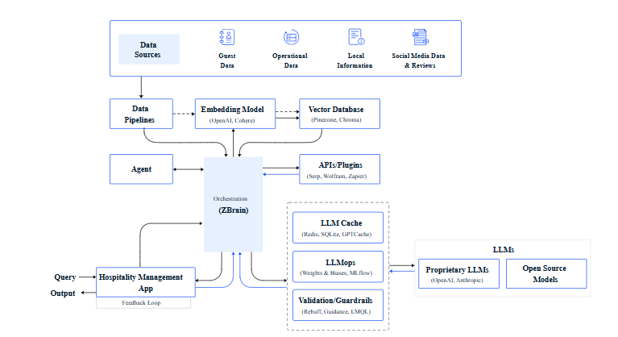
Figure 2 How does AI work in hospitality
Source: (Takyar, 2023)

Impact on the Chosen Department at Marriott Cardiff
In my experience at Marriott Cardiff, check-in is done manually, but there’s now an increasing number of people choosing to manage these tasks through mobile apps. In the future, AI might manage some of the main front desk responsibilities, so staff can focus more on making guests feel special. To meet these needs, front desk employees now require additional technical abilities and emotional intelligence, as AI can handle only some aspects of guest relationships (Flandrin et al., 2021). Hence, hotel staff will probably be more involved in relationships and addressing issues than simply carrying out their jobs.

Supporting Academic Literature and Reflection
According to Wang (2024), despite the benefits of AI, in hospitality, people still need to interact face-to-face to meet guests’ emotional and social needs. This also reflects what I noticed in my placement, as guests still value personalised treatment even with technology present. So, it is thought that AI will work alongside rather than replace hotel workers, meaning those in the field should keep up with such technologies to provide better service.

Conclusion
I learned at Marriott Cardiff that the role of the Front Desk is essential and that regular and reliable training is a major issue. I saw it myself that, according to Baum et al. (2020), to retain a high standard of service and staff assurance, constant education in the workplace matters. I achieved most of my learning objectives by working on the job and reviewing my experiences using the Gibbs cycle. AI may be useful for operations at the front desk, but it should not completely replace human contact, as highlighted by Wang (2024). Marriott can succeed in the future by using AI wisely and working on employee development to keep a personal touch. All things considered, this placement taught me a lot about hotel administration and showed me the importance of learning and adapting in this industry (Nickson, 2023).

References
Crawford, A., Weber, M.R. and Lee, J. (2020). Using a grounded theory approach to understand the process of teaching soft skills on the job so to apply it in the hospitality classroom. Journal of Hospitality Leisure Sport & Tourism Education, [online] 26, pp.100239–100239. doi:https://doi.org/10.1016/j.jhlste.2020.100239.
Fernandes, M.D., Wani, P.S. and Shah, G.D. (2024). The Integration of Artificial Intelligence in the Hospitality Industry. Advances in Hospitality, Tourism, and the Services Industry, [online] pp.525–550. doi:https://doi.org/10.4018/979-8-3693-7898-4.ch025.
Firth, M. (2020). Employability and Skills Handbook for Tourism, Hospitality and Events Students. [online] Routledge eBooks. Informa. doi:https://doi.org/10.4324/9781351026949.
Flandrin, P., Hellemans, C., Jan and Van, C. (2021). Smart technologies in hospitality: effects on activity, work design and employment. A case study about chatbot usage. [online] pp.1–11. doi:https://doi.org/10.1145/3486812.3486838.
Ghani, B., Zada, M., Memon, K.R., Ullah, R., Khattak, A., Han, H., Ariza-Montes, A. and Araya-Castillo, L. (2022). Challenges and Strategies for Employee Retention in the Hospitality Industry: A Review. Sustainability, [online] 14(5), pp.2885–2885. doi:https://doi.org/10.3390/su14052885.
Hazel, N.T. (2022). Critical success factors for small and medium enterprises: a case of the tourism industry in Cape Town. Cput.ac.za. [online] doi:https://etd.cput.ac.za/handle/20.500.11838/3779.
Hussain, S., Soni, G. and Shah, F.A. (2024). Soft Skills and Interpersonal Skills for Tourism and Hospitality Industry. Springer international handbooks of education, [online] pp.119–138. doi:https://doi.org/10.1007/978-981-97-4318-6_7.
Peterkin, K.Y. (2022). The impact of perceived enjoyment on employee continuance intention in computer-based training in the hotel industry. Polyu.edu.hk. [online] doi:https://theses.lib.polyu.edu.hk/handle/200/11720.
Takyar, A. (2023). AI use cases in hospitality. [online] LeewayHertz - AI Development Company. Available at: https://www.leewayhertz.com/ai-use-cases-in-hospitality/ [Accessed 2 Jun. 2025].
Wang, P. Q. (2024) ‘Personalizing guest experience with generative AI in the hotel industry: there’s more to it than meets a Kiwi’s eye’, Current Issues in Tourism, 28(4), pp. 527–544. doi: 10.1080/13683500.2023.2300030.
Yadav, N. and Raju, S.S. (2024). Smart Hotel Technologies Redefining Guest Convenience and Operational Efficiency. Advances in hospitality, tourism and the services industry (AHTSI) book series, [online] pp.25–56. doi:https://doi.org/10.4018/979-8-3693-7127-5.ch002.

‌
‌

