Essay: Environment Analysis of an Industry
Burberry

Assessment 2
Student Name: Vanya Dragneva
Student No: 2010312
Module Name: The Global Business Environment
Module Code: LCCB4005
Teachers Name: Mushfiqur Rahman

Executive Summary
A global problem is environmental pollution as a result of the fashion industry and the issue has risen across the World. Many of the key players in this industry have decided to follow strict rules to save our nature more than others. This work will discuss and critically analyse the changes made in the global luxury brand of Burberry. The UK icon genuine strives to keep the environmental standards and act responsibly, guided by their conscience as well as building trust to not exploit cheap labour in the less developed countries, having the responsibility to represent Britain on the World stage.

Table of Contents
1.0 Introduction……………………………………………………………………………p.1
1.1 Background of Burberry……………………………………………………………..p.1
1.2 Aims and Objectives……………………………………………………………...p.1,2
2.0 Main body…………………………………………………………………………….p.3
2.1 Porter’s five Forces Analysis …………………………………………………….p.3,4
2.2 SWOT Analysis………………………………………………………………..……p. 4,5
2.3 Value chain Analysis of Burberry………………………………………………….p.5,6
2.4 Stakeholders…………………………………………………………………………p.7-9
3.0 Recommendations…………………………………………………………………..p.9
4.0 Conclusion…………………………………………………………………………...p.9
5.0 References…………………………………………………………………………p.9-11

- Introduction
The fashion industry has been noted as a second polluting industry in the World which raised global concerns about our planet and introduced many laws especially in the developed countries aiming to keep much as possible our nature. This case study will focus on the Burberry brand and will provide a critically analyse of the changes within the company related to these global issues. As well as suitable frameworks will be used to access the essential information and approaches within the firm to analyze its behaviour in the light of these global concerns.
1.1 Background of Burberry
Burberry is a leading global fashion brand founded in the far 1856 year by 21-year old Thomas Burberry. Since invented the gabardine in the 1879 year by its founder and has been patented in 1888, many polar explorers going to the North, South Pole and Antarctica wore gabardine clothes (Burberry PLC, 2021) The iconic brand was open in 1891 its first store in London, then followed by another one in Paris and in 1955 had granted by HM Elizabeth second as a Royal Warrant for Weatherproofer. The company launched 2004 its first website in the USA, in 2006 the UK and nowadays is highly modernized.

1.2 Aim and objectives
Burberry is a luxury brand and being commercial is seeking profit. Although the company purpose is to make it through keeping their heritage, preserving values such as care of customers, community and creating new opportunities as noted in Burberry (PLC, 2021). Their hallmark is the uncompromising quality and commitment to excellence, therefore they are directed to target customers.

2.0 Main body
2.1 Porter’s Five Forces Analysis
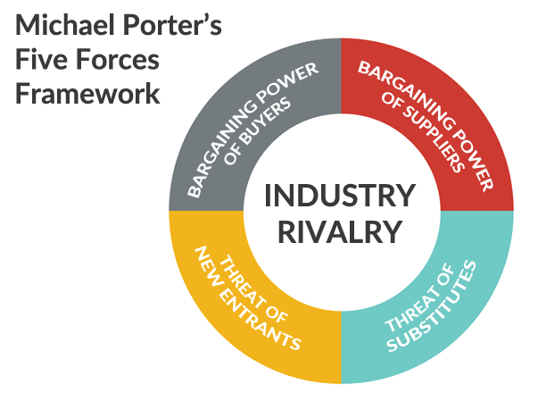
Source: Fern Fort University (2020)

Porter Five Forces Analysis is a highly effective tool to analyze the profitability of the company and to outline the different competitive forces as is noted by G. Scot (2020). It helps to classify the winningness of the industry in designation of the five competitive forces (Johnson et al. 2016, p. 64).
Starting with the Barging power of suppliers Burberry uses numerous of them to get the raw materials and have sustainable relationships with them, however not depending strongly on each one of them. Very creative is the new Econyl, which is designed with discarded nylon found in oceans and other waste therefore in this way they are tackling effectively their environmental footprint (Burberry UK, 2021). They are claiming that the main raw materials are cotton, leader and cashmere linked with the Burberry Product Strategy. In this way, they are aware of the sub-contractors, tanneries and trim suppliers covering 70% of them to be licenced as noted by Burberry UK (2021).

The bargaining power of buyers is controlled by creating and sustaining a large base of clients. Another strategy used by the icon firm is to offer many new products and thus the demands of the customers for lower prices can be managed effectively and limit their power.
Analysing the threat of substitute products in Burberry is seen that the firm is not only a product but a customer-oriented, seeking to understand the client needs more than what they will buy using the strategy of switching cost. The threats of a new entrance are high in the luxury industry, although the UK brand should build and keep safety the barriers of new key players. It is unlikely to enter a dynamic industry and define constantly high standards. The intense Rivalry among Existing Competitors in the fashion industry may drive the prices down and decrease the profit. To tackle with it effectively, Burberry is building sustainable differentiation and is oriented to collaborating with the key competitors such as Hermes, Gucci, Armani, Michael Kors, Prada, LVMH, etc. (Craft,2021)

2.2 SWOT Analysis

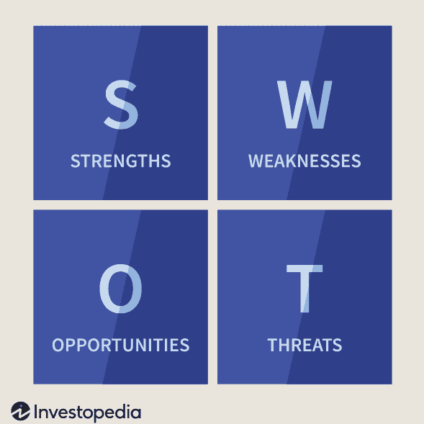
Source: Investopedia (2021)

The SWOT analysis is a tool for outline the internal and external factors within the company. The Strengths and Weaknesses provide the analysis of reservoirs and proficiency, while the Opportunities and Threats – of the surroundings (Johnson et al. 2016, p.115) The Treats for Burberry on this stage are the post-Brexit eras and the new trade regulations. Although they have a hub located in Italy as well as leather goods suppliers (Reuters, 2018) the negotiations are essential for the UK based firm.
Burberry’s opportunities are expanding widely into the Asian market, having been registered an increasing number of millionaires in China and India (The Guardian, 2012) and have accesses to the surrounding countries.
Burberry’s strengths are many such as the excellent reputation and high brand quality, the new approaches in online marketing which are rising in importance and involving famous people wearing the garments and accessories. Example of this is the Beckham family which active supports the marketing strategy (The Guardian, 2016)
The weaknesses of the brand are the strong competition in the luxury sector. According to Deloitte (2020, p. 17) in the top ten luxury good companies the Burberry does not appear, this means that the brand might follow some setup products and accessories.
2.3 Value chain Analysis of Burberry
Porter’s value chain analysis has been introduced by M. Porter and aims to define the value-creating activities in the business to create a product (Zucchi, K., 2020). Its components are primary and support activities.

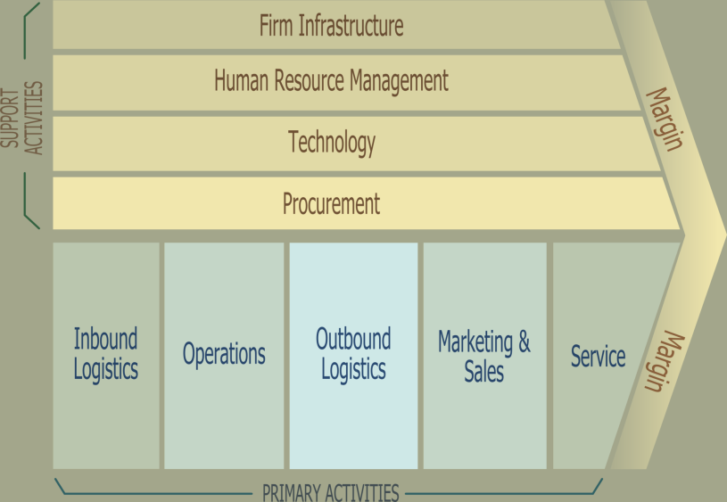
Source: Investopedia (2019)

Analysing Burberry’s value chain in light of the fashion pollution might be noticed that the company relies on ethical and sustainable suppliers, putting the brand name beyond all (Annual Report Burberry, 2013,p. 39). In addition, the three pillars of this are Burberry Impact, Engage and Invest. Emphasising their targets for sustainable cotton farming from 2013, the firm has started to educate and encourage Peruvian farmer to adopt the practise to reduce the environmental impact. This strategy includes reducing the use of pesticides, fertilizer and water (Annual Report, 2013, p. 41). However, the fashion house burnt unsold products in 2017 worth 28,6m pounds to protect the brand and avoid selling to knockdown prices (Kollewe, 2018) which rises seriously criticism way they did not sell them to the firm’s private investors.
For instance, the use of leader in Burberry is under credible suppliers having the Leather Working Group Certification and these are 70% of all working with them ( Annual Report, 2013, p. 41). However, in 2018 the fashion house claimed that stops using real fur as noted by BBC (2018).
The service in the brand is qualified and customer feedback is taken into important consideration. Furthermore, the support activities in Burberry are creating significant value for the customers such as their infrastructure is formed by channels, region, product and by function. To add more value for the customers the HRM is innovating many marketing approaches through the rise of social media and the internet.
Another strategy of the leading brand was starting the school programmes in 2008 which open a great opportunity to spread its brand value in the community as noted by Marjorie van Elven (Fashion United, 2018).
The new technologies highly used and developed by the brand, the growth of the service through the different online platforms are creating sustainable value for the customers.
2.4 Stakeholders
Some of the concerns that have risen by the different stakeholders are relative to the pollution caused by the fashion industry. Burberry has internal stakeholders such as customers, board of Directors, managers and owner. The external ones in the firm are Government, media, suppliers, society, shareholders and the local community.
Because of the pollution caused by the mode manufacturing most influence upon the brand has the external stakeholders to outline the performance within the firm and consequently make an impact of the behaviour of the internal ones. The Government has a huge influence on this issue and the company contributes to the sustainable changes meeting its requests with Business for Social Responsibility, UN Global Compact, Ethical Trading Initiative and Sustainable Apparel Coalition before 2017( Annual Report, 2017, p.40). Moreover, the company has started 2012 a separate evaluation of its environmental effect monitored the CO2 from materials, energy, water, chemical inputs and waste. Another company’s target is reducing greenhouse gas emissions throughout its value chain. Moreover, the brand claims that in 2020 they already build 15 years of progress pacted to the Paris Climate Agreement informed by the UN’s Sustainable Development Goals.
According to the company sustainability Bond Framework (2020, p. 3-4), the luxury brand assures that is more than halfway to reach the goals from their five- year Responsibility Agenda. Moreover, the scheme was expanded with the alliance of the key stakeholders. Examples of this collaboration are the partnership with Circular Fibres Initiative (CFI), the membership in Ethical Trading Initiative, as well the Burberry Responsibility Advisory Committee including the external experts of stakeholders working with Forum for the Future to problem-solving complexity of the sustainability challenges. Other partners and stakeholders are Living Wage Foundation which defends workers from work poverty, The Climate Group and The Carbon Disclosure Project and more than seven other groups from different stakeholders.
The company has set up its goals and marked its progress so far around the three pillars of the company, product and communities.
Table 1- Company
Goal | Progress
1. Zero- carbon footprint by 2022 | At the end of 2019/20- 86% reduction
2. 100% renewable electricity by 2022 | At the end of 2019/20- 90% renewable
3. Reduce and value waste | At the end of 2019/20 – zero waste to landfill and no product devastation
Source: Burberry Sustainability Bond Framework (2020, p.4)
Table 2-Product
Goal | Progress
1. To have 100% of product with more than one social/environmental improvements by 2022 | By the end of 2019/20 -89% achieved in products, 67%- achieved in more than one improvements
2. 100% cotton sustainably by 2022 | 75% achievement
3. All leather with licence for environmental, traceability, social compliance by 2022 | By the end of 2019/20- 64% achieved
Source: Burberry Sustainability Bond Framework (2020, p.5)
Table 3- Communities
Goal | Progress
Good impact to one million people by 2022 (education inequality, support social, economic development) | By the end of the 2019/20- 290,426 people were surely influenced
Source: Burberry Sustainability Bond Framework (2020, p.5)
3. 0 Recommendations
After all, Burberry has set up the company’s goal at a very high level and is achieving them step by step. Although the firm success so far, might be considered some recommendations such as reducing leather using, faster changes in the area of waste recycling and high, honest engagement with the workers across all firm’s fabrics.
4.0 Conclusion
Being one of the Worlds leading brands Burberry is genuinely striving to decrease as much as possible their footprint in the World fashion scene and treat the employees across all over the World honestly and lawful. Despite their ups and downs regarding this issue, the brand achieved high success in meeting customer demands, having licensed suppliers and acting responsibly to the community and our home –the Planet.

5.0 References:
1. Annual Report Burberry (2013), Available at: https://www.burberryplc.com/content/dam/burberry/corporate/Investors/Results_Reports/2014/5-annual_review_2013_14_interactivePDF_english/Report_burberry-annual-rev.pdf (Accessed: 30th April 2021)
2. BBC (2018), ’ Burberry stops burning unsold goods and using real fur’ Available at: https://www.bbc.co.uk/news/business-45430683, (Accessed: 5th May 2021)
3. Burberry PLC (2020) Available at: https://www.burberryplc.com/content/dam/burberry/corporate/Responsibility/Burberry%20Sustainable%20Bond%20Framework.pdf (Accessed: 30th 2021)
4. Burberry UK (2021), Available at: https://uk.burberry.com/legal-cookies/transparency-in-the-supply-chainmodern-slavery-statements/, (Accessed: 29th April 2021)
5. Burberry UK (2021), Available at: https://uk.burberry.com/the-econyl-capsule/, (Accessed: 29th April 2021)
6. Burberry PLC (2021), Available at: https://www.burberryplc.com/en/company/history.html, (Accessed: 29th April 2021)
7. Collaborations and Partnerships - Burberry (burberryplc.com) (2020), Available at: https://www.burberryplc.com/en/responsibility/collaborations-and-partnerships.html, (Accessed: 3th May 2021)
8. Craft (2021), Available at: https://craft.co/burberry/competitors, (Accessed: 29th April 2021)
9. Deloitte (2020), Available at https://www2.deloitte.com/content/dam/Deloitte/at/Documents/consumer-business/at-global-powers-luxury-goods-2020.pdf, (Accessed: 30th April 2021)
10. Elven, M.(2018), ’ Burberry launches in-school programme to study impact of arts education in the UK’, Fashion United, Available at: https://fashionunited.uk/news/culture/burberry-launches-in-school-programme-to-study-impact-of-arts-education-in-the-uk/201810083933, (Accessed: 30th April 2021)
11. Fern Fort University (2020), Available at: http://fernfortuniversity.com/images/business-pics/porter-5-forces.png, (Accessed: 29th April 2021)
12. Grant, M (2021), ’Strength, Weakness, Opportunity, and Threat (SWOT) Analysis’, Investopedia, Available at: https://www.investopedia.com/terms/s/swot.asp, (Accessed: 29th April 2021)
13. G. Scot (2020) Porter’s 5 forces advantage, Available at: https://www.investopedia.com/terms/p/porter.asp, (Accessed: 28th April 2021)
14. Investopedia (2019), Available at: https://www.investopedia.com/thmb/aEwkgHdh2i34YrMIvNRCUPer30s=/2048x1415/filters:fill(auto,1)/2048px-Porter_Value_Chain-78398cffb6364895b31c98549bf6f779.png, (Accessed: 30th April 2021)
15. Jones, J.(2016),’ Brooklyn Beckham's Burberry campaign – the art critic's verdict’, The Guardian, Available at: https://www.theguardian.com/fashion/2016/jul/13/brooklyn-beckham-burberry-campaign-art-critics-verdict, (Accessed: 30th April 2021)
16. Johnson, G. et al. (2016) Exploring Strategy: Text and Cases. 11th Ed. Pearson Education
17. Kollewe, J.,( 2018), Available at: https://www.theguardian.com/business/2018/sep/06/burberry-to-stop-burning-unsold-items-fur-after-green-criticism, (Accessed: 5th May 2021)
18. Neate, R.(2012), China and India swell ranks of millionaires in global rich list’, The Guardian, Available at: https://www.theguardian.com/business/2012/may/31/china-india-millionaires-global-rich-list, (Accessed: 30th April 2021)
19. Reuters (2018), Available at: https://www.reuters.com/article/uk-burberry-manufacturing-idUKKCN1IF1G6, (Accessed: 30th April 2021)
20. Wunderlich, N. (2014), Available at: https://prezi.com/tsbomwaj3mab/burberrys-value-chain/, (Accessed: 29th April 2021)
21. Zucchi, K., (2020), ’Value Chain Analysis’, Investopedia, Available at: https://www.investopedia.com/articles/investing/111014/basics-value-chain-analysis.asp, (Accessed: 29th April 2021)

