Maslow's hierarchy of human needs.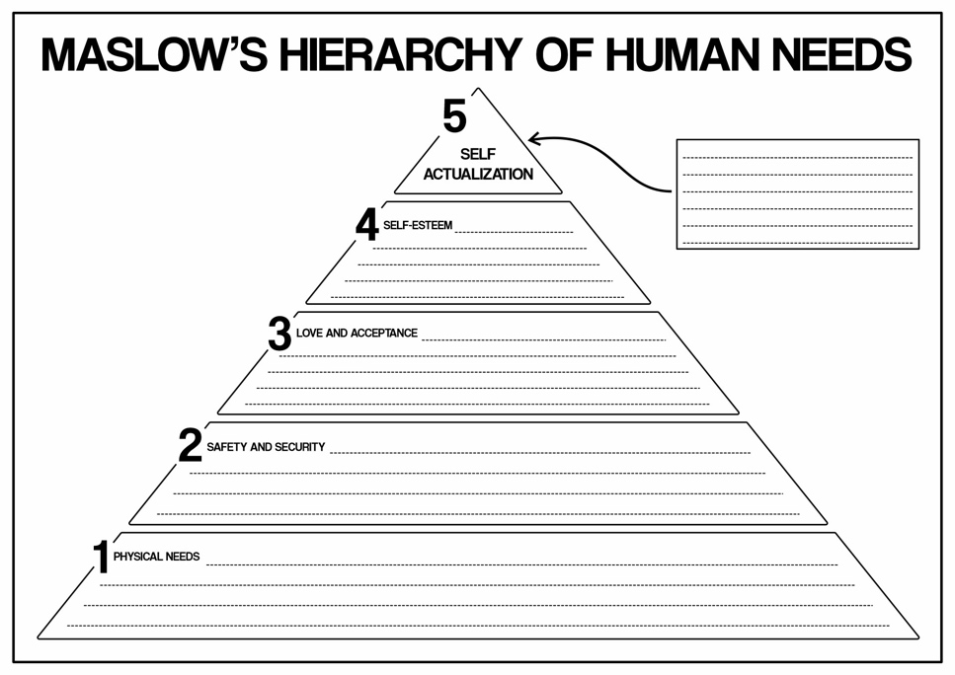
Abraham Maslow’s Hierarchy of Needs gives us a coherent model for human motivation. At the bottom of this pyramidal structure are physiological needs (food and water, for example) for survival. After these are satisfied, people seek protection and security, both physical and psychological. When those are met, humans turn to social needs, in search of affection, belonging and others. When these social needs are met, they become more aspiring for respect, for the respect of themselves and others. The top of the pyramid, if you will, is self-actualization, the motivation to be the best version of oneself and have a life worth living. According to Maslow, there are needs at the lower level that must be met before higher-level needs can emerge as chief motivators, a good way to think about human behavior and desires.
The physiological needs come right at the bottom of Maslow's Hierarchy of Needs. These are the primary conditions for survival. The body needs this most basic need and more indispensable needs to be met to be functional. They are the most basic, including elements like food, water, air, sleep, and shelter. Without access to any of these, a person’s physical health and survival are jeopardized, and the body concentrates only on meeting these needs.
For example, when a person's hunger or dehydration hasn't been satisfied, that person cannot think of elevating their needs towards anything else; so, for such a kind of person, the first step to happiness is nourishment or hydrated state. Sleep has to do with both physical restoration and mental examination, and shelter protects against dangers in the environment. Much of the interference caused by other physiological needs takes precedence because they sustain living.
Maslow states, "so long as these basic needs are not satisfied, an individual cannot possibly move on to any higher objectives like safety, relationships, or self-esteem." Only then after physiological needs have been met is a person able to turn to security, connection with others, and ultimately the fullest of selves, self-actualization: growing and feeling in touch with personal potential. Thus, physiological needs are essentially the foundation for all further human aspiration.
The next layer stretching to the second top in Maslow's pyramid is the Safety and Security category. When these primary survival needs are fulfilled, such as food and water one would then consider being secure and safe in their lives. That means protecting oneself from any form of harm or threatening situations both physically and emotionally.
Physical safety covers a lot of aspects: a safe home, access to health care, and security from any kind of violence or natural disaster. People need their environment to feel secure and stable.
Emotional security has much to do with feeling safe within relationships and knowing that life is following a planned routine. It has to do with having things like stability in jobs, finances, and social life, which means an individual doesn't always keep worrying about what will happen tomorrow.
Safety needs, when unattended, can generate an anxious, scared, or insecure person who would find it difficult to pursue other needs, like love, self-esteem, or personal growth. This, according to Maslow, means that you first need to be safe and secure before pursuing higher goals in life.
The third level in Maslow's hierarchy is Love and Belonging. It refers to emotional and social needs fulfilled by interpersonal relationships. Humans find the ability to love and belong to another person after attaining basic needs like survival and safety. Humans are sociable, and it is primary for mental well-being.
This means for this stage-they want to be part of a family, friends, or even a lover, where there is recognition of having good friends, good relationships, and active participation in communities, either as part of a family, social circle, or even a larger social group.
It is easy when this feeling is lacking, and people often feel lonely, isolated, or rejected. This really does hurt one incredibly bad, and the absence of love and belonging influences self-esteem as well as overall happiness because social support, emotional intimacy, or inclusion are paramount for mental health.

Maslow believes that once love and belonging are satisfied, people start to think of higher needs, such as esteem (self-worth and respect from others) and self-actualization (personal growth). Such establishment would build the emotional foundation required for people to thrive and achieve their best.
Self Esteem is the fourth aspect of Maslow's hierarchy. In this context, esteem relates to basing achievements in life and self-esteem, as well as recognition by others. After satisfying the necessities such as food, security, love, and other needs, people very naturally develop a need to create and maintain self-esteem through achievement and respect from others.
The core of esteem needs includes those aspects of self-esteem and esteem from others-having self-esteem is an individual assessment of self-worth, confidence, and competence; of how much this person believes he/she is worthwhile, accomplished, and above all good in creating a self-image that is very positive.
Confidence fills and degrades the sense of capability and value-neutrality in people, therefore forcing them to pursue higher goals. However, some people suffer to varying degrees from the effects of feelings of inferiority, self-doubt, or social anxiety. Emphasis was laid by Maslow on the fulfillment of esteem needs to be critical for personal growth and self-actualization. The strength of self-esteem ignites a person's desire to stretch towards reaching his full potential, achieve meaningful goals, and take pride in his accomplishments.
The highest level in Maslow's hierarchy of needs is termed as Self-Actualization, which refers to the ability of an individual to realize his maximum potential and personal growth. After satisfying all previous levels of needs (physiological, safety, love, esteem), a person may now seek to find the best possible self. Self-actualization means seeking personal fulfillment, creativity, and meaning in life.
Self-actualization is different for each person. It may entail professional advancement, establishing valuable friendships, artistic or intellectual exploration, or helping others. This includes realizing your gifts, best uses, as well as purpose in life. In a nutshell, it's living the true self and evolving forward in personal growth and happiness.
As Maslow refers to, "the desire to become more and more what one is, to become everything that one is capable of becoming" describes self-actualization. This is not a fixed point in time or condition but an ongoing process of growth and consideration of self. People who reach this level often feel a sense of fulfillment and develop a closer tie to their work and relationships.
Indeed, self-actualization is the highest goal. However, Maslow claimed it could only be pursued once all other needs were met since they lay the groundwork for legitimate personal growth.
The Concept of Holistic Child Development
Concept is a notion or category underlying how we can perceive and unite things, actions, or qualities under one umbrella. It is a simplifier of the much larger world and thereby classifies things under manageable categories. For instance, the all-encompassing "tree" includes all its species like oak, pine, maple, etc. in that they invariably share some common features, apparent as trunk, branches and leaves. This concept enables recognition and understanding of trees, although they may differ visibly. Concepts are thus either concrete, as in tree, or abstract, as in freedom. They are crucial to thinking, learning and communicating.
Holistic child development fosters and nurtures the all-round growth of children-boys and girls-as whole beings, thus including their bodies, emotions, social life, minds, and spirits. This all-round nurture is necessary because of the interdependence among all these aspects of a child's life and the entirety of an individual in developing resilient persons.
Physical and gross motor development in children involves strength and conditioning of the body and development of the capacity for executing gross movements using the great muscle groups, such as crawling, walking, jumping, and running. This is critical during the formative years, since it prepares the path for independence, exploration and contact with the surrounding environment.
According to Maslow's hierarchy of needs, physical development corresponds closely to the first two levels. First, the physiological and then safety needs. At the foundation level, these children need adequate providing for nutrition, sleep and health care that serve the optimal background for growth, and appropriate use of their body's physical abilities. Without these basic needs being met, such children could not develop strength or coordination in their bodies, which is necessary for gross motor skills. Following the physiological needs, children must then learn gross-motor skills in safe environments with the feeling of protection and freedom.
For example, walking or climbing represent sensory and cognitive abilities, which cultivate independence and self-assurance through measurement within Maslow's esteem needs. Also, acquiring milestones in gross motor skills contributes to children's play and social outlets, addressing their needs of belonging and love. Therefore, physical development serves as the foundation for all other aspects of a child's well-being that will later develop through the levels of Maslow's hierarchy into self-actualization.
Social development encompasses aspects of learning how to interact with others, develop relationships, and understand the complex rules governing the society in which children grow up. According to Vygotsky's Sociocultural Theory, it is certain that social development has connections with environmental interactions and people. Learning and development accessed through social interaction have been emphasized by Vygotsky and that these types of interactions are the most important factors in shaping cognitive and social growth.
Centrally, Vygotsky's theory is the Zone of Proximal Development (ZPD). This refers to the range of tasks that the child can perform with the help of a more knowledgeable other (parents, teachers, or peers) to benefit children socially. Some of the skills a child acquires thanks to social activity conducted by him or her in his or her ZPD are cooperation, empathy, and communication. For instance, during a period of play guided by a caregiver or peer, a child can share or learn how to solve a conflict.
Vygotsky also pointed out the role of language as an important tool to be exploited to develop both socially and cognitively. Through the dialogue, the internalization of social norms and behaviors does shape the ability to manipulate relationships. His theory goes on to clarify that social development does not take place in isolation, but through sharing of culture, relationship, and social context.
Children's sensory development denotes the technique beneath which children learn perceptions, concepts or recognize sensory inputs from the surroundings (sight, sound, touch, taste, and smell), and it is a key element in exploring that world, understanding its significance, and associating sensory phenomena with those that surround them. It develops motor skills, cognitive ability, and interactions.
Based on Bronfenbrenner's perspective of Ecological systems model, sensory development depends on close the environmental systems all around the child. At the microsystem level: through a parent simply playing with or including the child in the use of a set of sensory toys, or by a teacher promoting hands-on learning, stimulation generation occurs for sensory development.
Those nurturing spaces improve the contact to facilitate skill development in sensory processing. The mesosystem represents the way these different spaces work together, such as when parents work together with other caregivers or teachers to the further ensure an equal pattern of sensory attention.
An exosystemic would be a parent or caregiver's workspace or a community resource in the broader scope of things-an immediate experience-influencing but not directly changing sensory feeding, such as access to playgrounds or sensory-friendly spaces.
Macrosystem is the combined influence of cultural patterns with a society's outlook towards sensory play or sensory activities. Chronosystem represents the passage of time throughout which sensory development, again, is altered by defining life events, such as entering school or moving into a new area, which introduces new sensory space into the child's world.
Three examples from Early Years Practice:
Maslow's Hierarchy of Needs is an appropriate structure to comprehend children's growth in a care setting. A child must have basic needs fulfilled first before going for other needs that are developmental such as learning and socialization.
Physiological Needs (Basic Physical Needs)
The needs of a child are physical or the very primary needs in Maslow's hierarchy. Food, water, sleep, hygiene, and a comfortable environment make up the basic needs for a child. The child must learn socializing and be self-esteem building; otherwise, such basic needs will not enable one to learn or socialize or build self-esteem. For instance, Noah is a three-year-old boy who comes tired and cranky to the care setting, making it difficult for him to engage in any activity. An early year’s worker may meet the physical needs of Noah by first supplying him with a snack or nutritious meal, for instance, fruits and whole-grain crackers, for energy. He should be provided with a cozy and a bit dark place for a nap with soft bedding so that he can rest in case a nap seems needed, regular checks of his water intake as a means of ensuring hydration, together with water breaks, will avail him with anything possible-or maybe he becomes a bit drier than he usually is. Cleanliness is also part of hygiene; that is when he washes his hands just before having meals or after play. Another aspect that is of importance is a safe, comfortable environment: that will include clean classrooms in which the temperature is controlled and free from hazards so that Noah could feel physical security. All these basic needs are met, and in process of time, Noah will begin to feel comfortably ready to engage. Over time, as Noah's physiological needs are met continuously without a break, he would be able to participate in learning, build friendships, and gain confidence. Supporting physical needs benefits in the immediate and shapes the future physical, emotional, and cognitive development of a child. For children like Noah, this means caring for them, making them feel able to thrive in an environment that is supportive and nurturing.

Safety Needs (Physical and Emotional Security)
These needs are top requirements when it comes to growing up as a child since it involves feeling safe both emotionally and physically, helping the child explore, learn, and build relationships with confidence. For instance, there is a four-year-old girl named Ella, new to a care setting, who would show signs of anxiety during drops, cling to her, and cry when it is time for the parent to leave. Establishing predictable routine activities such as a warm morning greeting and explaining the day's schedule using a picture timetable from an early year’s practitioner is an action towards satisfying Ella's safety needs. Predictability makes Ella control herself better and relieves her anxiety. The other important thing is building a trusting relationship in which case the practitioner is more likely to give assurances by staying nearby, speaking softly and gently, and acknowledging Ella's feelings with statements such as "it is okay to feel sad when your parent leaves; I am here to help you feel better." Such a practitioner may give Ella a comfort object from home, a favorite toy. Well, ensuring a safe environment and providing her with easy, quiet corners do even further good for her security. Last but not the least, together with a parent, the practitioner may devise a good-bye ritual that Ella can be reassured with, perhaps a special hug or wave since it also eases separation anxiety. By involving Ella in interesting activities such as helping to prepare the art table or participating in a small group game, the practitioner can encourage her independence as well as provide her with distractions. Over time, as Ella becomes more familiar with the setting and begins to trust her caregivers, she will feel emotionally and physically safe enough to really begin exploring this new environment, begin making social connections, and feel confident participating in activities. Such actions as these satisfy safety needs and provide solid foundations on which everything else can be built.
Love and belonging
Love and belonging are significant for the emotional and social development of a child, wherein connection and care help him build trust, self-confidence, and positive relationships. One example can be taking the case of a 3-year-old boy, Alex, who is never seen as one who would ask for comfort and almost always isolates himself from group activities. To address Alex's need for love and belonging, the first approach an early-eater practitioner can take is to establish a safe, nurturing relationship through consistent support, involvement in preferred activities, and encouragement, such as, “I’m here to help you if you need me,” with child-appropriate language. Providing him one-on-one attention by reading his favorite book or sitting with him during the time he eats snacks reinforces this sense of being valued and cared for. Make opportunities for peer contact by providing Alex with comfortable, structured interaction with others, for example, encouraging building with blocks using a small group, or taking turns while playing a game. To collaborate with a student who has a friendly warmth, it would help even more to feel really included. Acknowledging social successes, even small ones, such as praise for joining a group activity or sharing a toy, would help Alex feel good about his work and also increase his bond with others. Being in a school for all certainly adds support from families and would encourage Alex as well to form ties with peers. All these approaches over time helped Alex acquire the essential components of trust and belonging, which will emotional security and engagement in play and learning for a child. Approaching Alex from the basis of love and belonging sets the groundwork for an institution for his social-emotional development.
Conclusion:
It is very important for an early year practitioner addressing a child's need based on Maslow's theory since providing such needs forms the foundation for overall well-being and development. When one caters to basic physical needs, provides safety, encourages love and belonging, and around self-esteem, a child feels secure, appreciated, and competent. Therefore, such children thrive emotionally, socially, and cognitively, making them fully realize their potential in a well-nurtured environment.

Reference list:
McMahon, S. and Dyer, M. (eds) (2018) Advanced Work-based Practice in the Early Years: A Guide for Students. First edition. Boca Raton, FL: Routledge.
Weinberg, D.R. (2011) Montessori, Maslow, and Self-Actualization, Montessori life. New York: American Montessori Society, pp. 16-.
Brodie, K. (2018) The holistic care and development of children from birth to three: an essential guide for students and practitioners. Abingdon, Oxon; Routledge, Taylor & Francis Group.
Sadownik, A.R. (2023) Bronfenbrenner: Ecology of Human Development in Ecology of Collaboration, International Perspectives on Early Childhood Education and Development. Springer Link.
Brodie, K. (2018) The holistic care and development of children from birth to three: an essential guide for students and practitioners. London, [England] ; Routledge.
Stoyanov, S 2017, An Analysis of Abraham H. Maslow's a Theory of Human Motivation, Macat International Limited, Milton. Available from: ProQuest Ebook Central. [1 December 2024].
Papaleontiou - Louca, E., Esmailnia, S. and Thoma, N. (2023) ‘Spirituality of the developing person according to Maslow’, New ideas in psychology, 69, pp. 100994-. Available at: https://doi.org/10.1016/j.newideapsych.2022.100994.
Whitters, H.G. (2020) Adverse childhood experiences, attachment, and the early years learning environment: research and inclusive practice. 1st ed. Abingdon, Oxon: Routledge.
Mukherji, P. and Dryden, L. (eds) (2014) Foundations of early childhood: principles and practice. 1st ed. Los Angeles, [California: SAGE.
Bodrova, E. and Leong, D. (2024) Tools of the mind: The Vygotskian Approach to Early Childhood Education. Taylor & Francis.
Loh, D., Schapper, J., Wrathall, J. and Monash University. Department Of Management (2000). The Maslow revival: Maslow’s hierarchy of needs as a motivational theory. Caulfield, Vic.: Monash University, Faculty of Business And Economics, Department Of Management.
‌

