
APPENDIX GA36d

LEVEL 7 ASSESSMENT SPECIFICATION

Student name: | Chan Hoi San | Student ID number: | 2247751
Programme: | MBA CONTRIBUTION TO OVERALL MODULE ASSESSMENT
Module: | Finance for Business Managers
Module code: | HKBM7008 | Contribution to Overall Module Assessment (%): | 100%
Lecturer: | Dr Katherine Mo | Internal Verifier: | Dr Arion Wong
Assignment Title: | Assignment 1 | Word count (or equivalent): | 5,000 words
Submission deadline: | 11 September 2023 | Return date of provisional marks & written feedback: | 10 October 2023
Submission method: | All written assessments, where practical and possible, must be submitted via Turnitin unless otherwise instructed by the Lecturer. (Please DO NOT put this assessment specification into Turnitin or it will match many similarities with other students’ submissions.)  Alternative submission method (if applicable):  Late submission of the assessment will result in a late penalty mark. Penalties for late submission: Up to one week late, maximum mark of 50%. Over one week late, 0%. Only the Extenuating Circumstances Panel may approve a change to submission dates.
Academic honesty / referencing: | Academic honesty is required. In the main body of your submission you must give credit to authors on whose research and ideas your work is based. Append to your submission a reference list that indicates the books, articles, etc. that you have used, cited or quoted in order to complete this assessment.

Contents
1. Abstract 2
2. Introduction 3
1.1 Company Background 3
1.2 Business Environment 3
1.3 Current Business Environment 4
1.4 Company structure 5
2. FINANCE Study 5
2.1 Comparison Between Fairwood and Café De Coral 5
2.2 Financial Analysis for Tsui Wah 6
Bankruptcy Prediction: Z Score 6
Liquidity Ratios 7
Leverage Ratios 7
Coverage Ratios 8
Inventory Ratios 8
Receivables Ratios 9
Payables Ratios 9
Operating Period and Cash Period 9
Profitability 10
Market Value Measures 11
Sustainable Growth Rate 11
3. Corporate Governance – Internal Control and risk management 12
4. Project Proposal: Online Ordering PLATFORM 14
Project Basic Information 15
Sale of the First Year 15
Calculation of the tax cost 16
Cashflow Calculation 16
Investment appraisal Summary 16
5. Capital Management and Considerations for New Project 17
Bank Loan 17
Share Issue 17
Own Fund 18
Inviting Potential Investors 18
Capital Raising Suggestion for Tsui Wah 18
6. Implementation Plan 18
7 Conclusion and Audit Plan 19
8 References 19
9. Appendix 23

Abstract
Tsui Wah Restaurant is one of the popular fast-food restaurants in Hong Kong. In 2023, it contains 79 restaurants covering the Southeast Asia region. Having faced a difficult situation caused by COVID-19 in 2020, the business operation conquered an unprecedented hurdle between 2020 and 2022. The gross profit for 2021 and 2022 was recorded as a loss. After releasing social distance policies in early 2023, the business situation of Tsui Wah became better. To stabilise the business of Tsui Wah, a new business project will be suggested to increase the revenue for Tsui Wah. To align with the purchase habits of customers nowadays, an online ordering platform is recommended for Tsui Wah to enhance the ordering efficiency for customers. Using their own funds is recommended for Tsui Wah to start its project. A comprehensive audit plan is needed to monitor the project’s implementation.

Introduction

Company Background
Tsui Wah Holding Limited (Tsui Wah) is a restaurant chain in Hong Kong. In 2023, its network already covered Hong Kong, China and Singapore, which contains 79 restaurants as of 31 March 2023 (Tsui Wah, 2023). Tsui Wah was listed on the Main Board of the Hong Kong Stock Exchange in 2012, which is the first listed “Cha Chaan Teng” in Hong Kong. Tsui Wah aims to effectively provide customers with high-quality food and a hygienic environment.
The effort of Tsui Wah has also been recognised by external organisations by receiving several awards, namely Best ERB Manpower Developer Award-ERB Best Employer by Employer Retaining Borad in 2019 and BEST in ESG Awards (Small Market Capitalisation) in 2019 (Tsui Wah, 2023). Meanwhile, it strives to perform its corporate and social responsibility to society with different community services and environmental protection events.
In 2017, it was the 50th year of operations in Hong Kong. Tsui Wah promoted some schemes to extend its footprint to the market deeply, such as opening the first restaurant in Zhongshan and broadening the sources of ingredients from various countries internationally. Unluckily, the spreading situation of COVID-19 drastically hit the business of Tsui Wah between 2020 and 2022, in which the financial situation is not ideal. In early 2023, the social distance policies were progressively abolished. To benefit from it, the business situation and the financial figure of Tsui Wah became better.

1.2 Business Environment
In 2020, the pandemic situation was largely spread in society. Several social distance policies were arranged to reduce the speed of viruses spreading in society, such as the suspension of dining in the restaurant and limiting the number of people on a table. The revenue of the restaurants was directly affected by those policies immediately. In 2022, Vaccine Pass was arranged to block the chain of infection. It was undoubtedly a double hit on the business situation of the restaurants, with no exception for Tsui Wah. It was recorded as a loss in 2021 and 2022, which are HK$126 094,000 and 124,049,00, respectively. The number of restaurants was also reduced from 85 in 2022 to 79 in 2023 (Tsui Wah, 2023).
Table 1: HK GDP Annual Growth Rate

Created by the Author
Tsui Wah's management quickly conquered the pandemic's influence during this critical period. They developed a “Tsui Wah Delivery” to address dining restrictions. Within this period, Hong Kong's economic growth decreased from –3.9% in Q1 2022 to –4.1 in Q4 2022 (Trading economic, 2023). It had a slight improvement starting from Q1 2023 (Table 1). The business situation of Tsui Wah accordingly improved a lot, containing a gross profit of about HK$61,855,000 in 2023.

1.3 Current Business Environment
In the post-pandemic situation, the living habits of Hong Kong Citizens have changed a lot (Oriental Daily, 2023). People are more willing to prepare their meals themselves rather than eat outside. Also, the night energy’s Hong Kong recently is less than before the pandemic situation (The Standard, 2023). The government have considered arranging a night market to boost the night energy of Hong Kong. However, if this proposal is implemented, it may negatively affect the catering industry, directly reducing the gross profit of restaurants. Therefore, in this current business environment, it may not be favourable for Tsui Wah to maintain sustaining growth afterwards. The market situation should be analysed cubically and provide a possibility for Tsui Wah to survive in the fierce market environment.

1.4 Company structure
The 2023 annual report (2023) mentioned that Mr Lee Yuen Hong is the chairman of Tsui Wah. Under his leadership, Borad has formed to decide the business strategies for Tsui Wah. Several supporting departments, such as Procurement, Finance, Human Recourse and Administration, support the operations of the 79 restaurants. The total number of staff is 2565, including full-time and part-time staff.
To sustain the growth of Tsui Wah, the current financial situation should study transparently to prepare for a comprehensive proposal for further development. At the same time, a benchmarking exercise should be executed to navigate the position of Tsui Wah in the current market.

2. FINANCE Study

2.1 Comparison Between Fairwood and Café De Coral
This part will show the financial performance of Tsui Wah between 2021-2023 in comparison with Fairwood and Café de Coral. Both are common and large-scale fast-food Restaurants (Table 2a) in Hong Kong which are major competitors for Tsui Wah. Therefore, their performance may be a significant reference for Tsui Wah to plan its future proposal.
Table 2a: Comparison Between Tsui Wah, Café De Carol and Fairwood
Company Name  (Stock Name) | Tsui Wah  (1314) | Café De Carol  (341) | Fairwood  (52)
Business Nature | Fast-Food Industry
Market Value as 31 March 2023  (HK$’000) | 3,457 | 6,091,322 | 1,526,134
Stock Value (HK$) as of 31 March 2023 | 0.25 | 10.14 | 11.78
Business Cover Area | Hong Kong, Macau, Mainland China and Singapore | Hong Kong and Mainland | Hong Kong and Mainland China
Number of Restaurants as of 31 March 2023 | 79 | 529 | 179
Created by the Author

2.2 Financial Analysis for Tsui Wah
Through the financial statement from Tsui Wah, the current financial performance of Tsui Wah will be visualised in this section, such as the bankruptcy index, liquidity ratios, leverage ratios, coverage ratios, inventory ratios, receivables ratios, cash period, total asset turnover, profitability ratios and market values to investigate the recent situation of Tsui Wah compared with two assigned companies.
Table 2b: Financial Information of Tsui Wah, Café de Carol & Fairwood
Company Name | Tsui Wah |  |  |  | Café De Carol | Fairwood
Company Name | 2020-2021 | 2021-2022 | 2022-2023 | 2022-2023
Total Assets | $1,552,238 | $1,267,918 | $1,039,619 | $7,175,340 |  | $2,302,545
Sales | $956,382 | $993,324 | $845,797 | $8,024,044 |  | $3,024,152
EBIT | -$117,777 | -$117,400 | $61,855 | $242,684 |  | $83,362
Net Income | -$126,994 | -$124,049 | $55,880 | 111,187.00 |  | $44,880
Total Liabilities | $935,630 | $760,797 | $505,459 | $4,383,277 |  | $1,621,916
Net Working Capital | -$125,548 | $15,664 | $96,407 | $-$652,197 |  | -$24,777
Stock Value (HKD) | 0.33 | 0.22 | 0.25 | 10.40 |  | 11.78
Number of Stock | 14,112 | 14,112 | 14,112 | 585,704 |  | 129553
Created by the Author

Bankruptcy Prediction: Z Score
In Table 2b, the primary financial data of them have been shown, which can help calculate the bankruptcy index for companies. Nikolaos, Konstantinos and Apostolos (2009) found that the Z score effectively investigates a company's bankruptcy probability. The danger zone is lower than 1.81, and the safety zone is above 2.99. Failure Prediction is definitely vital for a company in charge to be aware of the health of the company and act immediately (Altman et al. 2014).
Table 2c: Z Score
Company Name | Tsui Wah |  |  |  | Café De Carol | Fairwood
Company Name | 2020-2021 | 2021-2022 | 2022-2023 | 2022-2023
A | -0.10 | 0.01 | 0.11 | -0.01 |  | -0.11
B | 0.54 | 0.56 | 0.72 | 0.34 |  | 0.30
C | -0.25 | -0.31 | 0.20 | 0.12 |  | 0.11
D | 0.00 | 0.00 | 0.00 | 0.56 |  | 0.83
E | 0.62 | 0.78 | 0.81 | 1.31 |  | 1.12
Z score | 0.81 | 1.05 | 1.85 | 2.32 |  | 2.25
Z Score: Z=1.2A+1.4B+3.3C+0.6D+0.999E
Created by the Author
Referring to Table 2c, the situation of Tsui Wah is not unstable. The Z scores within 2020-2022 (2 years) are below 1.81, which is the danger zone for the company's operation. During 2022-2023, the Z score of Tsui Wah was 1.85, which marginally reached the grey zone. Compared with Café De Coral and Fairwood, the situation of Tsui Wah is the worst. As mentioned in their annual report (Tsui Wah, 2021), the pandemic situation severely destroyed the business operation of Tsui Wah.

Liquidity Ratios
Liquidity is very important for a company to hold sufficient cash to conquer short-term or immediate debts in due time (Breuer et al. 2012). If all ratios are equal or above, it means that the companies contain sufficient cash for their short-term financial needs. Referring to table 2d, the current ratio and quick ratio of Tsui Wah marginally passed, but the cash ratio is less than 1. To Compare with Café De Carol and Fairwood, the situation of Tsui Wah may be acceptable in this market.
Table 2d: Liquidity
Company Name | Tsui Wah |  |  |  | Café De Carol | Fairwood
Company Name | 2020-2021 | 2021-2022 | 2022-2023 | 2022-2023
Current Ratio | 0.71 | 1.04 | 1.33 | 0.77 |  | 0.97
Quick Ratio | 0.67 | 1.00 | 1.30 | 0.67 |  | 0.97
Cash Ratio | 0.39 | 0.26 | 0.64 | 0.60 |  | 0.79
Created by the Author

Leverage Ratios
The leverage ratios of a company will highly influence its credibility when further applying for a loan from the bank in future investment (Ma’in & Ismail, 2011). Referring to Table 2e, the overall ratios of Tsui Wah are less than Café De Carol and Fairwood. The situation of 2022-2023 had an improvement soundly. The long-term debt ratio decreased from 72% in 2021-202 to 40% that year. The equity is more than the debt they had in 2022-2023, which is 0.95.
Table 2e: Leverage Ratios
Company Name | Tsui Wah |  |  |  | Café De Carol | Fairwood
Company Name | 2020-2021 | 2021-2022 | 2022-2023 | 2022-2023
Total Debt Ratio | 60% | 60% | 49% | 61% |  | 70%
Debt / Equity | 1.52 | 1.50 | 0.95 | 1.57 |  | 2.38
Long-Term Debt Ratio | 82% | 72% | 40% | 57% |  | 118%
Equity Multiplier | 2.52 | 2.50 | 1.95 | 2.57 |  | 3.38
Created by the Author

Coverage Ratios
Coverage Ratios will affect the health of the company’s operation when facing the risk of sudden financial distress (Meryana & Erna, 2023). The higher ratio represents the higher ability for paying the interest expense. Referring to Table 2f, the coverage ratios of Tsui Wah had significant improvement in 2023 after the pandemic situation starting in 2020. Its ratio of times interested earned, 4.27, even is higher than Café de Carol, 2.46 and Fairwood, 2.63 in 2023. Therefore, it is healthy for Tsui Wah’s operation in this area.
Table 2f: Coverage Ratios
Company Name | Tsui Wah |  |  |  | Café De Carol | Fairwood
Company Name | 2020-2021 | 2021-2022 | 2022-2023 | 2022-2023
Times Interested Earned | -4.69 | -5.92 | 4.27 | 2.46 |  | 2.63
Cash Coverage | 5.89 | 6.52 | 16.34 | 14.41 |  | 17.73
Created by the Author

Inventory Ratios
The amount of inventory stored is another ratio to reflect the business performance of a company. An overestimated inventory store in a company usually represents negative phenomena occurring, for example, over-purchasing of raw materials or reducing the sale amount (Koumanakos, 2008). The higher ratios mean that higher turnover ratios of inventory occur in a company. Referring to Table 2g, the performance of Fairwood is the best of them in which the day’s sales in inventory is only 7.34. The performance of Tsui Wah in this area is almost the same as Café De Carol in 2023 after the influence of the pandemic between 2020 to 2022.
Table 2g: Inventory Ratios
Company Name | Tsui Wah |  |  |  | Café De Carol | Fairwood
Company Name | 2020-2021 | 2021-2022 | 2022-2023 | 2022-2023
Inventory Turnover | 15.81 | 20.14 | 26.55 | 27.29 |  | 49.75
Day’s Sales in Inventory | 23.09 | 18.13 | 13.75 | 13.37 |  | 7.34
Created by the Author

Receivables Ratios
The higher receivables ratios mean that receiving more receivables daily. The payment terms provided by the company will also affect the collection period of the receivables (Amanda, 2010). Referring to Table 2h, The performance of Tsui Wah is the best compared with Café De Carl and Fairwood. In 2023, its average collection period is 1.8 days which is within 2 days.

Table 2h: Receivables Ratios
Company Name | Tsui Wah |  |  |  | Café De Carol | Fairwood
Company Name | 2020-2021 | 2021-2022 | 2022-2023 | 2022-2023
Receivables Turnover | 191.93 | 173.99 | 203.22 | 58.13 |  | 33.59
Average Collection Period | 1.90 | 2.10 | 1.80 | 6.28 |  | 10.87
Created by the Author

Payables Ratios
The Account payables are the costs that should be paid to suppliers but have not yet been paid. The more extended payable period allows the postponement of the payment to the suppliers (Ikechukwu & Nwakaego, 2015). But it may affect the credibility of a company in a long-term cooperation. Referring to Table 2i, the overall account payable period of Tsui Wah is the longest, 44.54 days (about 1 and a half months) in 2023, compared with Café De Carol and Fairwood.
Table 2i: Payables Ratios and Cash Period
Company Name | Tsui Wah |  |  |  | Café De Carol | Fairwood
Company Name | 2020-2021 | 2021-2022 | 2022-2023 | 2022-2023
Payables Turnover | 7.40 | 10.33 | 8.19 | 58.13 |  | 33.59
Account payable Period (Day) | 49.31 | 35.33 | 44.54 | 6.28 |  | 10.87
Created by the Author

Operating Period and Cash Period
Referring to Table 2i, the cash period of Tsui Wah is the best compared with Café De Carol and Fairwood, which means that the payable period is longer than the operating period
Table 2g: Payables Ratios and Cash Period
Company Name | Tsui Wah |  |  |  | Café De Carol | Fairwood
Company Name | 2020-2021 | 2021-2022 | 2022-2023 | 2022-2023
Operating Period | 24.99 | 20.22 | 15.55 | 19.65 |  | 18.20
Cash Period | -24.32 | -15.11 | -29.00 | 8.39 |  | -34.62
Created by the Author

Total Asset Turnover
This figure showed how the company generated the profit through their total assets. The higher ratios mean that their assets can generate profits effectively (Sunjoko & Arilyn, 2016). The performance of Tsui Wah in this area is the worst compared with the other two companies. The sale of Tsui Wah between 2022-2023 is not satisfactory due to the influence of the pandemic.
Table 2k: Total Assets Turnover
Company Name | Tsui Wah |  |  |  | Café De Carol | Fairwood
Company Name | 2020-2021 | 2021-2022 | 2022-2023 | 2022-2023
Total Asset Turnover | 0.62 | 0.78 | 0.81 | 1.12 |  | 1.31
Created by the Author

Profitability
Rutkowska (2015) mentioned that the profitability of the company is highly determined the investment decision of the investors. The higher percentage of the index below means that higher profit they can create in their operation. In the case of Tsui Wah from Table 2l, after excluding the period between 202-2022, affecting by the pandemic situation, the overall profitability index of Tsui Wah is better than the other two companies, which may attract the attention of the investors. However, besides the profitability, other factors, such as reputation, and future view of the companies, should also be considered by investors.
Table 2l: Profit Index
Company Name | Tsui Wah |  |  |  | Café De Carol | Fairwood
Company Name | 2020-2021 | 2021-2022 | 2022-2023 | 2022-2023
Gross Profit Margin | 70% | 72% | 73% | 9% |  | 8%
Net Proft Margin | -13% | -12% | 7% | 1% |  | 1%
EBITDA Margin | 18% | 15% | 30% | 18% |  | 20%
Return on Assets (After Tax) | -8% | -10% | 5% | 2% |  | 2%
Return on Equity (After Tax) | -21% | -24% | 10% | 4% |  | 7%
Created by the Author

Market Value Measures
Warrad (2017) mentioned that the market value of companies highly influences the rewards of the shareholders regard to company’s profitability. The valuation of the companies is reflected from the PE ratio. To compare with Café De Carol, 54.78 and Fairwood, 34, Tsui Wah is only 0.06 which is the lowest. The value of Tsui Wah may be underestimated by the market. Furthermore, the average should be between 20-25 (Stash Team, 2023). The market-to-book ratio of Tsui Wah is also the lowest, 0.01, which means that the value of the company may also be underestimated.
Table 2m: Market Value Measures
Company Name | Tsui Wah (HK$’000) |  |  |  | Café De Carol | Fairwood
Company Name | 2020-2021 | 2021-2022 | 2022-2023 | 2022-2023
Market Capitalisation | $ 4,586 | $ 3,076 | $ 3,457 | $ 6,091,322 |  | $ 1,526,134
PE Ratio | -0.04 | -0.02 | 0.06 | 54.78 |  | 34.00
Market-to-Book Ratio | 0.01 | 0.01 | 0.01 | 2.18 |  | 2.24
Created by the Author

Sustainable Growth Rate
It is an indicator to study the operation continuity of the company without having to borrow other debt externally. Platt, Platt, & Chen (1995) mentioned that the sustainable growth rate may predict the functionality of companies facing financial ruin. The higher percentage means that their equity could help them to create more retained earnings. Table 2n, it shows that the performance of Fairwood is the best, and Tsui Wah is in the middle position.
Table 2n: Market Value Measures
Company Name | Tsui Wah (HK$’000) |  |  |  | Café De Carol | Fairwood
Company Name | 2020-2021 | 2021-2022 | 2022-2023 | 2022-2023
Sustainable Growth Rate | 98% | 99% | 100% | 54% |  | 124%
Created by the Author
To summarise the above financial findings, the below areas should be the concerns of Tsui Wah in future.
- Risk of Bankruptcy: The z-score of Tsui Wah in 2023 is 1.85 (Table 2b) which marginally reaches the safety zone. It will eliminate the investor and public’s confidence in us. It will highly their investment us. Therefore, Tsui Wah should consider how to improve the z-score to the safety zone.
- Improvement of the Market Value: The market value of Tsui Wah is the lowest compared with Café de Carol and Fairwood. Both PE ratio and market-to-book are the lowest compared with café De Carol and Fairwood (Table 2m). To attract the investment of new investors, the market value of Tsui Wah should be improved.
To achieve the above suggestions, the revenue of Tsui Wah should be increased through new business initiatives. After the influence of the pandemic, the business ecosystem is totally reversed. The online purchasing habit has been developed for customers. 50% of customers are more willing to purchase their goods online (OSOME, 2023). Therefore, to meet this tendency, Tsui Wah should consider adding this element to its business development.

Corporate Governance – Internal Control and risk management
Corporate Governance is something like a gatekeeper to protect the rights and interests of the investors through systematic and comprehensive regulations to monitor the business operations of listed companies. Claessens (2006) mentioned that it is related to a lower cost of capital, which can return on higher profit and greater efficiency. Due to the financial crisis that occurred in 2008, Lehman Brothers collapsed in September 2008 with USD $ 639 billion in assets and USD 619 billion in debt. (Lioudis, 2023). Many investors lost their investment, which was their lifelong savings then. It was a painful experience for different governments. They strongly reinforce the controllability of the corporate governance of companies, which not only protects the benefit of the investors but also protects the local finance stability.
Pradhan (2023) mentioned that ten focuses should be addressed for enhancing the public acceptability of corporate governance, including Conflict of Interest, asymmetry of information, separation between ownership and management, Independence of the Board, Checks and Balances, Compliance with Law and Regulations, Disclosure and Transparency, Minority Shareholders and Other Stakeholders, Accountability & Code of Conduct or ethics. Here, we will study the related situation of Tsui Wah according to the suggestions of Pradhan.
- Conflict Interest: If a company fails to handle the conflict of interest for their employees, including the management team, properly, the decision of the related issue may not be assessed as evidence based. The individual’s interest may affect the decision of colleagues who may be responsible for another company having business relationships with Tsui Wah, e.g., the selection of food suppliers. It may directly affect the advantages of the company and investors. Tsui Wah should develop a comprehensive mechanism to manage the interests of employees.
- Asymmetry of information: The distribution of sensitive information should be kept in a proper way to guarantee consistency and accuracy. As a listed company, the core information may influence the stock price, from which the benefit of the stakeholders may be affected. Tsui Wah should have a severe procedure to monitor the distribution of the information.
- Separation between ownership and management: The dual roles of the individual should be avoided to minimise the dual interests in some decision-making. Sometimes, the related individual should avoid attending particular meetings if the meeting’s agenda embraces the individual’s interests.
- Independence of the Board: The board should maintain a certain level of independence in the board meeting. Therefore, independent non-executive directors (INEDs) shall be included in the board meeting to monitor the operation of the company in a third-party role. Tsui Wah already had three (INEDs) in its board commitment.
- Checks and Balances: A structured audit mechanism shall be developed to monitor the operations of the company to ascertain the right procedures and practices for every decision. Both internal and external audit systems are recommended for a company.
- Compliance with Law and Regulations: A listed company should comply with certain core regulations to ensure the operation in proper and legal ways, such as anti-competition, anti-discrimination and anti-corruption, etc.
- Disclosure and Transparency: As a listed company, the transparency of promoted policies and decisions is very important to stakeholders. They should have the right to know the changing of the company. Therefore, Tsui Wah should also build up systematic communication channels to deliver important information to stakeholders.
- Minority Shareholders and Other Stakeholders: The minority shareholders and other stakeholders shall not be ignored, although they may not be involved in operational decisions. However, they should have a right to receive certain related information. Therefore, two-way communication channels should be arranged for Tsui Wah to understand both concerns in the business operation.
- Accountability: The entire mechanism for accountability should be created to monitor the management behaviours of the management because the performance of the company should be reported to shareholders and even the public.
- Code of Conduct: The code of conduct should be created for bounding the behaviours of employees and even management to avoid falling into pitfalls. The ultimate goals are to protect the interest of the stakeholders and the brand image towards the public.
Tsui Wah is a family-based business in which some family members are placed in senior positions. To maintain the independence of business decision-making, Tsui Wah should consider inviting more non-relatives to the management team. The decision may not skew to their own benefits. Meanwhile, to enhance the investor’s confidence in Tsui Wah, Tsui Wah should develop a comprehensive regulation system to ensure staff comply with it, such as anti-discrimination and Anti-corruption. To enhance its transparency, Tsui Wah should consider building up regular communication channels with the stakeholders to update the company's situation with them.

Project Proposal: Online Ordering PLATFORM
To respond to the updated customer habits, an online ordering platform is suggested, which may create certain benefits for Tsui Wah. The sales turnover rate may increase by 30%, and the manpower may also decrease by 30 % from the support of the online platform (Pin Me, 2023). Furthermore, pre-ordering through the online platform may reduce the waiting time for takeaway orders. It is definitely increasing the serving capacity of Tsui Wah during peak hours, such as lunchtime.

Project Basic Information
Development Cost
Items | Cost (HK$’000) | Remarks
Custom-made APP for Online Ordering System | HK$500 | (Cost for Custom made App Development)
Hardware (tablets for 79 Restaurants) | HK236 | (Reference: Xiaomi Pad 6: HK$2999 each)
5 year’s ISO Platform Cost (US$99 Per Year) | HK$3.8 | US$1: HK$7.8435 (Price at 26 August 2023 from yahoo)
Google Play (US$25 one-off) | HK$2 | US$1: HK$7.8435 (Price at 26 August 2023 from yahoo)
Total Cost | HK$741.8
Operation Cost
Items |  | Remarks
Depreciation | 5 years
2 Senior IT Experts for Maintenance | HK$1150
Promotions such as TV advertising & social media promotions) | HK$8
Sale Growth Rate | 4.9% | Benchmark with the growth rate of Café De Carol in 2023)
EBITDA (%) | 30% | Tsui Wah (2023)
Operating Period | 5 Years

Sale of the First Year
Project Items
Items | Cost (HK$’000) | Remarks
Estimated Sales | HK$42,439.9 | (5 % of Sale in 2023)

Calculation of the tax cost
Items (HK$’000) | Year 1 | Year 2 | Year 3 | Year 4 | Year 5
Sales=Last Year’s Sales x (1+ 5%) | $42,439.9 | $44,519.4 | $46,700.9 | $48,989.2 | $51,389.7
EBITDA | $12,732.0 | $13,355.8 | $14,010.3 | $14,696.8 | $15,416.9
System Depreciation | 100 | $100.0 | $100.0 | $100.0 | $100.0
Hardward Depreciation | $47.2 | $47.2 | $47.2 | $47.2 | $47.2
EDIT | $12,584.8 | $13,208.6 | $13,863.1 | $14,549.6 | $15,269.7
Tax Cost (16.5%) | $2,076.5 | $2,179.4 | $2,287.4 | $2,400.7 | $2,519.5
Profit | $10,508.3 | $11,029.2 | $11,575.7 | $12,148.9 | $12,750.2

Cashflow Calculation
Items (HK$’000) | Year 1 | Year 2 | Year 3 | Year 4 | Year 5
EBITDA | $12,732.0 | $13,355.8 | $14,010.3 | $14,696.8 | $15,416.9
Depreciation | -$147.2 | -$147.2 | -$147.2 | -$147.2 | -$147.2
Promotions such as TV advertising & social media promotions) | -$80.0 | -$80.0 | -$80.0 | -$80.0 | -$80.0
2 Senior IT Experts for Maintenance | -$1,150.0 | -$1,150.0 | -$1,150.0 | -$1,150.0 | -$1,150.0
Equipment Maintenace | -$25.0 | -$25.0 | -$25.0 | -$25.0 | -$25.0
Tax Cost (16.5%) | -$2,076.5 | -$2,179.4 | -$2,287.4 | -$2,400.7 | -$2,519.5
Cashflow | $9,253.3 | $9,774.2 | $10,320.7 | $10,893.9 | $11,495.2

Investment appraisal Summary
Discount Rate: 5 % (Tusi Wah 2023 ROA) | Year | Annual Cashflow | Cumulative Net Cash flow | Present Value of Net Cash flow
Initial Cost (HK$’000) | 0 | -$742 | -$742 | $8813
Net Present Value (NPV) | 1 | $9,253 | $8,511 | $8,865
Net Present Value (NPV) | 2 | $9,774 | $18,285 | $8,915
Net Present Value (NPV) | 3 | $10,321 | $28,606 | $9,007
Net Present Value (NPV) | 4 | $10,894 | $39,500 | $8,578
Net Present Value (NPV) | 5 | $11,495 | $50,995 | $8,813
NPV (Present Value of Net Cash Flow - Initial Cost): |  |  |  | $43,820.90
Interest Rate of Return (IRR) |  |  |  | 12.53
Accounting Rate of Return (ARR) |  |  |  | 15.64
Profit Index (PI) |  |  |  | 60.07
Pay Back Period (PBP) |  |  |  | 1 month
Based on the investment appraisal summary above, the value for this proposal should be positive. Firstly, the NPV is HK$43,820,900 which is larger than the initial cost, HK$741,000. (Žižlavský, 2014) pointed out that NPV helps the companies to assess the risk of implementing the project and the profit creation after reducing the investment amount.
Secondly, the IRR is used to assess the decision to invest in a new project (Magni, 2010). The IRR of this project is 12.53, which is higher than the 2023 ROA of Tsui Wah. Therefore, based on the IRR of this project, it is recommended to start. However, the limitation of IRR is that it excludes some factors affecting the return rate such as the inflation rate.
Thirdly, the APP and the PI are higher than the 2023 ROA, 5% of Tusi Wah which is 12.53 and 60.07 respectively. The payback period is within 1 month. With the above index, this project should be valuable for implementation and the risk is relatively low.

Capital Management and Considerations for New Project
To prepare a new business project, sufficient capital is vital for developing a new project in which several items should be considered by the managers before collecting the capital for the new project, namely, sources of the capital. In general, capital raising can be external capital, including investing potential investors, bank loans, share issues and bond issues, internal capital, own fund, and private investment (Kizielewicz, 2017). Before selecting the suitable capital raising method, the pros and cons of different methods should be studied by the management.

Bank Loan
Bank loan is a common capital for a company to start a new business initiative. The advantage is that the selected bank will not share the ownership of the company and be involved in the business operation (Tsang, 2023). However, during the application assessment, bulky documents may need to be prepared for the bank’s assessment which is both a time and cost-consuming exercise, especially the financial stability of the applied company and the potential profit of the initiative. Recently, it has been a high-interest environment, with 5.8775% p.a. of the best lending rate from HSBC, which may create an extra financial burden.

Share Issue
Shre issues is one of the capital raising methods. The company may sell the new shares to the public to collect capital from the public. The main benefit is that it can be a quick and easy way to collect capital for business development. It is also helpful for the company which is facing financial struggle (Robinson, 2022). However, the disadvantage is that it may reduce the earnings per share dividing by a larger number of shares.

Own Fund
It is a low-risk and conservative capital-raising method. The autonomy of the project implementation is relatively high. The company should review the current financial situation comprehensively for sourcing extra capital for a new business initiative, especially the recent year’s revenue. However, it may affect the financial struggle for the existing business if an inaccurate prediction appears at the beginning stage.

Inviting Potential Investors
An entire business proposal should be prepared for presentation to potential investors, such as your family members and business partners, for your project. Its benefits may only depend on the preference of the investors for your project subjectively. However, your project may also need to address or even adopt their advice, which may not be original thoughts, to the project. However, if the credibility of the companies is not ideal, it causes them to limit their loan in the bank (Prisciotta & Weber, 2005). This may be a suitable option for them.

Capital Raising Suggestion for Tsui Wah
Referring to the past 3-year financial situation of Tsui Wah, it has entered to the recovery stage in which the net income was improved from -HK$117,400,000 in 2022 to HK$61,855,000 in 2023 (Table 2b). It may not be an ideal financial situation to get a loan from the bank. Also, the interest is increasing now, from which the cost will also increase accordingly. Meanwhile, the market share measurement including PE ratio and market-to-book ratio is underestimated (Table 2m). The share of Tsui Wah may be not attractive to the public in the current stage. Therefore, using own funds will be more suitable for Tsui Wah now. Since the cost of the new project is HK$741,800 and the net income of 2023 is HK$61,855,000., the cost of the project is 12% of the net income created in 2023. It is a low-risk method for collecting capital for this project.

Implementation Plan
Based on the suggestions above, the implementation of this project is suggested below for management consideration.
Quarter | Month | Action | Financial Concern / Other
Q1 | 1 | Submit the proposal for management approval | - The current financial stability should be considered when part of the net income is used for this project. Also, the return on investment should also be clearly mentioned in the proposal for management discussion.
Q1 | 2 | Source the suitable vendor for | - The development cost, job references & qualification of the vendors should be the judging criteria for the selection.
Q1 | 3 | Confirm the vendor and form a task force for this project | - Line up with the relevant departments to discuss the structure that is practical for daily operations with the vendor.
Q2 | 4 | Design stage | - The task force should work closely with the vendor to ensure
Q2 | 5 | Design stage
Q2 | 6 | Trail stage | - To invite a group of users to order their foods through this system and turn fine if problems appear.
Q3 | 7 | Launch period with Souvenirs | - To increase the usage of this system, souvenirs can be given to the first 1000 users
Q3 | 8 | Launch period with Souvenirs
Q3 | 9 | Feedback collection | - To collect the user experience of this system for ordering their meal.
Q4 | 10 | Feedback collection
Q4 | 11 | Evaluation Stage | - To find out the improvement areas of this system
Q4 | 12 | Modification | - To streamline the system and create a better customer experience for customers

Conclusion and Audit Plan
The importance of Internal auditing is increasing to monitor the operations of the company to protect the benefits of the stakeholders (Pickett, 2006). This project is not expectational. Therefore, an internal auditing system should be developed to monitor the implementation of this project on the right track. The internal auditing team should directly report to the CEO about the progress and the issues they found during auditing. It will guarantee that the company resources will be used effectively and valuably. Quarterly auditing meetings, a total of 4 times per year, are recommended to follow up on this project. After the implementation, the internal auditing team also needs to evaluate the effect of this project. The ultimate goal of auditing is to balance the business and the benefits of stakeholders.

References
Amanda, R. I. (2019). ‘The impact of cash turnover, receivable turnover, inventory turnover, current ratio and debt-to-equity ratio on profitability’. Journal of research in management, 2(2), 14-22.
Altman, E. I., Iwanicz-Drozdowska, M., Laitinen, E. K., & Suvas, A. (2014). ‘Distressed firm and bankruptcy prediction in an international context: A review and empirical analysis of Altman's Z-score model’. Available at SSRN 2536340.
Breuer, A., Frumusanu, M. L., Breuer, B. L., & Manciu, A. (2012). ‘Cash and liquidity/liquidity and liquidity ratio’. Annals-Economy Series, 4, 78-82.
Catering Industry Voice Concerns of Finance Chiefs Night Market Proposal (2023). The standard. https://www.thestandard.com.hk/breaking-news/section/4/207141/Catering-industry-voices-concerns-on-finance-chief%E2%80%99s-night-market-proposal. (Assessed 28 August 2023)
Claessens, S. (2006). Corporate governance and development. The World bank research observer, 21(1), 91-122.
HKSAR (2022) Government Announces Implementation Arrangements. Available at: https://www.info.gov.hk/gia/general/202202/21/P2022022100781.htm (Assessed: 16th August 2023)
Hong Kong GDP Annual Growth Rate (2023). Trading Economics. Available at: https://tradingeconomics.com/hong-kong/gdp-growth-annual (Assessed: 16th August 2023)
研究：港人疫後習慣改變 主流消費領域料反彈(2023). Oriental daily. https://hk.on.cc/hk/bkn/cnt/finance/20230512/bkn-20230512123022798-0512_00842_001.html (Assesseded 28th August 2023
Ma’in, M., & Ismail, A. G. (2011). ‘Impact of the Debt Ratio on Firm Investment: Evidence from Malaysian listed firms’. International Proceedings of Economics Development and Research, 3, 134-139.
Magni, C. A. (2010). ‘Average Internal Rate of Return and investment decisions: a new perspective’. The Engineering Economist, 55(2), 150-180.
Suranta, E., Satrio, M. A. B., & Midiastuty, P. P. (2023). ‘Effect of Investment, Free Cash Flow, Earnings Management, Interest Coverage Ratio, Liquidity, and Leverage on Financial Distress’. Ilomata International Journal of Tax and Accounting, 4(2), 283-295.
Nikolaos, G., Konstantinos, V., & Apostolos, G. C. (2009). ‘Can Altman Z-Score Models Predict Business Failures in Greece?' . Research Journal of Internatıonal Studıes, (12).
Lioudis, N. (2003). ‘The Collapse of Lehman Brothers: A Case Study’ https://tradingeconomics.com/hong-kong/gdp-growth-annual (Assessed: 23 August 2023)
Ikechukwu, O. I., & Nwakaego, D. A. (2015). ‘The effect of accounts payable ratio on the financial performance of food and beverages manufacturing companies in Nigeria’. Journal of Research in Business and Management, 3(9), 15-21.
Kizielewicz, J. (2017). ‘Methods of raising funds for purchasing new cruise ships by international corporations’. International Journal of Management and Economics, 53(2), 69-83.
Koumanakos, D. P. (2008). ‘The effect of inventory management on firm performance’. International journal of productivity and performance management, 57(5), 355-369.
OSOME. (2023). ‘Must Know Hong Kong E-commerce Trends in 2023’. https://osome.com/hk/blog/hong-kong-ecommerce/ (Assessed: 28th August 2023)
Pradhan. V. (2023). Top Ten Issues in Corporate Governance Practices in India. https://excellenceenablers.com/top-10-issues-in-corporate-governance-practices-in-india/ (Assessed: 24 August 2023)
Pin Me. (2023). ‘PinMe Smart Restaurant System’. https://www.pin2eat.com/program/restaurant (Assessed: 28 August 2023)
Pickett, K. S. (2006). ‘Audit Planning: A Risk-Based Approach’. John Wiley & Sons.
Platt, H. D., Platt, M. B., & Chen, G. (1995). ‘The sustainable growth rate of firms in financial distress’. Journal of Economics and Finance, 19(2), 147-151.
Prisciotta, D. A., & Weber, R. M. (2005). ‘Raising capital and developing exit strategies for the closely held business owner: A tutorial for financial professionals’. Journal of Financial Service Professionals, 59(3), 61-72.
Stash Team. (2023). ‘What Is a Good P/E Ratio? A Beginner’s Guide’. https://www.stash.com/learn/what-is-a-good-pe-ratio/ (Assessed: 29 August 2023)
Sunjoko, M. I., & Arilyn, E. J. (2016). ‘Effects of inventory turnover, total asset turnover, fixed asset turnover, current ratio and average collection period on profitability’. Jurnal Bisnis dan Akuntansi, 18(1), 79-83.
Rutkowska-Ziarko, A. (2015). ‘The influence of profitability ratios and company size on profitability and investment risk in the capital market’. Folia Oeconomica Stetinensia, 15(1), 151-161.
Tsui Wah Group (2023) About us. Available at: http://www.tsuiwah.com/about-tsui-wah/tsuiwah-introduction/ (Assessed: 16 August 2023).
Tsang, Brian. (2023). ‘How Bank Loans Work: Advantages, Disadvantages and Things You Need To Know. Choco Up’. https://choco-up.com/blog/bank-loans (Assessed: 29 August 2023)
Robinson, A, S. (2022). ‘What Is A Share Issue & Why Might A Business Do It?’.bussinessadvice. https://businessadvice.co.uk/finance/what-is-a-share-issue/ (Assessed: 29 August 2023)
Warrad, L. H., & Warrad, L. H. (2017). ‘The effect of market valuation measures on stock price: an empirical investigation on Jordanian banks’. International Journal of Business and Social Science, 8(3), 67-74.
Žižlavský, O. (2014). ‘Net present value approach: method for economic assessment of innovation projects’. Procedia-Social and Behavioral Sciences, 156, 506-512.

9. Appendix

a. Tsui Wah Annual Report 2020-2021
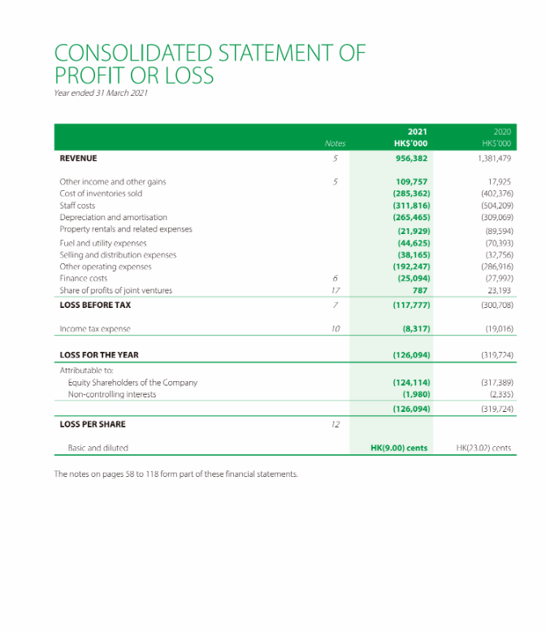

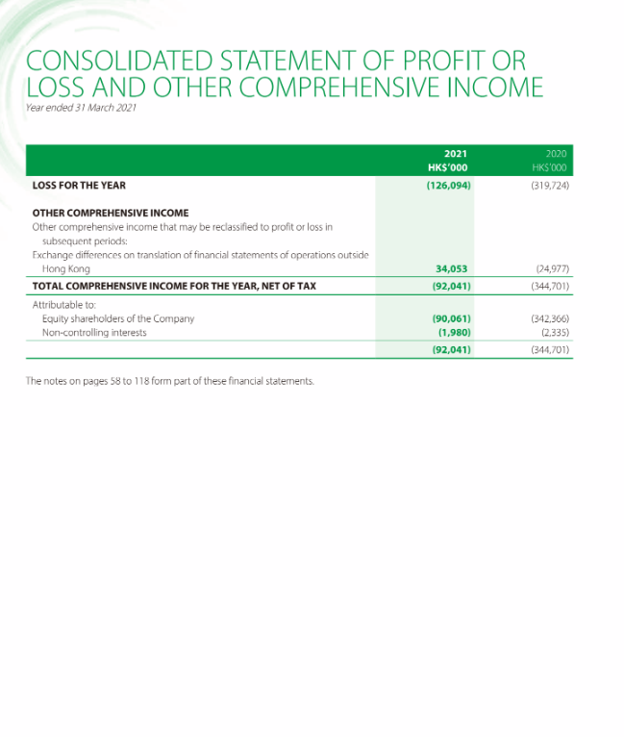

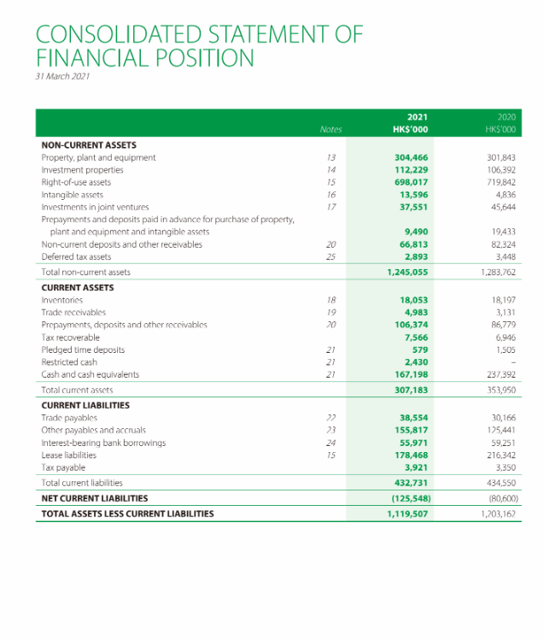

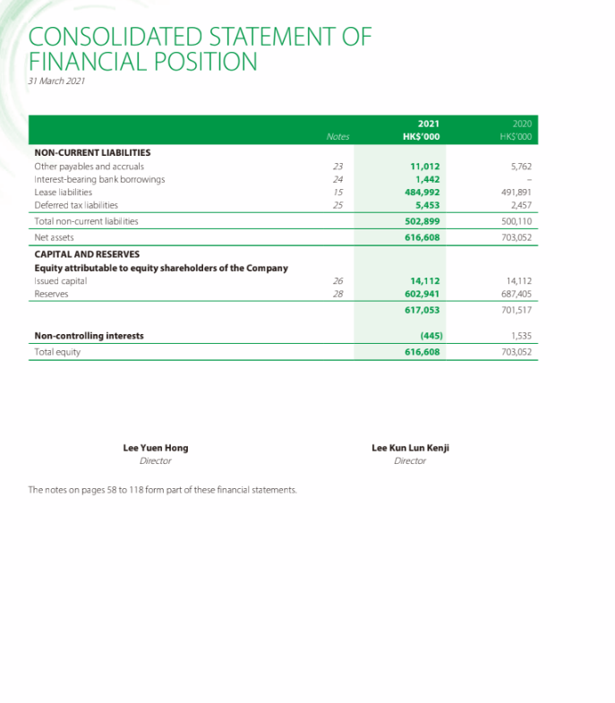

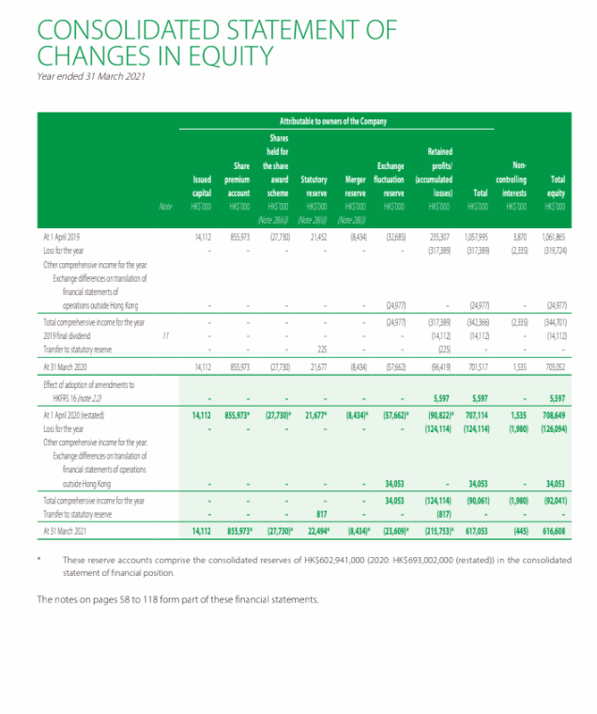

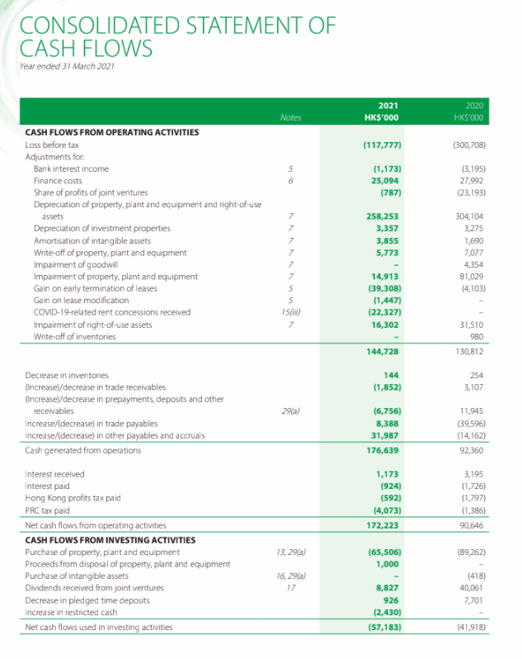

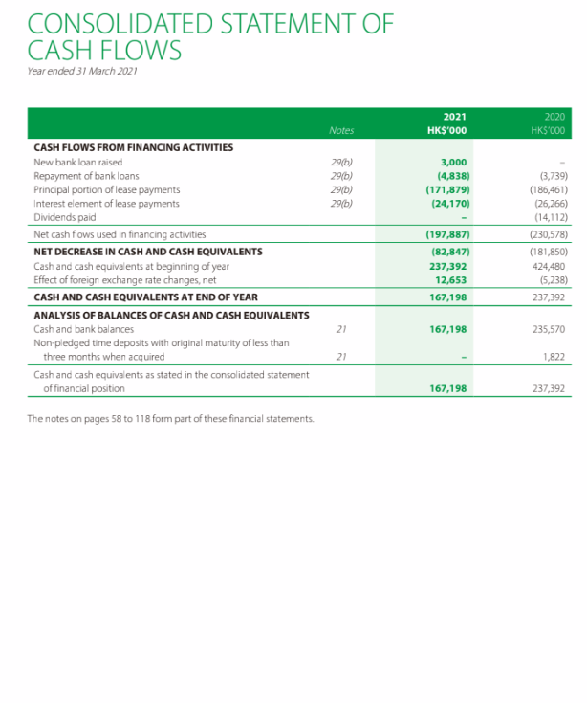

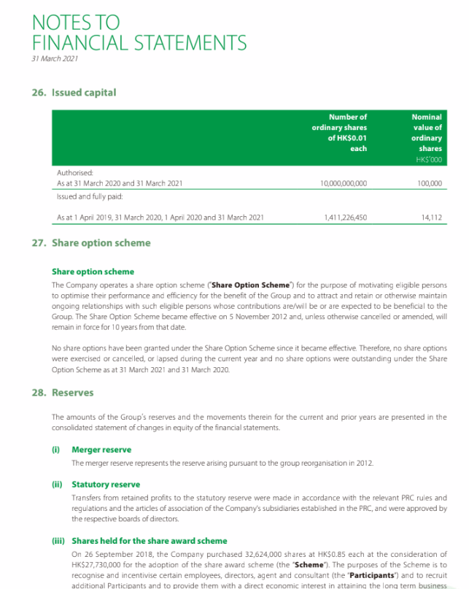

b. Tsui Wah Annual Report 2021-2022

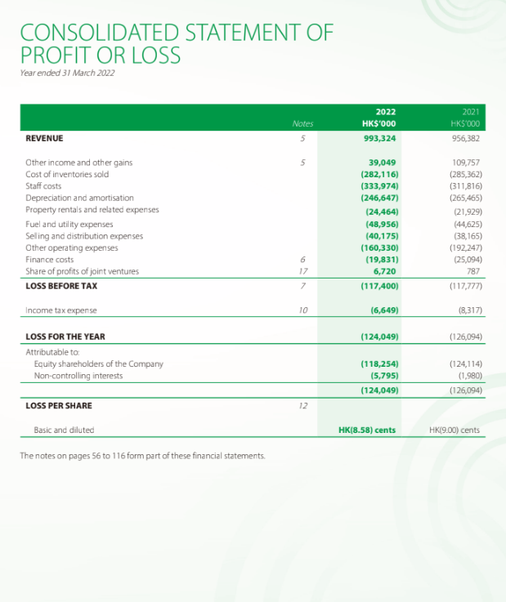

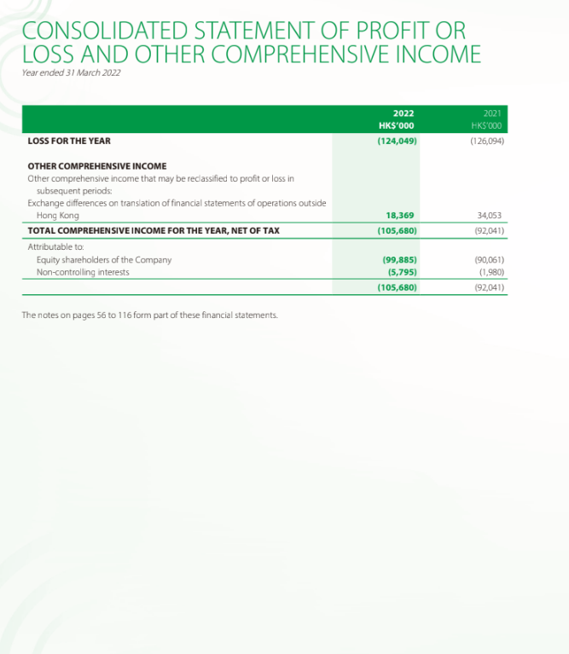

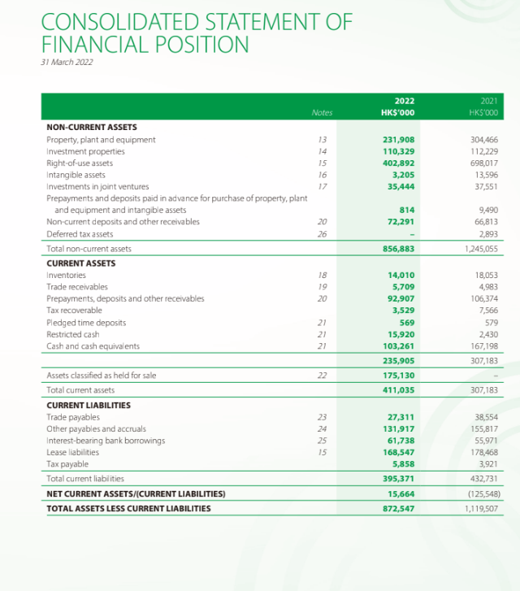

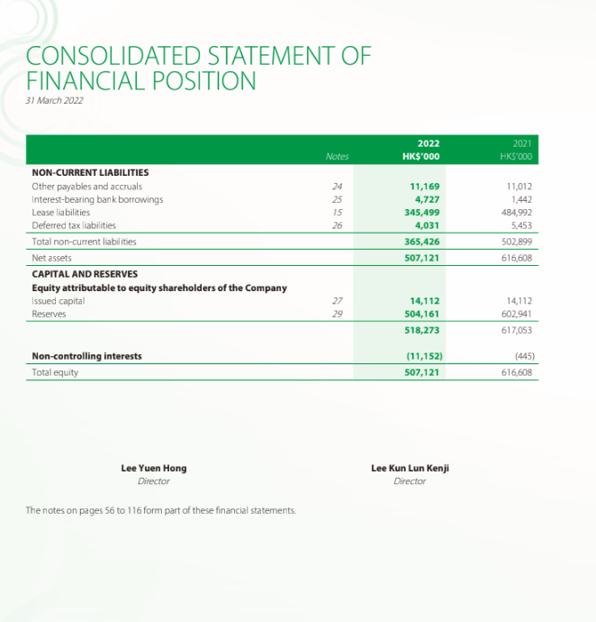

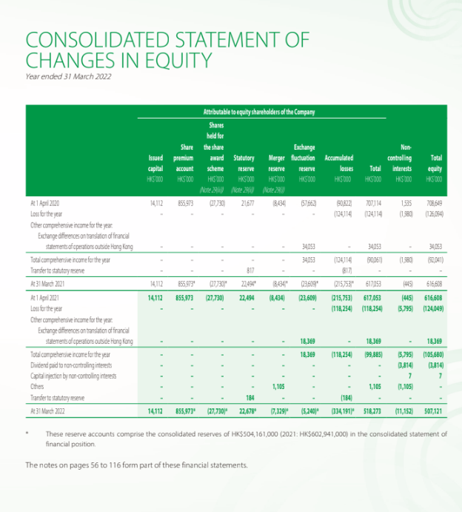

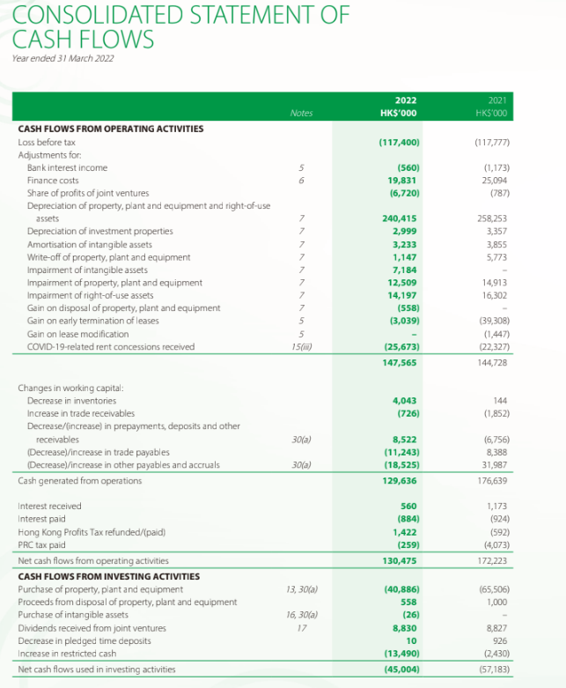

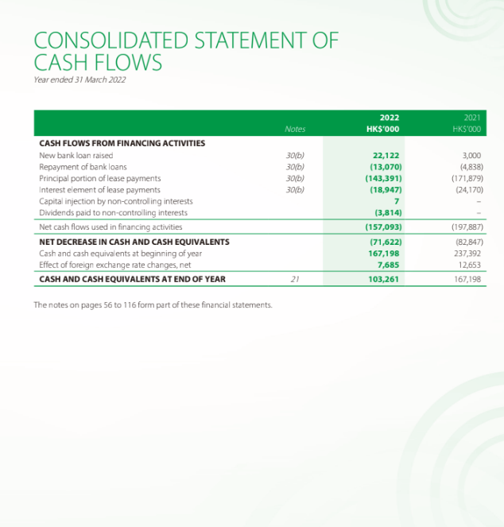

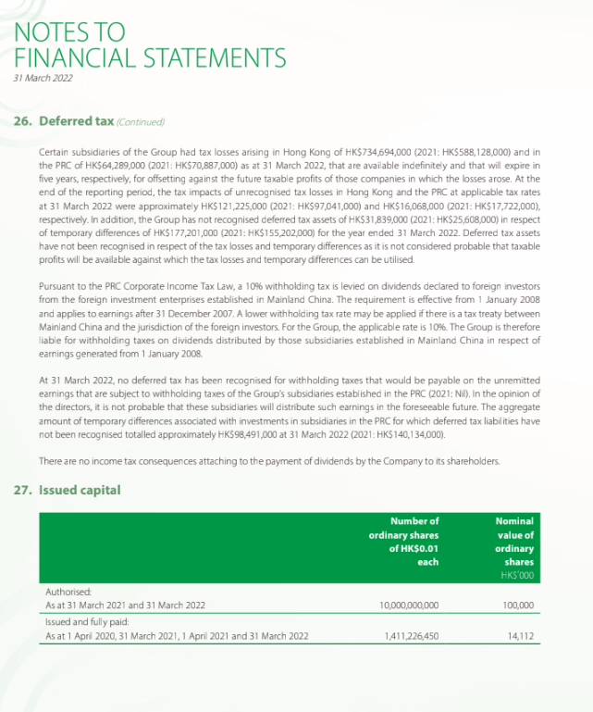

c. Tsui Wah Annual Report 2022-2023

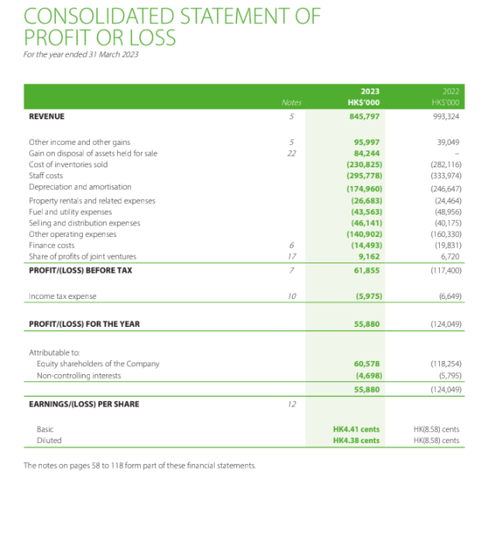

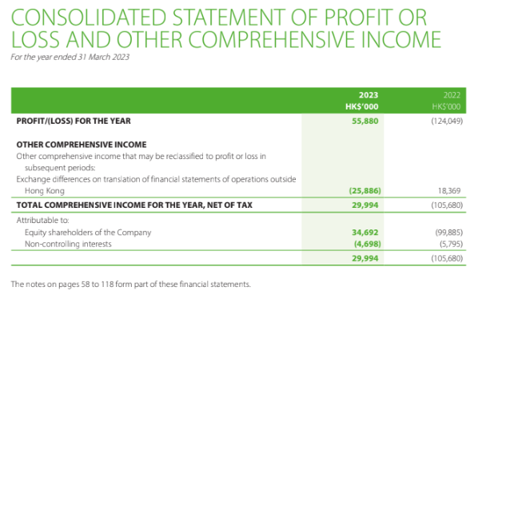

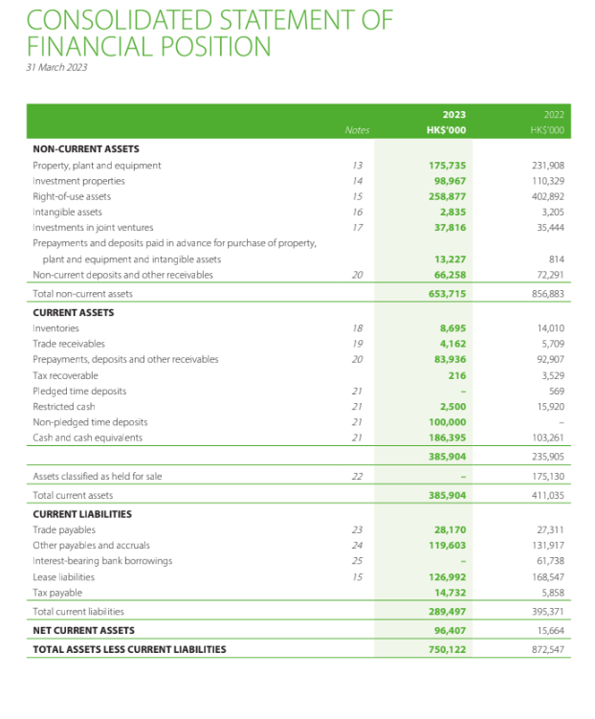

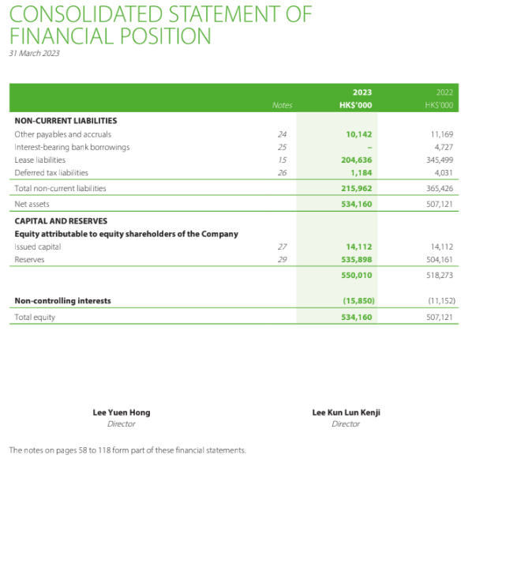

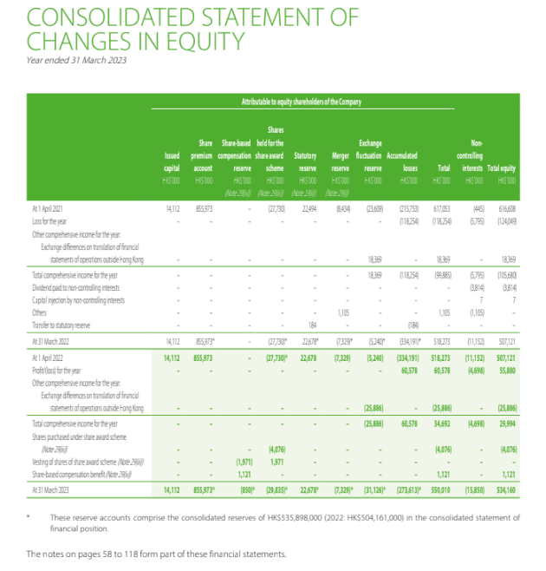

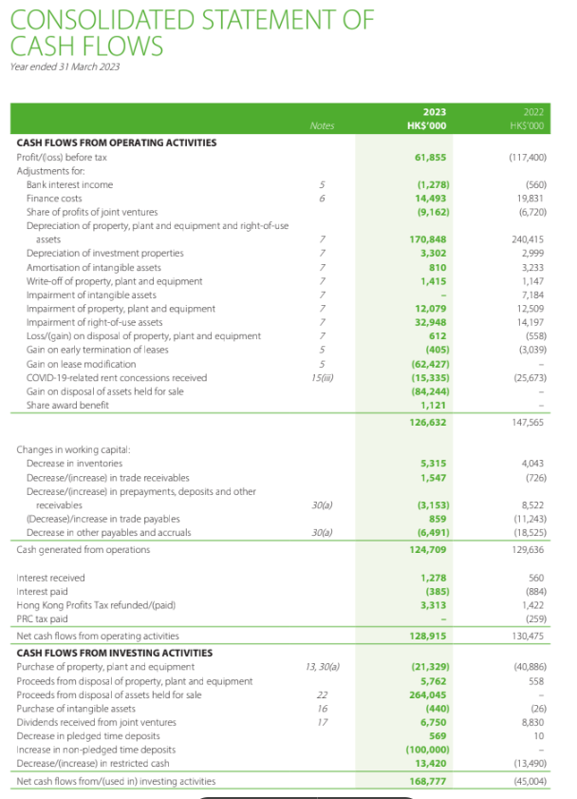
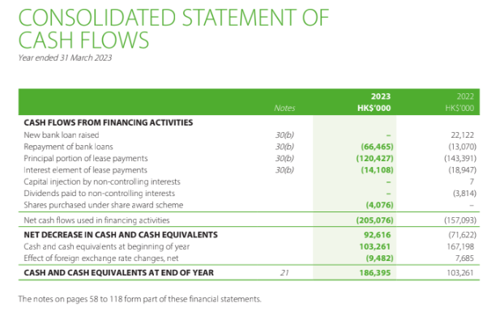

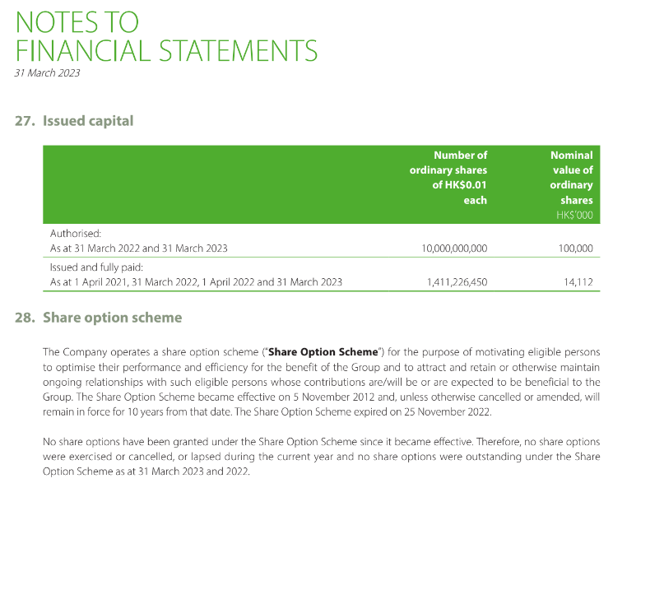

C. Financial Analysis Summary

Source from Tsui Wah Annual Report 2023
Source from Café De Carol Annual 2023
Source from Fairwood Annual 2023
Source from Yahoo
Closing Price of 31 March from Yahoo
Source from https://www.pin2eat.com/program/restaurant (Assessed: 28 August 2023)
Source from https://www.glassdoor.com.hk/Salaries/hong-kong-information-technology-salary-SRCH_IL.0,9_IC2308631_KO10,32.htm#:~:text=The%20average%20salary%20for%20Information%20Technology%20is%20HK%2448%2C000,HK%2422%2C500%2C%20with%20a%20range%20from%20HK%2417%2C600%20-%20HK%24231%2C250 (Assessed: 28 August 2023)
Source from https://www.globaldata.com/media/banking/hong-kongs-e-commerce-growth-will-continue-beyond-covid-19-pandemic-says-globaldata/ (Assessed: 20 August 2023)
Source: https://www.gov.hk/en/residents/taxes/taxfiling/taxrates/profitsrates.htm (Assessed: 28 August 2023)
Source from HSBC (Assessed: https://www.business.hsbc.com.hk/en-gb/regulations/best-lending-rate)
Source: Appendix 1

