

Programme: Master of Business Administration

Module: International Business Concepts

Module code: LCMB7034

Student Name: Yousaf Ali

Student ID:2430960

Table of Contents

Introduction 3
Benefits and Challenges of International Operations 4
Why McDonald’s is an MNC/TNC 4
Nature of McDonald’s Global Value Chain 5
Entry Modes Used Worldwide 6
Benefits McDonald’s Gains from International Operations 8
OLI and Market Entry Mode for McDonald’s in India 9
Ownership Advantages 9
Location Advantages (India) 10
Internalisation Advantages 11
Critical argument: How OLI influenced the chosen entry mode 11
Cultural Differences: Home Country vs India 12
Key Cultural Differences 12
Impact on Market Entry Strategy 13
Impact on Operational Success in India 14
Recommended SOP Adjustments for India 15
SOP Adjustment 1: Supply Chain Localisation & Food Sensitivity Protocols 15
SOP Adjustment 2: Human Resource & Service Culture Adaptational SOPs 15
SOP Adjustment 3: Market-Specific Menu & Marketing SOPs 16
Justification Table 17
Conclusion 19
References 20

Introduction
International business growth enables organisations to reach different markets and strategic growth opportunities. McDonald's is a large global MNC that has operations in a large number of international markets across the world. The enterprise has more than 43,000 restaurants worldwide (McDonald, 2024). This report evaluates the strategic operations of McDonald's in the Indian market. India is a major emerging economy with major opportunities and challenging operational issues. The report will focus on analysing the international business and related strategic issues of McDonald's. It also analyses the company based on the Ownership, Location and Internalisation framework. There are cultural differences between India and the United States that are critically analysed to be of influence. These insights help to explain the strategy of market entry and operational performance of McDonald's in India. SOP changes that are necessary to improve long-term success are also suggested in the report. The analysis is informed by secondary research that is based on academic sources and reliable publications on the industry.
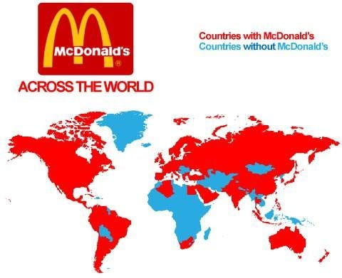
Figure 1: McDonald’s global presence
(Source: Willium, 2023)

Benefits and Challenges of International Operations

Why McDonald’s is an MNC/TNC
International business growth necessitates that organisations ensure activities in different international destinations are well coordinated in an effective manner. Multinational corporations have competitive advantages due to the ability to exploit global resources to ensure long-term operational efficiency. McDonald's is a multinational company that operates in highly diversified international markets. The multinational operation of McDonald’s makes it evident that it is a multinational corporation. It has global representation in about 119 different countries (DCF, 2025). By 2024, there were 43,477 restaurants of McDonalds all over the world (McDonald's, 2024). McDonald's pursues a trans national strategy that integrates efficiency around the globe. It standardises core systems in all parts of the world and flexibly adapts to local markets. McDonald's has managed to remain local with franchisees who are keen on the local preferences. According to the definition of TNCs, McDonald's does employ central control and local independence. The localisation is possible is the fact that the majority of its restaurants are franchised and not owned by the company (McDonald's, 2025). 95% of its restaurants are operated by freestanding franchisees. The benefit of franchising is that it would guarantee uniformity in terms of quality and services and provide local freedom at the same time. The transnational model is practical in balancing its cost efficiencies and cultural sensitivity in national markets which are very diverse. McDonald's can spread knowledge, processes and brand identity to other markets worldwide minimising uncertainty in new markets. It is advantageous in that much of the global learning innovations in one nation are disseminated to others in a short time. McDonald's illustrates a global MNC in size as well as the flexibility of a TNC. Its business model is based on the concepts of Bartlett and Ghoshal of efficiency, global learning and local responsiveness. The two-pronged approach allows it to continue to grow and survive in its over one hundred markets.
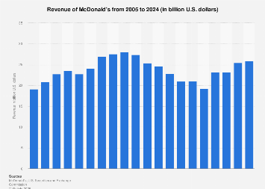
Figure 2: McDonald’s revenue
(Source: Statista, 2024)

Nature of McDonald’s Global Value Chain
McDonald's global value chain is intricate, designed and constructed at a scale and consistency. Its operations are easily traced on the main and support value-chain stages of Porter.
R&D (Innovation & Menu Localisation): McDonald's has a lot of investment in innovation to adjust the menus to the evolving tastes of consumers. It has created the McPlant burger using Beyond Meat through its collaboration with R&D (Reuters, 2020). This vegan patty is prepared separately, which maintains different preparation criteria throughout the world. This kind of R&D indicates the initiative of McDonald to fulfil the demand for alternative proteins in all parts of the world.
Global Sourcing: McDonald's effectively acquires ingredients both on an international scale and on a community scale. Its corporate sourcing covers the countries, continents and industries, as stated in its corporate location (McDonald's, 2022). In order to be sustainable, they collaborate with farmers, ranchers and producers who are near their restaurant locations. This assists them in retaining quality and minimising transport emissions through distance cut shortening of the supply chain.
Production & Operations: A large majority of the McDonald's restaurants operate on a franchise model to maximise the efficiency of operations. All restaurants in the world are franchised and this minimises the capital load on McDonald's (Ganti, 2024). The franchisees have stringent quality requirements so that they can have the same customer experience all over. The centralised quality control systems are employed to ensure food safety, hygiene and standardisation of the menu worldwide. This business model enables McDonald's to expand without necessarily having all the outlets.
Sales & Marketing: The marketing campaigns and customer recognition of McDonald's make its global brand equity work. Its marketing approaches are based on international marketing and international glocal menu marketing. The menu of Every Day Affordable Price is region-specific (DIM, 2024). This integrated approach generates more brand awareness and satisfies the needs of the local consumer tastes and buying capacity.
Financing: The business model of McDonald's is asset-light because of intense dependency on the rental revenues of franchisees instead of direct operations. In 2024, McDonald's recorded US$9.97 billion of rental income on franchise premises (Islas, 2025). This construction minimises operational risk and capital is no longer tied up in R&D and international expansion.

Entry Modes Used Worldwide
McDonald's employs various entry modes to grow its presence internationally profitably and strategically. The entry mode will depend on the risk of the country and control requirements and resource commitment.
Franchising (Dominant Mode):
McDonald's operates mainly on the franchise model, which is a quick and low-risk expansion all over the world. It has around 95% of its restaurants across the world being franchised, which guarantees an asset-light expansion. McDonald's franchises the operations of the company and its capital load to local owners (Mujtaba, 2024). This allows flexibility in the response to local regulatory environments and consumer tastes effectively. Franchisees will have access to the brand and systems of McDonald's. McDonald's expands based on royalties and rental fees. This model reduces the loss of control and good local knowledge as well as reducing international market risk.
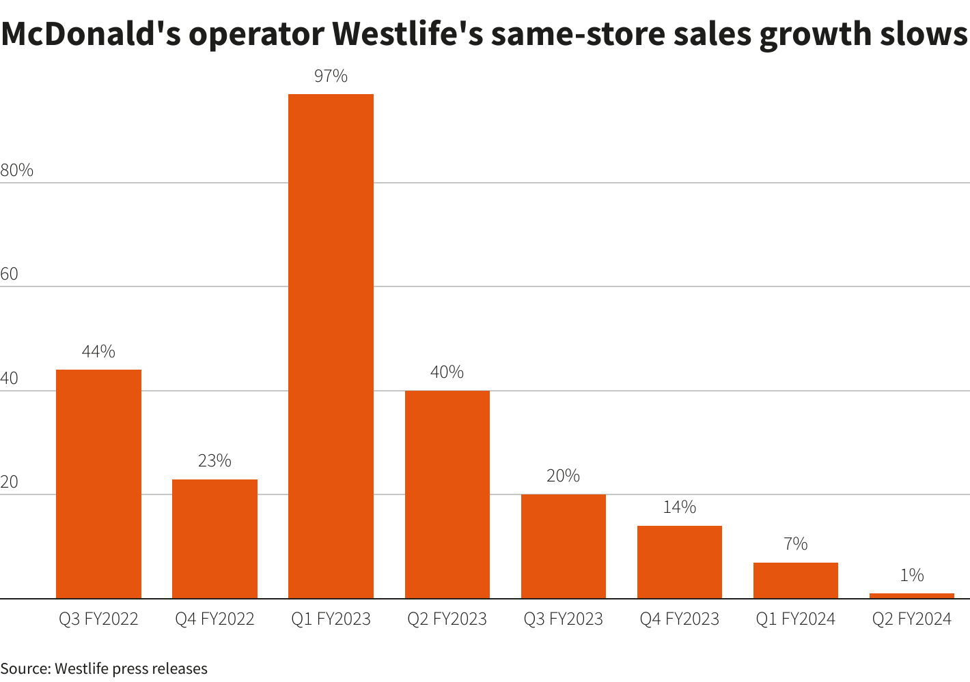
Figure 3: McDonald’s India franchisee
(Source: Paramasivam, 2023)
Joint Ventures: McDonald's has traditionally used joint ventures as an entry mode in some of its markets to gain further engagement and risk-sharing. India is a case in point where McDonald's has ventured in through a joint venture agreement with Connaught Plaza Restaurants (CPRL). Joint ventures enable the combination of local knowledge and funds and facilitate the process of overcoming the regulatory and cultural hurdles (Clyde, 2025).
Wholly-Owned Subsidiaries:
Wholly-owned subsidiaries are employed by McDonald's in markets that are either strategic or highly regulated. Full ownership gives the highest level of control in such markets in terms of operations, supply chains and standards of the brands. The restaurants owned by the company are used to test the new products, technologies and formats of the company and then expanded to a large scale through franchises. In 2024, McDonald's had 2,045 company-owned restaurants around the world (McDonald's, 2024). The presence of operations in the leading countries will alleviate the risks of knowledge leakage and will provide better control over quality and innovation.
Connection among Country Risk, Control and the Entry Mode: The country risk is minimal and institutional structures are well established, franchising is preferred by McDonald's to achieve the benefits of scale at the least amount of investment. In markets with a higher risk of risk or culturally diverse markets, joint ventures or wholly owned subsidiaries will enable McDonald's to maintain control and safeguard its brand identity. Increased control can be applied to control the reliability of the supply chain and the compliance with the international quality standards. Franchising minimises political or financial risk as it is distributed to local partners (Sadovnikova, Kacker and Mishra, 2023). To balance the trade-off between control, risk and growth, McDonald's applies a hybrid franchise, joint ventures and wholly owned subsidiary strategy. This entry-mode portfolio is flexible and promotes global expansion and at the same time maintaining brand consistency and quality of operation.

Benefits McDonald’s Gains from International Operations
Global purchasing provides McDonald's with huge efficiency in terms of economies of scale due to international expansion. McDonald's to enter into better contracts with international suppliers and logistics providers. Such efficiencies are typical of traditional cost-leadership benefits of Porter's scale theory. The advantage that McDonald's enjoys is global learning and transfer of knowledge in its operations across the globe (McDonald's, 2025b). Introductions made in a single market mobile ordering in China, spread around the world a few months later. This cross-market learning encourages the ongoing process, service and technology enhancement. Such dynamics are consistent with the concept of global learning of Bartlett and Ghoshal in the transnational theory. The McDonalds is quick to adopt the digital solutions, delivery and automation in the kitchen.
The important advantage of McDonald's international presence is revenue diversification. It established about 1,900 new restaurants around the world in 2024, which reinforced its non-US revenue base (Yahoo, 2023). Geographical diversification enables McDonald's to minimise the risks of any market and currencies. Its International Developmental Licenced (IDL) group registered a 4.1% growth in similar sales in the fourth quarter (McDonald's, 2025b). The trust between the national borders arising through the golden arches global identity creates trust between consumers. The bargaining power of McDonald's with suppliers and landlords throughout the world is improved through this brand equity worldwide. Brand strength helps franchisees get more customers and investments (Simpson, 2024).
The emerging market India gives McDonald's its innovation. This type of innovation allows it to take advantage of location-based benefits, which are in line with the OLI model proposed by Dunning. The advantages that McDonald's gets due to its international operations, economies of scale, learning worldwide, revenue diversification, brand corroboration and emerging-market innovation map can be directly related to its OLI strengths. The global brand ownership and systems provide scale location benefits in markets such as India can be innovated and internalisation conserves competencies. These benefits are the foundation of McDonald's transnational strategy and enable it to expand to other countries.

OLI and Market Entry Mode for McDonald’s in India

Ownership Advantages
The benefits associated with ownership of McDonald's manifested far-reaching impacts on its choice of entry modes in the Indian market. Its brand equity in the global context offers a competitive advantage and a good customer base in different countries. The company is quoted with a global brand value of above 191 billion dollars (Hluska, 2023). The brand strength was so much that it minimised the uncertainty of moving into an emerging economy that was culturally complicated such as India. The McDonald's service reliability that has been established worldwide is supported by Proprietary operating systems, such as structured kitchen workflows. Such systems also allow quality control even when partnering with various local franchise providers. The operations by McDonald's in difficult areas are stabilised by their cold-chain logistics and the use of standardised procurement practices (Setiawan and Ellitan, 2023). McDonald's owns specialised technologies that enhance internal control and standardisation of operations throughout the world. Digital POS and incorporated systems such as McDelivery allow smooth service and transparency of operation (Chan et al., 2023). The technological efficiency of this nature minimises risk factors when it comes to delegating to independent local operators in the first place. These ownership advantages in India were reasons to rely on formal collaborations instead of the uncontrollable independent franchising. The joint venture format enabled McDonald's to defend the ownership of the systems and the brand. It also facilitated uncovering closer supervision at a time when the market was young and reduced institutional and cultural risks. McDonald's trusted on brand, systems and technologies as a way of maximising entry mode. These benefits offered high-quality control mechanisms in favour of long-term positioning in the Indian market.
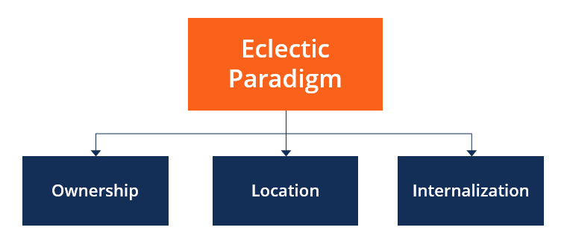
Figure 4: OLI Framework
(Source: CFI, 2022)

Location Advantages (India)
PESTLE
Factor | Insight | Impact
Political | India’s regulatory complexity includes FSSAI food-safety standards affecting imports. | Threat
Economic | Urbanisation is 36.87% of the total population in 2024, increasing food-service demand. | Opportunity
Social | About 31% of India’s population was middle class in 2020-21. | Threat
Technological | Rising digital adoption of POS, McDelivery helps food-service firms scale efficiently. | Opportunity
Legal | Meat and beef sensitivity due to religious regulations limits certain product categories. | Threat
Environmental | Food inflation hit 8.4% in FY 25, driven by climatic supply disruption. | Threat
Table 1: PESTLE
(Source: Self-Made)
India will provide great location benefits, which are fuelled by fast urbanisation and growing metropolitan regions. A gradually rising middle-income population is boosting the need for inexpensive and convenient food that is consumed at fast food outlets. Young population demographics in favour of the business would generate a long-lasting consumption opportunity for foreign food chains. Reductions in the labour and operation costs increase the chances of profitability for multinational restaurant brands venturing into India. The use of digital also fosters the use of convenient ordering behaviours via the ubiquity of mobile and platform applications in the country (Sindakis and Showkat, 2024). The foreign food-service companies entering India face challenges in predicting their operations because of the regulatory complexity. Global operators are expected to be more compliant and to monitor more regarding food safety laws. The sensitivity of beef requires keen localisation to the menu that complies with the various cultural and religious values in India. The factors provide opportunities as well as constraints that shape strategic entry decisions in a good manner.

Internalisation Advantages
Internalisation benefits of McDonald's are more focused on the in-depth quality control to guarantee food safety. In 2023, the company had 60,000+ food safety audits of its restaurants in the world (McDonald’s, 2023). Internal systems also mandate the global quality and operational standards of McDonald all its markets. Internalisation will enable McDonald's to ensure uniformity in the franchises through proprietary processes and training. The supply chain is centrally managed, which allows the restaurant to trace suppliers to activity in the supply chain world over. Internalisation of essential functions of the supply chain enables McDonald's to audit and respond rapidly when there is a deviation in the standards. Franchise owners are to adhere to the system of SQMS of McDonald's and be subjected to supplier-quality and restaurant-safety audit regularly (SGS, 2025). This transitional system can balance capital-light expansion and maintenance of firm internal standards at McDonald's. It maximises risk management as well as global brand integrity. The internalisation approach of McDonald's enables the company to maintain a high level of food quality that is the hallmark of the thousand restaurants that it operates.

Critical argument: How OLI influenced the chosen entry mode
The entry mode used by McDonald's in India is an indication of its OLI strengths in a strategic combination of entry modes. Location benefits were provided with good growth prospects, whereas institutional risks were found in the north and east to be complicated. The benefits associated with internalisation further made McDonald retain the strict control over quality that it practises even in the franchise agreements. The first entry mode of McDonald's was through a joint venture with Connaught Plaza Restaurants (CPRL) in a 50:50 partnership to ensure the reduction of high country risk (Ahluwalia, 2021). In May 2019, McDonald's bought a 50% stake in CPRL and turned it into a fully owned subsidiary (Bhushan, 2020). In the dispute, 165 restaurants were temporarily closed when McDonald's acquired its partner to have the franchise back (Sarkar, 2021). McDonald's took the initiative of undertaking operational checkups, retraining of employees and system audit before reopening the outlets. The ownership cost and capital burden with regard to direct management of 165 restaurants were high and pure OLI-based logic would not invite acquisition. It was arguably a trade-off that McDonald's decided against to protect its reputation and make use of its global standards (OECD, 2020). The OLI framework vehemently describes the shift of McDonald's production from a joint venture to a wholly-owned subsidiary in India due to its necessity to internalise the systems that it owns in order to secure brand value. It is faced with legal friction and reputational risk, which played a major strategic role in the reorganisation of the organisation.

Cultural Differences: Home Country vs India

Key Cultural Differences
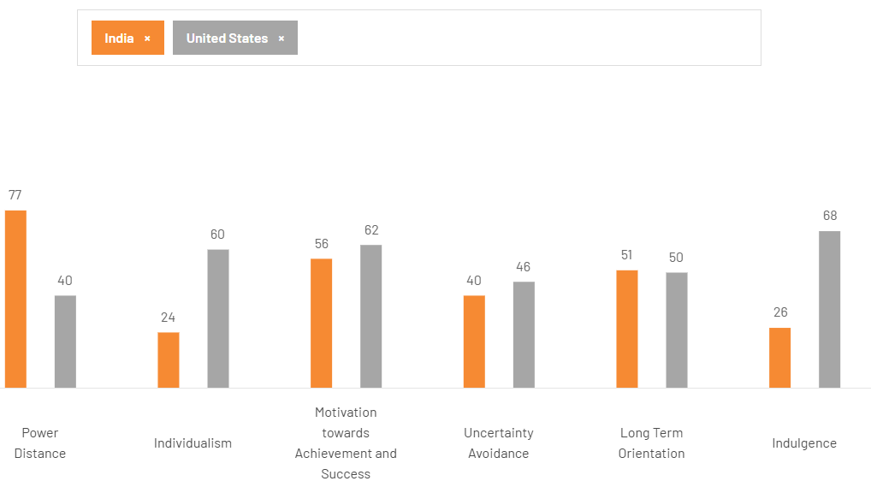
Figure 5: Country comparison
(Source: Hofstede Insights, 2025)
The presence of culture in the United States and India has a great effect on the business behaviour in their strategies. The framework by Hofstede brings out profound differences that influence the organisational structure, communication and management practices. Power distance in India is very high and it generates tolerance of the hierarchical systems of authority at the workplace. The United States has exhibited less power distance, which encourages decentralised decision-making and empowerment of employees. 64% of Indians think that hierarchy is an effective way of promoting stability in society (Pwonlyias, 2023). This cultural focus promotes leadership orientations that were based on direction, supervision and explicit managerial leadership. American workers, on the contrary, tend to perceive participatory leadership and independence in the performance of tasks. The concept of collectivism promotes teamwork, loyalty and development of long-term relationships in the context of Indian organisations. In the United States, there is a high index of individualism that promotes individual initiative and uncompromising decision-making (Leonard and Smith, 2021). This disparity influences managerial expectations in such aspects as incentives, feedback and even systems of motivation. Collectivist cultures need to focus on the harmony within a group, but individualistic cultures focus on individual recognition of achievement. There is moderate variation in uncertainty avoidance and India is more tolerant of ambiguous situations. In American culture, the structured process is typically used to minimise the instability in the organisational functioning by providing the employees with familiar role expectations on a regular basis (Beheshti, 2020). Indian workers tend to be flexible to changes in the environmental conditions without the presence of a rigid procedure. Indian society has the tendency to place more emphasis on the rewards that are assured in future, persistence and continuity of relationships than on the instant reward. The US focuses more on the short-term results, productivity and accelerating performance appraisals. The difference impacts supply-chain alliances, capital investment time spans and the marketing communications. There is a difference in the level of masculinity and India is a culturally competitive, achievement-oriented culture. There are gross differences in communication patterns that are present in high-context and low-context cultures. India is a high-context culture that needs indirect communication and norms of communicating through relationships (Raina and Zameer, 2020). The United States is a low-context culture in which communication is unambiguous, clear and laconic. In India, high-context communication obliges foreign companies to read between the lines when communicating. American culture of low context communication puts more focus on being clear, transparent and efficient in professional interactions. These cultural differences define marketing, leadership, customer interaction and human-resource practices. There is a need for multinational firms to modify their organisational strategies to fit the cultural expectations. It is necessary to understand these differences to gain competitive advantage in the Indian markets.

Impact on Market Entry Strategy
McDonald's suited its entry approach to meet the cultural imperatives of the Indians. The culture of high power divergence promoted in India made the global fast food giant, McDonald's, consider the legitimisation of the local stakeholders. McDonald's established a local leadership that is credible by way of forming a joint venture with Connaught Plaza Restaurants. Religious dietary laws forced McDonald's to withdraw beef and pork from its Indian menu. As reported by Corichi (2021), 39% of Indians are vegetarians. McDonald's introduced localised products such as McAloo Tikki Burger to satisfy the vegetarian taste. The company used more than 95% of local sources as a way of reassuring the Indian consumer (Sharma, 2025). McDonald's had fostered trust through steady interaction with Indian franchisors. McDonald's established a strong rapport with its suppliers in the host countries to make sure that the procurement is culturally aligned. McDonald's focused on long-term commitment through long-term investment in supply-chain infrastructure (Schramade, 2022). Cultural knowledge such as hierarchical power, eating traditions and collectivism contributed to the blueprint of entry by McDonald's in the market.

Impact on Operational Success in India
The burden of the cultural dietary restrictions in India on the McDonald's operational model was immense in order to ensure a local success in India. McDonald's avoids beef and pork in any of their restaurants in India, as 39% of adult Indians identify themselves as vegetarian. In India, the customer service expectations are characterised by respect, hospitality, with family values, relational warmth. The employees of McDonald's received training on how to provide cultural sensitivity (Khan et al., 2022). The brand focuses on the friendly, respectful treatment in India where the power distance is high. Localised marketing promotion pays much attention to families dining together at McDonald's restaurants during outings. The company makes McDonald's a destination for families and friends as well as kids. McDonald's in India implements value meals and low-price promotions that apply to customers who are of lower to middle income. McDonald's across West and South India, which reported a revenue of 2,260 crore in FY 23 (Britto, 2024). These low-price propositions make McDonald's remain relevant in a very competitive and cost-conscious market.
These festivals like Diwali, Holi or Ganesh Chaturthi, spike in the footfall, which affects the sales patterns of McDonald's. McDonald's operates special promotions such as those at certain festivals, combo deals and special packaging that leverage their consumption more based on the occasion (Pereira, 2024). There is an operational difficulty with the supply chain during festival surges the perishable products. The Indian culture and relationship norms influence supplier-relationship expectations in India as well. McDonald's has made a long-term investment relationship with the local farmers and suppliers to ensure quality and trust. McDonald's can negotiate more terms and have a stable supply of ingredients, which is essential to consistency.
McDonald, has been very successful in localising its businesses without abandoning the global standards, albeit with some tension. The authenticity of the high local QSR competition in India questions the authenticity of the global offerings of McDonald's. Problems with inventory outbursts or wastage are normally caused by pressure induced by the supply chain during festival periods. McDonald's has managed to strike the right balance between international identity and the Indian demands of operation and culture (Nandini, 2020). The cultural adaptation strategies of McDonald's in India include the purpose of keeping a vegetarian menu, relation-oriented service, family-oriented marketing, value pricing, festive responsive offers or promotions and other powerful supplier relations and due to these strategies the McDonald's has achieved success in India. These are culturally sensitive operational modifications that have enabled McDonald's multifaceted social landscape of India however, it has faced certain structural costs and logistical hassles.

Recommended SOP Adjustments for India

SOP Adjustment 1: Supply Chain Localisation & Food Sensitivity Protocols
McDonald’s ought to introduce local vegetarian cuisines in Indian shops where 81% of the adult population restricts meat intake in one way or the other (Sahgal et al., 2021). This SOP guarantees the separation of the vegetarian and non-vegetarian food at the source and at the service. FSSAI food safety inspections demand that there should be proper separation of the raw food, cooked food, vegetarian and non-vegetarian food. These requirements make the implementation institutionalise the respect for the culturally sensitive preparation practices of McDonald's. This strategy is justified by the theory through Dunning's location advantage, capitalising on high cultural conformity in India. Local kitchens lower chances of cross-contamination, brand loyalty and food safety standards.
Regarding the feasibility of operations, currently, the largest portion of McDonald's ingredients is sourced locally in India, which has established a strong localisation of the supply chains (McDonald's, 2022b). This local sourcing helps to create its own supply channels of vegetarian ingredients at a reliable cost. McDonald's should formalise explicit SOPs on different storage, temperature and labelling of the ingredients.
The risk assessment needs to denote the risk of contamination, higher capital cost and possible operational complexity. Failing to curb cross-contamination may harbour serious reputation issues for McDonald's with certain customer groups after they find out (Mujtaba, 2024). The introduction of additional refrigeration units and kitchen areas might not be rolled out in less profitable or smaller locations. A threat exists of overcapacity utilisation in case the demand for vegetarians is different across regions. The successful implementation generates great risk-reduction, it will secure the reliability of the McDonald's brand and adapt operations to the key socio-religious expectations of the Indian culture. SOP has given the location advantage of McDonalds in India, which guarantees the operation of sustainable supply chains to India, culturally respectful and compliant supply chains.

SOP Adjustment 2: Human Resource & Service Culture Adaptational SOPs
The India division of McDonald's requires SOPs, which will adjust human resource practices to cultural realities. India has high power-distance and ensures formalised hierarchical clarity and respect in the roles within the team. McDonald's has more than 6,000 employees in its North-East workforce, which is based in India (Chaturvedi, 2023). Building a strict hierarchy of SOPs for the team is useful in making employees understand the authority and reporting lines. The culture of collectivism requires McDonald's to promote group work and support among employees. The abstract rationality has theoretical grounds in a theory of collectivism of Hofstede, which grants importance to group unity and allegiance. The priorities of conflict-resolution SOPs should be on mediation led using senior team members and mutual respect. Indian employees are used to receiving guidance and protocols of the feedback based on gestures should be culturally sensitive. The internal training should also contain power-distance awareness modules and the relationship-based leadership style modules. McDonald's can use its ‘For Youth training programme’ as a way of bringing cultural sensitivity modules into the training programme, known as McDonald's For Youth (Restaurant India, 2025). These trainings aid the elimination of differences, promote respect and foster trust among diverse crews of different cultures. Operational feasibility is based on the fact that McDonald's has a well-organised training system and HR developmental channels. Cultural competence certification would require the trainers to provide sensitivity, hierarchy and teamwork training in a competent way. The SOPs would need to be detailed in defining how responsibilities in each role should be assigned, in what ways to escalate and how to make decisions. Regular workshops, role-plays and mentoring based on the principles of collectivism have to be included in the training programmes.. Dangers are connected to the problem of slower decision-making, as well as possible ambiguity, in the situation where hierarchy is too strict (Jerab, 2023). There is a risk that the inflexible SOPs would stifle employee initiative in an environment that supports obedience. McDonald's can first pilot this SOP in several outlets in the regions to counter the full rollout. The surveys of the feedback regarding employees being respected and heard at all hierarchical levels should be conducted periodically. Cost-effective training on cultural sensitivity and appropriate conflict lines should create a workplace environment of inclusiveness and respect. Such adaptation makes the global systems of HR within McDonald's fit the different cultural environment in India.

SOP Adjustment 3: Market-Specific Menu & Marketing SOPs
McDonald's needs to formalise menu localisation SOPs to localise its offerings to the Indian preferences systematically. Festivities and collectively oriented values, which dictate the local cultures have the demand for menu innovation regimes which are regionally and thematically specific. Theoretical grounds are based on the location advantage that Dunning has taken advantage of the unique consumer preferences in India. SOPs are supposed to require designing and launching limited-time offers for festivals during major Indian celebrations. It will be possible to make a McDonald's Festival Calendar SOP also in line with Diwali, Holi, Eid and Christmas cycles (Restaurant India, 2025a). As Westlife Foodworld explains, the corporation is scheduled to launch 45-50 new outlets of McDonald's in India on a yearly basis (Mahanta, 2024). With these SOPs, it is possible to offer price-promotional deals based on the ceremonies of the days which are related to the religion and family reunions. The family-oriented campaigns that focus on a community, tradition and sharing experiences should be included in the marketing strategy SOPs. The Indian society is collectivist encourages relationship-based as opposed to individual consumption-based messaging. In terms of pricing, McDonald's must have well-defined SOPs both to establish value segments, mid segments and premium segments. Internalisation advantage has theoretical support: the separation of the pricing levels helps McDonald's to maintain control and maximise profitability at the same time. In its operations, McDonald's India needs to have a product tier, which specifies the products that fall under the scope of McSaver, Classic and Gourmet tiers. Their 2024 report on Westlife Foodworld states that they have 438 McDonald's restaurants operating in 69 cities by the FY 2024-25 (Storyboard, 2025). This stratified ladder gives the outlets the ability to adjust to the local purchasing power discrepancy. In order to make them operative, SOPs must contain elaborate pricing tables, menu structure rules and profit margins. Festival-offering SOPs require an alignment of the supply chain to guarantee the availability of ingredients during peak selling periods. Risk evaluation: the menu-localisation makes the demand prediction of limited-time products more complex. Risk of pricing: value-combination goods can start to eat into superior products, unless closely distinguished. Marketing risk entails globally diluting the brand identity in case the local message becomes too deviated. Modified SOPs strengthen the OLI-driven benefits of McDonald's by harmonising global capabilities (ownership), taking advantage of the local consumer sub-context in India (location) and internalising control over product, pricing and positioning.

Justification Table
OLI Factor | Cultural Insight | Required SOP Change | Expected Performance Result
Ownership Advantage (global systems, brand standards) | High power distance requires clear hierarchical structures | Establish hierarchy-clarity SOPs and structured reporting lines | Improved internal coordination, reduced conflict, and stronger managerial authority alignment
Ownership Advantage (proprietary quality systems) | Strong vegetarian and religious norms influence food expectations | Segregated vegetarian kitchens and colour-coded equipment SOPs | Higher trust, compliance, safety and stronger brand reliability across markets
Location Advantage (India’s youthful, expanding market) | Collectivist preferences emphasise family and group dining culture | Family-oriented marketing SOPs and festival-calendar menu guidelines | Increased footfall, stronger emotional engagement and higher seasonal sales volume
Location Advantage (cost advantages, local sourcing) | Local suppliers value long-term collaboration relationships | Supplier-relationship SOPs emphasising stability and cooperation | Reduced costs, improved supply reliability and enhanced local integration
Internalisation Advantage (control over quality and service) | High-context communication requires relational service behaviour | Cultural-sensitivity training SOPs and structured conflict-resolution frameworks | Better service consistency, reduced misunderstandings and enhanced customer satisfaction
Internalisation Advantage (risk mitigation) | Regulatory complexity demands strict food-safety compliance | Compliance-driven SOPs aligned with FSSAI requirements nationwide | Lower legal risk, fewer violations and stronger operational resilience
Table 2: Justification
(Source: Self-Made)
SOP changes enhance the strategic fit of McDonald's in the complex Indian culture. Combine the benefits of OLI with the local operation and practices that mirror the local demands. The suggestions are beneficial in improving the quality of service, relevance in pricing, menu appropriateness and reliability in supply. These SOPs supplement competitive performance and pay attention to the sociocultural needs of India in a considerate manner.

Conclusion
The attributes of McDonald's as a multinational sight are evident in the broad international presence across the globe and versatile strategy responses. The scale benefits of its international expansion and the intricate cross-border operations issues are posed. The company enjoys a diversified revenue and learning in interconnected markets across the world. The OLI framework describes the ownership strengths in McDonald's that enable it to achieve efficient global standardisation and coordination. The opportunities available in India due to location favour growth in terms of urbanisation, population and increasing consumerism. The benefits of internalisation are sufficient to warrant that McDonald's keeps quality, training as well as operational process highly advanced. India and America have cultural variations that have a major impact on management, marketing and service expectations. Collectivist orientations dictate service norms on relationships and promotional strategies on the family level. Conscientious beliefs about food and diet have created the need to be a strict vegetarian and make sensitive decisions when it comes to localisation of menus. The suggested SOP amendments effectively mitigate the localisation of the supply chain and increase food safety measures. They have firm human-resource systems with cultural training and conflict-resolution systems. The menu localisation SOPs, festival calendar and pricing ladder enhance the market relevancy. The combination of these changes brings on board OLI thinking and the individual socio-cultural context of India. The operations have been facilitated by training facilities and established utilities with suppliers. Risk estimates suggest that problems do exist in the complexities, compliance and resource requirements. SOPs suggested strengthening strategic alignment that is necessary for long-term sustainable operational performance. The success of McDonald's in India has been pegged on an entrenchment of the world's best in the local expectations.

References
Ahluwalia, H. (2021) Inside the McDonald’s-Vikram Bakshi controversy, https://www.livemint.com. Livemint. Available at: https://www.livemint.com/Companies/Jxj8A0RLE0CkpWOoboaJ6J/Inside-the-McDonalds-Vikram-Bakshi-controversy.html (Accessed: 17 November 2025).
Beheshti, N. (2020) ‘10 Timely Statistics About The Connection Between Employee Engagement And Wellness’, Forbes, 16 January. Available at: https://www.forbes.com/sites/nazbeheshti/2019/01/16/10-timely-statistics-about-the-connection-between-employee-engagement-and-wellness/ (Accessed: 17 November 2025).
Bhushan, R. (2020) McDonald’s buys Vikram Bakshi’s 50% stake in Connaught Plaza Restaurants, The Economic Times. Economic Times. Available at: https://m.economictimes.com/industry/cons-products/food/mcdonalds-buys-vikram-bakshis-50-stake-in-connaught-plaza-restaurants/articleshow/69254066.cms (Accessed: 17 November 2025).
Britto, A.T. (2024) ‘McDonald’s India franchisee Westlife’s profit nearly wiped out on frail demand’, Reuters, 8 May. Available at: https://www.reuters.com/business/retail-consumer/mcdonalds-india-franchisee-westlifes-q4-profit-slumps-frail-demand-2024-05-08/ (Accessed: 17 November 2025).
CFI (2022) Eclectic Paradigm, Corporate Finance Institute. Available at: https://corporatefinanceinstitute.com/resources/management/eclectic-paradigm/ (Accessed: 17 November 2025).
Chan, H.-L., Cheung, T.-T., Choi, T.-M. and Sheu, J.-B. (2023) ‘Sustainable successes in third-party food delivery operations in the digital platform era’, Annals of Operations Research, pp. 1–37. Available at: https://doi.org/10.1007/s10479-023-05266-w.
Chaturvedi, A. (2023) McDonald’s north and east to invest up to ₹600 cr, The Economic Times. Economic Times. Available at: https://m.economictimes.com/industry/services/hotels-/-restaurants/mcdonalds-north-and-east-to-invest-up-to-600-cr/articleshow/98640917.cms (Accessed: 17 November 2025).
Clyde (2025) Cross border Joint Ventures: Why strategic partnerships make sense in turbulent times, Clydeco.com. Clyde & Co LLP. Available at: https://www.clydeco.com/en/insights/2025/08/cross-border-joint-ventures (Accessed: 17 November 2025).
Corichi, M. (2021) Eight-in-ten Indians limit meat in their diets, and four-in-ten consider themselves vegetarian, Pew Research Center. Available at: https://www.pewresearch.org/short-reads/2021/07/08/eight-in-ten-indians-limit-meat-in-their-diets-and-four-in-ten-consider-themselves-vegetarian/ (Accessed: 17 November 2025).
DCF (2025) McDonald’s Corporation (MCD): ANSOFF Matrix Analysis [Jan-2025 Updated], AI-Powered Discounted Cash Flow Editable Templates. Available at: https://dcfmodeling.com/products/mcd-ansoff-matrix?srsltid=AfmBOop4ra-Ce_148446-EscplrYSWymL7E7vm8CjrU2gTBGJoe721mC (Accessed: 17 November 2025).
DIM (2024) McDonald’s Corporation (MCD) Stock Price, Market Cap, Segmented Revenue & Earnings - Datainsightsmarket.com, Datainsightsmarket.com. Available at: https://www.datainsightsmarket.com/companies/MCD (Accessed: 17 November 2025).
Ganti, A. (2024) How McDonald’s Makes Money: Monetizing the Demand for Fast Food, Investopedia. Available at: https://www.investopedia.com/articles/markets/032015/how-mcdonalds-makes-its-money-mcd.asp (Accessed: 17 November 2025).
Hluska, D. (2023) McDonalds rises in the ranks, landing in the top 5 most valuable global brands, www.kantar.com. Available at: https://www.kantar.com/north-america/inspiration/brands/mcdonalds-rises-in-the-ranks-landing-in-the-top-5-most-valuable-global-brands (Accessed: 17 November 2025).
Hofstede Insights (2025) Country Comparison Tool, Theculturefactor.com. Available at: https://www.theculturefactor.com/country-comparison-tool?countries=india%2Cunited+states (Accessed: 17 November 2025).
Islas, L. (2025) What does McDonald’s make a living on? Rents and royalties exceed direct hamburger sales, Revista Merca2.0. Available at: https://www.merca20.com/what-does-mcdonalds-make-a-living-on-rents-and-royalties-exceed-direct-hamburger-sales/ (Accessed: 17 November 2025).
Jerab, D.A. (2023) How to Be an Effective Leader in Decision Making in an Unstable Environment, Social Science Research Network. Rochester, NY. Available at: https://doi.org/10.2139/ssrn.4525803.
Khan, M.A., Abu Elnasr Sobaih, Lee, K. and Inhyuck Steve Ha (2022) Cultural differences and McDonald’s: a multi-country comparative study, ResearchGate. Inderscience Publishers. Available at: https://www.researchgate.net/publication/365739209_Cultural_differences_and_McDonald (Accessed: 17 November 2025).
Leonard, B. and Smith, S.M. (2021) ‘Individualistic culture increases economic mobility in the United States’, Proceedings of the National Academy of Sciences, 118(37), p. e2107273118. Available at: https://doi.org/10.1073/pnas.2107273118.
Mahanta, A.P. (2024) McDonald’s India (W&S) to Open 45-50 Stores Every Year Until 2027; Plans to Invest INR 1400 Crore, Entrepreneur. Entrepreneur Media India. Available at: https://www.entrepreneur.com/en-in/news-and-trends/mccafe-aims-to-open-50-new-stores-every-year-until-2027/480536 (Accessed: 17 November 2025).
McDonald (2024) Purpose & Impact Report. Available at: https://corporate.mcdonalds.com/content/dam/sites/corp/nfl/pdf/McDonalds_PurposeImpact_ProgressReport_2024_2025.pdf (Accessed: 17 November 2025).
McDonald’s (2023) 2023–2024 Our Purpose & Impact Progress Summary McDonald’s Corporation. Available at: https://corporate.mcdonalds.com/content/dam/sites/corp/nfl/pdf/McDonald%E2%80%99s%20Progress%20Summary%202023-2024.pdf (Accessed: 17 November 2025).
McDonald's (2022a) Responsible Sourcing, McDonalds. Available at: https://corporate.mcdonalds.com/corpmcd/our-purpose-and-impact/food-quality-and-sourcing/responsible-sourcing.html (Accessed: 17 November 2025).
McDonald's (2022b) Two Decades Of Making In India, McDonald’s India | McDonald’s Blog. Available at: https://mcdonalds.in/2016/03/two-decades-of-making-in-india/.
McDonald's (2024) Moving with Purpose and Driving Lasting Impact. Available at: https://corporate.mcdonalds.com/content/dam/sites/corp/nfl/pdf/McD%20-%202024%20Annual%20Report%20to%20Shareholders.pdf (Accessed: 17 November 2025).
McDonald's (2025a) Franchising Overview, corporate.mcdonalds.com. Available at: https://corporate.mcdonalds.com/corpmcd/franchising-overview.html (Accessed: 17 November 2025).
McDonald's (2025b) McDonald’s Reports Fourth Quarter and Full Year 2024 Results, Mcdonalds.com. Available at: https://corporate.mcdonalds.com/corpmcd/our-stories/article/Q4-full-year-2024-results.html.
McDonald's (2025c) Our Business Model and Growth Strategy, McDonald’s. Available at: https://corporate.mcdonalds.com/corpmcd/our-company/who-we-are/business-model-and-growth-strategy.html (Accessed: 17 November 2025).
Mujtaba, B.G. (2024) McDonald’s Success Strategy and Global Expansion through Customer and Brand Loyalty, ResearchGate. Available at: https://www.researchgate.net/publication/228490432_McDonald (Accessed: 17 November 2025).
Nandini, Dr.A.S. (2020) McDonald’s Success Story in India, jcrm. Available at: https://jcrm.psgim.ac.in/index.php/jcrm/article/download/355/272/695 (Accessed: 17 November 2025).
OECD (2020) National Contact Point for the OECD Guidelines for Multinational Enterprises (NCP). Available at: https://files.nettsteder.regjeringen.no/wpuploads01/sites/263/2021/06/0077-McDo-APG-NorgesBank-OECD-Complaint.pdf (Accessed: 17 November 2025).
Paramasivam, P. (2023) ‘Fast-food slowdown catches up with McDonald’s India franchisee’, Reuters, 27 October. Available at: https://www.reuters.com/business/retail-consumer/fast-food-slowdown-catches-up-with-mcdonalds-india-franchisee-2023-10-27/ (Accessed: 17 November 2025).
Pereira, D. (2024) McDonald’s Marketing Strategy (2025), Business Model Analyst. Available at: https://businessmodelanalyst.com/mcdonalds-marketing-strategy/?srsltid=AfmBOoqJ7vWNuMqkcDM4YBhvdjy6umvm0GscyN-tI4JOuWfXoEppxSJ9 (Accessed: 17 November 2025).
Pwonlyias (2023) Measures For India’s Social Inequality: Economic, Social, And Political Strata In India - PWOnlyIAS, pwonlyias.com. Available at: https://pwonlyias.com/current-affairs/india-social-inequality-concern/ (Accessed: 17 November 2025).
Raina, R. and Zameer, A. (2020) ‘A study of non-verbal immediacy behaviour from the perspective of Indian cultural context, gender and experience’, International Journal of Indian Culture and Business Management, 13(1), p. 35. Available at: https://doi.org/10.1504/ijicbm.2016.077635.
Restaurant India (2025a) RestaurantIndia, Restaurant India. Available at: https://www.restaurantindia.in/article/how-to-attract-customers-beyond-special-occasions-and-festivals.14096 (Accessed: 17 November 2025).
Restaurant India (2025b) Trained to Thrive: How Upskilling Elevates the Dining Experience, Restaurant India. Available at: https://www.restaurantindia.in/article/trained-to-thrive-how-upskilling-elevates-the-dining-experience.13197 (Accessed: 17 November 2025).
Reuters (2020) ‘McDonald’s to debut “McPlant” in 2021, Beyond Meat says co-created patty’, Reuters, 9 November. Available at: https://www.reuters.com/world/asia-pacific/mcdonalds-debut-mcplant-2021-beyond-meat-says-co-created-patty-2020-11-09/ (Accessed: 17 November 2025).
Sadovnikova, A., Kacker, M. and Mishra, S. (2023) ‘Franchising structure changes and shareholder value: Evidence from store buybacks and refranchising’, Journal of the Academy of Marketing Science, 51(5). Available at: https://doi.org/10.1007/s11747-022-00921-3.
Sahgal, N., Evans, J., Salazar, A.M., Starr, K.J. and Corichi, M. (2021) Religion and food, Pew Research Center’s Religion & Public Life Project. Available at: https://www.pewresearch.org/religion/2021/06/29/religion-and-food/ (Accessed: 17 November 2025).
Sarkar, J. (2021) McDonald’s buys out partner, will temporarily shut 165 outlets, The Times of India. Times of India. Available at: https://timesofindia.indiatimes.com/business/india-business/mcdonalds-buys-out-partner-will-temporarily-shut-165-outlets/articleshow/69259738.cms (Accessed: 17 November 2025).
Schramade, W. (2022) Sustainable Finance Case study McDonald’s. Available at: https://www.researchgate.net/publication/336308912_Sustainable_Finance_Case_study_McDonald (Accessed: 17 November 2025).
Setiawan, V.N. and Ellitan, L. (2023) Supply Chain Management and Supply Chain Performace: The Case of Mcdonald’s, ResearchGate. Available at: https://www.researchgate.net/publication/368830943_Supply_Chain_Management_and_Supply_Chain_Performace_The_Case_of_Mcdonald (Accessed: 17 November 2025).
SGS (2025) McDonald’s Supplier Quality Management System (SQMS) Certification, SGSCorp. Available at: https://www.sgs.com/en-nz/services/mcdonalds-supplier-quality-management-system-sqms-certification (Accessed: 17 November 2025).
Sharma, A. (2025) McDonald’s India: A Comprehensive Analysis, prezi.com. Available at: https://prezi.com/p/nj4xn_0qtmo9/mcdonalds-india-a-comprehensive-analysis/ (Accessed: 17 November 2025).
Simpson, F. (2024) The Power Of Brand In Franchising, Forbes. Available at: https://www.forbes.com/sites/fionasimpson1/2024/04/24/the-power-of-brand-in-franchising/ (Accessed: 17 November 2025).
Sindakis, S. and Showkat, G. (2024) ‘The Digital Revolution in India: Bridging the Gap in Rural Technology Adoption’, Journal of Innovation and Entrepreneurship, 13(1), pp. 1–28. Available at: https://doi.org/10.1186/s13731-024-00380-w.
Statista (2024) McDonald’s revenue 2024| Statista, Statista. Available at: https://www.statista.com/statistics/208917/revenue-of-the-mcdonalds-corporation-since-2005/?srsltid=AfmBOoqSBg5Xikij2USDgVL68CryGsUTKMXD3orqDAIxblvv6sKvniem (Accessed: 17 November 2025).
Storyboard (2025) McDonald’s operator Westlife Foodworld records 7.3% YoY revenue growth; adds 18 new restaurants, Storyboard18.com. Storyboard18. Available at: https://www.storyboard18.com/brand-marketing/mcdonalds-operator-westlife-foodworld-records-7-3-yoy-revenue-growth-adds-18-new-restaurants-65949.htm (Accessed: 17 November 2025).
Willium, R. (2023) Can You Clarify How Many McDonald’s Are There in the World?, Medium. Available at: https://medium.com/@rajibbdtask2022/can-you-clarify-how-many-mcdonalds-are-there-in-the-world-3a76d7d1f462 (Accessed: 17 November 2025).
Yahoo (2023) McDonald’s plans record global expansion, remains optimistic about China: CEO, Yahoo Finance. Available at: https://finance.yahoo.com/news/mcdonalds-plans-record-global-expansion-remains-optimistic-about-china-ceo-213227692.html (Accessed: 17 November 2025)

