Student Name: Stanimira Yuliyanova Dimitrova
Student Number: 1909125
Lecture Name: Adesewa Ajayi
Module Name: Introduction to Physiology
Module Code: BMHP 5003 (LON)
Assessment Component 1


Do we know what diabetes is and what it has to do with the pancreas in the human body and the insulin it produces?

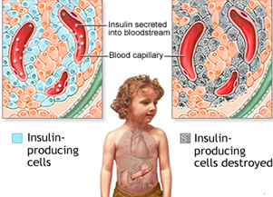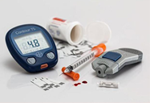
(On Medicine, 2019).
Other specific types of diabetes can also be observed. They are due to genetic defects in insulin secretion or insulin sensitivity, to a number of diseases (such as the pancreas), and to the effects of certain medications.

Gestational diabetes is a disease in which high blood sugar is found during pregnancy for the first time in a woman's life and without a diagnosis of diabetes.

The individual is born with a genetically determined level of insulin resistance. In this type of disease, the body's cells do not absorb glucose, which is necessary for their vital activity and normal functioning. Unlike type 1, the pancreas produces insulin but does not react with the body at the cellular level.

Gestational diabetes

Type 2 diabetes mellitus

Type 1 diabetes is a chronic autoimmune disease characterized by insulin deficiency leading to high blood sugar. Type 1 diabetes is diagnosed based on symptoms indicative of insulin deficiency. Insulin continues to be at the heart of the treatment of type 1 diabetes.

Type 1 diabetes mellitus

(MedlinePlus, 2020).

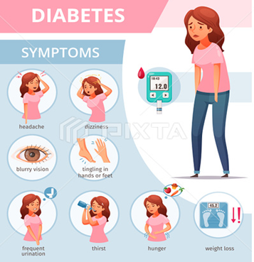



(Macro vector, 2020).

(The Times of India, 2020).
Other specific types of diabetes

(Pinnacle Care, 2018).

References

Cambridge, R.P.E. at B.C. studied N.S. at the U. of, July 2013, joined B.C. in and registry, now holds the position of D.E. for the I. (2019) Take a fresh look at diabetes research for UK Diabetes Week [Online] On Medicine Available at: https://blogs.biomedcentral.com/on-medicine/2019/06/06/take-a-fresh-look-at-diabetes-research-for-uk-diabetes-week/
[Accessed 05 November 2020].

MedlinePlus (2020) Type 1 diabetes: MedlinePlus Medical Encyclopedia [Online] Available at: https://medlineplus.gov/ency/article/000305.htm/
[Accessed 05 November 2020].

Pinnacle Care (2018) Could You Have Undiagnosed Diabetes? [Online] Available at: https://www.pinnaclecare.com/highlights/blog/undiagnosed-diabetes/
[Accessed 05 November 2020].

Macro vector (2020) Cartoon poster with icons showing diabetes symptoms vector illustration [Online] Available at: https://macrovector.com/vector-image/cartoon-poster-icons-showing-diabetes-symptoms-vector-illustration-48796?utm_content=/
[Accessed 06 November 2020].

The Times of India (2020) About pregnancy: Diet for gestational diabetes - Times of India [Online] Available at: https://timesofindia.indiatimes.com/life-style/health-fitness/health-news/About-pregnancy-Diet-for-gestational-diabetes/articleshow/18967102.cms/
[Accessed 06 November 2020].

