Virtual Learning Enviroment Student Research
Yordan Terziev 1914788
Digital skills and Research methods
Module code: BMSW4003
Lecturer: Paul Jenkins

Table of Contents
Introduction 3
Background 3
Aim and objectives 4
Method 5
Results 6
Q1. What is your age group? 6
Q2. How long have you been a student at University of Wales Trinity Saint David London Campus? 6
Q3. Do you agree that Moodle is useful in order to facilitate learning in an online environment? 7
Q4. How satisfied are you with the VLE / moodle? 8
Q5. Do you prefer VLE/Moodle or face-to-face contact for your studies? 8
Q6. Do you find it more difficult to engage in a VLE compared to face-to-face? 9
Q7. How effective do you find using the VLE as a learning tool / resource? 10
Q8. How confident are you in using the VLE / Moodle? 10
Q9. How often do you use the VLE / Moodle to help facilitate learning? 11
Q10. How satisfied are you of the experience of using the Library in the VLE? 12
Discussion 12
Question 1&2 12
Question 3 12
Question 4 13
Question 5&6 13
Question 7 13
Question 8 & 9 13
Question 10 13
Conclusion 14
Reference 14

Introduction

This Correlational Survey will show how students at the University of Wales Trinity Saint David understand, perceive and evaluate the Virtual Learning Environment according to their own experience. The targeted group of the research is first-year students who have the least experience with the platform. We are doing this research because the results are important for the University and will show the possible need for improvement of VLE.

Background
As advancement in technology continues to progress exponentially, the need for improved technology in different sectors has become a priority. Together with this growth, the use of these technologies in the educational sector has also increased and expanded. The core question of this study is to determine the acceptance and use of these technologies in the educational field, focusing mainly on the VLE used in many educational facilities (Kurt, 2017). In sync with the advancement and progression of technology and this being applied in the educational field, a question has arisen - are students contempt and compelled to use these new and improved versions of libraries, video conference lectures, and online resources to their full advantage? According to Tingoy (2017) studies by Davis, Bagozzi and Warshaw confirm that there are numerous important factors that contribute to the acceptance and use of new information technology practices by students with respect to differing cultures and nationalities, including social and behavioral traits. The model developed to theorize this is known as the Unified Theory of Acceptance and Use of Technology (UTAUT). Even with these theories and models being tested in differing countries, the size and quality of the results is limited. The Unified Theory of Acceptance and Use of Technology model can be used to determine whether an advancement of technology from a single source will be equally accepted by different cultures and societies which differ in beliefs and values, and whether the technology will be used in the same manner and provide the same function across all cultures and societies or will it differ depending on their traits and cultures.

Many higher education facilities use some sort of Virtual Learning Environment in order to facilitate and provide resources and materials to students. However, many tutors use this just as a file sharing service to provide course materials and reading lists. This practice is responsible for the increase in usage in VLE, but shows little evidence for the quality of acceptance or improved student success (Brown, 2012). According to Browne (2006) studies suggest that many tutors and teachers only use the bare minimum of features available in VLE. Despite this, Browne goes on saying that moving away from Virtual Learning Environments to Web 2.0 technologies can be beneficial for both students and staff as they tend to be more personalized, flexible and recognize student experiences. A study of 74 higher education institutions in the UK concluded that just after time availability, tutor’s knowledge and know how of VLE is the second highest issue for adopting and using such resources properly. Although training and support are known as important factors of its acceptance and use, not a single piece of research is available to conclude the impact that this type of support has on success, acceptance and usability of VLE (Jenkins, 2010). Its acceptance depends on the student’s and staff’s work style, availability of assistance, and the availability and quality of the resources required in relation to the technology being used. For example, if a tutor has introduced a discussion in the VLE forum to the students over a topic from class and the teacher has found the discussion forum useful, it would suggest that the teacher would be more inclined to use it again in the future. However, there is no available research to confirm the relation between the teacher’s intention and the actual use. Others argue that training is crucial to technology acceptance, even when the end user has already engaged in the VLE, it is important to continue to provide support and training in order to tighten the gap for acceptance. It should come as no surprise that most higher education institutes are contributing vast resources aimed at the implementation and maintenance of VLE. It is also important to note that what’s needed for acceptance differs between staff and students. Pynoo (2011) stated that perceived usefulness and ease of use were both related to the use and acceptance of virtual learning environments.

Aim and objectives

The purpose of the study is to find out what the students of the University of Wales Trinity Saint Davis have to say about the use of VLE and whether they are able to fully cope with its use. Also, this study should show whether virtual learning is preferred to face-to-face learning. The next aim is to show how often students use moodle as part of VLE as well as other parts of it, such as the online library.

Method
In order to get the results, we first had to look at the procedure that was needed to conduct a study. For this purpose, an electronic questionnaire was created using the application (Survey Monkey), which allows the quick spread of the issues via internet to more people.
After the questions were prepared, the campus of the University in London was chosen for geographical area for the study. However, due to the closure of the campus because of the pandemic situation, the only option for spreading the survey was through the VE of the university, the mail and the chat section.
The questionnaire was sent to 50 people by mail, most of them first-year students, and was posted in the university's general chat. A criteria for the participants selected to complete the survey was chosen so that most of them are facing the use of VLE for the first time, as in the above courses there is already some accustoming to its use.
Most of the quiz questions were qualitative which aim to show feelings, satisfaction, preferences, etc. Two of the questions are quantitative showing the age group and how long the students use the VE platform.

Results

Q1. What is your age group?
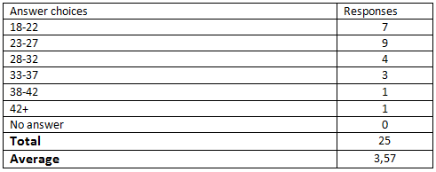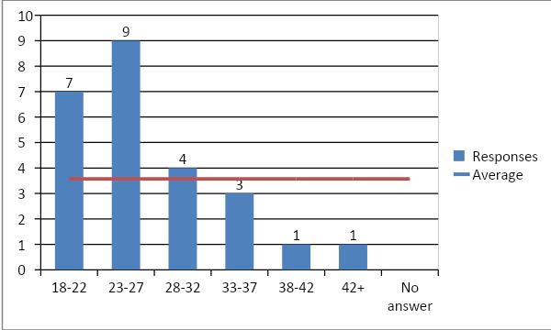

Q2. How long have you been a student at University of Wales Trinity Saint David London Campus?
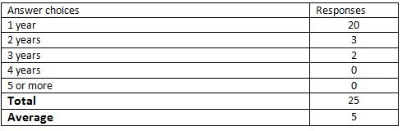

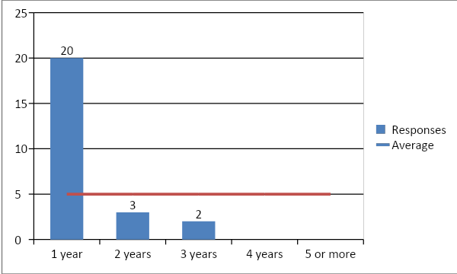

Q3. Do you agree that Moodle is useful in order to facilitate learning in an online environment?

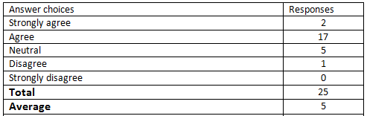
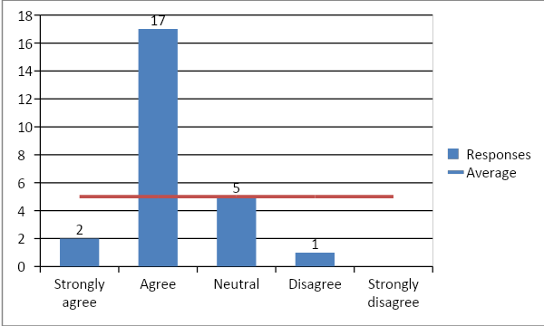

Q4. How satisfied are you with the VLE / moodle?
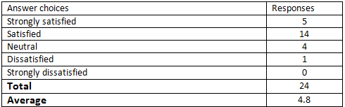
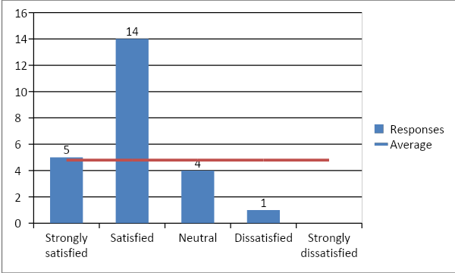

Q5. Do you prefer VLE/Moodle or face-to-face contact for your studies?
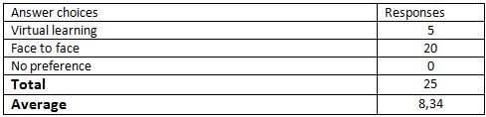
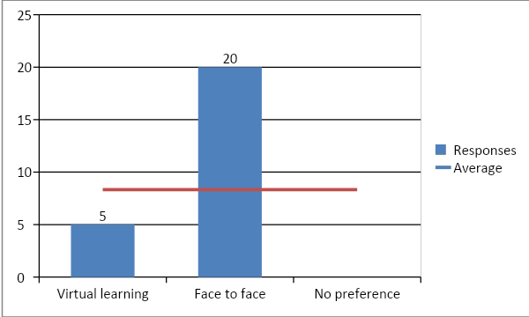

Q6. Do you find it more difficult to engage in a VLE compared to face-to-face?
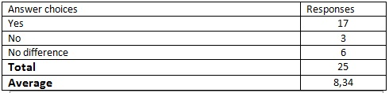
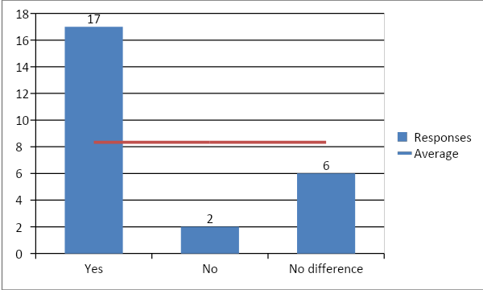

Q7. How effective do you find using the VLE as a learning tool / resource?
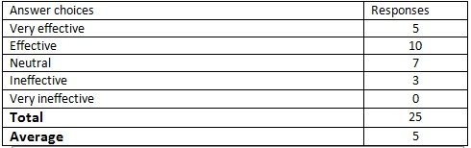
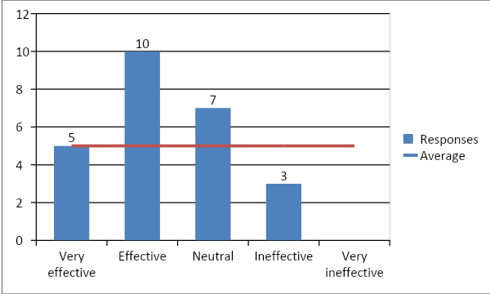

Q8. How confident are you in using the VLE / Moodle?
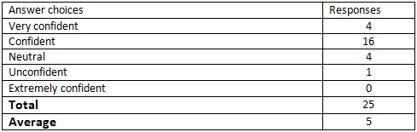
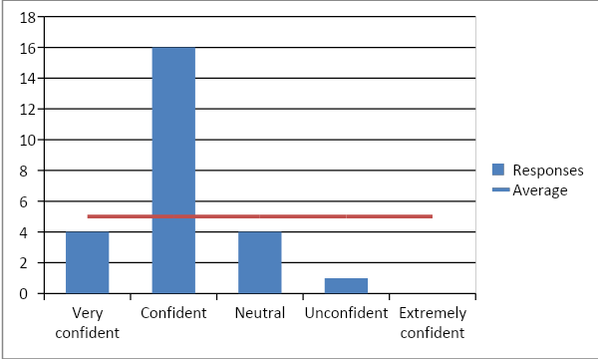

Q9. How often do you use the VLE / Moodle to help facilitate learning?
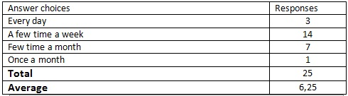
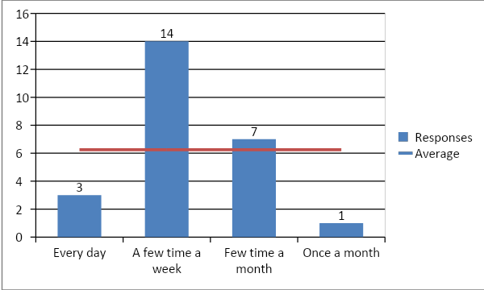

Q10. How satisfied are you of the experience of using the Library in the VLE?
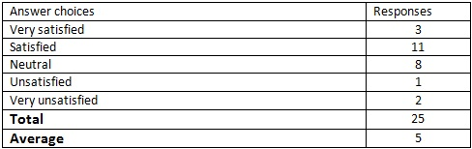

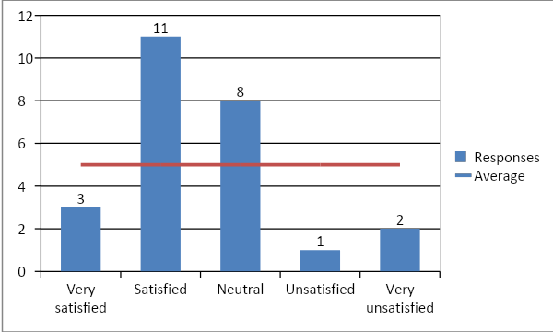

Discussion

Question 1&2

Twenty-five students completed the survey as the highest percentage (36%) is in the age group of 23-27. Most of them are students who study at the university and use VLE for the first year, ​​which was the target group of the study, namely 20 people or 80% of the respondents.

Question 3

The third question from the survey shows that students have realized how useful moodle is during a pandemic when university buildings are closed. Seventeen people answered with "agree" which is 68% of the respondents, it is understandable that only two people answered with "strongly agree” because most of them use Moodle for the first year and are still not sure about the full potential of the platform.

Question 4

In this question, we continue to maintain the tendency that most of the students find it useful to use VLE. Namely 14 people answer they are "satisfied" and another 5 that are "very satisfied" or a total of about 79% of the respondents fall into the category of satisfied with VLE and only 4% or 1 person enter the category of dissatisfied which is really big difference. But also the fact that not so many people have chosen "very satisfied" as an answer may raise the question "why?".

Question 5&6
In these two questions the result is eloquent that most of the respondents choose face-to-face training as preferred method. This is understandable because this is only the first term in which students from a normal way of learning are required to study and participate in classes from home. Perhaps if the survey was addressed to distance learning students, the results would be different. Here are the statistics, 80% prefer face-to-face learning, 68% find VLE more difficult.

Question 7

This is the question in which the percentages of the answers are closest to each other which shows the uncertainty in the respondents, it also depicts that the answer which is second in percentage is "neutral" namely with only 12% difference before the most effective answer by 40%. There is an answer for this because as we have already mentioned most respondents who use VLE for the first time still do not understand how effective it is for the simple reason that they still do not understand the final grades of the course they used.

Question 8 & 9

We can link the answers to these questions together because their results look almost the same. The reason for this is that the more you use a platform, the more confident you become that with it. 56% said they use the platform "several times a week", 12% say they use it every day, 64% are confident in using it and 16% are very confident.

Question 10
The answers to this question are also not eloquent. Although most are "satisfied" with the use of e-library, many people have filled in various columns. For the first time we notice that the group of "very satisfied" and the group of "very dissatisfied" is filled by almost the same number of people. Which may speak to one - the e-library does not have enough resources for learning or it is not made in a way that is easy for use.
According to the study, there are two areas in which students give hesitant answers: the e-library and the effectiveness of VLE. These responses are likely to be generated by the study target group due to the fact that there hasn’t been enough training in the use of these resources.

Conclusion
The results of the research give a solution for reaching its goals. A large percentage of the respondents are satisfied with the use of VLE, but still the preferred method of training remains face to face. The outcome of the attendance issue is also extremely indicative in the platform - despite attracting and facilitating student learning , there is still need of work on it. This must be its main goal.

Reference

Brown, S. (2008). From VLEs to learning webs: the implications of Web 2.0 for learning and teaching. Interactive Learning Environments, 18(1), 1-10.
Browne, T., Jenkins, M., & Walker, R. (2006). A longitudinal perspective regarding the use of VLEs by higher education institutions in the United Kingdom. Interactive Learning Environments, 14(2), 177-192.
Davis, F. D., Bagozzi, R. P., &Warshaw, P. R. (1989). User acceptance of computer technology: a comparison of Two theoretical models. Management Science, 35(8), 982–1003.
Jenkins, M., Browne, T., Walker, R., & Hewitt, R. (2010). The development of technology enhanced learning: findings from a 2008 survey of UK higher education institutions. 21 Interactive Learning Environments, 19(5), 447-465.
Kurt, O. (2017). The Acceptance and use of a VLE. Educational Technology Journal [online]. Available from: https://educationaltechnologyjournal.springeropen.com/articles/10.1186/s41239-017-0064-z#ref-CR13 [Accessed on 22/08/2020]
Tingoy, O. (2017). The Acceptance and use of a VLE. Educational Technology Journal [online]. Available from: https://educationaltechnologyjournal.springeropen.com/articles/10.1186/s41239-017-0064-z#ref-CR13 [Accessed on 22/08/2020]
Pynoo, B., Devolder, P., Tondeur, J., van Braak, J., Duyck, W., &Duyck, P. (2011). Predicting secondary school teachers’ acceptance and use of a digital learning environment: A cross-sectional study. Computers in Human Behavior, 27(1), 568- 575.

