APPLICATION for Sports Placement ETHICAL APPROVAL

This form must be completed and approved prior to undertaking any activity with the organisation. It will need to be signed by the student, placement organisation and a sports lecturer.

SECTION A: About You (Student)

Full Name: | Aaron Williams
Faculty/School/Centre: | Sport, Health and Outdoor Education
Campus: | Swansea Business Campus
E-mail address: | aarondavidwilliams@hotmail.com
Contact Telephone Number: | 07392826928
Student Number: | 1700800 | Undergraduate | ☒
Programme of Study: | BA Sports Management | Taught Postgraduate | ☐
Director of Studies/Supervisor: | Andrew Thomas | Research | ☐

SECTION B: Placement Activity Organisation (Employer)

Does the activity involve collaborators outside of the University? |  | YES | ☒ | NO | ☐
If Yes, please provide the name of the external organisation and name and contact details for the main contact person:

Organisation | Challenger Sports
Contact person name | Sophie Dewar
Contact person e-mail address | sdewar@challengersports.com
Contact telephone number | 401-352-6890 | 401-481-1802
Number of agreed contractual hours | 40 hours per week (May vary depending on camp

Location of activities
Identify all locations where activities will take place.
Baltimore (Will also vary depending on camp)

The placement student will work within the companies ethical framework
Organization representative name | Sophie Dewar
Signature | S.Dewar | Date | 09/06/19

SECTION C: Scope of Activity (Student)

Will the activities include: | YES | NO
Use of a questionnaire or similar research instrument? | ☒ | ☐
Use of interviews? | ☐ | ☒
Use of diaries? | ☐ | ☒
Participant observation with their knowledge? | ☒ | ☐
Participant observation without their knowledge? | ☒ | ☐
Use of picture, video or audio recording? | ☒ | ☐
Access to personal or confidential information without the participants’ specific consent? | ☒ | ☐
Administration of any questions, test stimuli, presentation that may be experienced as physically, mentally or emotionally harmful / offensive? | ☐ | ☒
If you have answered yes to any of the above then please explain below:

-The parents and campers will be provided with a feedback questionnaire to be completed by the end of the week regarding how they thought the camp went.

-Challenger works with a company called TopYa! Which allows the participants to video themselves participating in challenges and moving up levels on an interactive app.

NOTE – PICTURE and VIDEO for assessment - make sure you have approval from organisation

SECTION D: Intended Participants (Student)

Who are the intended participants: | YES | NO
Students or staff at the University? | ☐ | ☒
Adults (over the age of 18 and competent to give consent)? | ☐ | ☒
Vulnerable adults? | ☐ | ☒
Children under 18? | ☒ | ☐
Prisoners? | ☐ | ☒
Young offenders? | ☐ | ☒
Those who could be considered to have a particularly dependent relationship with the investigator or a gatekeeper? | ☐ | ☒
People engaged in illegal activities? | ☐ | ☒
Others (please identify): | ☐ | ☒
If you have answered yes to any of the above then please explain below:

-I will be coaching groups of children between the ages of 4-16

SECTION E: Anticipated Risks (Student)

Outline any anticipated risks that may adversely affect any of the participants, the student and/or the University, and the steps that will be taken to address them.
Risks to participants
For example: emotional distress, financial disclosure, physical harm, transfer of personal data, sensitive organisational information
-Physical harm ie: injury, dehydration, sun stroke
-Misuse of personal data

Risks to student
For example: personal safety, physical harm, emotional distress, risk of accusation of harm/impropriety, conflict of interest
-Physical harm ie: sun stroke, dehydration, injury
-Risk of accusations ie: physical harm, emotional harm
-Financial

University/institutional risks
For example: adverse publicity, financial loss, data protection
-Misrepresentation ie: behavioural issues, fired/contract retracted
-Data protection

Control measures
List measures put in place to limit and manage any of the risks identified above
-Scheduled water breaks, sun lotions, ensure shaded/indoor area
-Warm up to help prevent injury
-Ensure I represent myself and the university to the best of my ability ie: respectful, behaviour, professionalism

Disclosure and Barring Service
If the activity involves children or vulnerable adults, a Disclosure and Barring Service (DBS) certificate may be obtained before any contact with such participants. | YES | NO | N/A
Do you need a DBS certificate for this role? | ☒ | ☐ | ☐
Has a DBS certificate been obtained? | ☒ | ☐ | ☐
If yes, add picture copy below

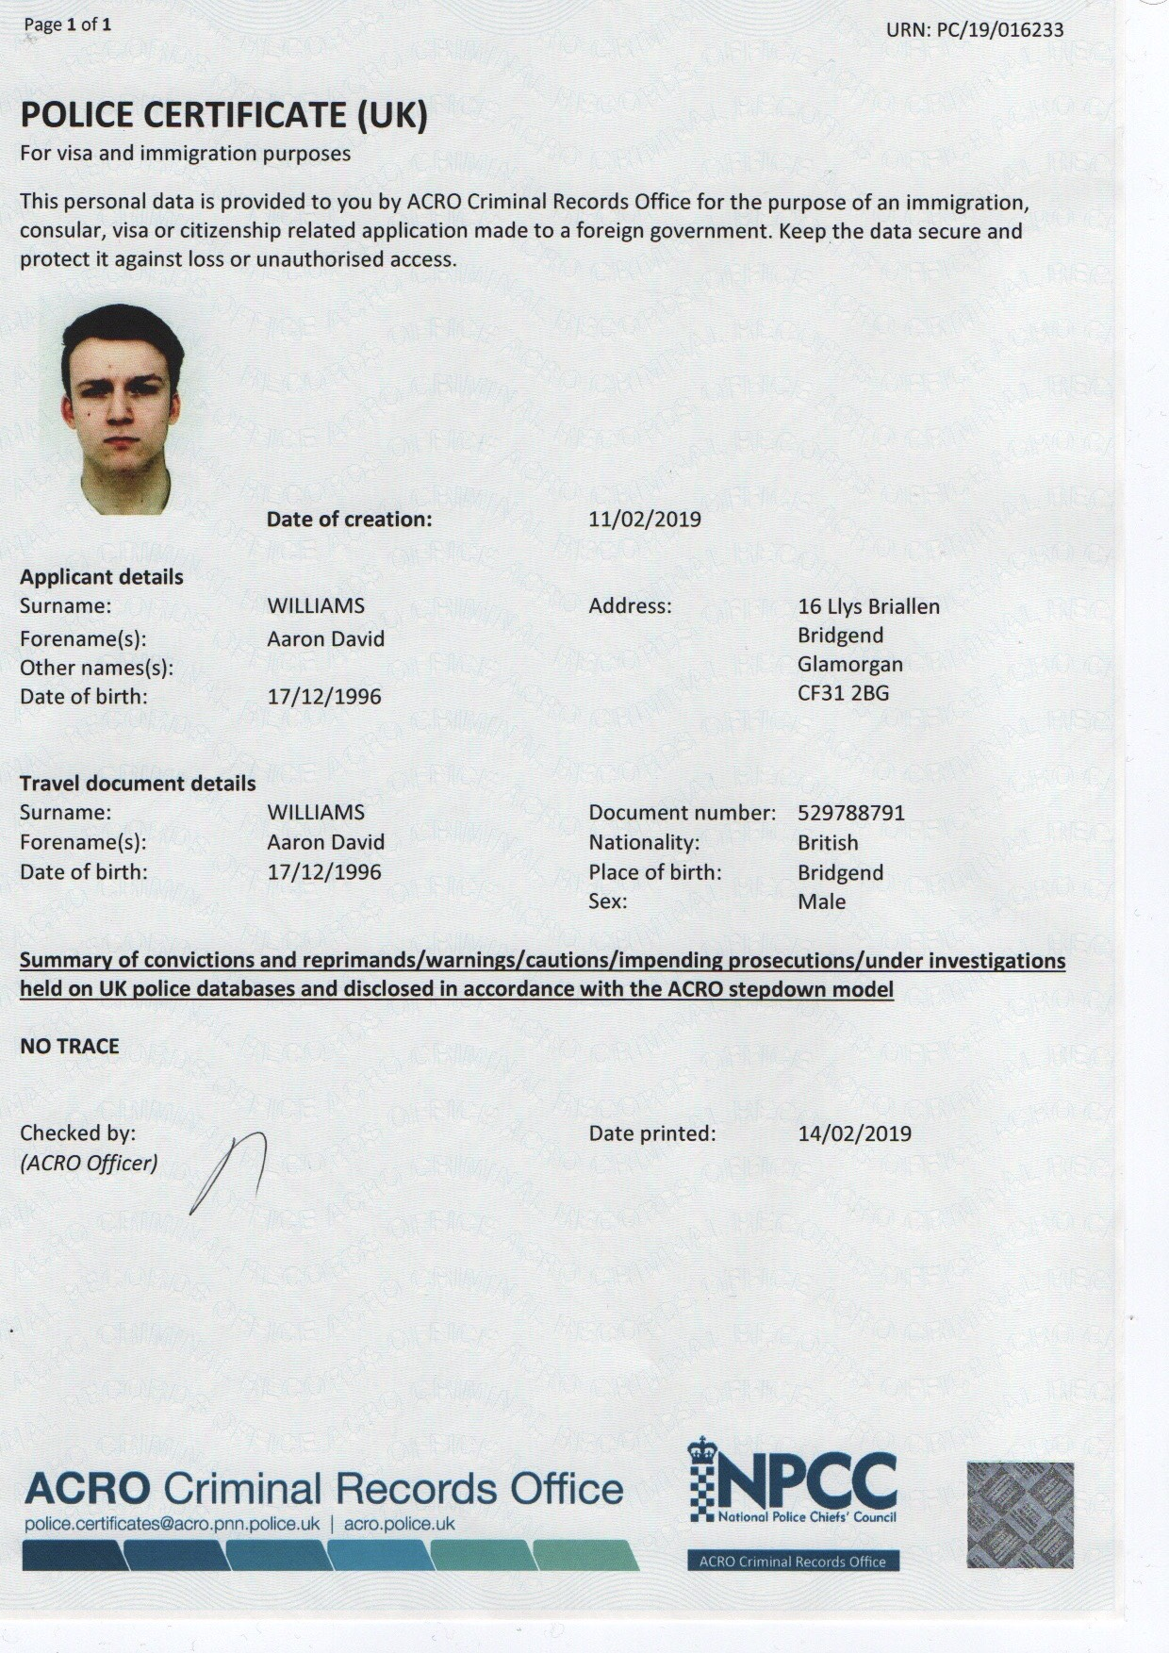

SECTION F: Declaration (Student and Staff)

For Students:
The information which I have provided is correct and complete to the best of my knowledge. I have attempted to identify any risks and issues related to the employment activity.
Name of applicant: Aaron Williams
Signature of student: A. Williams |  | Date: | 09/06/19

For Staff:
Placement Coordinator:
Signature:
Date:

Staff Checklist: The students completed/ submitted the following:

☐ | Completed all sections of the form in full.
☐ | Attached a copy of the DBS (where appropriate)
☐ | I can confirm that the activities has been approved providing they stay within the scope specified by the student.

