DATA CENTRE VIRTUALIZATION

Research Report by APOSTOL GEORGE-ADRIAN

DATA CENTRE VIRTUALIZATION
Koushik Modak

UNIVERSITY OF WALES TRINITY SAINT DAVID
London
04.05.2021
ABSTRACT
The activity in which a virtual version of something is created is known as virtualization; this includes storage devices, hardware platforms with virtual computer and computer network resources. It is found that these designed virtual machines work like a real computer that has an operating system.
The act of virtualization is appropriate for the use of UWTSD to improve the efficiency of virtualization. It involves support to hardware components through virtualization of CPUs performed to assist the guest environment improvement. Using virtualization, UWTSD can run several programs and make rapid changes and manage updates to applications and operating systems without interrupting the users.
Virtualization will assist the ABC Ltd company in valuing its previous investments with increased output. A hypervisor equipped with the physical hardware of the company host will be used for entertaining the resources of the guests, which eventually will reduce the ongoing limitations of management in the company. The computing resources will be treated as guests, including memory, CPU and storage. These resources are easy to be relocated at any place needed for the shift with control and operators’ virtual instances of other resources. In this way, it can accomplish all the needs of the guests associated with the resources.

Table of Contents
INTRODUCTION 5
Scenario 1: UWTSD Data Centre Implementation 5
Virtualization 5
Technical aspect of virtualization 6
Hypervisor types 6
Design principle 8
Scalability 9
Physical limitations 10
Organizational requirements 11
Technical analysis 11
Cost analysis 12
Scenario 2: ABC Data Ltd. 14
Understanding of Virtualization 14
Technology and Data Centre Infrastructure Management 14
Importance of the security policy and its influence 15
SAN 15
Disaster recovery 17
CONCLUSION 19
REFERENCES 20

List of figures
Figure 1 Types of hypervisor [4] 7
Figure 2 Detailed working of hypervisor [5] 7
Figure 3 Goals and principles [2] 8
Figure 4 Operations of the design principle [3] 9
Figure 5 Connection of the design principle [2] 9
Figure 6 network function of the design principle [3] 9
Figure 7 Horizontal scalability [1] 10
Figure 8 Vertical scalability [8] 10
Figure 9 Cost analysis for HyperV system [7] 12
Figure 10 Cost analysis for VMWare [5] 12
Figure 11 Cost analysis with Citrix server virtualization [5] 13
Figure 12 Storage area network [11] 16
Figure 13 Use of network in SAN [12] 16
Figure 14 SAN structure [12] 17
Figure 15 the elements of disaster recovery plan [14] 17
Figure 16 disaster recovery plan [11] 18

INTRODUCTION
The association named UWTSD requires a virtualized server for engaging its IT tasks. Be that as it may, UWTSD has the alternative to utilize a rethought for addressing the necessities of workers and its administrations. The association needs an act that is fit for dealing with the frameworks basically, while the re-appropriated arrangement is giving the office of overseeing such need successfully through arranging and providing every one of the assets. The movement wherein a virtual variant is made is known as virtualization; this incorporates stockpiling gadgets, equipment stages with virtual PC and PC network assets. It is tracked down that these made virtual machines work like genuine PC that has a working framework.
The demonstration of virtualization is proper for the utilization of UWTSD to generally improve the effectiveness of virtualization. It includes backing to the equipment segments through virtualization of CPUs performed to help the visitor climate improvement. The methodology of safety strategy will be created on multi-facet for various approaches including secrecy of information, email strategy, worthy use strategy, cell phone strategy, network security strategy, episode reaction strategy, basic security strategy, secret essential arrangement, visitor access strategy and remote organization strategy. The association should have the least of these arrangements for setting adequate security and IT hearty projects.
The organization can utilize SAN to acquire numerous information ways for improving application accessibility, isolate networks and off-load stockpiling capacities for upgrading the presentation of use, giving layered caching, and combining accumulating assets for expanding viability and capacity usage. The assignment evaluates the case of UWTSD and ABC Ltd for suggesting the use of virtualization in the companies.

Scenario 1: UWTSD Data Centre Implementation

Virtualization
The activity in which a virtual version of something is created is known as virtualization; this includes storage devices, hardware platforms with virtual computer and computer network resources. It is found that these built virtual machines work like a real computer that has an operating system [5]. Along with the hardware resources, these virtual machines have the execution of software. In this type of virtualization, the host machine is used by the guest machine and virtualization. The software run is distinguished by the words guest and host, where a software-based physical machine runs on a virtual machine. Utilizing software on the host's hardware, a virtual machine is created that is known as a virtual machine monitor or hypervisor [7].
The act of virtualization is appropriate for the use of UWTSD to improve the efficiency of virtualization. It involves support to hardware components through virtualization of CPUs performed to assist the guest environment improvement. The automatic computing and utility computing scenario can be considered through full virtualization or paravirtualization for managing the perceived activity with computer processing power [1]. Using the technique of virtualization, UWTSD can run several programs and make rapid changes and manage updates to applications and operating systems without interrupting the users.

Technical aspect of virtualization
Connecting with the internet becomes erratic and difficult sometimes. Therefore, maintaining a full-time connection with the internet is unrealistic. Similarly, using the hardware system for 24hours is a costly approach that requires high expense for maintenance, electricity, the array of costs and acquisition [4]. However, interrupting the business of UWTSD must be avoided with low operational cost and secure internet presence. In this regard, the imaginable need for the right virtualization technology is favourable that can be associated with the type of virtualization used by the company. It is stated that the effectiveness of technical aspects used in the virtualization allows offering a range of web technologies due to connecting with the array of cloud-based technologies [7].
The data centre must understand the technical elements to reduce the chances of consequences interconnected with the planning. It is found that virtual programs use to keep machine running which requires the proper selection of the type of virtualization for increasing the operational efficiency [2]. Furthermore, the administration's ability depends on the parts of the operating system that needs to be safe for the execution of virtual activities. Thus, utilization of the act is integral to the technical aspects, including hypervisor, design principle and scalability of virtualization [7]. The evaluation of the elements for UWTSD is presented below.

Hypervisor types
A hypervisor is of two types referred to as Type 1 and Type 2, the Type 1 hypervisor is named bare metal, and the Type 2 hypervisor is named as hosted [14]. Bare metal is the hypervisor that runs directly on the hardware of the host with a lightweight operating system. On the other side, the hosted hypervisor works on the operating system as a software layer, and it is similar to computer programs [4].
It is stated that bare-metal hypervisor is the most developed type of hypervisor. It uses to install the virtualization software on the hardware directly as usually the operating system gets installed. These systems are free from attack-prone operating systems and are considered highly secure. Moreover, the efficiency of the system is better as compared to hosted hypervisors. In this regard, the bare-metal hypervisor is selected to meet the computing needs of the UWTSD data centre [9].
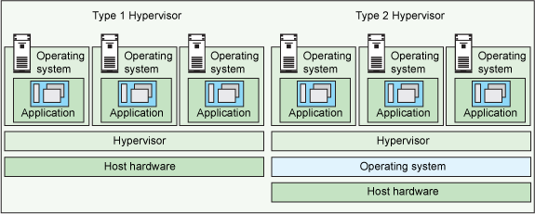

Figure 1 Types of hypervisor [4]

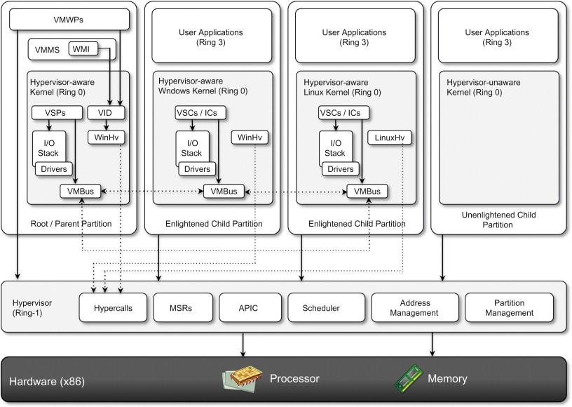

Figure 2 Detailed working of hypervisor [5]

The benefits UWTSD can obtain from the bare-metal hypervisor includes:
- Speed: it allows instant creation to the virtual machines, and the provision of resources get more effortless due to the dynamics of workloads as needed [5].
- Efficiency: the capacity of the hypervisor is efficient on single physical machines. Numerous virtual machines can run for better utilization of the physical server. In addition, it is energy-efficient and cost-efficient due to one physical device applied on several virtual machines to perform the same task with multiple underutilized physically machines [2].
- Flexibility: several hardware types are allowed to run on the applications of operating systems through the bare-metal hypervisor. It is due to OS separates underlined hardware from the formation of software on which the drivers and specific hardware devices rely [6].
- Portability: residing on multiple operating systems is allowed by the hypervisor on the same physical server. It is due to the hypervisor can independently run virtual machines from the virtual machines to make them portable. The IT teams can shift the allocation of networking and workloads to provide better storage, memory, and processing resources based on the need for multiple servers [2]. However, it varies based on need and moving from platform to platform and machine to machine. The virtualization software provides access to additional devices to increase their processing power [6].

Design principle
The virtualization infrastructure plays a vital role in the flexibility, transparency and planning of the design practices applied to the application. However, the system's design could be possibly inherited depending on the policies and support from the principles of management and maintenance needed in the future [3]. The method of the virtualization act is given in the figure below.

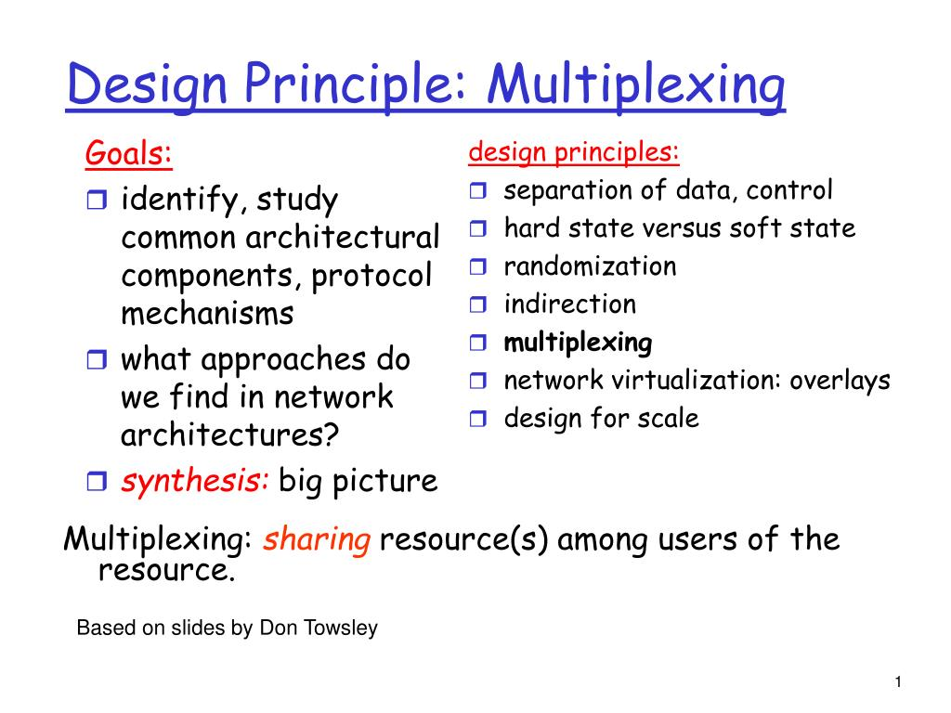

Figure 3 Goals and principles [2]

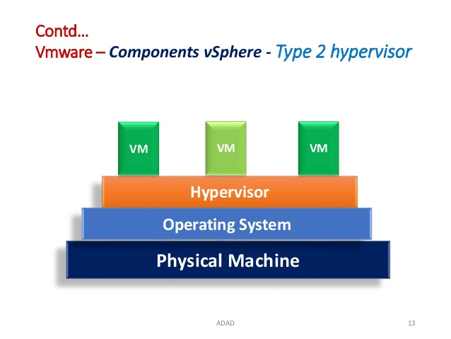

Figure 4 Operations of the design principle [3]
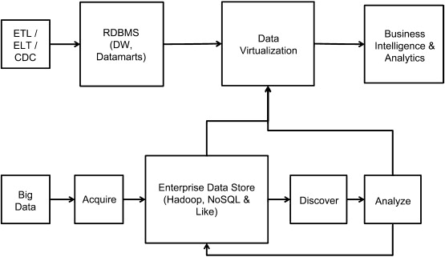

Figure 5 Connection of the design principle [2]

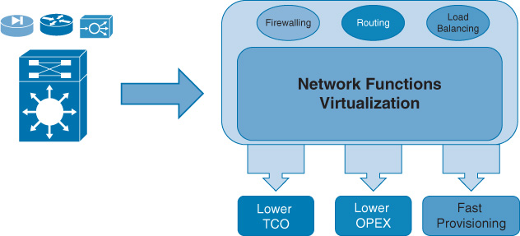

Figure 6 network function of the design principle [3]

Scalability
The ability of the system in terms of increased or decreased is measured by scalability. It focuses on the cost of performance, system processing demands and response to application change [1].
Vertical and horizontal are the two types of scalability used in virtualization. In horizontal scalability, the workload is accommodated due to the software and hardware connected to the network. The figure below presents the working principle of horizontal scalability in case of an increasing volume of data or new applications in the environment [8].

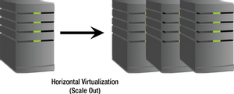
Figure 7 Horizontal scalability [1]

On the other side, in a virtual scalability environment scaling up is performed by the virtual central processing units (vCPU) that involve re-allocation and growing of bandwidth, memory and core of CPU in the network. Virtual machines are used for the management of the system. The figure below is presenting the working principle of vertical scalability [1].

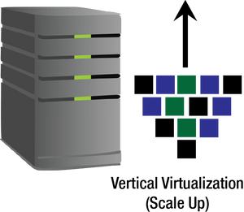
Figure 8 Vertical scalability [8]

Physical limitations
The data centre has many supportive and practical elements, but it also has several limitations; however, these concerns are solvable with preparation. The limitations of virtualization are concerned with server virtualization [9]. It is stated that magnified physical failures are the critical issues in virtualization. Due to the RAID controller effect on the physical host, malfunctioning in the RAID controller is likely to happen in the machine that impacts the capacity of the host to increase problematic redundancies and planned physical failures [3].
The act of virtualization is associated with the different use of hardware resources. At the same time, it is challenging for the company to estimate the additional requirement of resources, which develops difficulty in managing resources, thus leads to degraded performance [11]. Similarly, the tools and capacity planning guidelines are different for the virtualized environment under the physical server, making the applications relatively modest [5].
Indeed, the virtualized server requires profound changes in the system for enhancing its functionality. At the same time, for a new individual, it is complex to understand the need of every layer and concerning problems with it. Therefore, extra effort is required for dealing with the cause of the problem, which is a drawback of virtualization [2]. Furthermore, primarily, the employees and users of the act do not have the experience to use the application and understand its complexities, leading them to be limited with specific use of the application [10].

Organizational requirements
The organization named UWTSD requires a virtualized data centre for entertaining its IT operations. However, UWTSD can use an outsourced solution for meeting the needs of servers and their services. The organization needs to manage the systems virtually, while the outsourced solution is providing the facility of managing such demand effectively through planning and providing all the resources.
The university has to tell the outsourcing company their technical needs and requirements, which will lead the company to manage each and everything on their own. On the other side, if UWTSD decides to build their own virtualized setting, they have to do appropriate planning based on their needs, development of skills for incorporating with the systems and resource management. However, it is not easy for them to understand each aspect and functionality of the virtualized servers. Also, it is difficult to construct the plan without any limitation.
Meanwhile, the virtualized setting would allow the company to get an advanced connection and proper hold on the junctions with the software and hardware [5]. This will lead them to increase their understanding of the virtualized applications and technologies. In addition, over time, they will get the ability to judge the need for resources and strategies to manage the resources.

Technical analysis
Building a data centre is a complex but worthy decision for the company. Outsourcing is the best option for many reasons, while it is effective for achieving short-term goals. If UWTSD is planning to run the virtualized setting on a long-term basis, they must go there on DC due to change in the needs and demands, modifications required in the applications and an increase in the technical aspects [10].
On the other side, security and confidentiality of the data are mandatory for the company, which can be ensured by having all the connections and hold. In this regard, the company must consider many factors that include complexity, scalability, cost, and security concerns [3].
The consideration of the factors is listed below:
Complexity: it is complex for UWTSD to evaluate the correct use of the application, technology and virtualized structure. However, this can be done by assessing the virtualized form, classical application and functionality of the data centre [4].
Scalability: presently, the company's demand is not much; therefore, the performance can be increased with less cost and changes in the application. In response to the changes, the company can modify the system and improve its performance from time to time, carrying the cost measures [6].
Cost: cost is one of the essential factors in consideration of the data centre building; however, the cost of outsourcing and building a data centre is presented in the section coat analysis. It shows that there is not much increase in the price of building a data centre compared to outsourcing virtualization [10].
Security concerns: the security concerns, including threats, hacking, losing personal data, system variations and many others, are low with the structural formation of own data centre [3].

Cost analysis
The tables below are presenting the cost analysis for different virtualized networks.

- Cost analysis for HyperV system
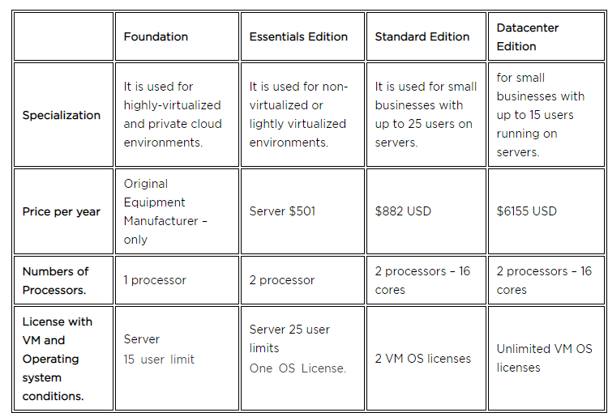
Figure 9 Cost analysis for HyperV system [7]
The table above presents all the needs, requirements, standards, resources and cost for the data centre with HyperV.

- Cost analysis for VMWare
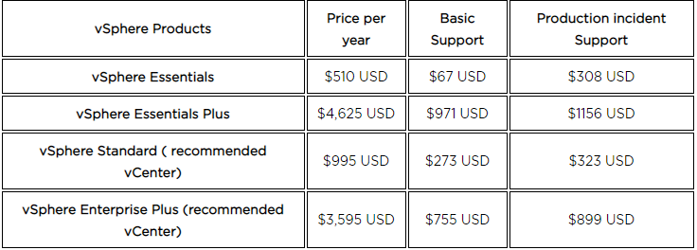

Figure 10 Cost analysis for VMWare [5]
The table above presents all the needs, requirements, standards, resources and cost for the data centre using VMWare.

- Cost analysis with Citrix server virtualization
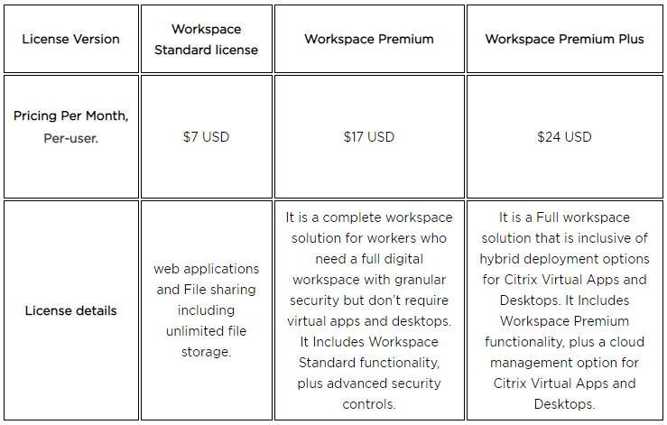
Figure 11 Cost analysis with Citrix server virtualization [5]
The table above presents all the needs, requirements, standards, resources and cost for the data center using Citrix server virtualization.

The organization can utilize SAN for acquiring numerous information ways for improving application accessibility, to isolate networks and off-load stockpiling capacities for upgrading the presentation of use, giving layered stockpiling, unite capacity assets for expanding adequacy and capacity usage [7]. This improves information security and assurance. Ordinarily, it assumes a decisive part in the exercises of business coherence the board of the association.

For maximizing the virtualization security for host servers and virtual servers, UWTSD needs to focus on preferring private networks for accessing the machines [6] and, in addition, setting up securities for the places where virtualized resources are stored, including files and permissions. Setting up the security firewalls can ensure the protection of the system and avoid theft and malware attacks. Last but not least, the recommended processors for building the virtualized set up are second-gen 64x bit to ensure sustainability [10].

Scenario 2: ABC Data Ltd.

Understanding of Virtualization
The technology that is capable of allowing machines for creating multiple simulated environments is termed virtualization technology. The virtualization technology of ABC Ltd has dedicated resources to connect with the physical hardware system. However, the implications associated with the structural use of the technology can be handled with the software known as hypervisor [11]. This software will get connected to the system's hardware directly, and foremostly, the system will allow the company to split the system into a separate, secure, distinct and efficient environment.
The environment in which the machines will work with enhanced functionality is known as virtual machines (VMs) [13]. VMs are boosted with the hypervisor's ability that separates the resources of the machines from elements of hardware distribution appropriately. Virtualization will assist the ABC Ltd company in valuing its previous investments with increased output [9].
A hypervisor equipped with the physical hardware of the company "host" will be used for entertaining the resources of the guests, which eventually will reduce the ongoing limitations of management in the company. The computing resources will be treated as guests, including memory, CPU and storage [15]. These resources are easy to be relocated at any place needed for a shift with control and operators’ virtual instances of other resources. In this way, all the guests' needs associated with the resources can be accomplished [11].

Technology and Data Centre Infrastructure Management
Datacenter infrastructure management (DCIM) is a comprehensive and consistent method to manage and monitor resources and the process of the data centre. It is impossible to optimize and control the monitoring of critical operations and systems of the data cent
re.
The fundamental purpose of applying the strategy in the company is to administrate the overview of a centralized data centre based on equipment, performance, and energy and floor space that is not possible to obtain efficiently in any other mean [10]. The software entirely relies on a high number of sensors used within the data centre. The IT Expert, interlinked with the DCIM software, must use the latest cloud base EcoStrcxure for providing an overview of simple visuals of the data centre. The configurable dashboards have the associative components for capturing the detailed report of sensor data and capacity planning manipulation [12].
The approach will be responsible for delivering and managing the relevant parties and critical alarms. However, to obtain potential benefits of the IT infrastructure, the company should monitor the tasks; if failed to do so, it would damage the reputation of the company [14]. The EcoStruxure software would analyze the company's systems by performing high-level analytics based on prescriptive and predictive maintenance. Benchmarks will be achieved by analyzing harsh operating conditions, anomalies, and failure patterns for the devices [8].

Importance of the security policy and its influence
The procedures and rules of security are identified utilizing cybersecurity policy. The formation of the policy follows every individual who accesses the organization's IT resources and assets [4]. The goal of network security policies is to address the potential threats that fall in security and implement strategies for mitigating the vulnerabilities and defining the way of recovery based on the design for the integrated consequences.
The security policy of ABC Ltd needs to consider three key objectives, which are confidentiality, integrity and availability [15]. The term confidentiality would protect the networks and assets of the company from unauthorized users. However, integrity will ensure development in the handling of IT support in an authorized and specific manner. Availability is needed to ensure continuous access to the networks and assets to the authorized users [11].
The security policy approach will be developed on multi-layer for several policies, including confidentiality of data, email policy, acceptable use policy, mobile device policy, network security policy, incident response policy, physical security policy, password policy, guest access & wireless network policy. The organization must have a minimum of these policies for placing a good position in the security and IT robust programs. However, the policies must comply basic security postures of the organization [14].

SAN
A high-speed specialized network capable of providing access to a block-level network is known as Storage Area Network (SAN). This access is offered to the storage. Typically, SANs are composed of switches, hosts, storage devices and storage elements interconnected to the topologies, technologies and protocols [3].
Multiple sites span to SANs, which presents storage appearance to the hosts and storage devices that are locally attached. The simple storage presentation is accomplished through storage use within different types of virtualization.
The company can use SAN to obtain multiple data paths for improving application availability, segregate networks and off-load storage functions for enhancing the performance of the application, provide tiered storage, and consolidate storage resources for increasing effectiveness and storage utilization [7]. This improves data security and protection, and typically it plays an influential role in the activities of business continuity management (BCM) of the organization.
The technology will be using FCP (Fiber Channel Protocol) implemented on Fiber Channel (FC) for proprietary and open system variants for mainframes [5]. The channel will increase the capacity for moving traffic on FC through existing coverage storage, high-speed Ethernet infrastructure and IP protocols, and the connection of a single cable [12].
The provision of the information and method of the computing environment is presented in the figures below.
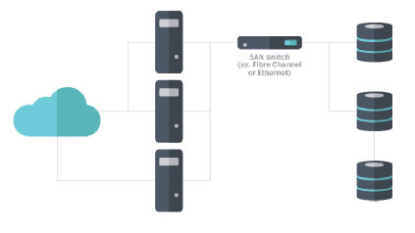
Figure 12 Storage area network [11]
The figure above is presenting the mechanism of using storage area within the network using SAN technology.

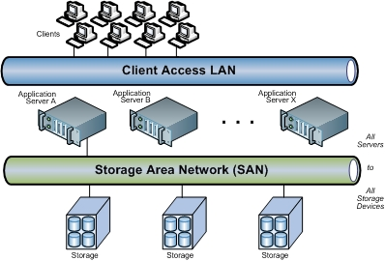
Figure 13 Use of network in SAN [12]
The figure above explains the SAN's working mechanism and the connection and access to the client.
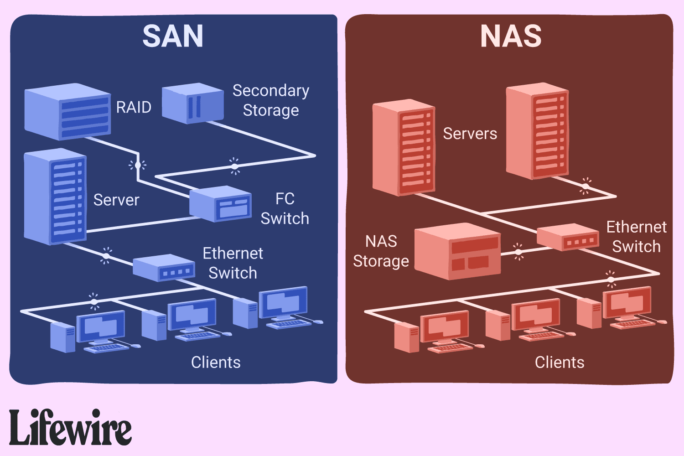
Figure 14 SAN structure [12]
The above picture is showing the structural formation of SAN and its connection with each device.

Disaster recovery
Documenting the methods used for recovering IT disaster infrastructure in the company is known as a disaster recovery plan (DR). This plan contains detailed instructions for the organization to deal with unplanned incidents, for instance, power outages, natural disaster, disruptive events and cyber-attacks [14].
The plan contains elements and strategies for minimizing operations and the effects of a disaster. The organization can quickly resume operations after the impact of a disaster. The method can include rapid recovery to reduce the chances of lost revenue, dissatisfied customers and disruption in the brand image regardless of source disruption [11].
The elements of a disaster recovery plan for the company are presented in the figure below.

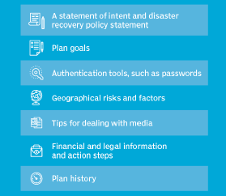
Figure 15 the elements of disaster recovery plan [14]
Following are the steps for ensuring effective recovery of disaster for the case of ABC Ltd.
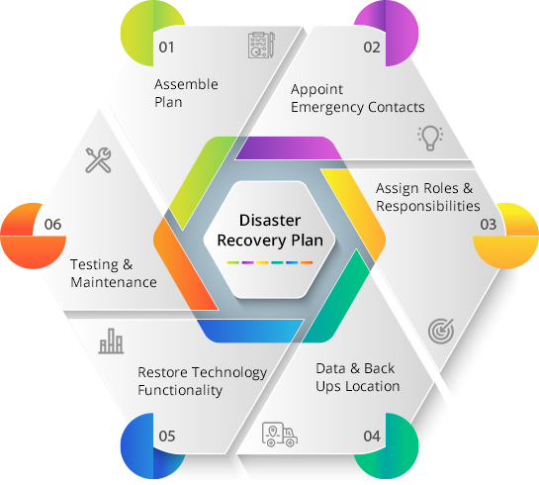
Figure 16 disaster recovery plan [11]
The innovation that can do permitting machines for establishing numerous recreated climate is named virtualization innovation. The virtualization innovation of ABC Ltd has committed assets to associate with the actual equipment framework. Nonetheless, the ramifications related to the underlying utilization of the innovation can be taken care of with the product known as a hypervisor. This product will get associated with the equipment of the framework straightforwardly. Generally, the framework will permit the organization to part the framework into an independent, secure, unmistakable and effective climate.

CONCLUSION
In conclusion, utilizing the virtualization method, UWTSD can run a few projects and roll out fast improvements just as oversee updates to applications and working frameworks without intruding on the clients. The capacity of the framework as far as expanded or diminished is estimated by versatility. It centres on the expense of execution, framework handling requests and reaction to application change.
The restrictions of virtualization are worried about the cut off virtualization. It is expressed that amplified real disappointments are the central question in virtualization. It happens because of the RAID regulator impact on the actual host. Breaking down in RAID regulator is probably going to occur in the machine that impacts on the limit of the host to increment risky redundancies and arranged real disappointments.
Setting up protections for where virtualized assets are put away include documents and consents. Assurance of the framework can be guaranteed with the security firewalls set up. In this way, burglary and malware assaults can stay away from. DCIM is a far-reaching and reliable technique to oversee and screen assets, just as the interaction of server farm. It is difficult to streamline and control the checking of basic tasks and frameworks of the server farm.
The objective of the arrangements of organization security is to address the potential dangers falls in security and execution of the methodologies for relieving the weaknesses and characterizing the method of recovery based on intended for the coordinated outcomes. The station will expand the limit regarding moving traffic on FC through existing inclusion stockpiling, rapid Ethernet foundation and IP conventions alongside the association of a single link.

REFERENCES
[1] Alam, I., Sharif, K., Li, F., Latif, Z., Karim, M. M., Biswas, S., ... & Wang, Y. A survey of network virtualization techniques for internet of things using sdn and nfv. ACM Computing Surveys (CSUR), 53(2), 1-40, 2020.
[2] Almutairy, N. M. A taxonomy of virtualization security issues in cloud computing environments. Indian Journal of Science and Technology, 2019.
[3] Basile, C., Valenza, F., Lioy, A., Lopez, D. R., & Perales, A. P. Adding support for automatic enforcement of security policies in NFV networks. IEEE/ACM Transactions on Networking, 27(2), 707-720, 2019.
[4] Boudi, A., Farris, I., Bagaa, M., & Taleb, T. Assessing lightweight virtualization for security-as-a-service at the network edge. IEICE Transactions on Communications, 102(5), 970-977, (2019).
[5] Chen, W., Rao, J., & Zhou, X. Preemptive, low latency datacenter scheduling via lightweight virtualization. In 2017 {USENIX} Annual Technical Conference ({USENIX}{ATC} 17) (pp. 251-263), (2017).
[6] Duan, J., & Yang, Y. A load balancing and multi-tenancy oriented data center virtualization framework. IEEE Transactions on Parallel and Distributed Systems, 28(8), 2131-2144, (2017).
[7] Gwebu, K. L., Wang, J., & Hu, M. Y. Information security policy noncompliance: An integrative social influence model. Information Systems Journal, 30(2), 220-269, (2020)
[8] Kondepu, K., Jackson, C., Ou, Y., Beldachi, A., Pagès, A., Agraz, F., ... & Nejabati, R. Fully SDN-enabled all-optical architecture for data center virtualization with time and space multiplexing. IEEE/OSA Journal of Optical Communications and Networking, 10(7), 90-101, (2018).
[9] Kong, J., Kim, I., Wang, X., Zhang, Q., Xie, W., Cankaya, H. C., ... & Jue, J. P. Guaranteed-availability network function virtualization in inter-datacenter networks. In Optical Fiber Communication Conference (pp. W1D-1). Optical Society of America, (2018, March)
[10] Mariia, S., & Oleksandr, R. The structure of a mobile provider network with network functions virtualization. In 2018 14th International Conference on Advanced Trends in Radioelecrtronics, Telecommunications and Computer Engineering (TCSET) (pp. 1032-1034). IEEE, (2018, February)
[11] Nam, T. M., Thanh, N. H., Hieu, H. T., Manh, N. T., Van Huynh, N., & Tuan, H. D. Joint network embedding and server consolidation for energy-efficient dynamic data center virtualization. Computer Networks, 125, 76-89, (2017).
[12] Shukur, H., Zeebaree, S., Zebari, R., Zeebaree, D., Ahmed, O., & Salih, A. Cloud computing virtualization of resources allocation for distributed systems. Journal of Applied Science and Technology Trends, 1(3), 98-105 (2020).
[13] Sun, G., Liao, D., Bu, S., Yu, H., Sun, Z., & Chang, V. The efficient framework and algorithm for provisioning evolving VDC in federated data centers. Future Generation Computer Systems, 73, 79-89. (2017).
[14] Vora, J., Kaneriya, S., Tanwar, S., & Tyagi, S.. Performance evaluation of SDN based virtualization for data center networks. In 2018 3rd international conference on internet of things: Smart innovation and usages (IoT-SIU) (pp. 1-5). IEEE. (2018, February)
[15] Yedder, H. B., Ding, Q., Zakia, U., Li, Z., Haeri, S., & Trajkovic, L.. Comparison of virtualization algorithms and topologies for data center networks. In 2017 26th International Conference on Computer Communication and Networks (ICCCN) (pp. 1-6). IEEE. (2017, July)

