LCBB4002
Community Engagement Assessment 1
Student Name:Adelina Camelia Perva
Student Id:2020310
Table of Contents
Introduction 3
Identification of the relationship of the community engagement project of Tower Bridge with its stakeholders and how they engage with them 4
The different eras of Tower Bridge and highlights of their social evolvement 6
The use of social media platform for supporting the community engagement project of Tower Bridge 6
The training and development required in Tower Bridge to equip employees for managing socio-cultural issues within society 7
Conclusion 9
Recommendations 9
Reference List 10

Introduction
The process through which an organisation or institution involve and participate different types of programs or project for the welfare of the individuals of the society or community is called community engagement (Dostilio and Welch, 2019). In this paper different aspects of a community engagement project of an organisation ‘Tower Bridge’ will be discussed and analysed. The particular community engagement activity of Tower Bridge that will be discussed throughout the report is the partnership of Tower Bridge with City Bridge Trust through raising funds for the charitable projects of Bridge House Estates (Communities and partnerships | Tower Bridge, 2021). Tower Bridge help them in increasing the fund by selling tickets to the individuals. Especially the relationship of the stakeholders with the community engagement project of the organisation and the organisational engagement with the stakeholders will be focused on in this report. Also, different eras of Tower Bridge will be evaluated where the evolvement of the organisation in case of community engagement with the explanation of the range of knowledge, skills, and strategies the employees of the organisation require to carry out their jobs effectively and efficiently will be discussed. The significance of social media platforms for supporting the engagement project and the required training and development arrangements for equipping the employees so that they can deal with social-cultural issues will be discussed. At last, some recommendations for improving community engagement of Tower Bridge through which it can gain competitive advantage will be provided.

Identification of the relationship of the community engagement project of Tower Bridge with its stakeholders and how they engage with them
An organisation involved in community engagement activities for increasing employee engagement, customer engagement and loyalty etc. (Dostilio and Welch, 2019). Stakeholders are the individuals or group of people that are connected with the organisation somehow and the major stakeholders of a social organisation are donors, beneficiaries, local community, employees and volunteers and government. (Lindgreen, 2012). The relationship of the community engagement project with the stakeholders of Tower Bridge and procedures of engagement with them are discussed below:
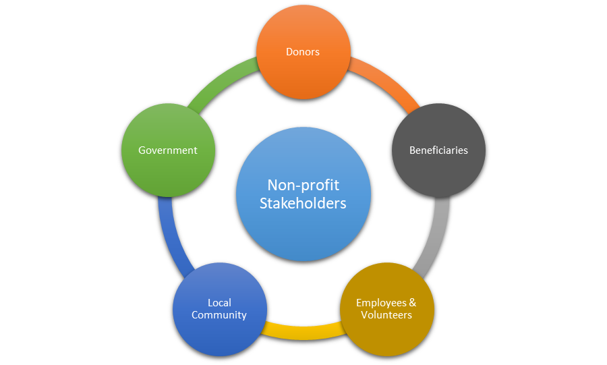
Figure 1: Stakeholders of Tower Bridge Organisation
Source: (Towerbridge.org.uk, 2021)
Donors: The people who buy tickets to Tower Bridge for helping the community mainly and for watching the bridge are called the donors of Tower Bridge. Donors are the major stakeholder of this type of organisation and the reason behind that is the organisation can raise the fund for City Bridge Trust to help the community or inhabitants of Greater London by selling tickets of the bridge to these donors or customers. That is why there remains a strong relationship between the City Bridge Trust project of Tower Bridge with the donors and for managing the relationship well the organisation follow many strategies such as proper communication with them through social media platforms, providing offers for them etc. (Lindgreen, 2012).
Beneficiaries: In the case of this project of Tower Bridge of helping the City Bridge Trust through raising funds they mainly want to help the community of London or the inhabitants of London. That is the reason why these inhabitants of London are the beneficiaries of the project as the beneficiaries are the ones who get helped by the organisation. As well as donors the organisation maintain a better relationship with the beneficiaries too as they are also a part of the stakeholders of the organisation (Rupp, Kern and Helmig, 2014). And for engaging with them properly and effectively the organisation go through different social media platforms such as Facebook, YouTube, Instagram, Twitter etc. and the organisation have a huge number of followers on these social media platforms.
Local Community: Local communities are stakeholders of the organisation who are external and these stakeholders include the individuals and groups of people of the communities (Rupp, Kern and Helmig, 2014). Different types of communities have a different attitude, belief, values, etc. and that is the reason why an organisation need to follow those activities or characteristics properly so that a great relationship exists among them. Tower Bridge organisation sell their tickets to the individuals of the local community within London which is why they need to maintain a great relationship with them through observing their activities and characteristics. And for doing that the organisation provide occasional offers in case of selling tickets and do occasional marketing on social media platforms.
Employees and Volunteers: Employees and volunteers are the integral stakeholders and major stakeholders of the organisation because they are the ones who are responsible for managing organisational operations, selling tickets, attracting customers, managing and raising the funds for providing them to the City Bridge Trust etc. That is the reason why Tower Bridge maintains a better relationship with these volunteers and employees of the organisation and for doing that they use different procedures where social media platforms are the major ones.
Government: Government is also a prime stakeholder of the organisation as Tower Bridge need to maintain the rules, regulations and policies of the government. This stakeholder of the organisation help Tower Bridge in raising fund for the needed people properly by tax exemption feature where the organisation need to provide no tax for raising the fund (Rupp, Kern and Helmig, 2014). Also, many times government help the organisation n raising funds through providing donations and which is why the organisation maintain a greater relationship with the Government for the betterment of the organisation.

The different eras of Tower Bridge and highlights of their social evolvement
To mention the different eras of Tower Bridge firstly the name of the City of London Corporation should be stated because it is the one that owned, managed and funded Tower Bridge (Towerbridge.org.uk, 2021). Throughout many different eras, the corporation is doing a lot for the local community of London through Tower Bridge and the social evolvement increased. About 125 years ago the bridge was founded and from then it is serving the whole of London by taxes, bridge tools, charity funds of the bridge. Currently, City Bridge Trust is the one the Tower Bridge directly provide help or raise fund for helping the inhabitants of London through selling tickets, bridge tolls, taxes etc. activities within the bridge (About us - City Bridge Trust, 2021). It can be mention that Tower Bridge is arranging several programs of community engagement for the people of London for so many years. That is how the Tower Bridge is evolving in social activities and serving the needed people with their fund through various trust and community engagement programs.

The use of social media platform for supporting the community engagement project of Tower Bridge
Since social media platforms i.e. YouTube, Facebook, Twitter, Instagram etc. are so popular means of communication nowadays all over the world almost all type of organisations uses these social media platforms for organisational purposes. (Friedrichsen and Mühl-Benninghaus, 2013) As well as Tower Bridge also use social media platforms for attracting the customers to sell their tickets and increasing fund for the inhabitants of the London. The use of different social media platforms within Tower Bridge in case of supporting community engagement project is mentioned below:
Facebook: Among the social media platforms the Tower Bridge use the Facebook page most because in this platform the organisation have around 178k followers (Towerbridge.org.uk, 2021). That is the reason why it posts valuable information about the bridge, share the latest information about the bridge, posts attractive photos and through that, it attracts customers for selling their tickets to raise the fund for the needed people of London. As well as posting the employees of Tower Bridge observe people through checking their reactions and comments and use these in case of making necessary decisions or strategies.
Instagram: As well as Facebook Tower Bridge has an Instagram account too where they share beautiful photos of the bridge as a marketing strategy because the account has about 20k followers in their account and through these amazing photos they sell tickets after attracting the customers. That is how this social media platform is used by the organisation for supporting their community engagement project (Friedrichsen and Mühl-Benninghaus, 2013).
YouTube: In YouTube the organisation share videos of the bridge and through doing that the customers who are interested to visit this place can take a look before buying tickets. That is the reason why Tower Bridge posts attractive videos of the bridge and places around it so that the customers get attracted to visiting the place. Also for increasing customer engagement the organisation post historical information of the place and they post updated videos regularly for retaining the customers and that is how this social media is used by Tower Bridge to support the community engagement project.
Twitter: In the Twitter account of Tower Bridge has about 32k followers and that is why it is a great means of attracting customers through attractive and proper tweets (Towerbridge.org.uk, 2021). In Twitter, the organisation tweet about the social activities the organisation are doing and the help it is providing to the people of the London is shared by it. Also, up-to-date information about visiting the place, the ticket price of visits, as well as information about the City of London Corporation and City Bridge Trust are also shared through the tweets. These strategies are a follower by the organisation in the social media platform Twitter for supporting the community engagement project of Tower Bridge.

The training and development required in Tower Bridge to equip employees for managing socio-cultural issues within society
Since the volunteers and employees of Tower Bridge need to deal with different types of visitors of different areas they have to deal with people with different culture and tradition regularly (Baumann, 2011). That is the reason why the organisation provide training to the recruits for managing different types of visitors with different society or culture. Also, these employees are trained and developed by the organisation for dealing with social or cultural issues properly if occurred. Multiculturalism is a critical factor in that case and that refers to the way of training employees for dealing with people of different or multiple cultures. Along with multiculturalism, there remain some other external issues that are required to be adopted and provided greater value by the employees (Baumann, 2011). Among these factors, some of the major ones are competitor analysis, globalisation, competitive marketplace, health and safety, political and environmental factors etc. Because these factors are the ones that are required to be maintained by the employees properly so that a sustainable business relationship between the Tower Bridge organisation and its network partners.

Conclusion
Community engagement contains the welfare of the individuals of the community through many donation fund and charity programs that are arranged by different types of organisation (Waterton and Watson, 2013). Tower Bridge raise its funds for helping the inhabitants of London by selling tickets to the visitors of the bridge through the City Bridge Trust. For the support, the organisation maintain a good relationship with its stakeholders and social media platforms are used for maintaining the relationship as well as attracting customers. For dealing with the people of different society and culture employees are trained in multiculturalism and that is how Tower Bridge is maintaining sustainability.

Recommendations
Every organisation want to increase their competitive advantage which is why different types of organisational strategies are used by the organisations (Tschirhart and Bielefeld, 2012). In the case of Tower Bridge for arranging more community engagement programs for helping the people of London the organisation need to attract more customers and for doing that employees should be given improved training so that they can attract more employees through proper techniques. In that case, multiculturalism will be helpful for dealing with different cultural people. Environmental factors should be maintained carefully by the organisation because the COVID-19 pandemic is a critical issue which is why the visitors will buy the tickets only if the bridge is safe and healthy for visiting. And finally, it can be recommended that Tower Bridge should focus more on the social media platforms so that they can increase more funds for providing it to the City Bridge Trust and can gain a competitive advantage.

Reference List
Baumann, G., 2011. Multiculturalism. London: Routledge.
City Bridge Trust. 2021. About us - City Bridge Trust. [online] Available at: <https://www.citybridgetrust.org.uk/about-us/> [Accessed 17 April 2021].
Dostilio, L. and Welch, M., 2019. The Community Engagement Professional's Guidebook. Bloomfield: Campus Compact.
Friedrichsen, M. and Mühl-Benninghaus, W., 2013. Handbook of social media management. Heidelberg: Springer.
Lindgreen, A., 2012. A stakeholder approach to corporate social responsibility. Burlington, VT: Gower.
Rupp, C., Kern, S. and Helmig, B., 2014. Segmenting nonprofit stakeholders to enable successful relationship marketing: a review. International Journal of Nonprofit and Voluntary Sector Marketing, 19(2), pp.76-91.
Tower Bridge. 2021. Communities and partnerships | Tower Bridge. [online] Available at: <https://www.towerbridge.org.uk/about-us/communities> [Accessed 17 April 2021].
Tschirhart, M. and Bielefeld, W., 2012. Managing nonprofit organizations. Hoboken, N.J.: Jossey-Bass.
Waterton, E. and Watson, S., 2013. Heritage and Community Engagement. Hoboken: Taylor and Francis.

