Student Name: Laila Shaikh
Student Number: 1711576
Module: BMSK4003
Lecturer: Balendran Kandasamy

EXECUTIVE SUMMARY
The current report highlights importance of marketing opportunities for an organisation and its impact on major area. Lack of possession of inadequate marketing knowledge or strategies on part of employees of the organisation concerned can be regarded as the major issue in this regard. Different issues based on lack of market plan and poor business strategy have created major barriers in case of achieving leading position for the organization. In addition, as per Maslow’s view, every business organization must maintain the basic criteria of customers such as cheap price as well as providing best quality services on time in order to capture the existing market scenario effectively. For the effective completion of the research the researcher has chosen deductive approach in order to understand properly the purport of marketing for the organization and analyze major issues without embedding marketing strategy into business process. In addition to that the company needs to discuss with other business organization that already uses strategic business plan into the business process so as to gather concept regarding effective growth. Therefore, it may help in avoiding competitive threat by providing innovative strategy into the business process as well as changing the whole infrastructure.

Table of Contents
CHAPTER 1: INTRODUCTION 4
CHAPTER 2: LITERATURE REVIEW 5
CHAPTER 3: RESEARCH DESIGN AND METHODOLOGY 7
CHAPTER 4: RESULT ANALYSIS AND DISCUSSION 9
CHAPTER 5: CONCLUSION AND RECOMMENDATIONS 12
REFERENCE LIST 14
APPENDIX: SURVEY QUESTIONNAIRE 16

CHAPTER 1: INTRODUCTION
Marketing is essentially a circular process through which different processes such as communicating with clients as well as delivering best quality product and improving the affected area as per customer’s requirements. The current research report demonstrates importance of marketing concept for Tesco plc, a famous retail industry in UK. In addition, the following report discusses the impact of using key strategic marketing plan on major areas of the organization so as to achieve competitive advantage.
The aim of the research is to describe the importance of marketing opportunities for an organisation namely Tesco plc to continue its business operations within existing market scenario.
Major objectives of the research report are listed as follows:
- To demonstrate the idea of marketing
- To analyse importance of marketing opportunities in maintaining a sustainable position
- To recommend means by which the concerned organisation can capture existing market scenario in better manner
- To identify issues related to marketing of goods or services
Tesco Company, a leading retail company of UK, has the capacity of generating £55.80 billion revenue. As per global survey report of 2017, net income of the company is £55 million and total operating income is £1290 million. In addition to that more than 470,000 employees are engaged with this company so as to perform well and develop the organizational growth. Tesco has diversified its business in much geographic location so as to enlarge the infrastructure and enhance its brand image within competitive market scenario of UK (TESCO, 2018). In the current scenario of modern world, modern generations are always looking for best quality products which emerges a need on part of the organisation concerned to make innovative strategy so as to capture the targeted market in an efficient manner.
Lack of possession of inadequate marketing knowledge or strategies on part of employees of the organisation concerned can be regarded as the major issue in this regard. As mentioned by Baker (2016, p.39), this is owing to the fact that without implementation of innovative business strategy and having enough knowledge regarding market demand, the whole infrastructure of the company might collapse within a short period of time. Currently, the management group and other senior heads of several department of the company are facing with major issues such as competitive threat as well as low earning profit and less number of products sale in a financial year. This is because, they are not focusing enough on requirements of consumers and market demand rather than only focusing on revenue generation. Different issues based on lack of market plan and poor business strategy have created major barriers in case of achieving leading position of UK retail market.
In short, it can be said that development of adequate marketing strategies plays an integral role in development of various business organisations such as Tesco. Such strategies help get access to adequate financial resources in form of revenue that contribute to maintenance of a sustainable position.

CHAPTER 2: LITERATURE REVIEW
The term marketing indicates to an action of selling products as well as promoting products by making improvements into the quality of product in order to fulfil consumer requirements. Business organisations can undertake an initiative to accomplish such promotional activities by advertising the products or services manufactured in various social media platforms.
Conceptual framework
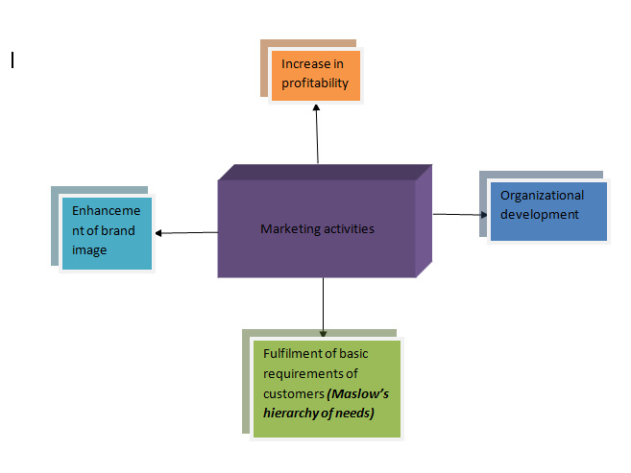
Figure 1: Conceptual framework
(Source: Wrenn and Mansfield, 2014, p.25)

Maslow’s Hierarchy of needs: As per this theory, basic requirements of customers targeted have to be fulfilled at first so as to go to the higher level of accomplishing requirements. In addition, as per Maslow’s view, every business organization must maintain the basic criteria of customers such as cheap price as well as providing best quality services on time in order to capture the existing market scenario effectively. Thereafter, it needs to focus on higher level of requirements such as exceeding customer expectations and providing fast delivery service. In words of Fallatah and Syed (2018, p.27), such beneficial factors can help in maintaining effective operational process of an organization as well as enhancing goodwill in the competitive market.
Modern Marketing Model: As per marketing model, proper way of planning and targeting customers are essential in case of starting a business in the competitive market. As cited by Filatotchev and Bruton (2017, p.605), by following that right way of executing performance is another important aspect in enhancing the business process. Due to which measurement of data as well as fulfilment of customer intention and establishment of marketing communication are dependent fully on executing a better performance. Moreover, appropriate marketing strategy can help in fulfilling customer requirements and enhancing the business profitability. Finally, analysis of market orientation is significant factor in case of maintaining whole circular process as well as enlarging whole infrastructure.
Critical analysis of the importance of marketing for enabling an organization maintain a sustainable position
Marketing is a monumental piece for the management group of an organization due to supporting the generation of analyzing tools to fulfil customer intention as well as maintaining brand recognition in the competitive market. In addition, effective way of growing business process is fully dependent upon successful marketing. As stated by Wrenn and Mansfield (2014, p.25), in this context, it can be demonstrated that business prosperity lies in its marketing process by which different factors such as customer relationship as well as product promotion and sales can be covered in an effective way.
For many entrepreneurs, marketing is not envisaged as a momentous part which is the biggest problem. This is because every business organization must consult with extremely artistic and anxious competitors willing to capture competitive market. In words of Davcik and Sharma (2016, p.5549), therefore, it will help them in maintaining strategic business plan into the operational process as well as achieving competitive advantage.
Henceforth, it can be described that proper way of taking the advantages of marketing really helps to maintain strong relationship and better collaboration with stakeholders as well as product promotion which are most significant piece in case of achieving leading position.

CHAPTER 3: RESEARCH DESIGN AND METHODOLOGY
The current research involves use of positivism philosophy along with the deductive approach and descriptive design (Saunders et al. 2009, p.52).
As per the view of Grimpe et al. (2015, p.23), positivism research philosophy indicates that factual knowledge can be gained through the ways of observing the relation between adoption of marketing strategy and development level of organisation. It helps in understanding the factors which may help to achieve definite goals and objectives. The researcher has emphasised on gathering of information through actual facts and proper observation.
As opined by Kothari (2004, p.22), for the effective completion of the research the researcher has chosen deductive approach in order to understand properly the purport of marketing for the organization and analyze major issues without embedding marketing strategy into business process.
Moreover, deductive approach has been considered by the researcher by following all scholars’ theory based on the magnitude of marketing for the retail company and then final result has been declared after observing properly (V Seixas et al. 2017, p.42). Descriptive approach has been exercised for discussing the obtained information regarding purport of marketing and its impact on organization in a descriptive way as well as evaluating the result in a meaningful way.
As the preferred research strategy, the researcher has chosen primary research method so as to gather different views based on current business scenario and marketing strategy of the organization by conducting a survey among a group of employees. In addition, it might help the researcher in describing the evidence based result.
In this research paper the profitability sampling research has been used to select 60 employees of the organization. The researcher has followed random sampling method at time of selecting the respondents to be survey for sole purpose of avoiding generation of biased outcome (Walliman, 2017, p.12).
Research Timeline
Activity | Week 1-2 | Week 3-4 | Week 5-6 | Week 7-8 | Week 9-10 | Week 11-12
Selection of topic
Review of literature
Identification of methods for research
Primary data collection
Analysis of collected data
Conclusion and Recommendation
Final submission

Figure 2: Gantt chart
(Source: V Seixas et al. 2017, p.42)
While conducting this research, the researcher has followed the ethical and moral principles. The researcher has ensured that the important information is kept secret and is not misused. In addition, the researcher has compiled with the guidelines of Data Protection Act 1988 in order to ensure that the ion is kept confidential. All essential data regarding the research topic is not manipulated and only the team members can access the information.
Thus, the research has been conducted by following thee positivism philosophy so as to define the factual results based on proper evidence. In addition, deductive approach is being used in the research method it helps to describe the reason of different issues within the organization.

CHAPTER 4: RESULT ANALYSIS AND DISCUSSION
Question 1: Do you agree to the fact that promotion of goods or services manufactured on part of Tesco play a vital role in upgrading its marketing activities?
Options | Respondents | % of respondents | Total respondents
Strongly Agree | 21 | 35 | 60
Agree | 29 | 47 | 60
Neutral | 6 | 10 | 60
Disagree | 4 | 8 | 60
Strongly Disagree | 0 | 0 | 60

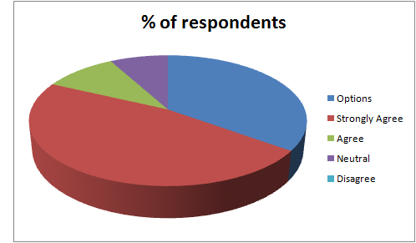
Figure 3: Response of employees of Tesco on importance of promotion of goods or services manufactured on its part
From the above result, it can be noticed that 47% of total respondents have given their view based on promotion of goods and services that play a vital role in enhancing organizational growth. Most people agreed with the decision due to considering that promotion of goods and services are the key reason of avoiding competitive threat (Baker, 2016, p.29). Whereas, 35% employees assume that customer relationship and better communication are the key reason of enhancing its marketing activities. This is because they assume customer relationship and better way of behaving with them by solving their queries related to product quality may be the reason of enlarging business process and enhancing marketing activities.
Question 2: What do you think is the most important marketing strategy in case of uplifting growth of the organisation?
Options | Respondents | % of respondents | Total respondents
Product promotion | 18 | 30 | 60
Maintaining customer relationship | 28 | 47 | 60
Delivering best quality product | 14 | 23 | 60

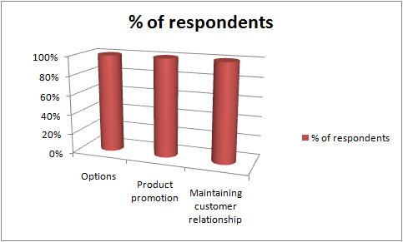
Figure 4: Response of employees of Tesco on importance of adoption of marketing strategy
As evident from collected data, 47% respondents out of total respondents have shown their view on the basis of effective relationship with customers and strong collaboration with stakeholders. The fast and foremost thing is that maintenance of good relationship with stakeholders of the organization so as to develop the organizational growth (McDonald and Wilson, 2016, p.43). With addition to that those employees have described that proper way of understanding the concept of marketing and embedding key strategy into business process may help to establish better communication. Maximum number of people have discussed that marketing primarily indicates to establishment of better communication based on which other major factors such as product promotion and customer satisfaction are dependent (as influenced by Filatotchev et al. 2017, p.605) On the other hand, some employees think that marketing indicates to product promotion and best quality product delivery by which good communication can be built up with company stakeholders.
Question 3: In which area of the organization marketing bears strong impact on?

Options | Respondents | % of respondents | Total respondents
Competitive advantage | 12 | 20 | 60
Revenue generation | 26 | 44 | 60
Brand image | 22 | 36 | 60

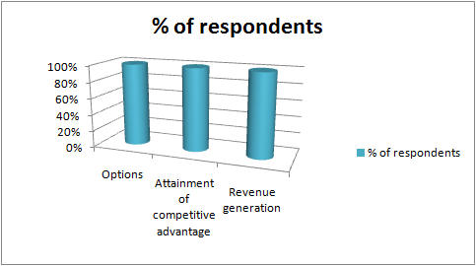
Figure 5: Response of employees of Tesco on major impact of marketing activities
From the above table, it can be deduced that majority of the employees working for Tesco are of the opinion that implementation of appropriate marketing strategies tend to be of great help to generate revenue as per level expected (Baker, 2014, p.8). This is followed by access to better brand image and attainment of a competitive advantageous position.

CHAPTER 5: CONCLUSION AND RECOMMENDATIONS
The senior heads of several department of the organization as well as hierarchical authority of the organization must focus on market demand based on the product quality and delivery service so as to take competitive advantage. In addition to that the company needs to discuss with other business organization that already uses strategic business plan into the business process so as to gather concept regarding effective growth (Einstein et al. 2016, p.22). Therefore, it may help in avoiding competitive threat by providing innovative strategy into the business process as well as changing the whole infrastructure. Moreover, the hierarchical authority of the organization needs to maintain good relationship with stakeholders so as to improve the affected area by discussing with them about issues (Fallatah and Syed, 2018, p.25). Apart from this, marketing indicates to a process involving customer relationship and delivering best quality product due to which Tesco needs to focus more on marketing concept so as to achieve leading position in the competitive market of UK. Therefore, a good quality training has to be provided to all employees so as to understand them about the basic concept of marketing and its positive impact on major area of the organization.
Thus, it may be concluded that proper way of understanding the concept of marketing might help in enlarging whole infrastructure as well as enhancing brand reputation in competitive market. Adoption of marketing strategies on part of Tesco can be seen to be of great help in enlarging whole infrastructure as well as capturing the market position in emulative market of UK. In addition, the retail company faces diverse issues due to not sighting on appropriate marketing strategy as well as customer intention rather than sighting only on net operating income.

REFERENCE LIST
Baker, M.J., (2014). Marketing strategy and management. Macmillan International Higher Education: London
Baker, M.J., 2016. What is marketing?. In The Marketing Book(pp. 25-42). Routledge: Abingdon.
Davcik, N.S. and Sharma, P., (2016). Marketing resources, performance, and competitive advantage: A review and future research directions. Journal of Business Research, 69(12), pp.5547-5552.
Einstein, A., Addams, J. and Roosevelt, E., (2016). Maslow's hierarchy of needs.
Fallatah, R.H.M. and Syed, J., (2018). A Critical Review of Maslow’s Hierarchy of Needs. In Employee Motivation in Saudi Arabia (pp. 19-59). Palgrave Macmillan, Cham.
Filatotchev, I., Su, Z. and Bruton, G.D., (2017). Market Orientation, Growth Strategy, and Firm Performance: The Moderating Effects of External Connections—ADDENDUM. Management and Organization Review, 13(3), pp.603-609.
Grimpe, C., Sofka, W., Bhargava, M. and Chatterjee, R., (2015). Novel but too complex? The importance of marketing innovation for new product performance. In The DRUID Society Conference 2015.
Kothari, C. R. (2004). Research methodology: Methods and techniques. New Age International: India
McDonald, M. and Wilson, H., (2016). Marketing Plans: How to prepare them, how to profit from them. John Wiley & Sons: New Jersey.
Saunders, M.N.K., Thornhill, A. & Lewis, P. (2009). Research Methods for Business Students, 5th edition. Pearson education: New York City, New York, United States
tesco.com. (2018). TESCO. Available at : https://www.tesco.com/ [Accessed on 16 August 2018]
V Seixas, B., Smith, N. and Mitton, C., (2017). The qualitative descriptive approach in international comparative studies: using online qualitative surveys. International Journal of Health Policy and Management.
Walliman, N., (2017). Research methods: The basics. Routledge: Abingdon
West, D.C., Ford, J. and Ibrahim, E., (2015). Strategic marketing: creating competitive advantage. Oxford University Press, USA.
Wrenn, B. and Mansfield, P.M., (2014). Marketing planning guide. Routledge: Abingdon.

APPENDIX: SURVEY QUESTIONNAIRE
Question 1: Do you agree to the fact that promotion of goods or services manufactured on part of Tesco play a vital role in upgrading its marketing activities?
- Strongly Agree
- Agree
- Neutral
- Disagree
- Strongly Disagree
Question 2: What do you think is the most important marketing strategy in case of uplifting growth of the organisation?
- Product promotion
- Maintaining customer relationship
- Delivering best quality product
Question 3: In which area of the organization marketing bears strong impact on?
- Attainment of competitive advantage
- Revenue Generation
- Brand image

