University of Wales Trinity Saint David

Data Handling & Business Intelligence (LCBB5000)

Assessment 2- FEB 2022

Student’s Name: Mr Radoslav Bozhkov
Student Number: 2010794

Professor’s Name: Miss Joy Botu

Part A 3
Excel uses for pre-processing 3
Excel uses for analysis 4
Excel uses for visualization 5
If condition 6
Pivot table 9
Percentage of each attribute according to the northern and southern region 12
Part B 13
Vanilla Flavor 13
Male and Female 14
Mean and Median 15
Clustering 16
Methods of data mining and text mining 18
Advantages and Disadvantages 19
References 21
Appendix 23

Part A

Excel uses for pre-processing
In this, the data which is available with the user is in the raw form so in this data lot of errors are there and for it, pre-processing is necessary as with the help of it cleaning of the data can be done and in excel there are many techniques available for it. When there are many outliers in the data where the values in the data which are given and some of the values are lying outside of it so for it there is the technique in the excel through which it can be eliminated which is the quartile function where the user can put the formula of it where the four quartiles are calculated separately and it can be known in which quartile the outliers are there and it can be eliminated from the data (Murphy, 2021).
In the available data there are many spaces in the data that is sometimes the respondents do not answer that data and that is left blank and for it, there is the function in the excel through which it can be known and can be left for the analysis by selecting all the data and going to f 5 key and pressing it so that in the dialogue box that opens select the blank so that all blank cells can be reflected. Also, the text which comes in the data can be sometimes improper that is some are in the capital and some in small so to get the text the same for all the data can be achieved with the help of lower, proper and upper cases there accordingly (Mishra, et.al., 2019).

Excel uses for analysis
The tool excel is very much useful in analysis because with the help of its analysis is needed to be done can be easily done with any kind of data which is available as it contains lots of functions for each kind of analysis that is needed to be done. For the analysis which is needed to be done using a hypothesis where assumptions are made in the study, it can be easily done with the help of solve in the tool which is there in the add on of excel and in its various kinds of test are there where the user just need to enter the data in the input range and select the range where the output is needed and the test options which are available in it are z test, regression, t-test, descriptive statistics and many more options (Brkić and Stajić, 2021).
The other option which makes it easy to analyse the data which are large in number is the option pivot table can be used where the data is reduced in size and the analysis of it can be done easily as this tool is having the option of the filter where the data which is needed is selected and the function which is needed to be performed in the data that is what kind of values are needed can be selected from the option which is there in both rows and columns like the average, sum and count and many more. Apart from it, the other functions which are there can be used like for calculating probability various formulas are there de[ending on kind of probability that is needed to be calculated, if the formula is also there where simple if a condition can be used or nested if where the formula is needed to be used in multiple rows or columns, sum if, count if and many other functions are available for the analysis in this software (Cosma, 2019).

Excel uses for visualization
To make the data attractive and easy for those people to understand the data who cannot understand the raw data which is made available to them the visualization plays a big role there and with the help of excel it can be done easily as it contains many options for it. For visualizing the data in this software simply select the data and go on insert and select the chart which is needed. In this software, there are many options of charts like histogram, column, bar, line, pie and many more and each chart is used according to the type of data which is needed for visualization. Another feature of it is that two or more charts can be used together which is known as a combination of charts to depict those data in which some relationships are there like the expenses, revenue and the profit generated by the firm (Díaz de los Ríos and Hernández).
The other feature of this tool is that discrimination of the data can be easily shown if the data is given of different periods like in its column, bar or any type of chart can be sue. Also, if the design of the chart is needed to change it can be done easily if in the background the colour is needed to change it can be done or if the graph is needed in the background, it can be done, also the colour of the graph can be changed easily and in there is an option of adding the labels which can be done, a trendline can also be shown, the title of the chart can also be shown and many other features are there through which the visualization can be done (Ramos, 2020).

If condition
Crime rate | Youth unemployment | IF
45.5 | 80 | high
52.3 | 135 | high
56.6 | 97 | high
60.3 | 135 | high
64.2 | 78 | low
67.6 | 77 | low
70.5 | 70 | low
73.2 | 114 | high
75 | 107 | high
78.1 | 99 | high
79.8 | 94 | high
82.3 | 124 | high
83.1 | 77 | low
84.9 | 84 | high
85.6 | 72 | low
88 | 100 | high
92.3 | 102 | high
94.3 | 78 | low
95.3 | 105 | high
96.8 | 108 | high
97.4 | 92 | high
98.7 | 73 | low
99.9 | 86 | high
103 | 76 | low
104.3 | 83 | high
105.9 | 113 | high
106.6 | 81 | high
107.2 | 84 | high
108.3 | 102 | high
109.4 | 89 | high
112.1 | 116 | high
114.3 | 97 | high
115.1 | 142 | high
117.2 | 111 | high
119.7 | 92 | high
121.6 | 76 | low
123.4 | 88 | high
127.2 | 83 | high
132.4 | 103 | high
135.5 | 130 | high
137.8 | 91 | high
140.8 | 87 | high
145.4 | 79 | low
149.3 | 96 | high
154.3 | 77 | low
157.7 | 102 | high
161.8 | 102 | high
Grand Total | 4487

Interpretation: The crime rate according to youth unemployment has been shown in which the condition which has been used to know if the crime that is taking place is due to low unemployment or high unemployment is given for which if the condition is used under which the condition which has been given is that if the unemployment rate is higher than 80 than it is considered higher and low than it is considered as lower. In the chart which is given is the line chart in which both the crime rate and youth unemployment are shown in which orange colour is of youth unemployment and the blue is of crime rate and form it can be observed that youth unemployment is fluctuating whereas crime rate is moving in the upward direction. The crime which is taking place more is due to more youth unemployment because only eleven conditions are there in which youth unemployment is lower and in all the conditions higher unemployment rate is there (Abdelwali, et.al., 2019).

Pivot table
Sum of Education | Column Labels
Row Labels | 0 | 1 | Grand Total
45.5 | 12.4 |  | 12.4
52.3 | 10.9 |  | 10.9
56.6 |  | 11.2 | 11.2
60.3 |  | 11.9 | 11.9
64.2 | 12.2 |  | 12.2
67.6 | 13.5 |  | 13.5
70.5 | 14.1 |  | 14.1
73.2 | 12.9 |  | 12.9
75 | 12.9 |  | 12.9
78.1 | 11.4 |  | 11.4
79.8 |  | 12.9 | 12.9
82.3 | 12.5 |  | 12.5
83.1 | 13.6 |  | 13.6
84.9 | 13.2 |  | 13.2
85.6 |  | 11.4 | 11.4
88 | 12.9 |  | 12.9
92.3 | 12.7 |  | 12.7
94.3 | 13.3 |  | 13.3
95.3 | 12 |  | 12
96.8 |  | 10 | 10
97.4 |  | 10.8 | 10.8
98.7 |  | 12.1 | 12.1
99.9 |  | 10.7 | 10.7
103 |  | 11 | 11
104.3 | 12.5 |  | 12.5
105.9 | 13.4 |  | 13.4
106.6 |  | 11.1 | 11.1
107.2 | 13.7 |  | 13.7
108.3 | 13.8 |  | 13.8
109.4 |  | 11.4 | 11.4
112.1 |  | 10.9 | 10.9
114.3 |  | 12.8 | 12.8
115.1 | 13.7 |  | 13.7
117.2 | 12.9 |  | 12.9
119.7 | 11.9 |  | 11.9
121.6 |  | 13.9 | 13.9
123.4 |  | 11.7 | 11.7
127.2 | 10.4 |  | 10.4
132.4 | 12 |  | 12
135.5 | 12.5 |  | 12.5
137.8 | 14.2 |  | 14.2
140.8 | 12 |  | 12
145.4 |  | 12.2 | 12.2
149.3 | 12.3 |  | 12.3
154.3 | 12.3 |  | 12.3
157.7 | 15.1 |  | 15.1
161.8 | 13.2 |  | 13.2
Grand Total | 396.4 | 186 | 582.4

Interpretation: In the pivot table and the column graph the crime rate has been shown in which the crime which is happening is shown according to the region which is northern and southern and from it can be inferred that the crime that is taking place more is in the northern region as the sum of it has come out to be 396.4 and in the southern region the sum is 186 which is half of it. Also, the lower crime rate which is 45.5 is in the northern region and also the higher crime rate which is 161.8 is in that region only where it is 12.4 and 13.2 respectively. Also, the columns are showcased above with one and two demonstrating the region northern and southern respectively (Ližbetinová, et.al., 2019).

Percentage of each attribute according to the northern and southern region
 |  | Northern | Southern
Youth | % | 63% | 37%
Education | % | 68% | 32%
ExpenditureYear0 | % | 72% | 28%
Labour Force | % | 68% | 32%
Males | % | 66% | 34%
More Males | % | 66% | 34%
State Size | % | 68% | 32%
Youth Unemployment | % | 67% | 33%
Mature Unemployment | % | 65% | 35%
High Youth Unemployment | % | 93% | 7%
Wage | % | 71% | 29%
Below Wage | % | 59% | 41%

Interpretation: The table which is showcased above is about the percentage share that each attribute is having in the northern and southern regions in which below wage is having the share of 59% in the northern region and all other variables in this region are having a share greater than 60% and the difference between expenditure year and wage is of one only as the share of them are 72% and 71% respectively. In the southern region, only two variables are having a percentage share of less than 30% which are high youth unemployment with a share of 7% and wage having a share of 29% respectively (Er Kara and Oktay Fırat, 2018).

Part B

Vanilla Flavor

ice_cream
 |  | Frequency | Percent | Valid Percent | Cumulative Percent
Valid | vanilla | 95 | 47.5 | 47.5 | 47.5
Valid | chocolate | 47 | 23.5 | 23.5 | 71.0
Valid | strawberry | 58 | 29.0 | 29.0 | 100.0
Valid | Total | 200 | 100.0 | 100.0

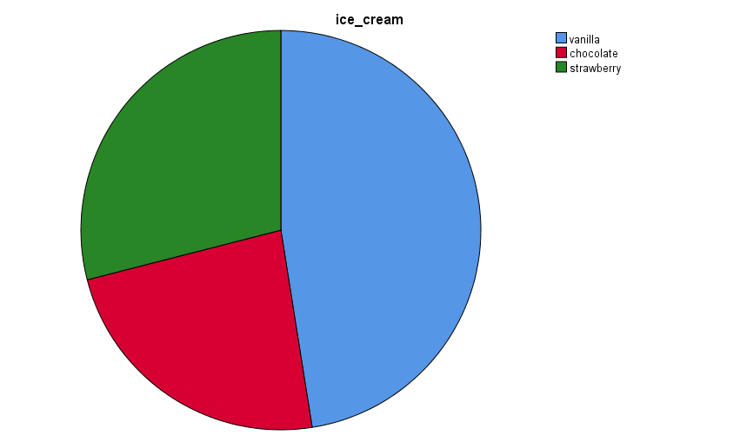

Interpretation: The number of students who are loving the flavour of vanilla in the ice cream is 95 which can be observed from the pie chart and the table which are depicted above and they form 47.5 per cent of the students (Cường, 2018).

Male and Female

female
 |  | Frequency | Percent | Valid Percent | Cumulative Percent
Valid | male | 91 | 45.5 | 45.5 | 45.5
Valid | female | 109 | 54.5 | 54.5 | 100.0
Valid | Total | 200 | 100.0 | 100.0

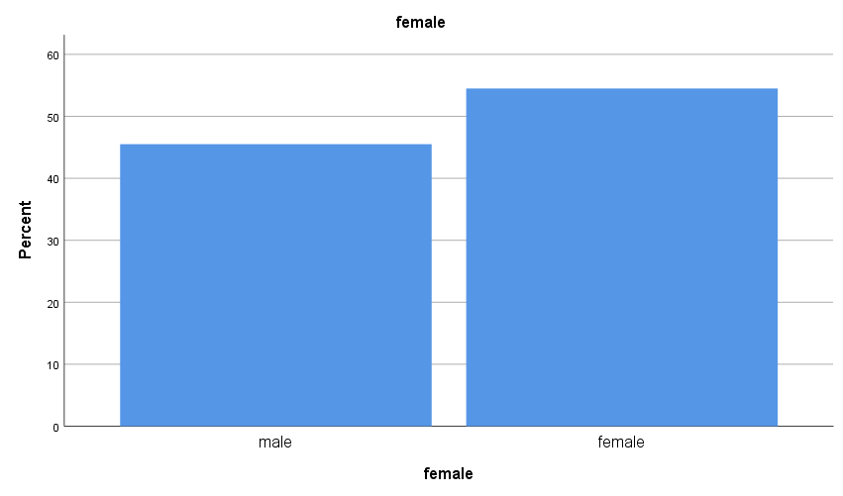

Interpretation: The gender which participated more in the survey was female as they were 109 in number and male were 91 in number and percentage terms female were 54.5 per cent and 45.5 were males (Weissgerber, et.al., 2019).

Mean and Median

Statistics
ice_cream
N | Valid | 200
N | Missing | 0
Mean |  | 1.82
Median |  | 2.00

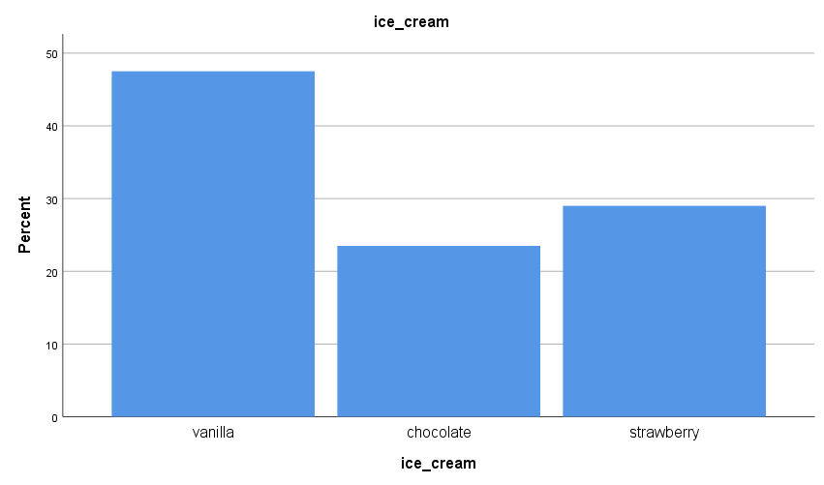

Interpretation: In the ice cream the mean and median of the two flavours which are chocolate and strawberry are respectively 1.82 and 2.00 which the difference is very low and it refers that the data is there in these two are distributed equally (Mahajan and Gokhale, 2019).

Clustering

Initial Cluster Centers
 | Cluster
 | 1 | 2
female | 0 | 0
video | 26 | 74

Iteration History
Iteration | Change in Cluster Centers
Iteration | 1 | 2
1 | 17.043 | 14.647
2 | .170 | .158
3 | .000 | .000
a. Convergence achieved due to no or small change in cluster centres. The maximum absolute coordinate change for any centre is .000. The current iteration is 3. The minimum distance between initial centres is 48.000.

Final Cluster Centers
 | Cluster
 | 1 | 2
female | 1 | 0
video | 43 | 60

Number of Cases in each Cluster
Cluster | 1 | 94.000
Cluster | 2 | 106.000
Valid |  | 200.000
Missing |  | .000

Interpretation: In the tables which are depicted above the result of clustering has been shown in which k means clustering has been done and in the initial cluster centre cluster one is having 26 values in video and in cluster two the values are 74 in the video. From the iteration history table, it can be observed that changes in the value of cluster centre are given in which the highest change is from one to one and two to two and the values in them are respectively 17 and 14. In the final cluster centre, the values are given after the iteration of the values has been done in which female is having a value of one in cluster one and zero in cluster two and video is having a value of 43 in cluster one and 60 in cluster two. The number of cases which are there in each cluster is 94 and 106 in clusters one and two respectively (Dakhil, Ali and Reda, 2018).

Methods of data mining and text mining
Data mining
- Association: This method is used to find the relationship between two or more variables which are there in the data and it is mainly done with the help of correlation analysis as with the help of it the hidden patterns can be traced in the data and this mining technique is used in the business mainly by the managers of the marketing so that they can run sales promotion with the help of it by predicting what is purchase by the customers together.
- Prediction: In this technique, the prediction is done with the help of the data which are available at the moment that is the past and the present to know what will be there in the future and for it mainly the regression analysis is used where independent variables are kept of past and present and dependent is future and in business, it is done to predict the sales of future so that production department is ready with that figure (Murphy, 2021).
Text mining
- Extraction of information: In this, the information which is there is in the raw form and to get the meaningful insight from it the extraction is done so that it can be known what the attributes are about and the relationship of them can be known so that the method of analysis can also be known for that data.
- Categorization: With this method, the categories are assigned to the data which is available so that it can be known what each category is about and the analysis can be performed according to it in business companies use this to identify the types of customers and send them message accordingly (Mishra, et.al., 2019).

Advantages and Disadvantages
SPSS
Advantages | Disadvantages
- In this tool, the data which is chosen for analysis can be imported from other tools which are used for analysis which makes it easy for the researcher to get the data easily as time is saved if this feature was not there then the data from that software needed to be manually entered by them. | - This tool is suitable for those persons only who know statistics and also know how to use this tool as without proper training working on this tool takes time and so it is necessary to get the training before starting this tool to know all the features that this tool is offering.
- The feature of it is that data can be entered manually in it where the user first needs to define the variable in the variable view which makes it easy for them to enter the data as they know in which field what data is needed to be entered as its data view is similar to the spreadsheet where rows and columns are there. | - In it, the software is not accessible to everyone because it is not open source and for it, the price is needed to be paid which is very high and so it is not accessible because everyone cannot afford it (Brkić and Stajić, 2021).

Excel
Advantages | Disadvantages
- In this tool, the analysis which is done is easy because here the sheet is very organised and referring to it becomes easy as every cell which is there in this sheet has its unique name like g1, a2 and many more so it becomes easy for anyone using the sheet for editing to refer those cells with their names and also if multiple sheets are there than the name can be provided to them according to user’s choice. | - Under it, various formulas are there for every mathematical or statistical function that is needed to be performed and for it syntax of every function is different and knowing all those requires a certification or training from persons knowing it so that it becomes for the user to analyses the data.
- The other feature of this tool is that if the same calculations are needed to be performed in each row or column then it is not necessary to write a formula in each column because there are two kinds of referencing it which are absolute and relative and with the help of them the cell in which formula is dragged. | - The security of this tool is very low and the data can be easily hacked which results in less use of this tool when the analysis is needed to be done of very sensitive data as if that data is leaked it will result in a loss for that firm (Cosma, 2019).

References
- Abdelwali, H.A., Swilem, S.M., El Shiaty, R. and Murad, M.M., 2019. Solving a transportation problem actual problem using Excel Solver. International Journal of Engineering and Technical Research (IJETR), 9(12), pp.2454-4698. https://www.academia.edu/download/63098472/IJETR283720200426-91929-1ausv6d.pdf
- Brkić, D. and Stajić, Z., 2021. Excel VBA-Based User Defined Functions for highly precise Colebrook’s pipe flow friction approximations: A comparative overview. Facta Universitatis, Series: Mechanical Engineering, 19(2), pp.253-269. http://casopisi.junis.ni.ac.rs/index.php/FUMechEng/article/view/7267
- Cosma, E., 2019. Pivot Table: A Tool to Calculate, Summarize, and Analyze Data. Ovidius University Annals, Economic Sciences Series, 19(1), pp.161-166. https://stec.univ-ovidius.ro/html/anale/RO/wp-content/uploads/2019/08/5-2.pdf
- Cường, V.H., 2018. Managing the kindergarten school using Microsoft Excel. International Journal of Advanced Research in Computer Engineering & Technology (IJARCET), 7(12). https://www.academia.edu/download/63163836/IJARCET-VOL-7-ISSUE-12-812-81720200501-74865-oa3rkb.pdf
- Dakhil, F.A., Ali, W.M. and Reda, A.A.A., 2018. Prioritizing software capabilities and focal points of MS Access and Excel in perspective of data management. Applied Computer Science, 14(3). https://yadda.icm.edu.pl/yadda/eleme nt/bwmeta1.element.baztech-84833171-cecf-4f3c-97af-682f52280810
- Díaz de los Ríos, M. and Hernández Ramos, E., 2020. Determination of the Hansen solubility parameters and the Hansen sphere radius with the aid of the solver add-in of Microsoft Excel. SN Applied Sciences, 2(4), pp.1-7. https://link.springer.com/article/10.1007/s42452-020-2512-y
- Er Kara, M. and Oktay Fırat, S.Ü., 2018. Supplier risk assessment based on best-worst method and K-means clustering: a case study. Sustainability, 10(4), p.1066. https://www.mdpi.com/278900
- Ližbetinová, L., Štarchoň, P., Lorincová, S., Weberová, D. and Průša, P., 2019. Application of cluster analysis in marketing communications in small and medium-sized enterprises: An empirical study in the Slovak Republic. Sustainability, 11(8), p.2302. https://www.mdpi.com/447056
- Mahajan, K. and Gokhale, L.A., 2019. Advanced Charting Techniques of Microsoft Excel 2016 Aiming Visualization. International Journal of Computer Sciences and Engineering (IJCSE), 7. https://www.researchgate.net/profile/Kirti-Mahajan/publication/332115080_Advanced_Charting_Techniques_of_Microsoft_Excel_2016_Aiming_Visualization/links/5fe46a0c45851553a0e75a6c/Advanced-Charting-Techniques-of-Microsoft-Excel-2016-Aiming-Visualization.pdf
- Mishra, P., Pandey, C.M., Singh, U., Gupta, A., Sahu, C. and Keshri, A., 2019. Descriptive statistics and normality tests for statistical data. Annals of cardiac anaesthesia, 22(1), p.67. https://www.ncbi.nlm.nih.gov/pmc/articles/PMC6350423/
- Murphy, K.R., 2021. In praise of table 1: The importance of making better use of descriptive statistics. Industrial and Organizational Psychology, 14(4), pp.461-477. https://www.cambridge.org/core/journals/industrial-and-organizational-psychology/article/in-praise-of-table-1-the-importance-of-making-better-use-of-descriptive-statistics/F11F114F1B5E26AACF8F1AF3C36F1EDE
- Weissgerber, T.L., Winham, S.J., Heinzen, E.P., Milin-Lazovic, J.S., Garcia-Valencia, O., Bukumiric, Z., Savic, M.D., Garovic, V.D. and Milic, N.M., 2019. Reveal, don’t conceal: transforming data visualization to improve transparency. Circulation, 140(18), pp.1506-1518. https://www.ahajournals.org/doi/abs/10.1161/CIRCULATIONAHA.118.037777

Appendix

