Luke Morgan
2413884
COnstruction technology
Assignment 1

Contents
Introduction 2
Site Conditions 2
Location 2
Climate 2
Ground Conditions 3
Structure and foundation 3
Structural requirements 3
Structure Frame 4
Suitable Frame 4
Foundation 5
Pile Calculations 6
What size pile is sufficient to hold the live weight of the hotel? 6
Building envelope 7
Performance requirements 7
Wall construction 7
Roof construction 7
Window and Panes. 8
Prefabrication 8
Advantages of Prefabrication 8
Prefabrication Elements 8
On-site construction 8
Fire Safety 8
Structural Resistance 9
Compartmentation 9
Means of Escape 9
Fire Systems 9
Sustainability and Environmental Impact 9
Conclusion 10
reference list 11
Advantages and Disadvantages 12
Reference List 13

Introduction
The development of a medium- to high-rise hotel requires careful integration of construction technology, structural engineering, building physics, fire safety, and sustainability principles. Unlike low-rise developments, taller buildings introduce additional challenges such as increased wind loading, more complex fire strategies, greater structural demands, and higher expectations in terms of durability and energy performance. This report has been prepared to guide an inexperienced client through these complexities and to justify appropriate construction solutions for a proposed hotel development in Swansea, close to Singleton Hospital.
The proposed hotel is assumed to be between 10 and 14 storeys in height, placing it within the medium-to-high-rise category. Such buildings typically accommodate a large number of occupants, many of whom may be unfamiliar with the building layout and emergency procedures. As a result, safety, resilience, and reliability must be prioritised in both design and construction.
This report focuses on three key areas requested by the client:
- Structural frame and foundations suitable for local ground conditions
- Building envelope materials and construction methods
- The balance between prefabrication and traditional on-site construction
Throughout the report, consideration is given to design quality, structural strength, stability, fire safety, aesthetics, and environmental sustainability. References are made to UK Building Regulations and recognised industry guidance to ensure that the proposed solutions align with best practice.

Site Conditions

Location
The proposed site is located near Singleton Hospital in Swansea, within a mixed-use urban environment. The surrounding area includes healthcare facilities, residential developments, university buildings, and supporting infrastructure. This context suggests that the introduction of a medium- to high-rise hotel would be appropriate, provided that the building massing, height, and façade design are carefully considered to integrate with the surrounding urban fabric.
The proximity to a major hospital places additional constraints on the construction process. Noise, vibration, dust, and traffic disruption must be minimised to avoid interference with hospital operations. These factors influence construction methodology, particularly the choice of foundation systems and the increased use of prefabricated components to reduce on-site activity.

Climate
Swansea has a maritime climate, heavily influenced by its coastal location. Key characteristics include:
- High levels of annual rainfall
- Frequent strong winds, predominantly from the south-west
- Mild winters and relatively cool summers
For a tall building, wind loading becomes a dominant design consideration. Wind pressure increases with height, resulting in significant lateral forces acting on the structure. These forces influence the selection of the structural frame, the need for a stiff stability system, and the detailing of the building envelope to prevent water ingress and air leakage.
Wind-driven rain is particularly problematic in coastal locations. Rain can be forced horizontally or upwards against building façades, increasing the risk of water penetration. As a result, the envelope must be robust, well-detailed, and capable of managing moisture effectively over the building’s lifespan.

Ground Conditions
Although detailed ground investigation data is not available at this stage, regional geological information suggests that ground conditions in coastal Swansea may include:
- Made ground from previous development
- Alluvial deposits or soft clay layers
- A relatively high groundwater table
Such conditions are typically unsuitable for shallow foundations supporting heavy multi-storey buildings. Shallow foundations could experience excessive settlement or differential movement, leading to structural damage and serviceability issues. Consequently, deep foundations capable of transferring loads to more competent strata are generally required for buildings of this scale.

Structure and foundation

Structural requirements
Hotel buildings impose a range of structural demands. In addition to supporting vertical loads from the self-weight of the structure and imposed loads from occupants and furniture, the frame must resist significant lateral forces from wind. Structural robustness is essential to prevent disproportionate collapse and to ensure long-term durability. Hotels also require repetitive layouts and good acoustic separation between floors and rooms.Vertical loads from the self-weight of the building
- Imposed loads from occupants, furniture, and services
- Lateral loads from wind
- Dynamic effects such as vibration
Additionally, hotels require repetitive room layouts, good acoustic separation between rooms, and long-term durability. Structural robustness is also essential to prevent disproportionate collapse in the event of accidental damage or fire.

Structure Frame
• Steel frame: Steel frames are lightweight and can be erected quickly. They allow long spans and flexible internal layouts, making them suitable for hotels. However, steel requires applied fire protection and may require additional bracing or cores to achieve sufficient stiffness for taller buildings
• Reinforced concrete frame: Concrete frames provide excellent fire resistance, stiffness, and acoustic performance. However, they are heavier than steel frames, increasing foundation loads, and typically require longer construction programmes due to curing times.
• Hybrid system: This system combines a reinforced concrete core with steel framing, offering a balance between stiffness, speed of construction, and flexibility.
Advantages | Disadvantages
Strength to weight ratio | Expensive
Efficient construction | Low fire resistance
Adaptability | Corrosion
Sustainable | High carbon footprint
Recyclable therefore sustainable | Not soundproof
Concrete framed buildings
Advantages | Disadvantages
Fire resistance | Non efficient construction
Wind resistant | High costs due to labour
Unique design | High carbon footprint
Long lifespan | Cracking issues
High strength

Suitable Frame
I would recommended a hybrid structural system for the Swansea hotel.
The reinforced concrete core houses stairwells, lift shafts, and service risers and acts as the primary lateral stability system. Concrete’s inherent mass and stiffness make it highly effective at resisting wind loads and limiting building sway, improving occupant comfort at upper levels.
The surrounding steel frame supports vertical loads and allows longer spans, reducing the number of internal columns and enabling flexible room layouts. Composite metal deck floors with an in-situ concrete topping are recommended, providing efficient structural performance and good acoustic separation between floors.
.

Foundation
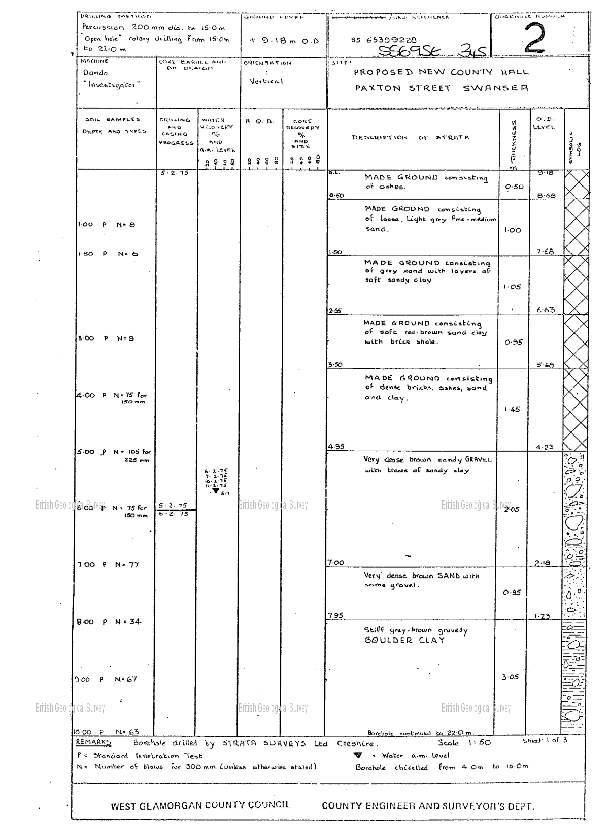
Given the ground conditions from the borehole log above, bored reinforced concrete piles are recommended. Bored piles generate minimal noise and vibration during installation, which is particularly important given the site’s proximity to Singleton Hospital.
A piled raft foundation may be used to distribute loads more efficiently, reduce the number of piles required, and improve settlement performance.

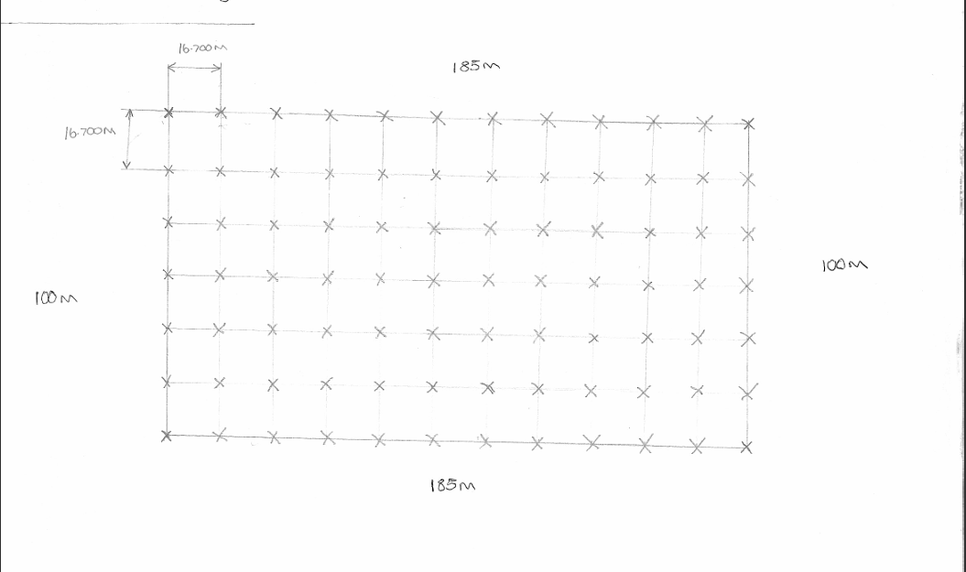

Pile Calculations
“Looking at other same size hotels this building would have an estimated weight of 12,950 tonne, looking at my drawing above I have specified there to be a pile every 16.7m vertically and horizontally starting from the corners of the structure in total I have specified there to be 84 piles in total. To work out the load on each of the piles I would need to do the following: 12,950/84 = 154.17 tonne” Luke Morgan, 2024, Fundamentals Assignment.

What size pile is sufficient to hold the live weight of the hotel?
“After understanding and analysing the table we can agree that we will need to have 84 piles where all of them would have a recommended max structural axial working load of at least 154.17 tonne. By using the table above we would be able to use a 450mm in diameter pile but given the height of the building and also the terrible ground conditions seen on the bore hole I will highly suggest using a 500mm diameter pile by doing this we will then ensure our building will easily meet the requirements, which will then be checked over by building control. By using a 500mm diameter pile we will have a max load of 18,060 ton (215ton x 84 piles). The other reason to be using a bigger pile and having a higher max load is so we can account for the extra weight such as live weight, doors and bathrooms.” Luke Morgan, 2024, Fundamentals Assignment.

Building envelope

Performance requirements
The building envelope must perform several critical functions:
- Protect the interior from wind and rain
- Provide thermal insulation and energy efficiency
- Offer acoustic separation from external noise
- Provide fire resistance
- Remain durable in a coastal environment
The building envelope must protect the interior from wind and rain, provide thermal and acoustic insulation, resist fire spread, and remain durable in a coastal environment. Compliance with the Building Regulations, particularly Approved Documents B and L, is essential.

Wall construction
Typical wall build-up:
- N A ventilated rainscreen cladding system fixed to a steel frame system (SFS) backing wall is recommended.
- Typical wall build-up:
- Non-combustible rainscreen panels (aluminium or fibre cement)
- Ventilated cavity
- Breather membrane
- Insulated SFS backing wall
- Vapour control layer
- Internal plasterboard lining
- Rainscreen systems are particularly suitable for coastal locations because the cavity allows wind-driven rain to drain and evaporate, reducing moisture penetration.
A ventilated rainscreen cladding system fixed to a steel frame system backing wall is recommended. The typical build-up includes non-combustible rainscreen panels, a ventilated cavity, a breather membrane, an insulated SFS wall, a vapour control layer, and internal plasterboard. This system is well suited to wet and windy climates, as the cavity allows wind-driven rain to drain and evaporate, reducing moisture penetration.

Roof construction
A warm flat roof system is proposed, with insulation placed above the structural deck. This reduces condensation risk, improves thermal continuity, and simplifies detailing.

Window and Panes.
High-performance aluminium-framed double or triple glazing with low-emissivity coatings is recommended. Acoustic glazing should be used on elevations exposed to traffic noise to improve guest comfort.

Prefabrication

Advantages of Prefabrication
Prefabrication offers significant advantages in terms of quality control, speed of construction, reduced waste, and improved health and safety. These benefits are particularly valuable on constrained urban sites.
Prefabricated elements recommended for the hotel include bathroom pods, precast stair flights, structural steel components, and potentially unitised façade panels. Bathroom pods are especially suited to hotel developments due to repetitive layouts and the need for consistent quality.
On-site construction will still be required for piled foundations, the reinforced concrete core, and final assembly and finishes. A hybrid approach combining off-site manufacture with efficient on-site assembly is therefore recommended

Prefabrication Elements
Recommended prefabricated components include:
- Fully fitted bathroom pods
- Precast stair flights
- Structural steel elements
- Unitised façade panels (where feasible)
Bathroom pods are particularly suited to hotel developments due to repetitive layouts.

On-site construction
Elements requiring on-site construction include:
- Piled foundations
- Reinforced concrete core (constructed using jumpform or slipform techniques)
- Final assembly and finishes

Fire Safety
Fire safety is a critical consideration in medium- to high-rise hotel buildings due to high occupancy levels, sleeping accommodation, and occupants’ unfamiliarity with escape routes. The proposed fire strategy integrates passive fire protection, active fire systems, and management procedures.
A stay-put strategy with phased evacuation is proposed. Under this approach, occupants in the room of fire origin evacuate immediately, while others remain in place unless instructed otherwise. This strategy relies on robust compartmentation and fire-resistant construction.
The reinforced concrete core provides up to 120 minutes fire resistance, protecting stairwells and firefighter access routes. Steel elements are protected using intumescent coatings or fire-resistant boards. Individual hotel rooms form separate fire compartments, with a minimum of 60 minutes fire resistance between rooms and floors. Fire-stopping at service penetrations prevents hidden fire spread.
Means of escape include a minimum of two protected stair cores, emergency lighting, illuminated signage, and fire-resisting self-closing doors. Active fire protection systems include automatic sprinklers, fire detection and alarm systems, wet risers, firefighter lifts, and smoke control systems. The rainscreen façade uses non-combustible materials with cavity barriers and fire-stopping to prevent external fire spread.

Structural Resistance
The reinforced concrete core provides up to 120 minutes fire resistance, protecting stairwells and firefighter access routes. Steel elements are protected using intumescent coatings or fire-resistant boards.
The structure is designed to resist disproportionate collapse in accordance with Approved Document A.

Compartmentation
- Individual hotel rooms act as fire compartments
- Floors and walls provide a minimum of 60 minutes fire resistance
- Fire-stopping at service penetrations prevents hidden fire spread

Means of Escape
- Minimum of two protected stair cores
- Remote stair separation
- Emergency lighting and signage
- Fire-resisting self-closing doors

Fire Systems
- Automatic sprinkler system throughout
- Fire detection and alarm system
- Firefighter lifts and wet risers
- Smoke control systems

Sustainability and Environmental Impact
Sustainability is addressed through material selection, energy efficiency, and construction methods. Steel is fully recyclable, while concrete mixes can incorporate ground granulated blast-furnace slag to reduce embodied carbon. High levels of insulation and airtightness reduce operational energy demand, while air source heat pumps and potential rooftop photovoltaic panels further improve performance.
Prefabrication reduces construction waste, noise, and site disturbance, supporting environmental objectives and reducing impact on neighbouring buildings.
- Steel is fully recyclable
- Concrete mixes can include GGBS to reduce embodied carbon
- High-performance insulation and airtightness reduce energy demand
- Air source heat pumps and rooftop photovoltaics may be incorporated

Conclusion
This report has identified and justified appropriate construction technologies for a proposed medium- to high-rise hotel development near Singleton Hospital in Swansea, taking into account local environmental conditions, structural performance, fire safety, buildability, and sustainability. The assessment of site constraints and ground conditions indicates that bored piled foundations provide a safe and low-risk solution, particularly given the proximity to sensitive neighbouring uses. A hybrid structural system comprising a reinforced concrete core and steel frame offers an optimal balance of stability, inherent fire resistance, and construction efficiency, while supporting flexible hotel layouts. The proposed building envelope, incorporating a non-combustible rainscreen façade, warm roof construction, and high-performance glazing, responds effectively to Swansea’s coastal climate and regulatory requirements. Fire safety is addressed through robust compartmentation, protected escape routes, and integrated active fire protection systems suitable for sleeping accommodation. The selective use of prefabrication enhances quality, reduces programme duration, and improves overall environmental performance, resulting in a safe, durable, and sustainable hotel development.

reference list

Anderson, J. (2013) Rainscreen Cladding Systems. London: BRE Press. Available at: https://www.brebookshop.com (Accessed: 8 January 2026).
BRE (2018) Fire Performance of External Wall Systems. Watford: Building Research Establishment. Available at: https://www.bre.co.uk (Accessed: 8 January 2026).
Chudley, R. and Greeno, R. (2020) Building Construction Handbook. 12th edn. London: Routledge. Available at: https://www.routledge.com (Accessed: 8 January 2026).
CIRIA (2020) Fire Safety in Tall Buildings (C758). London: Construction Industry Research and Information Association. Available at: https://www.ciria.org (Accessed: 8 January 2026).
Emmitt, S. and Gorse, C. (2019) Barry’s Introduction to Construction of Buildings. 4th edn. Chichester: Wiley Blackwell. Available at: https://www.wiley.com (Accessed: 8 January 2026).
HM Government (2019) Approved Document B: Fire Safety – Volume 2: Buildings Other Than Dwellinghouses. London: HMSO. Available at: https://www.gov.uk/government/publications/fire-safety-approved-document-b (Accessed: 8 January 2026).
HM Government (2021) Approved Document L: Conservation of Fuel and Power. London: HMSO. Available at: https://www.gov.uk/government/publications/conservation-of-fuel-and-power-approved-document-l (Accessed: 8 January 2026).
Lawson, R.M., Ogden, R.G. and Goodier, C.I. (2014) Design in Modular Construction. Boca Raton: CRC Press. Available at: https://www.routledge.com (Accessed: 8 January 2026).
MacGinley, T.J., Choo, B.S. and Gong, L. (2017) Structural Steelwork Design to Eurocode 3. 2nd edn. Oxford: Butterworth-Heinemann. Available at: https://www.elsevier.com (Accessed: 8 January 2026).
Tomlinson, M. and Woodward, J. (2015) Pile Design and Construction Practice. 6th edn. Boca Raton: CRC Press. Available at: https://www.routledge.com (Accessed: 8 January 2026).

Advantages and Disadvantages
Steel framed buildings
Advantages | Disadvantages
Strength to weight ratio | Expensive
Efficient construction | Low fire resistance
Adaptability | Corrosion
Sustainable | High carbon footprint
Recyclable therefore sustainable | Not soundproof
Concrete framed buildings
Advantages | Disadvantages
Fire resistance | Non efficient construction
Wind resistant | High costs due to labour
Unique design | High carbon footprint
Long lifespan | Cracking issues
High strength

Reference List
(2009). https://theskydeck.com/wp-content/uploads/2019/03/The-Hows-Whats-and-Wows-of-Willis-Tower-A-Guide-For-Teachers.pdf (Accessed: March 27, 2025).
Topic, R. (2023) Does the Sears Tower sway? https://roadtopic.xyz/does-the-sears-tower-sway/ (Accessed: March 27, 2025).
White, G. (2017) The Advantages & Disadvantages of steel frame construction. https://blog.glwengineering.co.uk/the-advantages-disadvantages-of-steel-frame-construction (Accessed: March 27, 2025).
Construction, H. (2023) Advantage & Disadvantage of Concrete Framed Structure (2025). https://www.hpdconsult.com/advantage-disadvantage-of-concrete-framed-structure/ (Accessed: March 27, 2025).
Historic Concrete Contractor Projects - Ingalls Building - Cincinnati, Ohio (no date). http://www.concretecontractor.com/concrete-construction-projects/ingalls-building/ (Accessed: March 27, 2025).
(2022) The history and legacy of the ground-breaking Ingalls Building in Cincinnati | Double Stone Steel. https://www.doublestonesteel.com/blog/architecture/the-history-and-legacy-of-the-ground-breaking-ingalls-building-in-cincinnati/ (Accessed: March 27, 2025).
Ingalls building (no date). https://www.asce.org/about-civil-engineering/history-and-heritage/historic-landmarks/ingalls-building/ (Accessed: March 27, 2025).
Ingalls Historic Building: Building Architecture – Cincinnati Design Awards (no date). https://cincinnatidesignawards.com/entry/ingalls-historic-building-building-architecture/ (Accessed: March 27, 2025).
Pls4e (2019) Ingalls building. https://sah-archipedia.org/buildings/OH-01-061-0054 (Accessed: March 27, 2025).
Discrete construction(2023) 'Willis Tower Chicago : Top-100 construction and Design Facts -,' Discrete Construction, 20 July. https://discreteconstruction.com/willis-tower-chicago-top-100-construction-and-design-facts/ (Accessed: March 27, 2025).
Sen (2025) Chicago’s Iconic Architectural Marvel: Willis Tower | illustrarch. https://illustrarch.com/projects/mixed-use/38022-willis-tower-chicagos-skyscraper-icon.html (Accessed: March 27, 2025).
Sears Tower - Willis Tower - WikiArquitectura (2023). https://en.wikiarquitectura.com/building/sears-tower-willis-tower/ (Accessed: March 27, 2025).

