Applied Computing
(data & information systems):
Introduction to web and database concepts
Assignment 2: Design and Implementation of a Relational Database System
January 9, 2026
Chris Powell (2508868)
2508868@student.uwtsd.ac.uk

Table of Contents
Scenario and Requirements 2
Scenario 2
Requirements 2
Implementation 3
Design planning 3
Entity-Relationship Diagram (ERD) 3
Data Structure Development 4
Tool of Choice 4
Database Creation 5
Relationships 6
User Interface 6
Form Creation 6
Custom Form Validation 8
Sample Data Population 8
Query Development 9
Validation and testing 10
Reflection 11
Summary 11
Development Challenges 11
Future Improvements 12
References 12

Scenario and Requirements

Scenario
The green transport initiative ‘EcoRide’ requires operational streamlining via a functional and robust database system. This system will support day-to-day activity of the initiative by aiming to address the following issues:
- Data entry is manual and time consuming
- Data capture is inconsistent across the various operational areas
- Poor staff and customer experience due to no sight of which bikes are available, as well as bikes being double booked or unreturned
- No data/reporting visibility due to a combination of the above, meaning service usage analysis isn’t currently possible.

Requirements
The design and implementation for this database will loosely follow the structured design lifecycle [1], the first step of which is to conduct a needs assessment to determine what the database should do to address the problem statements listed in the above scenario.
Based on the above problem statements, I have identified the solution requirements as follows:
- Store comprehensive data about various aspects of the initiative
- Streamline data entry for staff
- Enforce record integrity
- Minimise human error, such as double bookings or typo’s during data entry. Data validation on inputs as well as automated calculations where reasonable. The measure of success would be a human error rate of <1% (the typical error rate for manual data entry [2]
- Build a comprehensive reporting suit to track metrics such as:
  - Customer usage
  - Revenue
  - Bike availability

Implementation

Design planning
To appropriately meet the requirements, the following entities and attributes have been identified
- Customers – Repository of customers and relevant customer information. - ID, name, contact information
- Inventory (Bikes) – Information on the company ‘stock’
- ID, description, status, location
- Staff – Relevant information on staff
- ID, name, contact information
- Rentals – Logging rentals and related information
- ID, date, cost
- Maintenance History – Recording any work done on the bikes, with associated costs
- Date, cost, maintenance notes
Each entity will have their own associated primary key to uniquely identify each record within. Relationships will be enforced using foreign key constraints, preventing orphan records and maintaining consistency between the different entities.

Entity-Relationship Diagram (ERD)
An ERD is a useful tool in schema design because it allows us to get a visual, non-technical representation of the important entities in a database. This will make it easier to ensure the initiatives requirements can be met by a proposed design. [3]
The below diagram was created to visually represent the proposed entities and their relationships, including cardinality, for the EcoRide database.

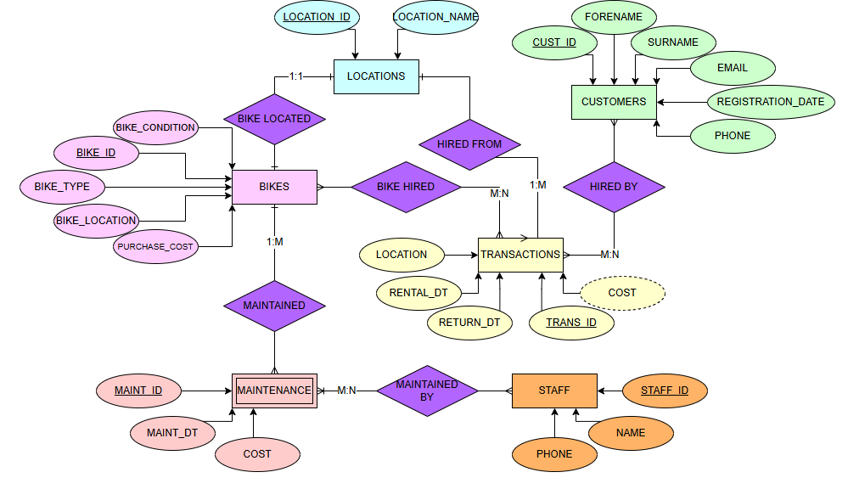
[Fig1 – Entity Relationship Diagram for ‘EcoRide’ created using draw.io]
During the ERD creation, it was identified that the location information would be useful across multiple entities. I therefore added a standalone ‘Location’ entity to the design to maintain consistency across the related records.
The ERD has also allowed me to design the solution in such a way that it adheres to Third Normal Form (3NF):
- Each entity has atomic attributes
- Has no partial dependencies
- The solution will lack non-key dependencies
Adhering to 3NF principles will minimise several different common issues that can be encountered in poorly structures databases, such as redundant data, modification/deletion anomalies, and insertion anomalies. [3] Such issues can lead to a database suffering long term poor performance, maintainability, scalability, and data integrity. [4]

Data Structure Development

Tool of Choice
The DMBS of choice for this assignment was Microsoft Access. During development, this tool made certain aspects of the development simple by providing user interface elements, easy to implement validation, customisable forms, and even more bespoke customisation through the use of VBA.
MS Access did however pose certain challenges for development, which will be covered in more detail in the development evaluation section.

Database Creation
As outlined in the ERD, there were 6 tables created to meet the requirements.
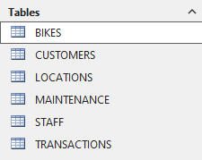
[Fig2 – Tables created in the EcoRide database]
Each table has a number of fields created within to enable proper function. Each field needed to have certain considerations during creation, such as setting primary keys, setting appropriate data types, and implementing any data validation to enforce data integrity. Descriptions have also been added for each field to support long term maintenance and usability.
In the screenshot below of the ‘TRANSACTIONS’ table, you can see the above considerations for each field, as well as the ‘Required’ flag applied to the ‘RENTAL_DATETIME’ field, ensuring that a rental transaction will always have data entered for that field.
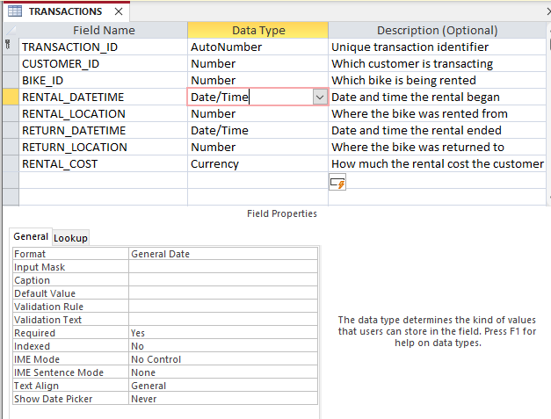
[Fig3 – Table schema for the ‘TRANSACTIONS’ table demonstrating datatypes, primary key, and elements of validation]

Relationships
Once all objects were created, appropriate relationships were set between them. This further enforces data integrity and the desired functionality, as well as being a key enabler to data entry streamlining via lookup lists.
As can be seen below, MS Access provides a convenient relationship diagram for simpler visual development.
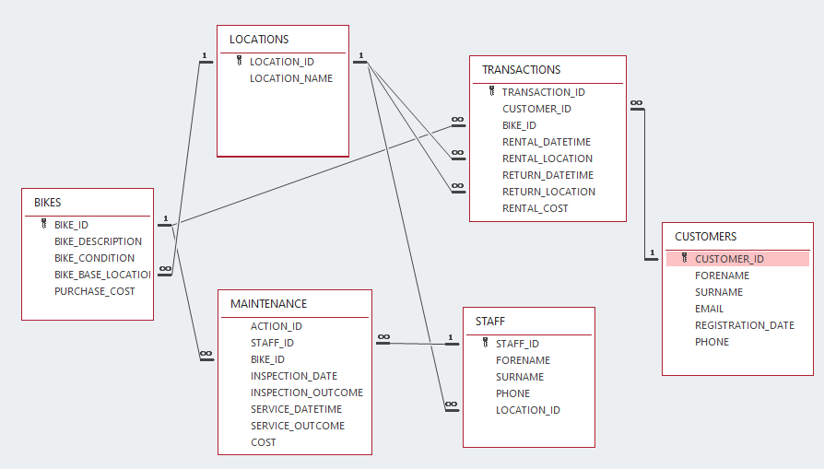
[Fig4 – Relationship view of the completed EcoRide databse]

User Interface

Form Creation
The human usability of the database needed to be thoroughly considered, leading to the creation of several user interfaces or ‘Forms’ that should be used by staff to handle data entry and record keeping.
When designing the forms, considerations were made for:
- Simplicity of use – To maximise usability for staff
- Navigation between records and a ‘search’ feature – Allowing staff to quickly find records they need to update
- Consistent design language – E.g. consistent button/feature placement to reduce mistakes
- Functionality – Each form has a specific purpose distinct from each other to make purpose clear
See below example showcasing a completed form. There are buttons available for simple record navigation in the top toolbar, and where possible data entry is handled through list boxes, removing the need to free-type and therefore reducing the possibility of human error.
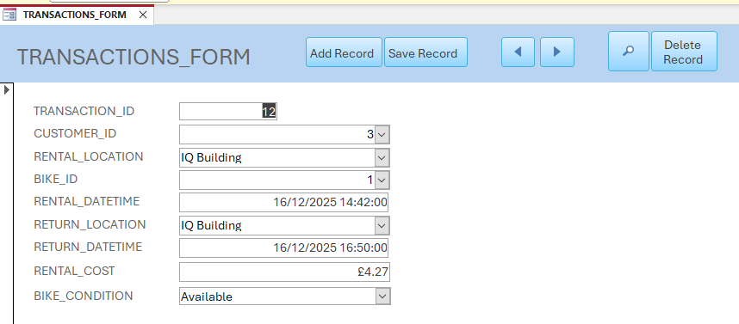
[Fig5 – Example record populating the ‘TRANSACTIONS’ form]

A form can be thought of as a ‘front end’ to the data in the background, and therefore should be responsible for the bulk of the user input validation, ensuring records are complete, formatted correctly, and consistent before they get sent to the table.
In the form design view we have a multitude of options available to control data entry and data format. See below example of TRANSACTIONS.CUSTOMER_ID being restricted to a dropdown list fed from a query of the CUSTOMERS table. This ensures only valid customers can action a rental.
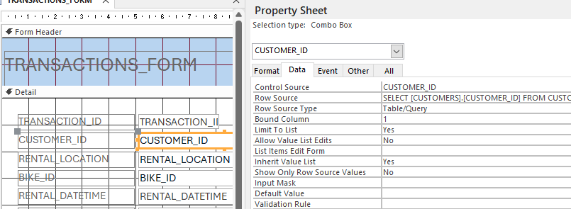
[Fig6 – Customer ID list with list source being a query of another table]

Custom Form Validation
During form design, I overcame some of the limitations of MS Access customisation using two features: VBA and Access built-in functions. [5]
The below code is used to customise the functionality of the ‘TRANSACTIONS’ form, which combines VBA and functions such as ‘DateDiff’. Each code block has comments applied to explain the functionality to future developers.
These custom functions were key in addressing some of the problem statements identified in the initial scenario, such as double bookings and human error.
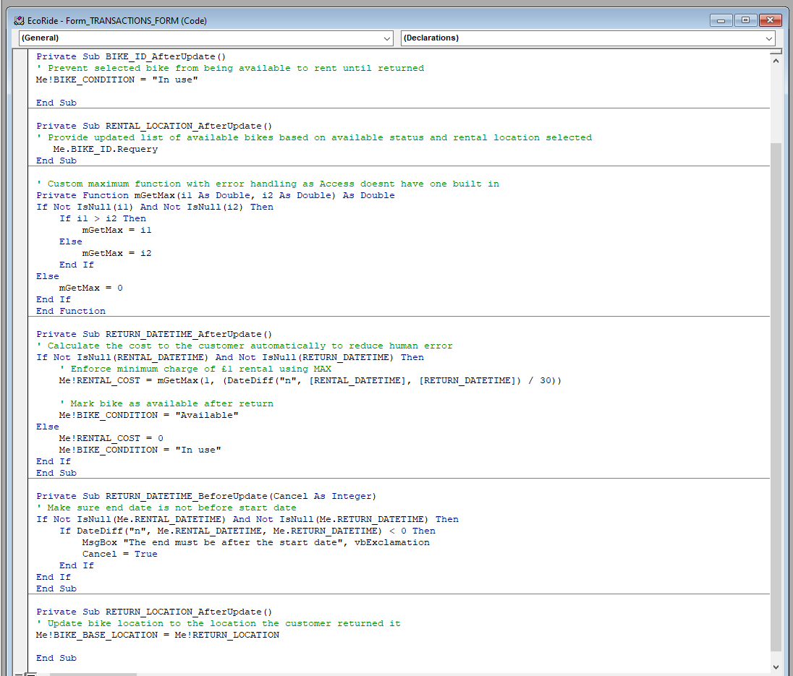
[Fig7 – VBA Code to support validation of the ‘TRANSACTIONS’ form]

Sample Data Population
To support in the validation of the build, a minimum of 5 sample records were populated in each of the tables. Where possible these were entered using the forms, as this will provide the most robust end-to-end view of whether the build is working as intended.
As can be seen in Fig5 and Fig8 below, the TRANSACTIONS table’s records are visible in both the table view as well as within the form view.
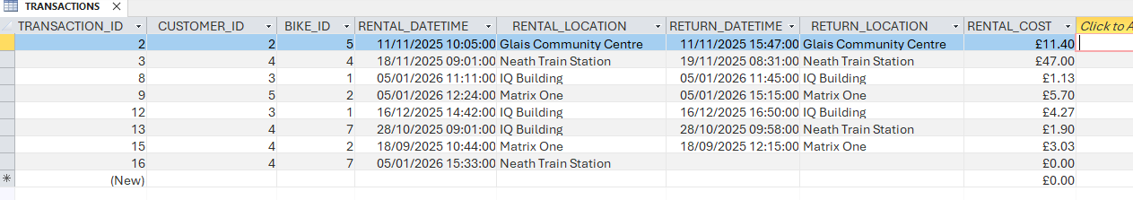
[Fig8 – Table view of transactions populated with sample records]

Query Development
Requirement number 5 outlines the need for a suite of queries that would enable better oversight of the day-to-day operation, as well as track the overall usage metrics of the initiative.
MS Access provides some flexibility in how queries are developed, you can either use the built in GUI with drag and drop functionality, or you can write SQL code depending on ability. In my case I used a combination of the two depending on query complexity, as SQL allows for significantly more bespoke functionality.
I made several queries to address some of the needs outlined in the scenario, two examples being:
- A report outlining revenue by customer
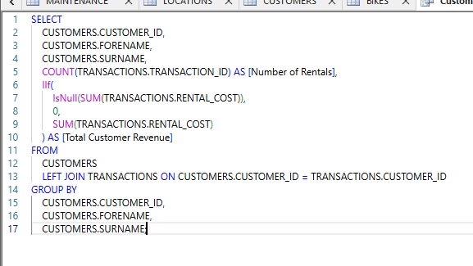
[Fig9 – Customer Revenue query SQL code]
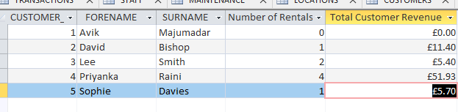
[Fig10 – Customer Revenue query results showing number or rentals and amount of revenue for each customer]
- A report outlining bike profitability
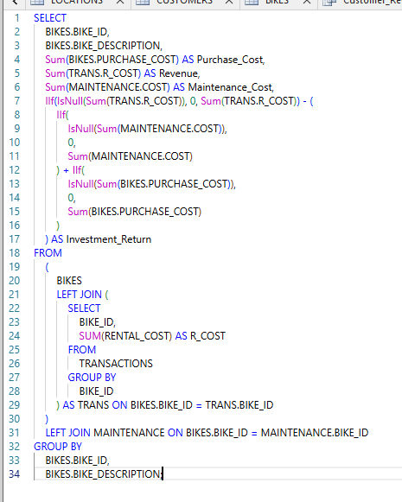
[Fig11 – Bike profitability query SQL code]
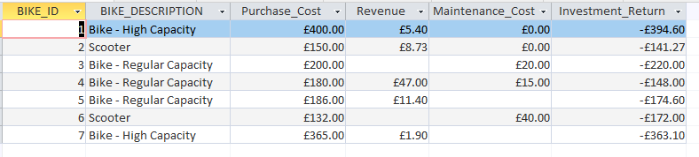
[Fig12 – Bike profitability query results showing costs, revenue, and profit for each bike]

Validation and testing
Testing was conducted throughout the entire built process to ensure each element was functional before moving onto the next, before finally testing the entire solution holistically once development was completed to ensure all elements worked together as intended.
The testing was done to confirm that the design satisfied all outlined requirements, and no errors would occur during intended system usage.
The testing methodology was as follows:
- On a table level, ensure appropriate fields were available in the appropriate data format, data entry validation was enforced (e.g. marking a field as ‘Required’), and data integrity maintained
- Ensure relationships between tables worked as intended to allow foreign-key linkages and queries
- Forms allowed the input of all relevant data, gave standardised input lists where reasonable, and sanitised user input before being saved to the source table
- Custom code procedures worked as intended, and any common edge cases were accounted for (such as null values during certain numerical calculations)
- Data queries provided intended results with all calculations evaluating correctly.
Were this system to be implemented in the real world, I would also like to build and test multi-user concurrency tests to allow several staff to update records at once.
The result of the testing was for all of the above areas to pass, indicating that the system should work as intended.

Reflection

Summary
Were I to be implementing this solution outside the scope of this assignment, I would look to use a different DBMS with a more customisable front end to allow for more granular control of functionality. Microsoft Access provides an entry level experience for new developers, but would struggle to scale with a business as it grows due to limitations such as a 2GB data storage limit [6]
I believe my schema design was logical, and as simple as was reasonable to meet all the requirements. My forms are easy to use, and they are made to minimise human error, manual effort, and data integrity issues. My queries are accurate and provide key information on certain aspects of the operation.

Development Challenges
Some of the custom designs and features were difficult to build in the Access environment, leading to a fast start to development, but slower final stages to tweak functionality to my needs. There was a difficult balance between development complexity vs return on effort.
MS Access is an old tool, and while it’s widely used in the industry, use is reducing year on year [7]. This has led to support forums and documentation being quite old and difficult to adapt to specific scenarios and modern standards.
The challenges were overcome through robust iterative development and testing, but they did draw out the development time.

Future Improvements
If this product was to undergo real-world use, and given enough time, I would like to enhance it with the following improvements:
- Add more design elements to forms, perhaps with company branding and consistent colour scheme, considering accessibility of the visuals.
- Significantly more input validation to further reduce the possibility of mistakes, e.g. improved datetime picker
- Create more queries to enrich the amount of data available to assess initiative performance
- A custom reporting dashboard in place of just running queries via the object window to enhance usability of management information.
- A split of Access into a back end and multiple front ends with record locking and user audit logs to manage concurrency and action auditing. The front ends would also be locked to just user forms to prevent any mis-use.
- Linkage to a Customer Records Management (CRM) System to automatically contact customers under specific scenarios like not returning a bike in a certain amount of time.

References

[1] | J. L. Harrington, Relational database design and implementation : clearly explained, Amsterdam: Morgan Kaufmann/Elsevier, 2009.
[2] | H. Laurila, “Manual Data Entry And Its Effects On Quality,” Quality, vol. 61, no. 2, 2022.
[3] | T. M. C. a. C. E. Begg, Database Systems : a practical approach to design, implementation, and management, Boston: Pearson, 2015.
[4] | T. J. Teorey, Database modeling and design : logical design, 5th ed, Amsterdam: Morgan Kaufmann Publishers, 2011.
[5] | S. Roman, Access database design and programming, 3rd ed, Beijing: O’Reilly, 2002.
[6] | P. Vigeant, “The dangers of Microsoft Access in 2025,” Witify, [Online]. Available: https://witify.io/en/blog/the-dangers-of-microsoft-access-in-2025/. [Accessed 09 01 2026].
[7] | “How Popular Is Microsoft Access, Really?!,” DEVelopers HUT, [Online]. Available: https://www.devhut.net/how-popular-is-microsoft-access-really/. [Accessed 09 01 2026].

