The Light Experiment: A Study of Conformity within Social Norms: Recreating Sherif’s Autokinetic Experiment

Introduction
Conformity is the act of fitting attitudes, beliefs and behaviours to group/set norms. People often choose to conform to society rather than pursue individual/personal desires because it is easier to follow the pathway others have already created, rather than creating a new one. The tendency to conform can often occur in small groups or even society in general and may come from subtle subconscious influences or immediate societal pressure (also known as “yielding to group pressure”) (Crutchfield 1955). These pressures can include a desire for security, a need to fit in, educational status etc. and unwillingness to conform causes risk of social/cultural rejection. Conformity is often associated with adolescence and youth but strongly impacts humans of all ages.
The first study of conformity came from Arthur Jenness in 1932. He asked students to estimate the number of beans in a bottle. He took each student’s estimate individually first before he put them in groups and told them to discuss their estimates with their peers before they provided a group estimate. Jenness then spoke to each student individually again and asked if they would like to change their original estimates or stick with the group’s estimate. Almost all the students changed their individual estimates to be closer the group one. According to Jenness, these results showed that in a situation where the answer was unknown, the students would listen to their peers and conform to their answers.
In 1955, two men, Morton Deutsch and Harold B Gerard, came up with the Dual-Processing Dependency Model which proposes the theory that people conform for two reasons, either due to Informational Social Influence (ISI) or Normative Social Influence (NSI). Normative Social Influence is the desire to be liked and fit in “with the norm”. A famous example of this is Asch’s line experiment. Asch took 50 male college students and asked them to partake in a vision line judgement test, but he placed one of them in a room with 7 others who were aware that this was an experiment. However, the student did not know this and was led to believe that the others were regular participants. Each participant in the room had to say out loud which comparison line (A, B or C) was most like the target line. The answer was always obvious. The real participant sat at the end of the row and gave his or her answer last. There were 18 trials in total. When the findings came back, they showed, on average, about 32% of the participants placed in this situation conformed to the incorrect majority. Asch said this proved people conformed due to their wanting to fit in with the group (NSI).
Informational Social Influence is a cognitive process which occurs in ambiguous situations where people seek information, guidance and often desire to be right. A famous example of this is Sherif’s Autokinetic experiment. Sherif gathered participants and placed them in a dark room before waiting a few minutes and asking them to say out loud how far they thought the light had moved (this is the autokinetic effect and it’s all inside the head but the participants didn’t know that). Numerous trials were completed and over time, findings found that the participants answers came to a joint estimated answer. Sherif said that this showed that when it came to an ambiguous situation, people would always tend to conform rather than make individual judgments.
For our experiment, myself and two other experimenters will be attempting to recreate Sherif’s famous experiment to find out if people really do conform when in groups and if other people’s opinions/judgements influence their answers.

Methodology
In order to ensure that our experiment would deliver the information we intended to evaluate, we had to make some adaptations to the original technique but still use the same framework as well as setting parameters to ensure ecological validity. The design/set up is almost identical to Sherif’s, a pitch-black room with a light set up a significant distance away from the participants.
The independent variable for our experiment whether the participant is stating their estimate privately or publicly. This is important because if participants put down their estimate privately, they are least likely to conform and be in the ISI category because they are making an individual judgement, not one based on other participants estimate. The dependent variable is the participants’ estimates of the apparent movement of the light in cm. This is important because

The first thing myself and the other experimenters had to do is select a group of participants to take part in our experiment and this was done by recruitment, going into classes and asking who would be interested. We managed to get a total of eight participants which we decided would be a solid number, we wanted enough people to get a wide range of data but not too many that we would have to perform the experiment. This is one of the things that differed from our experiment to Sherif's, he performed numerous trials, whilst we had already decided we were going to do it twice. Next, we designed a consent form to give to the participants to sign. This form gave a brief description of what was going to happen throughout the experiment and an option to leave the experiment if the participant felt uncomfortable. We also designed a set of two detailed Standardised Instructions for the participants to read through, so they knew exactly what they had to do.
The day of the experiment, myself and the other experimenters made sure the room was ready to go, that the LED light was set up 7.1 meters away from the participants. The windows were blacked out so nothing would interfere with the experiment and the chairs were set up for the participants. Then we went over to meet the participants and give them the consent form to sign, all were happy, so we took them over to the room we were using. Sherif used a lab room to conduct his experiment but we used a Media “dark” room with barely any light to fully make sure the only thing visible was the LED light and therefore, making sure the autokinetic effect would fully work. We also fully briefed the participants; they were asked to turn off their telephones and to remain silent for the entire duration, unless instructed otherwise. It was also made strongly aware that discussing with other participants was forbidden, this would have ruined the experiment if estimates were discussed.
The participants were guided into a completely dark room with the help of one of the experiments. They were taken to the seats and when all the participants were seated, the light turned on for 2 minutes. After the time was up, the participants were guided back out to write down their estimates. It. After the participants had written down their estimates on a numbered card (numbered so it would be anonymous), three of them were asked to take part in the second half of the practical .The decision of choosing the three remaining participants was made according to their estimates from the first trial. It was important to pick one participant with a higher range to the 2 other participants so there would be a chance for conformity. For the second part of the experiment, the participants were guided back to the dark room and this time, the red light was turned on 3 times. After each 2-minute period, the participants were asked to estimate their answers out loud. The participant with the lowest estimate on the first trial was the last one to be asked to state their estimate so that they could hear the estimates of the other participants before, therefore increasing the chances of conformity,

Results
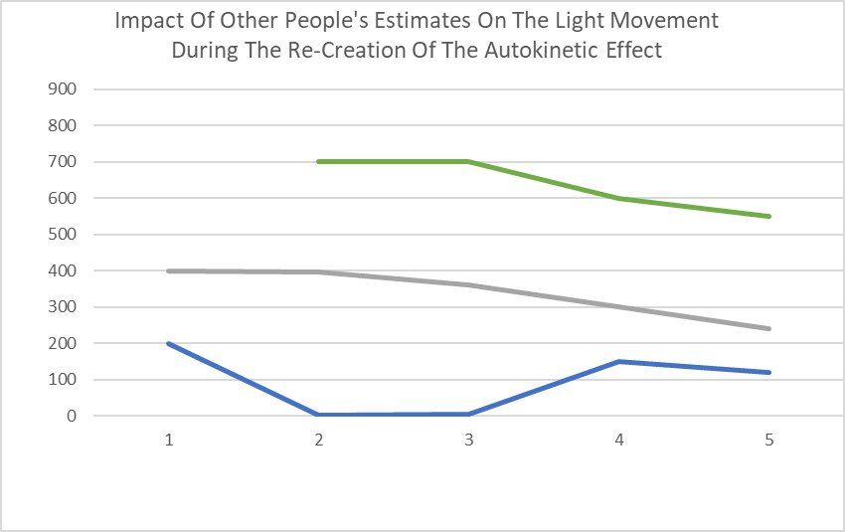

Participant 1 - Green
Participant 2 - Grey
​Participant 3 – Blue

Treatment of Results:
As you can see from the results, the graph shows the four different trials. The first one displays estimates of when participants were asked to write their answers down individually. The other three trials display the estimates given verbally. The graph shows that the estimates start to converge more after every trial. The range of the estimates goes from 696 cm (1st trial) to 430 cm (4th trial). Not only that but the average of the estimate began to decrease as the trials went forward. The average of the first trial was 366.67 cm and the average of the fourth trial was 303.33 cm.

Discussion:
As you can see, our results corresponded with the hypothesis, like Sherif’s (1935) Autokinetic study. Unfortunately, this experiment does not have much ecological validity as the participants were put in a situation where they had little freedom. The way people behave in laboratory experiments cannot be taken as an accurate indication for certainty of how people will behave in real life. Another issue with this experiment is the reliability. The sampling is quite biased, all the participants we chose were students from The University of Wales Trinity St David and all from the same campus too. Sherif had several participants but we only had around 8 to start and only 3 for the second trial meaning the reliability decreases. Not only that but the amount of trials is also an issue. Sherif conducted several trials whilst we only did our experiment twice. To improve reliability for next time, there needs to be more trials and more participants. However, even with taking a small number of participants and doing a small amount of trials, our experiment still ended up corresponding with Sherif’s study.
Choosing a constrained situation/location for our experiment does have some advantages though. There is an opportunity for debriefing the participants and making sure that everyone understands what happened and why it was done, things that could not be done if the experiment were done in a natural setting. It also means that the participants can be asked to write a consent form, which indicates that they are aware of being in an experiment, similarly to Asch’s line experiment.
Regarding other definitions, Zimbardo and Leippe define conformity as “a change in belief or behaviour in response to real or imagined group pressure when there is no direct request to comply with the group nor any reason to justify the behaviour change. “Gross, 2010, p. 401). Not only that but another good study to look at regarding conformity is Zimbardo’s Prison Study.

Conclusion
In conclusion, this re-creation of Sherif’s Autokinetic experiment did meet the aims and hypothesis mentioned in the beginning. Our findings showed that, like Sherif’s study, people do tend to conform in ambiguous situations and therefore, do fall into the ISI category.

References:
Mcleod, S., 2020. Stanford Prison Experiment. [online] Simplypsychology.org. Available at: <https://www.simplypsychology.org/zimbardo.html> [Accessed 30 April 2020].
Mcleod, S., 2020. What Is Conformity? | Simply Psychology. [online] Simplypsychology.org. Available at: <https://www.simplypsychology.org/conformity.html> [Accessed 30 April 2020].

Appendix:
(This is the consent form, and both sets of Standardised Instructions)


