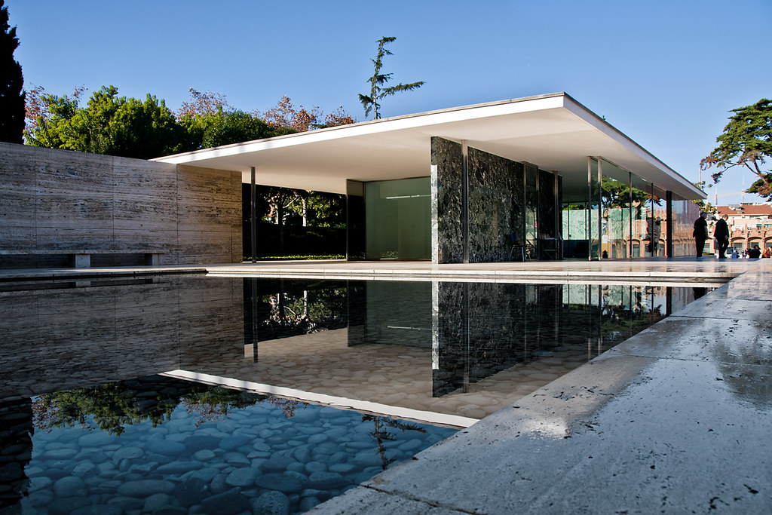

The Barcelona Pavilion.

April 9, 2021

History & Theory 1 (M4X01975)
Written by: Michelle Benalcázar.
2008160@student.uwtsd.ac.uk

The Barcelona pavilion.
“Less is more”

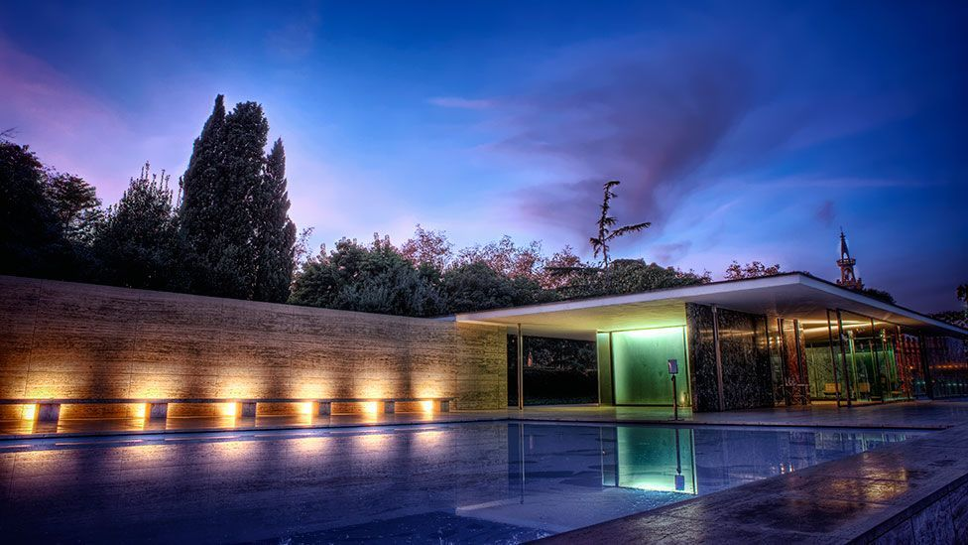  Image 1: Barcelona pavilion  Photo by: Jonathan Glancey | - Architect:  Ludwig Mies van der Rohe.  - Year:  Original building: 1929-1930  Replica: 1983- to present.  - Location:  Barcelona- Spain.  - Style:  Modernist twentieth-century architecture

The German pavilion, one building designed to last an exposition, finished becoming an icon for the twentieth-century architecture.
In 1905 (1) the Catalan architect Josep Puig proposed a second International Exposition (the first one was in 1888), but for some economic and political factors the planning got delayed until 1917. Barcelona was the chosen city, since they required almost 110 hectares of space, to host the exposition. The exposition started on May 20th, 1929 and finished on January 15th, 1930 Barcelona became the presenter of the International Exposition (Expo 1929). With the theme “Industry, Sports and Art” 20 European countries participated in the exposition, also, some private North American and Japanese organisations, but the Latin American countries didn’t participate in this Expo because they were in the Ibero-American Festival in Seville, celebrated the same year. The exposition had a good welcome, attracting over 200 000 people around the world.
Every participant had their own pavilion, most of them were designed by their own architects, and, because they were temporary buildings, it gave the chance to many architects and engineers to create new styles and techniques, this movement was called “Noucentisme”. Ludwig Mies van der Rohe was among all the architects and engineers, he was in charge in the design of the German pavilion, but little he knew that the pavilion he built will soon become an icon of the twentieth-century architecture.

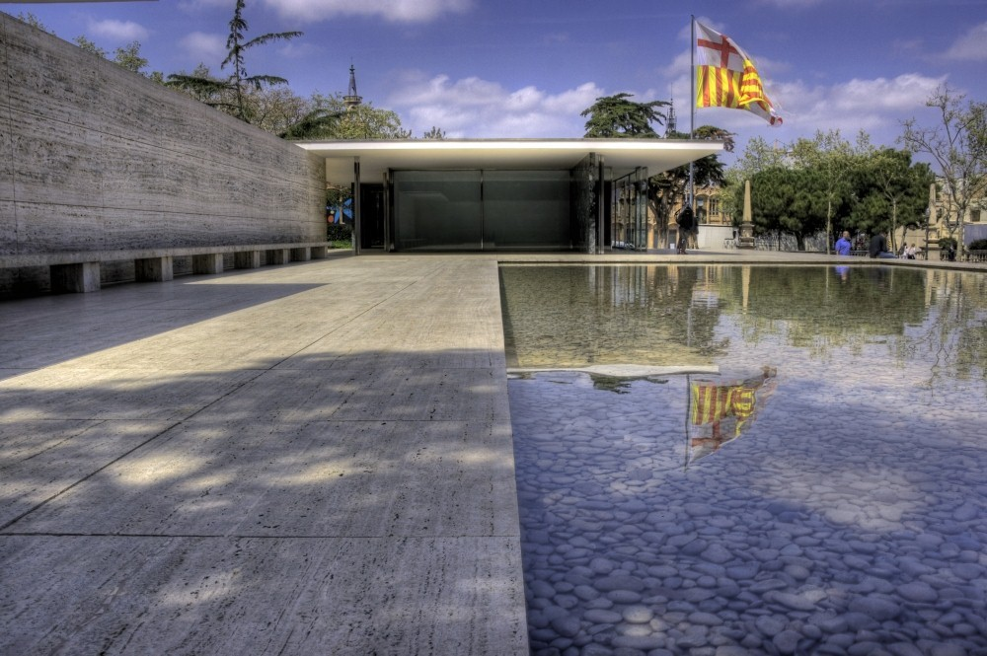
Image 2: Pavilion view from the big pool.
Photo by: Gili Merin.

Ludwig Mies van der Rohe was the best choice to design the pavilion that will represent Germany in the Expo 1929. Originally (2) the pavilion was going to be built on the esplanade between the Victoria Eugenia and Alfonso XIII palaces, but Mies van der Rohe decided to change places, and chose a site in a quiet corner at the foot of the National Art Museum of Catalonia, in a way, trying to hide the pavilion from the noise of the streets of the busy city of Barcelona, ​​creating an atmospheric effect that seems to create a void that dissolves the noise of the city (3).
The pavilion was dismantle just after the Expo1929 finished, but that pavilion was an incredible influential piece of work that in 1983 the group of architects: Ignasi de Solá-Mora les, Fernando Ramos and Cristian Cirici (4). With the help of photos and the plans of the original pavilion decided to recreate it in the exact place that was before, and, until this day we have the chance of visiting such a master piece of the twentieth-century architecture.

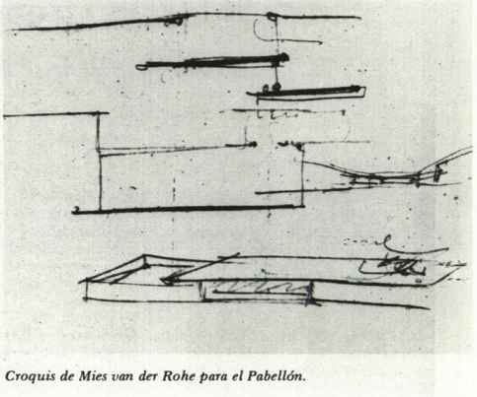
Image 3: Sketch of the pavilion by Mies van der Rohe.

The impression that the pavilion gives is of a luxurious space created by perpendicular planes in three dimensions, with little furniture consisting of: a red curtain, a black carpet and four white chairs (The well-known Barcelona chairs); colours representing the flag of Germany (5).
In the pavilion there are 3 main spaces:
- The reception patio. - This is where the large pool is located, here there is a contrast among the opacity of the walls, the reflections of the water in the pool and the glass of the entrance door.
- The built nucleus. - Here the walls are built of different types of marble, these determine different planes of the building, always controlling the opacities, transparencies and spaces of the materials.
- The backyard. – This room has a small and shallow black glass pool surrounded by beautiful green marble walls, in the pool is the statue "The Dawn" by the artist Georg Kolbe.
The statue is perfectly located in a corner where its reflection can be seen both in the water and on the walls of the room.
Mies van der Rohe from the beginning treated the pavilion as a temporary building, therefore he did not complicate making a very detailed plan, he wanted its construction to be simple, since the importance of the pavilion would be in the materials and the furniture. The pavilion has 8 cruciform columns built from 4 back to back angles and then enfolded in chromium plates that support a thin roof slab which is over sailing the edge. The building is assembled (6) on a 1.3m high travertine plinth that makes the ceiling of the Barcelona Pavilion, having a low horizontal orientation, seemed to float both inside and outside. Its design is inspired by the grid system of shapes, which also functions as a wall frame and pattern for travertine paving stones and was developed by Mies van der Rohe.
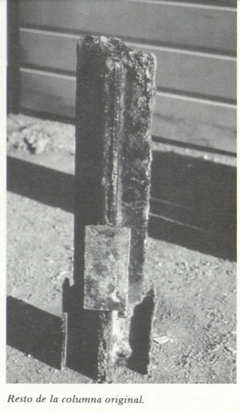
In the middle of the pavilion there is two leaves of Opal glass, with a very narrow roof light in the middle of the glasses. Because the glass, you can´t see from where the light comes from or how thick the wall is. One of the beauties of the pavilion.
The doors are built with the idea of not breaking the visual fluidity that exists in the pavilion, therefore they have no frame and have the same height as the walls, and they are pivoting made of chrome plate and glass. It can be said that the doors are camouflaged between the walls of the pavilion. While the walls are no-load bearing, making the columns the only support for the roof.
The pavilion has a proportional design composition with two juxtaposed reflecting pools. (7) The small pool, has a classical statue, is located behind the building, has a wall of black glass that gives the feeling of depth allowing the light to illuminate the inside marble and travertine pavers. While the large pool stretches across the front plinth giving extra volume to the building, its elegance and sleek lines establish a place of solitude and reflection.
Image 4: Remainder of original column.
Photo by: Isabel Bachs.

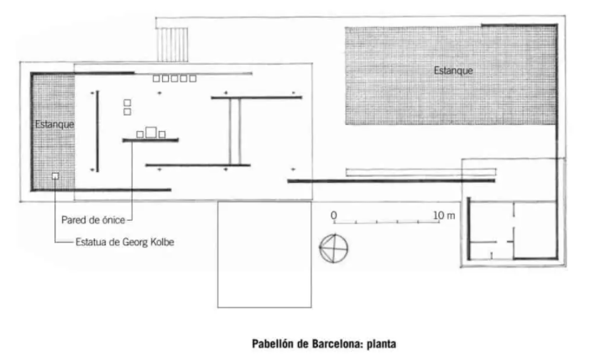
Image 5: Barcelona pavilion plan.

One of the main reasons of the impact that the German Pavilion had on everybody was the choice of materials that Mies van der Rohe used. Large surfaces of glass, stone, reinforced concrete, high-chrome steel and four different types of marble: Roman travertine, onyx from the Atlas in Africa, ancient green marble from Greece and the green marble of the Alps. (8), where some of the materials that he chose for the pavilion. The choice of these materials was with the idea of creating spatial illusions by using the light from the sun and moon reflecting into the materials (9).
Water is another very important element in the pavilion, with two pools that creates two different effects: The small pool creates an effect of depth, this pool is located in the backyard and has a bronze sculpture “The Dancer”, while the big pool creates the effect of reflection s located in front of the main entrance.
One of Mies van der Rohe´s favourite materials is the Italian travertine, he uses in the exterior walls and to wrap the plinth. The travertine when it gets exposed to the sun gets illuminated, giving the illusion of the stone turning into a natural light bulb. The marble he used came from the Swiss Alps and the Mediterranean (using the cutting process broaching to create the symmetrical pattern found in marble.)
The pavilion has two doors, both made of steel and glass and they were built to keep the building safe(10). The middle wall of the pavilion is covered with golden-onyx-clad.
The 8 slender columns that hold a thin roof made of steel and concrete render making it look like the roof is floating, are made of chromed-steel.
Lilly and Mies also designed the furniture, they created a stainless steel and leader chair that will become a 20th-cetury icon called “Barcelona chair”.

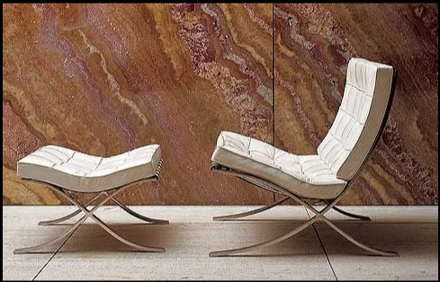
Image 6: Silla Barcelona.
The Barcelona chair.

Only an architect as talented as Ludwig Mies van der Rohe can transform a temporary pavilion created for an international exhibition into one of the most important architectural pieces of the 20th century. His work was so acclaimed that years after it was dismantled a group of architects rebuilt it with such precision in the use of the plans as in the materials, that for people who do not know the history of this pavilion, it seems to be the same one that Ludwig Mies van der Rohe built back in the late 20s.
Love it or hate it, this pavilion created a before and after in the history of 20th century architecture.

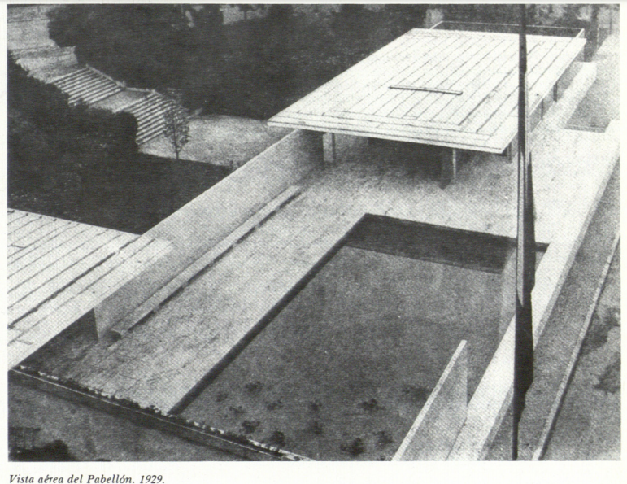
Image 7: Aerial view of the 1929 pavilion.
Photo by: Isabel Bachs.

Referencing list.

Images:

Image 1.- Jonathan Glancey, October21st, 2014. Why the ‘Barcelona’ Pavilion is a modernist classic. BBC, Culture. Barcelona pavilion
https://www.bbc.com/culture/article/20130924-less-is-more-a-design-classic

Image 2.- Andrew Kroll. "AD Classics: Barcelona Pavilion / Mies van der Rohe" 08 Feb 2011. ArchDaily. Pavilion view from the big pool.
https://www.archdaily.com/109135/ad-classics-barcelona-pavilion-mies-van-der-rohe

Image 3.- Alejandro de la Sota. 1929/ 1986 Reconstrucción del Pabellón Alemán de Barcelona. Sketch of the pavilion by Mies van der Rohe.
https://www.coam.org/media/Default%20Files/fundacion/biblioteca/revista-arquitectura-100/1981-1986/docs/revista-articulos/revista-arquitectura-1986-n261-pag04-15.pdf

Image 4.- Alejandro de la Sota. 1929/ 1986 Reconstrucción del Pabellón Alemán de Barcelona. Remainder of original column.
https://www.coam.org/media/Default%20Files/fundacion/biblioteca/revista-arquitectura-100/1981-1986/docs/revista-articulos/revista-arquitectura-1986-n261-pag04-15.pdf

Image 5.- Pabellón de Barcelona: Plano, Materiales y Construcción. Arquitectura Pura. Pabellón de Barcelona: planta.
https://www.arquitecturapura.com/el-pabellon-de-barcelona-de-mies-van-der-rohe/

Image 6.- Pabellón Alemán en Barcelona. Silla Barcelona.
https://es.wikiarquitectura.com/edificio/pabellon-aleman-en-barcelona/#silla-barcelona

Image 7.- Alejandro de la Sota. 1929/ 1986 Reconstrucción del Pabellón Alemán de Barcelona. Aerial view of the 1929 pavilion.
https://www.coam.org/media/Default%20Files/fundacion/biblioteca/revista-arquitectura-100/1981-1986/docs/revista-articulos/revista-arquitectura-1986-n261-pag04-15.pdf

Text:

1.- Tara Jessop. 5 May 2016. The legacy of the 1929 Barcelona International Exposition. Culture trip.
https://theculturetrip.com/europe/spain/articles/the-legacy-of-the-1929-barcelona-international-exposition/

2.- Alejandro de la Sota. 1929/ 1986 Reconstrucción del Pabellón Alemán de Barcelona. El lugar. Page 3, paragraph 3.
https://www.coam.org/media/Default%20Files/fundacion/biblioteca/revista-arquitectura-100/1981-1986/docs/revista-articulos/revista-arquitectura-1986-n261-pag04-15.pdf

3.- Andrew Kroll. "AD Classics: Barcelona Pavilion / Mies van der Rohe" 08 Feb 2011. ArchDaily.
https://www.archdaily.com/109135/ad-classics-barcelona-pavilion-mies-van-der-rohe

4.- Stephanie Wade. The Barcelona Pavilion by Ludwig Mies Van Der Rohe is a textural delight. Ignant.
https://www.ignant.com/2020/02/28/the-barcelona-pavilion-by-ludwig-mies-van-der-rohe-is-a-textural-delight/

5.- Pabellón Alemán en Barcelona. Wiki Arquitectura. Concepto.
https://es.wikiarquitectura.com/edificio/pabellon-aleman-en-barcelona/#

6.- Stephanie Wade. The Barcelona Pavilion by Ludwig Mies Van Der Rohe is a textural delight. Ignant. Paragraph 3.
https://www.ignant.com/2020/02/28/the-barcelona-pavilion-by-ludwig-mies-van-der-rohe-is-a-textural-delight/

7.- Pabellón Alemán en Barcelona. Wiki Arquitectura. Materiales.
https://es.wikiarquitectura.com/edificio/pabellon-aleman-en-barcelona/#

8.- Andrew Kroll. "AD Classics: Barcelona Pavilion / Mies van der Rohe" 08 Feb 2011. ArchDaily. Paragraph 8.
https://www.archdaily.com/109135/ad-classics-barcelona-pavilion-mies-van-der-rohe

9.- Jonathan Glancey. 21st October 2014. Why the ‘Barcelona’ Pavilion is a modernist classic. BBC. Out of this world.
https://www.bbc.com/culture/article/20130924-less-is-more-a-design-classic

10.- Andrew Kroll. "AD Classics: Barcelona Pavilion / Mies van der Rohe" 08 Feb 2011. ArchDaily. Paragraph.
https://www.archdaily.com/109135/ad-classics-barcelona-pavilion-mies-van-der-rohe

