Name: Nageena Akhtar
Student’s ID: 2232594
Module: Professional Development within Health and Social Care
Module Code: LCHS4009
Assignment Title: Personal Development Portfolio
Module Code: LCHS4009
Lecturer’s Name: Olubukola Adegbite

Table of Contents

Introduction 2
Job Advertisement 2
TASK 1: CV 3
TASK 2: PERSONAL STATEMENT 5
Career Aims 5
Education & Background 5
Key Skills & Strengths 5
Work Experience Relevance 6
Value of Employer 6
TASK 3A: SWOT ANALYSIS 7
Strengths 7
Weaknesses 7
Opportunities 7
Threats 7
TASK 3B: PERSONAL DEVELOPMENT PLAN (PDP) 9
Goal 1: Improve Communication & Presentation 9
Goal 2: Develop Care-Specific Skills 9
Goal 3: Career Progression 9
Monitoring & Evaluation 9
TASK 4: REFLECTIVE WRITING (GIBBS MODEL) 10
Description 10
Feelings 10
Evaluation 10
Analysis 10
Conclusion 11
Action Plan 11
References 12
Appendices 14
Appendix 1 – Job Advertisement 14

Introduction
The rising number of patients seeking the services of skilled care professionals in the UK also expresses the importance of professional development in sustaining safe, effective, and person-centred care delivery (Skills for Care, 2023). The present portfolio will identify the experience and knowledge necessary to be professionally ready to hold the position of Care Assistant/Support Worker in the UK health and social care field, where good communication, empathy, and protection are key elements of good care delivery (Department of Health and Social Care, 2022). It comprises an individualised CV, personal statement, SWOT analysis, a Personal Development Plan (PDP) and a reflective account based on Gibbs model. Overall, these activities intimately assess the skills of employability and specify the areas of constant professional growth. The competencies mentioned are vital in satisfying labour needs and providing patient-centric care in accordance with the existing UK healthcare practices.

Job Advertisement
The advertised position (see Appendix A) is to be a Care Assistant in a care organisation located in the United Kingdom, which needs strong communication, empathy, safeguarding awareness, and collaborative efforts to achieve person-centred care. These competencies are in line with the expectations of safe and effective practice outlined in the sector and are in line with the existing workforce standards in health and social care.

TASK 1: CV

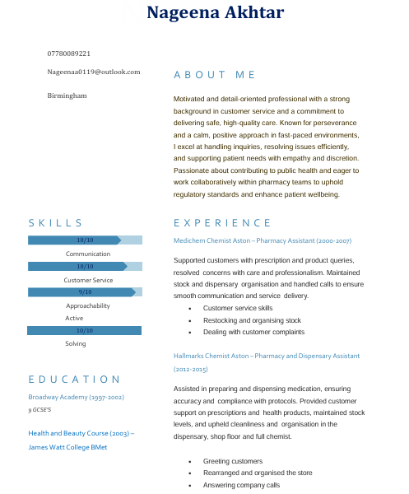
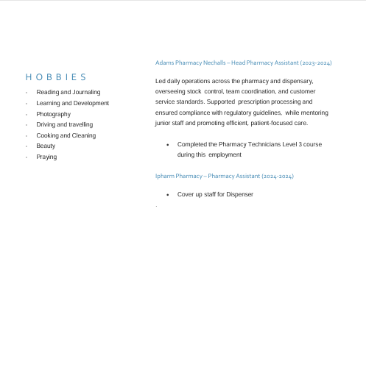

TASK 2: PERSONAL STATEMENT

Career Aims
I am a focused and empathic practitioner who would like to work as a Care Assistant/Support Worker in the health and social care sector and, in the long-term, secure a senior care practice or nursing position. I aspire to play a role in achieving high-quality and person-centred care and promote dignity, independence, and wellbeing, which are principles of core values that determine the provision of health and social care services in the UK (NHS England, 2022). Continuous professional development is the aspect that I am dedicated to because the constant learning process is crucial to fulfilling the changing care standards and enhancing service delivery effectiveness (Skills for Care, 2023).

Education & Background
I have a nine-GCSE level education at Broadway Academy and a Health and Beauty qualification at James Watt College BMet. These credentials enabled me to have background knowledge of health-related practices and interpersonal skills. Moreover, my comprehensive practice in pharmacy facilities has enhanced my knowledge of patient care, drug administration, and the significance of confidentiality and accuracy in practice (Department of Health and Social Care, 2022). These competencies are quite relevant in the setting of care, where the responsibility of safeguarding and safe practice is paramount.

Key Skills & Strengths
Communication is a part of my strength as shown by the fact that I can effectively communicate with patients, customers and other colleagues. Effective communication plays a vital role in eliminating errors and providing proper care coordination (Royal College of Nursing, 2021). The second strength is empathy because I am sensitive and understanding towards people, especially when working with vulnerable clients who might need encouragement. Active listening allows me to effectively learn about issues and to react accordingly, and this aspect helps me to build trust and establish positive relationships. In addition, my problem-solving skills enable me to respond to customer inquiries and handle problems effectively to remain professional in problematic circumstances.

Work Experience Relevance
The experience that I have gained in my workplace in pharmacy settings has given me good exposure to interacting with patients, whereby I would assist individuals with prescriptions, sensitive information and maintain the professional standards. I acted as a leader in making sure that the work was organised, that staff were monitored and that the quality of service remained at the desired level as Head Pharmacy Assistant (Skills for Care and The King’s Fund, 2022). This experience indicates that I have worked efficiently as a member of a team and have supported the principles of safeguarding and provided patient-centred care, which is in line with the expectations of the health and social care practice.

Value of Employer
I feel that I will value the workforce of an employer by my good work ethic, reliability, and dedication to providing quality care. This is because my practical experience, coupled with interpersonal skills, can assist me in playing a significant role in team-based care settings. Moreover, I have gained knowledge of protection, collaboration and professional principles that allow me to assist service users in a safe way without violating their dignity and respect according to UK healthcare values and expectations.

TASK 3A: SWOT ANALYSIS

Strengths
My communication traits are high (10/10), which was enabled by the years of working in pharmacy and communicating with patients and co-workers effectively. This is also in accordance with the needs of care roles, in which effective communication in care delivery is essential in the provision of safe and person-centred care (NHS England, 2022). Also, I have been able to gain substantial patient support, medication administration and confidentiality experience through my healthcare experience (Skills for Care, 2023). Another example of how I organise teams, assign them tasks, and ensure the quality of provided services is my leadership experience as a Head Pharmacy Assistant, which demonstrates the presence of vital competencies needed in collaborative care settings.

Weaknesses
Presentation skills are one of my areas of development, which have been expressed through the lecturer's remarks that I should speak more slowly, use less note-taking, and improve eye contact. This can be construed to mean low confidence in addressing an audience; the likelihood that effective communication would be hampered in a professional environment may affect it unless addressed (Royal College of Nursing, 2021). This aspect should be improved because one needs to be confident when communicating with service users and colleagues to develop trust.

Opportunities
The prospects of professional growth are evident with training, including the Care Certificate qualification or the NVQ qualification, which would help me to enhance my practical skills and knowledge base (Skills for Care and The King’s Fund, 2022). Such qualifications aid in career advancement in health and social care and improve employability in organised care settings.

Threats
The threats that it may face consist of a high level of competition, emotional burnout because of the stress of care work, and pressure at the workplace (Department of Health and Social Care, 2022). To address them, resilience, coping mechanisms, and unceasing professional progress are necessary to sustain performance and well-being. Figure 1 presents a SWOT matrix summarising the key internal and external factors identified in a clear and concise visual format.
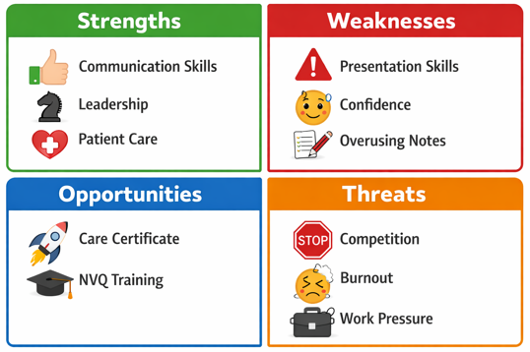
Figure 1. SWOT Matrix

TASK 3B: PERSONAL DEVELOPMENT PLAN (PDP)
My Personal Development Plan is aimed at defining achievable, specific goals that can be used to facilitate my transition into a Care Assistant/Support Worker position (Skills for Care, 2023) and support the project of developing the required skills and improving my employability in health and social care organisations.

Goal 1: Improve Communication & Presentation
In 3-6 months, I will be able to advance my presentation techniques by speaking more slowly, maintaining regular eye contact, and decreasing the use of notes. This will be done by practising the presentations on a regular basis and recording myself to analyse the performance. It is specific, can be measured by feedback, can be attained by measuring over time with consistency of practice, relevant to care communication and time-based (Department of Health and Social Care, 2022). Good communication is also necessary in care roles to achieve clarity and earn trust, as well as promote patient safety.

Goal 2: Develop Care-Specific Skills
Over the next 1–2 years, I aim to complete training in safeguarding and manual handling to strengthen my practical care competencies. These skills are essential for ensuring the safety and well-being of service users, particularly in supporting vulnerable individuals (Department of Health and Social Care, 2022). Achieving this goal will enhance my ability to meet professional standards and comply with regulatory expectations in health and social care practice.

Goal 3: Career Progression
I will advance to a more senior care position in the coming 2 years and pursue career routes in nursing. This will entail the acquisition of appropriate experience, pursuing additional qualifications, and pursuing an upward career path in the industry (Skills for Care and The King’s Fund, 2022). The importance of career development in sustaining motivation and ensuring workforce sustainability in the social care sector is significant.

Monitoring & Evaluation
Monitoring of progress will be done by reflective journaling, supervisor feedback, and formal skills tests. The ongoing evaluation process will contribute to the improvement process and remind us about the professional development goals and career aspirations.

TASK 4: REFLECTIVE WRITING (GIBBS MODEL)

Description
In my Component 1 assessment of the LCHS4009 module, I carried out a presentation about self-awareness and teamwork in the health and social care. The presentation included the definition of teamwork, the significance of teamwork in a professional environment, the Tuckman Team Development model and self-awareness in a team environment. I wrote it on my own, used scholarly sources to prove my points and presented it to my lecturer in a formal academic environment.

Feelings
During the preparation of the presentation, I was both excited and nervous. I had spent much time doing the research and planning the material, and felt nervous about expressing my ideas with certainty. I felt nervous, especially in explaining the model that Tuckman offers, but I became more relaxed as I went on with the presentation. Completion relieved me and gave me a humble satisfaction of having put academic literature to good use in a practical health and social care setting.

Evaluation
Several aspects went well. I was able to integrate the Tuckman Team Development Model and interrelate the concept with self-awareness in practice, and showed skill to bridge theory in the real-world practice. Good engagement with literature was manifested by my use of credible academic sources, such as Rosen (2020) on teamwork in healthcare. Nonetheless, I was not as analytical in my verbal presentation as I was with my written preparation. My lecturer observed that the content had been well-researched, but I should have expounded on the practical implications of self-awareness, especially how the awareness of personal weaknesses could have a direct impact as it pertains to patient care outcomes.

Analysis
Considering these strengths and weaknesses, I am convinced that my confidence in written work is more than in oral communication at the moment. The feedback that I got showed that I could have been able to be able to project more personal insight on the storming phase through Tuckman, relating it to my personal experiences in the group setting. Gibbs (1988) argues that meaningful reflection involves creating sense out of experience in such a way that informs how we behave in the future, and this experience has revealed a distinct lack of my knowledge and my performance of that knowledge in the form of spontaneous articulation in situations of pressure.

Conclusion
I have also come to know that the preparation itself is not enough to make the presentation successful. Verbal communicative proficiency on an analytic level is also a valuable professional skill, especially in the field of health and social care, in which articulate communication directly influences the quality of care provided.

Action Plan
In the future, I will use the practice of an out-loud presentation during preparation, when it is better to bring out important points simultaneously, instead of rehearsing the material individually. I will also participate more in group discussions and seminars to build on my verbal confidence. The actions will respond to my professional development objectives, because communicating effectively is one of the core elements of safe and collaborative health and social care practice (Shrivastava et al., 2025).
This portfolio demonstrates my readiness for a Care Assistant role through my CV, personal statement, SWOT analysis, PDP, and reflection. It highlights relevant skills, experience, and professional values aligned with health and social care standards while identifying development areas and clear goals for continuous improvement, employability, and career progression effectively.

References
Department of Health and Social Care (2022) People at the Heart of Care: Adult Social Care Reform White Paper. London: DHSC. https://www.gov.uk/government/publications/people-at-the-heart-of-care-adult-social-care-reform-white-paper [Accessed: 24 Mar. 2026].
Gibbs, G. (1988). Learning by Doing: A Guide to Teaching and Learning Methods. Oxford: Further Education Unit, Oxford Polytechnic.
NHS England (2022) Compassion in Practice: Nursing, Midwifery and Care Staff Vision and Strategy. London: NHS England. https://www.england.nhs.uk/nursingvision/ [Accessed: 24 Mar. 2026].
NHS England (2022). The NHS Constitution for England. London: NHS England. https://www.gov.uk/government/publications/the-nhs-constitution-for-england [Accessed: 24 Mar. 2026].
Rosen, M.A. (2020). Teamwork in healthcare: Key discoveries enabling safer, high-quality care. American Psychologist, 73(4), pp.433–450. doi: https://doi.org/10.1037/amp0000298.
Royal College of Nursing (2021). Principles of Nursing Practice. London: RCN. https://www.rcn.org.uk/professional-development/principles-of-nursing-practice [Accessed: 24 Mar. 2026].
Shrivastava, S.R., Chong, S.V. and Bobhate, P.S. (2025). Facilitating effective communication through the adoption of the SBAR tool in medical training. Journal of Education and Health Promotion, 14(1). doi: https://doi.org/10.4103/jehp.jehp_1213_24.
Skills for Care (2023). The State of the Adult Social Care Sector and Workforce in England. Leeds: Skills for Care. https://www.skillsforcare.org.uk/adult-social-care-workforce-data/Workforce-intelligence/publications/Topics/State-of-the-sector.aspx [Accessed: 24 Mar. 2026].
Skills for Care and The King’s Fund (2022) A Workforce Strategy for Adult Social Care in England. London: The King’s Fund. https://www.skillsforcare.org.uk/adult-social-care-workforce-data/Workforce-intelligence/publications/Topics/Workforce-strategy.aspx [Accessed: 24 Mar. 2026].

Appendices

Appendix 1 – Job Advertisement



