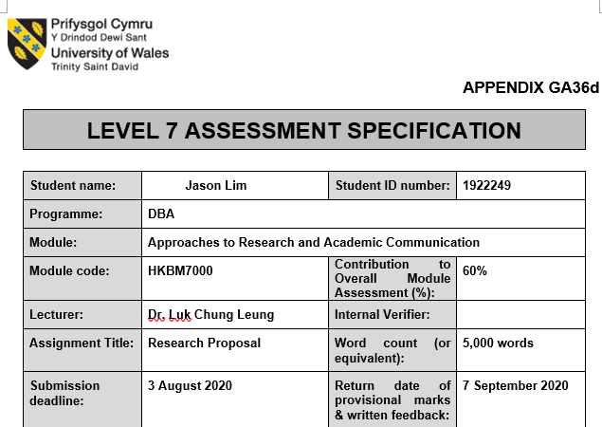
HKBM7000: Approaches to Research and Academic Communication

BY JASON LIM (1922249)

LECTURER: Dr. Luk CHUNG LEUNG

Word count: 5353

TITLE OF RESEARCH:

FUTURE of offices after the pandemic IN Hong Kong Context –

A CASE STUDY Research on compassionate leadership

Table of Contents
1 Abstract 3
2 Introduction 4
2.1 COVID-19 Pandemic and Its Impacts 4
2.2 Purpose, Aims and Objectives 5
2.2.1 Purpose 5
2.2.2 Aim 5
2.2.3 Objectives 6
2.3 Outcomes 6
3 Knowledge and information context 8
3.1 Literature Reviews 8
3.2 An Empirical Study on Compassionate Leadership 9
3.2.1 Compassionate Leadership 9
3.2.2 Wisdom (Knowledge + Experience) 10
3.2.3 Soul (Purpose) 10
3.2.4 Spirituality (Authenticity) 10
3.2.5 Hypotheses 11
3.2.6 Operationalise the constructs 11
3.3 Yu’s 3H Framework 13
4 Methodologies, Methods, source and Outcomes 14
4.1 Case Study Methodology 14
4.2 Qualitative analysis, Quantitative analysis, and Triangulation 15
4.3 Measurements 15
4.4 Timeline 17
5 Caveats 17
6 Ethical considerations 18
7 Summary 18
8 References 20

Abstract
Purpose – The purpose of this project is to research into the future and relevance of physical offices in Hong Kong after pandemic. This proposal lays out the research methodologies and approaches for this project. The objective is to identify impacts on property industry, especially offices, during COVID-19 and to predict future challenges. It will inform on the existing paradigms in the property industry thus reflecting current culture and development and how they may be shifted after COVID-19.
Study design and method - It will inform on existing knowledge and literature to validate the author’s choice on methodologies chosen for this research. The literature reviews are not exhaustive list of literature review. The methodology chosen for this research is Instrumental Case Study methodology. The primary data collection will be via questionnaire, surveys, and interviews. The data collected will be collated, exchanged and analysed to measure the effectiveness of Yu’s and Lim’s frameworks in making predicative outcomes.
Findings - The author’s initial finding is that both Yu’s 3H framework and Lim’s Trinity framework complement each other beautifully to provide predictive outcomes. It seems like Yu’s 3H framework focuses on the intelligence side usually associated with Key Performance Indicators (KPIs) while Lim’s Trinity framework focuses on the emotional side that usually associated with Objectives and Key Results (OKRs). The strengths of Yu’s framework are promoting long term relationship with stakeholders moving away from zero-sum game mentality while Lim’s framework is focused on the positivity, life giving elements and self-fulfilling environment. The two frameworks have in common is the focuses on ‘the human centric approach’.
Originality and value - The project is to prove the theoretical “Trinity Framework” that the author has conceptualised could be applied in resolving current issues and identifying future obstacles. The “Trinity” framework values Wisdom (knowledge + experience), Soul (purpose), and Spirituality (conscience / integrity). This framework will be applied simultaneously with Yu’s theoretical 3H framework and comparison of predicative outcomes generated from both frameworks.
The author’s project is to document first-hand experience on how these elements based on non-deficit theories work and if there is a relationship between the two frameworks. It is foreseen that this publication will document the whole process on how Yu’s and Lim’s frameworks have been applied to prove their effectiveness.
In conclusion, this research plan paves a new path to strengthen the author’s knowledge and to be an expert in Lim’s Trinity Framework. This may open new windows of opportunity to contribute in both commercial and academic environment, which appeals greatly.

Introduction

COVID-19 Pandemic and Its Impacts
The coronavirus pandemic was first discovered in December 2019 in China. It had wreaked havoc and resulted in soaring death tolls across the world. Countries were locked down and many companies encouraged their staff to work from home. (World Health Organisation, 2020)
In Hong Kong, companies faced unprecedented challenges that most had to close and left many vacant offices in the market. [Gerrity, 2020] This phenomenon might have a long-lasting impact. As companies experimented with working from home and experienced that the company could still function without a proper office. This might lead to change in mindset that offices are not a necessity for companies. (Lingnan University, 2020)
Twitter was the first few to introduce policies that allow staff to work from home forever. (Fung, 2020)
Further research should be conducted to find out if work from home forever is a temporary phenomenon or a major leap into future of work where cloud is the business place signalling a paradigm shift that offices might not be an organisation artifact in future (Lingnan University, 2020). Such paradigm shift will require a different leadership style to navigate that unchartered territory as it involved decisions in unchartered territory that are more on humanity than business related.
Traditional leadership theories from Great Man to Transformation Leadership may find it challenging in current pandemic situation as they cannot rely simply on their cognitive ability (Bolden, et al., 2003). Cognitive ability in problem-solving does not mean having ability to handle the emotional stress that come with the pandemic situation and the ongoing impacts on the organisation.
In such a crisis, a different style of leadership may be required. A leadership that possess the qualities and competencies identified in the established leadership theories but lead by compassion, empathy, love and understanding. During and post pandemic situation, where the economy and even the world could be reset, will require leadership that can look beyond profit and loss but seeing staff and even clients as fellow human beings (Davies, 2020).

Purpose, Aims and Objectives
Diagram 1: Purpose, Aims and Objectives

Purpose
This project opens opportunities to develop Lim’s Trinity framework on compassionate leadership and contribute to organisational development theories in Asian context. Many leadership styles that have been recognised focus on the analytical power of leaders (Cowen, 2018) but not many propagate to lead with the heart (McGovern, 2014). Compassionate leadership is about using heart of leaders to connect with various stakeholders and making decisions from an empathy perspective (West, et al., 2017).

Aim
The aim of this project is to research the cohesiveness of Yu’s 3H framework and Lim’s Trinity framework when applied simultaneously. Currently, there are limited empirical studies on compassionate leadership. The author noted that Yu’s 3H framework focused more on the intelligence of leaders (Yu, 2015) while Lim’s Trinity framework focused more on the empathy of leaders. The goal of this project is focused on developing Trinity framework while applying it simultaneously with Yu’s 3H framework to study and make predictive outcomes on future of Hong Kong property industry.

Objectives
The objectives are performing deep research to study Hong Kong property industry during the coronavirus pandemic which does not seem to be slowing down or going away by applying both Yu’s 3H framework and Lim’s Trinity framework. There are two objectives in this project. The commercial objective is to make a holistic review and making effective predictive outcomes in current and future situations of Hong Kong property industry after the pandemic.
Another objective is developing Lim’s Trinity framework on Compassionate Leadership, which is to contribute to organisational development theory, and specialisation on this topic.
Lim’s Trinity framework has three constructs, which are Wisdom, Soul and Spirituality. In this framework, Wisdom is expression of knowledge and experience, Soul is the purpose, and Spirituality is authenticity.
This project attempts to achieve the following:
- Further contribution to the literature on Yu’s 3H framework and conceptualising Lim’s Trinity framework.
There is currently limited literature on applying Yu’s 3H framework although this framework is being taught in the DBA program of University of Wales Trinity and Saint David. The author holds deep conviction that Lim’s Trinity framework on developing compassionate leaders are necessary for the future. It is important as the world is changing expeditiously, and many decisions make with empathy will be more appropriate than decisions make with intelligence. This is an important contribution as these frameworks are driving towards effective organisational development in Asian context. A literature on these frameworks can provide insights for further use as reference.

Outcomes
The common culture in Hong Kong property industry is to play by the rules and stick to what had worked in the past, however Hong Kong property industry is under tremendous stress under current pandemic environment. There may be a disruption in near horizon.
Changes are inevitable and successful companies are those that embrace them and mitigate negative impacts. There are many ways to drive and manage changes. From traditional methodologies like problem solving to systematic methodologies like lean six sigma that focus on the process largely ignoring the most important element – people’s positive emotions that determine the success (Cooperrider & Whitney, 2005).
A problem-solving methodological process entails identifying, evaluating, solving, and implementing to address an issue. It can be said that the starting point for problem solving methodologies commences from negative perspectives. Everyone will be looking at what and how the process goes wrong rather than what and how it can be done better. This approach does not invoke a sense of excitement since it may cause a person to become defensive, which leads to possible disinterest and becoming uncooperative. No one likes to have his or her mistakes exposed to public scrutiny regardless of context or situation. In this situation, there are seldom individual or group eureka moments. The above negative approaches to change are best summed up by Cooperrider and Whitney (2005).
The author has researched on several types of leadership. Most of the leadership styles focus on intelligence and the world needs more compassionate leaders. This project is to drive changes in current approach from gap analysis to Yu’s 3H framework and Lim’s Trinity framework that both frameworks move away from deficit-based approach. Both frameworks are new concepts and as such making the research more exciting and challenging at the same time. A change of paradigm of this magnitude requires a different approach, a positive approach!
The main output for this project is Lim’s Trinity framework for understanding and advancing organisational development theories on compassionate leadership.
Although there is plenty of literature on compassionate leadership, but they are not empirical studies to address spontaneous demands and pressures from the commercial world. There is also limited research on this topic conducted in Asia. Researching on this topic may result in wider acceptance of compassionate leadership as a leadership development in Asian context that link acceptance of valuable tacit knowledge and commercially available academic knowledge. This output is to bridge expectation gaps between organisation’s wants, leaders’ expectations, and employees’ deliverables.
This project aims to open dialogues in this field in organisational development by empirically researching on compassionate leadership.
This project opens possible trails for organisational development for a better understanding of Asians’ culture and leadership development.

Knowledge and information context
There is this element of exploration that is exciting about this project.

Literature Reviews
The rationale for literature search for this project is to focus on the areas which are relevant to the author’s personal and professional learning objectives on the organisational development’s goals of organisations and the contributions he can make to facilitating innovation through the research approach itself.
There are multiple sources for literature reviews in this digital age which are listed below, but not exhaustive:
- Books （hardcopy to electronic version） on advances in leadership, management, organisational behaviours, statistics, change management and culture change management.
- Journals, like Journal of Organisational Change Management, The Leadership Quarterly, and Journal of Leadership and Organisation Studies for latest academic papers.
- Magazines, like Harvard Business Reviews, for latest updates and insights
- Articles on compassionate leadership in websites like Academia, Researchgate, and other reputable online sources.
This research project is focused on identifying issues arisen in the property industry during the pandemic and future developments by applying Yu’s 3H framework, which are Heart, Head, and Hand as metaphoric expression for people, organisation, and competence (Yu, 2015) while Lim’s Trinity framework – Wisdom, Soul and Spirituality as expression for knowledge, purpose and conscience.
This research project will translate the Lim’s Trinity framework that the author has conceptualised into concrete. (Brown & Greene, 2006) The independent variables in the Trinity framework are Wisdom, Soul and Spirituality, which are metaphoric for knowledge and experience, purpose, and authenticity while the dependent variable is Compassionate Leadership.

An Empirical Study on Compassionate Leadership
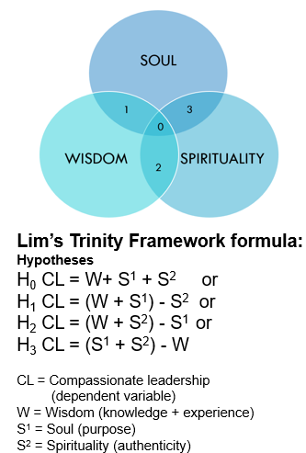
Diagram 2: Conceptualising the Trinity Framework

Compassionate Leadership
A compassionate leader could be seemed as soft for demonstrating their humanity. Compassionate leaders are not weak because it takes a lot of courage for a person to be willing to put themselves in a vulnerable position. Compassionate leadership is about making tough decisions with empathy. A compassionate leader is comfortable of oneself to be authentic. (Grant, 2008)
Atkins and Parker (2012) define compassion as a process involving feeling and action. West and his team outlined the relationship of compassionate leaders and problem-solving through demonstration of four compassionate behaviours in attending, understanding, empathising, and helping that create a compassionate culture (West, et al., 2017).

Wisdom (Knowledge + Experience)
Wisdom is an essential part in creating inner meaning for self-transcendence that is indispensable to leadership (McKenna, et al., 2009). Aristotle pointed to interdependence of practical wisdom and moral virtue in leadership (Parellada, 2005).
Wisdom has a critical role to play in compassionate leadership as it is required to make sound judgement especially in current pandemic situation. There is a succinct difference between wisdom and intelligence. Intelligent leaders may not have wisdom, but a wise leader will have intelligence. Wisdom is multifaceted and intelligence is not the one and only requirement (Rani & Devi, 2017).
Wisdom could be measured using self-report measures and performance-based measures. Self-report measures available are Three-Dimensional Wisdom Scale (3D-WS), Self-Assessed Wisdom Scale (SAWS), and Adult Self-Transcendence Inventory (ASTI). Performance-based measures available are Berlin wisdom paradigm (BWP), Bremen wisdom paradigm (Glück, et al., 2013).

Soul (Purpose)
The essence of purpose-driven leadership is much more focused on the rationale and purpose encompasses life’s meaning and indicates what one lives for one’s deepest aspirations (Cardona, et al., 2019).
A purpose provides not only a direction but a mission to achieve greatness in one’s life. A leader without a purpose in life is like a ship without a rudder and unable to reach its destination or full potential. Purpose-driven leadership
Empirical consideration using instruments like Purpose in Life (PIL) test by Crumbaugh & Maholick (1964), Sense of Purpose in Life Scale by Ryff (1989), and Life Attitude Profile by Reker and Peacock (1981).

Spirituality (Authenticity)
Authenticity is the free and natural expression of core feelings, motives, and inclinations (Kernis, 2003). Leroy, Palanski and Simons (2012) observed that authentic leaders are more aware of the values that drive their decision so that the values align with their words and actions.
Authenticity is important in compassionate leadership because being authentic means a leader is not faking his behaviors but instead walking their talks.
Authenticity could be measured based on standardised scores on these components - leadership behaviours, future orientation, and ethical climate of the organisation (Jensen & Luthans, 2006).

Hypotheses

H₀ CL = W + S¹ + S²
Leader who scores well in wisdom, soul and spirituality will be a compassionate leader as they will be able to make sound decision that put people first from a compassion perspective. comparing to other leadership styles of achieving results with little respect to other living beings.
H₁ CL = (W + S¹) - S²
Leader that scores low in spirituality (authenticity) may make decisions to benefit themselves as they might lack moral parameters and far remove from their own aspirations and values. Other noticeable effects could be observed in their relationships with stakeholders. Lack of authenticity results in relationship built on sand and not long lasting.
H₂ CL = (W + S²) - S¹
Leader that scores low in soul (purpose) may make decisions that does not have a defined purpose to decide what may be best for the company. Purpose is like a compass and loss of direction could be detrimental to a company resulting in its ability to survive during crisis. A leader’s purpose is not developed or discovered overnight but a journey that requires a lot of efforts and forge through deep reflections.
H₃ CL = (S¹ + S²) - W
Leader that scores low in wisdom (knowledge + experience) may be reflected in the decisions they make that may be detrimental to the company as they may not have the required mental ability in making sound judgement.

Operationalise the constructs

Compassionate Leadership
Holistically, compassionate leadership build on the competencies of a leader as identified in leadership theories but leading with compassion, empathy, love and understanding.
Compassionate leadership will look at current pandemic crisis differently by putting people first. Their decisions will place more concerns for their people not just for publicity but truly care about their staff’s wellbeing, rather than company’s profitability.

Wisdom
Continuously learning and doing to accumulate knowledge and experience.
A compassionate leader would demonstrate that they have more than intelligence but also wisdom. This construct can be demonstrated and measure by the quality and effectiveness of their decisions during times of uncertainty.

Soul
Knowing oneself through years of reflections and understanding oneself to lead with a life that is purpose driven.
A compassionate leader can reflect deeply to discover their life passion and values that translate into a purpose-driven lifestyle. This construct can be observed from the passion and drive to making an impact in people and organisation.

Spirituality
Ability to face vulnerability in public domain. Being authentic to build long lasting rapport and relationships.
A compassionate leader will demonstrate his authenticity when he is comfortable in drawing positive psychological capacities and encourage greater self-awareness and self-regulated positive behaviour. Such leaders also possess positive attributes that have optimistic outlook (Jensen & Luthans, 2006).

Yu’s 3H Framework
Diagram 3: Yu’s 3H Framework
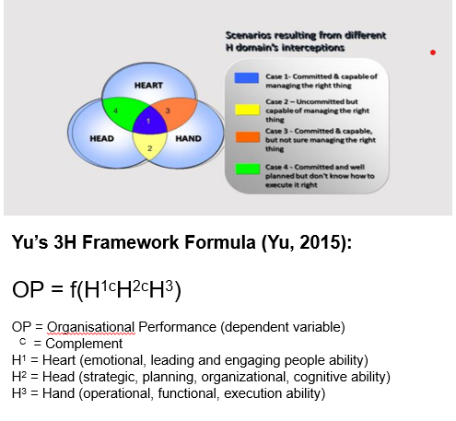

The constructs in this framework are Head, Heart and Hand. These are metaphoric expression to represent vital dimensions of people, organisation, and competence. It is proposed as a holistic solution to manage people and organisation issues means all 3H dimensions have to be effectively and efficiently managed in order to create their best performance (Yu, 2015).
Yu’s 3H Framework was conceptualised after observing that sound strategies and plans at all levels are necessary but not sufficient to guarantee the achievement of organisational goals and objectives, and identified that it also required effective organisational strategy implementation and required competencies (Yu, 2015).
In June 2020, Yu (2020) applied this framework to analyse China’s leadership and strategy in combating the Coronavirus pandemic.

Methodologies, Methods, source and Outcomes
Diagram 4: Methodologies, Methods, Source and Outcomes
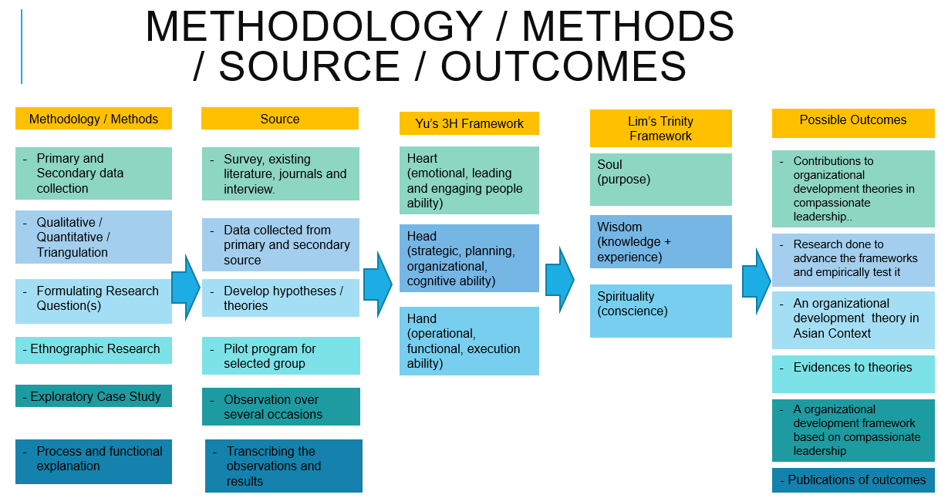

Case Study Methodology
This research will be applying instrumental case study methodology, which is ethnologically based. This will be supported through using different tools like conversations, interviews and surveys conducted. This approach is useful for in this research as it can illustrate what has worked well, what has been achieved and what have been the issues or dilemmas. As Yin (1984) puts it that case study methodology is an empirical research inquiry that examines a real life contemporary phenomenon, where there exist many grey areas, and allowing multiple sources of evidence to be used, which are needed for this research to make sense of that situation.
The author chooses instrumental case study methodology as this type of case study is used for providing insights into an issues and/or refining a theory (Yin, 2003). It emphasises the detailed contextual analysis of Yu’s 3H framework and Lim’s Trinity framework on reviewing and predicting future of offices after the pandemic in Hong Kong context.

Qualitative analysis, Quantitative analysis, and Triangulation
The project will start with determining and defining the research questions for surveys and interviews. It will encompass planning and designing of the entire blueprint of this research after setting the parameters deriving from insights collected.
The author will determine appropriate data gathering and analysis techniques.
The preparation to collect the data may include scheduling meetings with relevant stakeholders to gain insights from their perspectives. The insights collected will be put through a couple of pilot testing before sending out to the field.
Surveys and questionnaires may also be utilised for collecting data in the field. During this stage, the entire implementation process will be documented, and data analysed to draw some generalisations and trends (Malhotra, 2007).
Itemised rating scale will be applied in the form of semantic differential scale and/or Likert Scale (Malhotra, 2007). Evaluating and analysing the data collected by triangulating the data and processing the data through Yu’s 3H framework and Lim’s Trinity framework.

Measurements
The Lim’s Trinity framework will be tested and measured using structural equation (SEM). SEM’s measurement model will be used for measuring the reliability and validity of the framework follow by assessing the structural model validity if the measurement method is valid. Lim’s Trinity framework has one construct with three measured indicators that would require a target sample size of at least 200 (Malhotra, 2007).
Discriminant analysis will be applied to understand the relationship between dependent and independent variables (Malhotra, 2007).
For hypothesis testing, the scales for measurement will be interval scale and scaling techniques like paired comparison scaling and itemised rating scales like Likert scale and Semantic Differential for analysing the variables (Malhotra, 2007).
There are four hypotheses in Lim’s Trinity framework and hope to achieve a Cronbach alpha’s reliability rating of at least 0.70 as the example set out in Table 1.

Table 1: Example of Cronbach Alpha presentation
 | Number of items | Cronbach Alpha
Wisdom | 10 | 0.7
Soul | 10 | 0.7
Spirituality | 10 | 0.7

Intercorrelations between factors will be measured on Yu’s 3H framework and Lim’s Trinity framework, where the acceptable rating to achieve is higher than 0.5 as set out in Table 2.
Table 2: Example of intercorrelations between factors in confirmatory sample (all values significant at 0.5 level)
 | Head | Heart | Hand | Wisdom | Soul | Spirituality
Head | 1
Heart | 0.5 | 1
Hand | 0.5 | 0.5 | 1
Wisdom | 0.5 | 0.5 | 0.5 | 1
Soul | 0.5 | 0.5 | 0.5 | 0.5 | 1
Spirituality | 0.5 | 0.5 | 0.5 | 0.5 | 0.5 | 1

Timeline
The time starts upon approval duly received from the University to commence the research program. This research will have six stages focusing critical element in each stage and become more manageable after taking the limited resources into consideration (Yin, 2003) .
Diagram 5: Proposed timeline

Caveats
The results from this project can be affected by the following constraints and limited resources:
- Funding
Funding is a common constraint among researchers without grants and/or financial supports from universities and corporations.
- Time
The author faces time pressure as a part time research to complete the research within the projected timeframe. This will be acutely felt during data collection and analysis stages.

- Manpower
The author does not have the luxury of hiring a research team to assist with his research.
- Possible change to research subjects/participants
The current turbulent situation in Hong Kong may see participants leaving their positions due to personal reasons and business circumstances.

Ethical considerations
There are at least two layers of ethical considerations in my project as follows:
- Code of ethics which should be standard for human participation, confidentiality, no harm, intellectual property, and permissions.
- Insider researcher - being in a senior role and researching on my own team or people junior to me can have an impact on their responses, the advantages and disadvantages of being an insider researcher, intended and unintended consequences, perceived consequences by participants.
- Implicit power – being senior management of client’s company to property agencies and agents might subject them to undue pressure of agreeing to do surveys and/or interviews.

Summary
The purpose of pursuing this doctorate is to quench a thirst for knowledge triggered from the conceptualisation of Lim’s Trinity framework. The author developed deeper knowledge in several areas of interest. The areas of interest are philosophy, positive psychology, compassionate leadership, organisational development, and innovation. Admittedly, the transdisciplinary knowledge could be developed through reading literatures deeply on these topics, but the author found no satisfaction by keeping the knowledge to himself. A wider calling is to share and transfer the knowledge to more people. It was decided to achieve the dissemination to more people by pursuing a doctorate. Through this doctorate, the possibilities of opening more channels for disseminating this knowledge are immense.
The project refers to ethnology in developing Lim’s Trinity framework for property industry in Hong Kong context. Most frameworks and theories on leaderships are developed in Western countries, which did not address Asian culture when such concepts were introduced in Asia. Frameworks in Western countries lacks empathy to Asians’ learning differences and culture inculcated from a tender age. This project looks for differences or similarities and provides links to generate positive impact in leadership development by adopting Trinity framework.
The timeframe for the whole project is projected to be 2 years. This is an instrumental case study research conducted within a specific time to prevent the project from overrun.
The constraints identified for this research program are time, funding, possible change to research subject/participants, and manpower to manage the research program. These are not unique problems, but they must be overcome to ensure completion of the research program as planned.
In conclusion, this research program may result in an empirical study of compassionate leadership that could effectively and efficiently making predictive outcomes of possible disruption to current paradigms experienced in Hong Kong property industry in respect to office rentals and its future.

References
Atkins, P. & Parker, S., 2012. Understanding individual compassion in organisations: the role of appraisals and psychological flexibility. Academy of Management Review, 37(4), pp. 524-46.
Baxter, P. & Jack, S., 2008. Qualitative case study methodology: Study design and implementation for novice researchers. The Qualitative Report, 13(2), pp. 544-559.
Bolden, R., Gosling, J., Marturano, A. & Dennison, P., 2003. A Review of Leadreship Theory And Competency Framework. [Online]
Available at: https://ore.exeter.ac.uk/repository/handle/10036/17494
[Accessed 20 07 2020].
Bolman, L. & Deal, T., 1991. Reframing Organisation. San Francisco: Jossey-Bass..
Bordens, K. & Abbott, B., 2011. A Process Approach - Research Design and Mehtods. New York: McGraw-Hill.
Bradberry, T. & Greaves, J., 2012. Leadership 2.0. San Diego: Talent Smart.
Brown, S. C. & Greene, J. A., 2006. The Wisdom Development Scale: Translating the Conceptual to the Concrete. Journal of College Student Development, 47(1), p. 1–19.
Cardona, P., Rey, C. & Craig, N., 2019. Purpose-driven Leadership. In: C. Rey, M. Bastons & P. Sotok, eds. Purpose-driven Organizations. London: Palgrave Macmillan, pp. 57-71.
Cooperrider, D. & Whitney, D. D., 2005. Appreciative Inquiry - A Positive Revolution in Change. San Francisco: Berrett-Koehler Publishers, Inc..
Cowen, A., 2018. About Leaders: 8 Leadership Styles: Which One Are You?. [Online]
Available at: https://aboutleaders.com/8-leadership-styles-one/#gs.c6sd82
[Accessed 15 07 2020].
Cross, N., 1982. Designerly Ways of Knowing. Design Studies 3.4, pp. 221-27.
Crumbaugh, J. & Maholick, L. T., 1964. An experimental study in existentialism: The psychometric approach to Frankl's concept of noogenic neurosis. Journal of Clinical Psychology, 20(2), pp. 200 - 207.
Davies, K., 2020. Compassionate Leadership During the COVID-19 Pandemic. Aircraft Maintenance Technology, Apr/May, p. 48.
Dru, J., 1996. Overturning Conventions and Shaking up the Market Place. New York: John Wiley & Sons.
Dunne, D., 2015. 'Two inquiry-based approaches to sustainable value: Positive design and integrative thinking" In Positive Design and Appreciative Construction: From Sustainable Development to Sustainable Value.. Advances in Appreciative Inquiry volume 3, pp. 195-214.
Fung, B., 2020. CNN Business "Twitter will let some employees work from home 'forever'". [Online]
Available at: https://edition.cnn.com/2020/05/12/tech/twitter-work-from-home-forever/index.html
[Accessed 12 July 2020].
Gerrity, M., 2020. World Property Journal. [Online]
Available at: https://www.worldpropertyjournal.com/real-estate-news/hong-kong/hong-kong-real-estate-news-jll-2020-property-market-monitor-hong-kong-office-rents-may-2020-hong-kong-commercial-real-estate-report-12001.php
[Accessed 05 07 2020].
Glück, J. et al., 2013. How to measure wisdom: content, reliability, and validity of five measures. Frontiers in Psychology, Volume 4, p. 405.
Gonzalez-Loureiro, M. & Jardon, C., 2013. Human Capital as Source for Sustained Competitive Advantages in SMEs: A Core Competencies Approach. Economy - Management series., December.pp. 255-276.
Grant, K., 2008. Who Are the Lepers in Our Organizations?: A Case for Compassionate Leadership. Business Renaissance Quarterly , 3(2), p. 75.
Grove, A., 1999. Only the Paranoid Survive: How to Exploit the Crisis Points That Challenge Every Company. New York: Currency Doubleday.
Hellström, I., Nolan, M. & Lundh, U., 2005. “We do things together.” A case study of “couplehood” in dementia. Dementia, 4(1), pp. 7-22.
Jensen, S. & Luthans, F., 2006. Entrepreneurs as Authentic Leaders: Impact on Employees' Attitudes. Leadership & Organization Development Journal, 12, 27(8), pp. 646-666.
Jensen, S. M. & Luthans, F., 2006. Entrepreneurs as Authentic Leaders: Impact on Employees' Attitudes. Leadership & OrganizationDevelopment Journal, 27(8), pp. 646 - 666.
Joia, L. A., 2002. Analysing a web-based e-commerce learning community: A case study in Brazil. Internet Research, Vol. 12 Iss: 4, pp. 305-317.
Kernis, M., 2003. Toward a Conceptualizeation of Optimal Self-Esteem. Psychological Inquiry, 14(1), pp. 1-26.
Kitchener, K. & King, P., 1981. Reflective judgement: Concepts of Justification and their relationship to age and education. Journal of Appied Developmental Psychology, pp. 89-116.
Knowlton, S., 2016. The Positive Effects of Stress. [Online]
Available at: http://www.healthguidance.org/entry/15537/1/The-Positive-Effects-of-Stress.html
Kotter, J. P., 1996. Leading Change. Boston, MA: Harvard Business School Press.
Leroy, H., Palanski, M. E. & Simons, T., 2012. Authentic leadership and behavioral integrity as drivers of follower commitment and performance. Journal of Business Ethics, 107(3), pp. 255-264.
Lingnan University, 2020. Survey Findings on Working from Home under COVID19. [Online]
Available at: https://ln.edu.hk/research-and-impact/research-press-conferences/survey-findings-on-working-from-home-under-covid19
[Accessed 10 07 2020].
Lotzkar, M. & Bottorff, J., 2001. An observational study of the development of a nurse-patient relationship. Clinical Nursing Research, 10(3), pp. 275-294.
Malhotra, N. K., 2007. Marketing Research: An Applied Orientation. 6th ed. Upper Saddle River, NJ: Pearson/Prentice Hall.
McGovern, G., 2014. Harvard Business Review: Lead from the Heart. [Online]
Available at: https://hbr.org/2014/03/lead-from-the-heart
[Accessed 15 07 2020].
McKenna, B., Rooney, D. & Boal, K. B., 2009. Wisdom principles as a meta-theoretical basis for evaluating leadership. Leadership Quarterly, 20(2), pp. 177-190.
Parellada, R., 2005. Aristotle's Theory of Practical Wisdom. The Modern Schoolman, 83(1), pp. 1 - 18.
Parl, U., 2013. Learning about a social system in the change process of your own organization: An analysis of an analysis. Journal of Managment and Change, pp. 105-123.
Rani, G. S. & Devi, M. S., 2017. Relationship between intelligence and wisdom in older adults. IMPACT : International Journal of Research in Humanities, Arts and Literature (IMPACT : IJRHAL), 5(9), pp. 7-12.
Reker, G. T. & Peacock, E. J., 1981. The life attitude profile (LAP): A multidimensional instrument for assessing attitudes toward life. Canadian journal of Behavioural Science, 13(3), pp. 264 - 273.
Ryff, C. D., 1989. Happiness is every, or is it? Explorations on the meaning of psychological well-being. Journal of Personality and Social Psychology, 57(6), pp. 1069 - 1081.
Scheib, J. W., 2003. Role stress in the professional life of the school music teacher: A collective case study. Journal of Research in Music Education, 51(2), pp. 124-136.
Segal, S., 2005. Business Feel: From the Science of Management to the Philosophy of Leadership. New York: Palgrave Macmillan.
Soy, S. K., 1997. The case study as a research method. Unpublished paper, University of Texas at Austin.. [Online]
Available at: https://www.ischool.utexas.edu/~ssoy/usesusers/l391d1b.htm
Stake, R. E., 1995. The art of case study research. Thousand Oaks, CA: Sage.
Unluer, S., 2012. Being an Insider Researcher While Conducting Case Study Research. The Qualitative Report, 17(29), pp. 1-14.
West, M., Eckert, R., Collins, B. & Chowla, R., 2017. Caring to change: How compassionate leadership can stimulate innovation in health care. [Online]
Available at: https://www.kingsfund.org.uk/publications/caring-change?gclid=EAIaIQobChMI-IiV1rzy6gIVtMEWBR3pwQhUEAAYASAAEgJhBvD_BwE
[Accessed 15 07 2020].
World Health Organisation, 2020. Novel Coronavirus – China. [Online]
Available at: https://www.who.int/csr/don/12-january-2020-novel-coronavirus-china/en/
[Accessed 20 07 2020].
Yin, R. K., 1984. Case study research: Design and methods. In: Case study research: Design and methods. Newbury Park, CA: Sage, p. 23.
Yin, R. K., 2003. Case study research: Design and methods. 3rd ed ed. Thousand Oaks, CA: Sage.
Yu, E., 2015. Introudcing 3H Framework. Hong Kong: City University of Hong Kong.
Yu, E., 2020. A theoretical framework for analysing China's leadership and strategy in combating the Coronavirus pandemic, Hong Kong: Yu's 3H Framework Working Paper Series.

