On The Job
Performance management
1.
Discussion with line manager- who is also a director of the company.
When discussing the performance management of the company, there is only 1 appraisal per employee completed a year. It is much more of a review of individual performance than a tailored goal/target setting activity. Performance reviewed is usually the performance given over the last few months before the appraisal and not based on the whole year. An overall company target relating to overall sales growth is given and communicated to all during this time.
Remote working has caused some issues relating to performance management. Individuals asked to work from home found coping with their home life and completing all their role difficult, which meant for line managers and directors, checking work and productivity was impossible as they were in unprecedented times. The Director felt that employees should not be performance managed during this period of home working or challenged on why work was not completed because everyone was under enough stress already with the uncertainty of the economic climate/ pandemic.
The organisation is very reactive and tends to notice poor performance issues, rather than reward for high performance. Excellent customer feedback is always shared with all and recognised like this, however there is no formal recognition scheme and not all employees are customer facing.
Being a small team and everyone needing to play their part, poor performance is picked up quickly as it has a knock-on effect to others work. The company is incredibly slow with dealing with poor performance. Informal conversations will take place, but if the issue persists then there is a very slow response to formalising and dealing with the issue/behaviour. This is partly due to line managers not trained to manage staff, not knowing the HR processes, and from a lack of confidence due to this. The company has been stung before by not following routine HR processes which cost the company thousands to settle, which makes Directors hesitant to go into formal performance management processes with poor performing staff. We hope that the pressure from their colleagues to perform and pull their weight, along with coaching and mentoring from them will be enough to bring the employees performance back to where it should be. When this does not happen and poor performance continues, then a director will seek advice from our outsourced HR specialists and myself on what to do next. These steps are then followed and on the last 2 occasions, one member of staff has improved their performance, and another left after the first performance meeting. With these individuals the company followed the ACAS performance management procedure as they were capability issues and not conduct issues (ACAS, 2019).
It is extremely difficult to manage friends and family, and we trust that they have enough respect for us as Directors/friends/family, that they would not perform poorly and ask for the help they need before their performance reaches a stage where we must consider dismissal.

References:
ACAS (2019). Capability procedures | Acas. [online] Acas.org.uk. Available at: https://www.acas.org.uk/capability-procedures.

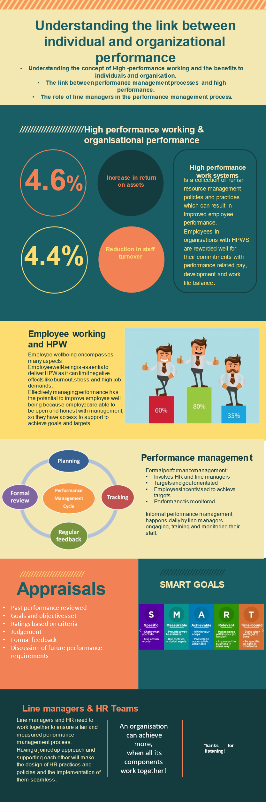
3.
After discussing my development needs with my line manager, she suggested that I need to spend some more time in the office when I am back to work full time after maternity leave. Completing training via remote means has worked for some but not others. She recommends doing some training in person with line managers, and then being available in person to offer further guidance and support. She thought my managers support sheet is a good prompt for them, as long as it is used continually as a live document and not forgotten about in a few weeks/months’ time.
Regarding formal performance management they are reluctant to give up control, due to previous incident. I acknowledged this and they would like me to take more control, but always to check with them first, or Redkite before proceeding with anything formal due to the risk to the company if anything was to be done wrong.
She suggests that I attend some Redkite workshops and training as soon as they are back running, which should be imminently, to gain more practical knowledge outside of the course.
The director is concerned that with the shortage of HGV drivers, along with general shortages, that we do not want to lose any staff at the moment, so feel currently the employees have significant power over the employer.

