Georgeta Antoche
1816337
M4X01916
Marketing Essentials
Lecturer Olu Adegbite

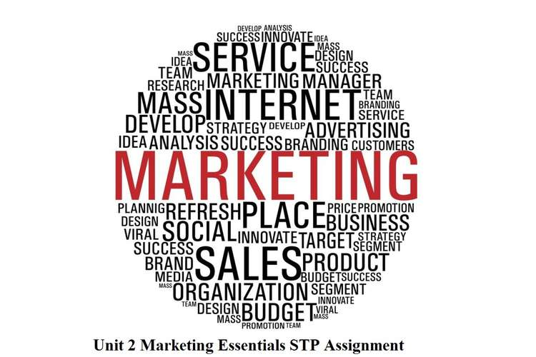

Contents
Introduction………………………………………………………………………….3
Discussion/ Evaluation and Critical Analysing……………………...………..3
Conclusion…………………………………………………………………………..5
References…………………………………………………………………………..6

Introduction
Currently, tourism is one of the outstanding significant factors in the marketing industry because of the constant movement of people outside their normal environment, usually for more than one night. In 2019, 38.8 million of visitors flew over to the UK and spent no more than 29.8 billion of pounds (VisitBritain,2019), not only increasing the total of jobs in tourism by 360,000 but also giving companies advanced ideas of improvement because of the tourists' continual change of needs that may alter from different perspectives. That may include the food service, lodging, recreation, and the transport that consumers use. There is a considerable difference between customers and consumers; that customers purchase products from a specific business or brand, whereas the consumers use the goods and services given. Companies' goals may as well include achieving their target-the needs of customers/consumers. One way to top the obligation of the further need for on-going development is by utilizing the system of marketing information, which technically means the commitment of finding out data to benefit the company advance. There are diverse types of products, which are part of companies still the focus will be on intangible products such as hotels, restaurants, bars, or clubs. For example, Marriott is a real-life intangible product which is situated in Birmingham City Centre in the UK, attracting tourists mainly for lodging, yet it is also known for its recreational side.

Discussion/Evaluation and Critical Analyses of Marriott
It established in Washington D.C. 1969, but soon after the chain of hotels grew in size and popularity overboard, so it ended up expanding in over 110 countries, starting as a limited business as a bar. An observation formed might be that this company began with a low market growth but over time, the increase materialized in the company.
It seemed that one complex strategy used by the company was to spread internationally, resulting in the company's success. Rather than keeping the association secure/national and risking to suffer from no international opportunities or even end the home market established (Kotler, Armstrong, Harris and Piercy,2017). With that in mind, the Marriott business decided not to go for the safe option, starting their global marketing and building relationships to form critical chains so the development of new product innovations will satisfy the customers' needs (Lee and Carter,2012).
At this moment, consumers travelling around the world prefer extravagance hotels over average or mediocre lodging companies, which leads to the family's or friends' consumer to stay at the same luxury hotel as them. This change of factors enhances the development of the company's earnings, especially if one of the strategies is to provide discounts or offers if tourists arrive as a family, such as complimentary breakfast or 25% off. Other opportunities can also manage to let Marriot hotels on the News because of the special offers given to some extent. For example, exceptional discounts were offered to same-sex couples to support the LGBTQ community, which resulted in more consumers to lodge at the Marriott hotels. The opportunities benefited both the consumers and the business. Out of the information gathered, another observation made is the audience's age and income. Marriott does seem to attract families and couples, accomplishing the audience to be both adults and children because of the options of eating free or having family film nights. There are also gyms and swimming pools, which captivate older tourists. However, the genuinely immense prices, tend to be for an audience with a greater income. After all, there are still threats to the exact association. Some may include the competition that has formed because of how fortunate Marriott is and how hotels such as Hilton want to be market leaders. On the other hand, the company might always consider being a step further from the competitors by upgrading their hotels in a superior manner, so any exposures are distant. Nonetheless, other threats may consult of susceptibility to terror attacks because hotels are an uncomplicated target and such events, might cause eventual tourists not to settle in luxury hotels.
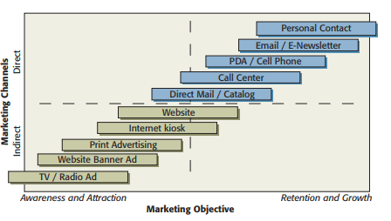
In spite of the risk, the Marriott chain is now multichannel, satisfying its consumers. The extension of the internet platform is truly one of the many approaches that the association uses because of how the management of the internet is now rising (even in the smaller firms), leading the firms to take advantage as a promotional intermediate (Wood,2001). One of the recent enhances is the creation of mobile apps, assisting the stay along with the purchases of the tourist indirectly. Meanwhile, direct interactions generate retention and a closer relationship with the customers, which would benefit the longevity of the client. Remarkably, retention is way more convenient than the appeal because regardless of the status of the hotel, the abiding customers will constantly be around the firm. Unfortunately, there has been a reason why indirect interaction is part of marketing with all said that is because of the recognition that the company earns by utilizing print advertisers or website banner ads.
On the contrary, the Marriott chain was not always as it is at the moment. In 2014, their share price was as low as 61.6 USD, even though in January 2016, there was an enormous deterioration from 62.5 dollars the exact, same month to $59.5, neglecting some of the firm's income. In addition, in Marriott's annual report, the company outlined how over $50 billion were spent in modern and contemporary hotels. One way that the association could have raised the sales was by moving nearer to the centroid of one more extensive section (Dickson and Ginter,1987). Moreover, the state shifted in the inception of the year 2018 when 147 USD were used on an individual, saleable stock. Because of the high profit, Marriott was able to accomplish18,000 more rooms in their hotel chain that year.
Fortunately, an alternative to detect the threats or strengths is to investigate the marketing information (Ismaeel,2015), which would additionally benefit the business and its consumers. MIS and especially marketing research would absolutely grant Marriott to individualize its marketing mix so consumers will be satisfied by the product (solution), price (cost), place (convenience) and promotions (communication). Of course, there are various types of marketing information and one of them is recurrent information, which is provided weekly, monthly or anytime set because it is data that is necessary for advertising the brand. Another type is monitoring information, which in theory means data about competitor's actions or the evolution of trends. Most of the time, this kind of information requires trade journalists who are being paid by the firm. At any rate, information can also be gathered by competitive marketing intelligence because the data is already public and is commonly about developments in the marketing environment, benefiting the Marriott chain in a way that their strategy will stand out. Whatever the case may be, this technique of collecting information is rising in usage by the association's competitors, inducing experienced teams to associate with the customers and find out more about what the clients determine as relevant for the company, suggesting that Marriot will need to advance their MIS in order to promote the business. Despite the opponents, the distinct company can still have data by applying marketing research, which would consist of an analyses selection that would include information just for the hotel chain. In consideration, there are distinct kinds of sources such as primary and secondary. Taking this in the account, primary sources are more effective than others because of the specialized data that they provide and reliable sources, even if they would be more expensive than the secondary type. Either way, the MIS benefits the relationship between Marriot and the customer because of the well-planned marketing management. That would result in the firm to give out discounts and promotions. knowing that customers prefer them.
Also, it seems that company's method is to know the macroenvironment such as the trends or technology so they will recognize what there is to improve in the microenvironment, which would contain the customers, distributors or suppliers.
Out of the examples, such as the family or same-sex couple trends, which were most presumably monitoring information, there is a remarkable usage of MIS and it is really effective on the Marriot business. That is because of how they are using the data to advance; there are hotels in over 110 countries, helping out tourists chose their next destination and pick the Marriot company in any country they are choosing to visit, improving the association's place or convenience.

Conclusion
To conclude, the strategies applied to the firm helped the Marriott hotel chain. Shockingly, even minor solutions impacted the estate in an impressive manner. By solving complications instead of leaving them, it proved the business's professionalism. Furthermore, the experience that the company gained effectively, will benefit the eventual projects that are about to rise. Besides their hospitality towards tourists has made an impact on their decisions, inducing the visitors to stay at the Marriott hotels in the near future, accomplishing a relationship with the client. Furthermore, Marriott's well management of MIS helped them achieve the results wanted, identifying that this company utilized primary sources and advanced approaches, such as competitive information intelligence.

References
- Dickson, P. R. and J. L. Ginter (1987) Market Segmentation, Product Differentiation, and Marketing Strategy. Journal of Marketing, Vol. 51 No. 2, pp. 1-10.
- Ismaeel, (2015) International Journal of Business Management and Administration Vol. 4(3), pp. 044-053, Available at http://academeresearchjournals.org/journal/ijbma [Accessed 26/05/19]
- Kotler, P. Armstrong, G. Harris, L. C. and Piercy, N. (2017). Principles of Marketing, 7th European Edition, Pearson.
- Lee, K., and Carter, S., (2012). Global Marketing Management, 3rd Edition, Oxford University Press.
- VisitBritain,(2019). 2019 Inbound Tourism Forecast. Available at:
https://www.visitbritain.org/2019-inbound-tourism-forecast [Accessed 25/05/19]
- Wood, (2001) International Journal of Tourism Research Int. J. Tourism Res. 3,283-299 DOI:10.1002/jtr.315 [Accessed 27/05/19]

