Tesco report

Building a sustainable marketing relationship
A critical evaluation of the impact a sustainable customer relationship has on Tesco and its customers
Individual report
2210 words
Submitted on Turnitin
Date and time of the submission: 29th of November 2024, 11:59pm

Student:Mariana Alina Orbeci
Student id:2221040

Executive summary

This report critically evaluates Tesco's sustainable relationship marketing strategies and their impact on organisational performance and customer satisfaction. It examines discussed historical development, market position, financial performance, and marketing strategies focusing on customer segmentation, loyalty programmes, and sustainability initiatives.
The main findings are:
- Tesco’s strong brand, loyalty programmes like Clubcard and data-driven Customer segmentation contribute significantly to building and sustaining long term customer relationship.(Decision Marketing, October 6,2021)
- The company's sustainability initiatives, such as net 0 emission by 2050 and food waste reduction, enhance his critical reputation, though they face scrutiny over transparency and feasibility.(TescoPLC, September 2024)
- Tesco’s competitive pricing strategies and diversified services, such as financial products and online delivery, ensure its market leadership, though competition from discount retailers like ALDI and Lidl remains intense.(Tesco marketing strategy 2024)
The report concludes that while Tesco's marketing strategies effectively customers loyalty and organisational performance, greater transparency in sustainability metrics and proactive approach to ethical practises and are needed to enhance credibility and long term success.

Table of contents 1.Introduction…………………………………………………………4
• Overview of Tesco’s leadership and strategies.
2. Tesco’s Profile…………………………………………………………4
2.1 Historical Development…………………………………………………….4
2.2 Market Share………………………………………………………………………………5
2.3 Financial Performance………………………………………………………5
3. SWOT Analysis…………………………………………………………5
3.1 strengths …………………………………………………………………….5
3.2 weaknesses………………………………………………………………….6
3.3 opportunities………………………………………………………………….7
3.4 threats…………………………………………………………………………8
4. Mission statement……………………………………………………………………10
5.Data-Driven Marketing and Customer Relationship Management.10
5.1 Data Collection………………………………………………………………..10
5.2 Data Analysis……………………………………………………………………………..11
5.3 Ethical Data Evaluation…………………………………………………………………11
6. Customer Segmentation and Competitive Strategies………………11
6.1 Segmentation Strategies…………………………………………….11
6.2 Differentiation Strategies……………………………………………11
7. Ethical and sustainability policies and practices12
8. Conclusion and Recommendations for Tesco’s Sustainable Marketing Relationship…12
• Strategies for enhancing long-term credibility and success.
9. Recomandations………………..13
• Summary of findings and key takeaways.
10. Conclusion……………………..13
11. References…………..14
• Comprehensive list of all sources cited.

1.Introduction

Tesco is the UK's largest grocery retailer, recognised for its innovative approaches to customer relationship management and sustainable practises.(Supermarkets in the United Kingdom-statistics&facts,2024)
This report evaluates Tesco's strategies for building sustainable customer relationship under critical impact on organisational performance. Using academic references, this report assesses Tesco’s Segmentation, differentiation and sustainability efforts to highlight strengths, weaknesses and areas for improvement.

2.Tesco's profile
2.1 historical development


Tesco was founded by Jack Cohen in 1919 as a market stall in london's east and. In 1924 it was called “Tesco” from the combination of tea supplier initials, T. E. Stockwell and Cohen. By 1970s it became one of the largest supermarket chains in UK. Between 1990 and 2000 Tesco launch Tesco Bank, Tesco mobile and expanded into international marketing.(Tesco PLC History-Tesco Corporate Website)

2.2Market share

At present Tesco is the largest retailer in the UK, commanding a marketing share of around 27%. Despite the operation of discount chains Like ALDI and Lidl, Tesco has always maintained its market position by focusing on value, customer loyalty programmes and improving its online services.(Kantar Wordpanel, 2024-“UK grocery market share”)
Lately his market share has stabilised which showed that Tesco adapted to changing customer preferences.(Markets.com-Tesco share price: Navigating market trends, dec 20, 2023)
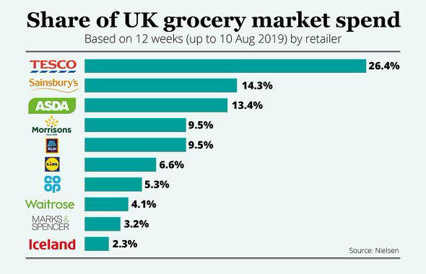
2.3 Financial performance

The fiscal year ending February 2023, this could reported an operating profit of £2.63 billion which indicate that Tesco remains profitable due to its financial services, its strong online and offline grocery business.(The annual report 2023, Tesco's financial performance)
Despite the inflationary pressure and supply chain challenges, the company has managed to sustain profitability.(The Guardian 2023-Tesco boss: food inflation has probably peaked but prices will stay high,16 June 2023)
- SWOT Analysis of Tesco
Tesco’s SWOT analysis provides an insightful overview of the internal and external factors influencing its business. However, a critical evaluation reveals how effectively these factors support Tesco’s strategic objectives and challenges.
(Business model analyst- Tesco sought analysts 2024, 4 June 2023)

3.1 Strengths

Strong Brand Image

Tesco’s reputation as the UK’s leading retailer ensures customer trust and loyalty. According to Kantar (2024), Tesco holds a 27% market share, significantly higher than its competitors. This strong brand image allows Tesco to retain its dominant market position.

Critical Perspective: While the brand is strong in the UK, its international reputation is less robust, particularly in markets like the United States, where Tesco faced failures (e.g., Fresh & Easy venture). This suggests that Tesco’s brand strength may be geographically constrained.

Efficient Supply Chain

Tesco’s supply chain is highly optimised, contributing to reduced operational costs and improved service delivery. Technologies like automated warehouses and data analytics enhance Tesco’s operational efficiency.

Critical Perspective: Although efficient, Tesco’s reliance on cost-cutting measures in its supply chain has occasionally led to quality issues. Reports of supplier dissatisfaction highlight the potential risks of over-optimisation (Baumann-Pauly & Scherer, 2020).

Large Store Network

Tesco’s vast physical presence enables it to cater to diverse customer needs. Its integration of in-store and online services provides a seamless shopping experience.

Critical Perspective: The large store network is both a strength and a liability. With increasing consumer preference for online shopping, some brick-and-mortar stores have become less profitable, leading to closures and redundancy costs (Mintel, 2024).

3.2Weaknesses

Adverse Effects of Cost-Cutting Measures

Cost-cutting strategies have impacted employee morale and supplier relationships. For example, reductions in staffing levels in some stores have led to customer service complaints.(Quandary consulting group, 21 December 2022)

Critical Perspective: While cost efficiency supports profitability, overemphasis on cutting costs risks undermining Tesco’s service quality, which is integral to customer loyalty.

Reputation Scandals

Tesco’s accounting scandal in 2014 severely damaged its reputation. Although the company has recovered, lingering skepticism among stakeholders reflects the long-term impact of such issues (The Guardian, 2017).

Critical Perspective: Effective governance measures are needed to rebuild trust fully. While Tesco has made strides in transparency, its recovery is not yet complete.

Online Delivery Challenges

Tesco’s online grocery service has faced criticism for delivery delays and stock issues, particularly during peak demand periods like the COVID-19 pandemic.

Critical Perspective: As the online market grows, Tesco’s delivery service must improve to remain competitive. Rivals like Amazon Fresh and Ocado have set higher standards for customer expectations.(Retail Gazette, 18 September 2024)

3.3Opportunities

Growth in Online Grocery Delivery

The COVID-19 pandemic accelerated the shift toward online shopping, and Tesco capitalised on this trend with its delivery and click-and-collect services.(Tesco PLV, 29 April 2020)

Critical Perspective: While the online grocery market presents growth opportunities, Tesco must address operational inefficiencies to fully realise its potential. Investments in delivery infrastructure are critical to competing with pure-play online retailers.

Sustainability Initiatives

Tesco’s commitment to net-zero emissions and sustainable sourcing resonates with eco-conscious consumers. Partnerships with organisations like WWF enhance Tesco’s reputation as an ethical retailer.

Critical Perspective: While these initiatives are commendable, the lack of concrete metrics and timelines undermines their credibility. For instance, achieving net-zero emissions by 2050 without clear intermediate goals raises questions about feasibility (Baumann-Pauly & Scherer, 2020).

Private Label Brands

Tesco’s private label products, such as “Tesco Finest” and “Tesco Everyday Value,” cater to both premium and budget-conscious customers. These products offer higher margins compared to branded goods.(Business Chronicler,2 august 2023)

Critical Perspective: The success of private labels depends on maintaining consistent quality. Any lapses in quality could harm Tesco’s reputation and customer trust.

3.4Threats

Intense Competition

Discount retailers like Aldi and Lidl continue to erode Tesco’s market share by offering lower prices. Tesco’s “Aldi Price Match” campaign is a defensive measure to retain price-sensitive customers.

Critical Perspective: Price matching is not a sustainable long-term strategy, as it risks compressing margins. Differentiation through value-added services may be more effective in countering discount competitors.

Economic Downturns

Inflation and economic instability impact consumer spending, particularly on premium products. Tesco’s diversified offerings help mitigate this, but challenges remain in retaining customer loyalty during tough economic times (Financial Times, 2024).

Critical Perspective: Tesco’s reliance on price-sensitive segments increases vulnerability to economic downturns. Diversifying its revenue streams, such as through financial services, is crucial.

Cybersecurity Risks

As Tesco increases its reliance on digital platforms, the risk of cyberattacks grows. Data breaches could harm both reputation and customer trust.(Tesco PLC-Cyber security, 18 May 2021)

Critical Perspective: Investing in cybersecurity measures is essential to safeguarding customer data and maintaining trust. Any breach could have long-term repercussions on Tesco’s brand.

Summary of Critical Analysis

Tesco’s SWOT analysis highlights significant strengths, such as its strong brand and efficient supply chain, which underpin its market leadership. However, weaknesses like cost-cutting measures and repetitional scandals pose risks to sustained growth. Opportunities in online grocery delivery and sustainability offer potential, but challenges such as intense competition and operational inefficiencies must be addressed. A more balanced and proactive approach is necessary to capitalise on opportunities while mitigating threats effectively.

This critical analysis underscores the need for Tesco to:
• Enhance its online delivery services.
• Provide measurable and transparent sustainability goals.
• Focus on differentiation strategies beyond price competition.

In this way, Tesco can strengthen its position as a sustainable and customer-centric retailer.

4.Mission statement

Tesco's mission statement highlights the company's customer-centered, continuous improvement in service, value and convenience to meet the needs of his shoppers. The customer first option is central to Tesco's sustainable marketing practises.(Tesco mission statement-“Serving shoppers a little better every day”. Annual report and financial statement 2021)
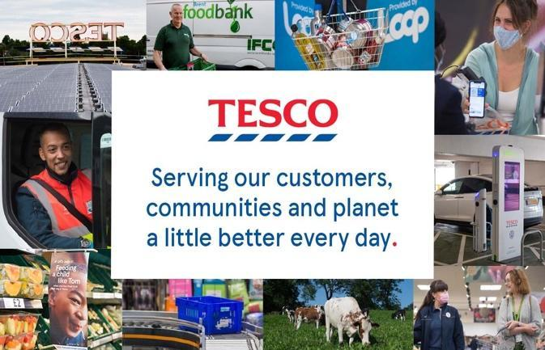

5.Data-Driven Marketing and Customer Relationship Management

5.1Data collection in marketing relationship

The ways Tesco is collecting customers data are:
- Through is loyalty programme new line
- Tesco club card which records customers purchases.
The reason behind this data collection is to build customer profiles, which allows to personalise marketing and product recommendations, And to build long term relationship with customers by meeting their specific needs.(Decision Marketing- Clubcard data in driving seat for Tesco growth strategy
OCTOBER 6, 2021)

5.2Data analysis

Through data analysis, Tesco can divide its customers base into groups based on purchasing patterns, Performance and demographics. Data analysis helps Tesco to manage inventory efficiently, to reduce waste and to forecast demand.(Business Research Methodology-Tesco Segmentation, Targeting and Positioning, 15 May 2016)

5.3Data evaluation

The continuous evaluation helps Tesco to refine its strategies and ensure that marketing efforts contribute to long term relationship sustainability.(“Data evaluation in marketing “-Harvard Business Review, 2022)
For sustainable relationship it is vital that the data collection it is being handled ethical and in this way gain the customer's trust.(“Ethical use of customer data”-a Tesco corporate responsibility report, 1 June 2022)

6.Customer Segmentation and Competitive Strategies

6.1Segmentation

Tesco employs a competitive pricing strategy, often bench marketing against discount retailers like Lidl and ALDI.
The “ALDI Price Match”campaign ensure that Tesco can offer similar prices maintaining the quality.
The purpose is to retain price sensitive customers without sacrificing its brand’s perceived value.( Retail Gazette,15 February 2023-“Tesco adds more products than ever to Aldi Price Match campaign “

6.2Differentiation

Compared with his competitors, tesco offers a wide range of services come up including banking, mobile on financial products. The Clubcard loyalty programme Provide personalised discounts and rewards, obtaining customer loyalty. Same day delivery and click and collect services, sets it apart in the increasingly Competitive online grocery market.(Richard Anderson BBC News-Tesco turns stale as competitors freshen up ideas)

6.3Ethical and sustainability policies and practises
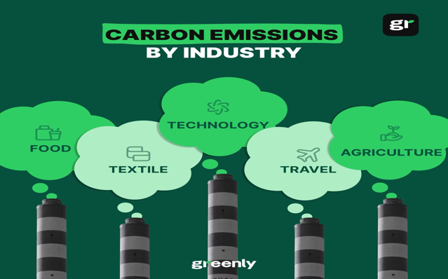

Some of the sustainability goals that Tesco is committed to are the reduction of carbon and ensuring that all its own brand products are sustainably sourced by 2030.

Another goals that Tesco is working towards are net-zero emissions by 2050 and is making efforts to reduce food wastage, through donations to local communities. (WWF and Tesco Partnership, 2022-“Food Waste Reduction Initiative”)
All these goals and the efforts that Tesco is committed to contribute to Tesco's reputation as an ethical retailer and it helps to build long term and trust based customer relationship.
Offering solutions two different customer segments and continuously improving experience through data-driven insights ensure that the retailer consistently met customers needs. This ethical and sustainable practises gain customer trusts, which is crucial to achieve long term loyalty and satisfaction. (Tesco Annual Report 2023-“Building long term customer loyalty “)

8.Conclusion and Recommendations for Tesco’s Sustainable Marketing Relationship

In order to provide a credible analysis over Tesco's sustainability goals, it is crucial to critically evaluate the factors digging under the credibility of the company’s stated commitments. Following, I will examine why the current analysis of Tesco sustainability goals lacks credibility, supported by updated references.

Ambiguous targets and lack of concrete
Sustainable sourcing by 2030 and net zero emissions by 2050 goals are ambitious but it does not clarify the metrics or strategies by which this will be achieved. According to an analysis by Baumann-Pauly and Scherer (2020), companies often set vague targets that appear impactful but lacks specificity, making it questionable about their viability.
The lack of mid term targets between now and 2050 live significant ambiguity in terms of progress tracking accountability.

Supply chain transparency issues
Tesco is supplying products from different countries with different environmental standards, and is making it difficult to ensure that all suppliers meet sustainable and ethical guidelines. Soundararajan et al(2021) highlighted that were supply networks are complex and involved multiple subcontractors it is challenging to achieve true supply chain transparency, which is essential for credibility and sustainability claims.

Food donation as a solution to food waste
Current research by Cicatiello and Franco(2022) suggests that rather than proactive approach to food waste, donations are often a reactive and is required a more systematic approach for significant food impact. Tesco’s donations improved its image but is questionable if are truly effective or merely symbolic or merely symbolic.

To: Executive Officer, Marketing Focus

Based on the report, Tesco demonstrates strong performance in areas crucial to building a sustainable marketing relationship, particularly through its loyalty programmes, data-driven marketing, and commitment to sustainability. However, certain areas require improvement to enhance long-term success and credibility.

9.Recommendations:

• Introduce measurable short-term goals for sustainability efforts, ensuring regular progress reporting to stakeholders.
• Invest in infrastructure to optimise online delivery and address peak demand challenges.
• Strengthen supply chain auditing processes to ensure compliance with ethical and sustainability standards.

10.Conclusion

Tesco’s dedication to sustainable marketing relationships has been instrumental in securing its strong market position and fostering lasting customer loyalty. By leveraging advanced segmentation strategies, the company tailors its offerings to diverse consumer needs, creating personalised shopping experiences that resonate with a broad customer base. Its innovative services, including the Clubcard loyalty program, same-day delivery, and click-and-collect options, further distinguish Tesco in a competitive retail landscape. Additionally, the company’s ethical practices, such as sustainability initiatives and efforts to reduce food waste, demonstrate a commitment to corporate responsibility and align with the growing demand for environmentally conscious business models.

However, to sustain and enhance this success, Tesco must address key challenges. Establishing clearer, measurable metrics for its sustainability goals, such as interim targets for its net-zero emissions commitment, is crucial to building trust and accountability. Improving supply chain transparency is equally important, as the complexity of global sourcing poses challenges in ensuring compliance with ethical and environmental standards. Furthermore, adopting more proactive strategies to reduce food waste, rather than relying solely on donations, can strengthen Tesco’s impact and credibility. By addressing these areas, Tesco can reinforce its position as a leader in sustainable retail while meeting evolving stakeholder expectations and achieving long-term success.

11.References:

1. Business Chronicler-Tesco Business Model Explained – What Makes It Successful?, 2 August 2023. Available at: https://businesschronicler.com/business-strategy/tesco-business-model-explained/
2. Business model analyst-Tesco SWOT analysis, June 4, 2023. Available at: https://businessmodelanalyst.com/tesco-swot-analysis/?srsltid=AfmBOorHgqzAi9JjpFYQuSbbEM1eAIJsXZwans2S3uPBg0kMRqD-aIUQ
3. Business Research Methodology-Tesco Segmentation, Targeting and Positioning, 15 May 2016. Available at: https://research-methodology.net/tesco-segmentation-targeting-and-positioning-2/
4. Cicatiello and Franco (2022)-Disclosure and assessment of unrecorded food waste at retail stores. Available at: https://www.researchgate.net/publication/338304570_Disclosure_and_assessment_of_unrecorded_food_waste_at_retail_stores
5. Decision Marketing-Clubcard data in driving seat for Tesco growth strategy, October 6, 2021. Available at: https://www.decisionmarketing.co.uk/news/clubcard-data-in-driving-seat-for-tesco-growth-strategy?utm_source=chatgpt.com
6. Ethical use of customer data-A Tesco corporate responsibility report, 1 June 2022. Available at: https://www.tescoplc.com/media/759057/tesco-annual-report-2022.pdf
7. Financial Times, 10 April 2024-Tesco forecasts rising profits as inflation ‘lessens substantially’. Available at: https://www.ft.com/content/04177d13-69e0-4c23-8c69-2c5e50b1181a
8. Kantar Worldpanel, 2024-“UK grocery market share”. Available at: https://www.kantarworldpanel.com/grocery-market-share/great-britain
9. Markets.com-Tesco share price: Navigating market trends, December 20, 2023. Available at: https://www.markets.com/education-centre/tesco-share-price/
10. Mintel, 2024-UK Convenience Stores Market Report 2024. Available at: https://store.mintel.com/report/uk-convenience-stores-market-report
11. Quandary Consulting Group, 21 December 2022-25 Detailed Cost Reduction Techniques for Growing Businesses. Available at: https://quandarycg.com/how-to-cut-costs-while-increasing-efficiency-in-your-business/
12. Retail Gazette, 15 February 2023-“Tesco adds more products than ever to Aldi Price Match campaign”. Available at: https://www.retailgazette.co.uk/blog/2023/02/tesco-adds-more-products-to-aldi-price-match-campaign/
13. Retail Gazette, 18 September 2024-How big a threat is Tesco’s new online grocery initiative to Ocado?. Available at: https://www.retailgazette.co.uk/blog/2024/09/tesco-transcend-ocado/
14. Richard Anderson BBC News-Tesco turns stale as competitors freshen up ideas, 2015. Available at: https://www.bbc.co.uk/news/business-29310445.amp
15. Soundararajan et al., 2021. Available at: https://strathprints.strath.ac.uk/78044/1/Sahasranamam_Soundararajan_BJM_2021_Innovation_ecosystems_what_makes_them_responsive.pdf
16. Supermarkets in the United Kingdom-statistics & facts, 3 May 2024. Available at: https://www.statista.com/statistics/280208/grocery-market-share-in-the-united-kingdom-uk/
17. Tesco Annual Report 2023-“Building long term customer loyalty”. Available at: https://www.tescoplc.com/media/u1wlq2qf/tesco-plc-annual-report-2023.pdf
18. Tesco Marketing Strategy 2024: A Case Study. Available at: https://www.latterly.org/tesco-marketing-strategy/?utm_content=cmp-true
19. Tesco Mission Statement-“Serving shoppers a little better every day”. Annual report and financial statement 2021. Available at: https://www.tescoplc.com/media/757589/tesco_annual_report_2021.pdf
20. Tesco PLC-Cyber Security – protecting customer and colleague data, last updated 18 May 2021. Available at: https://www.tescoplc.com/sustainability/documents/policies/cyber-security-protecting-customer-and-colleague-data
21. Tesco PLC-History-Tesco corporate website. Available at: https://www.tescoplc.com/about/our-history
22. Tesco PLC-Our latest response to COVID-19, 29 April 2020. Available at: https://www.tescoplc.com/our-latest-response-to-covid-19-29-april/
23. Tesco PLC-Tesco commits to net zero emissions from its supply chain and products by 2050. Available at: https://www.tescoplc.com/tesco-commits-to-net-zero-supply-chain-and-products-by-2050/?utm_source=chatgpt.com
24. Tesco Corporate, 2023-Sustainability and business practices. Available at: https://www.tescoplc.com/media/759030/tescocsrreview03_0-1.pdf
25. The annual report 2023, Tesco’s financial performance. Available at: https://www.tescoplc.com/investors/reports-results-and-presentations/annual-report-2023
26. The Guardian, 2017-High court approves £129m fine for Tesco over accounting scandal. Available at: https://amp.theguardian.com/business/2017/apr/10/high-court-approves-129m-fine-for-tesco-over-accounting-scandal
27. The Guardian, 2023-Tesco boss: food inflation has probably peaked but prices will stay high, 16 June 2023. Available at: https://amp.theguardian.com/business/2023/jun/16/tesco-boss-food-inflation-has-probably-peaked-but-prices-will-stay-high
28. WWF and Tesco Partnership, 2022-“Food Waste Reduction Initiative”. Available at: https://www.tescoplc.com/media/sm2hn54l/tesco-food-waste-report-jan24-96.pdf

