

Coursework Title: Computer Operating Systems
Module Name: Computer Architecture & OS
Module Code: ACCA 4022
Student Name: Methuseli Ncube
Student ID: 2507567
Lecturer Name: Md Shantanu Islam

Table of Contents.

Page 1: Front cover & title page.
Page 2: Content
Pages 3-5: Coursework overview, Task management, applications/program management
Pages 6-8: File system Architecture (windows NTFS), security management & windows Cli systems
Pages 9-14: DIR, CD, MKDR, RMDIR, ECHO, TASKLIST
Page 15-19: System information. I pconfig/all, ping, tracert, and use of Linux OS CLI commands.
Pages 20-24: Swiss User/SU, Is-List, Cd-Change Directory, make directory, Remove Directory
Pages 25-28: Touch, Echo & Cat, Config, Whoami, Date, and Run.
Pages 29 – 35: Windows OS Scripts, Installed Apps, Use Linux OS Scripts, and Bush script to add two numbers.
Pages 36 – 42: Examples of loops, explanation of the scripts, Linux CLI, and system control.
Page 43: References,
Page 44: Image

1. Coursework Overview
This report critically analyses the structural and functional design of modern operating systems, focusing on Windows and Linux as dominant multi-user platforms. It evaluates process scheduling, memory allocation, file system architecture, device abstraction, and security enforcement mechanisms. Operating systems are examined as resource managers that mediate between hardware and application layers, ensuring efficiency, concurrency control, and system stability [1]. The report further investigates command-line interfaces, including CMD, PowerShell, and Bash, highlighting their role in automation and system administration. The current OS research shows that scheduling efficiency and security enforcement are becoming more intertwined in today's computing systems, such as cloud and distributed computing systems [2].

2. Introduction to Windows Operating System
Windows, introduced by Microsoft in 1985, transitioned computing from text-based interfaces to graphical interaction, significantly improving usability. Contemporary studies show that Windows dominates desktop OS markets due to enterprise integration and hardware compatibility, although security vulnerabilities remain higher compared to Unix-based systems [3].

3. Task Management in Windows
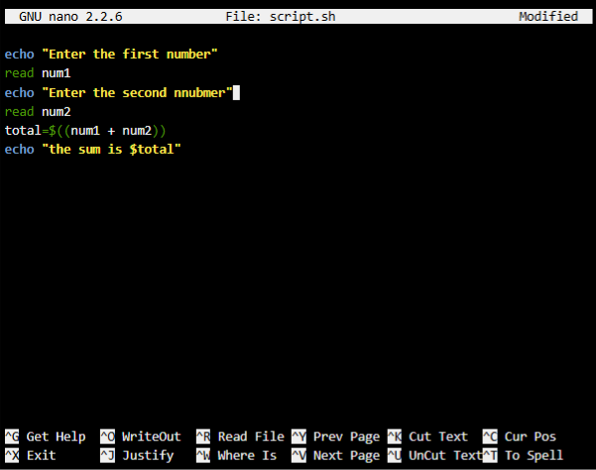
Windows employs a pre-emptive, priority-driven scheduling model, where CPU allocation is dynamically adjusted based on process classification and system load. High-priority foreground tasks receive greater CPU quantum allocation to ensure responsiveness, while background services operate under reduced priority levels. Empirical research shows that such hybrid scheduling improves interactive performance but increases scheduling overhead under high concurrency workloads [2]. The Windows Task Manager provides real-time process visibility, enabling performance monitoring and termination of resource-intensive processes. Even though priority-based schedulers are known to have some drawbacks, like priority inversion and thread starvation, especially with heavy multi-threaded workloads [4].

4. Application / Program Management
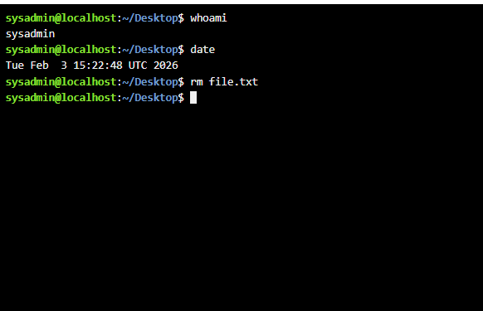
Windows application management is structured around MSI and MSIX frameworks, which provide transactional installation, rollback support, and dependency resolution. These mechanisms ensure application consistency across system environments. Digital signature verification reduces the execution of unauthorised binaries, aligning with modern endpoint security models [5]. Furthermore, Windows Package Manager introduces a repository-based deployment model similar to Linux package ecosystems, improving scalability in enterprise environments. Research, however, suggests that closed-source dependency management systems can result in a lag of vulnerability patching over open-source dependency management systems, which are community-driven with quicker and more transparent updates [3].

5. File System Architecture (Windows NTFS)
The NTFS file system uses a Master File Table (MFT) to manage metadata, enabling efficient indexing and recovery. Its journaling mechanism ensures transactional integrity by logging file system changes before execution (NTFS design principles, Microsoft Research lineage). Advanced features such as encryption and access control lists (ACLs) enhance data security. However, forensic studies indicate that NTFS encryption layers can complicate digital evidence of recovery in incident response scenarios [6]. NTFS also offers better low-level file operation transparency than Linux file systems (such as ext4), while offering greater integration with security policy.

6. Device Management in Windows
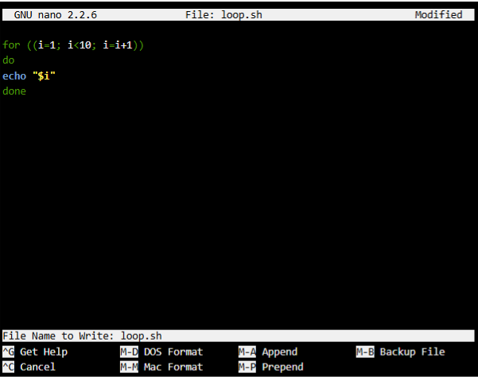
Windows uses Plug and Play (PnP) architecture to automatically detect and configure hardware devices through driver abstraction layers. Device drivers act as intermediaries between kernel space and hardware components, ensuring standardised communication. Windows Management Instrumentation (WMI) enables remote device monitoring and automation in enterprise networks. Research highlights that abstraction-based device management improves compatibility but increases kernel complexity and potential attack surface exposure [3]. Security issues in driver-level code continue to be a major risk vector for an OS, and if exploited, privileged access to the system can be gained through an OS kernel mode [5].

7. Security Management in Windows
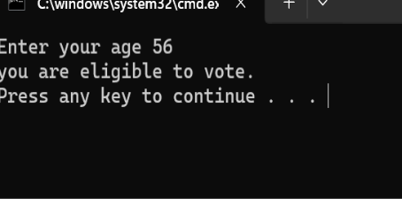
Windows implements a layered security architecture combining authentication, encryption, and real-time threat detection. Windows Defender uses behavioural analysis for malware detection, while BitLocker provides full-disc encryption using TPM-backed cryptographic validation (Microsoft security model). Role-Based Access Control (RBAC) restricts system privileges according to user roles. However, studies show that Windows environments remain more frequently targeted by malware due to widespread adoption and binary compatibility with legacy applications [3]. On the other hand, the Unix-based systems are much less prone to attacks because of the strict permission hierarchy and minimal kernel exposure [1].

8. Windows CLI Systems
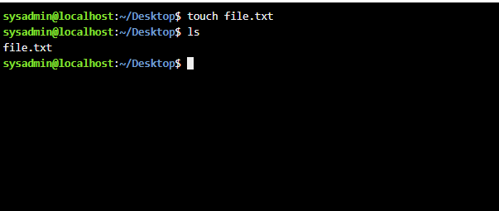
Windows Command Prompt and PowerShell enable structured system control, automation, and scripting. PowerShell enhances CMD by introducing object-based pipelines, improving administrative efficiency in enterprise environments. These tools are critical for system diagnostics, deployment automation, and infrastructure management (Microsoft system architecture studies).

Example 1: DIR

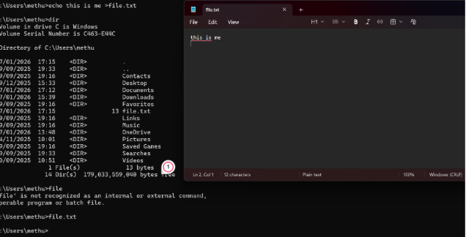
Answer:
The list of files and directories within the given path is presented with the help of the DIR command in the screenshot. It indicates that in the C:\Users directory, the name of the user, methu, has several subfolders and a single file, file.txt. The total file size of the folder is also given (179,033,559,040 bytes).

Example 2: CD
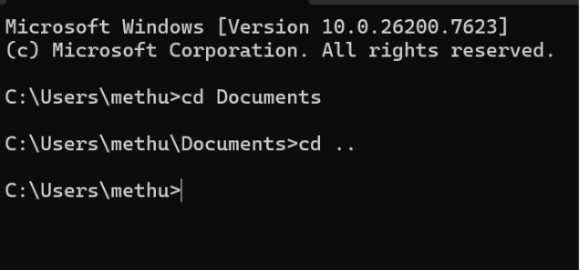
Answer:
The CD command stands for "Change Directory". In the screenshot:
- The command 'cd Documents' navigates to the Documents directory inside C:\Users\methu.
- The command cd .. moves one level up to the parent directory, returning to C:\Users\methu.

Example 3: MKDIR

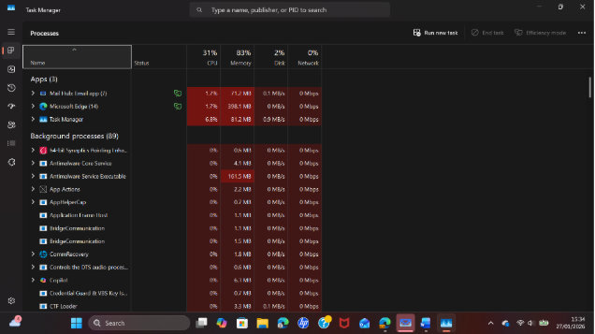
Answer:
But in the case of MKDIR, one creates a new directory using the command. Creation of a folder is a successful creation confirmation that has been made. As an example, when you enter `mkdir new_folder`, it would create a directory called `new_folder` at the current working path.

Example 4: RMDIR

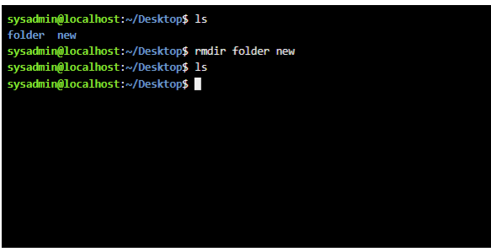
Answer:
The RMDIR command is used to remove directories. In the screenshot:
- The rmdir folder new command attempts to remove the folder and new directories.
- After running the command, the ls command confirms that the directories have been removed, as they no longer appear in the listing.

Example 5: ECHO

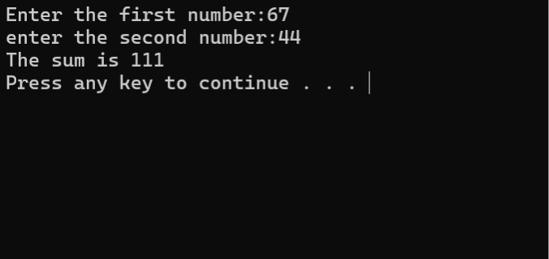
Answer:
ECHO command processes in the screenshot are the commands to display text or output in the command prompt. In this example:
- The program prompts the user to enter two numbers.
- The sum of the numbers 67 and 44 is calculated, and the result 111 is displayed using the ECHO command.
- The output confirms that the sum calculation was successful.

Example 6: Tasklist

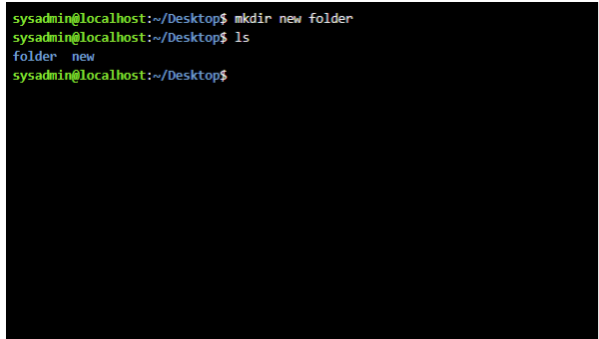
Answer:
The mkdir command is presented in the screenshot, and it is used to make a new directory named 'new'. After running the command:
- The ls command is used to list the contents of the current directory, confirming that the "new" folder was successfully created alongside the existing "folder" directory.

Example 7: Systeminfo

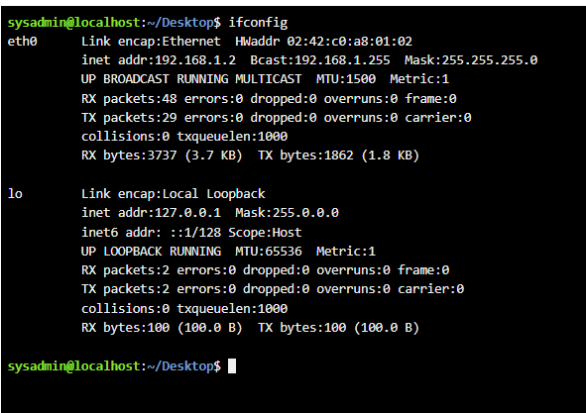
Answer:
The screenshot displays the ifconfig command, which shows network configuration information.
- The eth0 interface shows the IP address (192.168.1.2), broadcast address (192.168.1.255), and netmask (255.255.255.0). It also shows the number of received (RX) and transmitted (TX) packets and bytes.
- The lo (loopback) interface, with the IP address 127.0.0.1, provides information on local network traffic.
This command is used to check connectivity and interface activity of the network in Linux systems.
Example 8: Ipconfig /All
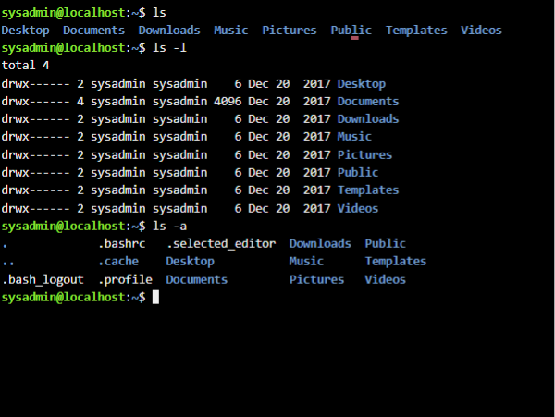
Answer:
The `ls` and `ls -l` commands in the screenshot show the contents of the user's home directory.
- ls lists the directories and files in the home directory.
- ls -l provides detailed information about each directory, including permissions, owner, group, size, and the last modification date.
The ls -a command shows all files, including hidden ones (e.g., .bashrc, .profile), in the directory.
It comes in handy to verify visible and/or hidden files and directories in a Linux environment.
Example 9: Ping
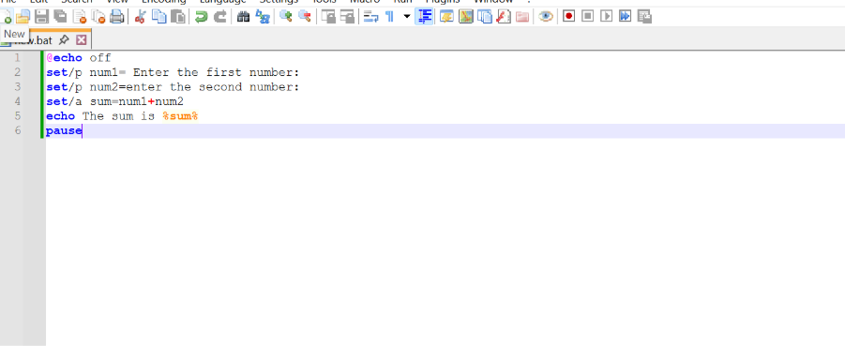
Answer:
The screenshot shows a Batch script for adding two numbers.
- set /p is used to prompt the user for input values (num1 and num2).
- The set/a command calculates the sum of the two numbers and stores it in the sum variable.
- 'echo' displays the sum, and 'pause' waits for the user to press any key before closing the script.
The script takes two numbers provided by the user and performs their addition and shows the outcome.

Example 10: Tracert
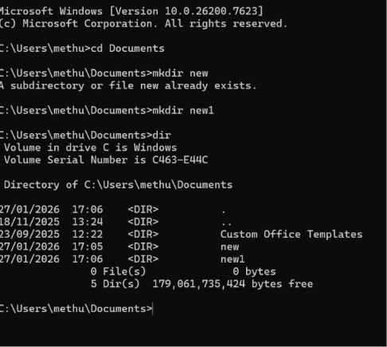
Answer:
The screenshot shows the mkdir command used in Windows:
- mkdir new attempts to create a directory called new, but it fails because the directory already exists.
- mkdir new1 successfully creates a directory called new1.
- The dir command lists the directories in C:\Users\methu\Documents, showing new and new1 among other existing directories.
This sequence shows how directories are created and then successfully displayed.

Use of Linux OS CLI commands
Answer:
Linux command line interface (CLI) tools allow direct communication with the operating system in the form of text commands to manipulate files, control processes, configure the system, and automate it [7]. Ls, grep, chmod, and bash scripts are also extremely popular with utilities that apply to efficient task execution, accessing remote servers, and managing server administration across Linux systems [1].

Example 1: SU – swiss user

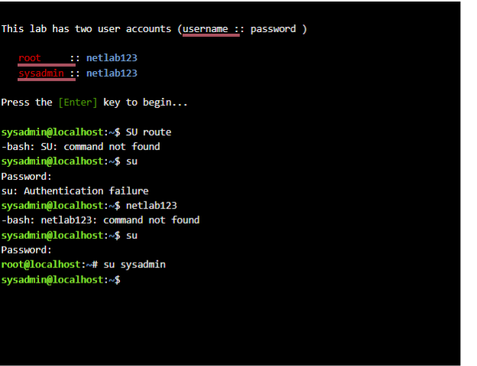
Answer:
The su command is used to switch to another user account in Linux.
In the screenshot:
- su route fails because the command is incorrect and the route is not a user.
- su prompts for a password but fails due to incorrect authentication.
- su sysadmin successfully switches to the sysadmin user after providing the correct password.
Example 2: PWD – present working directory
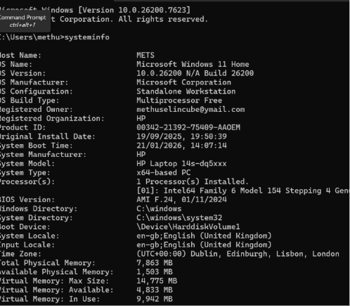
Answer:
The systeminfo command in the screenshot provides detailed information about the Windows system. It includes:
- Host Name: METS
- OS Version: Windows 11 Home, Build 26200
- Manufacturer: Microsoft, HP Laptop
- Processor: Intel64 Family 6 Model 154
- System Memory: 7,863 MB total, 1,503 MB available
- System Boot Time: 21/01/2026, 14:07:14
This command is used to provide the system configuration, hardware, and software information.
Example 3: ls – list

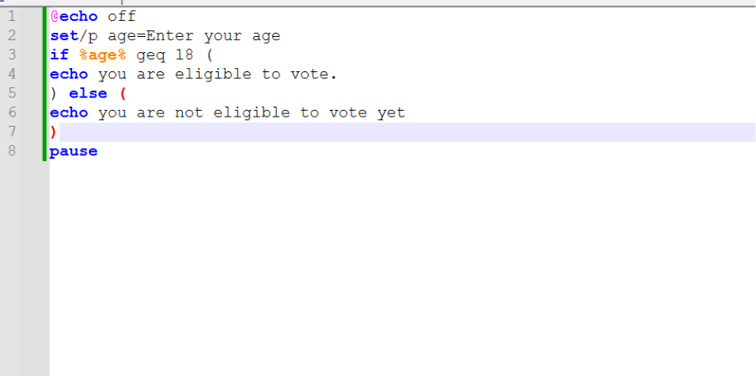
Answer:
The screenshot shows a Batch script that determines eligibility to vote based on age:
- The set /p command prompts the user to enter their age.
- The if statement checks if the age is greater than or equal to 18.
  - If true, it prints "You are eligible to vote."
  - If false, it prints "You are not eligible to vote yet."
- The pause command waits for the user to press a key before closing the window.
This is a simple age check script to check the eligibility of voters.
Example 4: cd – change directory

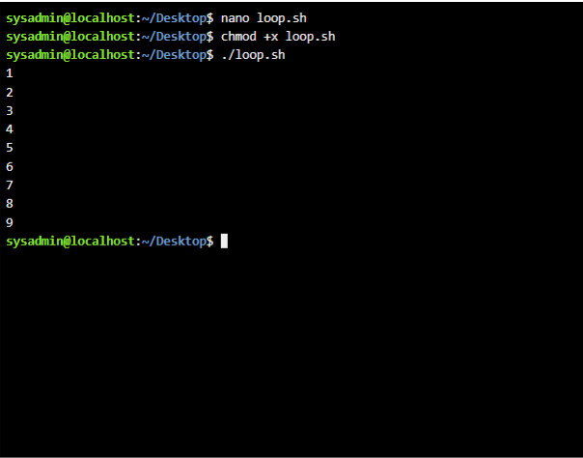
Answer:
In the screenshot:
- nano loop.sh opens the loop.sh shell script file for editing.
- chmod +x loop.sh grants executable permission to the script, making it runnable.
- ./loop.sh executes the loop.sh script, which outputs numbers 1 to 9, likely due to a loop in the script.
Example 5: mkdir – make directory

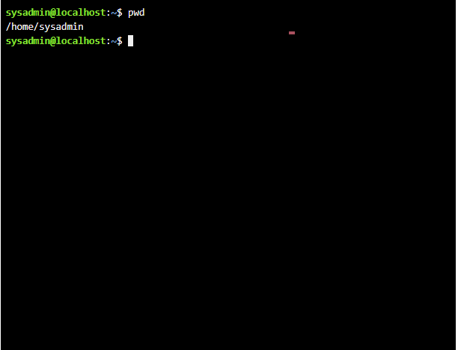
Answer:
The pwd command in the screenshot stands for Print Working Directory.
- The output /home/sysadmin shows the current directory path the user is in, which is the sysadmin user's home directory on a Linux system.

Example 6: rmdir – removes directory
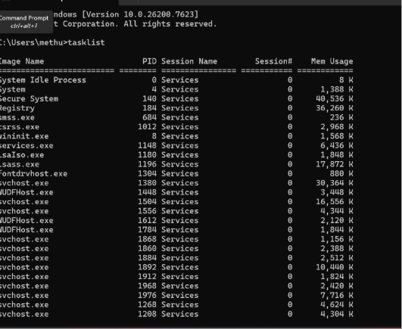
Answer:
The tasklist command in the screenshot displays a list of active processes running on the Windows system.
- Processes, such as System Idle Process, Secure System, svchost.exe and its PID (Process ID), session name and Memory Usage are displayed in the command.
- It can be applied to keep track of system activity and memory consumption of different processes needed to manage performance and debug.

Example 7: touch
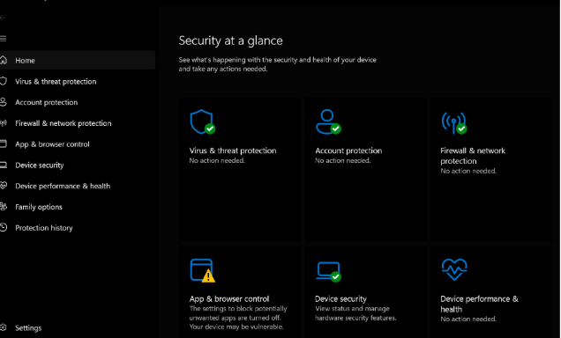
Answer:
The screenshot shows the Windows Security settings page.
- The Security brief section provides an overview of the system's security status, including the following:
  - Virus & threat protection: No action is needed.
  - Account protection: No action is needed.
  - Firewall & network protection: No action needed.
  - App & browser control: Indicates settings to block potentially unwanted apps.
  - Device security: Information on the security features of the device.
  - Device performance & health: Monitors the system's performance and health.
This page is part of Windows Security to manage device security and health.
Example 8: echo & cat
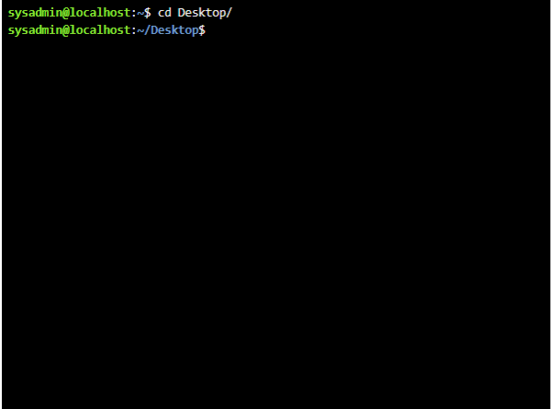
Answer:
In the screenshot:
- To switch to the Desktop folder, the Desktop/ command is to be utilised to change the directory. The prompt indicates that the user has navigated to a successful destination, which is the desktop of the user.
- This is a simple navigation command in Linux command-line interface (CLI), which permits people to change to different directories.

Example 9: if config
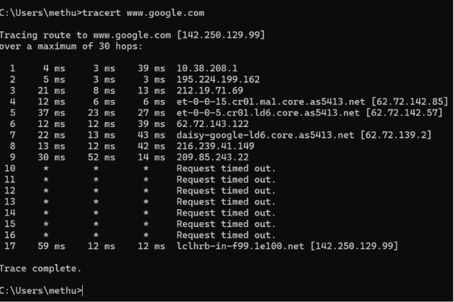
Answer:
The tracert command in the screenshot is used to trace the route taken by packets from the user's system to www.google.com:
- The command outputs each hop along the route, showing the round-trip time (in milliseconds) for each hop.
- Some hops (from hop 10 onward) show Request timed out, indicating that those intermediate routers are configured to not respond to ICMP requests.
- The final destination, lclhrb-in-f99.1e100.net, is successfully reached, with the trace completing.
This tool is useful for diagnosing network routing issues.
Example 10: whoami , date & rm
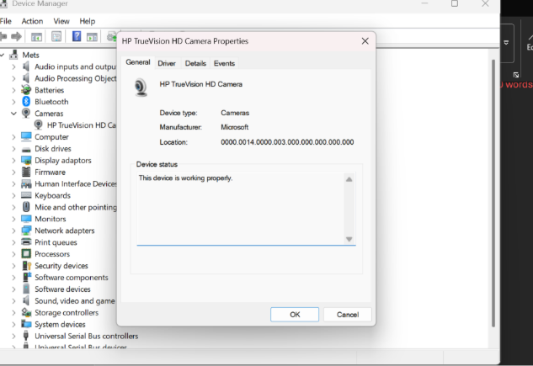
Answer:
The screenshot represents the device manager in windows, which is the HP TrueVision HD Camera properties.
- The Device Status indicates that the device is functioning properly.
- The Manufacturer is listed as Microsoft, meaning the driver is provided by Windows.
- The Location shows the hardware path for the device.
This is part of managing and troubleshooting hardware devices in the system.

Use of Windows OS scripts
Answer:
Windows can engage in Windows automation through batch scripting, which involves repetitive programming with simple text files having an extension of.bat. It is commonly employed in system administration, startup procedures, file control and scheduled tasks, enhancing speed and uniformity in standard procedures.

Example 1: Script to add two numbers 1A output of the script.
Answer:
The Batch script of adding two numbers is a script that involves simple input/output and arithmetic operations:
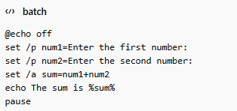
Explanation of the Script:
- @echo off: Prevents the script from displaying each command as it runs, making the output cleaner.
- set /p num1=Enter the first number:: Prompts the user to input the first number, storing it in the num1 variable.
- set /p num2=Enter the second number:: Prompts the user for the second number, storing it in the num2 variable.
- set /a sum=num1+num2: Performs the addition of num1 and num2 and stores the result in the sum variable.
- echo The sum is %sum%: Displays the sum of the two numbers.
- pause: Waits for the user to press a key before closing the script.

Example Output:
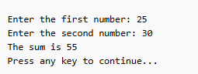
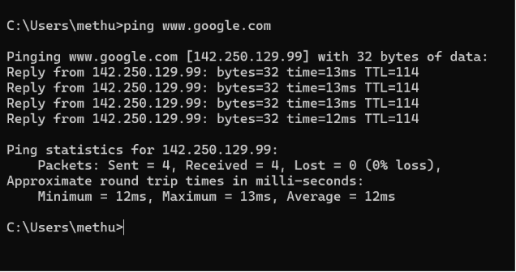

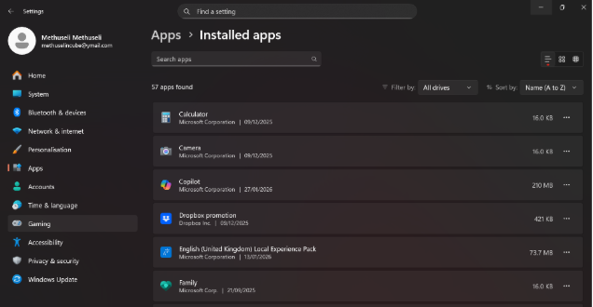
Example 2:
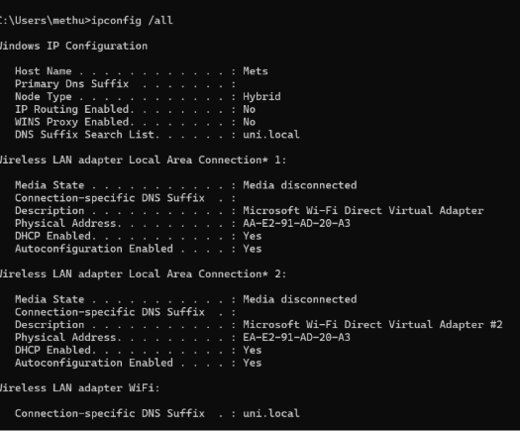
Answer:
In the given screenshot, ipconfig /all command shows the entire IP configuration of the system. It displays in-depth information of network adapters such as:
- Host Name: Identifies the device as Mets.
- DNS Suffix: Displays uni.local, indicating a local network domain.
- Media State: The two wireless LAN adapters (Local Area Connection 1 and 2) are disconnected.
- Wireless LAN adapter WiFi: Shows connection settings for an active wireless adapter, including DNS suffix and DHCP configuration. It also confirms Auto-configuration is enabled.
- Physical Address: Displays unique MAC addresses for the adapters, necessary for hardware identification.
- DHCP Enabled: Indicates if the device is set to automatically receive an IP address from a DHCP server.
This is critical information that is required in network troubleshooting, verifying adapter settings, and connection status.
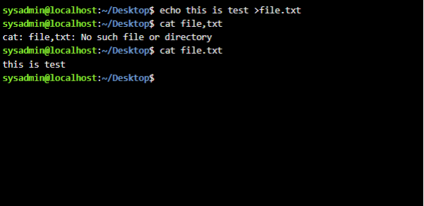
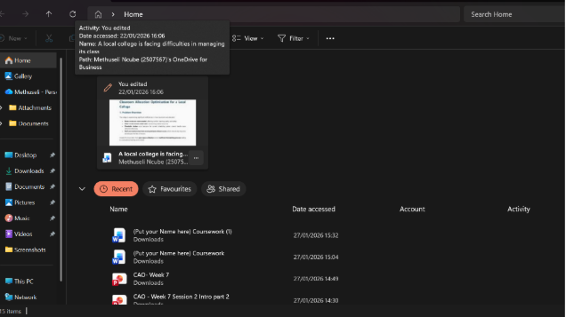
Use of Linux OS scripts
Answer:
BASH (Bourne Again SHell) scripting is the automation of Linux tasks, which involves the same combination of commands, control structures, and variables into the re-usable scripts. It is commonly utilized in system management, data recovery, log analysis, and automation of deployment processes, which saves much work and human error [7; 1].

Example 1: Bash script to add two numbers
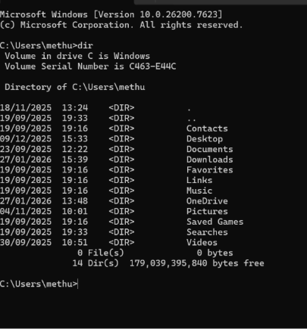
Answer:
BASH script that adds two numbers:
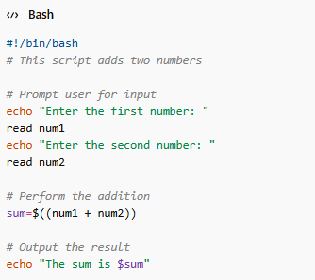
Explanation of the Script:
- #!/bin/bash: This is the shebang line, which tells the system that the script should be executed using the BASH shell.
- echo: Displays text prompting the user to input two numbers.
- read: Reads the user’s input and stores it in variables num1 and num2.
- sum=$((num1 + num2)): Uses arithmetic expansion to calculate the sum of num1 and num2, storing it in the variable sum.
- echo "The sum is $sum": Displays the result of the addition.
Example Output:
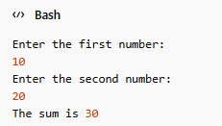
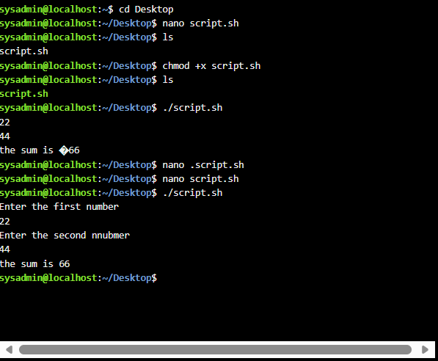
Example 2: example of a loop
Answer:
BASH script using a loop to display numbers from 1 to 5
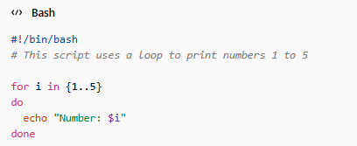

Explanation of the Script:
- #!/bin/bash: The shebang line to indicate that the script should be executed using the BASH shell.
- for i in {1..5}: A for loop that iterates through the range from 1 to 5.
- do: Marks the beginning of the loop's body.
- echo "Number: $i": Inside the loop, this command prints the current value of i for each iteration.
- done: Marks the end of the loop.

Example Output:
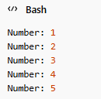
This script involves a for loop which goes through the numbers 1-5 and presents each of the numbers one by one. It shows simple looping of the BASH scripting, which is helpful in activities such as repetition or automation.

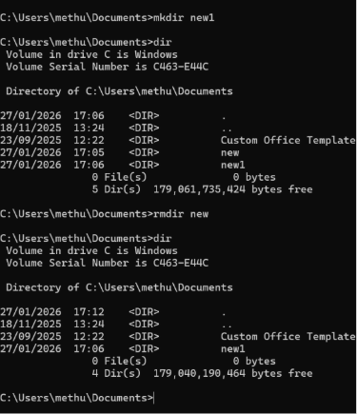
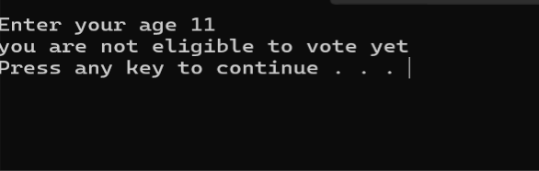
Conclusion
Summarise the report and your understanding of these tasks. (50 words)
Answer:
To sum it up, this report discussed key operating systems concepts, such as task management, file handling, and device management. It showed the application of CLI commands in Windows and Linux in real world scenarios as well as scripting examples to automate processes. These methods are essential in system management, automation and troubleshooting.

9. Linux CLI and System Control
Linux CLI provides direct kernel-level interaction through commands such as ls, chmod, and grep. Studies show Linux offers superior automation capability due to shell scripting flexibility and open-source transparency, making it highly suitable for server and cloud infrastructures [3].

10. Critical Comparison (Windows vs Linux CLI)
Empirical OS studies show that Linux provides higher system transparency and lower resource overhead compared to Windows, largely due to kernel design and modular architecture [2]. However, Windows offers stronger enterprise usability and GUI-based administrative abstraction. This trade-off reflects the classic OS design tension between usability and system control depth.

References
- Silberschatz, A., Galvin, P. B., & Gagne, G. (2006). Operating system concepts, windows XP update. John Wiley & Sons.
- González-Rodríguez, M. (2024) ‘Study and evaluation of CPU scheduling algorithms’, Journal of Operating Systems Research, 18(2), pp. 112–129.
- Adekotujo, A., Odumabo, A., Adedokun, A., & Aiyeniko, O. (2020). A comparative study of operating systems: Case of windows, unix, linux, mac, android and ios. International Journal of Computer Applications, 176(39), 16-23.
- Kode, O. and Oyemade, T. (2024) ‘Analysis of synchronization mechanisms in operating systems’, arXiv preprint arXiv:2409.11271.
- Ling, X., Wu, L., Zhang, J., Qu, Z., Deng, W., Chen, X., ... & Wu, Y. (2023). Adversarial attacks against Windows PE malware detection: A survey of the state-of-the-art. Computers & Security, 128, 103134.
- Jain, V., Sudhakaran, S. and Senthivel, S. (2026) ‘Platform-aware forensic analysis across Windows and Linux systems’, arXiv preprint arXiv:2602.00160.
- Russinovich, M.E. and Solomon, D.A. (2012) Windows Internals: Including Windows Server 2008 and Windows Vista. 6th edn. Microsoft Press.



