University of Wales Trinity Saint David
Wales Institute of Science and Art


Passive RC Filter Networks
Electrical and Electronic Principles ACDB4002

Morgan Davies
2205285
Date: 02/2023

Contents
Abstract 2
Introduction 2-3
Circuit Descriptions 3
Results 4-5
Discussion 5-6
Conclusion 6-7
References 7-8

Abstract
This report will cover what the experiment completed was in order to construct a high pass filter and a low pass filter at 5 volts peak to peak, following the circuit diagrams to do so. This was achieved by using a breadboard, a resistor, a capacitor, wires and oscilloscope leads to observe the output voltage when the frequency was increased. This could then be used to calculate the attenuation. In the experiment, it was observed that for the high pass filter that the attenuation increased with an increase in frequency, and a decrease in attenuation with an increase in frequency for the low pass.

Introduction
The purpose of these circuits is to attenuate a range of frequencies. This allows the user to control a cut-off in frequency at a specified frequency, so that a higher or lower range of frequencies to not pass through the filter if required. A low pass filter attenuates higher frequencies above a specified cut-off point in order to allow only lower frequencies to pass through (Schlette, 2013). Contrastingly, a high pass filter attenuates lower frequencies at a cut-off point to allow only higher frequencies to pass through above the cut-off point.
An example of where they are used is in the music industry, when recording, producing and mixing song tracks. For instance, pass filters can be combined with shelving EQ. Placing a low pass filter after a high frequency boost in the flow of a signal that is played will provide a better control over the tone of a particular sound. A similar method can be used to control the lower frequency content by pairing the shelving EQ with a high pass filter (Schlette, 2013).
However, the rest of the report will cover an explanation of the circuits on what is being evaluated and the parameters involved. The results that were obtained in the experiment and what was observed. A description of the results, stating what they show and why the observed values occur. This is so an in depth description of the circuits used can explain how these results are shown. Further, the observed results can be used to compare to the theoretical values and show how the experiment compares to the hypothesised outcome. This will moreover conclude to the reasoning behind these results and highlight how and why they happen.

Circuit Descriptions
The first circuit made was the low pass filter, this is arranged so that the signal generator and resistor is in series, while the capacitor is in parallel to the rest of the circuit (shown in figure 1.0). However, the opposite is true for the second circuit made, the high pass filter. This is constructed with the signal generator and capacitor in series with the resistor in parallel (shown in figure 1.1). This experiment was to evaluate the cut-off frequencies for the low and high pass filters, which in turn determines the frequency range that can pass through the filters. The parameters used for the low pass filter and the high pass filter is 5 volts peak to peak for the input voltage and range of frequencies from 10Hz to 300,000Hz. The output voltage will then be recorded so the attenuation can be calculated.
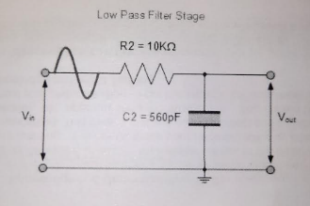
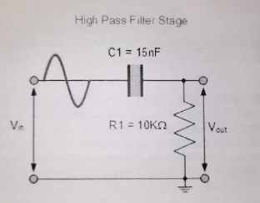
Figure 1.0
Figure 1.1

Results
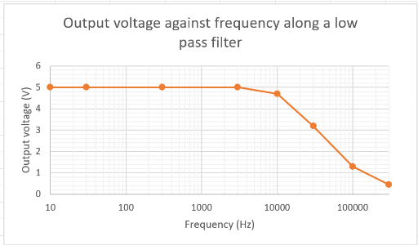
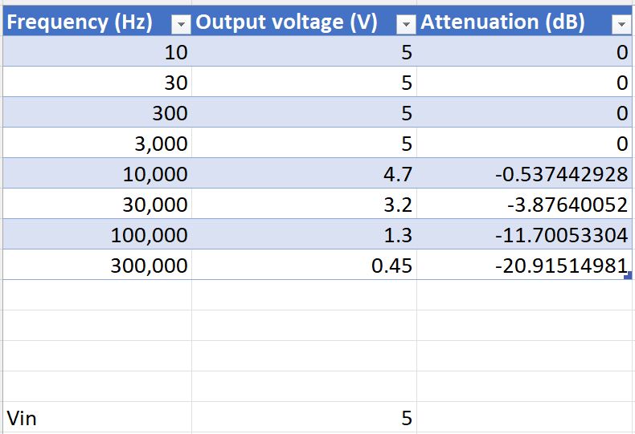
Low pass filter:
Figure 2.1
Figure 2.0

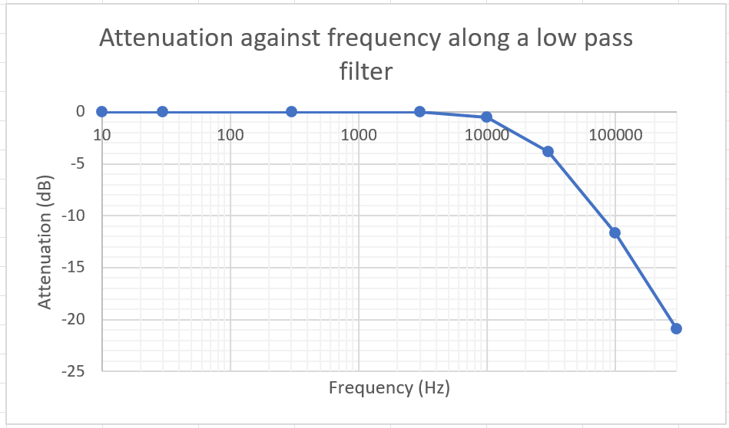
Figure 2.2

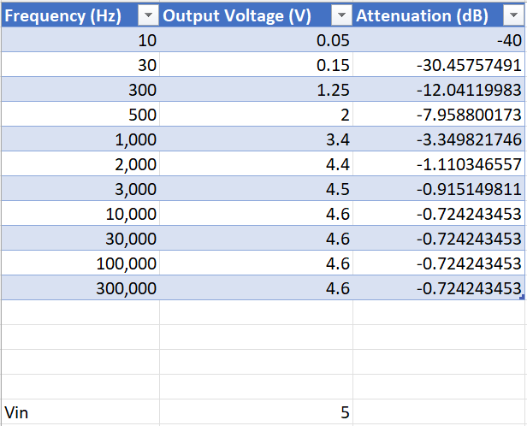
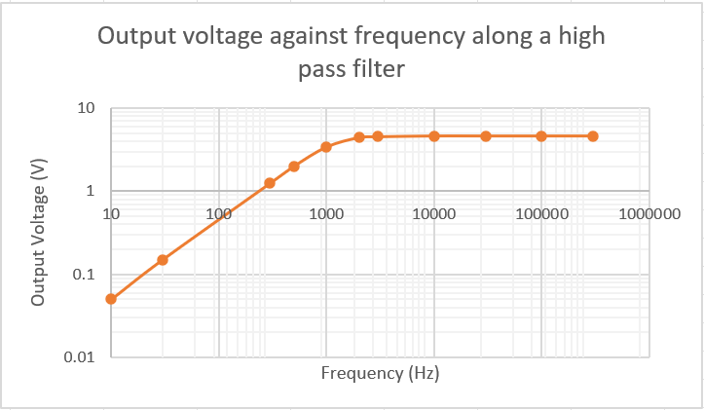
High pass filter:
Figure 2.4
Figure 2.3
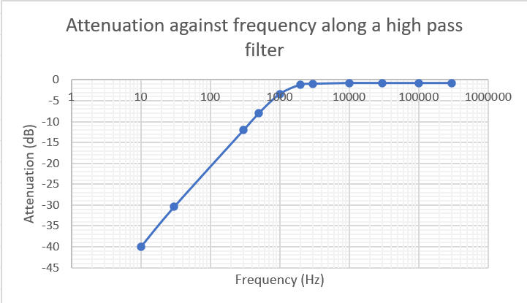
Figure 2.5

Discussion
The graph with frequency against output voltage for the low pass filter in figure 2.1 shows that as the frequency increased, the output voltage stayed constant at 5V until approximately 5,000Hz. Then, the trendline curves so that as the frequency continues to increase, the output voltage decreased at a steady rate until 100,000Hz then decreases at a decreasing rate. This occurs because the low pass filter only allows the lower frequencies to pass through the filter. Therefore, when higher frequencies are set on the function generator, there will be a lower output voltage as there is less current flowing through as less of the frequency range will be circuited around the filter, due to the low pass filter attenuating the higher frequencies.
The graph with frequency against attenuation for the low pass filter in figure 2.2 displays that as the frequency increases, the attenuation stays constant at 0dB until approximately 8,000Hz. As the frequency increases further, the attenuation decreases at an increasing rate. Attenuation is an amplitude loss when the signal generated passes through a digital filter, this is measured in decibels (International, I, n.d). This relationship occurs because the low pass filter only allows the lower frequencies that are generated to pass through the filter so the higher frequencies are attenuated so that the higher frequencies do not pass through.
In addition, the graph with frequency against output voltage for the high pass filter in figure 2.4 shows that as the frequency increases the output voltage increases at a steady rate until 1,000Hz. Then the output voltage increased at a decreasing rate until approximately 4,000Hz. As the frequency continues to increase the output voltage remains constant. This relationship is the same for the graph with frequency against attenuation shown in figure 2.5. This takes place due to the high pass filter only allows the higher frequencies to pass through the filter. Hence, when lower frequencies are set on the function generator, there will be a lower output voltage as there is less current flowing through due to less of the frequency range being circuited around the filter as the lower frequencies are attenuated. Further, this relationship occurs because as the frequency increases the gain increases also, which in turn allows the capacitor to produce the required amount of reactance. This will, however, depend on the capacitive reactance of the capacitor (WatElectronics, 2020).

Conclusion
In this experiment, it has been determined that the two filters made should be used for different purposes. For example, the low pass filter should be used in order to attenuate unwanted high frequencies emitted, but the high pass filter should be used to attenuate unwanted low frequencies. These can be used for a great number of things, one of these using a low and high pass filter simultaneously can be used to create a band pass filter. This is where a particular range of frequencies can be selected by attenuating the higher range and lower range to obtain a set range in between. An example of where this is used is in an op-amp, which is used for amplification when an active band pass is created (Electrical4U, 2021). In addition, it was found that when compared to the theoretical values for frequency against attenuation, the low pass filter created displayed similar results so compared well (shown in figure 3.1). Similarly, the high pass filter made compared well with the theoretical values as the results for frequency against attenuation also shown similar results (shown in figure 3.0). This demonstrates the experiment that was carried out was very effective at showing the capabilities of these filters and carried out correctly with little to no human error. This further shows that the results are accurate and repeatable.
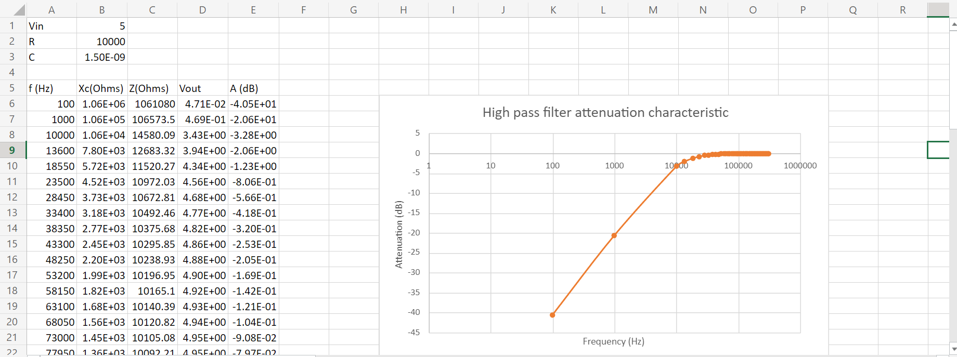
Figure 3.0

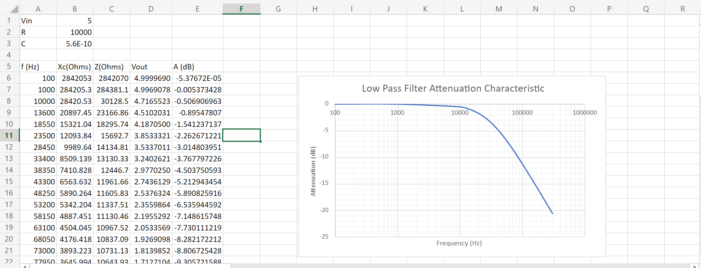
Figure 3.1

References
- Schlette, R. (2013). Complete Guide to Audio Pass Filters: High, Low & Everything In-Between. [Online] Pro Audio Files. Available at: https://theproaudiofiles.com/audio-pass-filters/#:~:text=A%20high%2Dpass%20filter%20(HPF. (Accessed 18/02/2023).
- International, I. (n.d.). Digital Filter Terminology. [Online] dspGuru. Available at: https://dspguru.com/dsp/reference/filter-terminology/#:~:text=Attenuation%20%E2%80%93%20an%20amplitude%20loss%2C%20usually%20measured%20in (Accessed 07/03/2023).
- WatElectronics (2020). High Pass Filter : Circuit, Characteristics and Its Applications. [Online] WatElectronics.com. Available at: https://www.watelectronics.com/what-is-high-pass-filter-working-its-applications/#:~:text=As%20the%20frequency%20increases%2C%20the%20gain%20increases.%20The (Accessed 08/03/2023).
- Electrical4U (2021). Band Pass Filter: Circuit and Transfer Function (Active and Passive).[Online] Electrical4U. Available at: Band Pass Filter: What is it? (Circuit, Design & Transfer Function) | Electrical4U (Accessed 08/03/2023).

