Assignment 2

Learning in the Digital Era

Module Name: Learning in the Digital Era
Module Code: ACCA 4025
Student Name: Eulalio Alesino Fernandes
Student ID: 2441942
Group:1

Lecturer’s Name: Koushik Modak

Video Link:
https://youtu.be/32PTWYIrzm8?si=Kopn0Nj9aOBBu-BK

UNIVERSITY OF WALES TRINITY SAINT DAVID
LONDON CAMPUS

Table of Contents
Introduction 3
Main Body 3
Video Link: 3
Conclusion 11
References 12

Introduction
This research examines learning in the digital age and contemplates my personal learning experience through reflective approaches. This assignment aims to assess my skills, flaws, and learning progress via self-reflection. The report employs Gibb’s Reflective Model to evaluate experiences and construct a professional growth plan. The study also encapsulates a crucial subject from Unit 4, emphasizing the significance of digital competencies in contemporary schooling.

Main Body

In video recording, I will cover introduction, the main discussion, Gibbs Reflection Model, self-evaluation, trait gain from reflection, my professional development plan, a unit 4 topic summary and the conclusion

Video Link:

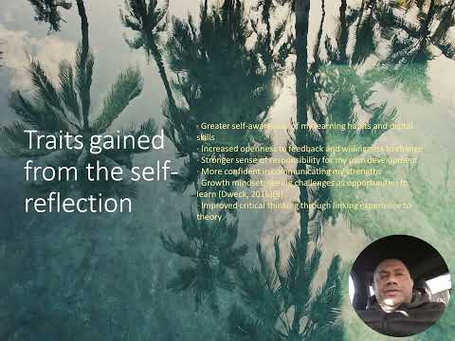

Slide 1 COVER PAGE
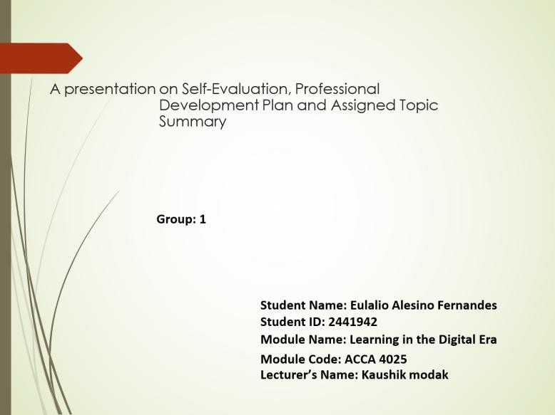

Slide 2 CONTENTS

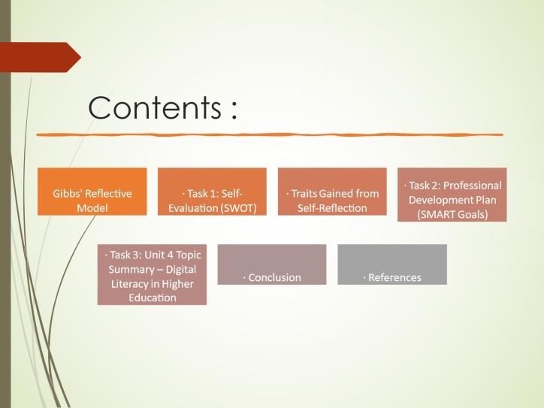

Slide 3 INTRODUCTION
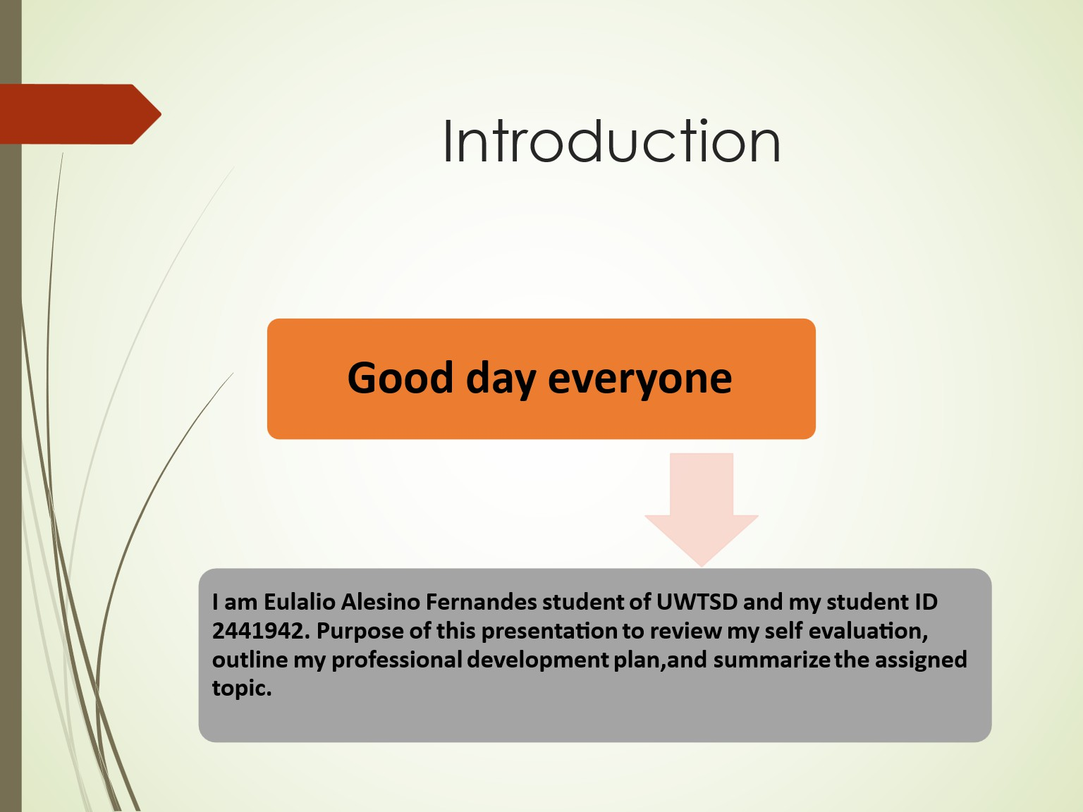

Slide 4 MAIN BODY

The main body of this report discusses self-evaluation, reflection using Gibb’s Reflective Model, traits gained from reflection, and the creation of a professional development plan. It also includes a summary of a selected Unit 4 topic related to digital learning.
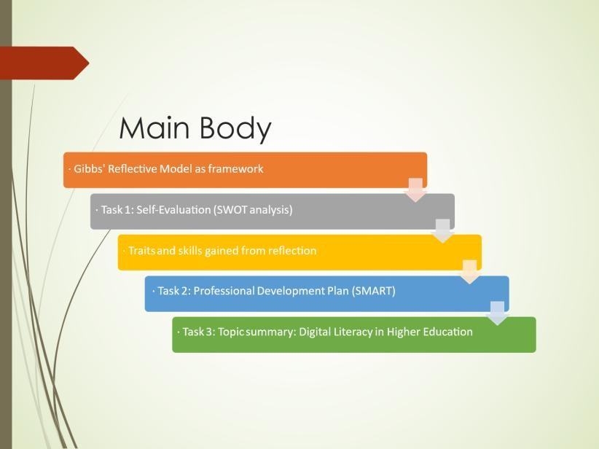

Slide 5 GIBB’s REFLECTIVE MODEL
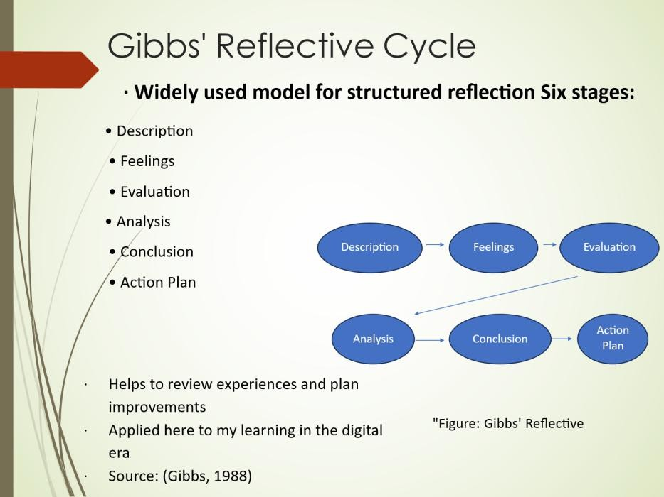

Gibb’s Reflective Model is a systematic framework that facilitates reflective learning through six stages: description, feelings, assessment, analysis, conclusion, and action plan (Gibbs, 1988). This assignment utilizes the model to analyze my learning experiences in the digital age, enabling me to pinpoint strengths, acknowledge problems, and devise strategies for future enhancement through ongoing education.

Slide 6 TASK 1: SELF EVALUATION
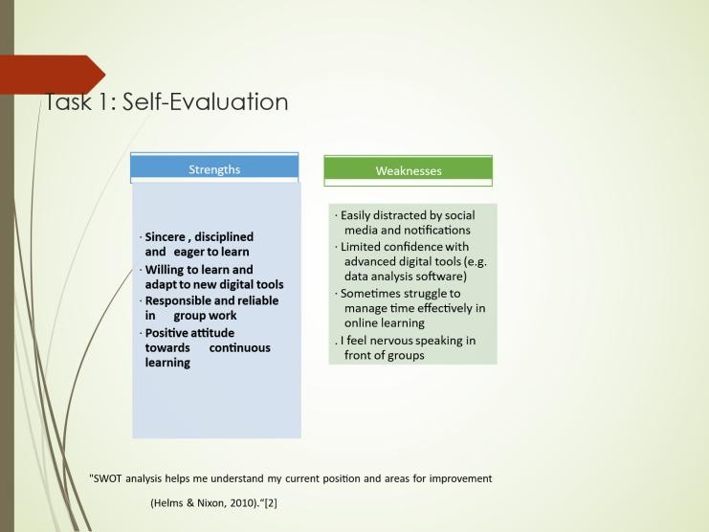

The self-assessment activity employs a SWOT analysis to ascertain my strengths and shortcomings as a student. My primary strength is in my capacity to adapt to digital learning technologies, facilitating effective engagement with online materials. A significant issue noted is time management, particularly in reconciling academic obligations with other commitments. This self-assessment aids in identifying areas for enhancement for improved academic success.

Slide 7 TRAITS GAINED FROM THE SELF EVALUATION

Traits gained from the self− reflection
- Greater self−awareness of my learning habits and digital skills

- Increased openness to feedback and willingness to change
- Stronger sense of responsibility for my own development
- More confident in communicating my strengths
- Growth mindset: seeing challenges as opportunities to learn (Dweck, 2016)[3]
- Improved critical thinking through linking experience to theory

Self-reflection has helped me develop greater self-awareness of my learning habits and digital skills. I have become more open to feedback and willing to make changes to improve myself. This process has strengthened my sense of responsibility for personal development and increased my confidence in communicating my strengths. Additionally, adopting a growth mindset allows me to view challenges as learning opportunities, supporting continuous improvement (Dweck, 2016).

Slide 8 PROFESSIONAL DEVELOPMENT PLAN
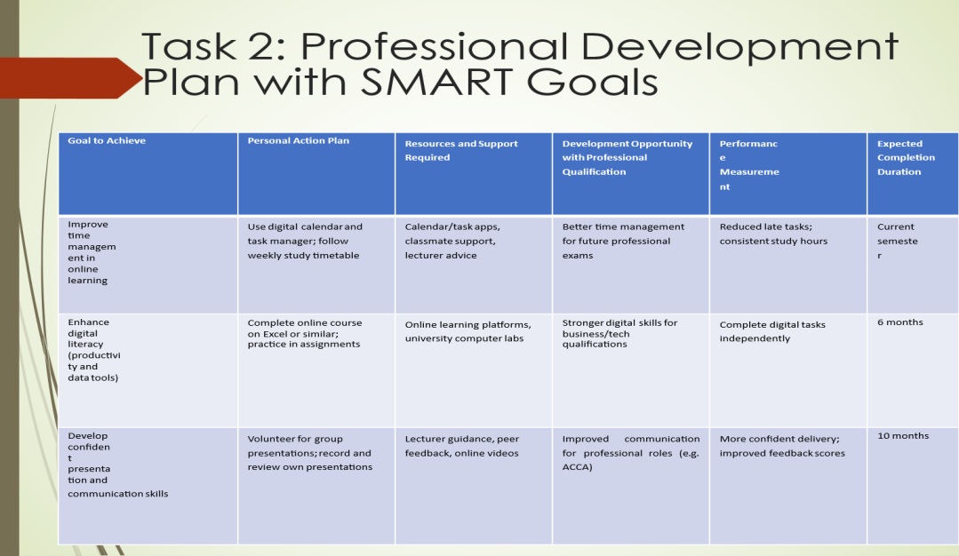

The professional development plan delineates specific objectives to improve my academic and digital competencies. It emphasizes enhancing time management, augmenting digital literacy, and cultivating critical thinking abilities. This strategy facilitates continuous learning and personal growth, important for success in the digital learning environment, by establishing attainable objectives and consistently evaluating progress.
Slide 9 UNIT 4 TOPIC SUMMARY
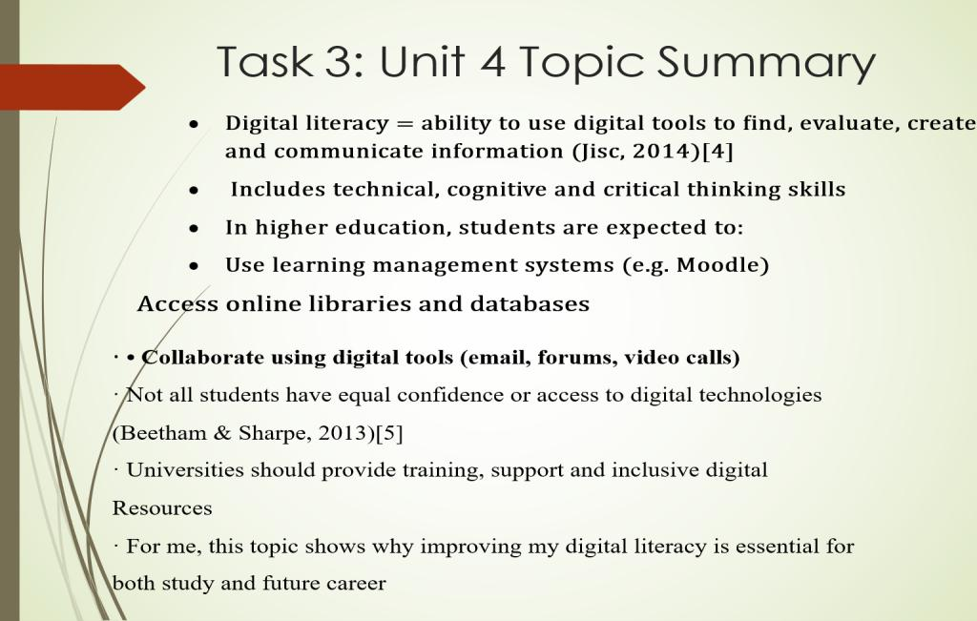

A prominent theme in Unit 4 is digital literacy, defined as the capacity to proficiently utilize digital tools and technologies for educational and communicative purposes. Digital literacy is essential in the digital age as it empowers students to obtain information, engage in online collaboration, and acclimate to emerging technology. Enhancing these abilities fosters continuous learning and employment in a technology-centric environment.

Slide 10 CONCLUSION
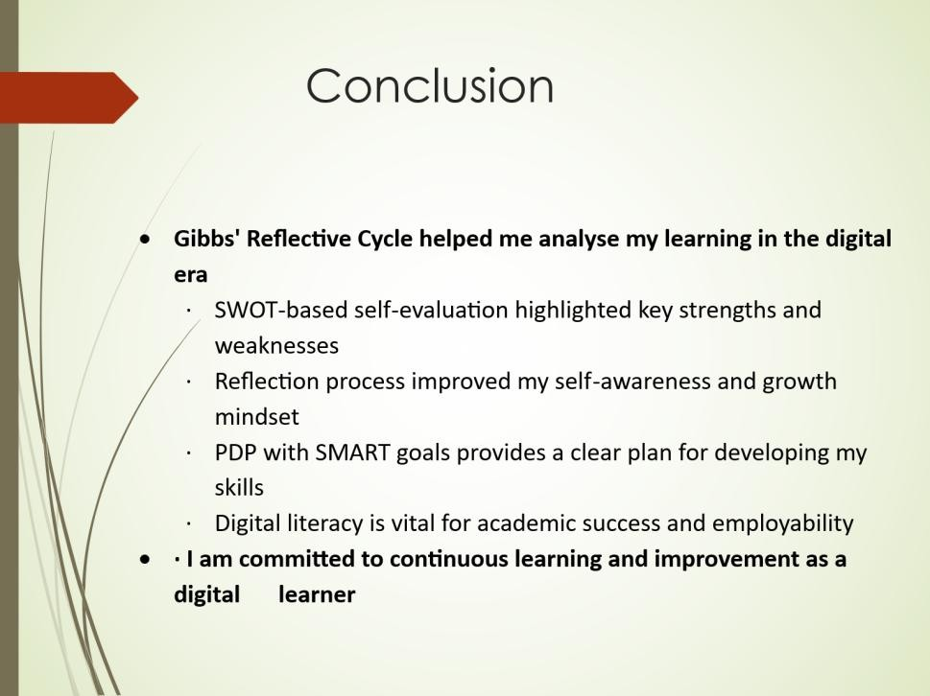

Finally, this task shows how important it is to learn by reflecting in this digital age. I was able to figure out my main strengths, weaknesses, and growth goals by using Gibb's Reflective Model and self-evaluation tools. These comments help with learning effectively in a digital setting and making improvements all the time.

Slide 11
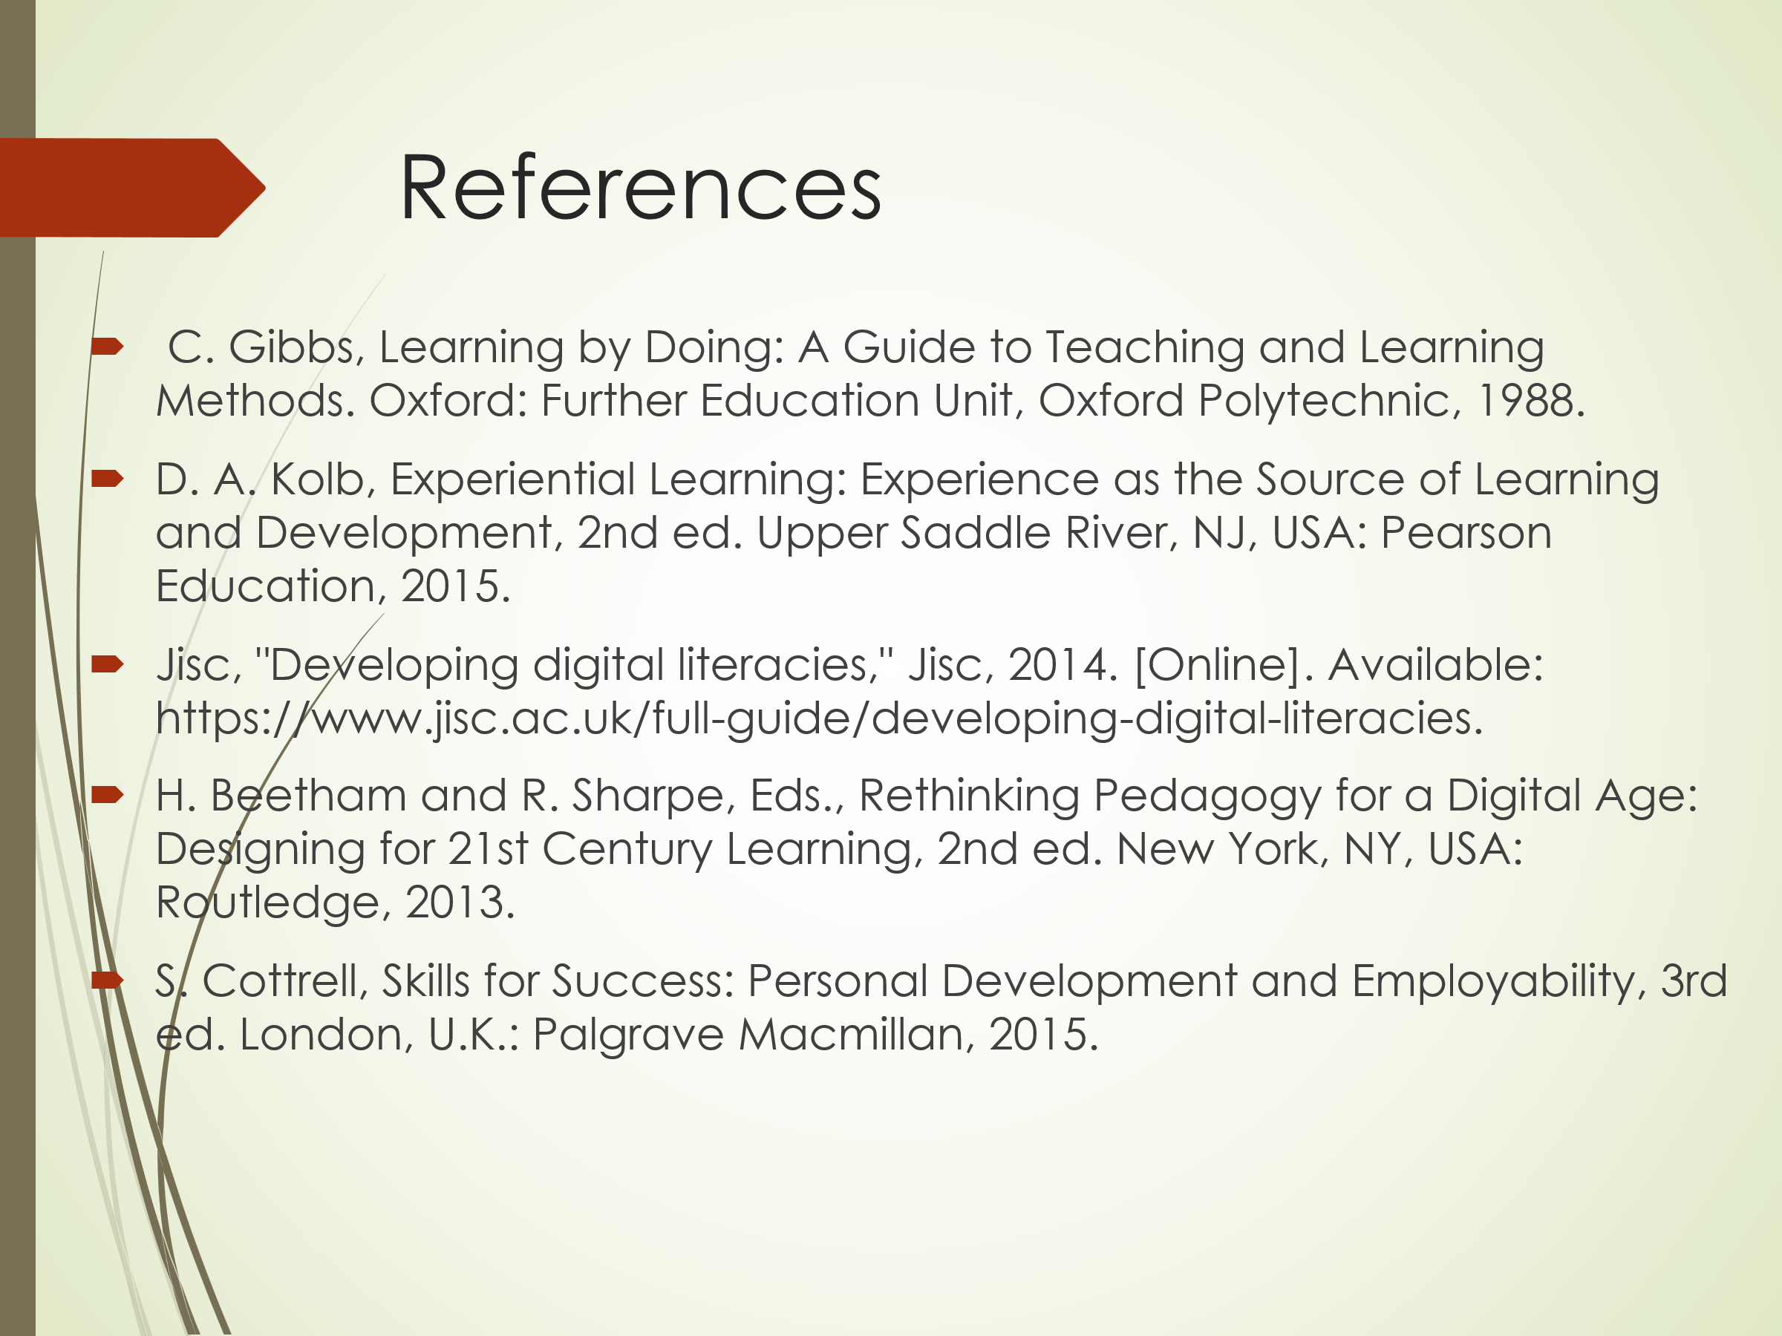

Conclusion
This study shows how reflective practice helps with both personal and academic growth in the digital age. I learned a lot about how I learn by evaluating myself, reflecting, and making plans for my career. Getting better at using technology and being more self-reflective will help me do well in school and at work.

References
- C. Gibbs, Learning by Doing: A Guide to Teaching and Learning Methods. Oxford: Further Education Unit, Oxford Polytechnic, 1988.
- D. A. Kolb, Experiential Learning: Experience as the Source of Learning and Development, 2nd ed. Upper Saddle River, NJ, USA: Pearson Education, 2015.
- Jisc, "Developing digital literacies," Jisc, 2014. [Online]. Available: https://www.jisc.ac.uk/full-guide/developing-digital-literacies.
- H. Beetham and R. Sharpe, Eds., Rethinking Pedagogy for a Digital Age: Designing for 21st Century Learning, 2nd ed. New York, NY, USA: Routledge, 2013.
- S. Cottrell, Skills for Success: Personal Development and Employability, 3rd ed. London, U.K.: Palgrave Macmillan, 2015.

