
Global Business Environment
(Assignment 1)
Student Name: Cristina Caraman
Student ID: 2125666
Lecturer: Alfred Mensah

Table of Contents
1. Introduction 3
2. Background of the industry 3
3. Evaluation of the internal and external business environment of chosen industry 4
3.1 Critical evaluation of the internal business environment 4
3.2 Critical evaluation over the external business environment 5
4. Analysis of the competitive advantage of the industry concerning core values on sustainability 8
5. Conclusion 13
6. References 15

1. Introduction
The below study will highlight the global business environment and develop a critical analysis of the changes that occurred owing to the Covid-19 pandemic. This discussion further analyses the various global business models and factors responsible for the changing in internal operations enormously. In addition, it will further demonstrate the variables responsible for future survival and expand the success ratio of the automobile industry effectively. Here the industry of automobile company namely Ford will highly demonstrate the global business situation owing to the Covid-19 pandemic. As the company faced various problems during the Covid-19 pandemic, hence they decided to uplift its long-term operations. This study will lastly discuss the competitive advantage of the automobile industry for sustainable operations in near future.

2. Background of the industry
The automobile industry is one of the supporting structures of the nation. Recently, the automotive industry USA and UK faced various problems due to the Covid-19 pandemic and it enhanced the barriers of operation of the leading automobile companies such as Ford. Ford is a very popular automobile company founded in the USA in 1903 that has customer bases in many European countries (Ford-about us, 2022). The company sells commercial vehicles worldwide and satisfies global customers. The global pandemic has raised the crisis and minimise the revenue of the automobile industry. In 2020, amidst the pandemic, the UK automobile industry produced 860,000 cars and provided a value of 15.3 Billion GBP, which was less than 2019 data (Statista, 2021). The goal of the automobile industry in the UK is to create a better world by giving people free movement and pursuing their dreams effectively. The Ford Company is mainly an automobile industry and they serve their functions by serving the people (Radović-Marković, Salamzadeh and Vujičić, 2019).
Ford’s revenue generated as of 31st December 2021 was the US $ 136.341 Billion and its operating income was US $ 4.523 Billion (Ford about-us, 2022). The company had manufactured 4.187 Million vehicles in 2020 and they built their profit margin highly influential. As the Ford Company is operating globally hence, their number of employees is 186,000 as per the year record in 2020, and further, they accumulated various software solutions for the development of the organisational goal. Ford is a family company and it operated through stakeholder support and indomitable trust among organisational people. Ford is applying the international business models for the development of the organisational purpose for a long-term operation as an automobile company with sustainable developments.

3. Evaluation of the internal and external business environment of chosen industry

3.1 Critical evaluation of the internal business environment
Strength  - Ford has the ability to gain more profit in its operations by building trust in the consumers.  - The present financial data helps them to improve their operations and expand the organisational culture for sustainability (Reuters, 2022).  - A huge network of dealers around the world improves their operational culture. | Weakness  - A huge amount of vehicle recalls minimise their operations and hinder their product quality.  - Poor reputation in the Japanese market and other countries is hindering the popularity of the firm and its expansion process (Aguilera-Caracuel and Guerrero-Villegas, 2018).  - Higher dependence on the US market minimises their innovation in the international market effectively.
Opportunity  - The eco-friendly vehicles of Ford help to improve their operations for future perspectives.  - A better customer base gives them an opportunity to produce more vehicles in the future.  - Digital marketing and self-driving cars are very popular, which expanding the growth of the organisation rapidly (Holstein, Dodig-Crnkovic and Pelliccione, 2018). | Threat  - The huge competition between other burdens such as Toyota, Tesla will create a burden on the organisation's operation.  - An increase in raw material prices hinders their operations in the manufacturing unit.  - Market uncertainties hamper the organisational performance and minimise the selling output enormously due to Covid-19 (Wen et al., 2021).
Table 1: SWOT Analysis of Ford

3.2 Critical evaluation over the external business environment
As per opined by Hall (2021), the PESTLE analysis is the tool that is used for the macro analysis of an industry on a particular country basis. This tool mainly considers the aspects such as political, environmental, social, technological, legal, and environmental factors of the country that significantly affect the business operation of an industry. Concerning this study, the PESTLE analysis of the automobile industry is described below.
Factors | Analysis
Political | According to the report of BBC (2020), the political aspect of the UK is mainly considered various aspects such as trading policies, changes of rules and regulations by the UK Government regarding Brexit, which can significantly affect the production of cars and the automobile industry by considering safety standards and carbon emission respectively.
Economical | 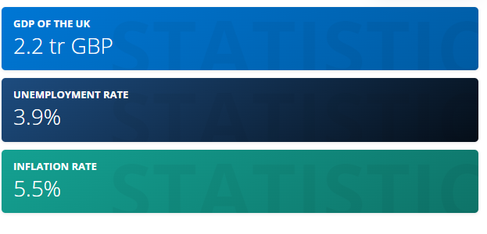  Figure 1: Impact of the pandemic on the economy of the UK  (Source: Clark, 2022)  As per reported by Clark (2022), the impact of the pandemic on the economy of the UK has a significant effect on the industries. The GDP of the country was 2.2 trillion due to the pandemic, which has been shrunk by 9.9% in 2020. Additionally, the impact of Brexit makes the economy of the UK further challenging. Considering this, the growth of the automobile industry would be challenging in the uncertain economic condition of the country.
Social | As per the opinion of EPA (2021), the society of the developed country such as the UK and the US has become environment friendly, and considering this the automobile industry in the UK region can face significant challenges due to their carbon emission and pollution. Additionally, the industries have to advance their technology with sustainable practice regarding social practice respectively.
Technological | 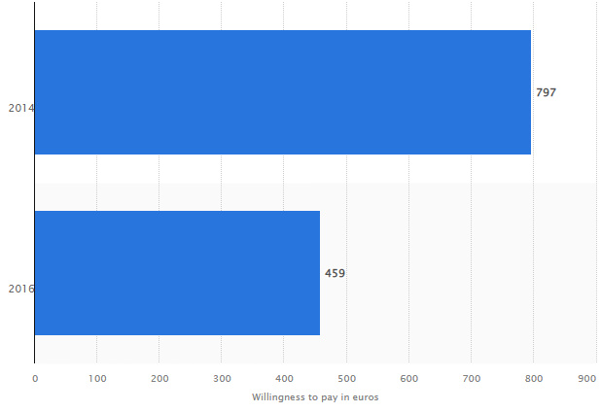  Figure 2: Technical advancement in the UK industry to attract consumers  (Source: Statista, 2022)  As per the report of Statista (2022), the technical innovation in automotive industries in the UK region has been enhanced since 2016. Consequently, the overhanging growth of technological advancement in the automobile industry in the UK region has attracted a large number of consumers towards it and thereby enhanced the growth of the automobile industry respectively.
Legal | Due to the high social influence on the innovative technological advancement in UK's automobile industry and environmental sustainability practice, the legal rules and regulations of the UK Government have a potential impact on the automobile industry respectively. Isted, Eddy and Cebon (2021) stated that Certain legal factors such as safety and standard rules, gas emission laws of the UK Gov., regulation on vehicle performance should be considered by the industries, which are significant challenging aspects regarding the industry.
Environmental | 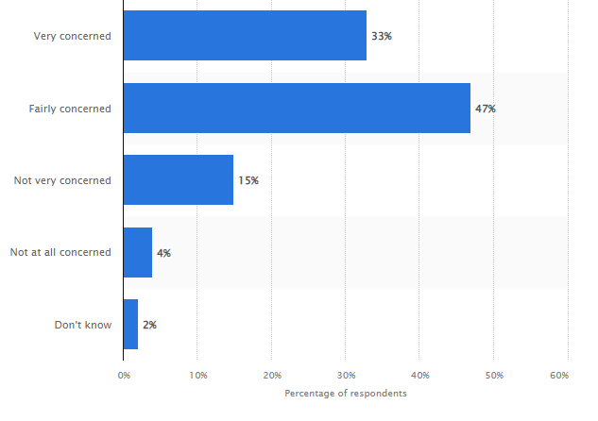  Figure 3: Environmental awareness among the UK citizen  (Source: Jaganmohan, 2021)  The awareness of environmental aspects among the UK citizen has been enhancing day by day. As per the report of Jaganmohan (2021), 80% of UK citizens are concerned about climate change and its impact and it can be a potential challenging factor regarding the operation of the automobile industry in the UK region respectively.
Table 2: PESTLE analysis of Ford

4. Analysis of the competitive advantage of the industry concerning core values on sustainability
Porter’s five forces analysis:
As per opined by Scott (2020), porter's five force analysis is mainly the business analysis model that helps to identify the key aspect behind the competitive advantage of a particular industry. This model primarily analyses the organisational structure of the company as well as its business strategy to ensure its competitive advantage respectively. There are five key aspects of this model that are present such as the threat of competition, the threat of new entrances, the bargaining power of consumers, the bargaining power of suppliers, and the threat of substitute products. Considering the following aspects, the analysis of the competitive advantage of the automobile industries such as Ford motor in the UK can be analysed.
The threat of competition: As per opined by Scott (2020), the threat of competition from the competitors in the target market can affect the business strategy of the company. The report of Statista (2022) stated that the leading competitors of Ford in the UK market are Volkswagen, BMW, Mercedes-Benz, Audi, Nissan, and so on, which possessed a high threat of competition regarding Ford respectively.
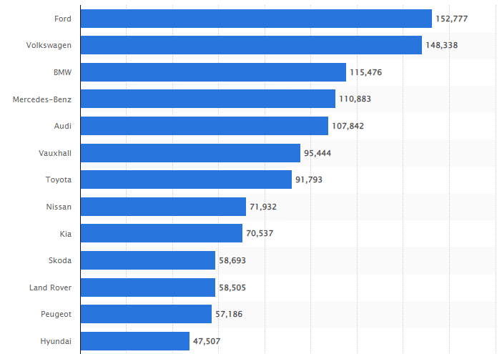
Figure 4: Competitors of Ford in the UK
(Source: Statista, 2022)
The threat of new entrance: Further Hall (2021) justified that the threat from the new entrance in the target market can significantly affect the power of the existing company respectively. However, as Ford is the second-largest automobile industry in the UK region, thus, its threat from the new entrance into the target market would be moderate. Considering this, the company should potentially improve its strategy to overcome the threat of new entrance.
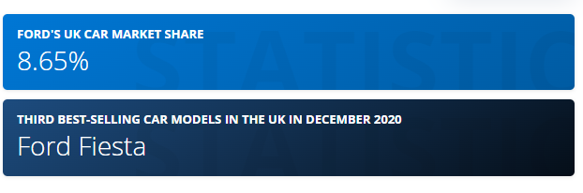
Figure 5: Market share of Ford in the UK
(Source: Statista, 2020)
Bargaining power of consumers: The bargaining power of the consumers depends on the consumer engagement of the company in the target market (Scott, 2020). A smaller consumer base regarding a company can interpret high consumer bargaining power. Considering Ford, the huge consumer base of the company can influence its consumer strategy effectively. As reported by Statista (2020), the automobile sector such as Ford has 8.65% of the market share and has become the third best-selling car model in the UK. Hence, the huge consumer base of this company has made the bargaining power of the consumer moderate to low.
Bargaining power of suppliers: The bargaining power of the suppliers can significantly drive up the cost of inputs. As described earlier, the impact of the pandemic, a huge negative impact has fallen on the automobile industries of the UK (Clark, 2022). Henceforth, supply chain disturbances occur, which can provide high bargaining power to the suppliers. Considering the automobile industry such as Ford, the company need to maintain its competitive advantage in the highly competitive market of the UK regarding which, effective supply chain management needs to be practiced by the company so that they have to depend on the suppliers, which make the bargaining power of suppliers moderate to high.
The threat of substitute products: As reported by Statista (2022), the threat of competitors in the UK market is high regarding Ford so the threat of substitute products will further high. Considering this, the company should maintain an effective business strategy by concerning social and environmental aspects to enhance their competitive advantage respectively.
Value Chain Model Analysis:
Porter’s value chain model provides information regarding organisational operations through effective steps. This model helps the industries have gigantic operations through innovative tactics and strategy implementation for various reasons. Porter’s Value Chain Model enhances the infrastructure of a firm for global operations and helps an organisation form effective HRM policies for the movement of flexible operations (Bruin, 2018). Furthermore, the inbound and outbound logistics of an organisation for the movement of the marketing and supply chain innovation through the digitalisation process are also elaborated. Porter’s value chain helps business organisations to provide maximum value with minimum cost.

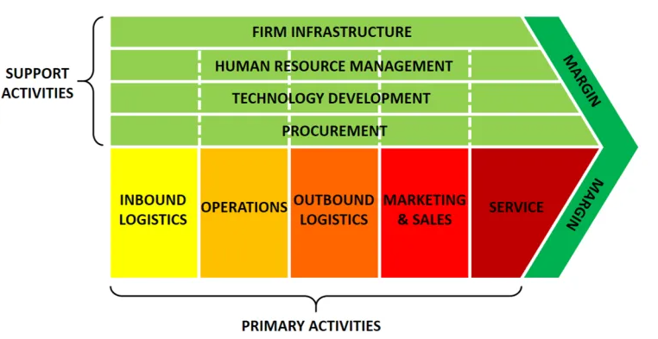
Figure 6: Porters Value Chain Model
(Source: Bruin, 2018)
Bruin (2018) opined that Ford, which is part of the automobile industry, operates very effectively and enhances the potentiality of the industry through Porter’s value chain model. Nagy et al., (2018) opined that industry 4.0 is a Technical Development factor, which is very crucial for industry outcome development and helps to expand the speed of recovery through this digitalisation process. Automobile industries are highly benefitted from the implementation of IoT services for digital improvement in organisations. The self-driving cars enable the IoT service very effectively and expand the competitive advantage for sustainable operations. The Firm infrastructure section improves the industrial collaboration and its dominance in the UK and the USA. This helps automobile industries for further development in their organisational context and can improve the firm condition very effectively.
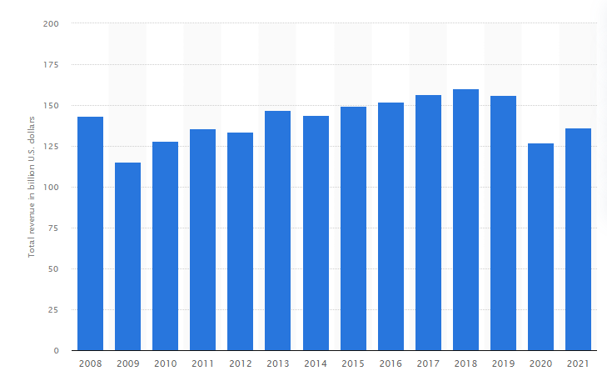
Figure 7: Revenue Figure of Ford of 2021
(Source: Carlier, 2022)
Carlier (2022) opined that the sales figure of Ford proved that the competitive advantage of the organisation is going through challenges on various issues. Ford developed software for the promotion of the digital business, but as per the data, it is not showing good operational tactics. The porter’s value chain model helps Ford organisation to operate long-term basis and minimise the challenges effectively through Procurement, as in innovation and creativity. Almomoni (2021) stated that supply chain management or Inbound logistics and Outbound Logistics help the industry to meet the competitive advantage and meet the customers' demand. Industrial output depends on the supply chain logistics and its proper monitoring largely. The variables in the porter’s value chain help the Ford industry to maintain the logistics department and meet the criterion of the organisational operation effectively. Almomoni (2021) further opined that supply chain operations make an organisation perfect for future goal achievement.
Porter’s value chain model is also crucial for better HRM practices with respect to organisation infrastructure. Wikhamn (2019) opined that sustainable HRM practices help the automobile industry formulate policies and improve their trust among the customers for better reflection. The model further evaluates the consequences of the green HRM practices for sustainable growth with integrity. This further helps Ford or automobile industries to sell huge and create a Market for global organisational development. As the organisation is suffering from low productivity hence, the organisation needs to rediscover its ethics and opportunities through sustainable functions (Štrukelj et al., 2020). Hence, last, the Service enables automobile industries more competitive and influence expansion.

5. Conclusion
The above discussion based on the global business environment of the automobile industry provided information for sustainable operation with minimum cost. The value chain model was taken as the analysis tool of the automobile industries such as Ford’s international business functions and gives proper recommendations for the development of their business. The above discussion further analyses the factors responsible for the changes in the global business environment of the Ford company and evaluated the risk factors for future perspectives. Concerning this, it can be said that the Automobile industry is belonging to less income and it must evaluate its operations through Porter’s Value Chain Model.

6. References
Aguilera‐Caracuel, J. and Guerrero‐Villegas, J., (2018). How corporate social responsibility helps MNEs to improve their reputation. The moderating effects of geographical diversification and operating in developing regions. Corporate Social Responsibility and Environmental Management, 25(4), pp.355-372, DOI: 10.1002/csr.1465.
Almomoni, M.A., (2021). The importance of supply chain management in achieving competitive advantage: A theoretical study. Journal of Social Sciences (COES&RJ-JSS), 10(2), pp.194-207, DOI: 10.25255/jss.2021.10.2.194.207.
BBC (2020) Brexit: What you need to know about the UK leaving the EU, BBC News. Available at: https://www.bbc.com/news/uk-politics-32810887 (Accessed: 29 March 2022).
Bruin, L. (2018) Value Chain Analysis Explained with Examples | B2U, B2U - Business-to-you.com. Available at: https://www.business-to-you.com/value-chain/ (Accessed: 29 March 2022).
Carlier, M. (2022) Total revenue of Ford 2021 | Statista, Statista. Available at: https://www.statista.com/statistics/267305/total-revenue-of-ford/ (Accessed: 29 March 2022).
Clark, D. (2022) Topic: The UK economy, Statista. Available at: https://www.statista.com/topics/6500/the-british-economy/#topicHeader__wrapper (Accessed: 29 March 2022).
EPA (2021) What You Can Do to Reduce Pollution from Vehicles and Engines | US EPA, US EPA. Available at: https://www.epa.gov/transportation-air-pollution-and-climate-change/what-you-can-do-reduce-pollution-vehicles-and (Accessed: 29 March 2022).
Ford about-us (2022) Ford, corporate.ford.com. Available at: https://corporate.ford.com/about.html (Accessed: 29 March 2022).
Hall, M. (2021) Porter's 5 Forces vs. PESTLE Analysis: What's the Difference?, Investopedia. Available at: https://www.investopedia.com/ask/answers/041015/whats-difference-between-porters-5-forces-and-pestle-analysis.asp (Accessed: 29 March 2022).
Holstein, T., Dodig-Crnkovic, G. and Pelliccione, P., (2018). Ethical and social aspects of self-driving cars. arXiv preprint arXiv:1802.04103, DOI: 10.48550/arXiv.1802.04103.
Isted, C.J., Eddy, C. and Cebon, D., (2021). Performance assessment of urban goods vehicles. Vehicle System Dynamics, pp.1-25.
Jaganmohan, M. (2021) UK: concern about climate change 2021 | Statista, Statista. Available at: https://www.statista.com/statistics/426733/united-kingdom-uk-concern-about-climate-change/ (Accessed: 29 March 2022).
Nagy, J., Oláh, J., Erdei, E., Máté, D. and Popp, J., (2018). The role and impact of Industry 4.0 and the internet of things on the business strategy of the value chain—the case of Hungary. Sustainability, 10(10), p.3491, DOI: 10.3390/su10103491.
Radović-Marković, M., Salamzadeh, A. and Vujičić, S., (2019). Selection of organization models and creation of competences of the employed people for the sake of competitiveness growth in global business environment. International Review, (1-2), pp.64-71, DOI: 10.5937/intrev1901064R.
Reuters (2022) Ford Motor company, reuters.com. Available at: https://www.reuters.com/companies/F.N (Accessed: 29 March 2022).
Scott, G. (2020) Porter's 5 Forces, Investopedia. Available at: https://www.investopedia.com/terms/p/porter.asp (Accessed: 29 March 2022).
Statista (2022) UK: Best selling passenger car brands 2020 | Statista, Statista. Available at: https://www.statista.com/statistics/300305/number-of-new-car-registrations-in-the-united-kingdom/ (Accessed: 29 March 2022).
Statista (2022) Willingness to pay for innovative automotive technologies in 2016 | Statista, Statista. Available at: https://www.statista.com/statistics/788626/willingness-to-pay-innovative-automotive-technologies-in-the-united-kingdom/ (Accessed: 29 March 2022).
Štrukelj, T., Nikolić, J., Zlatanović, D. and Sternad Zabukovšek, S., (2020). A strategic model for sustainable business policy development. Sustainability, 12(2), p.526, DOI: 10.3390/su12020526.
Wen, W., Yang, S., Zhou, P. and Gao, S.Z., (2021). Impacts of COVID-19 on the electric vehicle industry: Evidence from China. Renewable and Sustainable Energy Reviews, 144, p.111024, DOI: 10.1016/j.rser.2021.111024.
Wikhamn, W., (2019). Innovation, sustainable HRM and customer satisfaction. International Journal of Hospitality Management, 76, pp.102-110, DOI: 10.1016/j.ijhm.2018.04.009.
Statista (2021) Topic: Automotive manufacturing industry in the United Kingdom, Statista. Available at: https://www.statista.com/topics/5457/automotive-manufacturing-industry-in-the-uk/#dossierKeyfigures (Accessed: 29 March 2022).

