MSc Digital Transformation for the Health and Care Professionals
BMDS7007 CW1 - Managing Digital Strategy to Enhance Health and Care
Digital Strategy Evaluation Report

Executive Summary
Aneurin Bevan University Health Board (ABUHB) published its 'Transformation through digital' strategy in 2019, to guide digital innovation and transformation within ABUHB(Aneurin Bevan University Health Board, 2019). The strategy was developed around a series of core themes intended to shape ABUHB's organisational approach to digital innovation. Since its publication, the digital landscape has evolved faster than anticipated, driven by technological and society shifts. (UK Government, 2025). COVID-19 was a catalyst and accelerated digital developments and prompted realignment of national strategies. As a result, the digital strategy, has become outdated and misaligned with the current digital healthcare environment.
As an organisation, progress has been made in developing its digital roadmap and introducing new digital solutions, such as EPMA (Electronic Prescribing Service) and advancements in digital records. Fundamental gaps, in infrastructure, interoperability, and workforce, which limit ABUHB’s ability to fully align with national digital platforms. Further investment in digital technologies is needed to minimise this gap (Aneurin Bevan University Health Board, 2019).
Digital transformation within healthcare is inherently complex and non-linear, with different services and technologies at various levels of digital maturity, creating varied and sometimes conflicting starting points for change, which reflects the characteristics of complex adaptive systems described by Plsek and Greenhalgh, (2001). Healthcare is a complex and constantly evolving system, so digital transformation cannot follow a straightforward or predictable path.
ABUHB, although still in the initial stages of digital maturity, is actively working to accelerate technological adoption and progress its transformation ambitions. Due to the organisation’s scale and complexity, an adapted digital maturity model may be needed, as standard frameworks do not fully reflect the realities of a Health Board environment. Its digital strategy is shaped by internal needs and national policy drivers, aligning with government priorities to improve population health, enhance care quality and accessibility, deliver higher-value services, and support a sustainable workforce.

Within Wales, the Welsh Government and national authorities have produced multiple strategic reports, frameworks, and policy documents outlining priorities for digital transformation across the healthcare system, where the ambition of digital health is clearly documented (Welsh Government, 2018, 2023).These national documents place increasing demands and expectations on ABUHB to deliver digital highlights within its transformation plan.
ABUHB is currently reviewing its digital strategy as part of developing a new ten‑year digital plan (Aneurin Bevan University Health Board, 2025) Although the final strategy is yet to be published, this review reflects recognition that both the digital landscape and national expectations have advanced significantly since the 2019 strategy. Digital transformation offers opportunities to improve patient access, strengthen integration across health and social care, and enhance efficiency through increasing use of digital systems and data‑driven solutions.
However, several challenges limit progress. The most significant barrier is sustained underinvestment in digital technologies. While new systems continue to be deployed, the underlying infrastructure needed to support them has not been modernised at the same pace. Insufficient funding, outdated networks, and ageing infrastructure hinder performance and restrict ABUHB’s ability to fully meet national standards.
Strategic analysis highlights that although ABUHB is developing a more comprehensive digital roadmap, infrastructure weaknesses and cultural barriers persist. As a public-sector organisation, ABUHB operates within complex governance structures that slow decision‑making and implementation. Lengthy approval processes and extended deployment timelines mean digital solutions risk becoming outdated before they are fully embedded. Given the rapid pace of technological change, failure to modernise creates programme delays, potential risks to patients, and avoidable inefficiencies, issues that could be mitigated through more effective and prompt digital transformation.
This essay will examine digital transformation in relation to key business drivers shaping ABUHB’s strategic direction. ABUHB is progressing in digital healthcare; however, it must strengthen governance and modernise its digital foundations and infrastructure to achieve sustainable digital transformation across the health board.
Business Drivers
One of the most fundamental questions posed by ABUHB in relation to its digital transformation agenda is: Why Digital, Why Now? (Aneurin Bevan University Health Board, 2019). The Health Board provides integrated acute, primary, and community healthcare services to a population of approximately 650,000 people and employs more than 16,000 staff(ABUHB, no date) The purpose of ABUHB is to provide sustainable health services and high quality care to the community aligned through the long-term plan and its objectives, Better Health, Better Care, and Better Lives ((Aneurin Bevan University Health Board, 2019). Understanding the size and scope helps shape digital transformation, that direction is further reinforced by national policies A healthier Wales: long term plan for health and social care and Digital and data strategy for health (Welsh Government, 2018, 2023).
Understanding the distinctions between ABUHB's internal and external organisational environments is essential for analysing how ABUHB sets priorities, makes decisions, and achieves its strategic goals. The internal environment can be defined as the elements of an organisation that can be affected or affect the choices made by the organisation (Business Jargons, no date). The internal environment includes all organisational factors that shape ABUHB decisions, such as workforce, culture, structure, resources, internal processes, and financial budgets. Within the Digital Business Unit department at ABUHB, the focus on improving Stores and Asset Management systems reflects an internal aim to enhance operational efficiency, reduce expenditure, and support better resource utilisation across clinical services.
The illustration in Figure 1 highlights the Internal environment of the organisation (Business Jargons, no date).

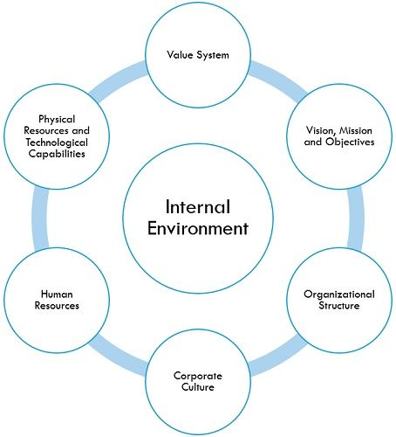
Figure 1 - Internal environment of organisation (Business Jargons, no date)
In contrast, the external environment includes factors outside the organisation that influence its operations, such as national health policies (Welsh NHS Confederation, 2020; Welsh Government, 2023), demographic changes, technological developments, and economic pressures. Additionally, wider economic conditions, technological advancements, and public expectations for digital access to healthcare further shape ABUHB’s objectives and service delivery models.
Although the internal and external environments at ABUHB can be considered separately, they continually interact to form and shape decision making. External drivers such as national policy influence internal drivers such as workforce and infrastructure. The interaction creates both opportunities and challenges.
ABUHB’s ability to achieve its long-term goals depends on how effectively it responds to both internal capabilities and external pressures. Understanding both the internal and external environments helps organisations plan effectively, avoid risks, and make the most of new opportunities (Mohamed, 2025). Although ABUHB is committed to Digital Transformation and to advancing the digital roadmap for healthcare, the process is far from straightforward. While the overarching ambition may appear to be simple, implementing and sustaining the digital transformation strategy within ABUHB healthcare environment is complex, with numerous factors contributing to the resistance and risk of the programme/Strategy.
In addition to infrastructure and legacy system constraints, ABUHB faces significant alignment challenges when coordinating its digital transformation priorities with national and regional strategies. The organisation must balance its own operational requirements and project timelines with wider Welsh Government and NHS Wales digital policies, as outlined in the draft Digital Transformation Policy currently under development within ABUHB (Aneurin Bevan University Health Board, 2025). These competing expectations can introduce complexity and contribute to slower implementation when strategic direction or funding arrangements do not fully align. Achieving coherence between local innovation and national standards is essential for progress but is still difficult when priorities diverge across organisational levels.

ABUHB’s digital transformation is intentionally aligned with national Welsh bodies, including the Welsh Government and Digital Health and Care Wales (DHCW). These external influences are shaped by key national policies and legislation, such as the Well-being of Future Generations (Wales) Act 2015, which sets a legally binding framework for long-term, sustainable public service delivery(Gov.Uk, 2015; Welsh Government, 2025).
Table 1 illustrates how national drivers and ABUHB Digital Transformation strategy align in key areas, taken from national policies and ABUHB Digital transformation plans.
Table 1 - Shared Themes in Digital Strategies
- Information taken from (Gov.UK, 2015; Aneurin Bevan University Health Board, 2019; Welsh NHS Confederation, 2020; Welsh Government, 2023, 2025)
Themes | Recurring Themes Across Policies
Purpose | Better Health, Better Care, better Lives.  Transformation through digital.  Empower communities on health and wellbeing.  Support Self-Management.
Workforce | Empower workforce, Inclusive access to digital health.
Infrastructure | Ensure secure, interoperable, and resilient digital foundations.  Strengthen services.
Innovate | Introduce, evaluate, and use modern technologies to improve services.
Governance | Strengthen governance, assurance, and transformation partnerships for delivery. Work to align with national and government targets.

Workforce capacity represents a significant barrier to digital transformation at ABUHB. Effective transformation depends on specialist technical expertise, advanced data literacy, and the ability to adapt rapidly to evolving technologies. However, the limited availability of digital specialists’ places pressure on programme delivery, with demand for skills frequently exceeding organisational capacity. This constraint contributes to delays in implementation and slows the successful adoption of digital initiatives. In addition, reliance on a small pool of specialist staff risks undermining long-term resilience.
At the same time, digital systems and data-driven solutions are more prevalent across ABUHB, reflecting the shift towards a more digitally enabled healthcare. When implemented correctly and with correct foresight, digital transformation within ABUHB could be used to further ease pressure on clinical services and improve efficiency and enhance outcomes at ABUHB. The barriers to digital Transformation at ABUHB highlight the need for well-resourced and strategic approach.
Technology and Digital Transformation
When examining the principles underpinning ABUHB digital transformation, the most compelling statement, guiding ABUHB approach, is simple but powerful simply saying that “Digital should work like electricity, it should always be on” (Aneurin Bevan University Health Board, 2025). This emphasises ABUHB's ambition to be a digital first organisation.
Despite ABUHB’s progress in developing a new digital strategy and roadmap, and its implementation of digital solutions such as Electronic Prescribing and Medicines Administration (EPMA) and improvements to digital records, overall digital maturity is still comparatively low when benchmarked against other sectors and organisations(Evenstad, 2020). While EPMA represents a significant technological step forward, it addresses only a small part of a wider digital landscape that is still fragmented, with many core systems and capabilities staying underdeveloped.
ABUHB demonstrates comparatively low digital maturity when assessed against other sectors and organisations, a position that mirrors systemic digital limitations across the NHS as a whole(Evenstad, 2020) This is highlighted in (Gov.UK, 2025) where it is discussed that the UK is still under digitised. Digital infrastructure also limits ABUHB’s ability to transform. Network performance varies across sites, particularly in older hospitals and community locations where outdated cabling, weak Wi-Fi, and limited bandwidth affect system speed and reliability.
Welsh government have previously issued a statement of intent in 2019 which highlights statement of better use of health and care data for safe, effective care and efficient services, Welsh government notice that digital improved can and must be made as per statement (Welsh Government, 2019)
“However, we can do more. Data is a critical tool for enabling efficient and effective public services, and its sharing and use is recognised as a key means to deliver prudent healthcare”(Welsh Government, 2019)
Recently ABUHB have adopted clinical terminology including SNOMED CT and made significant improvements in cybersecurity. While these developments represent important progress, they form only a small part of a wider digital landscape that remains fragmented, with many core systems, infrastructure, and data capabilities still underdeveloped.
When digital transformation is understood as a staged developmental process, such as the model presented by Right Star in Figure 2 (Right Star, no date), This model outlines six stages of digital transformation, enabling organisations to assess their position on the digital maturity scale. It helps identify the current stage of an organisation and the actions required to progress to the next level. ABUHB and other organisations can be positioned along a continuum from early adoption to full optimisation. Within this framework, ABUHB would be placed at Stage 1, with emerging characteristics of Stage 2. Moving from Stage 1 (Business as Usual) to Stage 2 (Present and Active) reflects a shift from legacy-based operations to the early adoption of a digital-first mindset. At this stage, organisations start recognising the need for digital change and begin small-scale experimentation, usually through isolated pilots rather than coordinated, organisation-wide activity. This reflects a context in which digital transformation is still at an early stage, with foundational capabilities being established. Despite this early positioning, ABUHB is actively seeking to adopt and accelerate new technological advancements, demonstrating a clear strategic intent to progress further along the digital maturity trajectory.
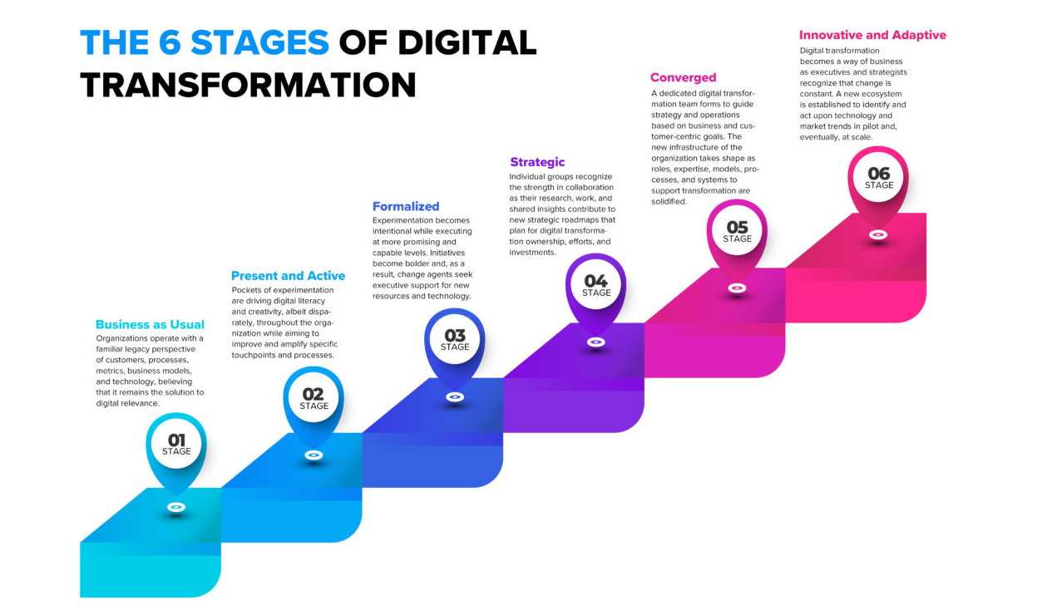
Figure 2 – 6 Stages of Digital Transformation (Right Star, no date)
When reviewing ABUHBs digital transformation policy with respect to sustainability and infrastructure, it is evident that the current plan addresses infrastructure both directly and indirectly (Aneurin Bevan University Health Board, 2019). The strategy sets out the level of digital maturity expected from the organisation and the principles of digital maturity expected to be achieved. including alignment with national standards and a whole-system approach. The illustration in Figure 3, (Aneurin Bevan University Health Board, 2019), highlights ABUHB's commitment to advancing through digital innovation.

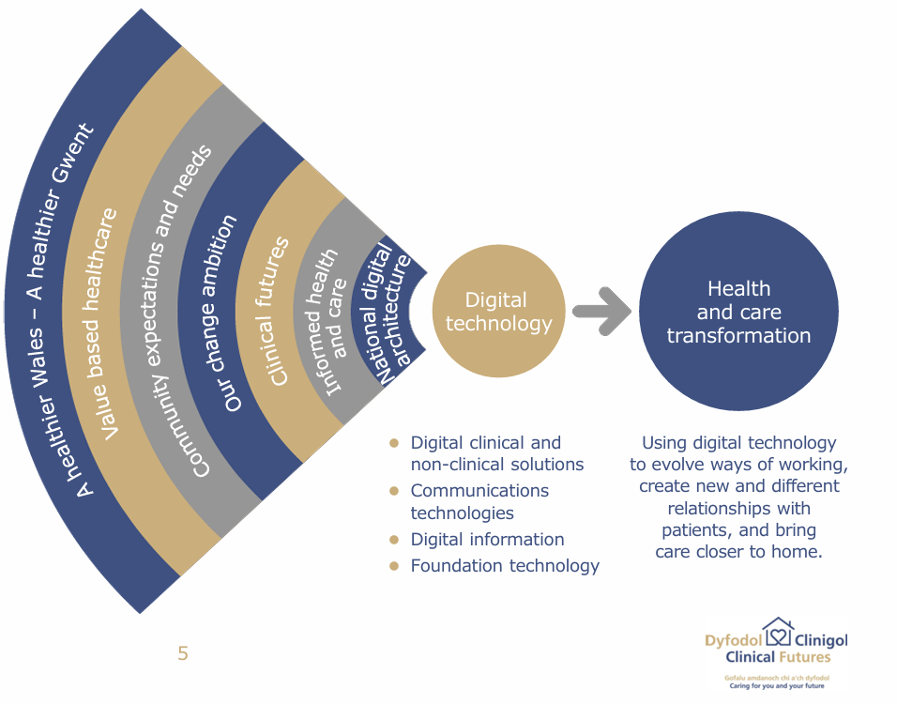
Figure 3 - ABUHB's commitment to advancing through digital innovation(Aneurin Bevan University Health Board, 2019)
ABUHB’s digital transformation initiative is designed to align with and embody the Welsh Government’s principles outlined in national policies (Welsh Government, 2018, 2023). The focus of digital transformation at ABUHB is to be a digital-first organisation and to empower patients to manage their health independently through innovative digital solutions and applications. This transition to digital care promotes greater flexibility and encourages self-management within the community, while simultaneously reducing waste and optimising staff resources (Aneurin Bevan University Health Board, 2019).
For ABUHB to address the challenges in managing and integrating aspects of its digital transformation strategy, ABUHB utilise ITIL framework in some departments leveraging ITIL best set of practices. The ITIL framework provides ABUHB with a dependable and structured approach to designing, delivering, and implementing digital services. Figure 5 Illustrates the ITIL framework which underpins ABUHB approach.
Within this framework, ABUHB digital transformation is delivered through several inter-related programmes. These include, such as the implementation and optimisation of Electronic Prescribing and Medicines Administration (EPMA) and the wider development of digital patient records. A further programme focuses on infrastructure and service resilience, addressing network performance, system availability, incident management, and service continuity, aligning digital services with clinical safety requirements.
In addition, ABUHB has programmes aligned to cybersecurity and information governance, covering activities such as vulnerability management, access control, and compliance with national NHS Wales security standards.
Figure 4 shows the ITIL framework that supports ABUHB’s approach and how these programmes are managed across the service lifecycle, from planning and design through to implementation and day-to-day operation.
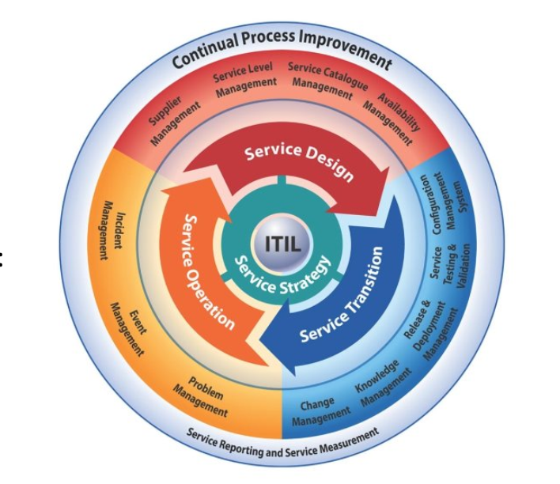
Figure 4 – ITIL Framework Diagram (ITIL Service Design, no date)
Strategic Analysis
To support, structure and review of the digital transformation within ABUHB, this essay applies established strategic frameworks: SWOT and PESTLE. When applied together, SWOT and PESTLE provide ABUHB with a comprehensive understanding of its digital transformation strategies and policies, and the factors influencing it.
SWOT analysis is described as a framework, which, when applied correctly, can help an organisation understand factors that may create opportunities and risks by looking four areas: Strengths, Weaknesses, Opportunities, and Threats (Peterdy, 2022).
PESTLE analysis, instead, is defined (What is PESTLE Analysis? (2024) as external factors affecting the organisation, these may be factors that the organisation has little or no control over: Political, Economic, Social, Technological, Legal, and Environmental factors.
Although these models deliver detailed insights, both Strategic and theoretical perspectives suggest that organisational value and success extend beyond strategic formulation and require effective implementation (Hall, Pilbeam, and Corbridge, 2013). This is particularly significant for ABUHB, as the successful execution of its digital transformation plan depends not only on the identification of strategic factors but also on the organisation's ability to implement these strategies effectively. Table2 outlines the key strengths, opportunities, and threats currently influencing ABUHB's digital transformation in the form of SWOT analysis.
Table 2 - SWOT Analysis created for ABUHB
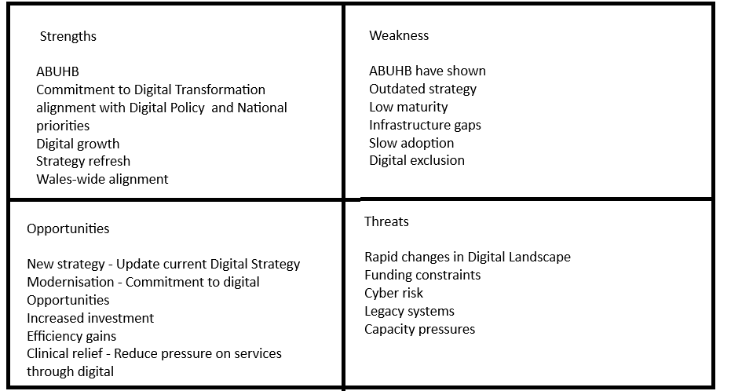
Although SWOT analysis can be a good strategic management tool if used correctly, its simplicity can also lead to flawed and unfounded strategic decisions (Pickton and Wright, 1998). To reduce the limitations of SWOT analysis, it could be used alongside a more detailed framework such as PESTLE.
PESTLE
Pestle is a tool used by organisations to understand and validate external influences and factors that can affect the organisation. It draws on six areas: Political, Economic, Social, Technological, Legal, and Environmental (Johnson et al., 2017)
Table 3 highlights how PESTLE can be applied to an organisation like ABUHB, and how digital strategy can be mapped utilising this model
Table 3 – PESTLE analysis of Digital Transformation Strategy ABUHB
Dimension of PESTLE | PESTLE dimension affects ABUHB
Political | ABUHB need to align with national legislation, Welsh Government frameworks such as A Healthier Wales and national digital transformation strategies, ensuring full compliance with national direction.  ensure alignment with the national digital architecture and the Once for Wales approach. ABUHB must ensure that decisions support local priorities while aligning with the national expectations.
Economic | ABUHB need to ensure that the correct level of Investment is applied to modernise infrastructure at ABUHB.  ABUHB need to ensure that the Digital transformation helps reduce operational costs and that the benefit of the transformation is realised. This can then allow ABUHB to reinvest in frontline service.  modernisation of ageing infrastructure and the adoption of cloud technologies at ABUHB .  control on digital transformation as the increasing demand on digital impacts several factors, Including Funding, Digital Exclusion.
Social | Access to digital health.  ABUHB's digital strategy focuses on enabling individuals to manage their own health and wellbeing through digital tools.  Staff culture change at ABUHB is needed to support digital-first approaches. Digital Inclusion is essential for ABUHB staff and communities to promote digital first.
Technological | ABUHB are continuing to improve digital services and apply continuity across hospitals and the community.  Network and infrastructure modernisation are being updated at ABUHB, but it is slow and costly.  ABUHB require a strong foundational technology platform.  The digital transformation strategy at ABUHB looks to ensure systems are interoperable, scalable, and aligned with national digital standards.
Legal | ABUHB need to ensure compliance with data protection, clinical safety, and information governance standards across digital systems.  ABUHB need to ensure they align fully with the governance created by the Welsh Government.
Environmental | ABUHB are aiming for Increased digital access across the community and care.  ABUHB are aiming for modern infrastructure, such as cloud services.  Reduced reliance on paper records, which protects the environment (Green footprint).

Figure 5 shows how combining SWOT and PESTLE analyses creates a stronger foundation for strategic decision-making at ABUHB by integrating internal and external environmental perspectives.

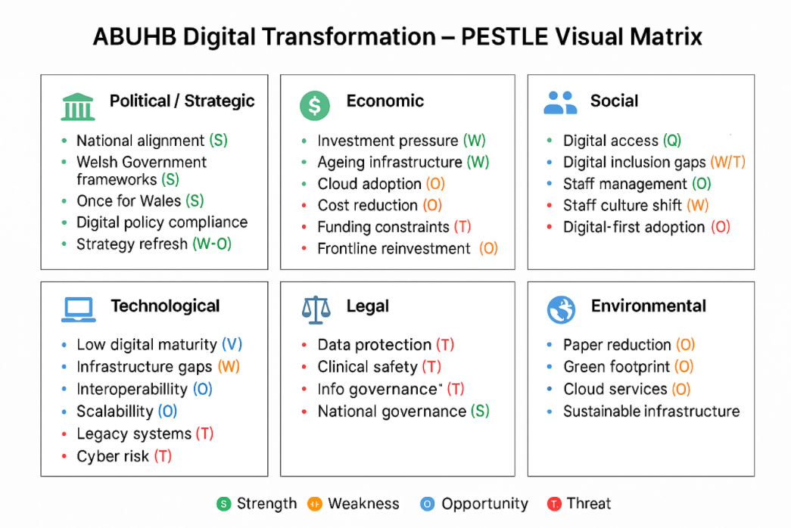
Figure 5 - Combined SWOT and PESTLE ABUHB

Root Cause Analysis
In line with the theoretical perspective presented by Hall, Pilbeam, and Corbridge, (2013)), which argues that organisational value and success cannot be achieved through strategy formulation alone, it becomes evident that a more comprehensive and integrated approach is required to ensure effective delivery. Root Cause Analysis (RCA) helps ABUHB examine the underlying factors affecting the adoption of ABUHB’s digital transformation programme. While strategic frameworks such as SWOT and PESTLE are valuable in identifying key factors, their limitations lie in the fact that they do not delve deeply into the underlying reasons behind operational challenges.
RCA is a highly effective risk identification technique (Knowledge Academy, no date) that enables ABUHB to identify and address the underlying barriers to digital adoption. Unlike tools such as SWOT and PESTLE, which focus on surface-level factors, RCA examines the root causes of operational challenges.
The application of RCA within ABUHB identified several interrelated factors contributing to poor digital adoption. A key root cause is staff resistance, which is primarily driven by limited digital capability and confidence rather than cultural opposition. This is intricately linked to fragmented engagement and ineffective communication during system rollout, where minimal early involvement of frontline users has resulted in digital solutions that are poorly aligned with clinical workflows and have reinforced negative perceptions of digital tools. In addition, organisational and governance complexity within ABUHB presents a significant barrier, as multi-layered decision-making processes and competing operational priorities delay implementation, reduce accountability, and weaken ownership of digital change initiatives.

By identifying these root causes rather than merely addressing the symptoms, organisations can gain meaningful insights into persistent barriers faced during the implementation of digital transformation strategies. This approach could significantly enhance the digital transformation strategy by facilitating more robust adoption and implementation across the organisation. In turn, this would promote sustainable, long-term organisational improvement.
Digital Transformation Strategy review ABUHB
A review of the existing digital strategy in ABUHB highlighted several concerns regarding its structure, clarity, and practical applicability across the organisation. Although the strategy outlines overarching aims and defines key digital priorities, it does not sufficiently explain how these objectives will be achieved. This limits its usefulness for stakeholders who require more operational detail to understand implementation pathways.
Digital transformation in ABUHB, although complex, has similarities to other organisations, Digital transformation is continuous and interconnected within areas at ABUHB and the wider infrastructure. ABUHB could use a similar Tool to the one illustrated in figure 6 to help ABUHB define core capabilities and conditions that will ensure digital transformation success at ABUHB.
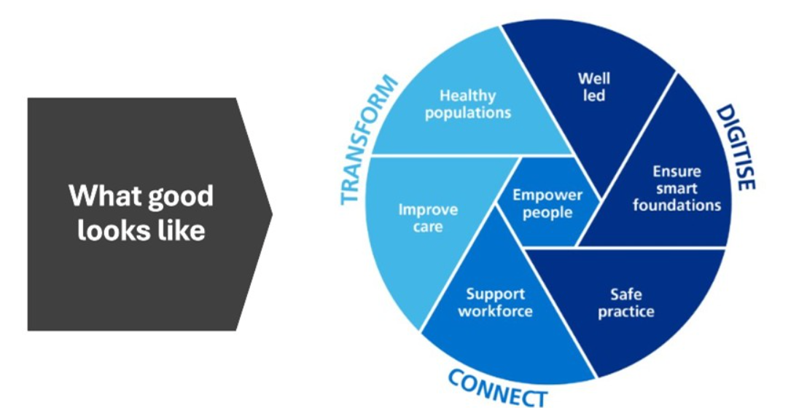
Figure 6 - What Good Looks Like in Digital Transformation(NHS England, 2021)

What looks good framework outlines, what digital transformation should aim to achieve in organisation. ABUHB digital transformation strategy does not clearly link to any evaluation Framework. The lack of this distinction makes it more difficult for ABUHB to assess how effective their digital strategy is, how mature it is or where it can be improved. The lack of alignment makes progress difficult to measure, and this can impact the digital transformations practical value.

Reviewing the current digital strategy highlights that there are concerns regarding its clarity and operational relevance. Although the existing strategy at ABUHB outlines high-level aims and digital priorities, it does not sufficiently explain how ABUHB will meet the objectives in practice. It details what it wants to achieve, just not how ABUHB will achieve it. This limits it use for staff and stakeholders as there are no clear pathways.

Since the current digital transformation strategy has been primarily written from a digital perspective, the language and narrative style are often highly technical. As a result, the strategy is less accessible to non-digital audiences, including clinicians, nurses, administrative teams, and other operational staff. While the intentions of the strategy may appear clear to digital professionals, this clarity does not always translate for those outside the digital domain.
.
Stakeholders within ABUHB expressed organisational concerns regarding the Digital Transformation policy, noting the limited involvement of operational and clinical colleagues in its development. This lack of engagement risks misalignment between policy intent and operational deliverability. Additionally, while digital strategies are commonly designed to span five to ten years, their development timelines are often prolonged. As a result, such strategies can become obsolete within a brief period due to rapid technological and service evolution. This highlights the need for more responsive future planning and an agile, iterative approach to strategic development.
.
The current digital transformation policy provides useful updates on risk identification, demonstrating that ABUHB recognises both the challenges and opportunities associated with digital change. However, the documentation does not consistently articulate the outcomes, impact, or benefits associated with these risks. To strengthen assurance and accountability, in the new transformation policy, ABUHB must clearly demonstrate that digital initiatives are not simply infrastructure upgrades presented as transformation but are supported by measurable indicators showing progression from intention to demonstrable improvement. One of which is Digital inclusion acknowledged as a priority within the strategy, but it lacks a detailed definition and clear explanation of how inclusion will be operationalised. The strategy often states that objectives will be achieved or included on the roadmap, but does not sufficiently describe the mechanisms, processes, or resources required to deliver these commitments. This represents an area for improvement in the forthcoming ABUHB digital strategy.

ABUHB maintains strong assurance structures, including certification processes and change boards that monitor, record, and report on digital changes and their outcomes. These mechanisms provide a solid foundation on which future; more collaborative and accessible digital strategies can be built. However, a perceived barrier has existed between clinical staff and the digital teams responsible for shaping digital solutions. Although the Digital Directorate at ABUHB functions effectively internally across its specialist areas, stakeholders have reported that accessing digital expertise from outside the directorate can be challenging. To address this, ABUHB has introduced a new front-of-house model through the New Digital Service Request (NDSR) process, as part of improving digital transformation. This mechanism is designed to improve engagement, ensure early assessment of innovative ideas, and strengthen cross-departmental collaboration. While not fully reflected in the existing digital transformation policy, these enhancements are incorporated within the draft Gwent 35 framework.
I confirm this essay is my own original work and does not include text created by a generative artificial intelligence tool

References

ABUHB (no date) ABUHB - About us. Available at: https://www.abuhb-jobs.co.uk/our-health-board/about-us/ (Accessed: April 7, 2026).
Aneurin Bevan University Health Board (2019) Digital Strategy Transformation through digital. Available at: http://howis.wales.nhs.uk/sitesplus/documents/866/ABUHB%20Digital%20Strategy.pdf (Accessed: March 4, 2026).
Aneurin Bevan University Health Board (2025) Gwent35:OurAims.
Business Jargons (no date) “Internal Environment.” Available at: https://businessjargons.com/internal-environment.html (Accessed: March 21, 2026).
Evenstad, L. (2020) NHS digital transformation ‘slower than expected’, says NAO, Computer Weekly. Available at: https://www.computerweekly.com/news/252483138/NHS-digital-transformation-slower-than-expected-says-NAO#:~:text=Published:%2015%20May%202020%200,lack%20of%20funding%20and%20confusion. (Accessed: April 7, 2026).
Gov.Uk (2015) Well-being of Future Generations (Wales) Act 2015, Gov.Uk. United Kingdom: Gov.UK. Available at: https://www.legislation.gov.uk/anaw/2015/2/contents (Accessed: March 5, 2026).
Gov.UK (2025) State of Digital Government Review. A Review of Technology and Data in the Public Sector : Successes, Challenges and Root Causes.
Hall, David., Pilbeam, Stephen. and Corbridge, Marjorie. (2013) Contemporary themes in strategic people management : a case-based approach. Palgrave Macmillan.
ITIL Service Design (no date) “Digital Transformation Overview,” ITIL Service design [Preprint]. The Service Factory. Available at: https://www.theservicefactory.eu/en/itil-service-design (Accessed: April 7, 2026).
Johnson, Gerry. et al. (2017) Exploring strategy : text and cases . Pearson Education Limited.
Johnston, D.S. (2017) “Digital maturity: are we ready to use technology in the NHS?,” Future Healthcare Journal, 4(3), pp. 189–192. Available at: https://doi.org/10.7861/futurehosp.4-3-189.
Mohamed, N. (2025) Business Environment Analysis: Internal & External Factors That Impact Growth, educatly.
NHS England (2021) “What Good Looks Like framework.” Available at: https://transform.england.nhs.uk/digitise-connect-transform/what-good-looks-like/what-good-looks-like-publication/ (Accessed: April 7, 2026).
Peterdy, K. (2022) SWOT Analysis, Corporate Finance Institute. Available at: https://corporatefinanceinstitute.com/resources/management/swot-analysis/ (Accessed: March 21, 2026).
Pickton, D.W. and Wright, S. (1998) “What’s swot in strategic analysis?,” Strategic Change, 7(2), pp. 101–109. Available at: https://doi.org/10.1002/(SICI)1099-1697(199803/04)7:2<101::AID-JSC332>3.0.CO;2-6.
Plsek, P.E. and Greenhalgh, T. (2001) “The challenge of complexity in health care,” BMJ, 323(7313), pp. 625–628. Available at: https://doi.org/10.1136/bmj.323.7313.625.
Right Star (no date) Digital Transformation with RightStar, Right Star. Available at: https://www.rightstar.com/services/digital-transformation/ (Accessed: March 4, 2026).
UK Government (2025) “The wider economic impacts of emerging technologies in the UK,” Gov.UK [Preprint]. Available at: https://www.gov.uk/government/publications/the-wider-economic-impacts-of-emerging-technologies-in-the-uk/the-wider-economic-impacts-of-emerging-technologies-in-the-uk-html (Accessed: March 21, 2026).
Welsh Government (2018) “A healthier Wales: long term plan for health and social care,” Welsh Government [Preprint].
Welsh Government (2019) “Statement of Intent - Better use of health and care data for safe, effective care and efficient services ,” Welsh Government [Preprint]. Available at: https://www.gov.wales/sites/default/files/publications/2019-05/statement-of-intent.pdf (Accessed: April 7, 2026).
Welsh Government (2023) Digital and data strategy for health and social care in Wales.
Welsh Government (2025) A healthier Wales: long term plan for health and social care. Available at: https://www.gov.wales/healthier-wales-long-term-plan-health-and-social-care (Accessed: March 5, 2026).
Welsh NHS Confederation (2020) Transforming NHS Wales services through digital developments.
What is PESTLE Analysis? (2024) PESTLE Analysis. Available at: https://pestleanalysis.com/what-is-pestle-analysis/ (Accessed: March 21, 2026).

.

