Jasmine Färling
P146187
An investigation into otherness, representation and the documentation of disappearing indigenous communities

Submitted in partial fulfilment of the requirements for the degree of BA (Hons) in Photojournalism & Documentary Photography in University of Wales Trinity St David, Swansea, December 2017.
Tutor: Siân Addicott

Table of contents

Introduction………………………………………………………………….….……..pages 5-6

Chapter one
Decline of indigenous communities & Orientalism………………..………………pages 7-11

Chapter two
Power structures, otherness & cultural appropriation……………..……….....…pages 12-19

Chapter three
Exoticising & representation through the media/art….……….....……………….pages 20-26

Conclusion…...……………………………………………………………………..…pages 27-28

Bibliography..………………………………………………………………..……...…pages 29-36

Word count: 6018
List of illustrations

1. Untitled – Indian Coastguard/Survival, 2004

2. Machu Picchu – Martin Parr, 2008

3. Cover of Life Magazine – Weldon King, 1953

4. Measuring Laplanders – F. Escard, 1886

5. Lapons (plate 13) - Per Josupsen Gohu – Roland Bonaparte, 1884

6. Grind – Jenni Hiltunen, 2012

7. Chief Good Wolf Kindness, Oneida/Mohawk – Matika Wilbur, 2017

8. Cover of Time Magazine, American Indians and Casinos – Mario Tama, 2002

9. Kazakh Eagle Hunting – Jimmy Nelson, 2011

10. Ralph Lauren campaign – Jimmy Nelson, 2015

11. Fishing in the Piulaga Laguna during the Kuarup ceremony of the Waura Group, Upper Xingu Basin, Mato Grosso, Brazil – Sebastião Salgado, 2005

Introduction

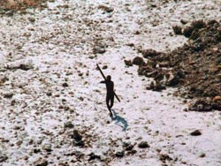
‘In the days after the cataclysmic tsunami of 2004, as the full scale of the destruction and horror wreaked upon the islands of the Indian Ocean became apparent, the fate of the tribal peoples of the Andaman Islands remained a mystery.’ (Survival International, n.d.) Even after a major natural disaster that affected millions, this tribe, often thought to be the most remote tribe in the world, has made it clear they do not want nor need the help of any outsiders by aiming arrows at the passing rescue helicopters (fig. 1). In fact, any contact from the Western society could lead to serious consequences in the survival of these remote communities. (Hamilton, Walker and Kesler, 2014)
Figure 1 - Indian Coastguard/Survival, 2004
There are still several remote indigenous communities left in the world with no connection to modern Western civilisation, and according to a study by Hamilton, Walker and Kesler (2014), factors such as globalisation, industrialisation and colonialism brought on by the Western society are affecting their survival. I believe photojournalists coming from a Western background, should consider whether photographing these communities for historical documentation is worth the possibility of them becoming extinct due to stress from external forces, or whether we should accept that they have the right to decide for themselves how they wish to live, and possibly allow them to leave no documented trace behind for future generations. In this dissertation, I am going to be discussing how remote and disappearing communities are being portrayed through the photographic medium, the resulting cultural appropriation within Western society and the ethical issues behind it. According to Stuart Hall (Hall, Evans and Nixon, 2013: 213) – one of the key theorists whose ideas will be further discussed within this dissertation – there is a secret fascination of difference, or ‘otherness’, and popular representation seems to be frequently drawn to it. This will be followed by analysis, supported by Hall’s ideas, about how minorities are being represented through the media, and how could these representations be affecting them – both negatively and positively. The concept of Orientalism and ‘otherness’ of the subject matter will be discussed with support from another key theorist, Edward Said. Discussion on the relationship between the photographer and subject, or industrialised and developing nation, will be further reinforced by Michel Foucault’s theory on power structures. I will present case studies of different approaches towards indigenous communities by accomplished photojournalists and other visual artists. There will be further discussion about the freedom of expression of the artist, and who is authorised to speak on behalf of the remote communities, if they are unable to represent themselves.

Decline of indigenous communities & Orientalism

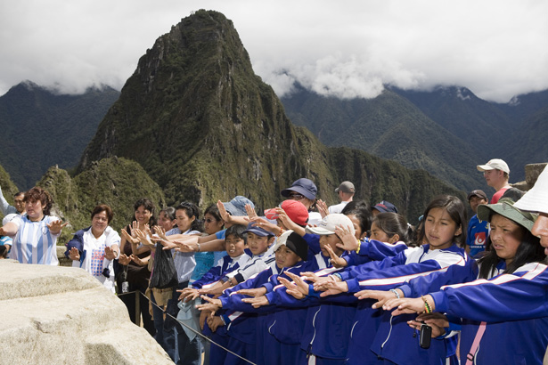
According to Oswald Spengler (Sunic, 1989: 51-63), human cultures do not have a linear history, but instead are organisms and very much comparable to plants – having different stages of life from birth, growth to their eventual decay and death. Roots of all culture derive from the countryside, as they are tied to certain geographical areas. Though, for culture to manifest itself, cities and towns are necessary, because according to Spengler (Sunic, 1989: 56) the countryside is “timeless”. In his predictions for the future, most human activity will be concentrated in only a few large cities, and eventually, rural areas only exist to feed the cosmopolitans. These cities will suck the life out of rural areas until there’s nothing left except an uninhabited desert (Sunic, 1989: 56). Globalisation has been taking place for decades and is causing people to move away from the countryside to larger cities. Metropoles keep growing while the countryside is decaying, leaving abandoned towns behind and people confused with their identities. According to a study by Sobol, Cleveland and Laroche (2017), the widespread migration of peoples across borders is undeniably impacting cultures worldwide. As cities grow, new urban values start manifesting themselves – values such as enjoying culture and art, travelling and being able to familiarise oneself with foreign cultures (Sobol, Cleveland and Laroche, 2017). This almost makes it seem as if privileged Westerners believe it is their right to travel to remote areas, only to marvel at the poor, uneducated, primitive peoples and then return home with photographs as evidence of their adventures. Their intentions may not be malicious, only to educate themselves about different cultures and lifestyles, but while doing so, they end up promoting tourism to areas that might not survive an influx of people, one such example being Machu Picchu. Although the indigenous Inca population had been long gone before the arrival of tourists, the area of Machu Picchu is still under a threat of the overcrowding of tourists destroying the important historical site, as reported by Barcelona Field Studies Centre (2007). According to travel writer Chris Leadbeater (2017) in an article for The Telegraph, as of June 2017, the Peruvian tourism authorities have started restricting access to the site in an attempt to preserve as much of the ruins as possible and lessen the impact of tourism. Photojournalist Martin Parr, who is known for documenting people at popular tourist destinations (fig. 2), wrote about his visit to Machu Picchu in his blog (2008): ‘It is one of the most beautiful sights on earth and is potentially about to become a victim of its own success as visitors swarm over the walls and terraces.’ This same phenomenon of wanting to see a ‘glimpse of a lost world’ (Parr, 2008) is apparent throughout the history of photojournalism, as photojournalists travel to remote areas to document indigenous communities unknown to Western spectators.
Figure 2 - Parr, 2008
Remote cultures are constantly being researched, photographed and documented, thus inevitably contacted by outsiders and influenced by the Western society. Let’s take Brazil for example – ‘the initial colonization of Brazil by Europeans in the 16th century, resulted in the extinction of ~75% of known societies, the loss of over 95% of the overall population, and the complete collapse of complex urban agricultural societies along coasts and major rivers.’ (Hamilton, Walker and Kesler, 2014) Hamilton, Walker and Kesler (2014) concluded in their recent research that all surviving populations suffered extensive mortality during and after contact with Westerners. After contacting these tribes, their long-term survival seems uncertain due to external powers, such as economics and politics. Although contact from the Western society is most certainly affecting the survival of indigenous communities, there may be even more brutalities and neo-colonialism directly aimed at these indigenous regions taking place, which are generally not discussed in Western media. Some of these communities may, for example, be experiencing brutal killings by the government soldiers, as told by Papuan tribal leader Benny Wenda in an article by John Vidal (2004). A good example of neo-colonialism taking place is the mega-dam construction in Belo Monte, Brazil, where government officials are prepared to destroy native tribal areas to be able to build a giant hydropower plant and go into business with China, as reported by The Guardian journalist Jonathan Watts (2014). This proves that the greed of the industrialised nation has no issues prioritising, when it comes to choosing between generating capital and preserving native cultures.
Indigenous communities worldwide are struggling to survive and are being destroyed by deforestation, globalisation and capitalism, yet they are often the ones portrayed as primitive barbarians through photography and images in the media, which is demonstrated
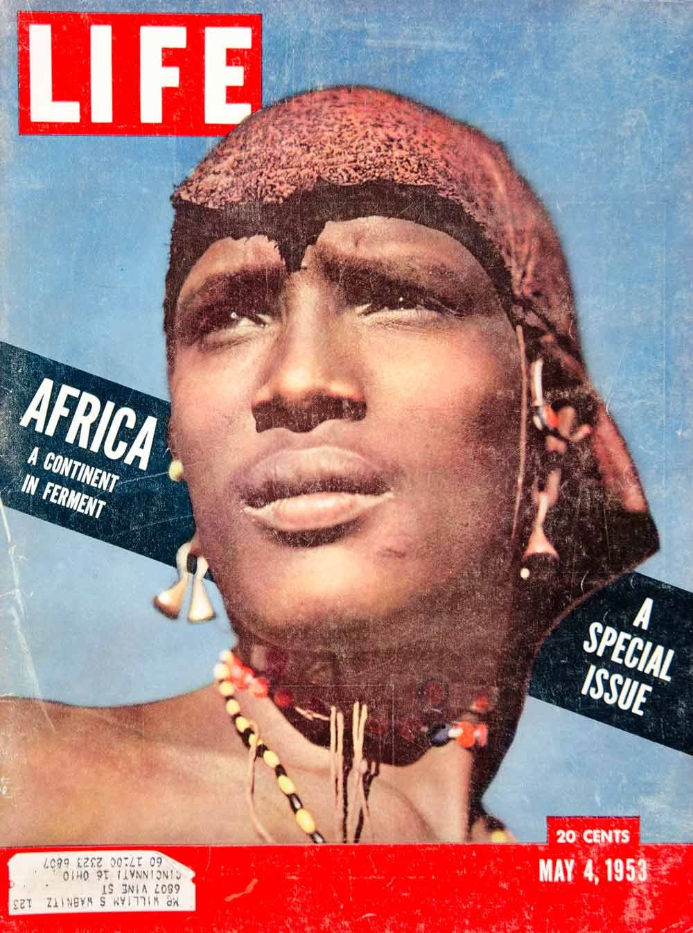
here with the cover of Life magazine from 1953 (fig. 3). Although subtle, the cover image by Weldon King presents a Maasai Warrior, whose facial expression looks like he is in distress. Accompanied by the text ‘Africa – A Continent in Ferment’, the cover could be suggesting African tribes needing the help of outsiders to survive and solve the issues they have brought upon themselves. He is wearing culturally distinctive traditional Maasai clothing that would be anomalous within Western context, which causes the subject to seem exotic & different to the Western viewers. These small details influence the overall representation of the tribe members portrayed to the Western public. Photography claims to be able to create an objective record of native peoples, yet what is often returned to the Western spectators is a representation of something ‘bizarre, barbaric and picturesque’ (Wells, 2006: 83). ‘Photographic and video images can reveal great truths, expose wrongdoing and neglect, inspire hope and understanding and connect people around the globe through the language of visual understanding. Photographs can also cause great harm if they are callously intrusive or are manipulated.’ (NPPA, n.d.) The media is most likely not helping the fight for equality by creating an overly exoticised representation, and further distancing the two cultures from each other.
Figure 3 - King, 1953
The word exotic derives from Ancient Greek exoticus, which means foreign or literally from the outside (Harper, 2017). Exoticising gaze prioritises its own existence, placing the white Western society in the hub of humanity. It views the world from its own context without understanding the limitations brought on by its cultural context. Edward Said (1991: 191) argued that scholarly writing from the West – Europe and America – presented an exotic, mislead and stereotyped cultural representation of the East, the Orient. Since the beginning of the Western speculation of the Orient, the one thing the Orient couldn’t do was represent itself. According to Said (1991: 93) the East is so unfamiliar and incomprehensible to the Western scholars because it differed from their own, so they portray the East as exotic, judging and romanticising it without ever understanding it. Westerners saw their society superior to the society of the East with different values. Said (1991: 191-123) went as far as to argue that the West, with a history of dominative imperialists, stereotyping and painting a picture of the East needing their salvation and civilising was a way of justifying their past actions. Said (1991: 109) believed that either the West is blind to its failing and doesn’t recognise its stereotyping, or it believes its own culture is superior. Said’s term Orientalism describes the patronising Western attitude towards other cultures. It’s always us versus them, rational versus irrational, civilisation versus barbarianism. You can still see signs of Orientalism in today’s media and this will be further discussed within the next chapter, along with the ‘otherness’ of the subject matter. One must have a very critical eye to spot Orientalist stereotypes in today’s news stories as these stereotypes often have so deep roots in our Western culture that they go completely unnoticed. No matter what the reasons behind the decline of indigenous communities, there is always the underlying complex relationship between the East and the West affecting the representations of indigenous communities distributed by the Western media.

Power structures, otherness & cultural appropriation

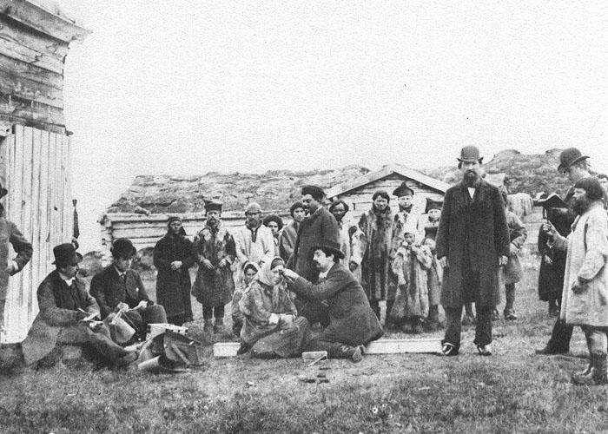
If we were to acknowledge Michel Foucault’s theory on power structures, it would be rather obvious that there is a power struggle between the industrial and developing world. According to Foucault (Mills, 2003: 36), power is not only institutional and something constant, like Marxist theorists before him would say, but rather something that needs to be constantly worked on, a constant performance and is found hidden in smaller scale within individual relations. Already in Victorian times when photography was raising its head in being considered the most reliable and popular source of documentation at the time, there was always a social gap between the photographer and the subject as the reporters were interested in documenting lives that they saw as simple, real and ‘free from the complexities of middle-class existence.’ (Wells, 2009: 77) While the photographers were middle-class, their anonymous subjects were likely to be poor and working class. Photography became a mode of surveying the unknown, and the mysterious lives that were unexplored by the common men were brought to the light of day. The ‘otherness’ of the subject matter is prevalent throughout the history of visual representation – apparent in photojournalism with the foreign, often racially defined groups, being represented as different and exotic compared to the white Western viewers (Hall, Evans and Nixon, 2013: 216). According to Ludmila Jordanova (Hallam and Street, 2000: 245), a Professor of Visual Arts, ‘otherness’ serves as a constant reminder of difference. This is evident in the distancing between the Western spectator and the member of an indigenous community represented through media. The history of documentary could be built around the power structures and relationship between the photographer and subject. The apparent interest in revealing harsh conditions of life to the public often caused photographers rendering their subjects as passive victims of their surroundings, rather than active participants in their own lives.
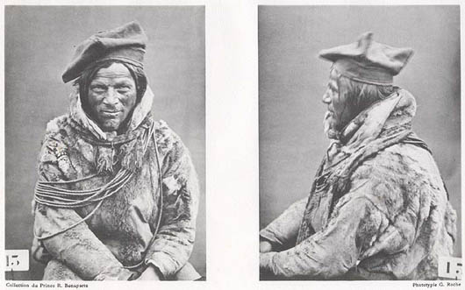
The Sámi people of the Arctic Fennoscandia have lived alongside peoples of Finland, Norway, Sweden and Russia for hundreds of years, yet managed to somehow retain their cultural distinctiveness. According to Svensk Information (2005: 1), the Sámi have been forced to change their way of life and adapt their culture and lifestyle to coincide with the modern society. At the end of the 19th century racism raised its head and Sámi people were claimed to be the inferior race to other Scandinavians, which resulted in a near cultural genocide and they have fought for their rights and land ever since (Svensk Information, 2005: 14). In the anthropological style of the time, races were distinguished through biological features and they went as far as measuring the circumference of the skull (fig. 4) to identify their heritage. Roland Bonaparte, a French prince related to the Emperor Napoleon Bonaparte, took interest in anthropological studies and especially photography as a scientific tool to record his findings. According to an article by Christopher Wahren (2006), Bonaparte documented “unusual” people around the world and in 1884, he set out on an expedition to Lapland to study the Sámi people. Bonaparte has paired frontal and profile portraits with each other (fig. 5), reminiscent of modern prison mugshots, which highlights the distant relationship between the photographer and the subject, and the ‘otherness’ of the subject matter. This is accentuated further by the number card held next to the subjects, stripping them of their dignity and human value, turning them into objects in front of the camera. Bonaparte’s scientific documentary approach and attitude toward his subjects brings them down to an inhumane level as if they are regarded as human specimens as part of an experiment. Photography was once seen as reality, but even then, it didn’t capture reality, but rather a copy of the things photographers encountered. ‘Like images in other media, photographs, too, symbolize our perception of the world and our remembrance of the world.’ (Belting, 2001: 145) Photography is always subjective and the photographer is never able to let go of their own cultural context and background, which is why these in-depth studies and documentations of the Sámi by Bonaparte can only be viewed as a snapshot of their time in history, and not reliable documentation of the lives of the indigenous Sámi.
Figure 4 - Escard, 1886
Figure 5 - Bonaparte, 1884
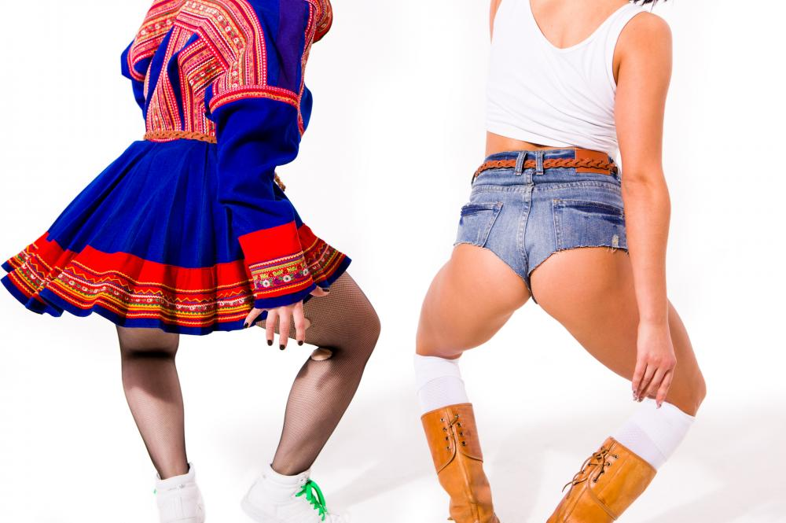
Recently, there has been a lot of discussion in the Finnish media about cultural appropriation and the use of the traditional Sámi costume in popular culture – one of the most provoking initiator of debate in social media being a video piece by a visual artist Jenni Hiltunen. In 2012, Hiltunen created the video piece Grind (fig. 6), where a group of women dance Jamaican Dancehall Queen Style in slow motion wearing fake alterations of the traditional costumes of the Sámi people as a ‘playful take on the dancehall culture with its provocative costumes, suggestive poses, roles and blatant sexuality.’ (Hiltunen, 2012) With her piece Hiltunen wanted to comment on the music video culture and Jamaican dancehall scene, and by using the Sámi dress her intention was to create a connection between the exotic dance style and the Finnish viewers – yet her own heritage is not connected to either Jamaica nor Sámi. The connection between the artist and these two seemingly random different cultures combined remains a mystery, but there may be an intention to provoke and shock viewers in the name of art, by unabashedly appropriating cultures Hiltunen is not a part of. The video piece was bought by the largest contemporary art museum in Finland, the prestigious Kiasma museum of modern art in Helsinki and added to their collection, which somehow may validate the artistic worth of the piece. Ever since the first screening in 2012, Kiasma has received harsh critique from Sámi artists. Journalist Anni-Saara Paltto (2016) wrote in an article for Yle Uutiset about two such Sámi artists, Outi Pieski and Marja Helander, according to whom ‘Kiasma has symbolically accepted the exploitation of indigenous peoples’ (Paltto, 2016) by showing a piece that blatantly degrades the native culture. Pieski & Helander believe that the use of a fake Sámi dress within Hiltunen’s piece has been only for exoticism, and by showing it in a major art museum, is causing the fight for equal rights of Finnish minorities take a step backwards. A group of young Sámi activists even held a flash mob in front of Hiltunen’s piece at the Kiasma contemporary art museum, protesting the use of their dress, taking advantage of the Sámi heritage and violating their public image (Haapala and Miller, 2016). Hiltunen’s piece was posted on an online video platform Vimeo, where some viewers have commented this piece simply being an instrument to discriminate and objectify both women and the Sámi people with no respect to their cultural integrity. There is an entirely different discourse around the ‘othering’ and objectifying of women throughout the history of representation of women that should be acknowledged, but won’t be looked at in-depth within this dissertation. In the article by Paltto (2016), Hiltunen comments that the piece is not about the Sámi culture, and her intentions were not to harm the perception of their culture. According to a post by Kiasma art museum in their official blog (Haapala and Miller, 2016), one of the tasks of contemporary art is to provoke, create a platform for discussion, and a museum as a facilitator offers room for different interpretations.
Figure 6 - Hiltunen, 2012
The Sámi minority have a history of being oppressed by the Finnish, Swedish and Norwegian majorities, and through the discussions on the media about cultural appropriation recently, they have gained the reputation of complainers and being easily offended. They wish to preserve their cultural identity and have asked for people to not wear their dress as a joke, humiliate them and take integrity away from their culture that has been on the verge of extinction for decades (Haapala and Miller, 2016). Re-appropriating items with cultural value is not only insulting, but also slowly eradicating the culture as they are adopted by the Western society and lose their value as cultural objects. Abolishing cultural appropriation once and for all is merely impossible, as items, such as the Sámi costume, Indian headdress or Maori tribal tattoos, make their way to popular culture and are no longer viewed as cultural artefacts. Western society plagiarising these for aesthetic pleasure or fancy dress costumes strips them from any meaning they may have in their respective cultures, and is slowly contributing to the stereotyping and eventual extinction of their cultural integrity, which is why these indigenous peoples should keep fighting to keep their cultures alive. This has brought up discussion of the clashing cultures of minorities and majorities, and on the other the freedom of expression of the artist, and who in the end can speak on the behalf of the indigenous people on matters important to them.
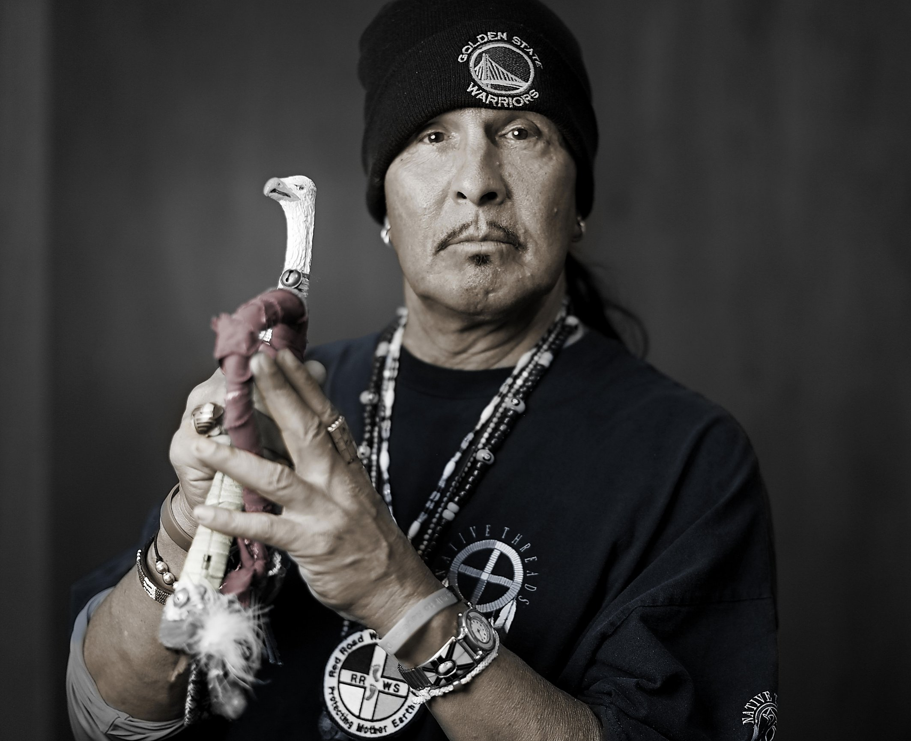
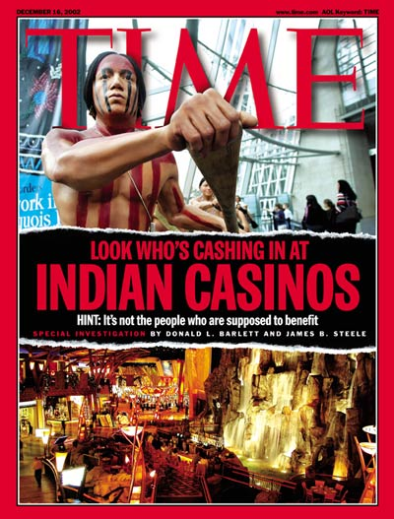
In fact, there doesn’t seem to be many members of indigenous cultures representing and documenting their own lives. Undoubtedly for the most remote communities it is not a case of wanting to document, but rather the inability – without access to modern technology and cameras they are not necessarily aware of the documentary possibilities, thus not being able to demand it. However, there is one photographer of Native American descent, Matika Wilbur, who has taken it upon herself to fight the negative stereotypes Native Americans struggle with daily in The United States of America (Wilbur, 2017). Native Americans have a very similar history of oppression in the United Sates as the Sámi in Scandinavia, and it predates to the bloody massacres of the indigenous tribes carried out by the European colonists. According to a journal article by Richard Hanes (1982: 203-221), Native Americans are still fighting a disadvantaged position compared to the white population – poverty, unemployment, sickness, inadequate healthcare, stripping of their land, just to name a few. Wilbur started the Project 562 which aims to document all recorded 562 Native American tribes in the mainland United States. Her intention is to, through photography, provide insights into contemporary Native American life, encouraging U.S. citizens to advance beyond the cultural insensitivity and appropriation of indigenous items and traditions (Wilbur, 2017). A lot of her photographs are straightforward portraits, in some of them the subject posing in a stance, that most likely has some significance and connotations to the traditions and rituals within their respective communities. Some of the images are black and white, some colour, but most of them have monotone background and the subject is somewhat coloured in (fig. 7). Wilbur may be using this effect to make the photographs strike as more powerful and conspicuous to the viewer, making a lasting impact in them. It should also be noted that Wilbur has gone out on a mission to promote Native American culture and correct some harmful stereotypes directed at them, therefore she must portray the peoples in her photographs in positive light. The modern stereotyped image of Native Americans that mainstream media often proclaims, is that they are unemployed alcoholics, gamblers, a burden to their society (fig. 8). Before Wilbur has even met her subjects, she is determined to construct an image of Native Americans that is contradictory to the one distributed by mainstream media outlets – thus, she is not documenting their lives objectively. It is also a complex matter when it comes to her being a part of the communities she is photographing – she is indeed of Native American descent, but living a very modern life compared to poorer, more primitive indigenous communities, and she is only a member of one tribe, whereas she is photographing all 562 of them around the United States. Therefore, she is unable to have full insight on the lives of every single tribe that she is photographing. Her work is aimed at the white American population, which means that her subjects are still being somewhat exoticised and portrayed as something different compared to the audience, although Native Americans have slowly integrated within modern society and could not necessarily any longer be considered purely indigenous as they do not live the same lifestyle as their ancestors. There is an ‘inherent cultural duality’ (Wilbur, 2017) that Native people live amongst and as their traditions make their way to mainstream media outlets, their culture is bound to be embraced and appropriated by the masses.
Figure 7 - Wilbur, 2017
Figure 8 - Tama, 2002

Exoticising & representation through the media/art

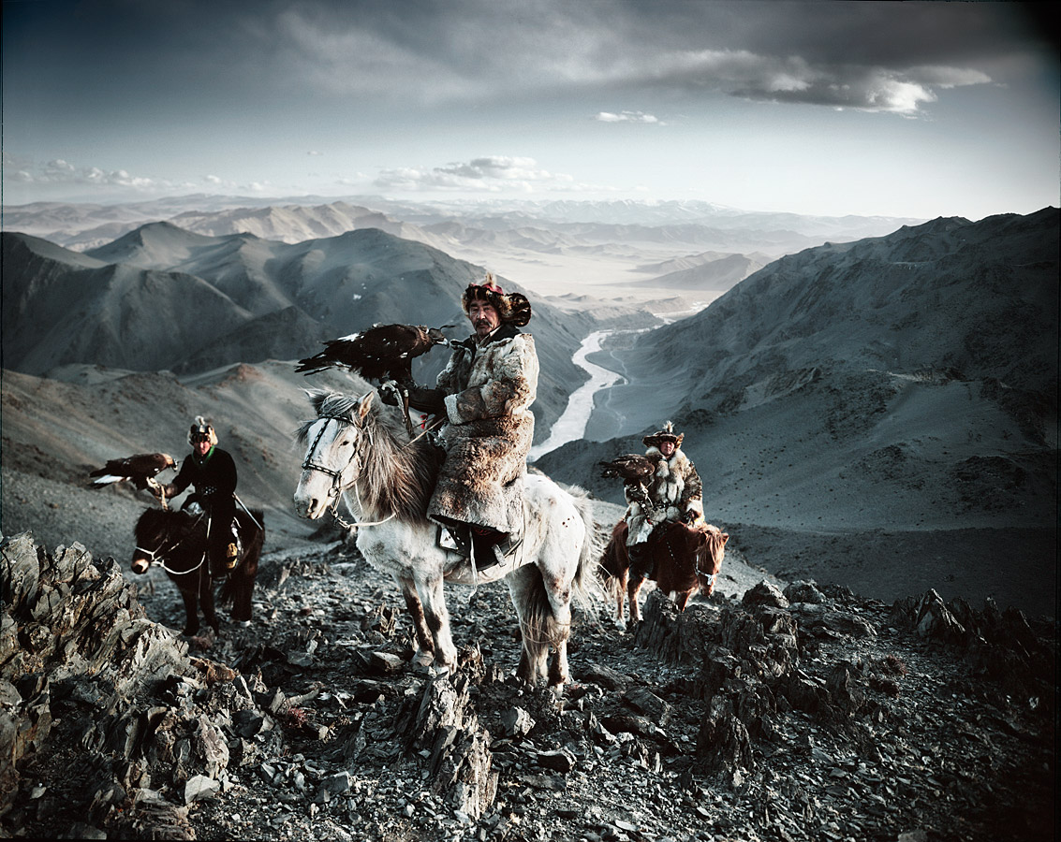
One of the key issues of contemporary documentary photography is how to portray events and subjects without exploiting or having been filtered through the consciousness of the photographer. According to Stuart Hall (Hall, Evans and Nixon, 2016: 249), photography is often used as a campaigning tool to highlight the disadvantaged people of the world to boost the sense of power and security within the Western viewers. Portraying tribes and communities that are unfamiliar to the photographer inaccurately and without necessary knowledge of their background and history, could lead to serious consequences. John Long (1999), the Ethics Co-Chair of National Press Photographers Association, argues: ‘Our credibility is damaged every time a reputable news organization is caught lying to the public’. It’s the photographer’s duty to do their research before making their way to the remote communities, not only out of courtesy to their customs, but also to be able to create the most accurate, truthful representation of the tribe in their imagery.
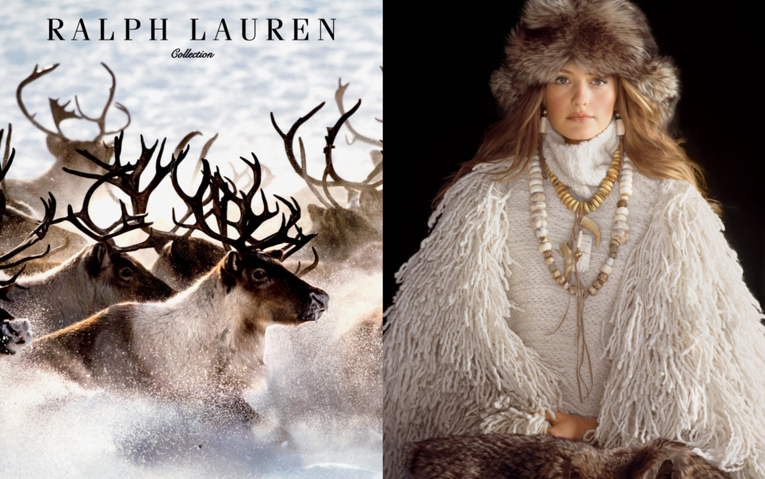
Jimmy Nelson (fig. 9) photographed indigenous people in Africa, Asia and South-America for his project Before they pass away. With a background in commercial photography, his intention may not have been solely in accurate documentation of the tribes, but to play with aesthetics and visual differences between people and cultures around the world. Writer John Vidal (2004) reports in an article about Jimmy Nelson, his images of indigenous people looking like staged situations and, not surprisingly, having angered the community leaders. According to Vidal (2004), these leaders are saying that Nelson doesn’t care about the indigenous peoples, doesn’t know facts about their lives and is pushing his personal ideas & views through the images. His photographs are heavily edited creating a hyperreal aesthetic, as if they are from out of this world. The subjects are posing for the camera very unnaturally, often looking like they are being directed and forced into a specific pose. These kinds of images render the people more exotic than they are, which has become almost a tradition in photojournalism. The photographs by Nelson are a fantasy of the photographer, and don’t reflect the peoples’ political or historical reality, thus rendering them worthless in the sense of historical record of the fast disappearing world. They are however demonstrating the status of photography within Western commodity culture – the purpose of photographs is to sell an illusion, a spectacle to ordinary people to improve sales of newspapers and books saturated with beautiful imagery (Wells, 2009: 210). Photojournalists, while delivering information and news, are aware of the need to produce spectacular images that draw the attention of the public. If the drama and spectacle needed to sell more products does not exist in real life, it must be artificially created, which Nelson has done by creating an unnecessarily dramatic and exotic atmosphere within his images. Thus, we must ask why were the images by Nelson created in the first place and what are the ulterior motives of the photographer. Nelson has appeared in several interviews with an ignorant, arrogant attitude, and has commented on the images having an editorial look, discussing the model Kate Moss: ‘You can picture here on the beach with a fag coming out of her mouth or in a studio.’ (Vidal, 2014) This further supports the argument of him not caring about his subjects, possibly only wanting to sell more books, and retain a reputation of a great photographer at his subjects’ expense.
Figure 9 - Nelson, 2011
Figure 10 - Nelson, 2015
The famous fashion designer Ralph Lauren approached Nelson after seeing his book Before they pass away in hopes of getting him to photograph their latest collection, which says something about the high fashion editorial style photography of the book. They ended up doing an Autumn/Winter production in the Finnish Lapland in 2015. The resulting photographs (fig. 10) visually resemble the ones from Nelson’s Before they pass away project, yet one of them features a model receiving a generous compensation, and the other members of an indigenous, oppressed culture, most likely receiving nothing in return for posing in the images, while the photographer is making a profit. Nelson is using elements of exotisation even in his editorial fashion photographs. The models are wearing winter gear mixed with materials that you might see indigenous Northern tribes wear, such as fur and large ethnic necklaces, and Nelson pairs these portraits with an environmental shot of the location and their surroundings, attempting to give the piece a documentary quality. There is, or should be, a shocking contrast between the stark reality of lives of the indigenous tribes and supermodels’, yet these two projects look hopelessly similar and present an unrealistic view of the world.
The media will push bias and opposition towards whatever gets them views and same could go for some photographers. According to Stuart Hall (Hall, Evans and Nixon, 2013: 215) media isn’t always reliable and is pushing their own ideologies and forwarding the othering of for example immigrants, Muslims and the poor. Hall (Hall, Evans and Nixon, 2013: 215) studied the power of mainstream media in representing race, gender, class, ethnicity and religion. He claims that their discourses are not innocent – they’re hidden in mass media as ideology, more specifically ideologies created by the Western society, and it’s up to the viewer to find those ideologies to see past them. Media is an active player in the process of keeping stereotypes alive, such as exotisation of indigenous tribes, racialisation of crime or the ‘othering’ of immigrants. Photography used to be thought as the most accurate form of documentation, but in the digital age of photography we have come to learn that it is no longer necessarily true. Image manipulation is more common than ever and audiences, rightfully, no longer believe everything they see. In the digital age of photography how we consume and produce images has changed, yet we must remember that in June 2017 only 10% of all worldwide internet users are in Africa and most people in the world don’t have access to cameras or internet (Internet World Stats, 2017). The subjects being photographed are the most important element within the photographs, yet they may never see the resulting images and have no say as to whether they are represented in an accurate way. A historian would focus on one area and a wide range of people from all ranges of life for the most accurate picture of the entire area and get poignant results, yet photographers generally concentrate on a small locality using only a few representatives for an entire community, which would make photography an inaccurate way of researching and documenting these communities. The commonplace exotisation of indigenous cultures within photography is further reducing the integrity of photojournalism.
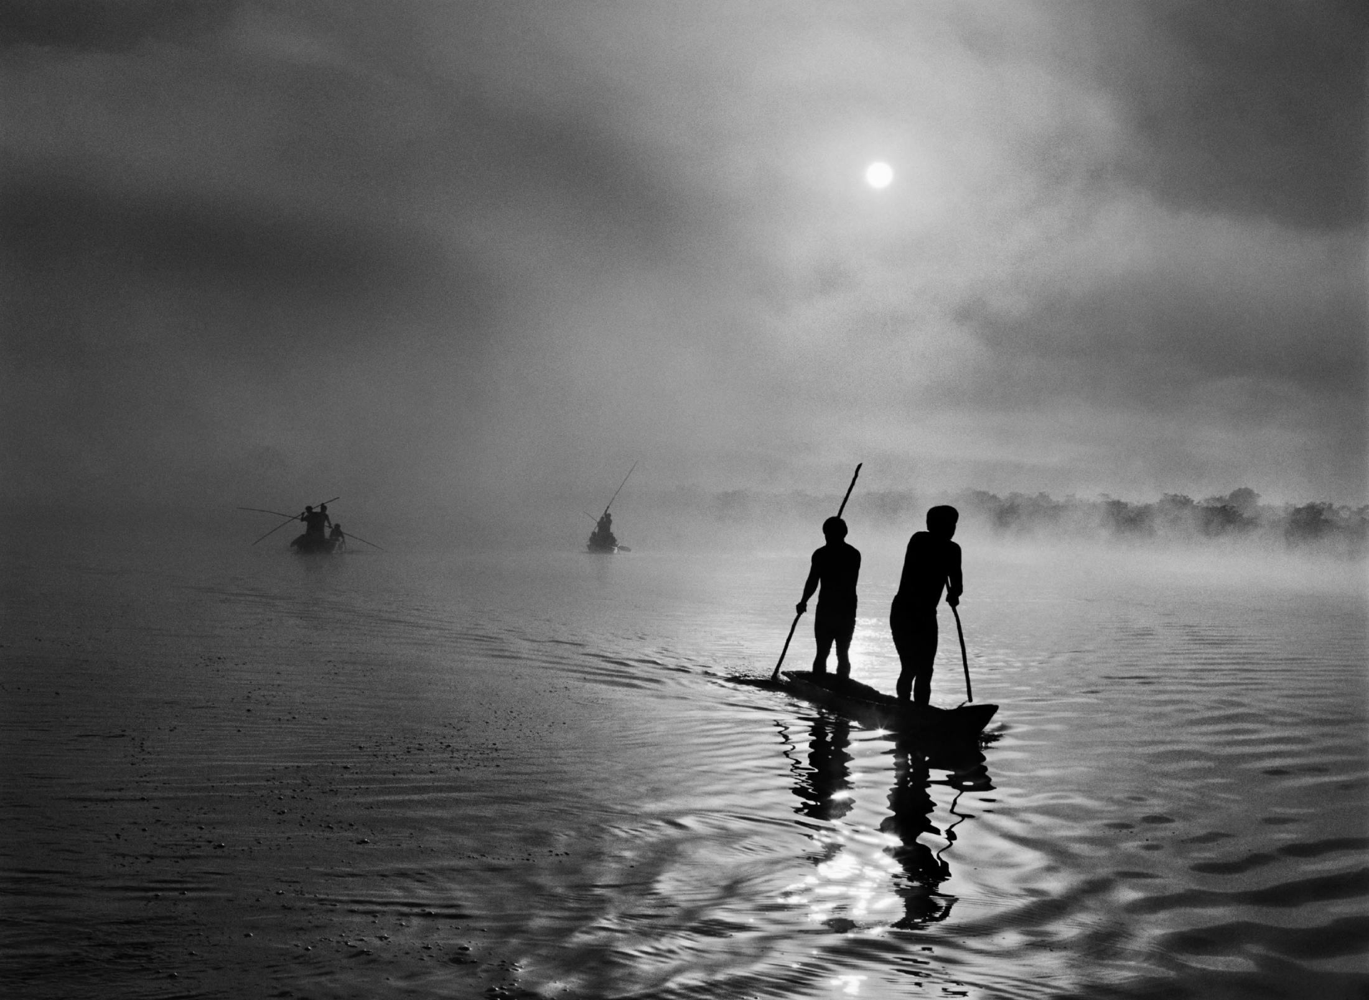
The victim narrative and exotisation of the ‘other’ are generally accepted as concepts within the Western society. Portraying the foreign victims makes them passive objects within the representations, the only active party in the photographs being the artist. Sebastião Salgado is known for his haunting black-and-white photographs of workers in near-slavery conditions and migrants on the move, forced away from their homes – always showing people struggling with some of the worst times in their lives. In his latest book, Genesis (fig. 11), he attempted to record unchanged landscapes and people around the world in the invasion of modern society and development, an attempt to show the beauty that still exists outside of Western civilisation. These types of representations of the ‘other’ are popular in the Western culture, where the exotic body is not of interest as an active participant, but rather a passive recipient. When a single representation continues the long line of objectification that’s been carried out by generations of photographers and photojournalists, it reinforces the stereotypes of the indigenous being passive victims within the collective consciousness. In the Western world, the photographer or artist is viewed as a hero who gives a voice to the oppressed nations, brings awareness of the atrocities going on around the world to the masses and changes lives along the way. South African editor and writer Ingrid Sischy famously criticised Salgado’s work in the New Yorker (1991) magazine: ‘to aestheticize tragedy is the fastest way to anesthetize the feelings of those who are witnessing it. Beauty is a call to admiration, not to action.’ Sischy was very critical towards the ‘beautification’ of his subjects, saying how Salgado concentrates too much on compositional aspects in his photographs, finding beauty and grace in convoluted situations, making us question whether suffering can be too beautiful. Excess beauty in extreme tragic situations will ultimately only reinforce the passivity of the viewers, even if the photographer’s intention is to get people take action. As Cartier-Bresson (Kimmelman, 2001) once said: 'There is something appalling about photographing people. It is certainly some form of violation. So if sensitivity is lacking, there can be something barbaric about it.' In a photography review in The New York Times, writer Michael Kimmelman (2001) argues that Salgado is following the suffering of the people and chooses to sentimentalise his subjects – smiling children, the overcoming of obstacles, good times in horrific conditions, which all goes to show the ‘voyeuristic and unashamedly manipulative sides of his work.’ (Kimmelman, 2001)
Figure 11 - Salgado, 2005
It can be argued that most photojournalism, like Salgado’s or Nelson’s work, is exploitative in one way or another. Photojournalists are feeding off the otherness of their subjects. Great pieces of art or photography are generally thought-provoking, which would indicate that an image that has generated discussion, positive or negative, is a successful one. Who in the end decides what is acceptable as a representation of the unknown foreign, and what is not. According to the journalist Anni-Saara Paltto (2016), Western institutions generally evaluate the representations made by the photographer according to their intentions. A photographer who purposely goes out to demonise the subject does not mean well, thus their photography is not acceptable. A photographer creating an exotic or victimised representation has good intentions behind their actions, thus it is acceptable. The imagery produced with these good intentions is therefore also accepted, even if the resulting photographs and representations may be harmful to the indigenous communities. ‘As individuals we are far – very far indeed – from knowing them in all their aspects. Conversely, exotic cultures seemed so different to early Western observers only when they succumbed to the temptation to read them through the ethnocentric grille of their own customary behaviour. Experience of the remote has taught us to de-centre our way of looking and we should make use of the lesson.’ (Augé, 1995: 35)

Conclusion

The future of the most remote tribes is uncertain, whether photojournalists and photographers continue documenting them. Paul Mason (2015: 257), a writer and economist, claims that globalisation, industrialisation and even global warming are threatening the livelihoods of remote communities, forcing them to eventually either perish or move to “civilisation” to be able to survive. Ethical issues cannot be avoided when photographing minorities, and as we have determined in this dissertation, it is impossible to objectively document and represent communities that are foreign to the photographer. This dissertation also touched upon issues of reliability of photojournalism as a method of historical documentation within the modern digital age, and with the support from several examples and key thinkers, concluded that it is no longer necessarily possible due to the subjectivity of the photographer and advancements in image manipulation. There has been analysis about some of the complexities and power struggles within the relationship between the East and West, the industrial and developing world, and on a smaller scale the photographer and their subject. The artist is always tied to their own cultural context and unable to fully understand the lives of the subjects, and could unknowingly be exoticising them for ‘newsworthiness’ and the resale value for consumers and newspapers (Wells, 2009: 210).
Stuart Hall (Hall, Evans and Nixon, 2013: 269) discussed the power of the media and how they may be abusing their power to promote false stereotypes for their own profit, but he also did not see the masses only as brainless viewers. He saw pockets of resistance forming all over the world outright rejecting the ideologies of the media – the bloggers in Tunisia, the graffiti artists in Brazil, Black Lives Matter movement. This only goes to prove that one can break free from the structured flow of information that is blasted our way daily and it only requires the acknowledgement of these stereotypes and ideologies. Although, one can never break free from their own context – it is a necessary paradox that can be learned to live with. To understand all the hidden layers of Orientalism and the representations of the ‘other’ within mass media & art, doesn’t mean one should become to be in a constant state of awareness, after which everything is clear and makes sense. It then becomes a permanent state of doubt and uncertainty to which one can surrender. It’s a space which every great artist or photographer must be very familiar with – outside one’s comfort zone. The space where all things interesting are created.

Bibliography

Books

Augé, M. (1995) Non-Places: Introduction to Anthropology of Supermodernity. Translated by Howe, J. London: Verso.

Belting, H. (2001) An Anthropology of Images: Picture, medium, body. Translated by Dunlap, T. New Jersey: Princeton University Press.

Hall, S., Evans, J. and Nixon, S. ed., (2013). Representation. 2nd ed. London: Sage : The Open University.

Hallam, E. and Street, B. ed., (2000). Cultural Encounters - Representing 'Otherness'. London: Routledge.

Jameson, F. (1998) The cultural turn : selected writings on the postmodern, 1983-1998. London: Verso.

Mason, P. (2015) Postcapitalism: A guide to our future. London: Penguin Books.

Mills, S. (2003) Routledge critical thinkers: Michel Foucault. Oxon: Routledge.

Said, E. (1991). Orientalism: Western Conceptions of the Orient. London: Penguin Books.

Sealy, M. (2008) Documenting disposable people: Contemporary global slavery. London: Hayward Publishing.

Strauss, D. (2003). Between the Eyes: Essays on Photography and Politics. New York: Aperture.

Stallabrass, J. ed., (2013). Documents of Contemporary Art: Documentary. London: Whitechapel Gallery.

Wells, L. ed., (2009). Photography: A Critical Introduction. 4th ed. Oxon: Routledge.

E-books

Mills, S. (2003). Michel Foucault. [ebook] London: Routledge. Available at: https://www-dawsonera-com.ezproxy.uwtsd.ac.uk/readonline/9780203380437 (Accessed: 23 October 2017).

Morley, D. and Chen, K. ed., (1996). Stuart Hall: Critical dialogues in cultural studies. [ebook] London: Routledge. Available at: https://www-dawsonera-com.ezproxy.uwtsd.ac.uk/readonline/9780203993262 (Accessed: 2 December 2017).

Svensk Information (2005). The Sami - An Indigenous People in Sweden. Translated by Crofts, R. [ebook] Västerås: Edita Västra Aros. Available at: http://www.samer.se/2137 (Accessed: 19 November 2017).

Journal articles

Hanes, R. (1982). Cultural Persistence in Nevada: Current Native American Issues. Journal of California and Great Basin Anthropology, [Online] 4(2), pp.203-221. Available at: https://escholarship.org/uc/item/7bt3z1tk (Accessed: 4 December 2017).

Sobol, K., Cleveland, M. and Laroche, M. (2017). Globalization, national identity, biculturalism and consumer behavior: A longitudinal study of Dutch consumers. Journal of Business Research.

Sunic, T. (1989). History and decadence: Spengler's cultural pessimism today. Clio, Vol 19, pp.51-63.

Newspaper articles

Sischy, I. (1991). Good intentions. The New Yorker, pp. 89-95.

Online articles

Hamilton, M., Walker, R. and Kesler, D. (2014). Crash and rebound of indigenous populations in lowland South America. [Online] Available at: https://www.nature.com/articles/srep04541 (Accessed: 15 October 2017).

Kimmelman, M. (2001) Photography review; Can suffering be too beautiful?. [Online] New York Times. http://www.nytimes.com/2001/07/13/arts/photography-review-can-suffering-be-too-beautiful.html (Accessed: 5 December 2017).

Leadbeater, C. (2017). Will new limits on visiting Machu Picchu save Peru's most famous Inca citadel?. The Telegraph. [Online] Available at: http://www.telegraph.co.uk/travel/destinations/south-america/peru/articles/machu-picchu-new-rules-for-access/ (Accessed: 12 December 2017).

Long, J. (1999) NPPA Special Report: Ethics in the Age of Digital Photography. [Online] NPPA. Available at: https://nppa.org/page/5127 (Accessed: 13 October 2017).

Paltto, A. (2016). Kiasmaa arvostellaan feikkisaamenpukuvideon ostamisesta. [Online] Yle Uutiset. Available at: https://yle.fi/uutiset/3-8869765 (Accessed: 10 December 2017).

Vidal, J. (2004) Photographer criticised by indigenous people and Survival International. [Online] The Guardian. Available at: https://www.theguardian.com/global-development/2014/oct/29/jimmy-nelson-indigenous-people-survival-international (Accessed: 15 October 2017).

Watts, J. (2014). Belo Monte, Brazil: The tribes living in the shadow of a megadam. The Guardian. [Online] Available at: https://www.theguardian.com/environment/2014/dec/16/belo-monte-brazil-tribes-living-in-shadow-megadam (Accessed: 12 December 2017).

Websites

Barcelona Field Studies Centre. (2007). Machu Picchu - Tourism Impact. [Online] Available at: https://geographyfieldwork.com/MachuTourismImpact.htm (Accessed: 12 December 2017).

Harper, D. (2017). Origin and meaning of exotic by Online Etymology Dictionary. [Online] Etymonline.com. Available at: https://www.etymonline.com/word/exotic (Accessed: 1 December 2017).

Internet World Stats. (2017). Africa Internet Users, 2017 Population and Facebook Statistics. [Online] Available at: http://www.internetworldstats.com/stats1.htm (Accessed: 31 October 2017).

Matika, W. (2017). [Online] Project562.com. Available at: http://www.project562.com (Accessed: 3 December 2017).

NPPA. (n.d.). Code of Ethics. [Online] Available at: https://nppa.org/code-ethics (Accessed: 13 October 2017).

Survival International. (n.d.). The most isolated tribe in the world?. [Online] Available at: https://www.survivalinternational.org/campaigns/mostisolated (Accessed: 15 October 2017).

Wahren, C. (2006). CWFP: Special Exhibit: Laplander Studies by Roland Bonaparte: Introduction. [Online] CHFP. Available at: https://cwfp.biz/cgi-bin/exhibits/tm.php?vw=intro&idxf=14&kw=BonaparteLapons (Accessed: 11 December 2017).

Blogs

Haapala, L. and Miller, A. (2016). Kiasma Paikkana Keskustelulle: Saamelaisuutta ja Sananvapautta. [Blog] Kiasma Blogi. Available at: http://blog.kiasma.fi/blog/kiasma-paikkana-keskustelulle-saamelaisuutta-ja-sananvapautta/ (Accessed: 12 December 2017).

Parr, M. (2008). Machu Picchu. [Blog] Available at: https://www.martinparr.com/2008/machu-picchu/ (Accessed: 12 December 2017)

Videos

Hiltunen, J. (2012). Grind. [Video] Available at: https://vimeo.com/44392653 (Accessed: 19 November 2017).

Images

Bonaparte, R. (1884). Lapons (plate 13) - Per Josupsen Gohu [Image] Available at: https://cwfp.biz/items/exhibits/dsc_0/14_BonaparteLapons_top.jpg (Accessed: 19 November 2017).

Escard, F. (1886). [Image] Available at: https://cwfp.biz/cgi-bin/exhibits/tm.php?itm=fd08.frontis&idxf=14&kw=BonaparteLapons&vw=itm&md=2 (Accessed: 19 November 2017).

Indian Coastguard/Survival (2004). [Image] Available at: http://assets.survivalinternational.org/static/lib/img/content/uncontacted/sentinelese_arrow.jpg (Accessed: 15 October 2017).

King, W. (1953). Cover of Life Magazine, May 4, 1953. [Image] Available at: https://cdn.shopify.com/s/files/1/1021/8371/products/YLMC1_054_2048x2048.jpg?v=1493294065 (Accessed: 12 December 2017).

Nelson, J. (2011). Kazakh Eagle Hunting. [Image] Available at: https://www.jimmynelson.com/media/images/Kazakh/K3.jpg (Accessed: 22 October 2017).

Nelson, J. (2015). [Image] Available at: https://www.jimmynelson.com/media/images/Events/Ralph%20Lauren/Screen%20Shot%202017-06-20%20at%2015.44.09.jpg (Accessed: 25 November 2017).

Parr, M. (2008). [Image] Available at: https://www.martinparr.com/wp-content/uploads/2008/11/LON108008.jpg (Accessed: 12 December 2017).

Salgado, S. (2005). [Image] Available at: https://www.icp.org/files/styles/large2xcustom_user_normal_2x/public/Salgado_river_high.jpg?itok=kuYR0_TH&timestamp=1456229722 (Accessed: 25 November 2017).

Tama, M. (2002). American Indians and Casinos. [Image] Available at: http://img.timeinc.net/time/magazine/archive/covers/2002/1101021216_400.jpg (Accessed: 13 December 2017).

Wilbur, M. (2017). Chief Good Wolf Kindness, Oneida/Mohawk. [image] Available at: http://www.project562.com/blog/native-americans-running-4-000-miles-for-sobriety-safety-and-solidarity/ (Accessed: 4 December 2017).

