Tutorial exercises and associated cases Answers
Exercise one
- What is the significance of the title of this case?
- refers to the football business context
- indicates how Wilhelm’s attempts to gain favour with his negotiator(s) made his situation even more difficult.
- How would you define the problem from your perspective?
Possible reference to conflicting assumptions and expectations between the two parties (Western and Arabic) – and the consequences.

- What do you think has caused the so-called stalemate? Refer to the culture values outlined in the lecture that have had an impact on the way the agent handled his encounter with Mr.Haider. Mention in particular:
Fundamental difference: importance of relationships: For Mr. Haider: a trustworthy and personal relationship is of greater value than a formal contract. For Wilhelm: pushing through the deal has priority: saw the terms of the contract which he received as a concrete offer. This opposition is reflected in the universalism/particularism dimension proposed by Trompenaars.
Time focus
Past orientation: upholding tradition; versus
– Present orientation: going for the deal
– Timing of the meeting: Haider no doubt considered having lunch with Wilhelm as an important way of becoming acquainted. Wilhelm saw 11.30 as the time a formal business meeting should start.
Competition;
Being competitive-oriented: Wilhelm wants the best deal possible; versus
Being cooperation-oriented: Mr. Haider is more concerned with the quality of the relationship with Wilhelm.
Action
Being: (Haider) spontaneous expression of what is inside you: sharing this with your client through social interaction; versus
Doing: (Wilhelm) accomplishing something: getting the deal; meeting external standards: gaining approval of his boss.
Space
Private space: Haider invites Wilhelm into his home with a view to establishing personal relationships. He is given access to a wider private sphere.
Communication
High context versus low context
Haider focuses on the context of their meeting: lunch, meeting his sons and wife. Wilhelm sees the context has a hindrance. He ignores the cues offered and non-verbal behaviour, wishing explicitly ‘to finalise the deal’.
Structure
Wilhelm is in a collectivist environment, where each person is encouraged to conform, to do what is best for the group.
However, Wilhelm was reluctant to cooperate:
– he refused lunch ‘out of politeness’
– he refused to call Haider by his first name
– he persevered with his attempt to resolve financial issues first
There is also question of Wilhelm’s friendly approach towards Haider’s wife. Haider may not have considered this is to be what Wilhelm doubtless intended it to be, namely a dignified attempt to recognise her presence.
- How do you think Wilhelm can rescue the deal?
Wilhelm could try to re-gain Haider’s trust by initiating a further meeting where Wilhelm introduces his client, the goalkeeper. Establishing relationships will have precedence over financial matters, so the choice of meeting-place could be a crucial one. Haider may be persuaded to attend since, in his eyes, the goalkeeper’ status is certainly higher than that of Wilhelm.
- How can Wilhelm best prepare for any future negotiations in the Middle East on behalf of his football clients?
Wilhelm should question his whole approach to doing business with people such as Haider. He should find out about local customs, habits and business behaviour, and then reflect critically about what happened during his encounter with Haider: what were Wilhelm’s assumptions and expectations and how did they differ from Haider’s? What did Wilhelm do, why did he behave the way he did and what may have caused offence? If he is willing and able, he will incorporate elements
to do with building trust and establishing long-term relationships into his future negotiating strategies.

Exercise two
Task 1: Developing your self-awareness
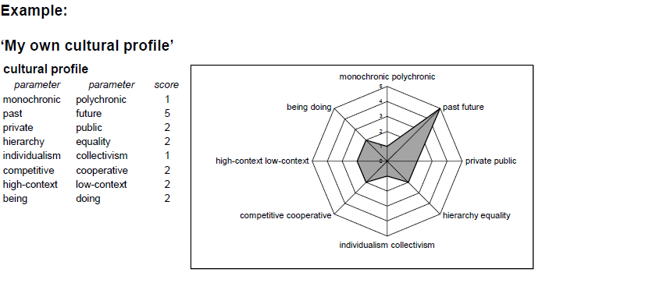
Task 2: Developing cross-cultural understanding
1 & 2
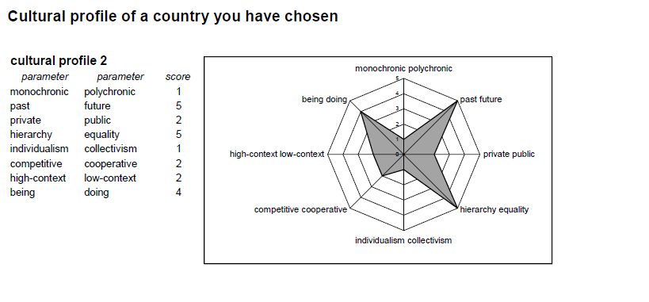
- Compare the two profiles and determine the differences and similarities in the
parameters.

- What are the differences and the similarities between which parameters?

If you compare the cultural profiles of the example you can identify only two parameters which score really differently: Power (Hierarchy/ Equality) and Action (Doing/Being). The other parameter scores are the same or similar.

- Define what you believe are the critical issues when representatives of the two cultures profiled work together?
- What are the critical issues when representatives of the two cultures profiled work together?

If you are going to do business with people in the country concerned, you will need to pay
attention only to the critical cultural differences. In this example, there are two parameters
which can cause problems: Hierarchy/Equality and Doing/Being. Therefore, you need to adapt your management skills (planning, organising, staffing, directing/leading, controlling) by taking into account these two cultural variables.

