Configure and manage the virtualised enterprise network
Network Operating Systems and Services – ACCA5023
07/05/2026
2317483@student.uwtsd.ac.uk
Daniel Leone (2317483)

Table of Contents
Table of Figures 2
1. Routing 3
2. Domain Server (Swansea) 4
5
5
3. Encrypted Connection (VPN) 6
6
7
7
4. Users 8
5. Domain Membership 8
6. DHCP Server 9
7. Test Network connectivity 9
8. Disk Drive 10
9. IIS Server 10
10. Remote Desktop Services 11

Table of Figures

Figure 1: Firewall ICMP Rule 3
Figure 2: Routing 3
Figure 3: Active Directory Computers 4
Figure 4: DNS Settings 4
Figure 5: Domains and Trusts 5
Figure 6: DNS outcome 5
Figure 7: Wireguard attempt - Windows 6
Figure 9: Wireguard attempt - Debian 6
Figure 10: PPTPD outcome 7
Figure 8: VPN interface 7
Figure 11: Imported Users 8
Figure 12: DHCP configuration 9
Figure 13: S-DC and L-CD connectivity after PPTPD 9
Figure 14: Shared Drive (E:\SwanseaFiles) With permissions 10
Figure 15: IIS Server (webs.daniel.acca) 10
Figure 16: RDS 11

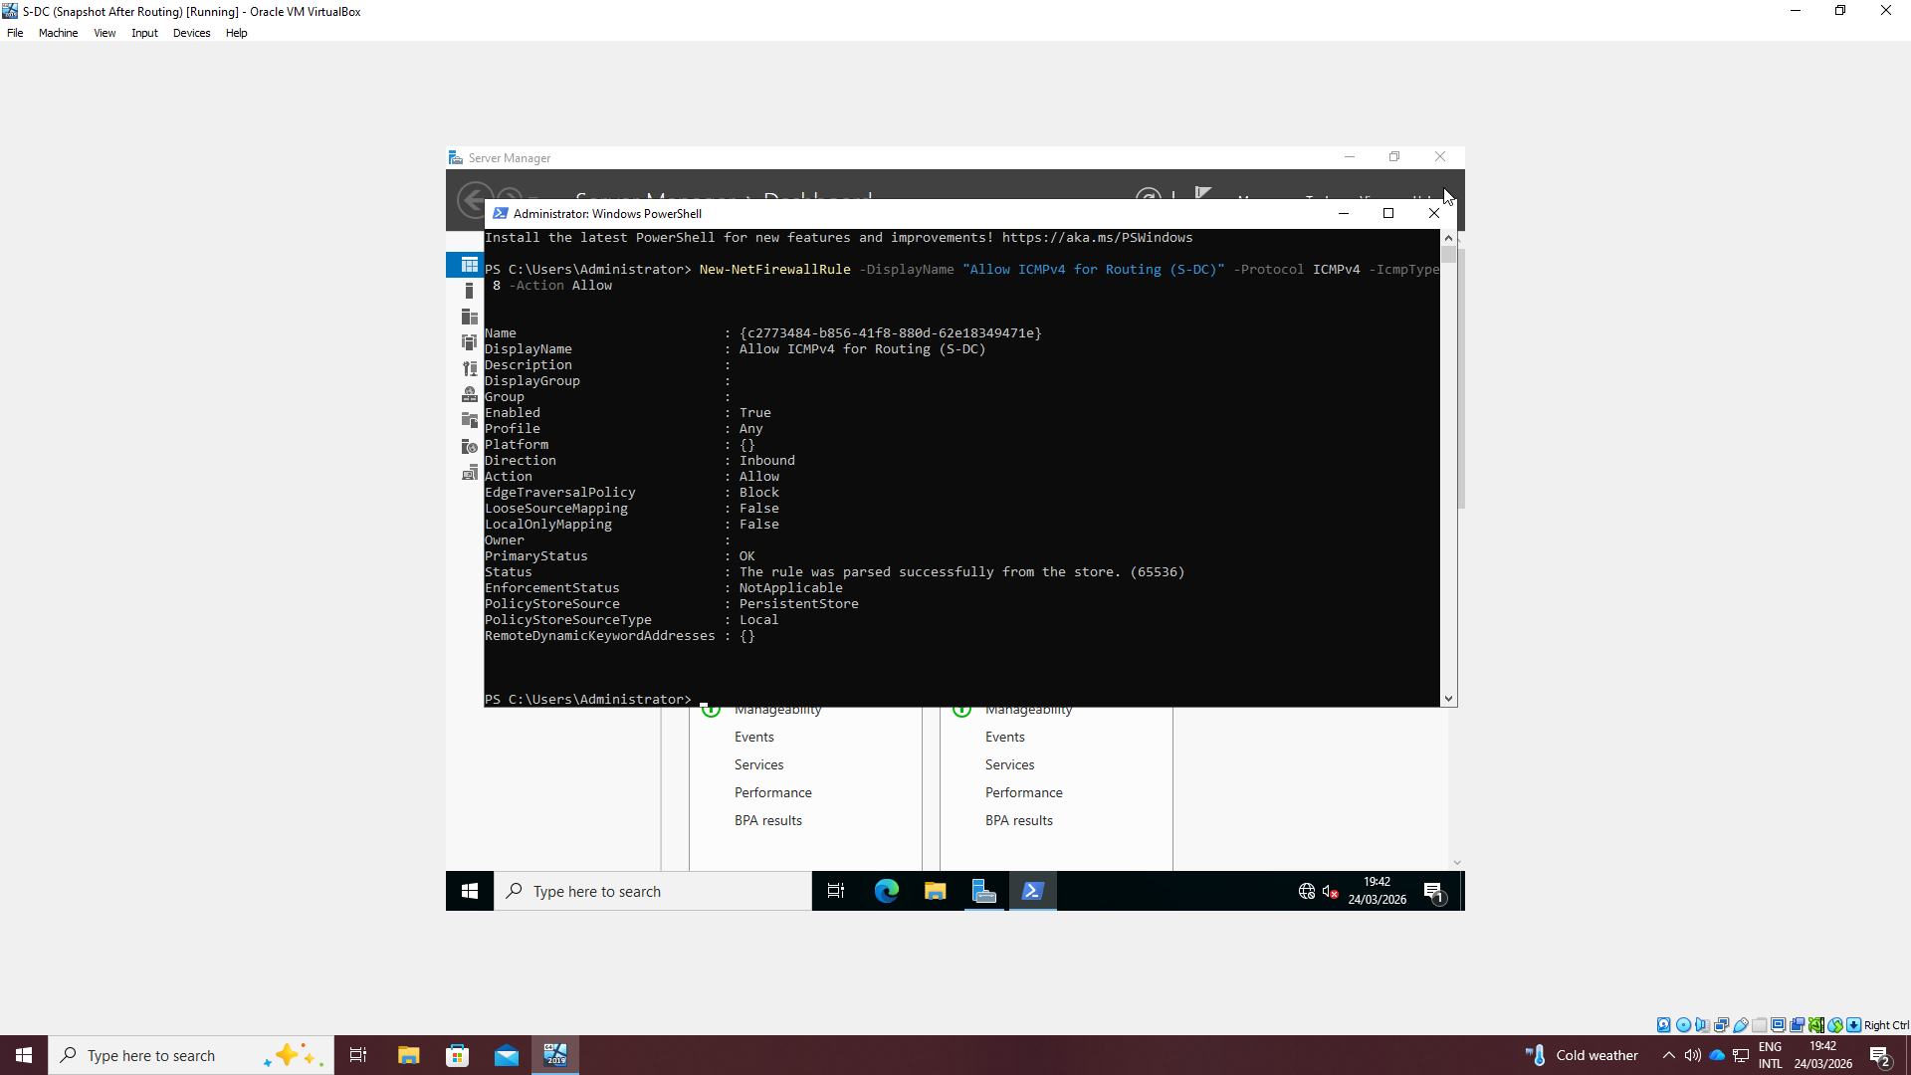
1. Routing
Figure 1: Firewall ICMP Rule
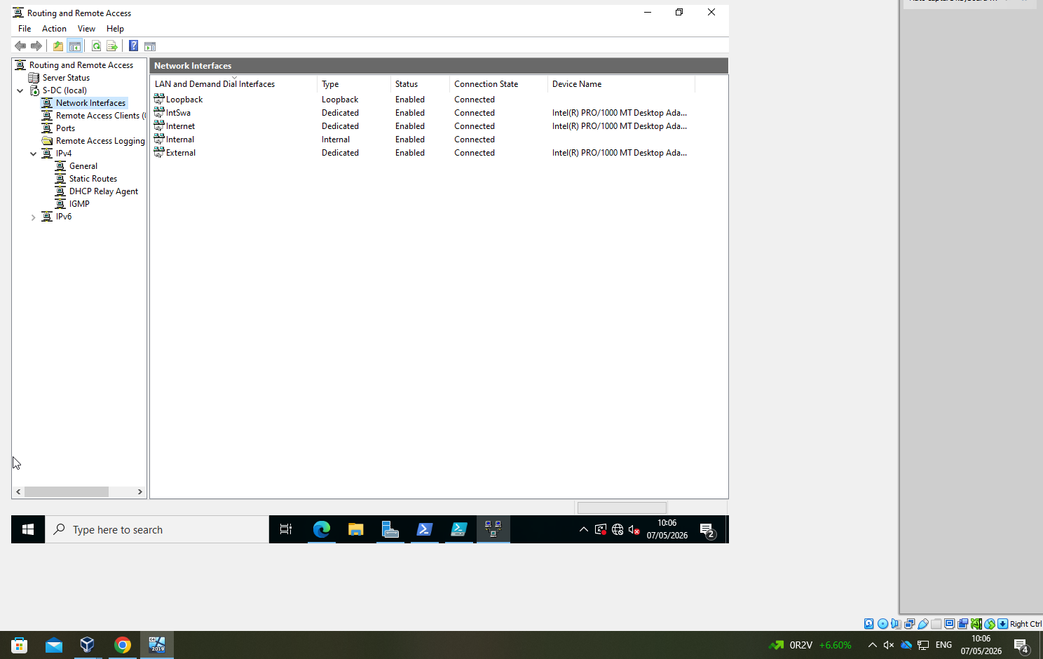
Figure 2: Routing

2. Domain Server (Swansea)
Figure 3: Active Directory Computers
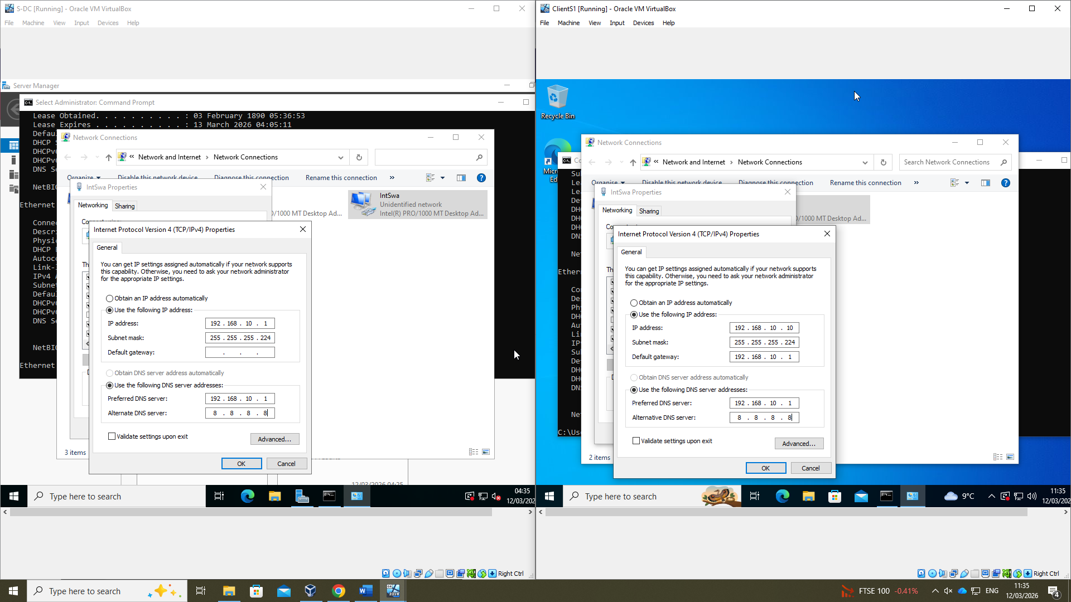
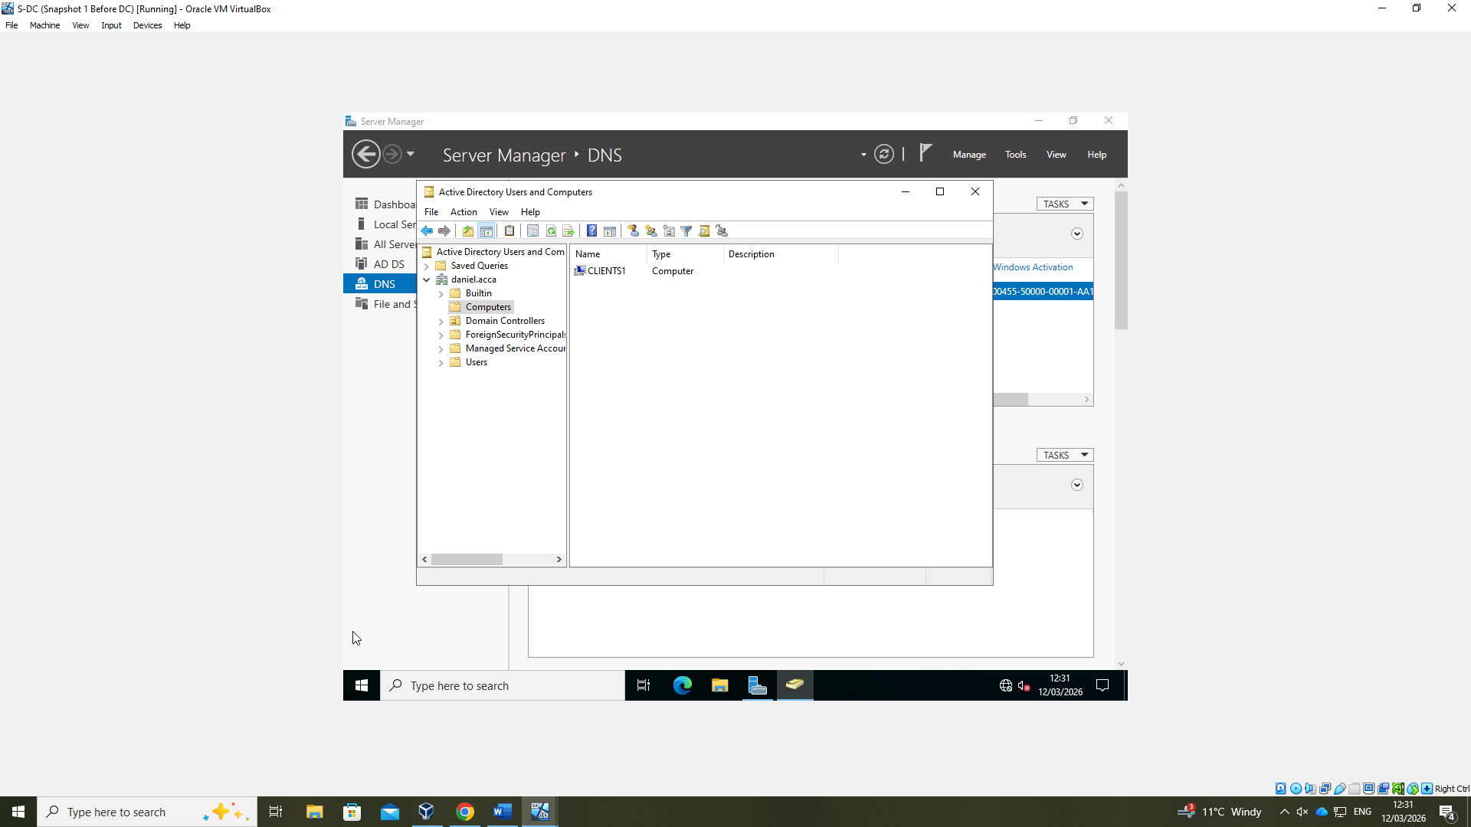
Figure 4: DNS Settings

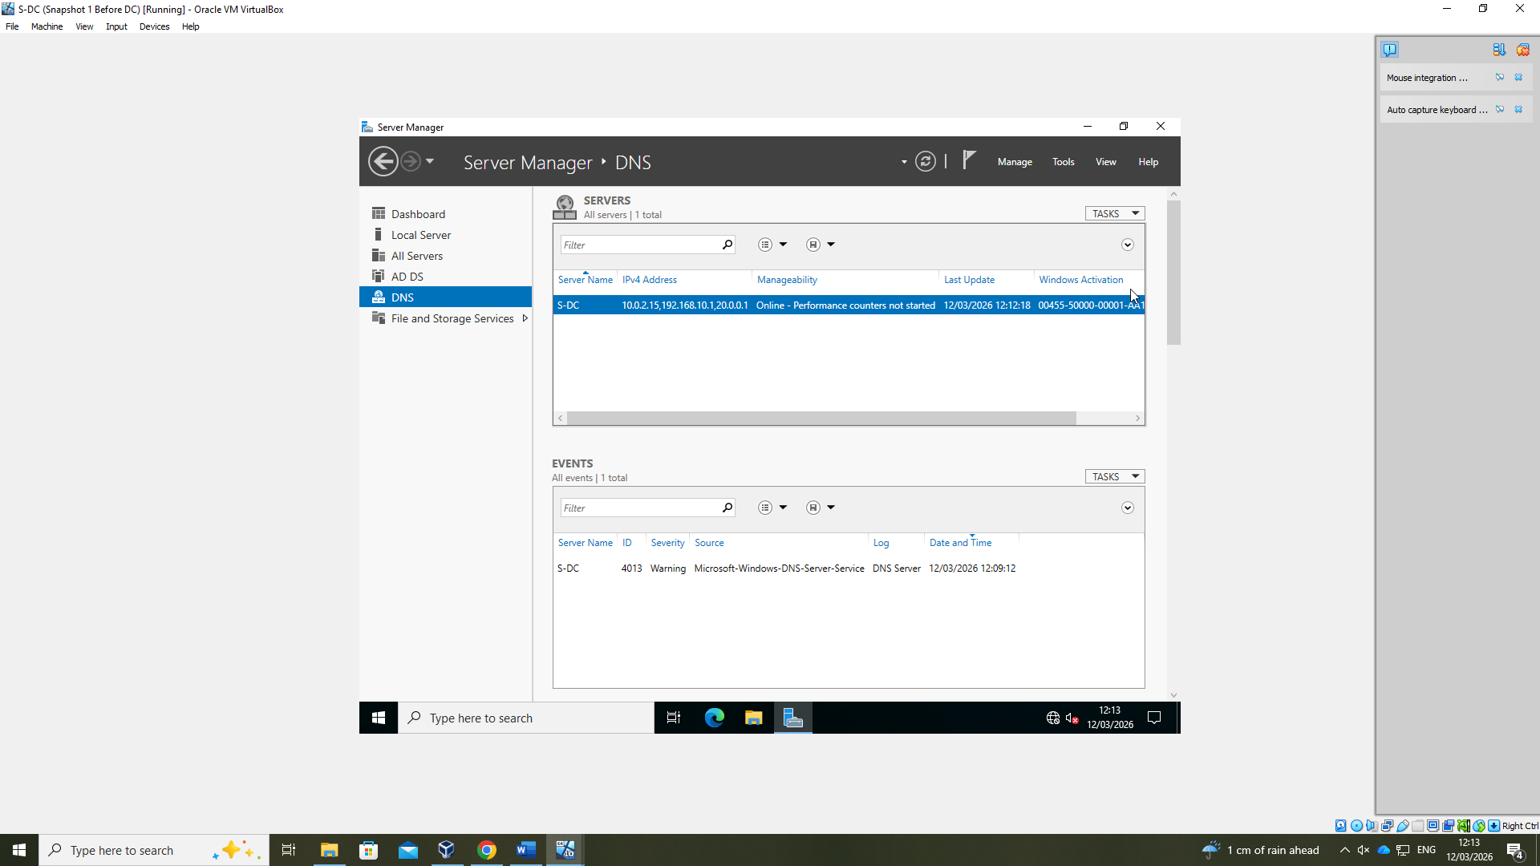
Figure 5: Domains and Trusts
Figure 6: DNS outcome
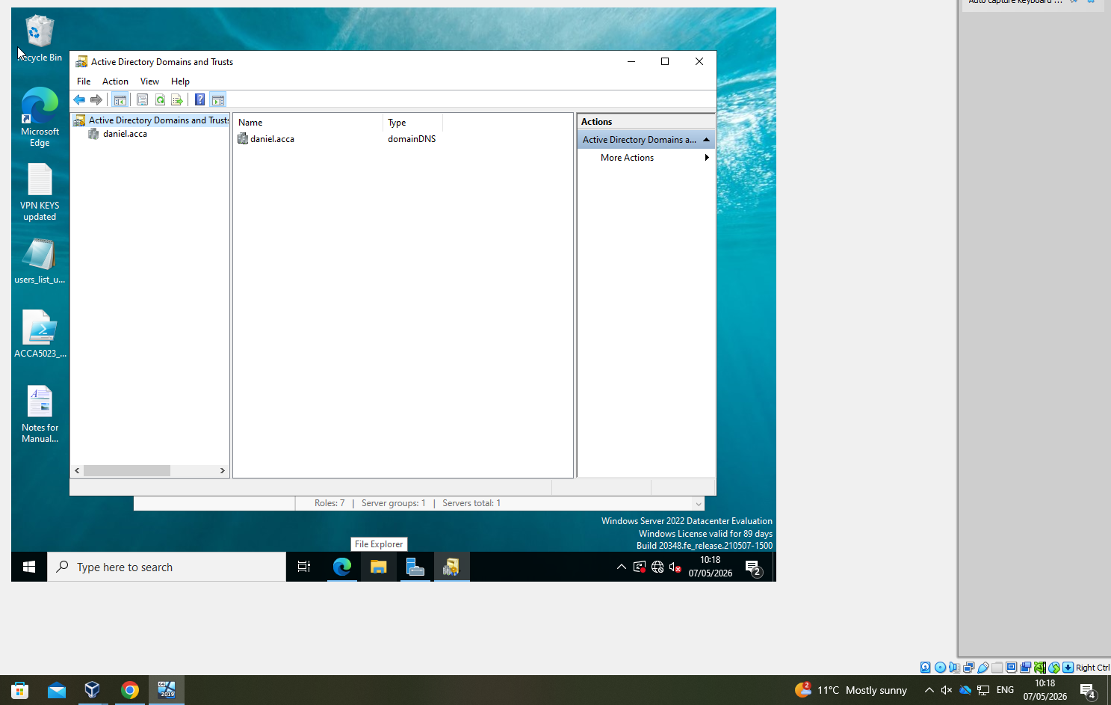

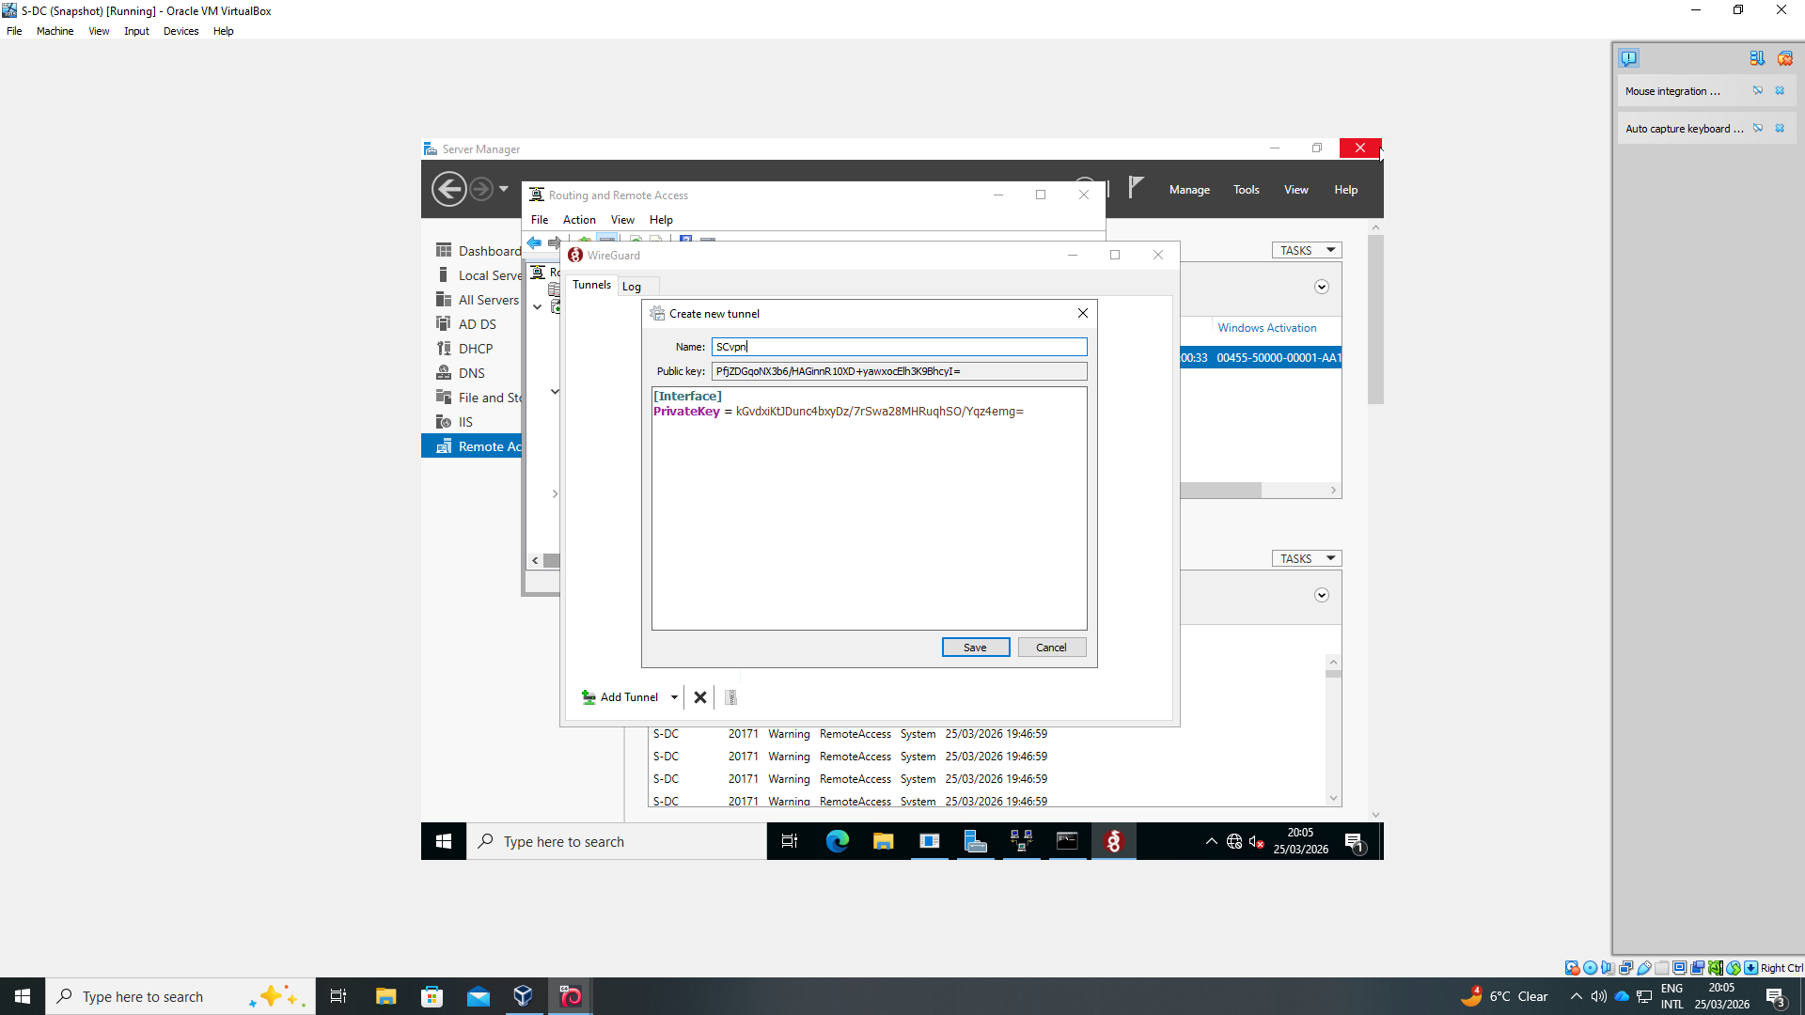
3. Encrypted Connection (VPN)
Figure 7: Wireguard attempt - Windows
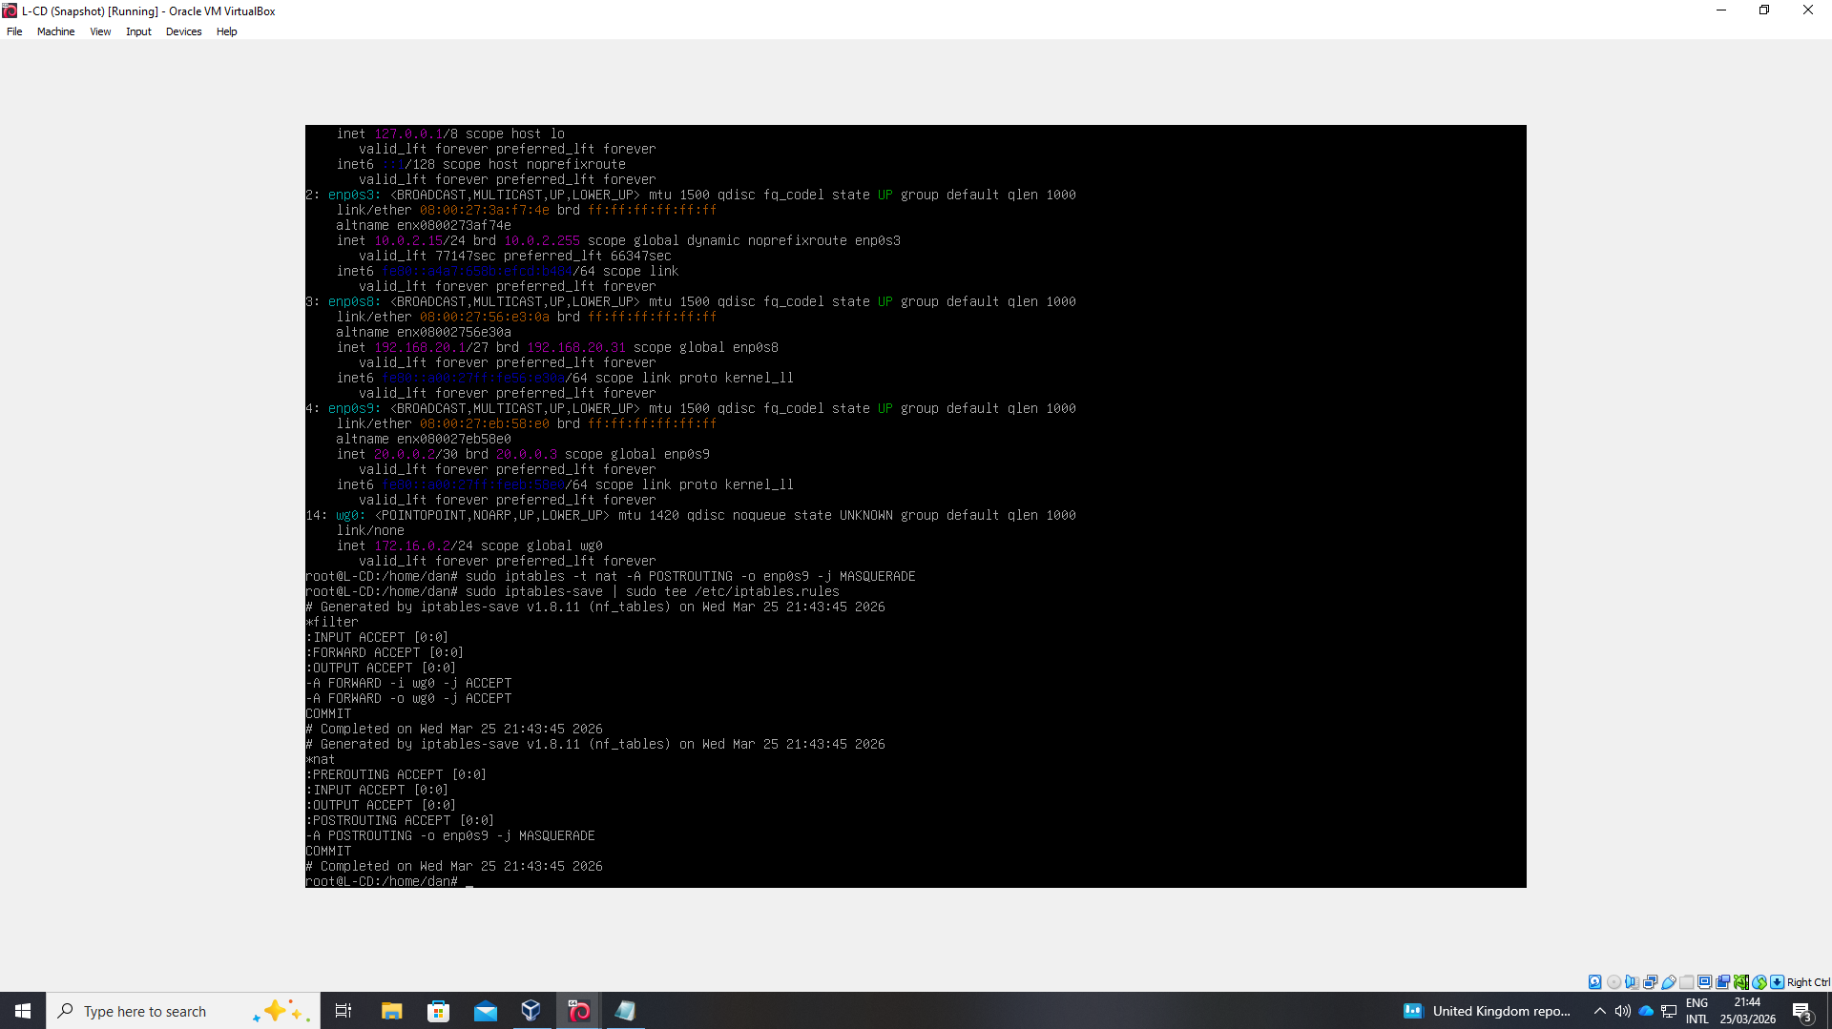
Figure 9: Wireguard attempt - Debian

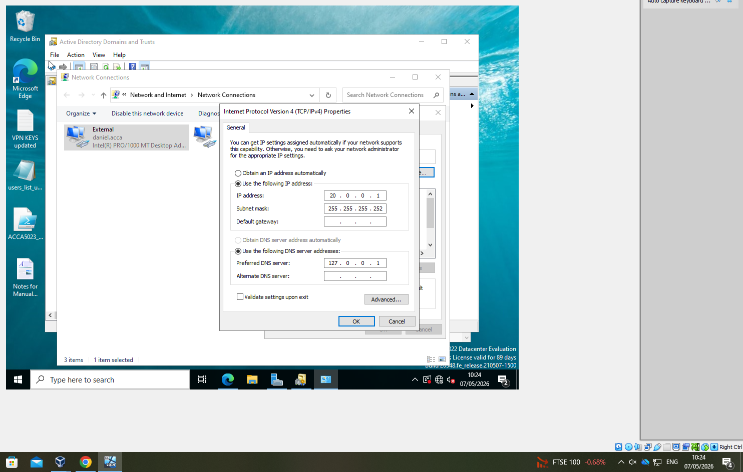
Figure 10: PPTPD outcome
Figure 8: VPN interface
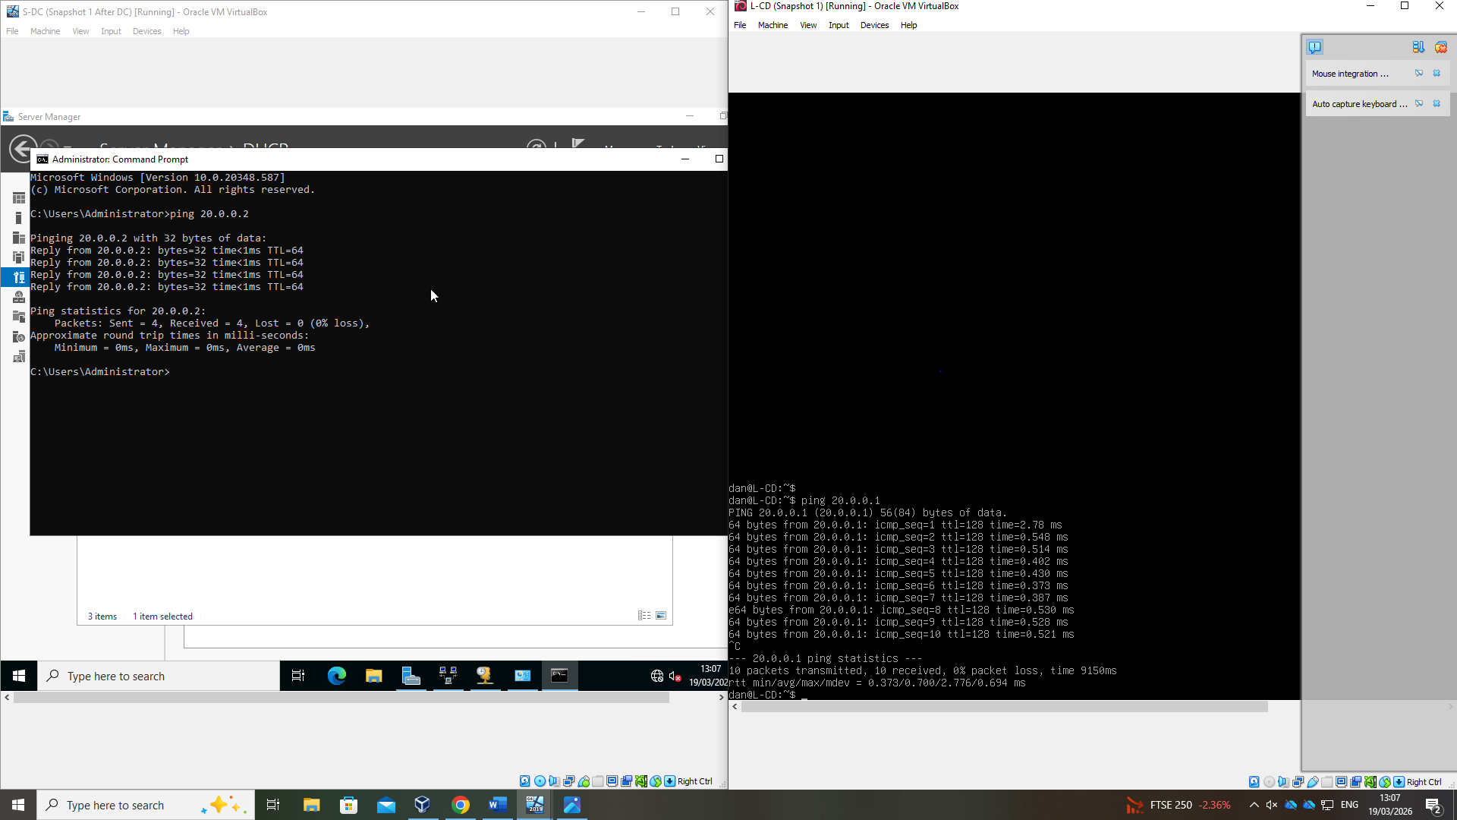

4. Users
Figure 11: Imported Users
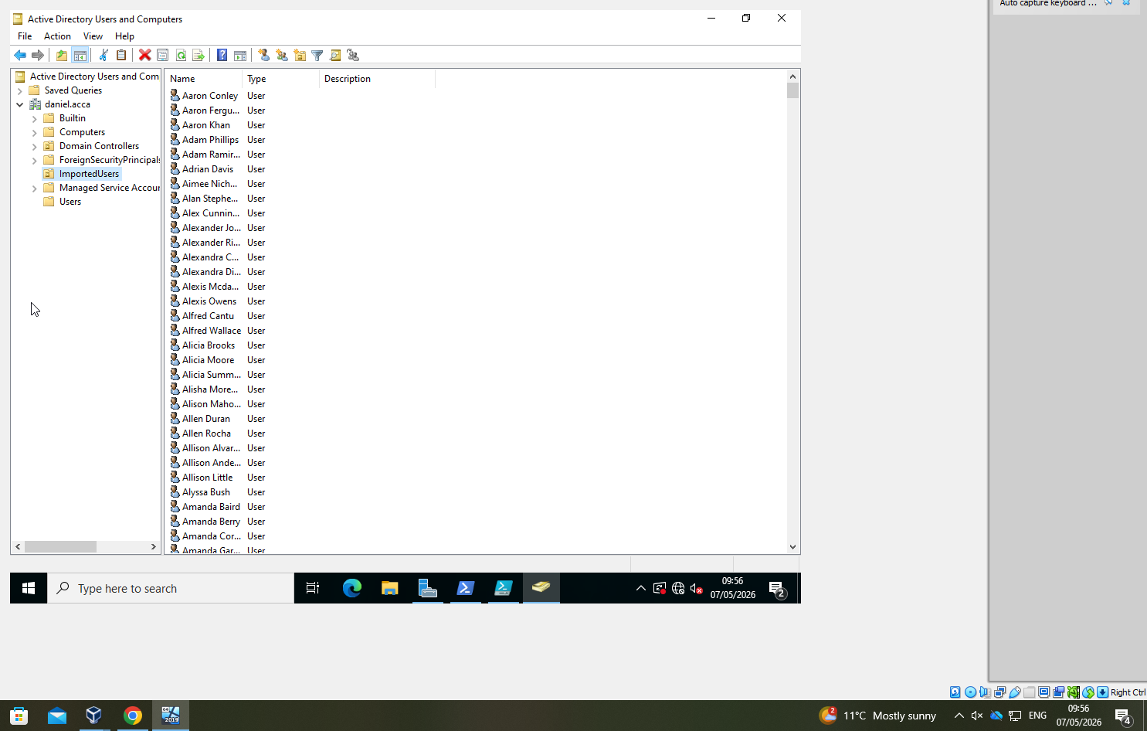

5. Domain Membership

*Not attempted

6. DHCP Server
Figure 12: DHCP configuration
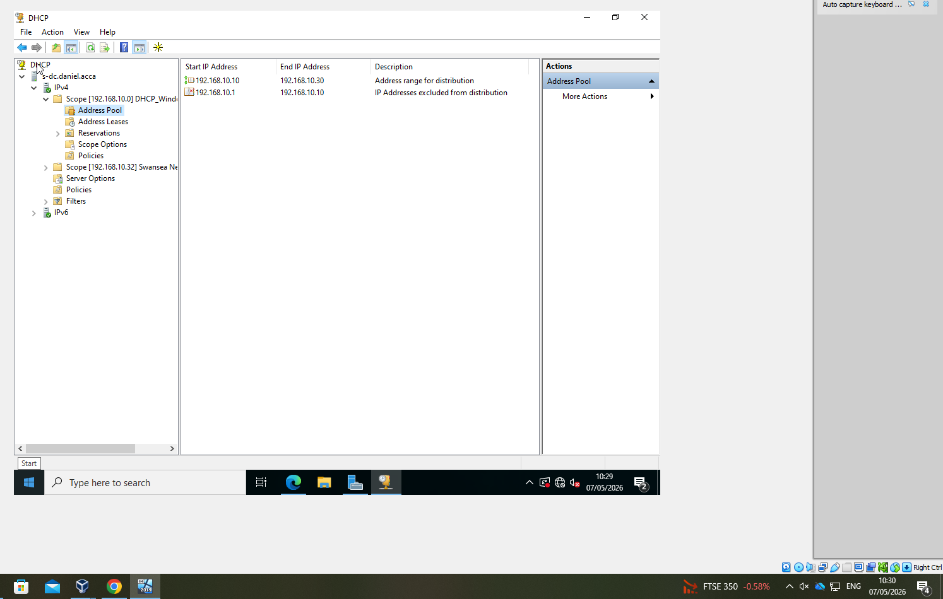

7. Test Network connectivity

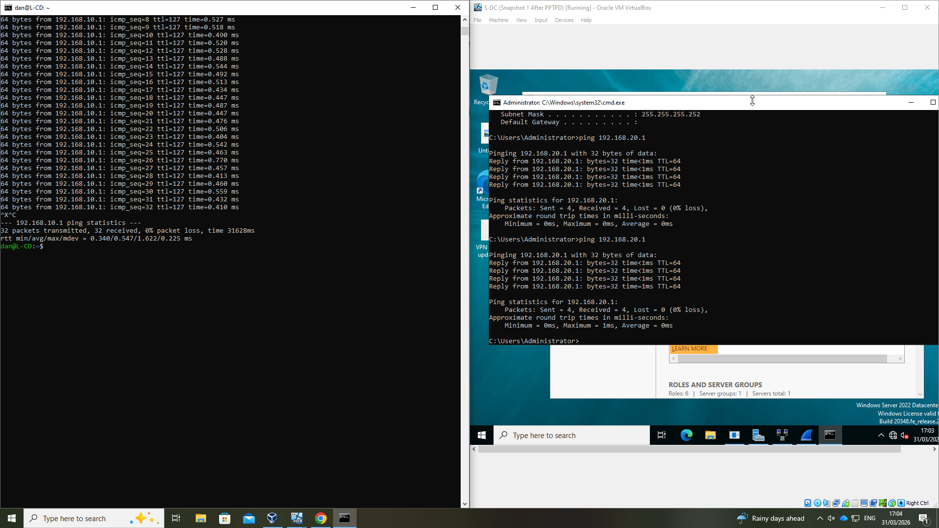
Figure 13: S-DC and L-CD connectivity after PPTPD

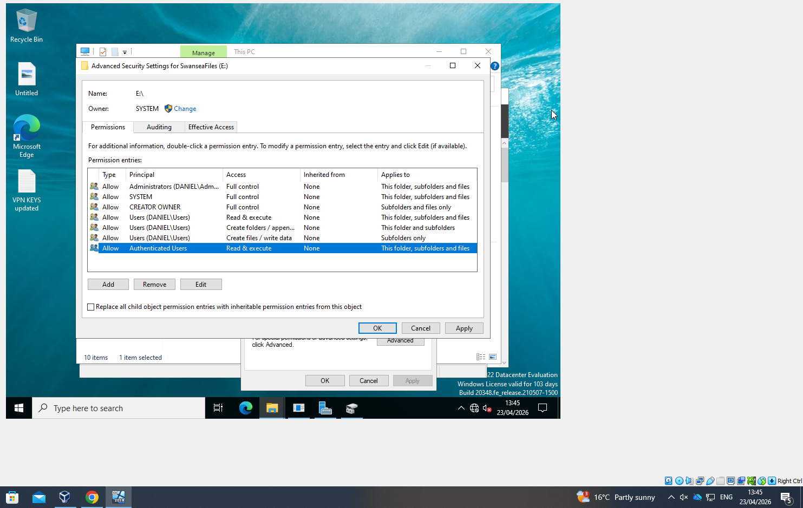
8. Disk Drive
Figure 14: Shared Drive (E:\SwanseaFiles) With permissions

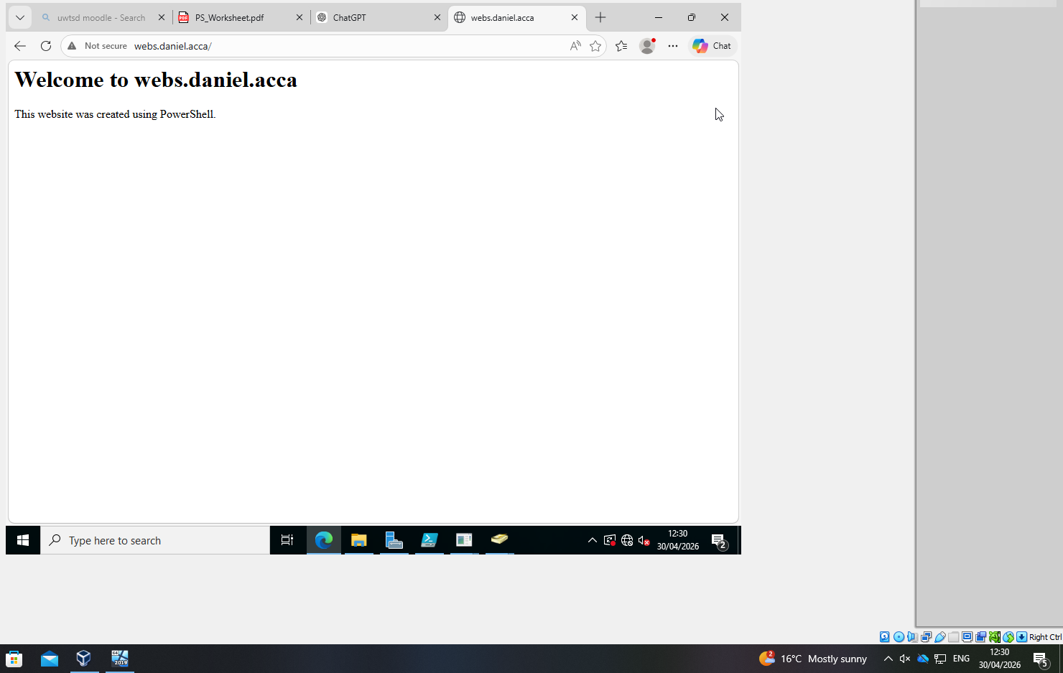
9. IIS Server
Figure 15: IIS Server (webs.daniel.acca)

10. Remote Desktop Services
Figure 16: RDS


