Assignment title: Financial Management

Student Name: Neslihan Aydin
Student Number:1606007
Module Name: Financial Management
Module Tutor: Jia Miao
Word Count:

Table of Contents
Introduction 3
Section 1: Apple background History 4
Section 1:1: Business Model and Competitors 5-6
Section 1:2: Apple Strategic change and Legal issues 6
Section 2: Apple Financial Report 7-11
Section 2:1: Recommendations to improve finance management 12
Section 3: Investment Project
Reference:

Introduction:
In this assignment there is three sections to be included into this report, the first section is to analyse a chosen company stating the company history, business model, position in the marketplace and any other strategic changes the company may have had. The second part is all about going over the company financial statements including, efficiency ratio's, profit, sales and growth within the last 5 years. The aim here is to find out the profitability of the company as well as the key financial ratios by comparing the figures to another leading brand. The final section is carrying out the investments of a new project and see whether the new business idea will bring back enough revenue as well as if it worth taking on the new investment for the existing company.
he companies I have chosen to analyse is Apple one of the most popular named brands out there. The reason for this is because I have recently written about Apple in another report and I have learnt more about the company legal issues and strategic changes. In order to analysis the company annual reports and give feedback on any strategic changes relating to Apple, I would need to research and provide statements, business model and their current position in the marketplace.

Section 1:
Apple background History:
Apple was invested and found by Steve Jobs and Steve Wozniak in the year 1976. The idea behind buying a new company was to change the way customers saw personal computers and to make them small enough to fit anywhere in your home or work offices. However, it took a few years to register the company as Apple in the United States January 1977 California in a city called Cupertino. Apple has around 132,000 people working for them in the company. They are one of the top companies within the IT sector. There is no need to check online to see how successful Apple really is, looking around you will see loads of Apple products everywhere such as, iPhone, iPad, or a MacBook. The name behind Apple could have caused many problems later as the name was very similar to the Beatles publisher called Apple Corps. The main reason behind the name Apple came about when Steve Jobs one day when he returned from visiting an apple farm. Mr. Jobs thought the name Apple was "fun, spirited and not intimidating at all’ The letting of the company starting with an A was beneficial as this was mean the company listing would always be at the front.
Apple sells a range of products which include as followed:
- Electronics, iPhone, iPad, IPod
- PC- MacBook
- Digital Media - iTunes music
- Software - IOS / Macintosh (Ahmet, 2019.)

Section 1:1:
Business Model and Market Place:
Apple Business Model is purely based on technology products and how well they products. Being both software and hardware is how Apple became successful. Apple growth in 2019, was mainly from segments things such as, Accessories, wearable's and services provided (Cuofano, 2020.)
Business Model of Apple in 2019
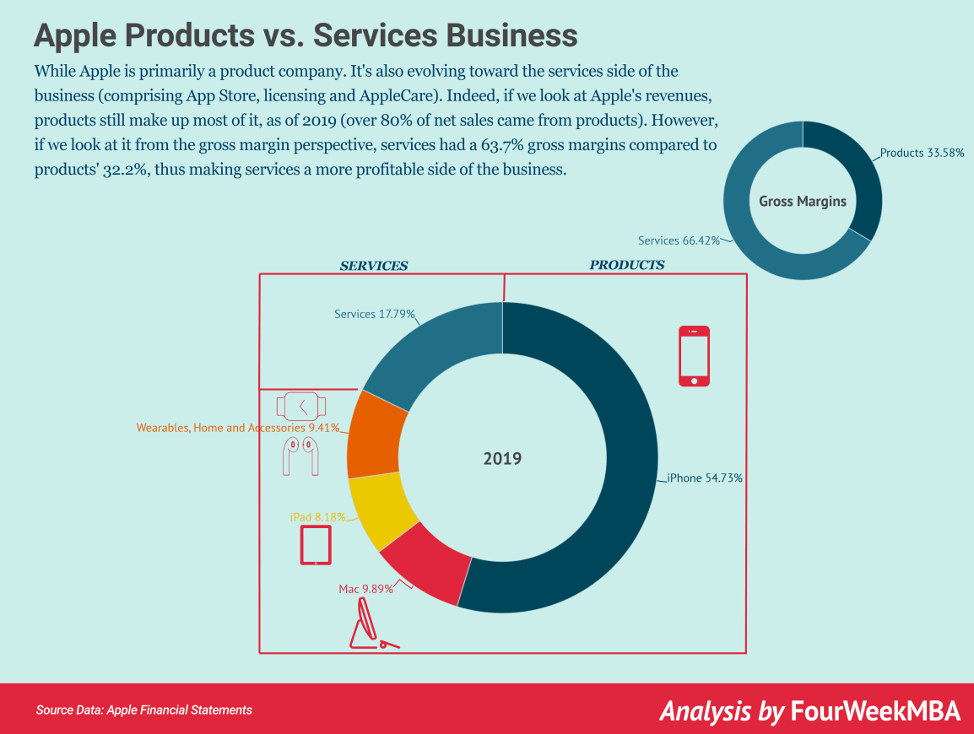
(Diagram 1: Business model of Apple 2019 Source: Cuofano, 2019)
The Competitors of Apple:
Apple has a product line which is very narrow however, the competitors within the global market are still very strong. Apple competes against 9 major retailer's there are as followed:
- Samsung (Android/PC)
- Dell (PC)
- HP (PC)
- Lenovo (PC)
- Sony (PC)
- Microsoft (Software)
- Google (Play store)
- Huawei (Android)
- Competitors against smart watch e.g. Samsung smart watches (Farooq, 2019.)
As you can see each company is selling different line of production most are cheaper than Apple products, which can do the same things as Apple phone apart from a few exclusive things such as, I-tunes and the App store is something they cannot copy.

Section 1:2:
Apple Strategic Change and Legal issues:
In order to compete against other leading brands Apple launched in 2019 an event where the price tags were much longer than expected from previous years. They lowered Apple TV to a lower rate a month, I-phone's and smart watches were also much cheaper. The I-phone 11 had three different models vary from size but mainly pricing. The I-phone 11 was the cheapest any apple fan has ever seen starting at £699. This came as a shock as with Apple we are used to high-end prices regardless of the costing. Anyone who brought an I-phone was also offered one year free Apple TV, this automatically upset other streaming rivals such as, Netflix as they charged a higher rate each month to their customers and didn't not offer for free under any offers (Poletti, 2019.) Using a different strategic change to bring in more customers by knocking out other competitors is a great way to boost business but also make more haters on the company.

Apple Legal issue:
The company had to pay a fine of $113 million to settle a lawsuit which included over 30 states on the same allegation that Apple was slowing down I-phones in order to make people buy a newer model. First Apple denied the slowing down of phones battery life then they admitted it was to help preserve the life of the battery, reports showed the phone would randomly turn off. The report had show it affected the I-phones released between 2014 and 2016. The I-phones users clocked on from the reddit and the technology blogs. By slowing down older models of phones the investigator found out the sales of I-phones had increased by millions of devices per year (Allyn, 2020.)

Section 2:
Apple Financial Report:
As mentioned in the introduction of this assignment the focus is on Apple financial analysis, to compare the performance and ratios against Samsung another leading brand. The profit ratios are an organization capability of earning a revenue return from sales, costs of operating, asset of the balance sheet and equity of shareholders. Profitability ratios are torn into two different groups which are margin and return ratios.
Margin ratios
Show how effective the company can transform sales into profit for the business. The three common margin ratios are as followed:
Gross Profit Margin
This is the first profitability ratio which formed business calculates. This shows how much a business has left over once it covers all costs of sales. This is known as the gross profit margin.
Formula: Gross profit ÷ Revenue = Gross profit margin %
The higher gross profit shows you have more money to cover expenses such as, taxes, operating expenses and other business-related costs.
Operating Profit Margin
If the calculation is done from the gross profit ratio this well help find the operating profit by using the figure. The operating profit is calculated by considering the gross profit and then deducting the operating costs. If the business shows low operating profit margin it means the company has spent too much on the operating costs.
Formula: Operating Profit ÷ Revenue = Operating Profit Margin %

Net Profit Margin
If you are a small business, the measurement of the profitability would matter most to the business net profit margin ratio. This shows how much money is earned before it reaches the bottom line. The percentage of the profit the business keeps is showed with the net profit margin. Having a high net profit margin clearly shows the company is working successful, by managing costs and pricing the business is doing well.
Formula: Net Income ÷ Revenue = Net Profit Margin %

Return Ratios
The return ratios show how if a company has generated profit for the owner and stakeholders. The most common return ratios are return on assets and return on equity. It can also be called investment on return it shows efficiency of a company. You can see how well the business is doing in turning investments into profit. Having a high return ratio shows the business income can become more efficient by using the assets available to them.
Formula: Net Income ÷ Total Assets = Return on Assets %

Return on Equity:
Every business is much more concerned with return on equity than any other financial ratios. It shows the company doing well by how they use stakeholders by generating them into profit. Having a low return on equity shows the management in the company is doing a bad job as they are not making full use of the funds given by investors to gain a return.
Formula: Net Income ÷ Average Stakeholder’s Equity = Return on Equity % (Black, 2020.)

Financial ratio analysis steps have been followed, by including income statements and cash flow statements of Apple in the last 5 years and compared against Samsung. Apple and Samsung are unique in many ways. Apple is where is it now thanks to the two Steve's Mr. Jobs and Mr. Wozniak. The first ever computer by Apply was first launched in 1976 and became one of the most significant innovations (Apple,2020.) Samsung on the other hand is a global company who was founded in south-eastern. Samsung was recognized in 1938 later the company was split into four different companies which are as follow, Team Samsung, Team Shinsegea, Team CJ and Team Hansol (Samsung, 2020.) Both organizations are in the same expanding market as demand for certain types of products or services are always on the increase. Both companies have their own loyal fans who return time after time to increase sales.
Table 1: Sales, sales growth and market share of Apple (2014-2019) Samsung (2019):
Apple | 2016 | 2017 | 2018 | 2019 | 2020 | Samsung 2019
Sales | 192.1 | 194 | 228.8 | 237.8 | 236.1 | 177.8
Sales Growth | -7.7% | 6.3% | 15.9% | -2.0% | 5.5% | -5.5
Market Share | 21.5 | 20.6 | 19.3 | 18.0 | 17.1 | 18.8
Gross Profit | 39.1 | 38.5 | 38.5 | 37.8 | 38.2 | 36.1
Operating profit | -15.7 | 2.2 | 15.6 | -9.8 | 3.7 | -52.8
Source: Annual Financial reports of Apple and Samsung
The average for Apple Sales was at 217.7. It increased in 2019 to 237.8 however, there is a decrease back in 2020 by -0.7%. The lowest in the five years for Apple was in 2016 standing at 192.1. Samsung averaged at 174.4 from 2015-2019. The lowest return for Samsung was in December 2015 at 157. The gross profit for Apple was the highest in year 2016 at 39.1. The all time low was in September 2019 at 37.8% The average gross profit stands at 38.3 which we can see it is very close in 2020 means Apple is going in the right direction (Apple, 2020.)

Table 2: The Profitability ratios of Apple (2016-2020) Samsung (2019)
Apple | 2016 | 2017 | 2018 | 2019 | 2020 | Samsung 2020
Operating profit margin | 27.8 | 26.8 | 26.7 | 24.6 | 24.1 | 36.1
Gross profit | 39.1 | 38.5 | 38.3 | 37.8 | 38.2 | 36.1
ROCE | 26.5 | 23.7 | 2.7 | 26.5 | 29.4 | 9.9
Return on equity | 36.9 | 36.9 | 49.4 | 55.9 | 73.7 | 8.7
Source: Annual Financial reports of Apple and Samsung
The operating profit margin seems to have decreased each year for Apple and it has since 2019 meaning it is costing them more to produce products. Samsung Has a low return on capital employment and return on equity compared to Apple with a big difference between the two. Gross profit on Apple seems to be stable throughout the whole 5 years not much seems to have changed in increasing profit with the company (Apple, 2020.)

Table 3: The Efficiency ratios of Apple (2016 - 2020) and Samsung (2019)
Apple | 2016 | 2017 | 2018 | 2019 | 2020 | Samsung 2019
Asset Turnover | 0.7 | 0.7 | 0.7 | 0.7 | 0.8 | 0.7
Return per employee | 26.5 | 23.7 | 27.0 | 26.5 | 29.4 | 9.9
Source: Annual Financial reports of Apple and Samsung
The average Apple's asset turnover for year 2016-2020 was at 0.7x. It did however decrease between 2016-17 and increased again in 2018 by +9.0% and +3.1% in year 2019. The asset peaked back up in September 2020 by +12.2% making it stand at 0.8 for the current year. The average for Apple return per employee is 26.5% from year's 2016 to 2020. Over the past five years the return on employed has increased the highest in 2020 compared to the past years and currently stands at 29.4%. The lowest in the five years was in September 2017 at 23.7%. Compared to Samsung the last 5 years for them 2019 is the lowest they have had at 9.9% as the average from 2015-2020 was 17.3% and it has nearly dropped to half since then.

Table 4: The Liquidity ratios of Apple (2014 - 2019) and Samsung (2019)
Apple | 2016 | 2017 | 2018 | 2019 | 2020 | Samsung 2019
Current ratio | 1.4 | 1.3 | 1.1 | 1.5 | 1.4 | 2.8
Quick ratio | 1.0 | 0.9 | 0.8 | 1.2 | 1.0 | 2.3
Source: Annual Financial reports of Apple and Samsung
The average ratio of Apple between 2016-2020 stands at 1.3. The all time low is in September 2018 at 1.1 however, the highest we have seen it at was in 2019 standing at 1.5. The quick ratio is averaged at 1.0 from 2016 up to year 2020. The highest we have seen the quick ratio in the last five years was 1.2 in 2019 but the following year dropped back down again. The average for Samsung from 2015 to 2019 is at 2.0. The lowest ever seen in the last five year is at 1.7 which was in 2017. Samsung seems to have much higher quick ratio in the last five years than Apple has in the same time. This means Samsung has higher sales, less bill payments and money is being collected on time from accounts unlike Apple as the ratios are very low (Apple, 2020.)

Table 5 The Investment ratios of Apple (2014 – 2019) and Samsung (2019)
Apple | 2015 | 2016 | 2017 | 2018 | 2019 | Samsung 2019
Dividend per share | 0 | 1.20 | 1.20 | 1.30 | 1.20 | 23.32
Dividend cover | 7.0 | 5.5 | 5.0 | 5.6 | 4.9 | 4.7
Source: Annual Financial reports of Apple and Samsung
The average dividend cover for Apple is 5.4 from 2015-2019. The lowest is has hit is in 2019 at 4.9 but still low compared to 7.0 in 2015 and since then it's been going down. Highest is in 2018 but still nowhere as close as it was 5 years ago. Samsung highest was 15.2 back in 2016. The lowest we have seen is in year 2019 with 4.7 as the average for the company stands at 9.7.

Section 2:2
Recommendations to improve finance management
Apple and Samsung financially seem to be doing well however, both have been in court due to having similar products or technology each other sell. Apple was in court for other reasons such as, slowing down phones and battery life which has cost thousands for the company in fines and court fees. To improve overall profit having long term liabilities will help the companies' have a better picture of the debt they have burdened. Apple's debt as of July 31, 2020 currently stands at $79.34 billion. The current debt ratio for Apple is 0.36 anything over 1 shows that the large section of debt belongs to assets. If debt ratios increase the risk of loans being defaulted would increase the interest rates as well (Media, 2021.) Samsung current debt stands at £19.27 billion. This is much higher than the company consumer goods and even higher than the company electronic equipment industry.
This shows that Samsung is doing much better financially than Apple as they have less debt to pay. My personally recommendation to Apple in order to improve financially they need to lower the debt they owe in order to benefit financially, you cannot be a successful company with so many amazing products for sales and being in more debt than other leading brands.
Section 3:
Investment Project
The payback period (PBP) This is the time an investment length measured which is required to make back the initial investment. This is the point between the cash inflows and initial investment put into the project.
Project A:
Year’s | Cash outflow | Cash inflow | Cumulative
0 | -85 | 0
1 |  | 10 | 10
2 |  | 20 | 30
3 |  | 40 | 70
4 |  | 55 | 125
Payback period B= 85-70 =15 A=3 years C= 55
= 3+15/55=3.27 years
Project B:
Years | Cash outflow | Cash inflow | Cumulative
0 | -90 | 0
1 |  | 25 | 25
2 |  | 30 | 55
3 |  | 35 | 90
4 |  | 40 | 130
Payback period B= 90-90=0 A=3 years C=35
3+0/35=3 years

Accounting rate of return:
This method is used to identify the company earning profit from investing into the project over the years of the investment.

 | Project A |  | Project B
Depreciation | 85/4 = 21.25 | 90/4 = 22.5
Average Investment | 85+0/2 = 42.5 | 90+0/2 = 45
Cash inflow (4 years) | 125 | 130
Net profit margin | 61.25 | 62.5
Average Profit | 61.25/4 = 15.31 | 15.62
ARR | 15.31/85*100  = 18.01% | 15.62/90*100  = 17.36%

Looking at the accounting rate of return project B is less than project A. This means the rate of return is higher on project A which could improve the return rate on investment.
The Net present value:
Net present value is the difference in present value of the cash inflows and cash flows present value one which is over a period. Net present value is normally used in finding out if a new investment whether to analyze the profitability of the investment being projected or a project (Fernando, 2020.)

Net present value of project A
Year | Cash out-flow | Cash in-flow | PV Factor @10.5% | NPV (£)
0 | 85 | 0 | 0 | 0
1 |  | 10 | 0.905 | 9.04977
2 |  | 20 | 0.819 | 16.3797
3 |  | 40 | 0.741 | 29.6465
4 |  | 55 | 0.671 | 36.8904
 |  | Total = |  | 91.9664
 |  | NPV = | 7

Net present value of project B
Year | Cash out-flow | Cash in-flow | PV Factor @10.5% | NPV (£)
0 | 90 | 0 | 0 | 0
1 |  | 25 | 0.905 | 22.6244
2 |  | 30 | 0.819 | 24.5695
3 |  | 35 | 0.741 | 25.9407
4 |  | 40 | 0.671 | 26.8294
 |  | Total = |  | 99.964
 |  | NPV = | 10

Looking at both projects from analyses the effective investment out of the two projects must be Project B, as project b can increase in value and improve stakeholder’s wealth. The payback period is less in project B which meant it will take less time to get a return. Overall Project B has more Net profit value and less payback period compared to project A.

Reference List:
Aamir Ahmer, (2019) 'A brief history of Apple Inc.' doersempire.com available at: https://www.doersempire.com/a-brief-history-of-apple-inc/ (Accessed 7th January 2021.)
Apple, (2020) https://investor.apple.com/investor-relations/default.aspx (Accessed 9th January 2021.)
Bobby Allyn, (2020) ' Apple agrees to pau $113 million to settle 'Batterygate' case over iphone slowdowns' npr.org available at: https://www.npr.org/2020/11/18/936268845/apple-agrees-to-pay-113-million-to-settle-batterygate-case-over-iphone-slowdowns?t=1610407278090/ (Accessed 7th January 2021.)

Gennaro Cuofano, (2020) 'Apple Business Model' fourweekmba.com available at: https://fourweekmba.com/apple-business-model/ (Accessed 7th January 2021.)
Umar Farooq, (2019) 'Apple competitors' marketingtutor.net available at: https://www.marketingtutor.net/apple-competitors/(Accessed 7th January 2021.)
Therese Poletti, (2019) ' Opinion: Apple I-phone event reveals a dramatic change in strategy' marketwatch.com available at: https://www.marketwatch.com/story/apple-iphone-event-reveals-a-dramatic-change-in-strategy-2019-09-10 (Accessed 7th January 2021.)
https://finbox.com/OTCPK:SSNL.F/explorer/roe
Michelle Black, (2020) 'Profitability ratios: types of profitability rations and why they matter' www.nav.com available at: https://www.nav.com/blog/profitability-ratios-types-of-profitability-ratios-444161/ (Accessed 9th January 2021.)
S & p Global Market Intelligence, (2020) https://finbox.com/DB:SSUN/explorer/dividend_coverage (Accessed 9th January 2021.)
Samsung, (2020) https://www.samsung.com/global/ir/
https://finance.yahoo.com/news/does-apples-debt-look-113425692.html?guccounter=1&guce_referrer=aHR0cHM6Ly93d3cuZ29vZ2xlLmNvLnVrLw&guce_referrer_sig=AQAAAFeT9Z8vIaqZq9W6SBYUfME-M-R5RcQmX2tJ8oZJLRpB0dRe8NrpnETRFXq6FvaTq0GWwo36ywHvisT-EAN12DlMolOdPzDclLmLzKc39yAX1T_BvriWtOY5ru2M5breetKmK0qXwCwYYtN6HnPx5MjBHZuMKCrpRQS5jfh3Cwal#:~:text=Based%20on%20Apple's%20financial%20statement,debt%20is%20at%20%2479.34%20billion.
https://www.macroaxis.com/invest/ratio/BC94.L--Total-Debt
Jason Fernando, (2020) ‘Net present value’ investopedia.com available at: https://www.investopedia.com/terms/n/npv.asp

