Postgraduate/Distance Learning
Assignment coversheet & feedback form

THIS SHEET MUST BE THE FIRST PAGE OF THE ASSIGNMENT YOU ARE SUBMITTING (DO NOT SEND AS A SEPARATE FILE)

For completion by the student:
Student Name: : Charlotte Wenner

Student University Email: : 2310536@student.uwtsd.ac.uk
Module code: HPCA7028  Module title: Sacred Skies | Student ID number:  2310536 |  |  | Educational support needs:  Yes/No
Assignment title: A Critical Examination of the Sky in Relation to Material Culture

Assignment due date: 1 May 2025
This assignment is for the 1st 2nd 3rd 4th 5th 6th module of the degree
I confirm that this is my original work and that I have adhered to the University policy on plagiarism.
Signed ……………………………………………………………
Email submission: you are submitting this form via email, please tick this box □
(as a substitute for your signature) to confirm that you agree to the above declaration.
Assignment Mark
1st Marker’s Provisional mark
2nd Marker’s/Moderator’s provisional mark
External Examiner’s mark (if relevant)
Final Mark

NB. All marks are provisional until confirmed by the Final Examination Board.

For completion by Marker 1 :
Comments:

Marker’s signature: |  |  | Date:
For completion by Marker 2/Moderator:

Comments:

Marker’s Signature: |  | Date:
External Examiner’s comments (if relevant)

External Examiner’s Signature: |  | Date:

A Critical Examination of the Sky in Relation to Material Culture
This essay will analyse the similarities and differences between two statues portraying the Virgin Mary standing on a crescent moon in order to compare the way each expresses the perspectives on the sky which their respective cultures held. Although both examples were commissioned by the Catholic church, the first is from late fifteenth-century Basel, Switzerland, while the second was sculpted in late nineteenth century Utrecht, the Netherlands. Nevertheless, despite the difference of time and place, these statues of the Queen of Heaven reflect ancient celestial images, and continue to offer their viewers traditional values, stability, protection and hope in times of changing morals, catastrophe, suffering and persecution.
Background of Iconography
The iconography of these statues is based on a passage in Revelations 12 by ‘John the Seer’, or John of Patmos, in the first century CE: ‘And there appeared a great wonder in heaven; a woman clothed with the sun, and the moon under her feet, and upon her head a crown of twelve stars’. The first rare examples of the Madonna on Crescent Moon were found in Bohemia and Germany, and date from the early 14th century. The motif was particularly popular in Germany and the Low Countries, or present day Switzerland, Belgium and the Netherlands.
John’s description employs the cultural symbols of the time, and these included ancient astrological concepts. Nicholas Campion points out that Christianity did not exist in a self-contained bubble, and its ‘cosmology was culled from Jewish sources, including the Old Testament Scriptures, combined with an overlay of Persian dualism and a strong element of Greek philosophy, mainly Stoicism and Platonism.’ The Revelations of John is, moreover, the ‘most overtly cosmological text in the New Testament … Its repetition of the number seven … ties Christian cosmology to the planets. The woman with a crown of twelve stars is complemented by the tree with twelve kinds of fruit, one for each month for the “healing of the nations” brings in the zodiac’.
This Madonna is also called the Queen of Heaven, a title held by a long lineage of ancient sky goddesses, from Inanna, to Isis, Astarte, Juno and ‘almost all the mythologies of ancient times’.’ But by the time monotheistic Christianity had become the predominant religion in Europe, the Virgin Mary, surrounded by the sun and standing on the moon, remained the sole female representative which linked people with the sky.

Madonna of Warmbach, Historical Museum Basel
Description of Object
This Madonna on Crescent Moon (Fig. 1) is currently located in the Basel Historical Museum, Barfüsserkirche. The museum acquired the statue from the St. Gallus Church, which lies slightly east on the Rhine in Warmbach, near Rheinfeld in the Aargau canton. However, she is still standing on holy ground, for the Basel Museum is a former Franciscan late-Gothic church in 1892.
Originally, the statue would have been on the altar of the Church of Warmbach. Similar to the ‘Virgin and Child on Crescent Moon’ statue from Nuremburg dated around 1470, the Warmbach Madonna ‘was probably enclosed in a shallow boxlike setting with flanking saints’, and protected by folding panels. At present, however, the statue is located inconspicuously next to a door leading to the southern galley on the right of an altar. It is slightly hidden from view by the only remaining item from the Barfüsserkirch, the late Gothic wing altar. Ironically, the panels on this altar specifically depict the debate around the dogma of the Immaculate Conception, which this Madonna represents.
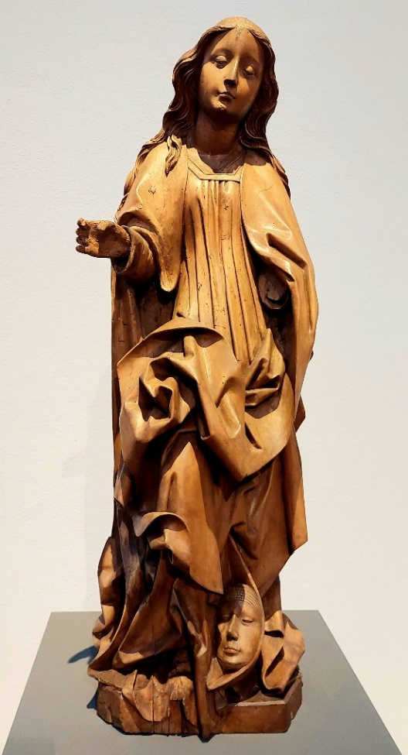
Figure 1. Atelier Guntersumer, Madonna on Crescent Moon c. 1480, Leeched linden wood and remains of frame, Inv. 1910.44, Basel Historical Museum - Barfuesserkirche, Basel. Image: Charlotte Wenner
The cult of Mary had grown throughout the Crusades, and by the 13th century she was a firmly established figure of devotion. Images of the Virgin Mother became popular, and the ‘Madonna of Humility’, with Mary breastfeeding the infant Jesus was popular in the 13th and 14th centuries. But by the 15th century, the cult of the Immaculate Conception had become a topic of fierce debate, and the Madonna on Crescent Moon was popularized to promote this dogma. The seventeenth ecumenical council held in Basel between 1431 and 1448 finally culminated in 1439 with the Council declaring itself above the Pope and legitimizing this dogma. Basel was the first city to officially adopt this tenant, and predated the rest of Christianity by more than three hundred years. In 1476, Pope Sixtus declared 8 December the Feast of the Immaculate Conception.
This statue of Mary is one of the remaining works from the Guntersumer Atelier, and is probably from their earlier period, around 1480. ‘Jos and Dominicus Guntersumer, father and son, represent, together with Heinrich Isenhut, the most important of the thirteen Late Gothic workshops active in Basel between 1450 and the beginning of the 16th century’. Although the statue is wooden, it originally had been painted, indicating that the Guntersumers would not only have belonged to a guild for sculptors but also of painters. The colours, however, were removed during the fires of the Reformation.
It is likely that the Guntersumers reproduced the design from an etching, which has since been lost, as were many of the statues from the Rhineland workshops. Another almost identical image from this Atelier stood in Hellikon, and is also housed in the Basel Museum. The delicate tranquillity of the two statues sets them apart from other, more dynamic versions of the Madonna on Crescent Moon sculpted at the time.
The Warmbach statue is a simple, yet strikingly noble and majestic linden wood statue, 97 cm. in height. ‘Delicate, somewhat stiff and serious, but nevertheless graceful’, the ‘frail frontal silhouette , the smooth and regular oval of her face, and the waves of her hair’ all convey the youth, purity and humility of the Virgin Mother of God. Her dress falls in rectilinear folds, while her robe rises in a characteristic motif like great waves above her right knee. It appears as though it is being lifted by a gust of wind , or perhaps by the presence of the Holy Spirit. Her hair falls loosely to the middle of her back in soft waves, like a young maiden’s. She gazes serenely, emitting a still, strong sense of peace, and her right arm is lifted halfway as if displaying something. Her downcast eyes and reserved expression emit such an overwhelming sense of calm that it transfixes the viewer’s attention for some time.
Mary’s left arm and the Infant Jesus are absent, most likely destroyed in the Reformation riots. However, it is likely she supported Christ in her left arm because her right hand seems to have held an object – too small to be a pomegranate, which is often used in similar statues to designate her role as New Eve. It may have been a sceptre, to identify her as Queen of Heaven, although this attribute usually appears when Mary wears a crown, such as the Vierge á l’Enfant at the church of Saint-Adelphe in Kingersheim. It is more likely that the Madonna in Basel originally held a bunch of grapes, as reference to ‘the wine of the Eucharist, and therefore to Christianity’ . The theme of Mary’s identification with the Church and its sacraments was an important purpose underlaying the promotion of this image at that time.
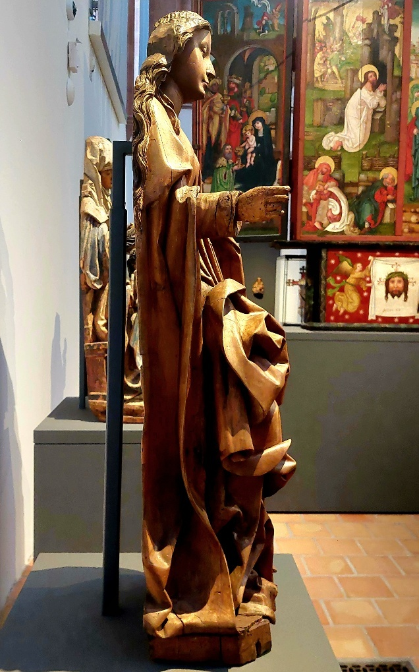
Figure 2. Atelier Guntersumer, Madonna on Crescent Moon view from side, c. 1480, leeched linden wood and remains of frame, Basel Historical Museum - Barfuesserkirche. Image: Charlotte Wenner
Although the frontal view gives the impression that the statue is a solid independent work, in fact the image has been sculpted in high relief (Fig. 2). It was hollowed out in the back, and on the edges there is still evidence of charring, possibly dating from the flames of the iconoclasm. Nevertheless, the statue remains relatively complete, owing to it having been located outside of Basel. She was spared the worst fires in Basel during the Reformation iconoclasm of 1529 – 1530.
The crescent moon before the Virgin’s left foot, however, clearly identifies her as the Woman of the Apocalypse. It is one of the rare examples in which the crescent moon contains a face, that is ‘either man or woman, which may evoke Eve or the devil’. Yet this moon’s face has a feminine appearance with soft lips, and the head is inclined at the same angle as Maria’s (Fig. 3). This mirror image suggests that the Warmbach Madonna represents the ‘new Eve’, while the face in the moon is the ‘fallen Eve’. The Virgin of the Apocalypse is thus untouched by original sin, but stands above it, an image demonstrating the Immaculate Conception.
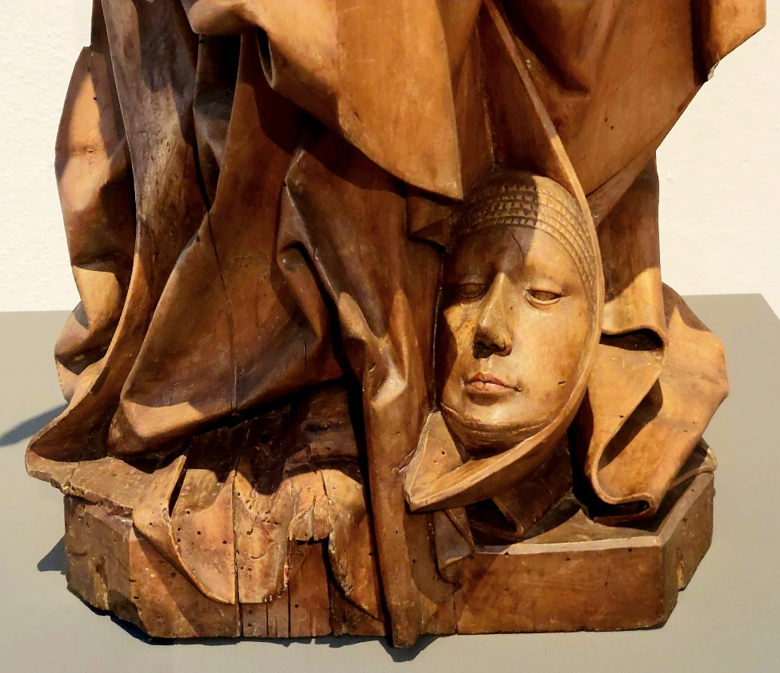
Figure 3. Atelier Guntersumer, Madonna on Crescent Moon view of base, c. 1480, Leeched lindenwood and remains of frame, Basel Historical Museum - Barfuesserkriche, Basel. Image: Charlotte Wenner
The other attributes from Revelations – the sun and its rays and the crown of stars – are absent, and whether they were ever included and later destroyed is unknown. Yet the crescent moon at her feet incudes the other symbols by implication. Christian exegesis modified the astrological associations and explained that they represent ‘both the Church and the Virgin resplendent in the light of Christ and triumphing over the devil. The sun that clothes her is the Incarnate Word, the stars of her crown are the twelve apostles, the crescent moon the symbol of the errors of the terrestrial world, dominated by the celestial figure’. Yet the celestial symbols would invoke memories embedded in Europe’s cultural inheritance, and would still resonate deeply in the 15th century.
Audience and Purpose
Like the blessed woman whose name she bears, the delicate, regal Madonna of Warmbach had an immense responsibility to bear for Christianity in the 15th and 16th centuries. Various forms of conflict disturbed Basel at the time, and caused insecurity and fear among its people, not the least of which were the religious conflicts and the rise of Protestantism. Basel was ‘one of the most populated and prosperous cities of the Holy Roman Empire’, and, as such, exhibited the tension that was developing throughout the Europe of the time to an extreme degree. The rise of commerce and local guilds threatened the feudal economic structure, Basel’s newly established university stimulated humanistic thought, the importation of the printing press fostered the circulation of pamphlets critical of the Church, and groups calling for reform grew in strength. The Church may have felt a need to reestablish its position through images which inspired awe and adoration, and the Woman of the Apocalypse would have conveyed the combination of purity and victory which the Church wished to project.
At the same time, those who had succumbed to the ‘errors of the terrestrial world’, that is, ‘witches’, were sought out and executed. The publication of Malleus Malifictorum in 1487 initiated a pogrom in which 200,000 to 500,000 witches were killed in continental Europe, and 3,000 in Basel alone. Witchcraft was elevated to a pivotal position in the struggle between man and the devil. It was given the responsibility for the world’s ever-increasing ills, while the Church, represented by the Virgin Mary in the heavens, was the world’s salvation. As Ben-Yehula succinctly put it, ‘These executions and the persecutions which preceded them were determined in part … by a differentiation process within medieval society. The witch craze answered the need for a redefinition of moral boundaries, as a result of the profound changes in the medieval social order’.
Thus, images of the Madonna on the Crescent Moon, who stood above the sin to which Eve had succumbed, presented an the antithesis to the devil and offered the Church as emissary to God in Heaven. Martin of Arles wrote at the time, ‘Just as true and Christian faith works miracles on those of good faith, so an evil and false belief, God permitting, sometimes works, or rather earns, misfortunes’. Wise citizens of Warmbach would adhere to the Church, and raise their eyes in worship at the altar of the Madonna on Crescent Moon. Only by focussing their devotions on the celestial Virgin could they avoid temptation and be blessed in an afterlife in Heaven. Even during the Reformation, the worship of Mary and her images was permitted, though she no longer could intercede for people with Christ.
Madonna on Crescent Moon, Willibrord Church in Utrecht, the Netherlands
While the Reformation was certainly disastrous for Swiss Catholic churches and their art in the 16th century, it provoked a revolt in the Netherland, the longest uprising in European history, and created a deep polarization between Dutch Protestants and Catholics. Located in the centre of European Calvinism, the newly founded Dutch government established the Protestant Reformed Church as official state religion after their defeat of Spain. Catholics, however, were not considered good Dutch citizens, and were denied the right of public worship. Yet when a new constitution was adopted in 1848, the Catholic congregation of the Saint Willibrordus, who had formerly been forced to worship in a small schuilkerk (hidden church), were able to move to a new location in the centre of Utrecht. The church was designed by one of the most prominent architects of Dutch Neo-Gothicism, Alfred Tepe. The beautiful, richly decorated colourful interior was designed in the workshop of Frederich Willem Mengelberg, and has been called ‘a vision of Heavenly Jerusalem’.
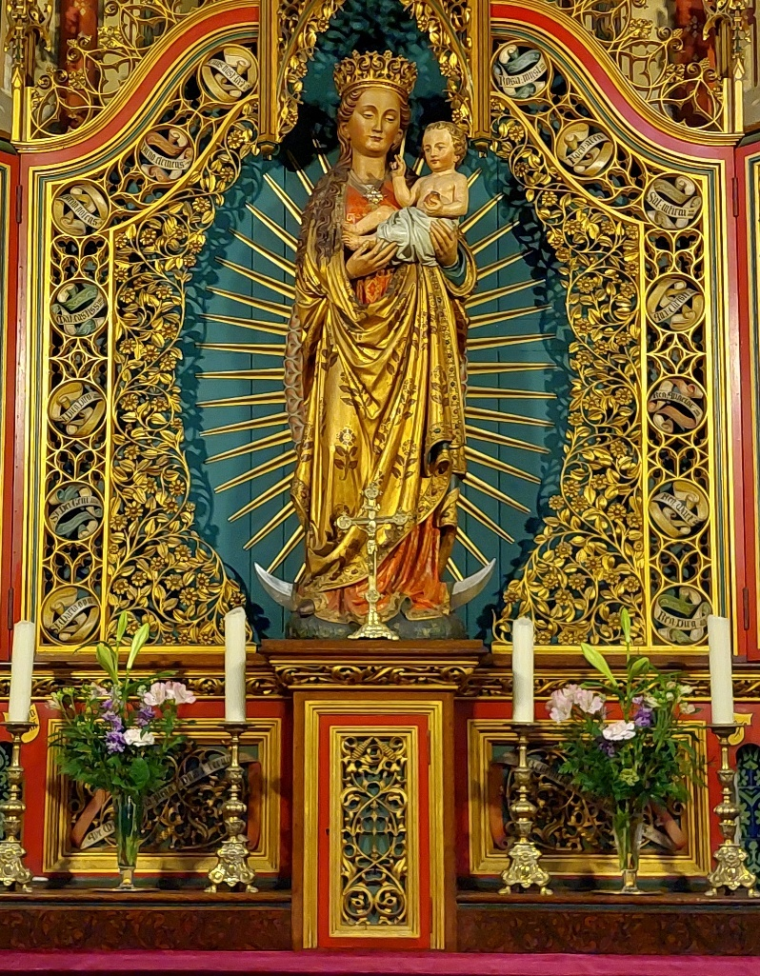
Figure 4: Atelier Friederich Mengelberg (1837-1919) Madonna on Crescent Moon, 1877, Polychrome on oak, Willibrord Church, Utrecht, the Netherlands. Image: Charlotte Wenner.
Description of Object
The Willibrord’s Madonna on Crescent Moon is housed in the Maria chapel left of the apse (Fig. 4). Bathed in the golden rays of the sun and standing on the silver sickle moon, the Virgin presents a resplendent image of celestial wonder. The chapel is six-sided, with the five walls behind the statue covered in bright colours, and the sixth opening to the Nave. The Madonna was deliberately designed to inspire Dutch Catholics of the time with a sense of renewed identity. This ornate statue of oak and polychrome colours is a stunning example of Neo-Gothic art, and presents quite a contrast to the simple wooden figure hidden in the Basel Museum.
While the entirety of the Virgin is magnificent, the glistening golden rays of the sun and golden robe adorned with roses are the objects which are central to the work. The prominence of golden attributes serve to accent the solar symbolism of both the ‘Word Incarnate’ and the Mother who has born God Incarnate. The thirty-six rays surrounding Maria’s body may represent the ten-degree divisions of the zodiac used in medieval astrology. This association of the thirty-six rays to astrology is supported by the presence of the zodiac signs and four elements on the ceiling of the Willibrord church. During the high middle ages, the church adopted Thomas Aquinas’s view that astrology could be useful when it was used as a form of natural science. The guidelines for the use of symbolism was quite strict, so Willibrord’s main designer, Gerard van Heukeleum, must have instructed Mengelberg to acknowledge Aquinas with these objects.
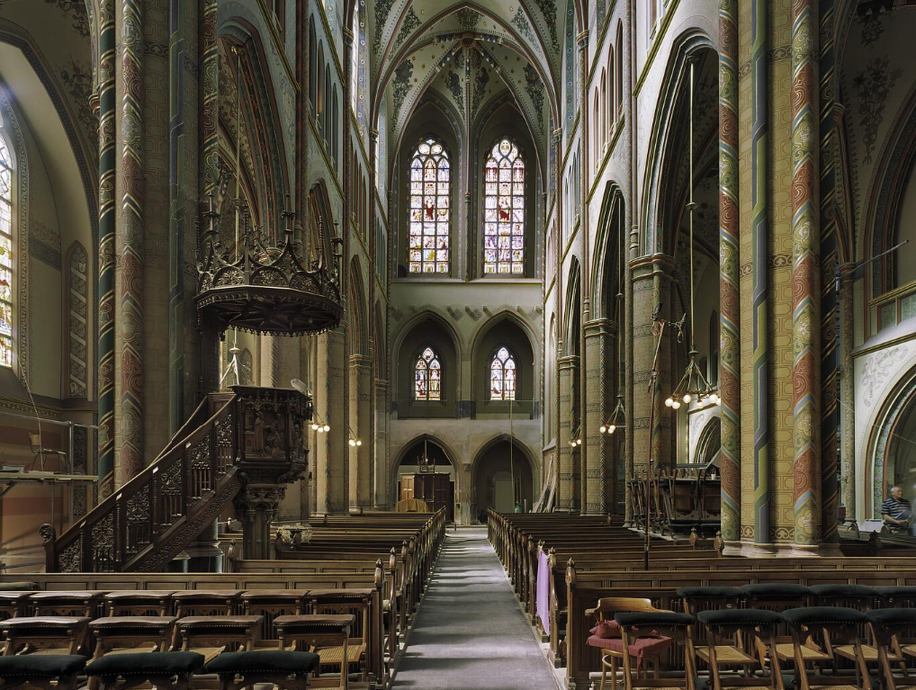
Figure 5 Interior View over Middle Nave, Willibrord Church, 2004, Photograph, 6 x 6 cm., Rijksdienst voor Cultureel Erfgoed, A.J. van der Wal - photographer.
Originally the Madonna on Crescent Moon may have also been illuminated by the actual rays of the sun. Two small rectangular windows stood underneath the tall windows in the western wall (Fig. 5), so that the rising and setting sun at the winter and summer solstices would have indirectly brightened the Maria chapel. However, during the renovation of the church that was carried out in the last decades of the twentieth century, the small windows were covered so the Maarschalkerweerd organ could be moved there from the north transept. Now only the great oblong stained-glass windows remain.
The Queen of Heaven stands directly above a boat-like, silver crescent moon which rests atop the Earth, which seems to emphasize her triumph over the sins of the world. This upturned crescent is the more common depiction of the moon. The thin sickle placed underneath the Virgin’s feet is less conspicuous than the human face adorning the Basel statue’s moon, making it more easily overlooked. The striking radiance of the golden solar attributes overshadows the moon as well, making it even less significant. The artist seems to have wanted to emphasize the glory of God and the heavenly realm, and downplay the temptation of the world and sin. This impression differs from that of the Warmbach Madonna, whose relationship with the moon illustrated her role as the New Eve.
The Utrecht Virgin’s eyes seem to gaze lovingly at the infant who she holds in both hands. She smiles slightly as though joyful that He has come. The infant is clothed in a loin cloth, and lifts his two right fingers blessing the world. In his left hand he holds an apple, representing the transgression by Eve for which he was to die. Mary’s dress is the red of royalty, rather than the lapis lazuli, or ultramarine, often used in medieval art. The choice of colour again depicts her as Queen of Heaven. The golden crown sits atop a head evenly framed patterned tresses that fall neatly beyond her shoulders behind her neck. The Willibrord Madonna presents a mature Mary, with rosy cheeks and full figure, the picture of health and well-being. It contrasts with the humble, almost shy, youthful maiden depicted in the Warmbach statue, although the removal of the paint from the latter may suggest an interpretation which was not intended in the original.
The most characteristic symbols, however, of the Willibrord Madonna are the numerous images related to conception, pregnancy, and birth. To begin with, the Virgin Mary and the sunrays stretching out from her body are framed within a cerulean, or blue-green, mandorla. While Christian descriptions of the mandorla tend to favour a theological interpretation, and claim that it represents ‘a vision or access into open space…an opening, a gateway between the spiritual and physical world’ such interpretations better fit the ‘desexualized’, almond-shaped form. In contrast, the upper section of the mandorla in the Willibrord church narrows around Mary’s head in such a way that it resembles a birth canal above a uterus (Fig. 6). From this opening, a very thin line of cerulean blue rises up the wall until it is even with the beginning of the long, thin golden staff that extends to the upper half of the vault. The staff seems like a symbol for the impregnation of Mary by the Holy Ghost.
Cerulean blue was historically used to represent God’s heaven, especially ‘when juxtaposed against gold leaf’. The deepest shades surround the Virgin Mother, as if they are darkened by the descent to Earth. In the column which rises above the Virgin, the blue gradually becomes lighter, until the upper half of the wall contains only small elements of cerulean against a white background. The golden spire begins in this realm of lightness, reinforcing the suggesting that it represents an emission from the heavenly Godhead into the Virgin womb.
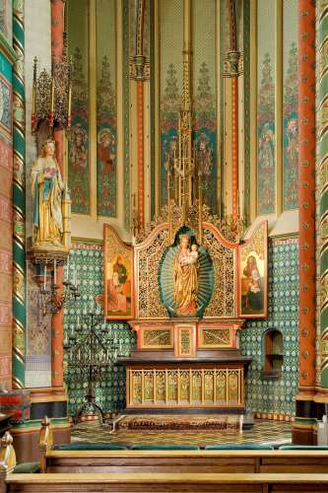
Figure 6. Atelier Mengelberg, Maria Chapel, c.1881, Willibrord Church, Utrecht, the Netherlands. Image: Charlotte Wenner
The numerous roses decorating the statue and altar also present symbols of fertility. Deep cerulean blue roses form a border around the mandorla, while golden flowers fill the altar’s frame. Like the symbolism of the mandorla, the lily and the rose are considered the European symbol for the female genitalia, or the generative role. ‘In the kind of reversal which often accompanies the transformation of pagan symbolism’, the lily, which was associated with Astarte and Aphrodite, became ‘associated with purity or virginity in Christianity’. Similarly, Inanna’s rosette ‘represented the fertility of the Mother goddess in all her various personifications and in all sense of the word fertility’. Thus, the symbolism of the Virgin Mary is again related to ancient sky goddesses.
The roses in this Maria chapel, however, are without thorns, and this is a specifically Christian symbol emphasizing her eternal virginity. The chapel is quite literally filled with various examples of these roses without thorn, from those painted on the six panels of the chapel’s ceiling (Fig. 7), to the rosettes on the walls behind her altar, to flowers on the predella upon which Maria stands, to the red flowers on her golden robe. ‘Roses from before the original sin did not bear thorns, and Maria was the unique exception to this sin through her “immaculate conception”.’
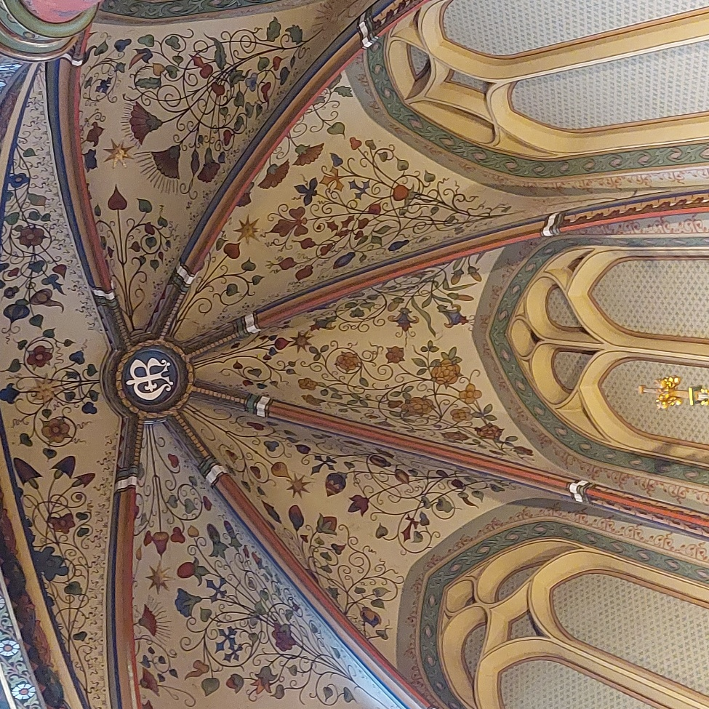
Figure 7. Chretien Lindsen (1840-1898),Ceiling Maria Chapel, c.1880, Polychrome, Willibrord Church, Utrecht, the Netherlands. Image: Charlotte Wenner.
While it is not unthinkable that the altar of the Madonna of Warmbach had born similar symbols of female fertility, at present the Virgin, bereft of chapel, only exhibits humble chastity. Both represent a powerful image of the Celestial Virgin and her Immaculate Conception. Yet while the Warmbach Madonna emphasizes the image of youthful purity and redeemer of Eve’s sin, the Willibrord Madonna, adorned magnificently as Queen of Heaven, emphasizes a vision of triumph over sin and the temptations of the world.
Audience and Purpose
The Catholic congregation of the St. Willibrordus who were welcomed into their spacious new church on the Minrebroederstraat in 1877, must have felt uplifted by the Neo-Gothic figure of the Mother of God, and her symbolism of birth and renewal, after a period of ignominy. Although Catholics had made up a vast majority of the population between 1815 – 1830, and were still a third of the population in 1840, they were considered by the governing Protestants as the antithesis of the one true religion and freedom. Despite having equal rights on paper, in practice ‘they remained second-class citizens’. However, with the new constitution and the re-establishment of the episcopal hierarchy by Pius IX in 1853, a new era began that has been called ‘the Catholic revival’.
The founding architects of the Dutch Neo-Gothic style Pierre Cuypers and Alberdingk Thijm were also ideologists who championed the Catholic emancipation movement. They envisioned a return to the values and traditions of the ‘golden age’ of Catholicism, and their buildings were modelled after medieval churches and their symbolism. Protestants viewed the spread of Neo-Gothicism as a ‘ultramontan’ conspiracy, that is the allegiance to Catholics ‘over the mountains’ in Italy and Spain. Yet despite their vigorous opposition, about eight hundred new churches were built in the last quarter of the 19th century, and Neo-Gothicism became synonymous with a new identity for Dutch Catholics.
The magnificent, ornate Madonna in the Willibrord Church is, thus, a fitting icon of victory over three centuries of persecution for the Catholics of Utrecht. The rich imagery representing the Immaculate Conception and God descending into human form may have been chosen to signify the rebirth of the Church. Likewise, emphasis on the Immaculate Conception may have been used to celebrate the official adaptation of the dogma in 1854. This symbolically implied that the Catholic mission and Church had remained pure, despite any assaults which it had had to endure.
The theme of rebirth, rather than repetition, is also evidenced by other 19th century elements in the church. For instance, the chapel on the right side of the apse is not dedicated to Saint Joseph, Maria’s husband, as was usual in the past, but to the Sacred Heart of Jesus. This image was rarely portrayed in the middle ages, but was elevated to mandatory observation by Pope Pius IX in 1856. The Sacrament, Virgin Mary, and the Sacred Hearts were the key symbols implemented by 19th century Dutch Catholic church against the secularization and the rising socialism of the time. They represented the Christian holy trinity in the heavens.
Like the Madonna of Warmbach from the 15th century, the Willibrord statue of Mary, Queen of Heaven would also have been a symbol of hope, the compassionate intercessor with God in Heaven. The economic circumstances of the second half of the 19th century were ‘particularly abominable’. Agricultural crises, the spread of disease, and the ‘Great Depression’, which caused poverty among workers in European industrialized countries, all contributed to an apocalyptic fear at the end of the century. Devotional figures like Mary became even more important to provide hope.
Finally, the Madonna on Crescent Moon in Utrecht, like that in Warmbach, would have been important in communicating the Church’s message to the uneducated. This was particularly true when Pius IX instituted Latin as the official language. The Bernulphus guild in Utrecht gathered the architects and artists to build the Willibrord in order to play ‘a dominant role in the spreading of the Catholic word and image’ and provide ‘symbols and tools for understanding the devotion and above all the words … to guide the Catholic in his or her devotion’. Their mission echoed the words of early theologians, that ‘pictorial representation is made use of in churches for this reason; that such as are ignorant of letters may at least read by looking at the walls what they cannot read in books’. Although some contemporaries were critical of the bright, overwhelming polychrome interior painted by Chrétien Lindsen, the effect was, and is, nothing less than magical. Both the unlettered and the educated worshippers at the Willibrord Church would be moved to reflect on the divine.
With the sharp drop in the numbers of churchgoers in the second half of the 20th century, however, the Willibrord Church fell into disuse and disrepair. It was only through the intervention of private citizens and the faithful that the building was not covered with a layer of white paint and the interior destroyed or sold, as was the case with many other Neo-Gothic churches. Finally it was made a national monument, restored, and purchased in 2019 by a small group of Catholics aligned with canonically irregular Society of Pius X. They maintain an anti-Modernist stance, and have retained pre-Vatican II books and liturgy. A condition for the purchase of the church is that it remain open daily to the public, and hosts pubic events, such as concerts, owing to its superb acoustics.
Thus, both the Willibrord Madonna and the Madonna of Warmbach are now largely viewed by a secular public that may be completely ignorant of the celestial symbolism and history which she presents. However, both the elegant simplicity of the Swiss linden wood Virgin and the brilliant polychrome Dutch Queen of Heaven still provide an experience of Eliade’s definition of the sacred, one that is out of the ordinary, evokes feelings of awe, and of having stepped into a higher realm.
Conclusion
This essay set out to analyse the similarities and differences between two sculptures of the Virgin Mary on Crescent Moon, and what they suggest about the relationship their respective cultures had with the sky. Both the Madonna of Warmbach and of that of Utrecht incorporate ancient celestial symbols that are familiar to their audience, most obviously the rays of the sun, with which the Virgin is ‘clothed’, and the crescent moon at her feet. The two statues differ from each other in appearance, owing in part to the effects of the Reformation. Moreover, while one is on exhibition at a museum, the other can be viewed in its original religious setting. Nevertheless, certain themes can be identified from both figures about each culture viewed the Queen of Heaven.
The wooden 15th century figure presents a rare example of a woman’s face inside the crescent moon, suggesting she is the New Eve, born untouched by the sin of the old Eve. This image was provided an antithesis to witchcraft at that time, as well as placing the Church in a position to rise above humanist and protestant criticism. In contrast, the brilliant Neo-Gothic statue in Utrecht presents triumph over the world’s sins. This Madonna is the mother who gives birth to a new Catholic identity. Dutch Catholics forged a new place for themselves in society by returning to the Gothic style of the middle ages in art and architecture. The magnificent Madonna on Crescent Moon in the Willibrord church provided a fitting symbol for the triumph and rebirth of Catholicism.
Yet in both 15th century Switzerland and 19th century Netherlands, the iconography was deliberately chosen to attract people to the theology and devotions of the Catholic Church, and discourage interest in modernization. The symbolism of the Woman of the Apocalypse raised people’s thoughts from the instability of their society, the economy, and changing morals, and provided them with the support of traditional Catholic values and the promise of a blessed heavenly afterlife.
In addition, both statues were created during periods when the dogma of the Immaculate Conception was especially topical. The Madonna of Warmbach was created shortly after Basel had officially adopted this tenant, while the Madonna of the Willibrord Church was sculpted when the Immaculate conception was officially adopted worldwide. The Woman of the Apocalypse was promoted to represent a figure of eternal purity, an unchanging icon in a world of constant change.
In conclusion, the analysis of the two statues reveals the manner with which European Catholics have used the veneration of the Madonna on Crescent Moon at crucial moments in history to strengthen their relationship with celestial Divinity. The image of the Virgin Mother, Queen of Heaven, offers a model of devotion to the faithful which, when emulated, offers the security of an afterlife in the realm above.

Bibliography
Abelmann, Annelies, ‘‘Ite ad Joseph’; A Short Survey on Textual Concepts in the Neo-Gothic Interior Decoration in Catholic Churches in the 19th and First Decades of the 20th Century’, Language, Discourse & Society, 7.1(13), (2019), pp. 59 – 65 (pp. 60-61). < https://bibliotekanauki.pl/articles/513804.pdf > [Accessed 2 March 2025].
Basel Historical Museum, ‘Mary, the Queen of Heaven’, < https://www.hmb.ch/en/museums/objects-in-the-collection/details/s/the-madonna-enthroned-with-the-christchild > [ Accessed 20 April 2025].
Basel Historical Museum, ‘Peter Rot Altar (closed)’, < https://www.hmb.ch/en/museums/objects-in-the-collection/details/s/the-peter-rot-altar-closed/> [Accessed 23 April 2025].
Ben-Yehuda, Nachman ,‘The European Witch Craze of the 14th to 17th Centuries: A Sociologist's Perspective’, American Journal of Sociology, 86. 1 (Jul., 1980), pp. 1-31. < https://www.jstor.org/stable/2778849 > [ Accessed 21 April 2025].
Benedict XVI, ‘General Audience 23 August 2006’, Vatican.va. < https://www.vatican.va/content/benedict-xvi/en/audiences/2006/documents/hf_ben-xvi_aud_20060823.html > [ Accessed 21 April 2025].
Broedel, Hans Peter, The Malleus Maleficarum and the Construction of Witchcraft: Theology and Popular Belief, (Manchester: Manchester University Press, 2003).
Campion, Nicholas, A History of Western Astrology, Volume 1: The Ancient World, (London: Bloomsbury Academic, 2008).
Campion, Nicholas, A History of Western Astrology, Volume II: The Medieval and Modern Worlds, (London: Bloomsbury Academic, 2009).
Eliade, Mircea, The Sacred and the Profane (New York: Harcourt Brace 1959).
Guillant de Suduiraut, Sophie, La Vierge á l’Enfant d’Issenheim, (Paris: Réunion des Musées Nationaux, 1998).
Irenaeus of Lyons, ‘Chapter XXX’, Against Heresies, Verse 3 (line 30-31). < https://www.earlychristianwritings.com/text/irenaeus-book5.html > [ Accessed 20 April 2025].
Jimkes-Verkade, Els and Casper Staal, with assistance from Annemarie van Santen, ‘Visioen van het Hemels Jeruzalem: Het interieur van de Sint Willibrordkerk’ in De Utrechtse Willibrordkerk, Els Jimkes-Verkade, Casper Staal, Elisabeth Stades-Vischer (editors), (Utrecht: Uitgeverij Matrijs, 2024), pp. 55 – 151.
Karant-Nunn, Susan C., ‘Review: The Cult of the Virgin Mary in Early Modern Germany: Protestant and Catholic Piety, 1500–1648 by Bridget Heal’, Renaissance Quarterly , 62.1 (Spring 2009), pp. 287-289. < https://www.jstor.org/stable/10.1086/598446 > [ Accessed 19 April 2025].
King, Jade, ‘The Night Sky in Art’, (10 March 2023) < https://artuk.org/discover/stories/the-night-sky-in-art > [ Accessed 26 April 2025].
Leeuwen, Wies van and Mascha van Damme, ‘Een neogotische kerk naar ontwerp van Alfred Tepe’ in De Utrechtse Willibrordkerk, Els Jimkes-Verkade, Casper Staal, Elisabeth Stades-Vischer (editors), (Utrecht: Uitgeverij Matrijs, 2024), pp. 33 - 55.
Mocholí Martínez, María Elvira, ‘The Nursing Madonna in the Middle Ages: An Interdisciplinary Study’, Religions, 14:568, (2023) p. 25. < https://doi.org/10.3390/rel14050568 > [Accessed 19 April 2025].
Parker, Geoffrey, ‘Why Did the Dutch Revolt Last Eighty Years?’, Transactions of the Royal Historical Society , 26 (1976), pp. 53-72. < https://www.jstor.org/stable/3679072 > [Accessed 25 April 2025].
Pearson, E. Ann, ‘Revealing and Concealing: the Persistence of Vaginal Iconography in Medieval Imagery: The Mandorla, the Vesica Piscis, the Rose, Sheela-Na-Gigs, and the Double-Tailed Mermaid’, Ph.D. thesis (Ottawa: University of Ottawa, 2002) pp. 1 – 257. < https://ruor.uottawa.ca/bitstreams/e5491faa-6c40-44b2-a562-dead2c79b328/download > [ Accessed 26 April 2025].
Salvador-González, José María, ‘Regina Coeli—Doctrine and Iconography of the Virgin Mary’s Heavenly Royalty’, Religions, 14.815, (2023), p. 37.< https://doi.org/10.3390/rel14060815 > [ Accessed 22 April 2025].
Schaik, Ton H.M. van, ‘Heropening en restauratie, 1967-2020’ in in De Utrechtse Willibrordkerk, Els Jimkes-Verkade, Casper Staal, Elisabeth Stades-Vischer (editors), (Utrecht: Uitgeverij Matrijs, 2024), pp. 151 – 161.
Spaans, Jo, ‘Religious Policies in the seventeenth-Century Dutch Republic’ in Ronnie Po-chia Hsia and Henk van Nierop (eds.), Calvinism and Religious Toleration in the Dutch Golden Age, (Cambridge: Cambridge University Press, 2002) pp. 72-86 (p. 77). < https://museumandgallery.org/wp-content/uploads/2024/05/Religious-Toleration-in-the-Dutch-Republic.pdf > [ Accessed 25 April 2025].
The Queen of Heaven’, The Catholic Layman, 4.42 (Jun., 1855), pp. 61-62 (p. 61). < https://www.jstor.org/stable/30065966> [ Accessed 20 April 2025].
Todorova, Rostislava Georgieva, ‘The Mandorla Symbol in Byzantine and Post-Byzantine Iconography of the Dormition: Function and Meaning’, Religions, 14: 473.< https://doi.org/ 10.3390/rel14040473 > [Accessed 19 April 2025].
Wixom, William D. (ed.), Mirrors on the Medieval World (New York: Metropolitan Museum of Art, 1999).
Ziolkowski, Jan M., ‘Images of the Virgin’ in The Juggler of Notre Dame and the Medievalizing of Modernity: Volume 4: Picture That: Making a Show of the Jongleur (Cambridge: Open Book Publishing, 2018), pp. 159-192. < https://www.jstor.org/stable/j.ctv8d5t5s.6 > [ Accessed 26 April 2025].
Zwegers, Bart ‘Particularity and Communality. Gothic Architecture and Catholic Emancipation in the Netherlands, 1850–1890’, Dutch Access. < https://doi.org/10.1080/03096564.2025.2461380 > [ Accessed 17 March 2025].

Pope Benedict XVI, ‘General Audience 23 August 2006’, Vatican.va. < https://www.vatican.va/content/benedict-xvi/en/audiences/2006/documents/hf_ben-xvi_aud_20060823.html > [ Accessed 21 April 2025].
Irenaeus of Lyons, ‘Chapter XXX’, Against Heresies, Verse 3 (line 30-31). < https://www.earlychristianwritings.com/text/irenaeus-book5.html > [ Accessed 20 April 2025].
Sophie Guillant de Suduiraut, La Vierge á l’Enfant d’Issenheim, (Paris: Réunion des Musées Nationaux, 1998), p. 12.
Nicholas Campion, A History of Western Astrology, Volume II: The Medieval and Modern Worlds, (London: Bloomsbury Academic, 2009), p. 248.
Nicholas Campion, A History of Western Astrology, Volume 1: The Ancient World, (London: Bloomsbury Academic, 2008), p. 248.
‘The Queen of Heaven’, The Catholic Layman, 4.42 (Jun., 1855), pp. 61-62 (p. 61). < https://www.jstor.org/stable/30065966> [ Accessed 20 April 2025].
William D. Wixom, ed., Mirrors on the Medieval World (New York: Metropolitan Museum of Art, 1999), p. 185 - 186. See also Sophie Guillant de Suduiraut, La Vierge á l’Enfant d’Issenheim, (Paris: Réunion des Musées Nationaux, 1998), p. 44.
Basel Historical Museum, ‘Peter Rot Altar (closed)’, < https://www.hmb.ch/en/museums/objects-in-the-collection/details/s/the-peter-rot-altar-closed/> [Accessed 23 April 2025].
María Elvira Mocholí Martínez, ‘The Nursing Madonna in the Middle Ages: An Interdisciplinary Study’, Religions, 14:568, p. 25. < https://doi.org/10.3390/rel14050568 > [Accessed 19 April 2025].
Guillant de Suduiraut, p. 12.
Guillant de Suduiraut, pp. 10 – 11.
Basel Historical Museum, ‘Mary, the Queen of Heaven’, < https://www.hmb.ch/en/museums/objects-in-the-collection/details/s/the-madonna-enthroned-with-the-christchild > [ Accessed 20 April 2025].
Guillant de Suduiraut, p. 43.
Guillant de Suduiraut, p. 46.
Guillant de Suduiraut, p. 45.
Basel Historical Museum, ‘Mary, the Queen of Heaven’.
Guillant de Suduiraut, p. 86, Fig. 105.
Guillant de Suduiraut, p. 75, Figure 80.
José María Salvador-González, ‘Regina Coeli—Doctrine and Iconography of the Virgin Mary’s Heavenly Royalty’, Religions, 14.815, (2023), p. 37.< https://doi.org/10.3390/rel14060815 > [ Accessed 22 April 2025].
Guillant de Suduiraut, pp. 44 – 45.
Andrezev Grzybkoswski cited by Sophie Guillant de Suduiraut, p. 13.
Guillant de Suduiraut, p. 12.
Guillant de Suduiraut,, p. 43.
Hans Peter Broedel, The Malleus Maleficarum and the Construction of Witchcraft: Theology and Popular Belief, (Manchester: Manchester University Press, 2003), p. 19-20.
Nachman Ben-Yehuda, ‘The European Witch Craze of the 14th to 17th Centuries: A Sociologist's Perspective’, American Journal of Sociology, 86. 1 (Jul., 1980), pp. 1-31 (p. 1). < https://www.jstor.org/stable/2778849 > [ Accessed 21 April 2025].
Martin of Arles, cited in Broedel, p. 81.
Susan C Karant-Nunn, ‘Review: The Cult of the Virgin Mary in Early Modern Germany: Protestant and Catholic Piety, 1500–1648 by Bridget Heal’, Renaissance Quarterly , 62.1 (Spring 2009), pp. 287-289 (p. 287). < https://www.jstor.org/stable/10.1086/598446 > [ Accessed 19 April 2025].
Geoffrey Parker, ‘Why Did the Dutch Revolt Last Eighty Years?’, Transactions of the Royal Historical Society , 26 (1976), pp. 53-72 (p. 53). < https://www.jstor.org/stable/3679072 > [Accessed 25 April 2025].
Jo Spaans, ‘Religious Policies in the seventeenth-Century Dutch Republic’ in Ronnie Po-chia Hsia and Henk van Nierop (eds.), Calvinism and Religious Toleration in the Dutch Golden Age, (Cambridge: Cambridge University Press, 2002) pp. 72-86 (p. 77). < https://museumandgallery.org/wp-content/uploads/2024/05/Religious-Toleration-in-the-Dutch-Republic.pdf > [ Accessed 25 April 2025].
Els Jimkes-Verkade and Casper Staal, with assistance from Annemarie van Santen, ‘Visioen van het Hemels Jeruzalem: Het interieur van de Sint Willibrordkerk’ in De Utrechtse Willibrordkerk, Els Jimkes-Verkade, Casper Staal, Elisabeth Stades-Vischer (editors), (Utrecht: Uitgeverij Matrijs, 2024), pp. 55 – 151 (p. 55).
Bart Zwegers, ‘Particularity and Communality. Gothic Architecture and Catholic Emancipation in the Netherlands, 1850–1890’, Dutch Access, pp. 7 -10. < https://doi.org/10.1080/03096564.2025.2461380 > [ Accessed 17 March 2025].
Campion, A History: Volume II, pp. 51 – 52.
Els Jimkes-Verkade and Casper Staal, pp. 55 – 61.
Wies van Leeuwen and Mascha van Damme, ‘Een neogotische kerk naar ontwerp van Alfred Tepe’ in De Utrechtse Willibrordkerk, Els Jimkes-Verkade, Casper Staal, Elisabeth Stades-Vischer (editors), (Utrecht: Uitgeverij Matrijs, 2024), pp. 33 - 55 (pp. 51 – 53).
Jimkes-Verkade and Staal, pp. 84 – 85.
Jan M. Ziolkowski, ‘Images of the Virgin’ in The Juggler of Notre Dame and the Medievalizing of Modernity: Volume 4: Picture That: Making a Show of the Jongleur (Cambridge: Open Book Publishing, 2018), pp. 159-192 (pp. 167 – 168). < https://www.jstor.org/stable/j.ctv8d5t5s.6 > [ Accessed 26 April 2025].
Rostislava Georgieva Todorova, ‘The Mandorla Symbol in Byzantine and Post-Byzantine Iconography of the Dormition: Function and Meaning’, Religions, 14: 473.< https://doi.org/ 10.3390/rel14040473 > [Accessed 19 April 2025].
E. Ann Pearson, ‘Revealing and Concealing: the Persistence of Vaginal Iconography in Medieval Imagery: The Mandorla, the Vesica Piscis, the Rose, Sheela-Na-Gigs, and the Double-Tailed Mermaid’, Ph.D. thesis (Ottawa: University of Ottawa, 2002) pp. 1 – 257 (p. 83). < https://ruor.uottawa.ca/bitstreams/e5491faa-6c40-44b2-a562-dead2c79b328/download > [ Accessed 26 April 2025].
Pearson, p. 90.
Jade King, ‘The Night Sky in Art’, (10 March 2023) < https://artuk.org/discover/stories/the-night-sky-in-art > [ Accessed 26 April 2025].
Pearson, pp. 108 – 111.
Jimkes-Verkade and Staal, p. 85.
Zwegers, Particularity and Community, p. 3.
L.J. Rogier, cited in H. Knippenberg, ‘1853: How Pope Pius IX Stimulated Pillarization in the Netherlands’, Historical Life Course Studies, 10, pp. 162-166 (164). < https://doi.org/10.51964/hlcs9587 > [Accessed 24 April 2025].
Van Leeuwen and van Damme, p.34 - 36.
Zwegers, pp. 6 – 10.
Jimkes-Verkade and Staal, pp. 80 – 81.
Ibid, p. 57.
Annelies Abelmann, ‘‘Ite ad Joseph’; A Short Survey on Textual Concepts in the Neo-Gothic Interior Decoration in Catholic Churches in the 19th and First Decades of the 20th Century’, Language, Discourse & Society, 7.1(13), (2019), pp. 59 – 65 (pp. 60-61). < https://bibliotekanauki.pl/articles/513804.pdf > [Accessed 2 March 2025].
Abelmann, pp. 62 – 63.
Van Leeuwen and van Damme, p. 49.
Ton H.M. van Schaik, ‘Heropening en restauratie, 1967-2020’ in in De Utrechtse Willibrordkerk, Els Jimkes-Verkade, Casper Staal, Elisabeth Stades-Vischer (editors), (Utrecht: Uitgeverij Matrijs, 2024), pp. 151 – 161 (p. 159).
Mircea Eliade, The Sacred and the Profane (New York: Harcourt Brace 1959), p. 9.

