BMIH5007 Financial Management for the Hotel Industry
Report Case Study: The Seaview Resort

Student Name: Alexandra Stroe
Student ID: 2029014

Executive Summary
Due to declining revenue, inefficiency, and high debt, the Seaview Resort is struggling financially. A detailed turnaround strategy is needed after the financial analysis. The resort's best outcome demonstrates its potential to offer eco-tourism, experiential tourism, and events. The strategy includes reorganising finances, creating a new brand identity, extending marketing methods, and improving constantly. Revenue and profitability are expected to rise because of the turnaround strategies. This report recommends market research, change management, budgeting, and environmental compliance to reduce risk. If these recommendations are implemented, the resort will be revitalised and financially stable.

Table of Contents
Executive Summary 2
Introduction 4
Financial Analysis 5
Analysis of Income Statement 5
Analysis of Balance Sheet 5
Analysis of Cash Flow Statement 5
Ration Calculation 6
Ratio Analysis 6
Swot Analysis of the Seaview Resort 7
Market Analysis for Seaview Resort 9
Turnaround Strategy for the Seaview Resort 10
Financial Projections 12
Risk Assessment 15
Conclusion 16
Recommendations 16
References 17

Introduction
The Seaview Resort, long a coastal luxury icon, has witnessed revenues and customer satisfaction decrease in recent years. A three-year drop in earnings demonstrates the need for a strategic change. Due to operational inefficiencies and a shifting market that promotes eco-friendly tourism, the occupancy rate and average room rate have been dropping (Rosen, 2020). This study will evaluate the resort's financial issues and provide a sound recovery plan. The objective is to evaluate the financial sustainability of Seaview Resort and recommend actions to strengthen its position in the market and increase profitability. The primary aim of this dual focus is the financial stability of Seaview Resort. The financial and competitive position of Seaview Resort are the main topics of this report. The objectives include pinpointing the reasons behind the decline in performance and devising a plan to enhance profitability, elevate client contentment, and establish the resort as a leader in the sector.

Financial Analysis

Analysis of Income Statement
Concern has been raised by the Seaview Resort's declining financial performance over the last three years. From £520,000 in 2020 to £430,000 in 2022, revenue declined steadily, indicating a potential loss of market share or pricing power for the company (Frow and Marginson, 2020). The rise in operational expenditures from £390,000 to £450,000 might be a sign of inefficiencies or cost increases that the organisation is unable to control (Boyns, 2022). As a result of this, gross profit decreased from £130,000 to £20,000, which was indicative of significant operational limitations. Net profit fell as a result of this trend, from £78,000 (a 15% increase) to £47,500 (an 11.5% decrease). The resort's diminishing profitability emphasises the need for a thorough makeover to curb the financial trend (Purnomo, 2018).

Analysis of Balance Sheet
According to the Seaview Resort's 2022 balance sheet, £1,030,000 in assets represents a significant portion of its capital. The bulk of the value is £630,000 in property and equipment, while current assets are just £250,000, which may affect liquidity. However, just £100,000 inventory is available. The resort has £580,000 in liabilities, including £180,000 in short-term liabilities and £400,000 in long-term debt. The resort's equity of £450,000 suggests it is severely leveraged, which may restrict its borrowing and investment possibilities (Troy, 2020). Due to the financial condition, debt management and asset productivity demand a deliberate approach.

Analysis of Cash Flow Statement
The Seaview Resort's 2022 cash flow study shows major financial difficulties. A negative net cash flow from operations of -£80,000 implies that the company's main activities are not earning enough cash to fund continuous activity (Velez-Pareja, 2020). Additionally, the resort spent £30,000 on capital. These expenses may have been necessary to maintain or improve the resort's property and equipment, but they strained cash reserves (Boyns, 2022). A -£110,000 cash balance drop happened during the year at the resort. If this high cash outflow persists, the resort may be unable to support its daily operations, meet its short-term obligations, and invest in the necessary business improvements to attract tourists and stay competitive.

Ration Calculation
Financial Ratio | Formula | Calculation | Result
Current Ratio | Current Assets / Current Liabilities | £250,000 / £180,000 | 1.4
Quick Ratio | (Current Assets - Inventory) / Current Liabilities | (£250,000- - £100,000) / £180,000 | 0.8
Debt-to-Equity Ratio | Total Debt / Total Equity | £750,000 / £450,000 | 1.7
Return on Assets (ROA) | Net Profit / Total Assets | (£47,500) / £1200,000 | (0.04)
Return on Equity (ROE) | Net Profit / Total Equity | (£47,500) / £450,000 | 0.11
Table 1: Financial Ratio Calculation, Source: Author.

Ratio Analysis
The Seaview Resort's financials show liquidity and profitability issues. The resort's current ratio of 1.4 indicates a low ability to pay short-term commitments using short-term assets (Purnomo, 2018). However, the quick ratio drops to 0.83, below the optimum 1 level, signalling that meeting existing obligations without selling inventory may be problematic (Frow and Marginson, 2020). The resort relies heavily on debt, which might be problematic if revenue declines or interest rates rise. A debt-to-equity ratio of 1.7 implies significant leverage. The resort's ROA is negative (0.04), indicating that its assets are not being exploited to their maximum potential to generate a profit (Frow and Marginson, 2020). The resort's 0.11 ROE is also concerning since it generates a negative return for its shareholders. This decreases stock value and raises concerns about the resort's financial viability and business model efficiency.

Swot Analysis of the Seaview Resort

Figure 1: SWOT Analysis, Source: (Somekh, 2022).
Strengths
The Seaview Resort's coastal location remains a draw. The property's restaurant, bar and event facilities provide a variety of cash. The ratio suggests near-term financial stability, while the 25 beds suggest a personalised visitor experience.
Weaknesses
Financial ratios reveal major issues. A quick ratio below one implies liquidity issues that may slow the resort's market response. Negative ROA and ROE ratios reflect the resort's poor financial management and operational inefficiency (Purnomo, 2018). These numbers show the resort is not using its assets profitably or returning to its owners. Lower accommodation pricing and occupancy rates indicate a declining market position and customer dissatisfaction.
Opportunities
Due to industry trends towards ecologically responsible and experiential tourism, the Seaview Resort may stand out. By making use of its natural surroundings, the resort can adapt its offerings to changing consumer needs (Evans and Elphick, 2019). Refocusing marketing on unique experiences may attract new customers as it is a huge industry with a $1.21 trillion market value in 2023 (Statista, 2023).
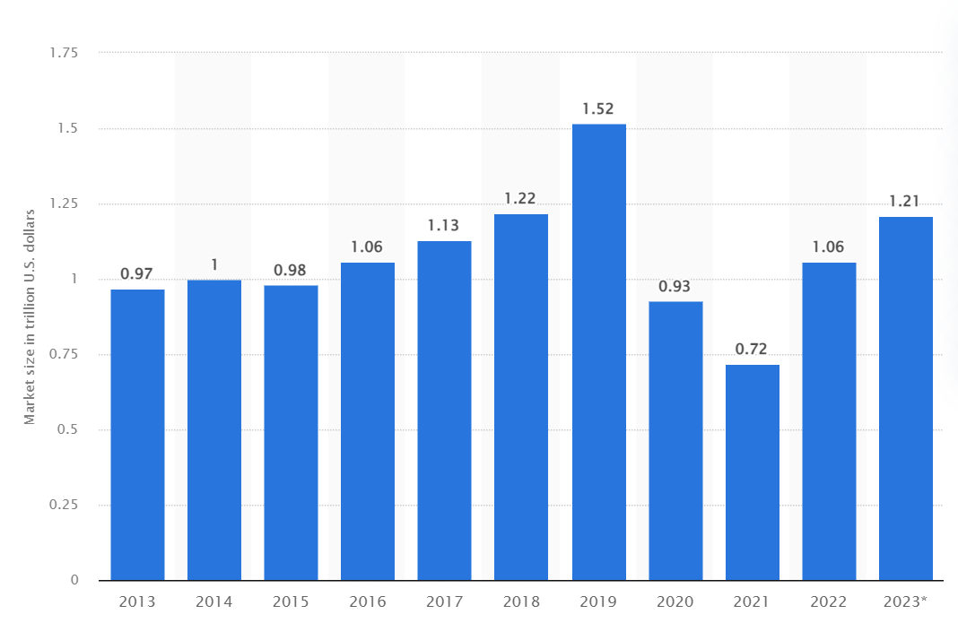
Figure 2: Hotel and Resort Industry’s Market Size, Source; (Statista, 2023).
Threats
Growing competition from modern facilities threatens the resort. The company's high debt-to-equity ratio makes it sensitive to revenue and interest rate swings. This susceptibility may rise with economic downturns or new competitors. Changes in customer tastes and negative perceptions of service and facilities are additional pressing issues that must be addressed to reverse the decline (Tsai and Chen, 2017).

Market Analysis for Seaview Resort
Competitive Landscape and Customer Expectations
The hospitality industry, especially seaside hotels, is very competitive. New rivals with cutting-edge conveniences and extensive feature sets enhance customers' expectations (Mueller and Kaufmann, 2021). In this competitive market, the Seaview Resort can compete with more contemporary rooms, electronically integrated amenities, or all-inclusive experiences. These businesses appeal to folks who want to learn technology more easily.
Current Trends in the Hotel Industry
Sustainability and environmental friendliness are trending in tourism. Travellers are growing more environmentally conscious and choose hotels with organic bedding and renewable energy. Experienced travel has grown in popularity, with travellers choosing unique, authentic trips to typical vacation packages (Rosen, 2020). The Seaview Resort may use this trend to stand out in a segment of the ecotourism and customised holiday experience market.
Target Market Segment
Thus, the resort may attract eco-conscious visitors, thrill-seekers, and health-conscious fitness enthusiasts. It may also attract remote workers looking for 'workstations,' providing them the ability to mix vacation relaxation with workplace productivity. This group values quiet, scenic locations with high-speed internet and comfortable workplaces (Shackleford, 2021).
Potential Growth Opportunities
The Resort has significant untapped growth potential. Local social parties, weddings, and business retreats might utilise the resort's event facilities. This would increase occupancy rates and generate revenue from event planning and catering (Sharpley, 2022). The Seaview Resort must assess its facilities against market needs to decide how to capitalise on these opportunities. To attract the designated target groups, it may invest in ecologically responsible practices and infrastructure, provide locally immersive experiences, and increase marketing. Strategic partnerships with ecotourism, adventure, and remote working retreat providers may also be useful (Rosen, 2020). Considering the resort's online ratings and digital presence, improving its service and modernising its amenities must be a major goal to manage and improve its online image.

Turnaround Strategy for the Seaview Resort
Reviving The Seaview Resort requires a detailed solution to its financial challenges and long-term market positioning.

Figure 3: Turnaround Strategies, Source: Author.
Financial Restructuring and Operational Efficiency
To lower the costs, the resort must first improve operational efficiency. Renegotiating with suppliers, optimising staff schedules to better serve visitors, and reducing energy consumption may achieve this. Analysing unprofitable services allows to concentrate on profitable ones (Evans and Elphick, 2019). The cash flow analysis revealed liquidity issues that may necessitate strict working capital management and debt restructuring.

Rebranding and Market Repositioning
Rebranding to match eco-friendly and experiential travel trends may meet industry need. The resort must invest in green infrastructure and certifications to attract eco-conscious guests (McTeigue et al., 2021). Seaview has to provide unique seaside experiences like guided eco-tours and cooking classes to stand out in a competitive industry.
Marketing and Revenue Diversification
To reach new customers, a concentrated marketing approach using social media and travel platforms is necessary. Offering remote job packages and unique event offerings may diversify revenue (Niculescu, 2019). The resort's reputation will increase if it improves its website, customer service, and guest amenities.
Engagement and Continuous Improvement
The resort must aggressively solicit visitor feedback to improve service and stay ahead of market trends (Wickramasinghe and Takano, 2021). Employee training to enhance service delivery and periodic market strategy assessments will keep the resort relevant and competitive.
This turnaround strategy requires a large upfront investment, but it will set The Seaview Resort on a sustainable and profitable path.

Financial Projections
The Seaview Resort's financial projections are intended to estimate possible results from the turnaround strategy's implementation over the next four years (2023 to 2026).
Projected Income Statement
Item | 2023 | 2024 | 2025 | 2026
Total Revenue | 500,000 | 550,000 | 605,000 | 665,500
Operating Expenses | 380,000 | 370,000 | 360,000 | 350,000
Gross Profit | 120,000 | 180,000 | 245,000 | 315,500
Depreciation | 20,000 | 20,000 | 20,000 | 20,000
EBIT | 100,000 | 160,000 | 225,000 | 295,500
Interest Expense | 25,000 | 22,500 | 20,000 | 17,500
EBT | 75,000 | 137,500 | 205,000 | 278,000
Tax (25%) | 18,750 | 34,375 | 51,250 | 69,500
Net Profit | 56,250 | 103,125 | 153,750 | 208,500
Table 3: Revenue and Expenditure Projections, Source: Author.

Projected Balance Sheet
Item | 2023 | 2024 | 2025 | 2026
Total Assets | 1,050,000 | 1,100,000 | 1,155,000 | 1,215,250
- Current Assets | 260,000 | 270,000 | 280,500 | 291,525
- Property & Equip. | 640,000 | 650,000 | 665,000 | 683,250
- Other Assets | 150,000 | 180,000 | 209,500 | 240,475
Total Liabilities | 550,000 | 510,000 | 460,000 | 402,500
- Current Liabilities | 170,000 | 160,000 | 150,000 | 140,000
- Long-term Debt | 380,000 | 350,000 | 310,000 | 262,500
-Equity | 500,000 | 590,000 | 695,000 | 812,750
Table 4: Assets and Liabilities Projections, Source: Author.

Projected Cash Flow Statement
Item | 2023 | 2024 | 2025 | 2026
Net Cash Flow from Operations | 100,000 | 150,000 | 200,000 | 250,000
Capital Expenditures | (50,000) | (30,000) | (25,000) | (20,000)
Financing Activities | (20,000) | (20,000) | (20,000) | (20,000)
Net Cash Flow | 30,000 | 100,000 | 155,000 | 210,000
Change in Cash Balance | 30,000 | 130,000 | 285,000 | 495,000
Table 5: Cash Flow Projections, Source: Author
The expected cash flow statement shows that The Seaview Resort will be profitable in 2023. In 2023, the resort began generating a positive cash flow of £3,000 above its capital expenditures and financial obligations, indicating that the corporation may have achieved its cash flow break-even threshold. These projections illustrate that the turnaround strategy will boost revenue and profitability while decreasing debt and capital asset expenditures. Current market circumstances, resort history, and recovery plan strategic initiatives are used to make projections.

Risk Assessment
The Seaview Resort turnaround plan is comprehensive yet exposed to many risks:
- Market Risks: The rebranding may not resonate with the intended demographic or competitors may use identical approaches, undermining The Seaview Resort's uniqueness (Spector, 2020).
- Operational Risks: Reorganising operations may cause temporary service disruptions that upset customers or employees.
- Financial Risks: This type of risk includes cash flow issues and the possibility that it may underestimate change costs or overestimate revenue growth (Dimopoulos and Queiros, 2019).
- Regulatory Risks: If the resort adopts greener practices, environmental regulations may affect its daily operations (Kour, 2023).
Risk Mitigation Plan
Risk Type | Potential Risk | Mitigation Strategy
Market | Ineffective rebranding, intense competition | Conduct market research, continuously innovate, foster partnerships
Operational | Disruptions, staff/clientele dissatisfaction | Effective change management, staff engagement, and maintaining high service standards
Financial | Cash flow management, cost/revenue misjudgement | Conservative financial planning, regular financial reviews, contingency funds
Regulatory | Changes in environmental/tourism laws | Stay informed on legislation, engage in compliance planning, and environmental audits
Table 6: Risk Mitigation Plan, Source: Author.

Conclusion
Management must act quickly and strategically when The Seaview Resort's financial research shows significant revenue management and operational efficiency shortcomings (Penney et al., 2018). The resort's financial challenges, market expectations, and attractiveness are addressed by the turnaround plan. If the plan works, profits, brand reputation, and customer experience will increase.

Recommendations
Here are the recommendations to the hotel owner and managers to implement the turnaround strategies:
- Revamp marketing efforts to highlight new eco-friendly initiatives and experiences.
- Invest in staff training for improved service quality and guest satisfaction.
- Upgrade amenities to meet current market trends and preferences.
- Implement rigorous financial controls to manage expenses and cash flow.
- Develop unique, local partnerships to expand the resort’s attraction offerings.
- Regularly review customer feedback to continuously adapt and improve.

References
Boyns, T. (2022). Budgets and budgetary control in British businesses. Accounting, Business & Financial History, 8, pp.261–301. doi:https://doi.org/10.1080/095852098330413.
Bull, R. (2019). Financial ratios : how to use financial ratios to maximise value and success for your business. Burlington, Ma, Usa: Elsevier Ltd.
Dimopoulos, D. and Queiros, D. (2019). Sinking deeper: The most significant risks impacting the dive tourism industry in the East African Marine Ecoregion. Ocean & Coastal Management, 181(9), p.104897. doi:https://doi.org/10.1016/j.ocecoaman.2019.104897.
Evans, N. and Elphick, S. (2019). Models of crisis management: an evaluation of their value for strategic planning in the international travel industry. International Journal of Tourism Research, 7(3), pp.135–150. doi:https://doi.org/10.1002/jtr.527.
Frow, N. and Marginson, D. (2020). ‘Continuous’ budgeting: Reconciling budget flexibility with budgetary control. Accounting, Organizations and Society, 35, pp.444–461. doi:https://doi.org/10.1016/j.aos.2009.10.003.
Kour, P. (2023). Recovery marketing for conflict sensitive destination: Stakeholders perspective on tourism revival. Conflict Resolution Quarterly, 19(7). doi:https://doi.org/10.1002/crq.21393.
McTeigue, C., Sanchez, C., Santos, E., Walter, C.E. and Au-Yong-Oliveira, M. (2021). A Strategy for Tourism Growth, Rebound, and Revival. Sustainability, [online] 13(22), p.12588. doi:https://doi.org/10.3390/su132212588.
Mueller, H. and Kaufmann, E.L. (2021). Wellness tourism: Market analysis of a special health tourism segment and implications for the hotel industry. Journal of Vacation Marketing, 7(1), pp.5–17. doi:https://doi.org/10.1177/135676670100700101.
Niculescu, G. (2019). TOURISM AND CULTURAL REVIVAL. Annals - Economy Series, 3(13), pp.369–376.
Owen, C. (2019). Changing trends in business tourism. Tourism Management, 13(2), pp.224–226. doi:https://doi.org/10.1016/0261-5177(92)90063-d.
Penney, K., Snyder, J., Crooks, V.A. and Johnston, R. (2018). Risk communication and informed consent in the medical tourism industry: A thematic content analysis of canadian broker websites. BMC Medical Ethics, 12(1). doi:https://doi.org/10.1186/1472-6939-12-17.
Purnomo, A. (2018). Influence of The Ratio of Profit Margin, Financial Leverage Ratio, Current Ratio, Quick Ratio Against The Conditions and Financial Distress. Indonesian Journal of Business, Accounting and Management, 1(1). doi:https://doi.org/10.36406/ijbam.v1i1.218.
Rosen, S. (2020). Hedonic Prices and Implicit Markets: Product Differentiation in Pure Competition. Journal of Political Economy, 82(1), pp.34–55.
Shackleford, P. (2021). Global tourism trends. Tourism Management, 8(2), pp.98–101. doi:https://doi.org/10.1016/0261-5177(87)90009-4.
Sharpley, R. (2022). Trends in European Tourism Planning and Organisation. Tourism Management, 51(11), pp.33–34. doi:https://doi.org/10.1016/j.tourman.2015.04.004.
Somekh, S. (2022). SWOT Analysis of a Product and What Can You Use It For? [online] ww.revuze.it. Available at: https://www.revuze.it/blog/what-is-a-swot-analysis-for-products-and-what-can-you-use-it-for/.
Spector, S. (2020). Delineating acceptable risk in the tourism industry. Tourism Recreation Research, 34(14), pp.1–11. doi:https://doi.org/10.1080/02508281.2020.1747798.
Statista (2023). Hotel and Resort Industry Market Size Worldwide 2023. [online] Statista. Available at: https://www.statista.com/statistics/1186201/hotel-and-resort-industry-market-size-global/.
Troy, L. (2020). Almanac of business and industrial financial ratios. Chicago, Il: Cch.
Tsai, C.-H. and Chen, C.-W. (2017). The establishment of a rapid natural disaster risk assessment model for the tourism industry. Tourism Management, 32(1), pp.158–171. doi:https://doi.org/10.1016/j.tourman.2010.05.015.

