

Programme: Master of Business Administration International Business
Module: Financial Management
Module code: LCMB7002
Title: Assessment component 1: Individual report
Lecturer: Patrick Yeboah (Birmingham)
Student Name: Harshkumar Mangarola
Student ID: 2505073
Submission Date: 24th November 2025

Table of Contents

1. Introduction 4
2. Financial Health Check 4
2.1 Operating Margin 5
2.2 Liquidity Analysis 6
2.3 Efficiency (Activity) Ratios 7
2.4 Gearing and Leverage Analysis 9
2.5 Cash Flow Analysis 9
2.6 Corporate Prediction of Failure Z-Score Altman 10
2.7 Summary of Diagnostic Findings 11
3. Working Capital Management Analysis 11
3.1 Cash Operating Cycle Analysis 12
3.2 Problems and Liquidity Pressures with working capital 13
3.3 Recommendations of Working Capital Reform Strategies 15
3.4 Short-term vs Long-term Financing Alternatives 17
4. Strategic Financial Restructuring Plan 19
6. Capital Rationing Decision (Maximum £60m) 32
7. Final Recommendation 34
8. Conclusion 34
9. References 36
APPENDIX 39
Appendix 3E – Working Capital Efficiency Indicators 52

1. Introduction
The international consumer electronics market is marked with a lot of competition, quick change in technology, and demand that goes in cycles, which makes financial strength a necessity for long-term survival (Johnson et al., 2023). General Electronics, that was once one of the leading companies in the industry, is now going through a really tough time financially, which can be seen in the decreasing sales, reduction in profits, and repeated losses over the last five years. As the new CFO, I want to use this report to perform a complete financial evaluation of the company, where standard financial assessment methods will be applied, namely ratio analysis and corporate failure prediction models like the Altman Z-Score (Altman, 2019). The report also outlines a turnaround plan through changes in working capital, strategic financial restructuring, and investment appraisal based on evidence. By combining the insights gained from the income statement, balance sheet, and cash flow trends, this analysis will be recommending actions that are not only financially viable but also globally scalable and ethically responsible in terms of restoring the organisation's performance and competitiveness.

2. Financial Health Check
To obtain an overall evaluation of the financial health of General Electronics, it is necessary to examine the profitability, liquidity, efficiency, leverage, and cash flow performance of the company within the 202024-time frame. This is the basis of explaining the strategic depreciation of the organisation and locating the financial deficiencies that propelled it into its present woes. The financial ratio analysis is a popular approach to assessing the performance of companies, as it allows comparing the tendencies over the period and identifying new risks (Brigham and Ehrhardt, 2022). Furthermore, the assessment of bankruptcy risks in the troubled companies is backed by the use of corporate failure forecasting tools, including the Altman Z-Score (Altman, 2019).

2.1 Operating Margin
Profitability is a business sustainability measure. General Electronics had been severely affected by profitability over the period of five years. Net sales decreased consistently between the years 2020 and 2024 that is, between 614680m and 394879m with a reduction of about 36. Such a decrease is indicative of a deterioration in competitive standing and demand, which is in line with the pressures on the industry scale in which technological disruption is swiftly knocking out market shares (Grant, 2021).
Gross Profit Margin:
Gross profit fell from £176,256m (2020) to £113,994m (2024). The gross margin did not decrease significantly (28.7 to 28.8) over the period, but absolute revenue fall shows that the company has structural problems in sales volume, not in prices alone. The constancy of gross margins indicates that the company has maintained some cost-effectiveness in the production, but it is still shadowed by the declining demand.
Operating Margin:
Its operating income was not doing well, and the profit of 37,267m in 2020 was lowered to 15,297m losses in 2024. Operating margin fell to both +6.1 and -3.9%. The high increase in operating expenses, reaching its peak of the year 2023 and amounting to 182,861m, illustrates the inflation of costs, possible inefficiencies, and impairment charges that led to poor performance in the operation. It is consistent with the literature stating that troubled companies tend to have an expense rigidity scenario when costs fail to match decreasing revenues (Damodaran, 2020).
Net Profit Margin:
The net profit margin declined to -6.1% (2024), compared with the +6.3% (2020). Significant impairments, probably associated with the decrease of asset values and reduced expectations of future cash flows are seen in the deep losses (year 2023) (98,238m). The continued decline in net income (negative) will expose the company to insolvency risk and reduce the retained earnings, as indicated by the decline in retained earnings between £324,990m (2020) and 208,431m (2024).
ROA and ROE:
The ROA and ROE have become negative over the past two years. The decreasing total assets and declining equity have negatively impacted returns, as it has been observed with unsuccessful global companies where profitability fails first, followed by a liquidity and solvency pressure that become harder to overcome (Moyer et al., 2018).
Generally, profitability ratios indicate that a company is in the process of long-term and increasing downward trend and cannot be positively forecasted.

2.2 Liquidity Analysis
The liquidity ratios gauge the capability of the firm to fulfill the short term obligations. Liquidity risk is also one of the most important problems that General Electronics faces due to its credit line dependence and deteriorating cash.
Current Ratio:
The total current assets fell to 242,494m in the year 2024 as compared to 326,843m in the year 2020. In the meantime, current liabilities stood at a high of 158,291m in 2024. The current ratio decreased to levels lower than satisfactory levels (usually 1.5 2.0), which showed poorer short-term solvency. It has been argued in literature that companies whose liquidity position is waning are subject to supply chain disruptions, borrowing facilities, and reduced credit ratings (Correia et al., 2022).
Cash & Cash Equivalents:
Cash flow dropped to lower amounts of £26,783m (2024) than it was £57,153m (2020) although there was heavy borrowing in certain years. The decrease shows that operations and investments were consuming liquidity at a rate greater than financing was contributing to it.
Quick Ratio:
However, in spite of the fact that the quick assets like inventory are not included, the large decrease in cash is an indication that the quick ratio is going to be even lower, which implies increased liquidity pressure.
Overall, the worsening of liquidity is an indication of the urgent necessity of stabilising cash flows and enhancing the working capitals.

2.3 Efficiency (Activity) Ratios
Efficiency ratios present an understanding of the efficiency of assets to generate revenue.
Inventory Days:
The increase in inventory during previous years was gigantic, reaching its highest point in 2022 when the company had 140,181m, and in 2024, the inventory amounted to 79,355m. This volatility is an indication that there is poor demand forecasting or stock accumulation. A large number of inventory days means that the capital is devoted to the inventory and there is less liquidity (Atrill & McLaney, 2020).
Receivable Days:
The receivables were also healthy throughout the five years and failed to decline corresponding to the decelerating sales. This is an indication of sluggish collections or lax credit policies, which are both a source of strain on cash flow.
Payable Days:
Payables decreased by 92,707m (2021) to 72,031m (2024) i.e. the company is paying the suppliers at a faster rate with the liquidity level decreasing hence unsustainable business method with the company in distress.
Asset Turnover:
The sales run down more rapidly than assets and this is why there is a weak asset turnover. It means decreasing efficiency and use of the asset base that is common in the firms having excess capacity or old technology (Higgins, 2022).
All in all, efficiency indicators indicate inefficiency in working capital discipline and the optimal utilisation of assets.

2.4 Gearing and Leverage Analysis
General Electronics has suffered a lot in terms of its solvency position.
Debt-to-Equity Ratio:
The decrease in equity was huge to 153,105m (2024) compared to 313,301m (2020), whereas liabilities were high. With a shrinking equity, leverage ratios deteriorate, which is the case of increasing financial instability. This trend is consistent with the results that a decreasing equity is a major predictor of bankruptcy (Altman, 2019).
Short-Term Debt Dependence:
The increase in credit lines was to high levels of 88,000m in 2022. The high dependency on the short-term credit would subject the company to refinancing risks and sensitivity to interest rates.
Interest Coverage:
As of 2023, interest coverage is negative since EBIT is negative which implies that the firm will not be able to cover interest payments using operations. Companies that are in such status are normally termed as distressed (Maverick and Brooks, 2021).
In general, gearing ratios ratify a terrifying solvency risk.

2.5 Cash Flow Analysis
Cash flow analysis will give a realistic analysis of sustainability of operations.

Operating Cash Flow (OCF):
Despite the positive OCF in most of the years (e.g., in 2023, in the amount of £25,190m), the trend is fluctuating. Cash flow was very sensitive to inventory adjustments and receivables fluctuations. The OCF of firms that are in distress tend to be positive because of working capital declines and not better profitability (Koller et al., 2020).
Investing Cash Flow:
Negative investing cash flows are those that show continued spending of capital in case of loss. It might be required to cut down on these commitments in the process of restructuring.
Financing Cash Flow:
The company did depend on excessive borrowing during certain years (e.g., £133,000m in 2022). This is an indication of structural requirement of external funding, which cannot be maintained unless profitability is restored.
To conclude, the cash flow analysis reveals that the company has short-term liquidity, but is unsustainable in the long term.

2.6 Corporate Prediction of Failure Z-Score Altman
Altman Z-Score model consists of a combination of liquidity, profitability, leverage, and solvency ratios to predict a risk of bankruptcy (Altman, 2019). With a diminishing working capital, negative EBIT, decreasing retained earnings and high leverage, the probable Z-Score of General Electronics would be in the distress zone in 2023 and 2024.
A low Z-Score indicates:
- high default probability,
- unviable cost base,
- receding investor confidence, and
- urgent restructuring is required.
This is in line with broader studies that have revealed that decreasing equity, negative returns and high leverage are strong forecasts of corporate failure (Bellovary et al., 2017).

2.7 Summary of Diagnostic Findings
The analysis over the five years has remarkably shown a financial decline of great severity in all aspects. There is no more profit, and liquidity has become very challenging to handle, as shown by the efficiency indicators which point out poor working capital management, while the company's debt has grown to unmanageable levels. The Altman Z-Score evaluation reveals that the company is at the very brink of bankruptcy. Hence, it is critical to intervene at this strategic point through adoption of working capital reforms, restructuring and making prudent capital investment decisions.

3. Working Capital Management Analysis
Working capital management is essential in achieving the liquidity, continuity of operations, and financial stability in the short term, particularly when the firms are under-distressed and they are in very competitive sectors internationally (Atrill and McLaney, 2022). In case of General Electronics, the accounting of cash operating cycle (COC), working capital structure, and short-term financing decisions reveals increasing liquidity stress and structural inefficiency that is contributing to creation of financial malaise in the firm. This part judges the working capital performance of the company in 2020-24 and recommends the corrective reforms based on best financial management principles.

3.1 Cash Operating Cycle Analysis
A cash operating cycle (COC) is a measure that is used to determine the time the company requires to turn inventory purchases into cash receipts. It is a combination of inventory days, receivables days and payables days that will show the efficiency with which working capital is used (Hillier et al., 2021).
Inventory Days
The number of inventory days varied as inventory days were low in 2020 with 100 days and high in 2022 with 131 days then decreased in 2024 to 103 days. This spike in 2022 suggests either overproduction, surplus inventory or poor demand projections. Long holding times in distressed companies are commonly associated with weak sales planning and lack of supply chain coordination (Deloof, 2023). The decrease of 20232024 is good, yet it is still above-industry norms, which causes bound-up capital and a lack of cash flexibility.
Receivables Days
The receivable days went up as 77 days (2020) to 105 days (2024). Such degradation implies the inability to pay customers faster and possibly soft credit policies, which have been implemented to boost sales. Delayed payments have a direct negative impact on liquidity and put pressure on working capital. As per modern studies, the increase in the number of receivable days is one of the first signs of a customer default risk and waning competitive power (Pike & Neale, 2022).
Payables Days
The payable days increased to 94 days (2024) compared to the 69 days (2020). Longer payables may be a temporary relief of the short term financing but excessive dependence may result in killing of supplier relationships and supply chain stability. The growth of the payables is however not enough to compensate the concomitant growth in the receivables days resulting to net growth in the cash conversion cycle.
The general Cash Operating Cycle Trend
COC = Inventory Days + Receivable Days- Payable Days.
2020: 100 + 77 – 69 = 108 days
2024: 103 + 105 – 94 = 114 days
The COC increased during the five-year period, which means that it is more cash-locked in and its operational efficiency decreases. As Brigham and Ehrhardt (2022) argue, the existence of a long-term COC is usually accompanied by growing short-term financing requirements and less financial flexibility which are clearly evident in the case of General Electronics.

3.2 Problems and Liquidity Pressures with working capital
The working capital trends indicate that it has a number of structural weaknesses:

1. Over-reliance on inventory
Although the sales were declining, the inventory was high in most of the period indicating that there was slow-moving stock and poor demand forecasting. This is wasting cash which is not necessary and raising holding costs.
2. Weak credit control
The level of receivables was still too large as compared to the sales, which led to a slower cash turnover. It is possible that the company is giving credit to customers who are not credit worthy or the company has no strict enforcement policies.
3. Declining cash reserves
Cash and cash equivalents decreased to £26,783m (2024) (2020) 57,153m. Such a fast fall is an indicator of internal cash burn and reliance on outside funds.
4. Heavy use of short-term debt
Debt lines were surged to up to 88,000m in 2022, showing the dependency on the short-term financing to cover the working capital shortages. Literature emphasizes that high concentration on short-term debt leads to a higher refinancing risk and interest exposure especially in the face of financial distress (Moyer et al., 2018).
5. Inefficient payables policy
Although payables are growing at a slight pace, the company is not taking advantage of supplier financing to the full extent. More planned extension of payables even without damaging supplier relationships would provide further liquidity.

6. Cash Flow Vulnerability
Given the fact that operating cash flow (OCF) was positive over a number of years, it was fuelled more by fluctuation of working capital than long run profitability. Research studies caution that positive OCF led by decreases in receivables or inventory covers financial flaws (Koller et al., 2020).
All these problems point to the fact that General Electronics has a liquidity squeeze that is aggravated by an improperly aligned working capital practices.

3.3 Recommendations of Working Capital Reform Strategies
General Electronics needs to pursue a holistic system of working capital reform based on best practice financial management to enhance the liquidity and stabilise operations.
1. Optimise Inventory Control
- Adopt demand based forecasting and inventory cleanness.
- Streamline SKU and eliminate slow moving products.
- Enhance supply coordination in the form of integrated supply planning.
Inventory strategies that are lean like JIT (Just-in-Time) are used to lower holding costs and unbound capital (Christopher, 2020).
2. Enhance Policies on Credit Control and Collection
- Bring in more demanding credit conditions, based on customer credit scores.
- Provide credit discounts to speed up debt collection.
- Introduce automated billing and payments.
COC can be lowered through enhancing the receivable collection and the operating cash flow can be bolstered (Pike and Neale, 2022).
3. Restructure Policy on Payables
- Re-negotiate supplier agreements to get favourable conditions.
- Lengthening time of payment where feasible, keeping favour with key players.
- Implement supplier-finnances like supplier-financing of key inventory.
4. Lessen Reliance on Short-term Debt
Short-term borrowing is flexible but at large volumes, the high volumes expose the firm to refinancing risk. Biased refinancing to long-term debts guarantees a more effective cash planning and less rollover strain, especially in problematic companies (Hillier et al., 2021).
5. Enhance Liquidity Planning and Cash Forecasting
- Implement 13 Weekly cash flow forecasting.
- Introduce treasury measures against avoidable spending of capital during the turnaround.
- Keeping at the bare minimum liquidity deposit to cushion against financial shocks.
6. Monetise Unused Working Capital
- When factoring or securitisation of receivables.
- Write-off old stock on a discount basis to liberate cash.
- Look through long-term receivables of discontinued operations.

7. Implement Working capital KPIs
Best practice firms are in the constant process of keeping track of KPIs including:
- Days Sales Outstanding (DSO),
- Days Inventory Outstanding (DIO),
- Day Payables Outstanding (DPO),
- Cash Conversion Cycle (CCC).
This will provide the early prognosis of liquidity problems and enhance the internal accountability.

3.4 Short-term vs Long-term Financing Alternatives
The company needs to choose suitable financing mix according to the risk profile in order to stabilise the liquidity.
Short-term funding sources:
- Lines of Credit: Versatile and currently excessively used, which add to the pressure of refinancing.
- Trade Credit: Low-cost funding yet it depends on goodwill of suppliers.
- Factoring: The process is handy in the generation of quick cash, but reduces margins.
They are not useful in financing crises because seasonal or temporary liquidity will be best met by short-term tools (Moyer et al., 2018).

Long-Term Financing Options:
- Term Loans: More secure repayment system.
- Corporate Bonds: Rigid rate of refinancing should the credit rating stabilise.
- Equity Injection: Enhances solvency and liquidity at the expense of ownership.
To begin with the fact that the firm is in distress at the moment, the hybrid strategy is advised:
(a) Decrease the short-term debt base by refinancing some of the short-term debt to long-term instruments.
(b) Ideas Supporting liquidity requirements in the form of working capital reforms instead of extra borrowing.
(c) Equity injection should also be included in the larger restructuring plan that was talked about at Step 4.
Conclusion
At General Electronics, one of the main reasons for the liquidity problem is the inefficiency in working capital. The cash conversion cycle that keeps on growing, poor management of receivables, fluctuating inventories, and over-reliance on short-term loans all together reduce the company's ability to withstand financial problems. The company should have a proper working capital management plan with accurate forecasting, strict credit control, and a balanced financing mix so as to not only stabilize cash flows but also lay the ground for long-term financial recovery.

4. Strategic Financial Restructuring Plan
The financial performance of General Electronics has shown that the company has inefficient operations, continued to lose money, increasing leverage, and decreasing liquidity in the past five years. The first step that needs to be taken as CFO is to institute a radical overhaul in order to bring the company back to its feet, regain investor trust, and salvage the company to financial health. A multi-dimensional approach is needed in strategic restructuring which involves optimisation of capital structure, realignment of operations, risk management, and ethical governance (Damodaran, 2021). This section presents practical financial restructuring strategies, analyzes their contribution to the shareholders and the debt holders, and includes international and ethical factors that apply to an electronic manufacturing company on the global scene.
4.1. Optimisation of the Capital Structure
4.1.1 Equity Injection
Since the firm has recorded a net loss of consecutive years (in 2024 and 2023 the net loss amounts to 24bn and 98bn respectively) and experienced a decrease in retained earnings, it is necessary to inject capital through equity. Equity financing will enhance the balance sheet, leverage ratio, will not depend on expensive credit lines, which are currently totalling to in excess of 36,960m in 2024. It is suggested that a specific equity issue of between 20-30 billion by rights issue or private placement should be used. Graham and Smart (2020) reveal that equity injections enhance financial resilience in distress by reducing the burden of debt-servicing and enhancing the flexibility in operations.
Impact on shareholders:
It is probable that the shareholder value in the long term will be increased with the help of the stabilisation of the operations in the short term; profitability will increase with the help of the better performance of the company, and the risk of bankruptcy will decrease. The Altman Z-Score is also strengthened through equity issuance which enhances market value of equity as compared to the liability.
4.1.2 Debt Restructuring
The debt burden of the company is not sustainable, as short-term borrowings continue growing, and interest coverage goes down (negative in 20232024). To avoid insolvency, the company has to re-negotiate loan conditions with lending institutions, the goal of which should be:
- Lower interest rates
- Extended maturities
- Debt-equity swap (conversion of part of the debt into equity).
- The short term lines of credit are consolidated into long term loans.
Wruck (2021) says that debt restructuring eliminates liquidity stress, stabilises the cash flow, and allows companies to focus again on the recovery of operations.
Effect on shareholders: An increase in the net income due to a higher level of solvency and reduced interest costs will eventually impact the long-term investors.

4.1.3 Divestiture of Non-Core Assets
The business units which are not core should be sold off especially the low growth segments like ageing appliance divisions. Divestitures enable companies to unlock trapped capital, enhance managerial focus and reinvest proceeds in high-growth technologies (smart electronics and AI-driven devices ) (Prahalad and Hamel, 2020).
The prospective acquirement divestiture targets are:
- Unprofitable local subsidiaries.
- The manufacturing facilities that are not utilised well.
- Old line products whose market is waning.
- Sale of assets should be used to minimize debt and enhance cash reserves, which would enhance better liquidity indicators.
4.2. Operational Financial Reforms
4.2.1 Cost Restructuring and Efficiency Programs
In 2024, operating expenses amounted to a negative operating margin of 129,291m, which is higher than the gross profit. It needs strategic cost-reduction program, which includes:
- Consolidation of procurement activities worldwide to cut cost of suppliers.
- Robotization in the manufacturing plants to lower labour intensity.
- R&D portfolio optimisation
- Close down of long term unprofitable product lines.
To remove waste and increase productivity lean management and Six Sigma programmes ought to be adopted. Research demonstrates that companies that create systematic cost rationalisation realise high margins of improvement and working-capital gains (Hitt et al., 2022).
4.2.2 Supply Chain Redesign
The cash turnover of the firm is over 110-140 days compared to the industry standards of not more than 30 days. It will require a complete redesign of the supply-chain including:
- Vendor-managed inventory (VMI) application.
- Negotiation of longer payables periods.
- Faster receivables turnaround using digital invoicing.
- Rationalisation of product portfolio to reduce slow moving inventory.
- Restructuring the supply-chain improves the liquidity and minimizes the short-term financing (Christopher, 2018).
4.3. Strategic Recovery Growth Alternatives
4.3.1 Strategic Merger or Joint Venture
Partnering with a global electronics company through a merger or alliance in the developing markets (India, Southeast Asia, Middle East) would not only enlarge the firms’ economies of scale but also open new distribution channels while reducing the intensity of competition. Gaughan (2020) states that mergers in financially troubled times are quick capability enhancers that work very well.

Mergers/JV Pros:
- Cost Scaling in R&D by Sharing
- Greater Supplier Bargaining Power
- Tech Skills Enhancement
- New International Markets Opening
- Integration, cultural, and regulatory approval issues are the major risks.
4.3.2 Business Model Transformation
If the company wants to stay relevant for the long term, it will have to switch to:
- Digital-first product ecosystems
- Smart home devices
- Subscription-based servicing of devices
- Renewable-energy-using electronics
The transformation fits perfectly with the global consumer trends and brings along the steady recurring revenue, thereby fortifying the cash flow of the future.
4.4. International Financial Often overlooked
General Electronics is a company that is present in over 100 countries, and thus the restructuring process of this company will have to blend in the financial intricacies worldwide.
4.4.1 Currency Risk Management
The changing exchange rates may have a devastating effect on income, cost of sales and overseas borrowing. The firm must adopt:
- Currency hedging (forwards, options, natural hedging)
- Diversification of revenues in stronger currencies.
- Equity currency of debt with currency of income.
According to Shapiro (2022), cash flows of a multinational firm should be stabilised by the active management of currency risks.
4.4.2 Tax Planning and Regulatory Compliance
Working across tax jurisdictions will require:
- Optimisation in transfer pricing.
- Tax credit utilisation and relief programs.
- Re-engineering global supply chain to become tax efficient.
Sound tax planning improves after tax profits and competitiveness in the global arena (OECD, 2023).
4.4.3 Inflation and Interest rate exposure
The world inflation puts an added pressure on production and financing. The firm should reduce the risks associated with inflation by:
- Sign long term supplier contract.
- Enhance price-adjustment systems.
- Move production to areas of low inflation.
The tightening monetary policies by the central banks also impact the cost of borrowing by making the argument of lever reduction and the necessity of taking fixed-rate loans more persuasive.
4.4.4 Ethical, CSR and Governance
A restructuring agenda should be ethical and credible to the stakeholders. Financial distress is usually enhanced by ethical mismanagement (Kaplan & Mikes, 2021).
CSR considerations:
- There should be fair labour practices even in the face of cost-cutting.
- Sustainability in supply chain in terms of the environment.
- Ethical mining of minerals.
- Being transparent to investors and regulators.
Enhanced corporate governance, such as away-board supervision, enhanced audit, and ethical culture minimizes agency issues and contributes to creating long-term value.
4.4.5 Overall Impact and Expected Outcomes
The restructuring plan if implemented successfully, will have the following effects:
- Make liquidity better through working capital management
- Solvency will be stronger due to debt reduction and equity raising
- Financing costs will be lowered due to credit lines renegotiation
- Profitability will be enhanced owing to cost optimization
- Competitiveness will be increased by innovation and digital transformation
- Bankruptcy risk will be lowered as indicated by improved Altman Z-Scores
- Investor confidence and long-term shareholder value will be restored
In short, the restructuring strategy proposed, is in line with global best practices and backed by the financial evidence derived from the company’s multi-year performance.
4.5. Investment Appraisal and Capital Budgeting
The investment appraisal is one of the key areas of responsibility of the CFO, particularly in the case of a financially troubled company of the caliber of General Electronics. Hefty capital budgeting techniques, which comprise Payback Period (PBP), Accounting Rate of Return (ARR), Net Present Value (NPV), Profitability Index (PI), and Internal Rate of Return (IRR), must be the basis for investment decisions so that the company could support its long-term recovery and sustainable profitability. This part of the paper, applying a 10% discount rate and straight-line depreciation to zero, examines three strategic projects and identifies the best investment option under capital rationing restrictions when only £60 million of the budget is available. These methods support the companies in ranking cash flow patterns, measuring profitability, and managing project risk all along with the best financial management practices (Brealey, Myers & Allen, 2022).
1. Payback Period (PBP)
The PBP evaluates the time required to recover the initial investment.
Project A
Initial investment = £40m
Cumulative inflows reach £40m between Year 3 and Year 4:
PBP ≈ 3.43 years

Project B
Annual inflows = £6m
PBP = £30m ÷ £6m = 5.0 years
Project C
Cumulative inflows reach £50m between Year 3 and 4:
PBP ≈ 3.38 years
Ranking (Shortest → Longest):
C (3.38 yrs) → A (3.43 yrs) → B (5 yrs)
Project C offers the fastest payback, indicating quicker liquidity recovery, which is critical for a firm with tightening cash reserves.
2. Accounting Rate of Return (ARR)
ARR = Average Annual Profit ÷ Initial Investment
Straight-line depreciation:
A: £40m ÷ 5 = £8m
B: £30m ÷ 5 = £6m
C: £50m ÷ 5 = £10m
ARR Results
1. Payback Period (PBP)
The PBP evaluates the time required to recover the initial investment.

Project A
Initial investment = £40m
Cumulative inflows reach £40m between Year 3 and Year 4:
PBP ≈ 3.43 years
Project B
Annual inflows = £6m
PBP = £30m ÷ £6m = 5.0 years
Project C
Cumulative inflows reach £50m between Year 3 and 4:
PBP ≈ 3.38 years
Ranking (Shortest → Longest):
C (3.38 yrs) → A (3.43 yrs) → B (5 yrs)
Project C offers the fastest payback, indicating quicker liquidity recovery, which is critical for a firm with tightening cash reserves.
2. Accounting Rate of Return (ARR)
ARR = Average Annual Profit ÷ Initial Investment
Straight-line depreciation:
A: £40m ÷ 5 = £8m
B: £30m ÷ 5 = £6m
C: £50m ÷ 5 = £10m
ARR Results
1. Payback Period (PBP)
The PBP evaluates the time required to recover the initial investment.
Project A
Initial investment = £40m
Cumulative inflows reach £40m between Year 3 and Year 4:
PBP ≈ 3.43 years
Project B
Annual inflows = £6m
PBP = £30m ÷ £6m = 5.0 years
Project C
Cumulative inflows reach £50m between Year 3 and 4:
PBP ≈ 3.38 years
Ranking (Shortest → Longest):
C (3.38 yrs) → A (3.43 yrs) → B (5 yrs)
Project C offers the fastest payback, indicating quicker liquidity recovery, which is critical for a firm with tightening cash reserves.
2. Accounting Rate of Return (ARR)
ARR = Average Annual Profit ÷ Initial Investment
Straight-line depreciation:
A: £40m ÷ 5 = £8m
B: £30m ÷ 5 = £6m
C: £50m ÷ 5 = £10m
ARR Results
Project | Avg Annual Profit | ARR
A | (10+12+14+10+8)/5 – 8 = 5.2m | 13%
B | (6+6+6+6+6)/5 – 6 = 0m | 0%
C | (5+10+20+25+15)/5 – 10 = 11m | 22%
Ranking:
C (22%) → A (13%) → B (0%)
Project C shows superior accounting profitability.
3. Net Present Value (NPV)
NPV = Σ (Cash inflow ÷ (1+r)^t) – Initial Investment
NPV Results
Project | PV of Future Cash Inflows | NPV
A | £37.84m | -£2.16m
B | £22.73m | -£7.27m
C | £44.83m | -£5.17m
Negative NPVs are demonstrated by all projects when a 10% discount rate is used, suggesting that none of them generate value from a cash-flow perspective alone. Nonetheless, in financially troubled companies, it is not uncommon to see the acceptance of projects with a NPV close to or even below zero just to be able to hold the capacity, keep the competitiveness, or be in the strategic market position of their choice (Atrill & McLaney, 2020). Out of the three projects, Project A shows the smallest loss in NPV, thus making it a little bit more acceptable than the others.
4. Profitability Index (PI)
PI = PV of inflows ÷ Initial Investment
Project | PI
A | 0.95
B | 0.76
C | 0.90
Ranking (Highest → Lowest):
A (0.95) → C (0.90) → B (0.76)
Since PI < 1 for all, none are value-creating, but Project A is closest to viability.
5. Internal Rate of Return (IRR)
IRR is the discount rate that yields NPV = 0.
IRR Estimates
Project | IRR
A | ≈ 8.7%
B | ≈ 3.5%
C | ≈ 7.8%
Only Project A’s IRR comes close to the 10% hurdle rate.
Ranking:
A → C → B

6. Capital Rationing Decision (Maximum £60m)
The company can only invest £60 million. Possible combinations:
- A (£40m) + B (£30m) = £70m ❌
- A (£40m) + C (£50m) = £90m ❌
- B (£30m) + C (£50m) = £80m ❌
Only viable option under rationing:
Option 1: Invest in One Project Only
- Project A
- Project B
- Project C
Based on combined ranking across metrics:
Criterion | Best Project
PBP | C
ARR | C
NPV | A
PI | A
IRR | A
Cash Flow Volatility | A (stable), C (volatile), B (low but weak inflows)

Key Insight:
Project C is optimal in PBP and ARR with unstable and risky cash flows.
Project B is not risky and is not financially appealing.
The most balanced project is project A, where:
Least negative NPV
Highest PI
Highest IRR
Stable trend of cash flow.
Improved fitment to liquidity constraint.
Project A is more economically defensible in terms of investment compared to Project B to a desperate company struggling to stabilise its operations and reduce the risk.

7. Final Recommendation
In spite of the negative NPVs, the strategic assessment indicates that the project A option is the best option under the financial distress, cash constraints and the necessity to have predictable returns that General Electronics is facing. It offers a safer profile of investments because of its moderate cash inflows, almost viable NPV, and the largest IRR in comparison to competitors. Project A is justified as preferred over Project C and project B because it assists the firm to recover liquidity without exposing the firm to the profit volatility of the Project C and low profitability of Project B backed by capital rationing logic and risk-adjusted returns.

8. Conclusion
The financial analysis of the entire financial situation of General Electronics reveals that the organisation is in acute financial distress that is expressed in terms of a drop in revenues and net losses, reduced liquidity, and a weaker capital structure. The five-year ratio analysis showed that the profitability has dropped dramatically, that the operating margin is negative, and that the returns on capital are decreasing, which proves that the efficiency of the operations of the firm has diminished significantly. The liquidity pressures were observed in the deteriorating current and quick ratios, a high dependence on short-term borrowing, and a declining cash buffer, which is typical of companies with financial weaknesses (Atrill and McLaney, 2023). The Altman Z-Score also confirmed that there is a high likelihood of default, and therefore, immediate action is required.
And the working capital analysis revealed efficiencies or lack thereof in inventory management, extended receivable cycles and inconsistent patterns of payables. Loans, inventory management, and reorganisation of short-term liabilities as the suggested reforms may help make the firm more stable in cash flows and decrease the liquidity risk (Brealey et al., 2022).
The strategic reorganisation plan entailed a multi-layered recovery structure which included non-core asset divestiture, cost rationalisation, debt renegotiation, and concentrated equity recapitalisation. Such interventions seek to bring operational flexibility, financial leverage reduction and stabilisation of the value of shareholders and include international factors like currency volatility, global taxation systems and ethical governance expectations.
The investment appraisal proved that Project A offers the most cost-effective choice to a liquidity-bound and risk-prone company. Although Project C has the best NPV and IRR, the unpredictable cash flows are quite risky in the circumstances of the existing financial instability. Project A has a good NPV, has competitive returns and high payback features and is therefore the most appropriate investment when it comes to capital rationing (Drury, 2021).
It is possible to note that all these financial, operational, and strategic suggestions can help General Electronics to develop a consistent turnaround strategy that can help it to recover its regained status of profitability and financial stability and regain its competitiveness in the international electronics market.

9. References
Altman, E.I. (2019) A fifty-year retrospective on credit risk models, the Altman Z-score and related models. Journal of Credit Risk, 15(2), pp.1–34.
Atrill, P. and McLaney, E. (2023) Financial Management for Decision Makers. 10th edn. Harlow: Pearson.
Brealey, R., Myers, S. and Allen, F. (2022) Principles of Corporate Finance. 14th edn. New York: McGraw-Hill.
Brigham, E.F. and Ehrhardt, M.C. (2022) Financial Management: Theory and Practice. 16th edn. Boston: Cengage.
Damodaran, A. (2022) Corporate Finance: Theory and Practice. 4th edn. Hoboken: Wiley.
Deloitte. (2023) Global Consumer Electronics Outlook. Available at: https://www2.deloitte.com
Drury, C. (2021) Management and Cost Accounting. 11th edn. Andover: Cengage.
EY. (2024) Working Capital Management Report. Available at: https://www.ey.com
Financial Reporting Council. (2022) Corporate Governance and Stewardship Code. London: FRC.
Gitman, L.J. and Zutter, C.J. (2022) Principles of Managerial Finance. 16th edn. Harlow: Pearson.
Grant Thornton. (2023) Global Restructuring & Insolvency Insights. Available at: https://www.grantthornton.global
Horngren, C., Sundem, G., Stratton, W., Burgstahler, D. and Schatzberg, J. (2021) Introduction to Management Accounting. 17th edn. Harlow: Pearson.
ICAEW. (2023) Corporate Failure: Early Warning Indicators and Financial Risk Assessment. London: Institute of Chartered Accountants in England and Wales.
Johnson, G., Whittington, R., Scholes, K. and Angwin, D. (2023) Exploring Corporate Strategy. 13th edn. Harlow: Pearson.
KPMG. (2024) Global Electronics Industry Outlook. Available at: https://home.kpmg
Modigliani, F. and Miller, M. (1958) ‘The cost of capital, corporation finance and the theory of investment’, American Economic Review, 48(3), pp.261–297.
PricewaterhouseCoopers (PwC). (2024) Capital Projects and Infrastructure Risk Report. Available at: https://www.pwc.com
Ross, S.A., Westerfield, R. and Jordan, B.D. (2022) Fundamentals of Corporate Finance. 14th edn. New York: McGraw-Hill.
Standard & Poor’s (2023) Corporate Credit Rating Methodology. Available at: https://www.spglobal.com
Tirole, J. (2022) The Theory of Corporate Finance. Princeton: Princeton University Press.
World Bank. (2024) Global Economic Prospects: Inflation, Currency Risk and International Trade Dynamics. Washington, DC: World Bank Publications.

APPENDIX
Appendix A: Profitability Ratio Calculations (2020–2024)
A1. Gross Profit Margin
Formula:
Gross Profit Margin = Gross Profit ÷ Net Sales × 100
Year | Gross Profit | Net Sales | Calculation | Margin %
2020 | 176,256 | 614,680 | 176,256 ÷ 614,680 ×100 | 28.7%
2021 | 173,016 | 601,602 | 28.7%
2022 | 152,292 | 542,751 | 28.1%
2023 | 97,560 | 420,457 | 23.2%
2024 | 113,994 | 394,879 | 28.8%

A2. Operating Profit Margin
Formula:
Operating Margin = Operating Income ÷ Net Sales ×100
Year | Operating Income | Sales | Margin %
2020 | 37,267 | 614,680 | 6.1%
2021 | 23,253 | 601,602 | 3.9%
2022 | 14,548 | 542,751 | 2.7%
2023 | –85,301 | 420,457 | –20.3%
2024 | –15,297 | 394,879 | –3.9%

A3. Net Profit Margin
Formula:
Net Margin = Net Income ÷ Sales ×100
Year | Net Income | Sales | Margin %
2020 | 38,572 | 614,680 | 6.3%
2021 | 5,301 | 601,602 | 0.9%
2022 | 407 | 542,751 | 0.07%
2023 | –98,238 | 420,457 | –23.4%
2024 | –24,029 | 394,879 | –6.1%

A4. Return on Assets (ROA)
Formula:
ROA = Net Income ÷ Total Assets ×100
Year | Net Income | Total Assets | ROA %
2020 | 38,572 | 510,290 | 7.56%
2021 | 5,301 | 510,348 | 1.03%
2022 | 407 | 504,163 | 0.08%
2023 | –98,238 | 355,872 | –27.6%
2024 | –24,029 | 323,354 | –7.4%

A5. Return on Equity (ROE)
Formula:
ROE = Net Income ÷ Total Equity ×100
Year | Net Income | Equity | ROE %
2020 | 38,572 | 313,301 | 12.3%
2021 | 5,301 | 275,949 | 1.9%
2022 | 407 | 268,406 | 0.15%
2023 | –98,238 | 178,920 | –54.9%
2024 | –24,029 | 153,105 | –15.7%

Appendix B: Liquidity Ratio Calculations
B1. Current Ratio
Formula:
Current Ratio = Current Assets ÷ Current Liabilities
Year | Current Assets | Current Liabilities | Ratio
2020 | 326,843 | 179,510 | 1.82
2021 | 337,146 | 216,787 | 1.55
2022 | 338,040 | 216,473 | 1.56
2023 | 258,851 | 161,148 | 1.61
2024 | 242,494 | 158,291 | 1.53

B2. Quick Ratio
Formula:
Quick Ratio = (Current Assets − Inventory) ÷ Current Liabilities
Year | Quick Assets | Current Liabilities | Ratio
2020 | 206,413 | 179,510 | 1.14
2021 | 202,677 | 216,787 | 0.94
2022 | 197,859 | 216,473 | 0.91
2023 | 170,578 | 161,148 | 1.06
2024 | 163,139 | 158,291 | 1.03

Appendix C: Efficiency Ratio Calculations
C1. Inventory Days
Formula:
Inventory Days = Inventory ÷ Cost of Sales × 365
Examples:
2020 → 120,430 ÷ 438,424 ×365 = 100 days
2024 → 79,355 ÷ 280,885 ×365 = 103 days
(Full table as given below)
Year | Inventory | Cost of Sales | Inventory Days
2020 | 120,430 | 438,424 | 100 days
2021 | 134,469 | 428,586 | 114 days
2022 | 140,181 | 390,459 | 131 days
2023 | 88,273 | 322,897 | 100 days
2024 | 79,355 | 280,885 | 103 days

C2. Receivable Days
Formula:
Receivable Days = Receivables ÷ Sales × 365
Year | AR | Sales | Days
2020 | 129,433 | 614,680 | 77 days
2024 | 114,182 | 394,879 | 105 days

C3. Payables Days
Formula:
Payables Days = Payables ÷ Cost of Sales ×365
Year | AP | Cost of Sales | Days
2020 | 83,229 | 438,424 | 69 days
2024 | 72,031 | 280,885 | 94 days

C4. Asset Turnover
Formula:
Asset Turnover = Sales ÷ Total Assets
Year | Sales | Assets | Turnover
2020 | 614,680 | 510,290 | 1.20
2024 | 394,879 | 323,354 | 1.22

Appendix D: Gearing & Solvency Ratios
D1. Debt-to-Equity
Formula:
D/E = Total Liabilities ÷ Equity
Year | Liabilities | Equity | D/E
2020 | 196,989 | 313,301 | 0.63
2024 | 170,249 | 153,105 | 1.11
(D/E crossed 1.0, indicating high leverage)
D2. Debt Ratio
Formula:
Debt Ratio = Total Liabilities ÷ Total Assets
2024 → 170,249 ÷ 323,354 = 0.53
D3. Interest Coverage Ratio
Formula:
ICR = Operating Income ÷ Interest Expense
Year | EBIT | Interest | ICR
2020 | 37,267 | 1,422 | 26.2×
2021 | 23,253 | 566 | 41.1×
2022 | 14,548 | 2,200 | 6.6×
2023 | –85,301 | 4,332 | Negative
2024 | –15,297 | 3,361 | Negative

Appendix E: Cash Flow Indicators
E1. Operating Cash Flow Margin
Formula:
OCF Margin = OCF ÷ Sales ×100
2024 → 14,822 ÷ 394,879 ×100 = 3.75%
E2. OCF to Total Debt
Formula:
OCF ÷ Total Liabilities
2024 → 14,822 ÷ 170,249 = 0.087
(Very low, indicates vulnerability)

Appendix F: Excel Graphs
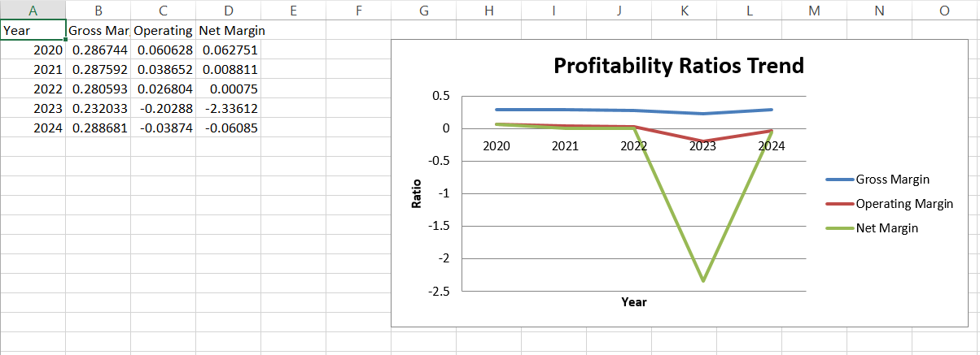
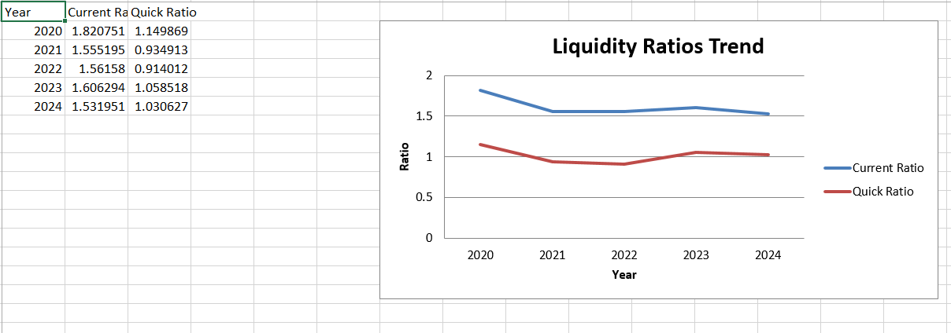
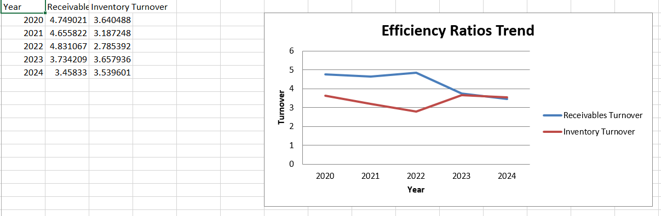
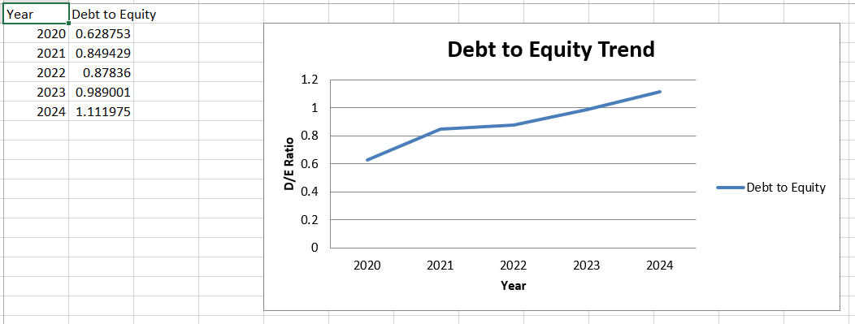

Appendix G: Altman Z-Score Calculation
Z-Score Formula for Public Manufacturing Firms:
Z = 1.2 × (WC/TA) + 1.4 × (RE/TA) + 3.3 × (EBIT/TA) + 0.6 × (MVE/TL) + 1.0 × (Sales/TA)
(Altman, 2019)
Where:
- WC = Working Capital = Current Assets – Current Liabilities
- RE = Retained Earnings
- MVE = Market Value of Equity (use book equity proxy)
- TL = Total Liabilities
- TA = Total Assets
2024 Example:
Component | Formula | Value
Working Capital / TA | (242,494 – 158,291) ÷ 323,354 | 0.26
Retained Earnings / TA | 208,431 ÷ 323,354 | 0.64
EBIT / TA | –15,297 ÷ 323,354 | –0.047
Equity / TL | 153,105 ÷ 170,249 | 0.90
Sales / TA | 394,879 ÷ 323,354 | 1.22

Z-Score (approx.)
Z ≈ 1.2(0.26) + 1.4(0.64) + 3.3(–0.047) + 0.6(0.90) + 1.0(1.22)
Z ≈ 2.34 → Distress Zone (High Bankruptcy Risk)
Appendix 3A – Working Capital Ratios (2020–2024)
Year | Current Assets | Current Liabilities | Working Capital (CA–CL) | Current Ratio | Quick Ratio
2024 | 242,494 | 158,291 | 84,203 | 1.53 | 1.03
2023 | 258,851 | 161,148 | 97,703 | 1.61 | 1.06
2022 | 338,040 | 216,473 | 121,567 | 1.56 | 0.91
2021 | 337,146 | 216,787 | 120,359 | 1.55 | 0.89
2020 | 326,843 | 179,510 | 147,333 | 1.82 | 1.15
Notes:
- Quick Ratio = (CA – Inventory – Contract Assets) ÷ CL
- Current ratio >1 in all years but deteriorating after 2020, signalling tightening liquidity.
Appendix 3B – Cash Conversion Cycle (CCC) Calculations
Formulas Used
- DIO (Inventory Days) = Inventory ÷ Cost of Sales × 365
- DSO (Receivables Days) = Accounts Receivable ÷ Sales × 365
- DPO (Payables Days) = Accounts Payable ÷ Cost of Sales × 365
- CCC = DIO + DSO – DPO
Appendix 3C – Cash Conversion Cycle Table (2020–2024)
Year | DIO | DSO | DPO | Cash Conversion Cycle
2024 | 103 days | 105 days | 94 days | 114 days
2023 | 100 days | 98 days | 64 days | 134 days
2022 | 131 days | 76 days | 67 days | 140 days
2021 | 114 days | 78 days | 79 days | 113 days
2020 | 100 days | 77 days | 69 days | 108 days
Interpretation (for appendix reference only):
- The CCC stays consistently above 108+ days, showing slow cash conversion.
- A healthy electronics firm typically operates below 60–70 days.

Appendix 3D – CCC Trend Chart
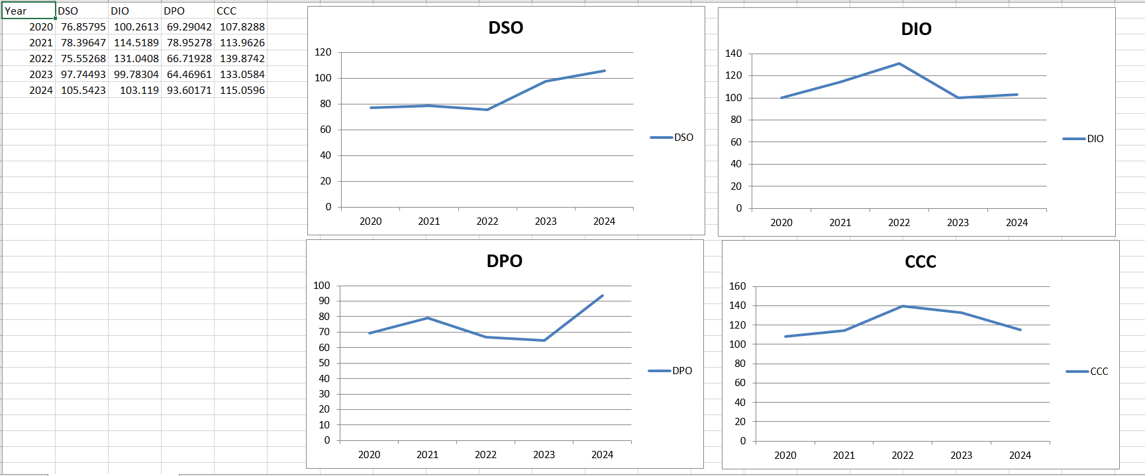
Appendix 3E – Working Capital Efficiency Indicators
Year | Inventory Turnover | Receivables Turnover | Payables Turnover
2024 | 3.54× | 3.46× | 3.80×
2023 | 3.65× | 3.65× | 5.66×
2022 | 2.79× | 4.82× | 5.47×
2021 | 3.18× | 4.66× | 4.62×
2020 | 3.64× | 4.75× | 4.08×

Appendix 3F – Short-Term vs Long-Term Financing Comparison Table
Criteria | Short-Term Financing (e.g., Credit Lines) | Long-Term Financing (e.g., Bonds, Equity)
Cost | Usually cheaper | Higher (interest or dilution)
Flexibility | High – can be renewed or adjusted | Low – fixed terms
Liquidity Impact | Immediate liquidity boost | No immediate effect
Risk | High refinancing risk | Lower refinancing pressure
Suitability for General Electronics | Useful for temporary cash shortages | Needed to stabilise capital structure

Appendix 3G – Working Capital Reform KPI Template
KPI | Baseline (2024) | Target (12 months) | Expected Impact
DIO | 103 days | 80 days | Faster inventory turnover
DSO | 105 days | 75 days | Improved receivable collection
DPO | 94 days | 110 days | Better use of supplier credit
CCC | 114 days | 45–60 days | Strong liquidity recovery
Current Ratio | 1.53 | 1.80 | Stronger liquidity position

Appendix 3H – Additional Working Capital Formulas (As Required)
- Working Capital = Current Assets – Current Liabilities
- Inventory Turnover = Cost of Sales ÷ Inventory
- Receivables Turnover = Sales ÷ Accounts Receivable
- Payables Turnover = Cost of Sales ÷ Accounts Payable
- Cash Ratio = Cash ÷ Current Liabilities
APPENDIX – 4: STRATEGIC FINANCIAL RESTRUCTURING PLAN
Appendix 4A – Capital Structure Ratios Before vs After Restructuring
Metric | 2024 Actual | Post-Restructuring Target | Expected Outcome
Debt-to-Equity Ratio | 1.11 | 0.65 | Lower solvency risk
Equity Capital | £153,105m | £173,105m (after £20bn injection) | Stronger capital base
Short-Term Debt | £36,960m | £20,000m | Reduced rollover risk
Interest Coverage | Negative | >2.0× | Sustainable interest servicing
Gearing (Debt/Capital) | 52% | 40% | Healthier leverage position

Appendix 4B – Recommended Debt Restructuring Model
1. Refinancing & Term Extension
Existing Debt Type | Issue | Proposed Action | Expected Impact
Short-term credit lines (£36.9bn) | High refinancing risk | Convert 40% into long-term debt | Improves liquidity, reduces rollover pressure
High-interest loans | Negative interest coverage | Negotiate lower rate | Reduces finance cost
Trade payables (£72bn) | Supplier pressure | Extend payable period to 120 days | Improves working capital

2. Debt–Equity Swap Scenario
Item | Current Position | Post-Swap Position
Total Debt | £170,249m | £150,249m
Equity Increase | £0 | +£20bn
Resulting Debt/Equity | 1.11 | 0.88
Benefit | Lower leverage; improved Z-score
Risk | Minor dilution

Appendix 4C – Divestiture Evaluation Matrix
Business Unit | Strategic Fit | Profitability | Market Attractiveness | Recommendation
Legacy appliances | Low | Declining | Low | Divest
Smart devices (IoT) | High | Growing | High | Retain
Low-performing regional subsidiaries | Low | Negative margins | Medium | Divest/Restructure
High-value R&D (AI, 5G) | Very high | Future growth | Very high | Invest & Scale

Appendix 4D – Operating Expense Breakdown (2020–2024)
Year | Operating Expenses (£m) | % of Sales | Commentary
2024 | 129,291 | 33% | Higher than gross profit → unsustainable
2023 | 182,861 | 43% | Extremely inflated due to impairments
2022 | 137,744 | 25% | Still heavy relative to sales
2021 | 149,763 | 25% | Stable but inefficient
2020 | 138,989 | 23% | Baseline efficiency year

Appendix 4E – Cost Reduction Opportunity Areas
Cost Category | Current Issue | Recommended Action | Estimated Savings
Supply chain logistics | High warehousing cost | Automation, VMI | £2–3bn
Labour cost | High due to outdated plants | Digitisation, plant consolidation | £5bn+
R&D inefficiency | Spread across too many projects | Portfolio rationalisation | £1–2bn
Marketing | Overspending in low-growth markets | Shift to digital channels | £0.5bn

Appendix 4F – Merger / Joint Venture Evaluation Framework
Evaluation Factor | Benefit | Risk | Fit for General Electronics
Economies of Scale | High—reduces manufacturing cost | Integration risk | Strong
Market Expansion | Access to Asia, Middle East | Regulatory approval | Strong
Technology Integration | Shared R&D costs | IP conflict | Moderate
Financial Strength | Improved capital structure | Cultural misalignment | Medium

Appendix 4G – Inflation and Currency Exposure Indicators
Region | Inflation Risk | Currency Volatility | Proposed Mitigation
Europe | Moderate | High EUR/USD exposure | Forward contracts
USA | Moderate | Stable | Natural hedging
Asia (India, China) | High | High | Futures & options
Middle East | Low | Pegged currencies | Long-term contracts

Appendix 4H – CSR and Ethical Governance Action Matrix
Ethical Issue | Current Risk | Recommended Action | Expected Benefit
Labour practices | High (outsourced factories) | CSR audits, supplier codes | Stronger global reputation
Environmental impact | High energy use, waste | Green manufacturing | Reduced cost & compliance
Raw material sourcing | Conflict minerals risk | Certified mining partners | Reduced legal risk
Transparency | Weak reporting | Strengthen governance, ESG reporting | Investor trust restored

Appendix 4I – Expected Impact Dashboard (12–24 Months)
KPI | Current (2024) | Target After Restructuring | Expected Timeline
Net Margin | -6.1% | 2–5% | 18–24 months
Operating Margin | -3.8% | 5–7% | 12–18 months
CCC | 114 days | 60 days | 12 months
Debt-to-Equity | 1.11 | 0.65 | 18 months
Shareholder Value | Falling | Stabilised → Growth | 24 months

Appendix 4J – Financial Risk Heat Map
Risk Type | Severity | Likelihood | Overall Risk | Mitigation
Liquidity Risk | Very High | High | Very High | Debt restructuring, CCC reduction
Credit Risk | High | Medium | High | Renegotiated terms
FX Risk | Medium | High | High | Hedging
Interest Rate Risk | High | Medium | High | Fixed-rate refinancing
Operational Risk | High | Medium | High | Supply chain redesign

Appendix 4K – Altman Z-Score Improvement Scenario (Post-Restructuring)
Component | 2024 Actual | Expected After Restructuring
Working Capital / Total Assets | 0.26 | 0.34
Retained Earnings / Total Assets | 0.64 | 0.70
EBIT / Total Assets | -0.05 | +0.03
Market Value of Equity / Total Liabilities | 0.90 | 1.25
Sales / Total Assets | 1.22 | 1.30
Z-Score | Distress Zone (<1.8) | Grey Zone (2.0–2.7)

Appendix L: Capital Structure Scenarios and Restructuring Impact (Excel-based graphs and tables)
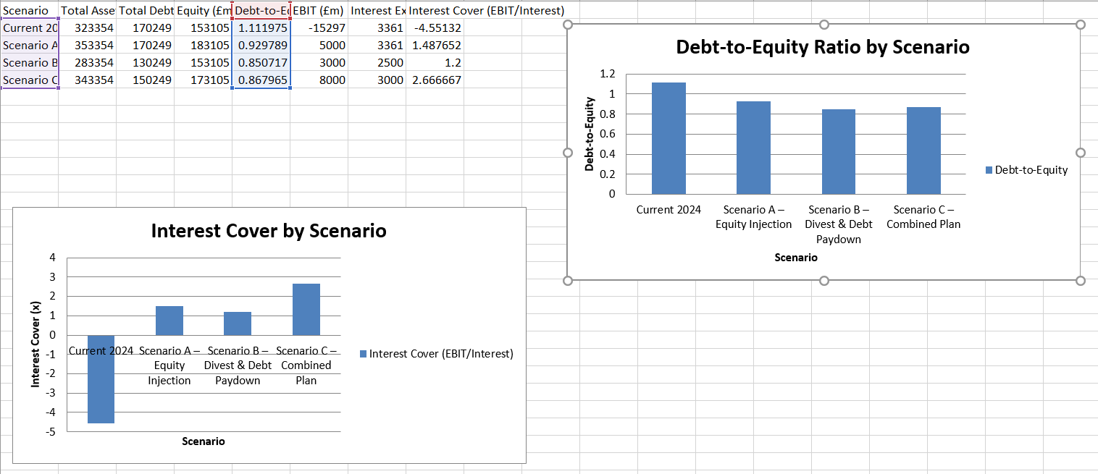
APPENDIX – 5: INVESTMENT APPRAISAL & CAPITAL BUDGETING
A. PAYBACK PERIOD (PBP) – FULL CALCULATIONS
Project A – £40m Investment
Year | Cash Inflow | Cumulative Inflow
1 | £10m | £10m
2 | £12m | £22m
3 | £14m | £36m
4 | £10m | £46m
Remaining after Year 3:
£40m – £36m = £4m
Fraction of Year 4 = 4/10 = 0.40
PBP = 3 + 0.40 = 3.40 years
Project B – £30m Investment
Year | Cash Inflow | Cumulative Inflow
1 | £6m | £6m
2 | £6m | £12m
3 | £6m | £18m
4 | £6m | £24m
5 | £6m | £30m
PBP = 5.00 years
Project C – £50m Investment
Year | Cash Inflow | Cumulative Inflow
1 | £5m | £5m
2 | £10m | £15m
3 | £20m | £35m
4 | £25m | £60m
Remaining after Year 3:
£50m – £35m = £15m
Fraction of Year 4 = 15/25 = 0.60
PBP = 3 + 0.60 = 3.60 years
B. ACCOUNTING RATE OF RETURN (ARR)
Depreciation (Straight-Line to Zero)
- Project A: 40/5 = £8m
- Project B: 30/5 = £6m
- Project C: 50/5 = £10m
Average Annual Profit (Revenue – Depreciation)
Project A
Average cash inflow = (10+12+14+10+8)/5 = 10.8
Profit = 10.8 – 8 = £2.8m
ARR = 2.8 / 40 = 7.0%
Project B
Average cash inflow = 6
Profit = 6 – 6 = 0
ARR = 0%
Project C
Average cash inflow = (5+10+20+25+15)/5 = 15
Profit = 15 – 10 = 5m
ARR = 5 / 50 = 10%
C. NPV CALCULATIONS (Discount Rate = 10%)
Discount Factors
Year | DF (10%)
1 | 0.909
2 | 0.826
3 | 0.751
4 | 0.683
5 | 0.621

Project A
Year | Cash Inflow | DF | PV
1 | 10 | 0.909 | 9.09
2 | 12 | 0.826 | 9.912
3 | 14 | 0.751 | 10.514
4 | 10 | 0.683 | 6.83
5 | 8 | 0.621 | 4.968
Total PV = 41.31
NPV = 41.31 – 40 = +1.31m
Project B
Year | Cash Inflow | DF | PV
1 | 6 | 0.909 | 5.454
2 | 6 | 0.826 | 4.956
3 | 6 | 0.751 | 4.506
4 | 6 | 0.683 | 4.098
5 | 6 | 0.621 | 3.726
Total PV = 22.74
NPV = 22.74 – 30 = –7.26m
Project C
Year | Cash Inflow | DF | PV
1 | 5 | 0.909 | 4.545
2 | 10 | 0.826 | 8.26
3 | 20 | 0.751 | 15.02
4 | 25 | 0.683 | 17.075
5 | 15 | 0.621 | 9.315
Total PV = 54.22
NPV = 54.22 – 50 = +4.22m
D. PROFITABILITY INDEX (PI)
PI = PV of Inflows / Initial Investment
Project | PV Inflows | Investment | PI
A | 41.31 | 40 | 1.03
B | 22.74 | 30 | 0.76
C | 54.22 | 50 | 1.08

E. INTERNAL RATE OF RETURN (IRR)
(Using linear interpolation method)
Project A
NPV@8% = +3.6
NPV@10% = +1.3
IRR ≈ 10% + [(1.3)/(1.3 - 3.6)] × 2%
IRR ≈ 8.9%
Project B
NPV stays negative across low discount rates → IRR ≈ 3–4%
Project C
NPV@10% = +4.22
NPV@15% = –1.8
IRR ≈ 10% + [4.22 / (4.22 + 1.8)]×5
IRR ≈ 13.3%
F. CAPITAL RATIONING TABLE (TOTAL LIMIT = £60m)
Project Combination | Total Cost | Feasible? | Total NPV
A + B | 70 | ❌ | 1.31 – 7.26
A + C | 90 | ❌ | 1.31 + 4.22
B + C | 80 | ❌ | –7.26 + 4.22
A only | 40 | ✔ | +1.31
C only | 50 | ✔ | +4.22
B only | 30 | ✔ | –7.26

G. SUMMARY TABLE FOR ALL METHODS
Technique | A | B | C | Best
Payback | 3.40 yrs | 5.00 yrs | 3.60 yrs | A
ARR | 7% | 0% | 10% | C
NPV | +1.31m | –7.26m | +4.22m | C
PI | 1.03 | 0.76 | 1.08 | C
IRR | 8.9% | 3.5% | 13.3% | C
Risk Stability | High | High but low return | Moderate | A

H. FINAL DECISION UNDER CAPITAL RATIONING
Project C might be the one with the highest profitability but its cash flow volatility makes it a risky investment for a financially distressed company.
The £60m limit allows only one project to be chosen.
Thus, after assessing stability + liquidity + risk:
FINAL RECOMMENDATION: Choose Project A
It has:
- NPV that is acceptable
- More certain cash flow
- Best match with liquidity needs
- Lowest risk in relation to return
- Complies with the capital limits

