

Vessel Trajectory Prediction based on Spatio-Temporal Multitask Data Mining

by
Zhenzhong Yin

Supervisor: Dr Gordon Dickers

Project submitted as part of the requirements for the award of MSc Applied Computing

November 2021
DECLARATION

I, ............................................ Zhenzhong Yin………………………………… declare that I am the sole author of this Project; that all references cited have been consulted; that I have conducted all work of which this is a record, and that the finished work lies within the prescribed word limits.

This work has not previously been accepted as part of any other degree submission.

Signed : .......... 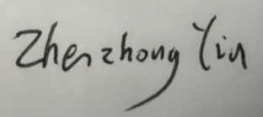................

Date : ...... November 12, 2021......

FORM OF CONSENT

I ............................................Zhenzhong Yin………………………………… hereby consent that my Project, submitted in candidature for the M.Sc. Applied Computing degree, if successful, may be made available for inter-library loan or photocopying (subject to the law of copyright), and that the title and abstract may be made available to outside organisations.

Signed : .......... ................

Date : ...... November 12, 2021......

Abstract
Economic globalization has affected the rapid development of maritime trade, which makes the marine shipping environment has become increasingly complex. Mining spatio-temporal data from large-scale trajectory data of various types of vessels to predict the future trajectory of vessels in real time can help effectively dispatch vessels in busy waters, improve traffic efficiency, and identify different vessel encounters to enhance the safety of ship navigation. However, due to the complex marine environment and equipment failures, vessel trajectories have the characteristics of large scale, high noise, discontinuity, and inconsistent scales. Moreover, existing models cannot learn the latent features of sparse trajectory data, and usually use a single model instead of using shared features of multiple related tasks to improve prediction performance. In this work, a new vessel trajectory prediction model is proposed to predict the next trajectory based on the vessel's historical trajectory. Based on the Variational Autoencoder (VAE) with attention mechanism, it can mine the latent patterns of vessel trajectory and solve the sparsity of vessel trajectory. The structure can better fit the real vessel trajectory, and learn the interaction between the trajectory points. In addition, the model also learns the shared characteristics of multiple related tasks, so that each task can promote each other, thereby improving the effect of trajectory prediction. By comparison with several baselines, my model has achieved good results in all evaluation metrics. In the future, the model will be further improved on the study of spatial features and the mining of the relationship between vessels.

Content

Abstract 3
Content 4
CHAPTER 1: INTRODUCTION 5
CHAPTER 2: LITERATURE REVIEW 6
2.1 Trajectory Prediction 7
2.1.1 Index-based Methods 7
2.1.2 Content-based Methods 8
2.1.3 Pattern-based Methods 9
2.1.4 Semantics-based Methods 10
2.2 Deep Learning and Multi-task Learning 11
2.3 Data Mining of Vessel Trajectory 12
CHAPTER 3: Methodology 13
3.1 Preliminary 13
3.2 Framework 15
3.2.1 Preprocessing Component 16
3.2.2 Traj2Tarj Model 17
3.2.3 Multi-task Learning Component 19
CHAPTER 4: Experimental Design 20
4.1 Dataset 20
4.2 Resources Required 21
4.3 Baselines 21
4.4 Evaluation Metric 22
CHAPTER 5: Results & Discussions 23
CHAPTER 6: Conclusions and Recommendations 26
CHAPTER 7: REFLECTION 27
REFERENCES 29

CHAPTER 1: INTRODUCTION
The rapid growth of wireless communication and data acquisition technology, as well as the development of big data storage and processing technology, has promoted the significant growth of trajectory data. Trajectory data is a series of data information sampled during the movement of one or more moving objects, including longitude, latitude, time, etc. These location point data are sequential ^{[1]}. For a given trajectory sequence of a moving object, predicting its future trajectory is an important basis of location-based services (LBS) , which can provide support for applications such as traffic management, location recommendation, and route planning. For example, the prediction of the future location of vehicles and people is helpful to predict traffic flow of an area in the future. In this way, transportation department can manage the urban traffic more effectively and enhance the safety of public. Therefore, accurate prediction of future trajectory of mobile objects can provide a basis for the construction of intelligent transportation.
However, with the construction of unmanned cars and smart cities, most of the current research focus on the trajectory of vehicles and pedestrians. Economic globalization has affected the rapid development of maritime trade. Ocean transportation has become the most effective way of long-distance commodity transportation. According to statistics, 90% of the world's cargo transportation is inseparable from vessels ^{[2]}. However, with the continuous expansion of international trade, the demand for ocean transportation, the number of ships and the capacity of ships are all increasing, which makes the marine shipping environment has become increasingly complex. In some coastal areas, ports, bridge and other areas, complex routes not only lead to serious load and frequent jam of the channel, but also may cause ship collision accidents. These have brought challenges to shipping management and navigation safety. Therefore, it is necessary for researchers to mine spatio-temporal data from large-scale trajectory data of various types of vessels, and predict future trajectory of the vessel in real time, so as to prevent possible accidents in advance. Vessel trajectory prediction can not only help effectively dispatch vessels in busy waters and improve the traffic efficiency, but also identify different vessel encounter situations. For unmanned vessel, related research can achieve intelligent safety judgment, route planning and decision-making of collision avoidance. In addition, the prevention of ship accidents will not only ensures the safety of people's lives and property, but also protects marine animals and plants from irreversible harm.
Different from GPS records of land vehicles or pedestrians, it is a huge challenge to achieve accurate and efficient vessel trajectory prediction due to the vast sea area, complex marine environment and the large variety of ships. With the wide application of Automatic Identification System (AIS), people can obtain a large amount of vessel trajectory data. These near real-time monitoring data contain a lot of valuable information. With the continuous exploration of researchers, a large number of data mining methods are used to analyze AIS data and accurately model ship trajectory, which makes vessel trajectory prediction possible.
However, as a subclass of big data, vessel trajectory data is special. On the one hand, due to the complex marine environment and equipment failure, there are many error values and missing values in the transmission and decoding process of AIS data. Furthermore, different AIS devices have different sampling frequencies. These factors make vessel trajectories have the characteristics of large scale, high noise, discontinuity, and inconsistent scale. On the other hand, the marine environment is more complex than land, not only without the support of road topology, but also the behavior of vessels is also affected by some environmental factors such as ocean currents, tides, and typhoons. These special factors make it more difficult to predict vessel trajectories. Instead of using AIS data directly, a series of feature engineering methods are needed to preprocess vessel trajectories.
Moreover, in the field of spatio-temporal data mining, there are few researches related to vessels. While many researchers in the field of vessels focus on traditional statistical models, which need to take into account the dynamic characteristics of vessels and construct complex kinematics models to obtain kinematic equations. Another type of recent research method uses machine learning and deep learning models to represent spatio-temporal features of trajectories. And then apply them to the scene of channel correction, vessel collision avoidance, abnormal track monitoring and so on. However, these methods not only require high-quality data, but also require researchers to have some background knowledge and professional experience in the field of ships. Existing models cannot learn the potential features of sparse trajectory data. In addition, existing trajectory prediction methods usually use a single model, and do not take advantage of the shared features of multiple related tasks to improve prediction performance.
On the basis of above analysis, the purpose of my research is to design a new vessel trajectory prediction model based on variational auto encoder (VAE) and multitask learning. Based on the structure of traditional sequence to sequence (Seq2Seq) model, I chose the variational auto encoder to mine potential patterns of vessel trajectories and solve the sparseness of ship trajectories. Experimental results show that VAE can improve the prediction accuracy of prediction and better fit the real vessel trajectories. In addition, the model proposed in this paper also uses attention mechanism and multitask learning. Attention mechanism can well capture the rudder turning, avoidance, chase and other behaviors of vessels. Multi-task learning enables each task to promote each other by learning the shared features of multiple related tasks, thus improving the effect of trajectory prediction.
The rest of this paper is organized as follows. I first make a systematic literature review in CHAPTER 2 from three aspects: trajectory prediction, deep learning & multi-task learning, and data mining of vessel trajectory. In CHAPTER 3, I make a mathematical definition of the problem, introduced key technologies used in the model, and then elaborated the whole model framework in detail. In CHAPTER 4, I introduce the data set and experimental environment, and then introduce my experimental design, including baselines and evaluation methods. After that, I analyze the experimental results in CHAPTER 5, and compared my results with baselines to verify the validity of the proposed model. In CHAPTER 6, I summarized the whole work and described possible future improvements to the model, as well as my future research directions. At last, I talked about my experience in the whole work in CHAPTER 7, and summarized my efforts for the experiment.

CHAPTER 2: LITERATURE REVIEW
With the development of mobile positioning technology and the popularization of mobile intelligent terminals, moving objects such as ships, cars, and pedestrians generate a large amount of mobile data. In recent years, many studies have focused on mining the mobility patterns and rules implied in these trajectory data and further predicting the location changes of these moving objects in a short or long term. Long-term location prediction usually pays more attention to understanding the travel purpose, points of interest (POI) or movement patterns of moving objects. For example, by predicting a user's next location, enterprises and businesses can not only provide service recommendations related to the user's current location, but also provide recommendations related to the user's future destinations. Mining of this long-term mobility patterns focuses more on the correlation between history and expected mobility patterns, which often combines semantic information such as check-in points. This kind of researches are often applied to travel time estimation, understanding of people's lifestyle, travel purpose recommendations, and so on.
The research in this paper focuses more on trajectory prediction, that is, predicting the precise location change of moving objects. For example, trajectory prediction of cars can enhance the condition of urban transportation and promote the development and applications of intelligent transportation systems. In addition, accurately predicting the trajectory of vehicles can greatly improve the safety and stability of the driverless assistance system, improve user's driving style and predict the traffic flow on different urban areas. These works help users choose more appropriate travel routes and alleviate traffic jams. Similarly, trajectory prediction of vessels is also conducive to traffic dispatch in busy waters, berthing of vessels, and collision avoidance. With the development of data science, this field has witnessed great changes in the past few decades, and many researchers have proposed a variety of trajectory prediction methods. In this chapter, I will make a systematic literature review from three aspects: trajectory prediction, deep learning & multi-task learning, and data mining of vessel trajectory.

2.1 Trajectory Prediction
Trajectory prediction can be divided into two categories according to the number of research object: the first category is a single moving object, which uses its own historical trajectory to mine and analyze its own mobility pattern, and predict the trajectory based on the extracted information. The second type of trajectory prediction methods use group trajectory data to model the mobility of objects and extract their common regularity. In the past few decades, there have been a lot of studies using trajectory data for prediction. However, the existing location prediction methods face three challenges: First, most of the existing work is based on continuous data such as the Global Positioning System (GPS) to analyze the trajectory law, but lacks effective analysis methods for discrete, semantically missing or incomplete trajectory data. Second, the existing historical trajectory mining methods based on a single user have not fully considered the influence of the correlation between objects in the location prediction, resulting in the cold start problem has not been effectively solved. Third, the existing methods have not fully considered the impact of weather, traffic conditions and other contextual factors on location prediction, so they cannot fully meet the diversified needs of users for location prediction. According to different implementation methods, trajectory prediction can be classified into four categories, which are index-based methods, content-based methods, pattern-based methods, and semantics-based methods.

2.1.1 Index-based Methods
The index-based methods aim to simulate the behavior expected of a moving object by using mathematical or probabilistic models to establish a spatial data index. Inspired by the field of spatial database management, this type of method models the current position of an object as a motion function, making predictions by establishing a spatial index of the motion vector, which is also known as prediction and query processing technology. Existing prediction and query processing algorithms can be divided into three categories according to different query types.
The first type is range query, which has one query region R and a future time window T. The goal is to query the objects that are expected to be in R during the time window T. The earliest method in this field is the index technology based on PMR quadtree proposed by Tayeb et al ^{[3]}, which uses a variant of the quadtree structure to solve the problem of dynamic attribute indexing. The model stores the information about the line segment in each quadrant of the basic space it passes through, and then builds an index based on the linear time function for each dynamic attribute, which can used to predict future values. Jeung et al. ^{[4]} proposed a method that can accurately predict the future path of a moving target. The model capture the turning pattern of single target intersections and driving speeds of each road section by considering the constraints of the road network. Much work puts the query region as a rectangle, while Zhang et al ^{[5]} optimize tree node access by introducing the transformed Minkowski sum to deal with the circular range. In addition, they also introduced two algorithms: range query and k neighbor query to traverse the spatio-temporal index tree.
The second type is trajectory point query. The trajectory point query prediction has a point position P and a future time window T, and we need to query the K objects closest to P in the time window T. Inspired by the spatial indexing method based on R-tree pairs, Saltenis et al. ^{[6]} proposed a time parameterized R-tree (TPR tree), which can support the query of the current and future projection positions of moving objects in one- dimensional to three-dimensional space. Based on the TPR tree, Tao et al. ^{[7]} proposed the TPR* tree, which utilizes the characteristics of dynamic moving objects, so as to retrieve only the objects that meet specific spatial standards within a given time interval. However, this type of model cannot be applied to the situation that the object does nonlinear move. Tao et al. ^{[8]} also proposed a spatio-temporal prediction STP tree, which captures the motion of any moving pattern (linear, polynomial, elliptical, etc.) by calculating different non-linear moving patterns. Indexing the position movement pattern in this way can support predictive queries more effectively. The P-Tree proposed by Hendawi et al ^{[9]} enables predictive queries for mobile objects of the road network without historical trajectories, and can perform custom queries based on the query types (point query, range query, etc.) received during the query.
The third type is aggregate query, which has a query area R and a future time window T, querying the data N of objects expected to be in R during the time window T. Hendawi et al. ^{[10]} proposed a general query processing framework Panda, which can query and predict moving targets in Euclidean space. The framework can be extended to a large number of moving objects and supports a large number of predictive queries. Wang et al. ^{[11]} proposed Torch, a road network trajectory query engine, which can support trajectory similarity queries and Boolean searches, and supports multiple trajectory similarity functions. Wang et al. ^{[12]} also studied the clustering of large-scale trajectory data and proposed a scalable k-path clustering algorithm that is able to identify k representative paths in the road network effectively.

2.1.2 Content-based Methods
Content-based methods study the behavior patterns of moving objects by calculating the position transition probability or content correlation. Such methods are usually based on Markov models, assuming that the state at each time point is related to the past. The earliest method in this field is LeZi-update, an adaptive online algorithm proposed by Bhattacharya et al. ^{[13]}, which uses movement trajectory data of user profile in personal communication system to infer knowledge, and realize the prediction task by establishing and maintaining a dictionary. Ishikawa et al. ^{[14]} proposed an algorithm to extract movement statistics from indexed spatio-temporal data set, and then conduct interactive analysis on a large number of moving object trajectory collections. Their method constructs the trajectory in R-tree, and uses this index to calculate transition probability of the Markov chain. Then the model generates statistical information by effectively organizing the target space and Markov chain model based on unit form. Gambs et al. ^{[15]} proposed an n-MMC model to predict the next location, combining n locations that have been visited through an extended Markov chain. Most of the above work focuses on the next visit behavior, while humans will make some complex exploration behaviors to visit some unknown places. The CEPR model ^{[16]} combines Markov model with the recommendation system, that can simplify exploration and prediction problem into a binary classification problem to explore new positions. In order to improve prediction accuracy, Wang et al. ^{[17]} proposed a model combining Markov algorithm and Adaboost algorithm on the Geolife data set to predict a user's next movement. The trajectory filters out meaningless locations and only records a series of important locations with high usage density or access frequency. Then, the model uses historical and current check-in data to predict the next move. Fang et al. ^{[18]} proposed a gray Markov model to analyze the motion of pedestrians, divide the gray prediction correlation value of the state and calculate the state transition probability matrix. For long overlapping sequences on dense roads, Rathore et al. ^{[19]} proposed a hybrid framework coupled clustering algorithm based on hidden Markov trajectory clustering model. The model first uses VAT clustering to process large trajectories, then uses representative points to cluster them. At last, it use the most recent prototype to match pattern.

2.1.3 Pattern-based Methods
The particularity of mobile data has also led researchers to use frequent patterns and association rules to model the behavior of moving objects. The pattern-based method first finds popular sequential movement patterns from the trajectory, and then predicts movement based on these popular patterns. In the early days, Verhein et al. ^{[20]} introduced Spatio-temporal Association Rules (STARs) to describe the movement of objects from one area to another over time. The algorithm mines pre-defined patterns on the basis of time windows, and prunes the search space of STARS according to spatial features. The algorithm has better temporal performance in rules mining and can achieve higher accuracy even when the data is noisy. Giannott et al. ^{[21]} introduced T-patterns as a concise description of frequent behaviors, which represents a set of separate trajectories that can access the same time annotation sequence with similar travel duration. Zheng et al. ^{[22]} considered the user’s travel process and his continuously visited locations. They proposed a method to mine the correlation between places from the historical locations of many users. According to this method, they build a personalized location recommendation system based on location relevance, which can be used to better predict individual preferences.
Matrix factorization can also be regarded as a type of pattern discovery method, which can decompose the user-item matrix into two latent matrices, representing the features of users and items respectively. Cheng et al. ^{[23]} combined matrix factorization with geographic influence by modeling the location probability as a multi-center Gaussian model. Rendle et al. ^{[24]} combined the Markov model with matrix factorization, and proposed a FPMC model for project recommendation. Cheng et al. ^{[25]} proposed a matrix factorization method FPMC-LR, based on FPMC, which uses Markov chains to capture sequence transformations while considering local area constraints. Some other researchers have proposed a new method for predicting long-term target state using the Ornstein-Uhlenbeck (OU) stochastic process ^{[26, 27]}. This method provides a correction to the target state equation, so that the uncertainty in the time scale is several orders of magnitude lower than the uncertainty under the assumption of close to constant speed. Feng et al. ^{[28]} proposed DeepMove, an attention recurrent network for predicting movement of long and sparse trajectories. This model captures multiple factors that affect human mobility by designing a multi-modal embedded recurrent neural network, and mining multi-level periodicity of human movement by designing a historical attention model based on two mechanisms.

2.1.4 Semantics-based Methods
In recent years, the research of realizing the semantic perception prediction of mobile entities by acquiring rich spatial-temporal data with context and other behavioral features has received extensive attention. Ying et al. ^{[29]} first used the geographic and semantic features of trajectories to design a cluster-based prediction method to estimate the future location of mobile users by using frequent patterns of similar user's behaviors. The model consists of offline mining and online mining. The sequence pattern mining technology is used to mine the geographic information of the cluster, that is, the location information, to construct the prefix tree. Ying et al. ^{[30]} also proposed Geographic Time Semantic Location Prediction (GPS-LP), which only considers the user's intention to visit the location next time that is triggered geographically, temporally and semantically. GPS-LP is a user-based collaborative filtering structure with online and offline prediction models. The offline module considers pattern discovery and similarity calculation. The online module proposes a scoring function to estimate the probability of the next stay position. However, due to the use of complex parameters, the model has high complexity. Ying et al. ^{[31]} proposed an improved TrajUltiRec model, which combines geographic and practical item recommendations to predict the next location and a set of items to be sold or displayed in the next location.
Since most of the existing models, such as hidden Markov models and RNNs, cannot handle long sequences. Wu et al. ^{[32]} proposed the spatio-temporal semantic neural network algorithm STS-LST to solve this problem. The model first extracts the features of discrete long points in the road system, and then uses the LSTM model to predict the next position. In this process, a sliding window is used to divide the entire positioning sequence into different fixed-length sequences, and the next position is used as the classification label. Ding et al. ^{[33]} proposed ATD-RNN that can learn the semantics of long sequences and applied it to abnormal trajectory detection. This model uses embedding learning to extract hidden features between the normal trajectory and the abnormal trajectory from the sequence information of trajectory data, and proposes an attention mechanism to learn high-quality trajectory embedding.
The RNN-based model is an effective tool to capture the long-term dependence of the sequence. Yao et al. ^{[34]} proposed the SERM model, which uses a unified framework to learn the embedding and RNN parameters of multiple factors such as users, time, location, and keywords. Kong et al. ^{[35]} proposed a spatio-temporal long short-term memory model ST-LSTM, which combines spatio-temporal effects into LSTM to alleviate the problem of data sparsity. Then they applied the proposed ST-LSTM (HST-LSTM) hierarchical extension to the encoder-decoder structure, which models contextual historical information to improve prediction performance. Manotumruksa et al. ^{[36]} proposed the contextual attention loop model CARA, which uses the gating mechanism of GRU to capture the dynamic preferences of users. In this model, the contextual attention gate controls the influence of the normal context on the user's context preferences, while the time and geography gate controls the influence of the hidden state based on the previous check-in of the transition context. STGN model ^{[37]} uses the gated LSTM architecture to learn the spatio-temporal context. The architecture models the user’s long-term and short-term preferences in a personalized sequence pattern, uses the rich context of the POI to construct a structure diagram, and finally jointly trains the POI context prediction and the next POI recommendation.
Although the mutual geographic relationship of location points is very important for discovering long-term and short-term user behavior patterns, these methods do not incorporate important spatial context when learning long-term preferences. Sun et al. ^{[38]} proposed the LSTPM framework to explore the temporal and spatial correlation between historical trajectories and current trajectories through a context-aware non-local network structure. In order to overcome the limitations of random neural networks in short-term user preference modeling, the model proposes a random neural network structure based on geographic expansion to make full use of the geographic relationships between discontinuous locations. In addition, in order to predict typical movement pattern of the crowd, Cao et al. ^{[39]} proposed Habit2Vec model, which learns the user's life habits information through the semantic trajectory in the vector space. The model regards user's location within a certain period of time as a type of POI according to the context, establishes a vector representation of each user's living habits, and realizes the classical clustering based on density.

2.2 Deep Learning and Multi-task Learning
In recent years, with the rapid development of deep learning technology, deep learning models have achieved excellent results in the fields of computer vision and natural language processing, more and more researchers have begun to use it to solve various problems. Researchers often use RNN to mine and analyze time series data such as trajectories. For example, Wu et al. ^{[40]} designed a model based on a unique topological constraint RNN to model the trajectory. Liu et al. ^{[41]} used Conv-LSTM to extract the temporal and spatial features of traffic flow data, and used the BiLSTM model to analyze historical traffic flow data to obtain the periodic features of traffic flow, and then use them to predict traffic flow. Lv et al. ^{[42]} proposed an LC-RNN model that integrates CNN and RNN models to achieve accurate traffic speed prediction. In addition, Kim et al. ^{[43]} proposed a model that uses LSTM network to analyze temporal features and predict future locations of surrounding vehicles. Yao et al. ^{[44]} proposed a DMVST-Net framework, which uses CNN and LSTM networks to consider the impact of time and space at the same time, and then predicts the demand for taxis. Liang et al. ^{[45]} used attention-based RNN to learn multi-level sensors distributed in different locations, and then predict air quality. In addition, Wang et al. ^{[46]} use autoencoder to analyze the driver's driving behavior from GPS data, which can evaluate the driver's driving skill. Song et al. ^{[47]} use the deep learning model architecture to mine user movement patterns and traffic patterns from heterogeneous data sources, and are able to predict the user's future movements and vehicles. In addition, due to the remarkable effect of CNN, it is also widely used to solve spatio-temporal problems. For example, Zhang et al. ^{[48]} proposed using spatio-temporal residual network to predict traffic flow, and achieved good results. Wang et al. ^{[49]} used one-dimensional convolutional nerves to extract trajectory features and predict travel time, which can well capture spatial features, recognize spatial changes such as turns, and finally predict the arrival time more accurately.
In addition, the attention mechanism mainly comes from the attention mechanism that imitates human vision, and is widely used in applications such as image recognition and machine translation. Attention mechanism can well capture the hidden features of the trajectory. Among them, the Seq2Seq model is also used in trajectory processing. For example, Park et al. ^{[50]} use sequence models to predict vehicle position. Yao et al. ^{[51]} used the Seq2Seq method to represent the feature of the trajectory and complete the task of clustering the trajectory. In terms of network structure optimization, He et al. ^{[52]} proposed a deep residual network ResNet, which regards the convolution of several layers of convolutional neural networks as a residual module, and adds the input of the module and the output of the module together as the input of next residual module. This structure makes the entire network easier to train and converge, which increases the number of trainable layers to hundreds. In terms of preventing overfitting of the model, Huang et al. ^{[53]} proposed an architecture DenseNet that connects each layer of the convolution to the subsequent layer, and integrates it in the depth dimension as the input of the subsequent layer. This method can get a more tightly connected network and makes the network easier to converge.
Multi-task learning (MTL) is the ability to process multiple tasks at the same time. It is a common method to solve multi-task problems. It can use the shared characteristics of multiple related tasks to improve each other's performance ^{[54]}. It mainly uses shared features implicit in multiple related tasks, and improves the generalization ability of the model by using shared representations and parallel training of multiple tasks ^{[55]}. To put it simply, multi-task learning can acquire useful knowledge and higher-level information about other related problems by using shared features while learning a major problem. Multi-task learning has the ability to apply the knowledge required by one problem to other problems, so it can improve the learning effect of the model, effectively use the data, and solve the problem that the data is not fully utilized and learned in a single task. Since multiple targets need to be output at the same time in some cases, multitasking also has very important practical applications in the field of image processing. For example, Ranjan et al. ^{[56]} proposed a multi-task learning method for face detection, facial landmark positioning, gesture and gender recognition fusion features using CNN. Rao et al. ^{[57]} used multi-tasking to understand entertainment platform users' queries through the three tasks of programs, user intentions, and query tags, so as to enhance the user's experience of using the entertainment platform. Multitasking methods are not only effectively used in the fields of natural language processing and computer vision, but also widely used in other data mining tasks. For example, in trajectory data analysis, Wang et al. ^{[49]} used a multi-task framework to predict travel time, and mainly used multi-task methods to calculate local running time and global running time to effectively improve the accuracy of the final travel time prediction. Zhao et al. ^{[58]} used a multi-task framework to enable multiple locations to share features to predict major events at multiple locations.

2.3 Data Mining of Vessel Trajectory
As the main object of water transportation activities, the understanding and prediction of ship behavior patterns are of great significance for intelligent maritime applications, such as shipping management, navigation safety, and route optimization. The traditional method of analyzing vessel behavior through expert experience has limitations such as time-consuming, high cost, difficulty, and limited scope of supervision, and it relies on the background knowledge and professional experience of maritime managers. With the widespread application of AIS and VTS, researchers have been able to collect a large amount of vessel trajectory data, which provides a new way to explore the regularity of ship moving and mine valuable behavior patterns. However, unlike land vehicles or pedestrians, vessels have special behavior patterns. On the one hand, this particularity stems from the large-scale, high-noise, discontinuous, and different-scale characteristics of the ship's trajectory. On the other hand, because the water environment is more complex than land, not only is there no support of road topology, but the behavior of ships is also affected by environmental factors such as ocean currents, tides, and typhoons. All of these have brought difficulties to the understanding and prediction of ship behavior patterns.
The basic vessel behavior model research method focuses on the geographic location of the ship, and predicts the vessel's single or multiple future location points based on historical trajectory data. Xiaopeng et al. ^{[59]} focused on the regularity of vessel's position transformation in inland river bends, and proposed a method combining hidden Markov and gray prediction. The model first uses the gray prediction method to fit the original trajectory, and then uses the hidden Markov model to make the prediction of latitude and longitude. Rong et al. ^{[60]} proposed a probabilistic trajectory prediction model, which decomposes the prediction of ship motion into horizontal and vertical directions, and then calculates the position probabilities along these two directions respectively. The model uses a data-driven non-parametric Bayesian model based on Gaussian process to describe the uncertainty of the ship's lateral motion, while the uncertainty of the longitudinal motion is affected by the uncertainty of the ship's acceleration along the course.
However, vessel behavior is not only a time-series change process of spatial position, but also includes kinematic features such as ground speed and ground course, which is a co-evolution process of multi-dimensional features. Murray et al. ^{[61]} propose a data-driven single-point nearest neighbor search model, which consider the similarity between the speed over ground (SOG) and course over ground (COG). The model searches historical trajectory at the current position, and matches a behavior state with the highest probability. Gan et al. ^{[62]} use k-means clustering algorithm to cluster the historical AIS trajectories of ships in the Yangtze River, and then use the clustering results and known factors such as ship speed and ship power to establish an artificial neural network model, then predict ship's motion trajectory. Gan et al. ^{[63]} also propose a fuzzy c-means clustering algorithm to predict the ship’s trajectory length, using artificial neural networks to establish the mathematical model of known ship features and the relationship between each member.
In recent years, more and more researches have focused on the influence of external data such as waterway, weather, ocean currents , etc. on ship behavior patterns. Guo et al. ^{[64]} proposed TPOV model based on k-order multivariate Markov chain to establish the state transition matrix for ship's trajectory prediction, considering various factors such as weather, tide, and fishing cessation period comprehensively. The model selects the ship’s location, direction, and speed features to establish a transfer matrix, which improves the accuracy of ship trajectory prediction. However, these external factors are only used as the reference for feature selection. Xiao et al. ^{[65]} used the grid-based DBSCAN algorithm to fit the ship’s channel pattern, and then used kernel density estimation to quantitatively model the ship’s behavior. At last, they combined the ship's route pattern and ship behavior, and proposed a trajectory prediction model that predicts the probability of corresponding coordinates.
Moreover, some studies have also proposed that the vessel behavior sequence can be encoded to learn the context features of trajectory, and then the decoder can decode the features to generate an output sequence. The sequence to be predicted can be the latitude and longitude coordinates of the vessel ^{[66]}, the spatial grid number ^{[67]}, or the representation of multi-dimensional trajectory features ^{[68]}. For example, Nguyen et al. ^{[67]} transformed AIS coordinates into sequence groups through spatial grid division, and proposed a sequence to sequence recurrent neural network model to predict the future trajectory of ships. Forti et al. ^{[66]} designed a Seq2Seq model based on LSTM to predict vessel trajectory, and Gao et al. ^{[68]} use Bi-directional LSTM to establish an online and real-time prediction model of vessel behavior.

CHAPTER 3: Methodology

3.1 Preliminary
Before presenting the detailed design of vessel trajectory prediction framework, I provide some background knowledge in this part. First of all, I introduced mathematical definition of ship trajectory and the prediction of ship trajectory in this work. Next, I introduced the variational auto encoder and the attention mechanism respectively, which help the model better learn the features of trajectory. Finally, I introduced multi-task learning. By learning the shared features of multiple related tasks, each task can promote each other and improve the effect of trajectory prediction.
Vessel trajectory prediction. Trajectory refers to the motion sequence generated by the moving object in a certain spatio-temporal scene, which is represented by a series of points arranged according to the sequence of time. In other words, trajectory data is essentially a sequence of spatial points sorted by time stamp, which usually has some descriptive information in addition to the basic spatio-temporal information. Trajectory data is usually collected by installing a sensor on a moving object, which periodically transmits information about the position of the object, such as AIS devices periodically transmits ship position information. In this work, we can express the trajectory of a vessel as ${tra}_{i}: p_{1}^{i} →p_{2}^{i} →…→{ p}_{n}^{i}$ , each point ${ p}_{}^{i}∈ {tra}_{j}$ is a d-dimensional vector. The d-dimensional vector can be expressed as $(p_{k}^{i}.l , p_{k}^{i}.t , p_{k}^{i}.d )$ , where $p_{k}^{i}.l$ represents the geographical longitude and latitude point with the timestamp $p_{k}^{i}.t$, and $p_{k}^{i}.d$ represents descriptive information such as course over ground (COG), speed over ground (SOG) and vessel heading that used in multi-task learning. Based on the above description of vessel trajectory, I define the vessel trajectory prediction of this work as: The historical trajectory of a vessel is known as ${tra}_{i}: p_{1}^{i} →p_{2}^{i} →…→{ p}_{n}^{i}$. The model input is a subsequence $S=\{s_{1}, s_{2}, …, s_{m}\}$ of trajectory ${tra}_{i}$ , where m is length of the sequence. The model outputs a position sequence $O=\{o_{1}, o_{2}, …, o_{m}\}$ that the vessel may reach next, where n is the number of positions to be predicted.
Deep generative model. Deep generative model has achieved remarkable success in recent years. Generative model is a kind of model that determines its parameters by learning from the real data distribution, so that the model distribution it learned is consistent with the real data distribution as much as possible. The process of generating the model is : Firstly, the model randomly samples data from a known distribution (such as Gaussian distribution or uniform distribution), and then inputs the sampled samples into the generation model. Next, the generative model continuously updates its parameters according to the information of the real distribution feedback. After several iterations, a model that can be generated as consistent as possible with the real data is obtained through training. Most generative models are based on the maximum likelihood principle. Assuming that all training samples are independent and identically distributed, according to the principle of maximum likelihood, and under the premise of known likelihood function, training the model with the principle of maximum likelihood can maximize the likelihood that the model obeys the distribution of real data. Based on the principle of maximum likelihood, generative models can be divided into two categories: generative models based on explicit density and generative models based on implicit density. The generative model based on explicit density defines an explicit density function that is easy to calculate. A representative of this class of generative models is the variational auto-encoder (VAE).
Variational Auto-Encoder (VAE). The auto-encoder model has always played an important role in representation learning and has received extensive attention from researchers. The auto-encoder is composed of two parts: an encoder and a decoder. The encoder converts the input x into an intermediate variable y, and the decoder restores the obtained intermediate compressed information to $\tilde{x}$, and its optimization goal is to make x close to x, that is, to reduce the error between them. The structure of auto-encoder is shown in Figure 3-1.
Figure 3-1: the structure of auto-encoder
There are many variants of auto-encoders, one of which is the variational auto-encoder (VAE). VAE is a probabilistic latent variable model, which links the observed variable vector x with the low-dimensional latent variable vector z through conditional distribution to model the probability of the data point x.
$p_{θ}\left(x\right)= \int{p_{θ}(x|z)}p_{λ}(z)dz$ (3-1)
Where $p_{θ}\left(x\right)$ is the prior of the implicit variable. $\int{p_{θ}(x|z)}$ is the conditional distribution of the neural network x modeled by the parameter θ given z. For example, if x is binary, this distribution is modeled by the Bernoulli distribution. These neural networks are called interpreters. The lower bound of the logarithmic marginal likelihood $lnp_{θ}\left(x\right)$ is the lower bound of evidence (ELBO), and the parameters of encoder and decoder are optimized by maximizing the expectation of the lower bound of the logarithmic marginal likelihood.
Therefore, VAE is based on the lower bound of evidence. First, assume that all data are independent and identically distributed. Suppose there is a hidden variable z and an observed variable x. Generally speaking, we can observe x relatively easily, but the z behind x is not so easy to see. However, in many cases, x is constructed from z. Assume that the parameter in the encoder network is θ, and the parameter in the decoder network is ϕ. θ is the mapping of the network from x to z, and ϕ allows the network to complete the reconstruction from z to x. By formula derivation, $p_{θ}(x|z)$ can be regarded as a posterior distribution of z derived from x, and p(z) can be regarded as a prior distribution of z. We want these two distributions to fit as closely as possible. The hidden variable in VAE is an approximate Gaussian distribution. By sampling this probability distribution and then passing through the decoder network, VAE can generate different data.
Multi-task learning. Many problems in real life have multiple characteristics. A single task always has multi-dimensional features. For example, predicting where the user will go next is a single task, which is often affected by many factors, such as the current location, the transportation used, personal preferences and so on. Nevertheless, the multi-task model can achieve dimensional association by sharing features or sharing weights. For example, movie reviews and article classification are two related tasks. They both use features of the bag of words model, and both have dimensions based on their own tasks, so these two tasks can promote each other's effects. In addition, the image labeling task can also be a multi-task, which can mark multiple types of things at the same time.
Different from the traditional single-task learning, the multi-task learning mechanism can find the correlation between multiple tasks and extract their shared features. Shared features can reduce the problem of over-fitting or under-fitting, and improve the generalization ability of the algorithm [40]. The multi-task model extracts shared features, shared parameters, etc. through the correlation features of multiple tasks. When learning multiple related tasks, the multi-task model can get a common representation, which can be seen as an abstraction of multiple tasks. As multiple related targets are accommodated at the same time, the main task can gets better results, especially when training insufficient data samples, the multi-task model architecture can effectively improve the accuracy of the model. In this work, by learning the shared features of multiple related tasks in vessel trajectory data, each task can promote each other, thereby improving the effect of trajectory prediction.

3.2 Framework
In this part, I introduce the framework of vessel trajectory prediction model. The model is mainly composed of three parts, including preprocessing component, traj2traj model and multi-task learning component. The preprocessing component is used to process the original trajectory data, and perform data cleaning, trajectory interpolation and sub-trajectory division successively on the original vessel trajectory. The output of the original trajectory is used as the input of the traj2traj model. The traj2traj component is used to encode position sequences and learn the temporal and spatial dependencies between coordinate points. It mainly uses a variational auto encoder with an attention mechanism, which can better reconstruct and generate sparse trajectory data and pay attention to special points in vessel trajectory. Based on the structure of the auto-encoder, the model adds a multi-task learning component to learn shared feature representations by balancing the weights of position, distance, and speed tasks, and make full use of shared features to improve the model's prediction effect. The overall structure of the frame is shown in Figure 3-2.

Figure 3-2: Structure of Vessel Trajectory Prediction Model

3.2.1 Preprocessing Component
The first part of the model is preprocess component. It is mainly divided into three steps: abnormal data cleaning, missing value interpolation and sub-trajectory division. The purpose of data cleaning is to remove illegal and noise data to eliminate the impact on trajectory modeling. The data cleaning rules used in this work are as follows:
a) Delete data with the same time and the same MMSI. Reasons for cleaning: As the AIS transmission channel is congested and there is no handshake response mechanism, a piece of data may be received repeatedly, and repeated data may affect the subsequent steps.
b) Delete the data with the same MMSI but different IMO call signs. Reason for cleaning: Due to the resale of AIS equipment, different ships may have the same MMSI.
c) Delete the data of SOG>51.1 or COG>155.2. Cleaning reason: SOG>51.1 or COG>155.2 are meaningless and belong to noise data.
d) Delete the data of LON>180 or LAT>90. Cleaning reason: LON>180 or LAT>90 are meaningless and belong to noise data.
e) Delete data that SOG is continuously 0 for more than five time points. Reason for cleaning: The SOG of 0 for 5 consecutive points can be preliminarily judged that the ship is stationary during this period of time.
f) Delete ship data with trajectory points is less than 1000 points. Reason for cleaning: less than 1000 track points in a month indicates that the track is relatively scattered and has poor time continuity, which is not suitable for use as a data set.
g) Delete data that vessel type is not cargo or tanker. Reasons for cleaning: The movement patterns of large vessels are less susceptible to environmental factors such as ocean currents, wind and waves, and their data may be more regular and can reduce the overfitting of model.
After the data cleaning, the next step is missing value interpolation. The collected original trajectory data may have too long intervals between trajectory points, which will result in the lack of data between these trajectory points. As shown in Figure 3-3, it is the trajectory data of one ship, and the time interval between trajectory point m and trajectory point n is too large, causing some data to be lost. In order to solve this problem, we estimate the missing value to complete its imputation. The main methods of missing value completion are: linear interpolation, average interpolation, maximum likelihood estimation, Lagrange interpolation and so on.
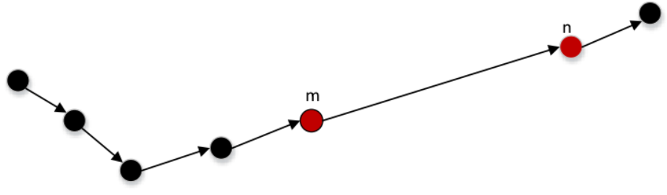
Figure 3-3: Missing value of vessel trajectory
I choose linear interpolation method to repair the missing and offset points of straight trajectories, and choose Lagrange interpolation method for the missing and offset points of curve trajectories. Linear interpolation mainly uses the two data closest to the missing data to linearly complete the missing data. When the trajectory changes relatively smoothly, the linear interpolation effect is better, while when the trajectory changes more drastically, the linear interpolation effect is poor. Lagrange interpolation is a polynomial interpolation whose purpose is to find a polynomial so that all observation points are on the polynomial function. After experiments, Lagrange interpolation method can get better results in complementing the missing value of curve trajectory. In addition, if the trajectory is too sparse, there will be a lot of missing data. Too much missing data leads to little valid data for the trajectory, which will cause difficulties in trajectory data analysis. Moreover, due to too much missing data, the effect of missing data completion is not good, which will cause large errors. Therefore, this article will remove sparse trajectories and will no longer use them.
Some of the original AIS trajectory data are too dense, which is count against trajectory prediction. So this research will use the resample function in the pandas library to resample the data. Moreover, this work standardizes the input data, maps the latitude and longitude of the input to a uniform range, so as to speed up the solution of gradient decline and improve the convergence speed of the model. In addition, a sliding window is used to extract the appropriate length of sub-trajectories. If the trajectory is too long, it will make the model more complex to learn; while if the trajectory is too short and close to a straight line, it will have no need to modeling and fit it. Therefore, my work selects 100 as the optimal length of the input data.

3.2.2 Traj2Tarj Model
Based on the encoder-decoder structure, I combine the characteristics of spatio-temporal sequence data and the sequence to sequence model, and proposed the structure of traj2traj. The basic structure of the model can be regarded as encoding the preprocessed ship AIS trajectory data and obtaining trajectory features and then decoding the features to help predict future ship AIS trajectories. The goal of this basic model is to estimate the conditional probability $p(y_{1} , …, y_{m}|x_{1}, …, x_{n})$, where $x_{1}, …, x_{n}$ represents the input historical trajectory sequence and $y_{1} , …, y_{m}$ represents the output predicted trajectory sequence. Our model adds attention mechanism and variational encoder to the encoder of this structure. The encoder part uses a recurrent neural network composed of a single-layer GRU unit to obtain the context feature information of the trajectory point sequence, and encodes the ship trajectory input sequence (historical trajectory) into an abstract context vector e. An attention mechanism is added to this recurrent neural network. The attention mechanism can pay attention to important information in long trajectories and focus on them. Specifically, the attention mechanism calculates the correlation between each trajectory point and other trajectory points through query and key, and normalizes the obtained scores, thereby capturing the interdependence between trajectory points in a long trajectory. Then, for the output of two-layer GRU encoder e, train the mean and variance sequence through two dense network respectively, and encode trajectory data as latent variable z. Finally, the hidden variables z are used to reconstruct the original trajectory. The following is a detailed description of the variational encoder and decoder.
The traj2traj module uses a variational encoder to encode the trajectory data into a latent variable z, and then uses the latent variable to reconstruct the original trajectory: given a trajectory, its likelihood is
$\log{p_{θ} }(T_{i})$ =$\log{p_{θ} }(T_{i})$ $\int_{z}{{ q}_{ϕ}} (z|T_{i})\text{dz} ≥≜$ ζ$(T_{i})$
=$Ε_{z∼q_{ϕ}(z|T_{i})}[\log{p_{θ}}(T_{i}|z)]$ $\text{-KL}[q_{ϕ}(z|T_{i})||p_{θ}(z)]$ (3-2)
Where $q_{ϕ }(z|T_{i})$ is the approximate value of the true posterior $p_{θ} (z|T_{i})$ parameterized by ∅. The difference between the two distributions is measured by KL[$q_{ϕ }\left(z | T_{i}\right)| p_{θ} (z|T_{i})$], which is the KL hashing degree between learning the potential posterior distribution $q_{ϕ }(z|T_{i})$ and the prior probability $p_{θ} (z|T_{i})$. The optimization goal of the model is to minimize the KL hash degree between $q_{ϕ }(z|T_{i})$ and the true distribution $p_{θ} (z|T_{i})$, which can also be achieved by maximizing the lower bound of evidence (ELBO) ζ ($T_{u}$). Both θ and ϕ are jointly trained with independent neural networks, such as multilayer perceptrons.
The traditional attention mechanism uses alignment and enhanced feature selection. Specifically, calculate a probability distribution
γ = $\frac{\exp{(}s_{i±1}^{v}{ W}^{T}h_{i}^{t})}{\sum_{\text{t'=1}}^{N}{\exp{(}s_{i±1}^{v}W^{T}h_{i}^{t'})}}$ (3-3)
Where $s_{i±1}^{v}$ represents the v-th hidden state of the previous segment (next segment) of the trajectory, $h_{i}^{t}$ is the t-th hidden state of the recurrent encoder, and W is the parameter matrix that needs to be learned. Then, the attention vector $c_{i±1}^{v}$ is calculated by summing the weighted inputs:
$c_{i±1}^{v}$= $\sum_{t=1}^{N}{ γ h_{i}^{t}}$ (3-4)
It is input into the decoder in step v. For the sake of simplicity, the attention vector will be denoted as c. However, if the attention vector c is used directly for calculation, this deterministic attention can eliminate the effect of the variational encoder. Therefore, a variational attention is introduced to the hidden state of the recurrent encoder. In other words, the attention vector c is also regarded as a hidden variable, and we can combine both of them to reconstruct the data by maximizing ELBO:
ζ$\left(T_{i}\right)$ =${ Ε}_{z∼q_{ϕ }\left(z | T_{i}\right)}[\log{p_{θ}} (T_{i}|z,c)]\text{-KL}[q_{ϕ} \left(\text{z,c} | T_{i}\right) ||{ p}_{θ} (z,c)]$
=$Ε_{z∼q_{ϕ}(z|T_{i})}[\log{p_{θ} }(T_{i}|z,c)]-ρ\text{KL}[q_{ϕ} \left(z | T_{i}\right) || p_{θ} (z)]-ψ\text{KL}[q_{ϕ} (c|T_{i})||p_{θ} (c)]$ (3-5)
The formula is derived based on the fact that c and z are independent at a given $T_{i}$ condition. The prior probability p(c) is initialized by the Gaussian distribution $p\left(c\right)=N({\tilde{h}}_{i}, I)$, and ${\tilde{h}}_{i}$ is the mean value of the hidden state of the cyclic encoder. In the early stage of variational training, $\text{KL}[q_{ϕ} (c|T_{i})||p_{θ} (c)]$ in the equation may prevent useful information from being encoded into the latent variables z and c, mainly because the autoregressive model has a strong learning ability. One solution is to control the weight of the KL divergence term by gradually increasing its co-efficiency ρ and ψ (range from 0 to 1).
There are two decoders in the model: two two-layer GRUs are trained to reconstruct the original trajectory $x_{1}, …, x_{n}$ and predict the next trajectory $y_{1} , …, y_{m}$ respectively. The first decoder predicts the next m position points $y_{1} , …, y_{m}$ use the given variational attention vector c and hidden variable z. For example, train the decoder to maximize the probability of $x_{1}, …, x_{n}$ for a given vessel trajectory $T_{i}$ and decompose it into ordered conditional probabilities:
$p$ ({$x_{1} , …, x_{n}\}$)=$\prod_{t=1}^{Z}{p (y_{i+1}^{t} |{ y}_{i+1}^{<t},c,z)}$ (3-6)
Where $y_{i+1}^{<t}$ represents the first t-1 position point in the next trajectory. Each conditional probability $p (y_{i+1}^{t} |{ y}_{i+1}^{<t},c,z)$ depends on the context vectors c and z. Through the first GRU decoder, the conditional probability can be modeled as:
$p(l_{i+1}^{t}|l_{i+1}^{<t},c,z)$ =$\text{GRU}(v_{i+1}^{t-1},c,z,s_{i+1}^{t-1})$ (3-7)
Where $s_{i+1}^{t-1}$ is the hidden state of the decoder GRU. Therefore, given a tuple of < $T_{i-1}$, $T_{i}$, $T_{i+1}$>, the purpose of trajectory context encoding is to maximize the logarithmic probability of the previous trajectory and the next trajectory of $T_{i}$:
ℒ = $\log{ (}\prod_{t}{p \left({ y}_{i+1}^{t} \right| y_{i+1}^{<t}, { c}_{i+1}, z) p \left({y }_{i-1}^{t} \right| {y }_{i-1}^{<t}, {c }_{i-1}, z)})$ (3-8)
Among them, two decoders ($T_{i-1}$, $T_{i+1}$) focus on different vessel trajectory points in $T_{i}$ with different context vectors c, and traverse all tuples in the data set in each period of TCL training.
Intuitively, the first decoder can already be used to reconstruct the surrounding vessel trajectory of $T_{i}$. However, the generated vessel trajectories (previous and next) suffer from a "short-sighted" posterior, because the trajectory points previously generated at time step t did not inform the entire sequence-at time step t, ${y }_{i-1}^{<t}$ was not taken into account. Now, when we infer the surrounding trajectory, my model introduces a refinement process.
Specifically, a second decoder Dec2 is added to the first decoder Dec1 to refine the final trajectory. Compared with Dec1, Dec2 uses the information of all the POIs of the trajectory generated by Dec1 in each time step. In addition to the previous hidden state and the previously generated POI, Dec2 also uses the context vector $\text{c}{\text{t}}_{i+1}^{t}$, which is the weighted sum of the hidden state of Dec1, to "polish" the generated trajectory, namely $T_{i-1}$ and $T_{i+1}$. Dec2 updates the context vector $\text{c}{\text{t}}_{i+1}^{t}$ at time step t as :
$\text{c}{\text{t}}_{i+1}^{t}$=$\sum_{u=1}^{M}{βs_{i+1}^{u}}$ (3-9)
Where $\text{c}{\text{t}}_{i+1}^{t}$ is actually another attention vector on the first decoder weighted by the probability distribution.

3.2.3 Multi-task Learning Component
Finally, the model introduces a multi-task learning component to learn multiple tasks at the same time. I selected three candidate tasks speed, distance, and direction, because the next position has a strong correlation with speed, distance, and direction. Using a multi-task approach, training these tasks at the same time can obtain shared features between tasks. Input the output of shared features by the traj2traj learning component into the decoder of each task. Each decoder has its own linear mapping function, which maps the shared features to the hidden space, and finally outputs the final prediction result. In addition, by adjusting the weights between tasks, the balance between multi-task learning is achieved, so that the best balance point will be found, and the best trajectory prediction effect will be obtained. When the model is trained, a multi-task loss function is calculated, so that multiple related tasks can be trained at the same time. Feature expression of the obtained original trajectory data is denoted as XR. XR is entered into the multitasking component after passing through the fully connected layer.
In multi-task learning, an important issue is how to design the loss function. This work adds a hyperparameter to measure the importance of tasks. By adjusting the hyperparameter a, the information between tasks can be balanced, and the model has a better effect. Suppose there are two tasks. Task1 is to predict the next n trajectory points, task2 is to predict the speed value corresponding to the next n points. The loss function of task1 is loss1, the loss function of task 2 is loss2, and the total loss function is ${loss}_{total}$, α is a linear combination coefficient that balances loss1 and loss2. The ${loss}_{total}$ calculation formula is as follows:
${loss}_{total} = α·loss1+\left(1 -α\right)·loss2$ (3-10)

CHAPTER 4: Experimental Design

4.1 Dataset
The dataset of this research is collected from Marinecadastre.gov which includes the location and features of large vessels in the U.S.A and international waters. The data is provided by U.S. Coast Guard. And the information is not anonymized after 2015, different ships can be identified by MMSI (Maritime Mobile Service Identity), so the data in June 2020 will be used in my study. The size of each day data is about 300 MB and all of the data is stored in CSV format. For one ship's trajectory, the time interval of each record is one minute, and the location point is represented by the Universal Transverse Mercator Grid System (UTM).The main dynamic information of AIS data include not only spatio-temporal data, but include Course over ground (COG), Speed over ground (SOG) and so on. The data contains 17 features, and the meaning and data type of seven main column are as follows.
The full name of MMSI is Maritime Mobile Service Identity, which is text type field with size of 8. Base Date Time represents full UTC date and time, which is Date Time type. LAT means latitude and LON means longitude. They are all double type with size of 8. SOG means speed over ground and COG means course over ground, both of them are float type. The heading field indicates the true heading angle of the vessel, which is float type with size of 4. The Vessel Type field records the type number of different vessels. According to the official information, the numbers 70 to 79 represent AIS data from cargo, and the numbers 80 to 89 represent tanker. For our problem, the trajectories of these two kinds of ships have better regularity and representativeness, so the trajectories of these two kinds of ships are screened out in the preprocessing module for research. For our research subject, the trajectories of these two types of vessels have better regularity and representativeness, so the trajectories of these two types of vessels are selected in the preprocessing module. The complete data dictionary is as follows.
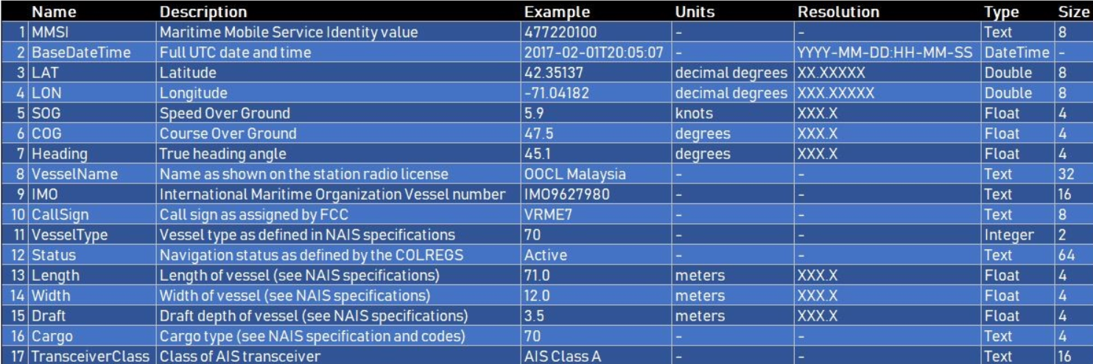
Figure 4-1: Data Dictionary
The data set covers a large ocean area, a long time span, and a sufficient number of samples. It is representative and can well verify the adaptability of the model. Therefore, I choose this data set as the research object of ship trajectory prediction.

4.2 Resources Required
The experimental code in this study is mainly written in python 3, using Keras and Tensorflow frameworks to build the model, and some data processing and drawing libraries are installed, such as numpy, pandas, matplotlib, etc. Taking into account the convenience of running and debugging, t he experiment is written in Jupyter notebook. All of the experiments will be run on the server. The server is equipped with a CPU 2.5 GHz Intel Xeon E5-2678 v3 12-core processor and 4 GTX 1080Ti GPU with 11G video memory. Moreover, the system environment is Ubuntu 16.04.4 LTS, in which I created a virtual environment to do my experiments.
The latent dimension of VAE is 200, and relu is selected as the activation function. The training set and the test set are divided by 3:1, and the training set and the validation set are divided by 4:1. Epoch size is set to 60, batch size is set to 32, and initial learning rate of the model is 0.001. My model is a smooth, interconnected model, and the encoder and decoder parts of the model are differentiable, that is, the trainable parameters in the model can be updated using the gradient descent method, so this work uses self-adaptive learning rate optimization algorithm Adam to update the network parameters.

4.3 Baselines
We can notice that the experimental task is to predict a sequence of trajectories, which is more complicated than position prediction or the need to predict/recommend a point. In order to verify the effectiveness of the ship trajectory prediction model, I first compare the results of sequence prediction and point prediction. Then I designed five different Seq2Seq structures to compare with the effect of the ship trajectory prediction model in my work. The specific description of the baseline is as follows:
Single point prediction model of LSTM (LSTM). LSTM is the most common sequence prediction model with long and short-term memory capabilities. LSTM predicts the next position through sequence, which can alleviate the long-term timing dependency problem that exists in ordinary RNN to a certain extent. The hidden layer size of the model is 100, and the dropout rate is set to 0.3. The model predicts the next trajectory point based on the previous 100 trajectory points, and can only perform single-step prediction or multiple predictions through recursive.
Encoder-decoder model based on LSTM (LAE). The encoder and decoder are composed of two layers of long short-term neural networks, and the number of layers are 128 and 256 respectively. The model use Time Distributed to apply the same fully connected layer to each time step.
Encoder-decoder model based on GRU (GAE). The recurrent neural network composed of two-layer GRU units is used as the structure of the encoder and the decoder, and the number of units in the two layers is set to 128 and 256 respectively. Compared with LSTM, GRU as a variant of LSTM network, improves its computational efficiency by simplifying the structure of the timing unit, and its convergence time and model training time are shorter.
GRU autoencoder with attention mechanism (AGAE). On the basis of the GAE model, an attention mechanism is added. The attention mechanism considers the effect of each position point on the current position point. Using this attention mechanism, the encoder can selectively focus on specific special points instead of all sequence of input positions are taken into account. This model can better pay attention to the turning points of complex vessel trajectories.
Composite GRU autoencoder with attention mechanism (CAGAE). On the basis of the auto-encoder model, a decoder is added to reconstruct the original trajectory. Due to the addition of the attention mechanism, it can better predict the next trajectory based on the information of the original trajectory.
Composite variational autoencoder with attention mechanism (CAVAE). This model uses a variational autoencoder. VAE adds Gaussian noise to the result of the encoder on the basis of the conventional autoencoder, so that the decoder can be robust to noise. VAE internally maps the trajectory information to the distribution of the latent variable z, and the dimension of the latent variable is set to 200.

4.4 Evaluation Metric
In order to evaluate the performance of vessel trajectory model, several popular evaluation indicators are introduced.
Mean Square Error (MSE). It is obtained by averaging the difference between the value predicted by the model and the true value after the square sum, and the value range is [0, +∞). When the predicted value is completely consistent with the true value, its value is 0. The better the model prediction effect, the closer the MSE value is to 0; the worse the model prediction effect, the greater the error, the greater the MSE value. To a certain extent, the value of MSE can be used to evaluate the changes of data. The more the value of MSE tends to 0, the stronger the ability of the established prediction model to describe the experimental data and the higher the accuracy of the model.
Mean Absolute Percentage Error (MAPE). When the value of MAPE is 0%, it means that the prediction effect of the model is absolutely perfect. If the value of MAPE is greater than 100%, it means that the prediction effect of the model is extremely poor. Compared with RMSE, MAPE is equivalent to normalizing the error of each point, reducing the influence of the absolute error caused by individual outliers, and its value range is [0, +∞). But note that when the real value has data equal to 0, there is a problem that the denominator may be 0, and this formula is not available. In view of the fact that RMSE can more intuitively reflect the actual situation of the error between the predicted value and the true value, the RMSE indicator is chosen as one of the evaluation criteria of the model in this article.
Dynamic Time Warping (DTW). DTW is a method of calculating the similarity between two time series. Given two time series, such as a trajectory sequence, because the predicted trajectory does not completely coincide with the original trajectory, there is a difference in geographic coordinates between them. This situation leads to the fact that even if the two trajectories have very similar shapes in the sequence as a whole, they cannot correspond one to one at the time point. Instead, the fluctuations will be delayed and the fluctuation intervals will be different, as shown in Figure 4-2 (Left) shown. The traditional Euclidean distance cannot effectively find the distance or similarity between two trajectory sequences. If some algorithms can be used to align the two sequences to reduce the impact of delay and fluctuation, the similarity of the two can be better measured. DTW is an algorithm that uses warping to scale the time series to calculate the similarity. Intuitively, as shown in Figure 4-2 (right), the points on the time series are no longer in one-to-one correspondence, but there will be "one-to-many" and "many-to-one" correspondence.
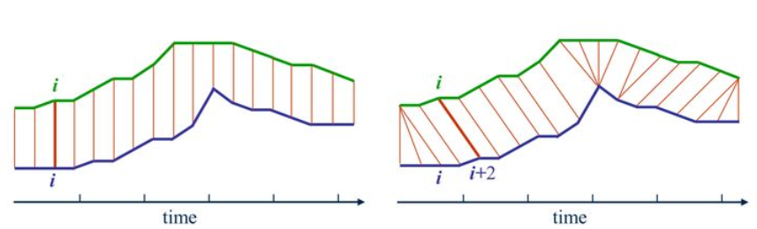
Figure 4-2: Alignment of Euclidean distance and DTW distance
Specifically, denote the two time series as $X =\{x1,x1, …,xn\}$ and $Y =\{y1,y1, …,ym\}$ respectively. The corresponding relationship between X and Y we are looking for can be seen as the red path $P=\{p1,…, ps , …, pk\}$ in Figure 4-3, ps = (is, js). P is called warping function.
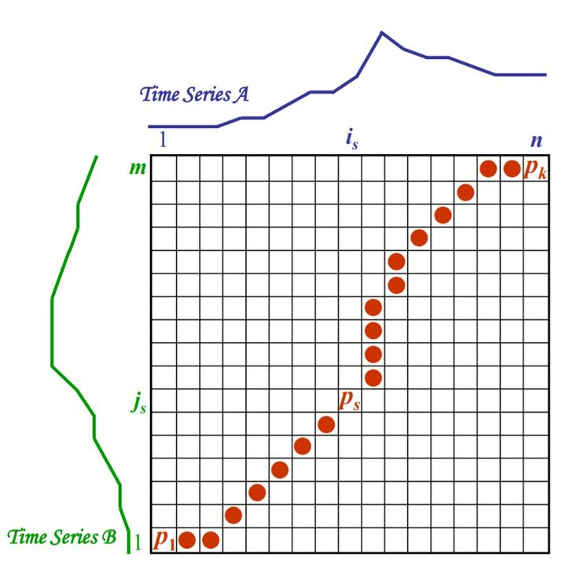
Figure 4-3: solution path of DTW algorithm

CHAPTER 5: Results & Discussions
This chapter compares the experimental results between the vessel trajectory prediction model and the baselines proposed in Chapter 4. Taking the vessel trajectory with MMSI of 211311970 as an example, I selected the trajectory of this ship from June 1, 2020 to June 5, 2020. After the preprocessing module, the shape of final training set feature value is (1800, 100, 2), the shape of target value shape is (1800, 10, 2), and there are 594 records in the test set. The original trajectory is shown in Figure 5-1. It can be seen from the figure that the shape of the trajectory is complex and has large turning points, which can well verify the performance of the model.
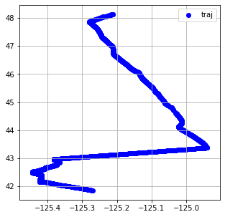
Figure 5-1: Original trajectory
Then, input the trajectory into the proposed model and baselines. For the model proposed in this work, the three-dimensional features of the trajectory's speed over ground, course over ground, and heading orientation are also input into the multi-task learning module. The final prediction results are shown in Table 5-1.
Table 5-1: Comparison of model results
Model | MSE | MAPE | DTW | predict sequence
LSTM | 0.000416 | 0.022116 | 0.02402 | no
LAE | 0.000503 | 0.027105 | 0.33506 | yes
GAE | 0.000180 | 0.01268 | 0.29993 | yes
AGAE | 0.000266 | 0.021797 | 0.26738 | yes
CAGAE | 0.00025 | 0.02095 | 0.20772 | yes
CAVAE | 0.00020 | 0.01302 | 0.19385 | yes
Vessel Trajectory Prediction Model | 0.00019 | 0.01125 | 0.176533 | yes
For the single point prediction model of LSTM, the input of the model is the sub-trajectory segment, and the output is one trajectory point that may be reached in the next step. Since the model can only predict the position of the next step, its applicability in the real world is poor. Although it has achieved good scores in various indicators, it is not used as a comparison object for our sequence prediction question. The fitting result of the single point prediction model of LSTM on the test set is shown in Figure 5-2, and it can be seen that it is close to the original trajectory to a certain extent.
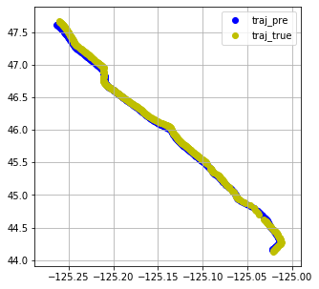
Figure 5-2: Result of single point prediction model of LSTM
For the encoder-decoder model based on LSTM and GRU, they have not achieved good results in trajectory sequence prediction. As shown in Figure 5-3, the prediction results are printed every 20 groups, and the prediction results on different segments of the training set can be seen on each sub-graph. It can be seen from the figure that compared with the original trajectory, the predicted trajectory points have a larger offset. Although the accuracy of the model is very high, it does not fit the original trajectory very intuitively. The reason may be that although LSTM and GRU solve the problem of gradient disappearance and gradient explosion of RNN, they can well capture information in long sequences. However, the model did not consider the mutual influence between the trajectory points and different weights, resulting in overfitting on the training set. As the length of the sequence increases, we may get worse results.
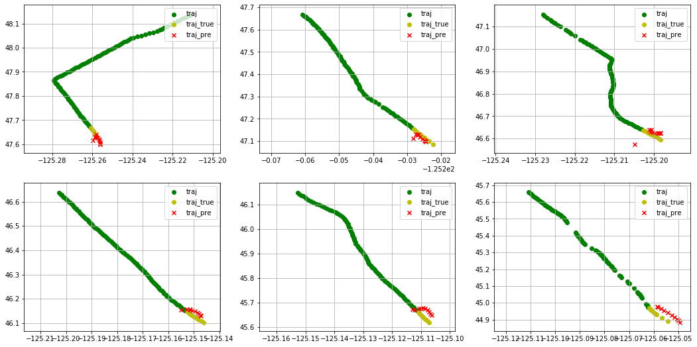
Figure 5-3: Result of the encoder-decoder model based on LSTM
For the model of GRU autoencoder with attention mechanism, the fitting degree is obviously higher than the previous model. It can be seen from Figure 5-4 that in some sub-trajectories with turning points, the model has also achieved better results, but there is still a little deviation compared with the original trajectory. The reason may be that the sparsity of the trajectory itself leads to poor training models. Compared with the previous model, AGAE has made progress in the two evaluation indicators of DTW and SME, but it is inferior in the evaluation indicator MAPE.
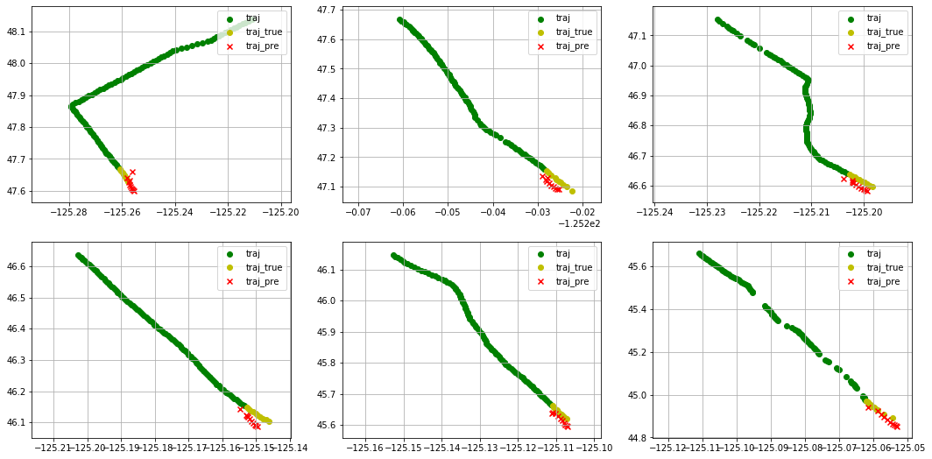
Figure 5-4: Result of GRU autoencoder with attention mechanism
The use of variational autoencoder and combined autoencoder structure significantly improves the prediction effect of the model. As can be seen in Figure 5-5, the predicted trajectory point is closer to the real trajectory point. Moreover, the model has greatly improved on the three evaluation metrics, especially the improvement of DTW, indicating that the distance between the two trajectories is closer.
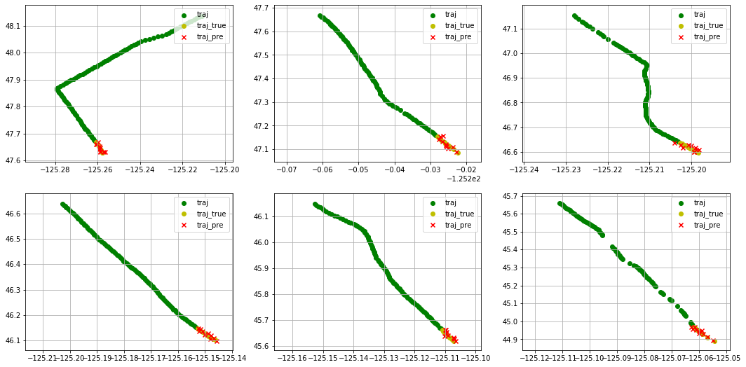
Figure 5-5: Result of composite variational autoencoder with attention mechanism
The last is the prediction result of the vessel trajectory prediction model proposed in this work. It can be seen from Figure 5-6 that the trajectory predicted by the model is closer to the real trajectory, and it is also better than other models in three evaluation metrics.
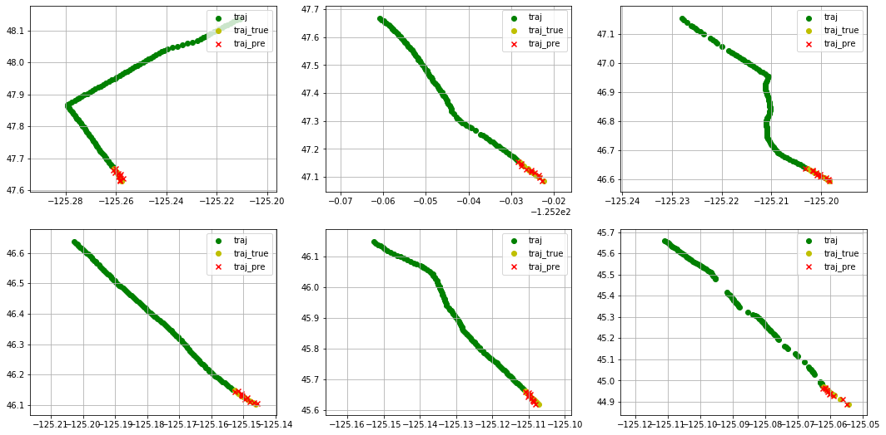
Figure 5-6: Result of the vessel trajectory prediction model
From the above analysis of experiments, it can be seen that the vessel trajectory prediction model proposed in my work is effective for learning multi-task sharing characteristics. The model is better than the baseline method in three evaluation metrics, which shows that the model can improve the trajectory prediction result.

CHAPTER 6: Conclusions and Recommendations
In recent years, with the rapid development of the mobile Internet and the advancement of location collection technology, a large amount of trajectory data has been generated and collected in our daily life. Especially in applications based on location services, it is necessary to be able to accurately predict the location of users to provide effective and feasible services. However, how to quickly and effectively predict the future location of users based on these trajectory data is a very valuable problem. In the shipping field, predicting the trajectory of ships is of great significance to maritime management and ship safety. However, due to the characteristics of uneven sampling, sparseness, errors and missing values of ship trajectory, the prediction of ship trajectory has always been one of the challenges in the field of time series data prediction.
After investigating the relevant literature on position prediction, this work analyzes the characteristics of trajectory data, and proposes a ship trajectory prediction framework based on a multi-task learning model. Based on the structure of the variational autoencoder, a new type of sequence to sequence prediction model is designed. The model is mainly composed of three parts, including preprocessing component, traj2traj model and multi-task learning component. The preprocessing component is used to process the original trajectory data. The traj2traj component is used to encode position sequences and learn the temporal and spatial dependencies between coordinate points. It mainly uses a variational auto encoder with an attention mechanism, which can better reconstruct and generate sparse trajectory data and pay attention to special points in vessel trajectory. Based on the structure of the auto-encoder, the model adds a multi-task learning component to learn shared feature representations by balancing the weights of position, distance, and speed tasks, and make full use of shared features to improve the model's prediction effect. Finally, after comparing with several of baselines, the model has achieved good results.
In trajectory data mining and analysis research, trajectory prediction is one of the important and practical problems. More detailed and in-depth work can also be carried out from multiple angles. The following are the research directions for ship trajectory prediction in future work:
a) Convolutional neural networks have been widely used in computer vision, and one-dimensional convolutional structures can also be applied to time series data prediction problems. In the future, I can try to add convolutional neural networks to multi-task learning model of vessel trajectory prediction. The new model can obtain the spatial features of the trajectory and achieve better learning results.
b) Graph neural network is widely used in traffic flow forecasting problems. It can learn the relationship between different ships, and extract the trajectory features of multiple ships. I can use graph convolutional networks to model the trajectory information of multiple ships, analyze ship behavior and predict the ship intention more accurately.

CHAPTER 7: REFLECTION
In this experiment, I gained a lot of practical experience and learned a lot of knowledge. This knowledge is not only about the basic models of machine learning and deep learning, but also about the field of spatio-temporal data processing and the field of ships. I learned the basics of machine learning from Mr. Gordon's course, and his wonderful explanations made me interested in using machine learning to solve practical problems. My research direction in China is spatio-temporal data and smart city, so I decided to do a topic related to traffic forecasting. Through reading the relevant literature at home and abroad, I have a preliminary understanding of the basic research contents and the latest research progress of deep learning and trajectory data mining. Through reading the representative literature in the field in recent years, I have a further understanding of the research background, current situation and significance. After analyzing the challenges faced by the current trajectory data mining and the shortcomings of the current research methods, the preliminary research scheme of the subject is put forward. The goal of some spatiotemporal trajectory mining tasks is to reveal the hidden behavior patterns, which can be further used for location recommendation, behavior prediction, life pattern discovery and so on. Traditional behavior pattern mining methods focus on location level learning, and find out the typical patterns of trajectories through clustering or classification of spatio-temporal trajectories, such as sequence and periodic pattern mining. It needs to use various time series measurement methods to measure the similarity of location or trajectories and gather similar behavior patterns together. The higher-level mobility mode learning focuses more on the context learning of the trajectory, and understands and encodes the semantics of the trajectory at the overall level of the trajectory. Therefore, I decided to predict based on the autoencoder structure. During the research process, I learned a lot of methods to solve the problem of spatio-temporal prediction, but most of the research is related to vehicles and people, so I decided to focus on ship data. I found the AIS data set on the official website of the US government, and at the same time I checked a lot of knowledge about ships, and got an understanding of the format and meaning of ship data. Next, I began to think about how to apply the sequence prediction model to the ship trajectory. After several improvements, my model achieved good results compared with the baseline.
In the process of completing this subject, I also learned how to find and solve problems, and developed the habit of actively collecting and searching for information. Combining the learned techniques with real-world problems is very interesting. Finally, in the process of writing the thesis, I improved my English writing skills, and also improved my skills such as typing formulas and drawing pictures. In the process of completing the whole project, I still have some problems that need to be improved. For the literature research work, what I did was not systematic enough. I didn't have a comprehensive research on the latest work. It took a lot of time to read and summarize different types of work. This also made me understand that I need to read more literature to improve my ability of summarize. During the experiment, I still have several ideas that have not been realized. On the one hand, I have not mastered the implementation technology well, on the other hand, the reproduced model has not achieved good results. Therefore, I will improve my code ability in the future. In addition, I had less contact with my supervisor and did not discuss my work with him more and get advice from him. I will also improve my English in the future and communicate with people from different countries more naturally and fluently.
The learning process this year was very exciting and memorable for me. It is my honor to learn from all outstanding teachers. Although I did not go to Swansea to study offline, the online courses also greatly improved my English and knowledge skills. In the process of completing the tasks of various courses, my skills in all aspects have been improved, especially this work. Therefore, in the future, I will better integrate the knowledge I have learned with real life problems, generate ideas in life, and improve my ability in practice. Finally, I would like to thank all my classmates for their help and all the teachers for their dedication.

REFERENCES
[1] Zheng Y. Trajectory data mining: An overview [J]. ACM Transactions on Intelligent Systems Technology, 2015, 6(3): 1-41.
[2] Pallotta, Giuliana, Vespe, et al. Vessel pattern knowledge discovery from ais data: A framework for anomaly detection and route prediction [J]. Entropy, 2013.
[3] Tayeb, Tayeb，J. A quadtree-based dynamic attribute indexing method [J]. Computer Journal, 1998, 41(3): 185-200.
[4] Jeung H, Man L Y, Zhou X, et al. Path prediction and predictive range querying in road network databases [J]. VLDB journal: The international journal of very large data bases, 2010.
[5] Zhang R, Jagadish H, Dai B T, et al. Optimized algorithms for predictive range and knn queries on moving objects [J]. 2010, 35(8): 911-932.
[6] Šaltenis S, Jensen C S, Leutenegger S T, et al. Indexing the positions of continuously moving objects [C]. Proceedings of the 2000 ACM SIGMOD international conference on Management of data, 2000: 331-342.
[7] Tao Y, Papadias D, Sun J. The tpr*-tree: An optimized spatio-temporal access method for predictive queries [C]. Proceedings 2003 VLDB conference, 2003: 790-801.
[8] Tao Y, Faloutsos C, Papadias D, et al. Prediction and indexing of moving objects with unknown motion patterns [C]. Proceedings of the 2004 ACM SIGMOD international conference on Management of data, 2004: 611-622.
[9] Hendawi A M, Bao J, Mokbel M F, et al. Predictive tree: An efficient index for predictive queries on road networks [C]. 2015 IEEE 31st International Conference on Data Engineering, 2015: 1215-1226.
[10] Hendawi A M, Mokbel M F. Panda: A predictive spatio-temporal query processor [C]. Proceedings of the 20th International Conference on Advances in Geographic Information Systems, 2012: 13-22.
[11] Wang S, Bao Z, Culpepper J S, et al. Torch: A search engine for trajectory data [C]. The 41st International ACM SIGIR Conference on Research & Development in Information Retrieval, 2018: 535-544.
[12] Wang S, Bao Z, Culpepper J S, et al. Fast large-scale trajectory clustering [J]. 2019, 13(1): 29-42.
[13] Bhattacharya A, Das S K. Lezi-update: An information-theoretic approach to track mobile users in pcs networks [C]. Proceedings of the 5th annual ACM/IEEE international conference on Mobile computing and networking, 1999: 1-12.
[14] Ishikawa Y, Tsukamoto Y, Kitagawa H. Extracting mobility statistics from indexed spatio-temporal datasets [C]. STDBM, 2004: 9-16.
[15] Gambs S, Killijian M-O, del Prado Cortez M N. Next place prediction using mobility markov chains [C]. Proceedings of the first workshop on measurement, privacy, and mobility, 2012: 1-6.
[16] Lian D, Xie X, Zheng V W, et al. Cepr: A collaborative exploration and periodically returning model for location prediction [J]. 2015, 6(1): 1-27.
[17] Wang H, Yang Z, Shi Y J S. Next location prediction based on an adaboost-markov model of mobile users [J]. 2019, 19(6): 1475.
[18] Fang X, Li X, Yu T, et al. Grey markov model prediction method for regular pedestrian movement trend [C]. Proceedings of 2018 Chinese intelligent systems conference, 2019: 575-584.
[19] Rathore P, Kumar D, Rajasegarar S, et al. A scalable framework for trajectory prediction [J]. 2019, 20(10): 3860-3874.
[20] Verhein F, Chawla S. Mining spatio-temporal association rules, sources, sinks, stationary regions and thoroughfares in object mobility databases [C]. International conference on database systems for advanced applications, 2006: 187-201.
[21] Giannotti F, Nanni M, Pinelli F, et al. Trajectory pattern mining [C]. Proceedings of the 13th ACM SIGKDD international conference on Knowledge discovery and data mining, 2007: 330-339.
[22] Zheng Y, Zhang L, Xie X, et al. Mining correlation between locations using human location history [C]. Proceedings of the 17th ACM SIGSPATIAL international conference on advances in geographic information systems, 2009: 472-475.
[23] Cheng C, Yang H, King I, et al. Fused matrix factorization with geographical and social influence in location-based social networks [C]. Proceedings of the AAAI conference on artificial intelligence, 2012:
[24] Rendle S, Freudenthaler C, Schmidt-Thieme L. Factorizing personalized markov chains for next-basket recommendation [C]. Proceedings of the 19th international conference on World wide web, 2010: 811-820.
[25] Cheng C, Yang H, Lyu M R, et al. Where you like to go next: Successive point-of-interest recommendation [C]. Twenty-Third international joint conference on Artificial Intelligence, 2013:
[26] Millefiori L M, Braca P, Bryan K, et al. Modeling vessel kinematics using a stochastic mean-reverting process for long-term prediction [J]. 2016, 52(5): 2313-2330.
[27] Vivone G, Millefiori L M, Braca P, et al. Performance assessment of vessel dynamic models for long-term prediction using heterogeneous data [J]. 2017, 55(11): 6533-6546.
[28] Feng J, Li Y, Zhang C, et al. Deepmove: Predicting human mobility with attentional recurrent networks [C]. Proceedings of the 2018 world wide web conference, 2018: 1459-1468.
[29] Ying J J-C, Lee W-C, Weng T-C, et al. Semantic trajectory mining for location prediction [C]. Proceedings of the 19th ACM SIGSPATIAL international conference on advances in geographic information systems, 2011: 34-43.
[30] Ying J J-C, Lee W-C, Tseng V S J A T o I S, et al. Mining geographic-temporal-semantic patterns in trajectories for location prediction [J]. 2014, 5(1): 1-33.
[31] Ying J-C, Chen H-S, Lin K W, et al. Semantic trajectory-based high utility item recommendation system [J]. 2014, 41(10): 4762-4776.
[32] Wu F, Fu K, Wang Y, et al. A spatial-temporal-semantic neural network algorithm for location prediction on moving objects [J]. 2017, 10(2): 37.
[33] Xiao D, Song L, Wang R, et al. Embedding geographic information for anomalous trajectory detection [J]. 2020, 23(5): 2789-2809.
[34] Yao D, Zhang C, Huang J, et al. Serm: A recurrent model for next location prediction in semantic trajectories [C]. Proceedings of the 2017 ACM on Conference on Information and Knowledge Management, 2017: 2411-2414.
[35] Kong D, Wu F. Hst-lstm: A hierarchical spatial-temporal long-short term memory network for location prediction [C]. IJCAI, 2018: 2341-2347.
[36] Manotumruksa J, Macdonald C, Ounis I. A contextual attention recurrent architecture for context-aware venue recommendation [C]. The 41st International ACM SIGIR Conference on Research & Development in Information Retrieval, 2018: 555-564.
[37] Zhao P, Luo A, Liu Y, et al. Where to go next: A spatio-temporal gated network for next poi recommendation [J]. 2020.
[38] Sun K, Qian T, Chen T, et al. Where to go next: Modeling long-and short-term user preferences for point-of-interest recommendation [C]. Proceedings of the AAAI Conference on Artificial Intelligence, 2020: 214-221.
[39] Cao H, Xu F, Sankaranarayanan J, et al. Habit2vec: Trajectory semantic embedding for living pattern recognition in population [J]. 2019, 19(5): 1096-1108.
[40] Wu H, Chen Z, Sun W, et al. Modeling trajectories with recurrent neural networks [C]. 2017:
[41] Liu Y, Zheng H, Feng X, et al. Short-term traffic flow prediction with conv-lstm [C]. 2017 9th International Conference on Wireless Communications and Signal Processing (WCSP), 2017: 1-6.
[42] Lv Z, Xu J, Zheng K, et al. Lc-rnn: A deep learning model for traffic speed prediction [C]. IJCAI, 2018: 3470-3476.
[43] Kim B, Kang C M, Kim J, et al. Probabilistic vehicle trajectory prediction over occupancy grid map via recurrent neural network [C]. 2017 IEEE 20th International Conference on Intelligent Transportation Systems (ITSC), 2017: 399-404.
[44] Yao H, Wu F, Ke J, et al. Deep multi-view spatial-temporal network for taxi demand prediction [C]. Proceedings of the AAAI Conference on Artificial Intelligence, 2018:
[45] Liang Y, Ke S, Zhang J, et al. Geoman: Multi-level attention networks for geo-sensory time series prediction [C]. IJCAI, 2018: 3428-3434.
[46] Wang P, Fu Y, Zhang J, et al. You are how you drive: Peer and temporal-aware representation learning for driving behavior analysis [C]. Proceedings of the 24th ACM SIGKDD International Conference on Knowledge Discovery & Data Mining, 2018: 2457-2466.
[47] Song X, Kanasugi H, Shibasaki R. Deeptransport: Prediction and simulation of human mobility and transportation mode at a citywide level [C]. Proceedings of the Twenty-Fifth International Joint Conference on Artificial Intelligence, 2016: 2618-2624.
[48] Zhang J, Zheng Y, Qi D. Deep spatio-temporal residual networks for citywide crowd flows prediction [C]. Thirty-first AAAI conference on artificial intelligence, 2017:
[49] Wang D, Zhang J, Cao W, et al. When will you arrive? Estimating travel time based on deep neural networks [C]. Thirty-Second AAAI Conference on Artificial Intelligence, 2018:
[50] Park S H, Kim B, Kang C M, et al. Sequence-to-sequence prediction of vehicle trajectory via lstm encoder-decoder architecture [C]. 2018 IEEE Intelligent Vehicles Symposium (IV), 2018: 1672-1678.
[51] Yao D, Zhang C, Zhu Z, et al. Trajectory clustering via deep representation learning [C]. 2017 international joint conference on neural networks (IJCNN), 2017: 3880-3887.
[52] He K, Zhang X, Ren S, et al. Deep residual learning for image recognition [C]. Proceedings of the IEEE conference on computer vision and pattern recognition, 2016: 770-778.
[53] Huang G, Liu Z, Van Der Maaten L, et al. Densely connected convolutional networks [C]. Proceedings of the IEEE conference on computer vision and pattern recognition, 2017: 4700-4708.
[54] Caruana R J M l. Multitask learning [J]. 1997, 28(1): 41-75.
[55] He J, Lawrence R. A graphbased framework for multi-task multi-view learning [C]. ICML, 2011:
[56] Ranjan R, Patel V M, Chellappa R J I t o p a, et al. Hyperface: A deep multi-task learning framework for face detection, landmark localization, pose estimation, and gender recognition [J]. 2017, 41(1): 121-135.
[57] Rao J, Ture F, Lin J. Multi-task learning with neural networks for voice query understanding on an entertainment platform [C]. Proceedings of the 24th ACM SIGKDD International Conference on Knowledge Discovery & Data Mining, 2018: 636-645.
[58] Zhao L, Sun Q, Ye J, et al. Multi-task learning for spatio-temporal event forecasting [C]. Proceedings of the 21th ACM SIGKDD international conference on knowledge discovery and data mining, 2015: 1503-1512.
[59] Xiaopeng T, Xu C, Lingzhi S, et al. Vessel trajectory prediction in curving channel of inland river [C]. 2015 International Conference on Transportation Information and Safety (ICTIS), 2015: 706-714.
[60] Rong H, Teixeira A, Soares C G J O E. Ship trajectory uncertainty prediction based on a gaussian process model [J]. 2019, 182: 499-511.
[61] Murray B, Perera L P. A data-driven approach to vessel trajectory prediction for safe autonomous ship operations [C]. 2018 Thirteenth International Conference on Digital Information Management (ICDIM), 2018: 240-247.
[62] Gan S, Liang S, Li K, et al. Ship trajectory prediction for intelligent traffic management using clustering and ann [C]. 2016 UKACC 11th International Conference on Control (CONTROL), 2016: 1-6.
[63] Gan S, Liang S, Li K, et al. Trajectory length prediction for intelligent traffic signaling: A data-driven approach [J]. 2017, 19(2): 426-435.
[64] Guo S, Liu C, Guo Z, et al. Trajectory prediction for ocean vessels base on k-order multivariate markov chain [C]. International Conference on Wireless Algorithms, Systems, and Applications, 2018: 140-150.
[65] Xiao Z, Ponnambalam L, Fu X, et al. Maritime traffic probabilistic forecasting based on vessels’ waterway patterns and motion behaviors [J]. 2017, 18(11): 3122-3134.
[66] Forti N, Millefiori L M, Braca P, et al. Prediction oof vessel trajectories from ais data via sequence-to-sequence recurrent neural networks [C]. ICASSP 2020-2020 IEEE International Conference on Acoustics, Speech and Signal Processing (ICASSP), 2020: 8936-8940.
[67] Nguyen D-D, Le Van C, Ali M I. Vessel trajectory prediction using sequence-to-sequence models over spatial grid [C]. Proceedings of the 12th ACM International Conference on Distributed and Event-based Systems, 2018: 258-261.
[68] Gao M, Shi G, Li S J S. Online prediction of ship behavior with automatic identification system sensor data using bidirectional long short-term memory recurrent neural network [J]. 2018, 18(12): 4211.

