

Assessment 1 – Reading Task Template
PART 1: Upload your photo of your A3 in-class notes here:
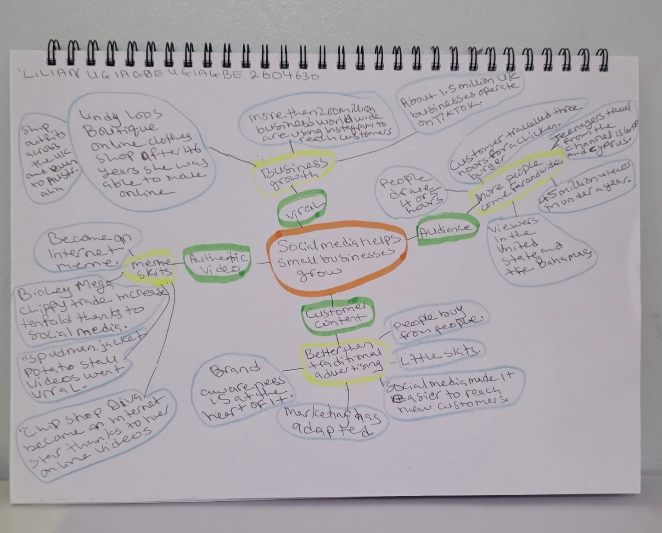

PART 2:
- Answer every question below in 1-3 full sentences.
- Use your own words. Do not use generative AI to answer these questions.
- Include a specific detail from the text when asked.
REMINDER
- The main idea is the overall message of the whole text.
- A key point helps to explain the main idea.
- A specific detail or example from the text shows that the key point is true.

- What is the main idea of the whole text?
The main idea is that social media helps small businesses grow and makes it easier to reach a wider audience. Social media is a good way to market and expand your business. It also explains how customer made content and authentic videos impact positively on small businesses.

- What is one key point that supports the main idea, and which specific example from the text shows this?
A key point supporting the main idea is that going viral makes your business grow.
This is shown in the text when Linda Hunters clothes shop started posting on the platform (Instagram), The 62-year-old has moved the business fully online and ships outfits across the UK and even Australia.
With out social media her business wouldn’t have grown this far. social media boosted her business growth.

- What is a different key point that supports the main idea, and which specific example from the text shows this?
Another key point is social media brings more people from further away to your business. Like when people travelled four or five hours to visit Krystall’s Boutique, and when customers travelled three hours for chicken burger. This shows people are willing to travel long distances because of the marketing on social media. Social media widens the range of customers coming to your business.

- Which part of the text do you think is most important, and why?
I think that the most important part of the text is how small business can grow because of social media. Like when Linda Hunter went from selling clothes on markets in Essex, Kent, London and she was able to park up her stall and moved the business fully online and ship outfit across the UK and even to Australia. Social media changed her business a lot to gain more customers increasing her profit.

Reflection:
- What did you find difficult in this task (including in-class components), and why was it difficult?
I found it difficult to make mind maps and find the key points that supports the main idea in the text. It was difficult for me to arrange my ideas in to sentences. At the start, I did not understand the mind map properly then the lecturer explains it in details and we did a group class work. It is a bit challenging for me to use a computer.

- What helped you with this difficulty, and how did it help you?
Emailing my lecturer asking for feedback helped me to finish my mind map for the assessment.
I read the text several times to understand it better. Spend a lot of time to find the key points in the text. I took regular breaks and drank lots of water, which helped to maintain my focus.

