

LOCATION: Swansea | LLEOLIAD: abertawe
LEVEL 5 | LEFEL 5
EXAMINATION PERIOD | CYFNOD ARHOLIADAU
JULy 2023 | 2023

MODULE CODE: ACDC5009
Electromagnetic Radiation
Programme:
B.Eng.(Hons.) iN Embedded Electronic Systems

TIME: 2 HOURS
answer Any five questions

Equipment or materials required – Calculator, Formula sheet
Adnoddau neu ddefnyddiau sydd eu hangen - Cyfrifiannell

ANSWER ANY 5 QUESTIONS

Question 1 [20 marks]
- Define total Internal Reflection in fiber optics with necessary diagram. [2 marks]
Answer: Total internal reflection is the phenomenon that involves the reflection of all the incident light off the boundary. [1 mark]
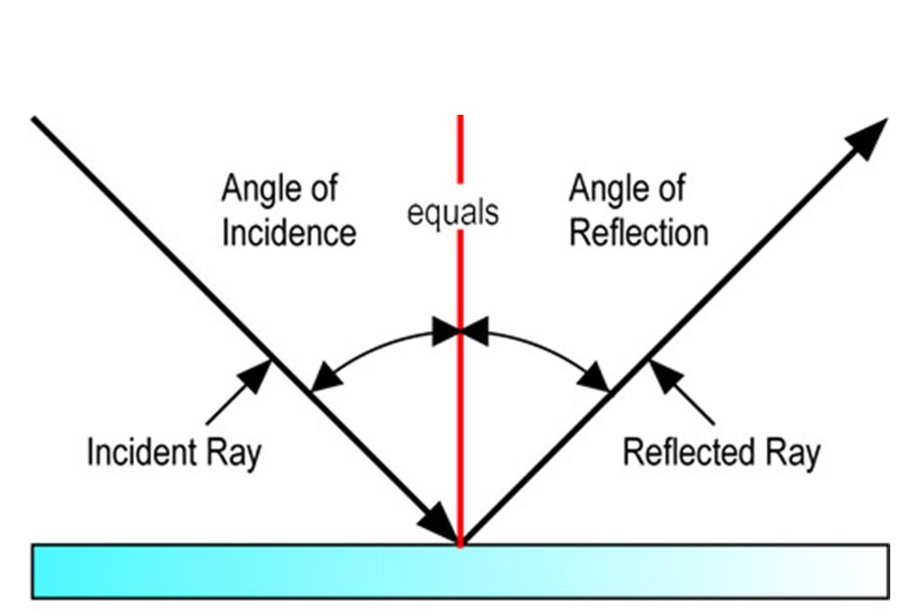 [1 mark]

- Describe the functions of the following components with the aid of necessary diagram.
- Directional Coupler [5 marks]
- Magic Tee [5 marks]
Answer:
- Directional Coupler
- It is a 4-port device, used to sample a small amount of input signal power for measurement purposes.
- Port 1 is the input port, port 2 is the output port, port 3 is the coupled port and port 4 is the isolated/terminated port.
- When an input signal travels from port 1 to port 2, a part of this signal is coupled to port 3. The portion of the power coupled to port 3 depends on the coupling value of the coupler being used. [3 marks]
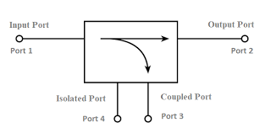 [2 marks]
- Magic Tee
A Magic Tee or Hybrid Tee is a 4 port waveguide tee that is a combination of an E-Plane and H-Plane Waveguide Tee.
A magic tee has four ports:
- Port 1 - Co-linear
- Port 2 - Co-linear
- Port 3 - Difference Port
- Port 4 - Sum Port [3 marks]
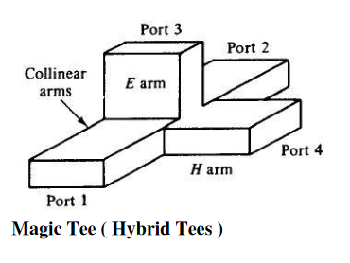 [2 marks]
- A Charge $Q_{1}= -20μC$ is located at P(-6,4,6) and a charge $Q_{2}= 50μC$ is located at R (5,8,-2) in a free space. Find the force exerted on $Q_{2}$ by $Q_{1}$. The distance given are in meters. [8 marks]
Answer:
${\overline{F}}_{Q_{1}Q_{2}}=\frac{Q_{1}Q_{2}}{4πε_{0}d_{12}^{2}}{\overline{a}}_{12}$
$\overline{P}=-6{\overline{a}}_{x}+4{\overline{a}}_{y}+6{\overline{a}}_{z}$
$\overline{P}=5{\overline{a}}_{x}+8-2{\overline{a}}_{z}$ [2 marks]
${\overline{d}}_{PR}=\overline{R}-\overline{P}=11{\overline{a}}_{x}+4{\overline{a}}_{y}-8{\overline{a}}_{z}$ [1 mark]
$\left|{\overline{d}}_{PR}\right|=\sqrt{{11}^{2}+4^{2}+{(-8)}^{2}}=14.177$ [1 mark]
${\overline{a}}_{12}=\frac{{\overline{d}}_{PR}}{\left|{\overline{d}}_{PR}\right|}=\frac{11{\overline{a}}_{x}+4{\overline{a}}_{y}-8{\overline{a}}_{z}}{14.177}=0.776{\overline{a}}_{x}+0.28{\overline{a}}_{y}-0.564{\overline{a}}_{z}$ [2 mark]
${\overline{F}}_{Q_{1}Q_{2}}=\frac{-20×{10}^{-6}×50×{10}^{-6}}{4π×8.85×{10}^{-12}×{14.177}^{2}}[0.776{\overline{a}}_{x}+0.28{\overline{a}}_{y}-0.564{\overline{a}}_{z}]$
${\overline{F}}_{Q_{1}Q_{2}}=-0.0447[0.776{\overline{a}}_{x}+0.28{\overline{a}}_{y}-0.564{\overline{a}}_{z}]$ [2 marks]
${\overline{F}}_{Q_{1}Q_{2}}=-0.0346{\overline{a}}_{x}-0.0126{\overline{a}}_{y}+00.2522{\overline{a}}_{z}]$ N
$\left\lceil {\overline{F}}_{Q_{1}Q_{2}}\right\rceil =\sqrt{{(-0.0346)}^{2}+{(-0.0126)}^{2}+{(-0.02522)}^{2}}=44634mN$ [2 marks]
Question 2 [20 marks]
- What is an Electromagnetic Spectrum? Describe the features and applications of Radio Frequency waves. [10 marks]
Answer: The electromagnetic (EM) spectrum is the range of all types of EM radiation, which travels and spreads out as it goes. Electromagnetic energy travels in waves and spans a broad spectrum from very long radio waves to very short gamma rays. EM waves are in order of increasing frequency and decreasing wavelength. [3 marks]
- Radio waves have the longest wavelengths and lowest frequency in the electromagnetic spectrum.
- Frequency - 300 gigahertz (GHz) and below.
- Wavelength – 1mm to 10,000 kilometers
- AM – Frequency range - 535-1605 kHz.
- FM – Frequency range - 88 to 108 MHz
- At 300 GHz, the corresponding wavelength is 1 mm (shorter than a grain of rice); at 30 Hz the corresponding wavelength is 10,000 kilometers (6,200 miles) (longer than the radius of the Earth).
- Radio waves are very widely used in modern technology for fixed and mobile radio communication, broadcasting, radar and radio navigation systems, communications satellites, wireless computer networks and many other applications.
- The radio "receives" these electromagnetic radio waves and converts them to mechanical vibrations in the speaker to create the sound waves you can hear.
[ 7 marks]
- Describe the properties of Electromagnetic waves. [6 marks]
Answer:
- They does not require any medium for propagation.
- Electromagnetic waves can be reflected, refracted, absorbed, diffracted, scattered and produce interference patterns.
- They are transverse in nature.
- Electromagnetic waves travel with a constant velocity in vacuum. The speed of the waves is 3x10⁸m/s.
- They obey the equation c = fλ. Here, f is the frequency in Hertz and λ is the wavelength in metres. C= 3 x 10⁸ m/s. From this relation, the electromagnetic waves will travel with the speed of light regardless of wavelength and frequency.
- The oscillating electric field and magnetic field are in the same phase.
- They may be polarized. [ Each point 1 mark, maximum of 6 marks]
- Describe the propagation of Electromagnetic wave with the aid of diagram. [4 marks]
Answer: Electromagnetic waves are Self-Propagating in nature. The magnetic and the electric fields come at 90° to each other, and the combined waves move perpendicular to both electric and magnetic oscillating fields occurring during the disturbance. [2 marks]
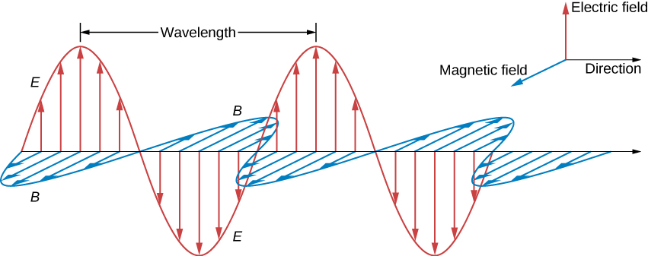
[2 marks]
Question 3 [20 marks]
- What are the uses of a waveguide? [3 marks]
Answer: A waveguide is a structure that guides waves, such as electromagnetic waves or sound, with minimal loss of energy by restricting the transmission of energy to one direction. Waveguide helps in the propagation of high frequency Electromagnetic waves like Microwaves, Radio waves, and Infrared Rays. [3 marks]
- Describe the following waveguide with necessary diagrams.
- Step index fiber [7 marks]
- Graded index fiber [7 marks]
Answer:
- Step Index Fiber
- step-index fiber, where a uniform refractive index exists within the core and a sharply decreased refractive index exists in the core-cladding interface because of the lower refractive index in cladding.
- For step-index multimode fiber, the light propagates in the shape of a zigzag along the fiber/core axis according to the principle of total reflection.
- Light entering the fiber at different angles of incidence will go through different paths.
- Although the incident lights propagate at the same speed simultaneously at the input, the time to reach the output of the fiber is different, resulting in a temporal dispersion called modal dispersion. [5 marks]
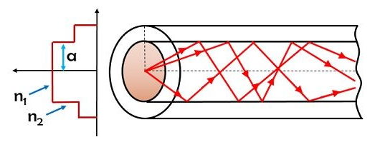
[2 marks]
- Graded index fiber
- Graded index multimode fiber is a type of optical fiber where the refractive index is higher at the axis of the core and then it decreases gradually towards the core-cladding interface.
- That is to say, the refractive index of a graded-index fiber gradually decreases from its center, and eventually decreases to the same value as the cladding at the core edge.
- The change in refractive index causes refraction rather than total internal reflection.
- When light passes through a layer with a lower refractive index, the light will fold back to the fiber axis. Total internal reflection does not occur because refraction folds the light back into the fiber axis before it reaches the cladding boundary. ` [5 marks]
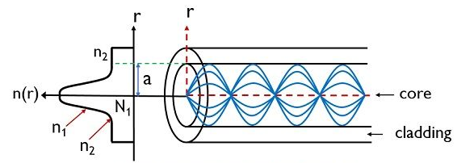
[2 marks]
- Define a TE mode. [3 marks]
Answer: These are sometimes called H modes because there is only a magnetic field along the direction of propagation (H is the conventional symbol for magnetic field). Electric Field (E) vector is transverse or perpendicular to the Waveguide’s axis. No electric field in the direction of propagation. [3 marks]
Question 4 [20 marks]
- A silica optical fiber with a core diameter large enough to be considered by ray theory analysis has a core refractive index of 1.50 and a cladding refractive index of 1.47. Determine the critical angle at the core–cladding interface, Numerical Aperture and the acceptance angle in air for the fiber. [6 marks]
Answer:
Critical angle:
$ϕ_{c}={Sin}^{-1}\frac{n_{2}}{n_{1}}={Sin}^{-1}\frac{1.47}{1.50}={78.5}^{o}$ [2 marks]
$NA={(n_{2}^{2}-n_{1}^{1})}^{1/2}$ =0.3 [2 marks]
$Acceptance angle$
$ϕ_{c}={Sin}^{-1}NA={Sin}^{-1}\left(0.30\right)= {17.4}^{o}$ [2 marks]
- Describe the function of an isolator in a waveguide. [2 marks]
Answer: An isolator is a two-port device that transmits microwave or radio frequency power in one direction. It isolates the unwanted reflected signals which may cause damage to the RF transmitter and other units. [2 marks]
- Describe the following terms used in Electromagnetic Radiation with necessary diagram,
- Diffraction, [2 marks]
- Scattering [2 marks]
- Interference [4 marks]
- Refraction [2 marks]
- Polarisation [2 marks]
Answer:
- Diffraction,
Diffraction is defined as the interference or bending of waves around the corners of an obstacle or through an aperture into the region of geometrical shadow of the obstacle/aperture. The diffracting object or aperture effectively becomes a secondary source of the propagating wave. [1 mark]
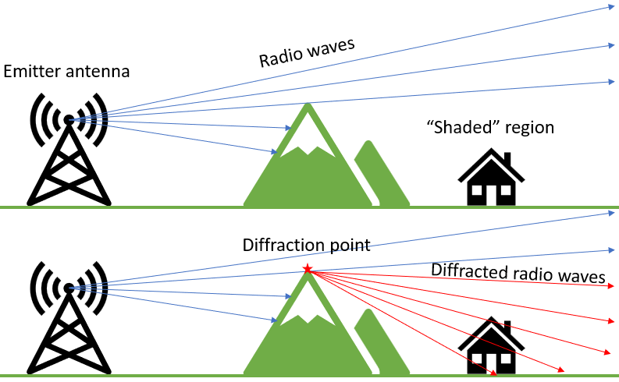 [1 mark]
- Scattering
Scattering is the process by which a particle in the path of an electromagnetic wave continuously removes energy from the incident wave and re-radiates the energy into the total solid angle centred at the particle. [1 mark]
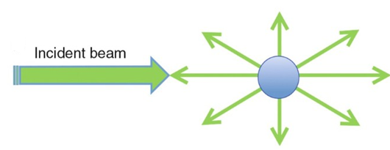 [1 mark]
- Interference
Electromagnetic interference (EMI) is unwanted noise or interference in an electrical path or circuit caused by an outside source. EMI can cause electronics to operate poorly, malfunction or stop working completely.
Interference is a phenomenon in which two waves combine by adding their displacement together at every single point in space and time, to form a resultant wave of greater, lower, or the same amplitude which is due to constructive or destructive interference. [3 marks]
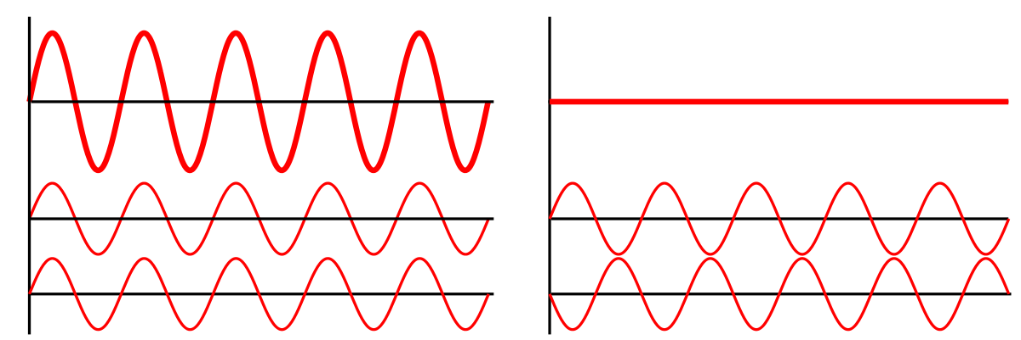 [1 mark]
- Refraction
Refraction is the change in the direction of a wave passing from one medium to another. Refraction is the bending of light (it also happens with sound, water and other waves) as it passes from one transparent substance into another. [1 mark] 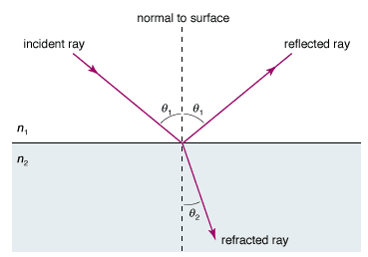 [1 mark]
- Polarisation:
The polarisation of an electromagnetic wave indicates the plane in which it is vibrating. As electromagnetic waves consist of an electric and a magnetic field vibrating at right angles to each other. It is necessary to adopt a convention to determine the polarisation of the signal. [2 marks]
Question 5 [20 marks]
- Find the inductance per unit length of a co-axial cable radius of inner and outer conductors are 1mm and 3mm respectively. Assume relative permeability as unity.
[5 marks]
Answer:
$\frac{L}{d}=\frac{μ}{2π}ln\left(b/a\right)$ [2 marks]
$=\frac{μ_{o}μ_{r}}{2π}ln\left(b/a\right)$
$=\frac{4π×{10}^{-7}×1}{2π}ln\left({3×{10}^{-3}}/{1×{10}^{-3}}\right)$
$=0.2197μH/m$ [3 marks]
- A coil of 500 turns wound on a iron ring of medium radius 10cm and cross section area of 3cm². Find the self-inductance of the winding if the relative permeability of iron is 800. [5 marks]
Answer:
N=500turns
R=10cm, A=3cm² $, μ_{r}$=800
$L=\frac{μ_{0}μ_{r}N^{2}A}{2πR}$ [2 marks]
$=\frac{4π×{10}^{-7}×800×{500}^{2}×3×{({10}^{-2})}^{2}}{2π×10×{10}^{-2}}$ =0.12H [3 marks]
- What is a Parasitic Array antenna? [2 marks]
Answer: In Parasitic Array Antenna Parasitic element depends on other’s feed. It does not have its own feed. Hence, in this type of arrays parasitic elements are employed, which help in increasing the radiation indirectly. These parasitic elements are not directly connected to the feed. [2 marks]
- Describe the functions of each component in a Parasitic Array Antenna with necessary diagram. [8 marks]
Answer:
The components of parasitic array antennas are
- Driven element
- Parasitic elements
  - Reflector
  - Director
- Boom [1 mark]
Driven element
- The antennas radiate individually and while in array, the radiation of all the elements sum up to form the radiation beam. All the elements of the array need not be connected to the feed. The dipole that is connected to the feed is known as a driven element. [1 mark]
Parasitic Elements
- The elements, which are added that do not possess an electrical connection between them to the driven element or the feed. They are positioned so that they lie in the induction field of the driven element. Hence, they are known as parasitic elements. [1 mark]
Reflector
- If one of the parasitic element, which is 5% longer than driven element, is placed close to the driven element is longer, then it acts as a concave mirror, which reflects the energy in the direction of the radiation pattern rather than its own direction and hence is known as a reflector. [1 mark]
Director
- A parasitic element, which is 5% shorter than the driven element, from which it receives energy, tends to increase radiation in its own direction and therefore, behaves like convergent convex lens. This element is called as a director. A number of directors are placed to increase the directivity. [1 mark]
Boom
- The element on which all these are placed is called a boom. It is a non-metallic structure which provides insulation, so that there will not be any short circuit between the other elements of the array. These are all the main elements, which contribute the radiation. [1 mark]
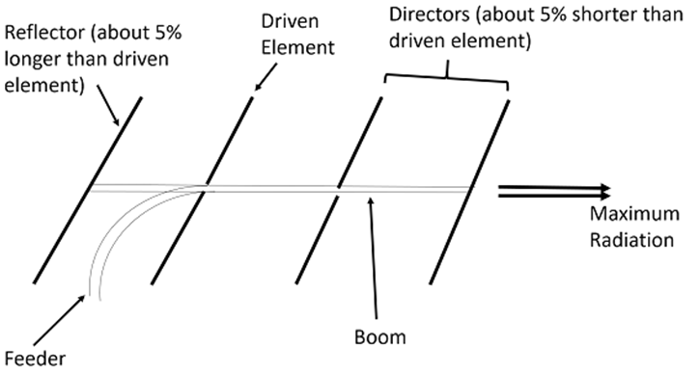 [2 marks]

Question 6 [20 marks]
- Define Doppler Effect with an example [4 marks]
Answer: Doppler effect is defined as the increase (or decrease) in the frequency of sound, light, or other waves as the source and observer move towards (or away from) each other. [2 marks]
The drop in pitch of ambulance sirens as they pass by and the shift in red light are common examples of the Doppler Effect. [2 marks]
- Describe the types of Continuous wave radar system with the aid of necessary diagram. [12 marks]
Answer:
- Three main forms of Continuous radars are: (1) autodyne, (2) homodyne, and (3) heterodyne. [1 mark]
- The simplest of all the configurations is the autodyne. Its configuration uses a free running oscillator as the transmission source.
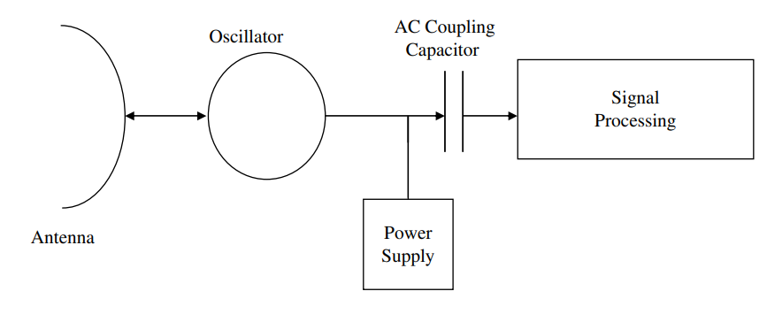
[2 marks]
- The autodyne configuration sometimes referred to as a self-mixing oscillator or self oscillating mixer.
- While stationary targets are not detectable with this CW radar configuration, the return signal from moving targets experiences a Doppler frequency shift.
- The different transmit and receive frequencies are mixed via the oscillator, yielding a difference frequency equal to the Doppler shift.
- This difference or beat frequency passes via capacitive coupling to the radar for signal processing.
[3 marks]
Homodyne CW Radar Block Diagram with Separate Antennas for Transmit and Receive.

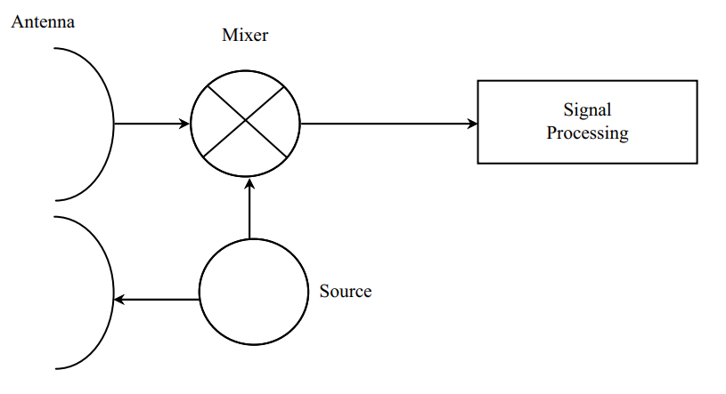
[1 mark]
Single Antenna Homodyne CW Radar Block Diagram
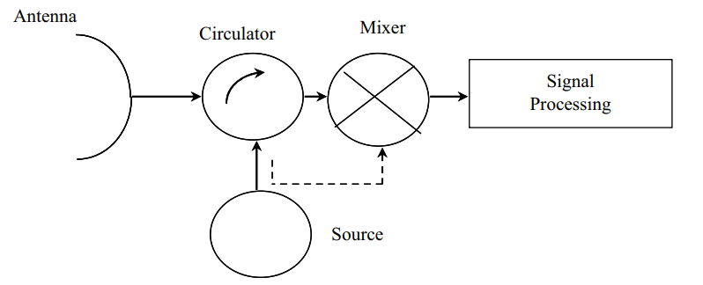
[1 mark]
- The homodyne CW radar configuration offers improved sensitivity because of better performance when using a separate mixer and because of the greater transmit-to-receive isolation with separate antennas for transmit and receive.
- A block diagram of a homodyne CW radar with the transmit signal coupled to the mixer.
- While a transmit–receive switch cannot be used with CW waveforms, a single-antenna CW radar configuration is feasible.
- This requires a transmit–receive diplexer, such as a circulator, to separate the transmit and receive signals.
- Different polarizations on transmit and receive have also been used in some CW radars to enhance isolation, although this can add expense. [4 marks]
- Find the Characteristics impedance of a transmission line of 1600Hz, if the following measurements have been made on the line at 1600Hz, $Z_{SC}=600∠-{20}^{0}Ω$, $Z_{OC}=750∠-{30}^{0}Ω$ [4 marks]
Answer:
$Z_{0}=\sqrt{Z_{OC}Z_{SC}}=\sqrt{600×750∠-{62}^{o}-{30}^{o}}$ [2 marks]
$=670.8∠\frac{-{50}^{o}}{2}=670.8∠{-25}^{o}Ω$ [2 marks]

Diwedd/End

