 | Student No: | 2132061
 | Module Title: | Operating Hotel Facilities
 | Module Code: | BMIH4006
 | Lecturer: | Lola Villard

Component One
The skills that are needed while working in house-Keeping are:
Body Language
Body language is also an important factor. While it may be involuntary, body language lets out a ton. It's important to make sure the workers are providing a fair message with the route they hold themselves throughout the property.
Communication
Communication is perhaps the greatest crucial aspect of consumer assistance. How the workers deal with guests can bring in or break an occasion. Workers requirement to be calm, quiet and steady, but they likewise demand to be adapting and conformational as well (Khatri, 2019). They need to be entirely acquainted with interactive simulations and methods so they are never caught off guard.
Department Expectations
There needs to be an apparent understanding of what is hoped from each position. While crew fellows can get on above and beyond their visitation of tasks, duty or employment should invariably be appointed to a specific position. Each worker should understand which responsibilities are allocated to each division. While it is crucial to understand what is anticipated of each worker, it is furthermore helpful so workers will understand where to oversee distinct inquiries. With apparent anticipations, visitors will appreciate better assistance and more methodical exchange with the team.
Enhance Managerial apprenticeship
When contemplating how to acquaint the hotel team, we would need to remember that promising training programmes begin at the top. The hotel administrators will supervise the running of the hotel and so they require to be acquainted with the highest norms to assure that everything else operates nicely (Konovalova et al., 2018). For executives, one of the main training locales to concentrate on is communication. This will entitle them to chat candidly and frankly with other executives, team and hotel visitors and can enable a favourable culture in the inn. It’s furthermore crucial to integrate training on decision-making, negotiation, and confrontation solution into the training process.

Optimize Housekeeping Standards
Many visitors review a hotel by its impression and cleanliness, so among the different hotel team workout issues for housekeeping employees, we might like to contain the significance of how to tidy up rooms and public rooms entirely, as well as health and security provisions and how to deal with visitors appropriately (Konovalova et al., 2018).
Automatic technical knowledge
Mechanical fusses are about problems with the hotel’s supplies. The maximum of customer objections was about hotel supplies disappointments. It is frequently concerned with AC, lights, authority, room furnishings, vending appliances, ice appliances, entry keys, plumbing, Tv, and different identical problems. Utilizing a front office log book and keeping work orders properly can help us to minimise the repetition of technical fusses from the clients.

Component Two:
Problem | Why did it happen? | What are you going to do? | How will you prevent this from happening in the future? | What measures would you introduce to improve team effectiveness?
Dirty rooms | Whether it’s hair in the bathtub or footwear found in a bottom drawer, tourists generally have reasonable grounds for complaining about the cleanliness of the room. | When these problems are negotiated with fast and thoughtfully, they are usually less hard to settle. | For every new tourist, hotel rooms are presumed to be perfect and clean, and a dirty room is any hotel manager's connotation of a bad day (Asirifi et al., 2013). | We will assure that housekeeping staff are neat to proper hotel norms on a normal basis, we will inquire if Front-desk workers should make incoming consumers defer until the room can be tidied up rather than giving them a messy room.
Poor food or beverage quality | Today’s hotel consumers foresee rates in all aspects of their visit, comprising food grade. | This does not only refer to room service; breakfast served in combined spaces should be of reasonable quality, no matter if it is continental (Hole, 2019). | The promising manner to get around such objections is to take time to time feedback about the food from consumers and bring in the essential modifications. | Food-related objections should be supervised instantly by the employees accountable for qualifying and providing the dinners to evade such crises in the future.
Lack of proper communication | Lack of communication between the hotel staff and the consumers directs to one of the greatest typical consumer objections in the hotel enterprise. | Hotel assistance needs to be shut down for a combination of justifications, and tourists will certainly be disappointed if the assistance or installation they had planned to utilize is no longer functional. | To lessen shocks, hotel leadership need to do their maximum to communicate the level of unavailable services to current and prospective customers. | The travel schedules are a lot influenced by their appropriation, so when they find surprising payments after booking their expedition, they are possible to be disappointed.  Through the booking procedure, be forthright with the tourists' heeding expenses and payments, and make sure the workers can direct to the jotted-down statement of those payments if an objection occurs.
Bad team perspective | Perspective and conduct issues in hotels are extremely regular (Hole, 2019). | Each hotel, big or little, obtains objections from guests considering the disrespectful, unskilled, and uncaring conduct of hotel assistance staff. | Bad comments, laughing at hotel visitors, or even fetching into a hot discussion with hotel visitors all occur on an everyday rationale in hotels around the globe. | Half of the whole hotel occasion is committed by the (un)pleasantness of the workers, so I'll make sure they are sufficiently acquainted.  Our Team members will be well-trained in our Management System to fast determine guest objections, convey serious apologies, and implement mandated improvements to reduce the duplication of the problem

Component Three:
Having this standard manner of interacting with visitors will assist the hotel in cooperating nicely, but it needs some action on the front end, for example, training for the staff. Management requirements to acquaint fresh workers to accompany guests and provide intermittent refresher lessons to existing workers.
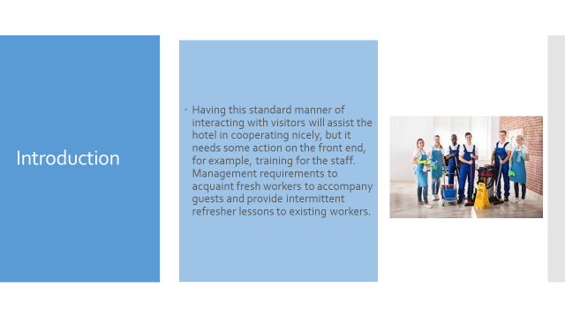
Crucial Hospitality Industry Courses
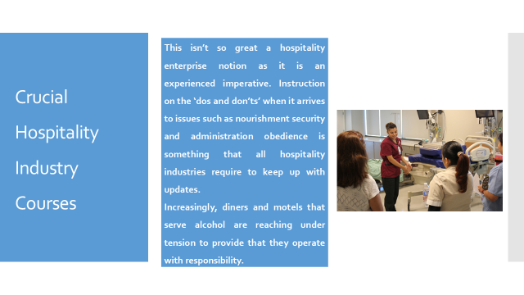
This isn’t so great a hospitality enterprise notion as it is an experienced imperative. Instruction on the ‘dos and don’ts’ when it arrives to issues such as nourishment security and administration obedience is something that all hospitality industries require to keep up with updates.
Increasingly, diners and motels that serve alcohol are reaching under tension to provide that they operate with responsibility.
Orientation and Organizational Structure Hospitality Training
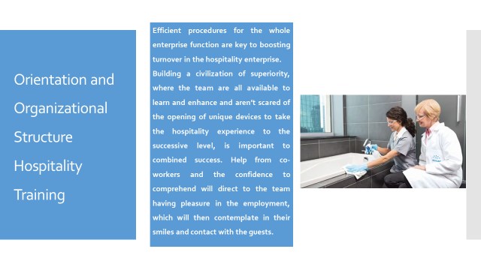
Efficient procedures for the whole enterprise function are key to boosting turnover in the hospitality enterprise.
Building a civilization of superiority, where the team are all available to learn and enhance and aren’t scared of the opening of unique devices to take the hospitality experience to the successive level, is important to combined success. Help from co-workers and the confidence to comprehend will direct to the team having pleasure in the employment, which will then contemplate in their smiles and contact with the guests.
Training Security Awareness Training
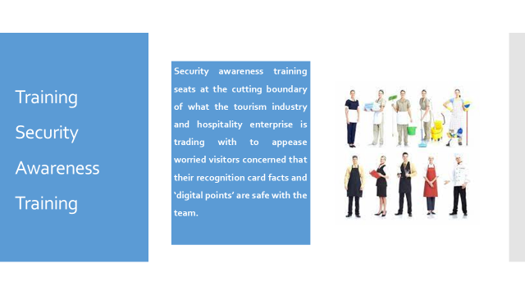
Security awareness training seats at the cutting boundary of what the tourism industry and hospitality enterprise is trading with to appease worried visitors concerned that their recognition card facts and ‘digital points’ are safe with the team.
Training and Development
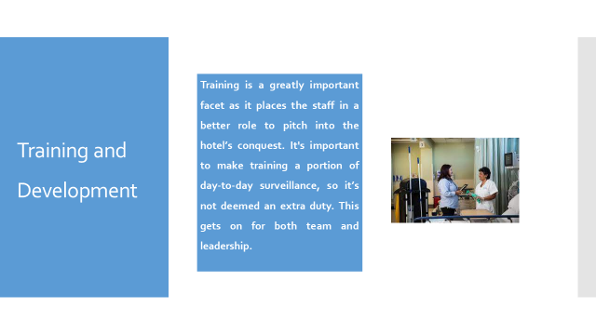
Training is a greatly important facet as it places the staff in a better role to pitch into the hotel’s conquest. It's important to make training a portion of day-to-day surveillance, so it’s not deemed an extra duty. This gets on for both team and leadership.

Conclusion
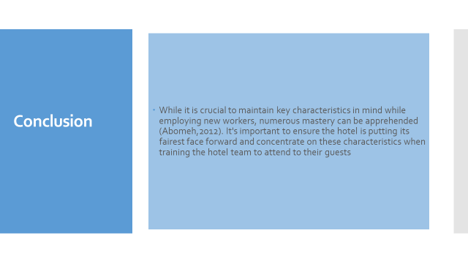
While it is crucial to maintain key characteristics in mind while employing new workers, numerous masteries can be apprehended (Abomeh,2012). It's important to ensure the hotel is putting its fairest face forward and concentrate on these characteristics when training the hotel team to attend to their guests:

References
Abomeh, O.S., 2012. Hospitality and tourism manpower training and education in Nigeria. Afro-Asian Journal of Social Sciences, 3(3.4), pp.1-18.
Adeola, O. and Ezenwafor, K., 2016. The hospitality business in Nigeria: Issues, challenges and opportunities. Worldwide Hospitality and Tourism Themes, 8(2), pp.182-194.
Arwab, M., Adil, M., Nasir, M. and Ali, M.A., 2022. Task performance and training of employees: the mediating role of employee engagement in the tourism and hospitality industry. European Journal of Training and Development, (ahead-of-print).
Asirifi, G.H., Doku, V., Morrison, S. and Sackey, A.S., 2013. The gap between hospitality education and the hospitality industry. Journal of Education and Practice, 4(24), pp.19-23.
Hole, Y., 2019. Challenges and solutions to the development of the tourism and hospitality industry in India. African Journal of Hospitality, Tourism and Leisure, 8(3), pp.1-11.
Hyasat, A.S., Al-Weshah, G.A. and Kakeesh, D.F., 2022. Training Needs Assessment for Small Businesses: The Case of the Hospitality Industry in Jordan. Geo Journal of Tourism and Geosites, 40(1), pp.20-29.
Khatri, I., 2019. Information technology in tourism & hospitality industry: A review of ten years’ publications. Journal of Tourism and Hospitality Education, 9, pp.74-87.
Konovalova, E.E., Yudina, E.V., Ukhina, T.V., Lagusev, Y.M. and Zvyagintseva, O.P., 2018. Methodological approaches to develop strategies for the tourism and hospitality industry enterprises. International Journal of Engineering and Technology (UAE), 7(4.38), pp.277-280.
Ntounis, N., Parker, C., Skinner, H., Steadman, C. and Warnaby, G., 2022. Tourism and Hospitality industry resilience during the Covid-19 pandemic: Evidence from England. Current Issues in Tourism, 25(1), pp.46-59.
Sanjeev, G.M. and Birdie, A.K., 2019. The tourism and hospitality industry in India: emerging issues for the next decade. Worldwide Hospitality and Tourism Themes, 11(4), pp.355-361.
Tews, M.J., Hoefnagels, A., Jolly, P.M. and Stafford, K., 2020. Turnover among young adults in the hospitality industry: examining the impact of fun in the workplace and training climate. Employee Relations: The International Journal, 43(1), pp.245-261.
Zaitseva, N.A., Goncharova, I.V. and Androsenko, M.E., 2016. The necessity of changes in the system of hospitality industry and tourism training in terms of import substitution. International Journal of Economics and Financial Issues, 6(1), pp.288-293.
Zsarnoczky, M., 2018. The digital future of the tourism & hospitality industry. Boston Hospitality Review, 6, pp.1-9.

