
Module: Marketing Management
Module Code: LCMB7024

Marketing Environment Analysis of BHP: Evaluating External Environmental Drivers, Strategic Growth Opportunities, and Competitive Advantage in the Transition to a Lower-Carbon Business Model
Student Name: Humbal Shivani Gagubhai
Student ID: 2544428

Table of Contents
1. Introduction 3
2. Task 1: Marketing Environment Analysis 4
2.1 Company Selection and Context 4
2.2 External Marketing Environment Actor 1 – Natural Environment 5
2.3 External Marketing Environment Actor 2 – Political and Regulatory Environment 6
3. Task 2: Strategic Growth and Competitive Positioning 7
3.1 Strategic Growth Recommendation Using Ansoff Matrix 7
3.2 Competitive Advantage through Lower-Carbon Business Model 10
4. Task 3: Critical Reflection on AI Usage 14
4.1 Tool Disclosure 14
4.2 Critical Evaluation of AI Output 14
4.3 Contribution Analysis 14
4.4 Ethical and Professional Reflection 15
5. Conclusion 15
References 16

1. Introduction
The mining sector contributes to a variety of critical minerals essential for infrastructure, manufacturing and transition to clean energy, and is a significant contributor to global supply. However, it is more and more asked to lower greenhouse gas emissions, improve environmental performance and sustainable production techniques in the industry.
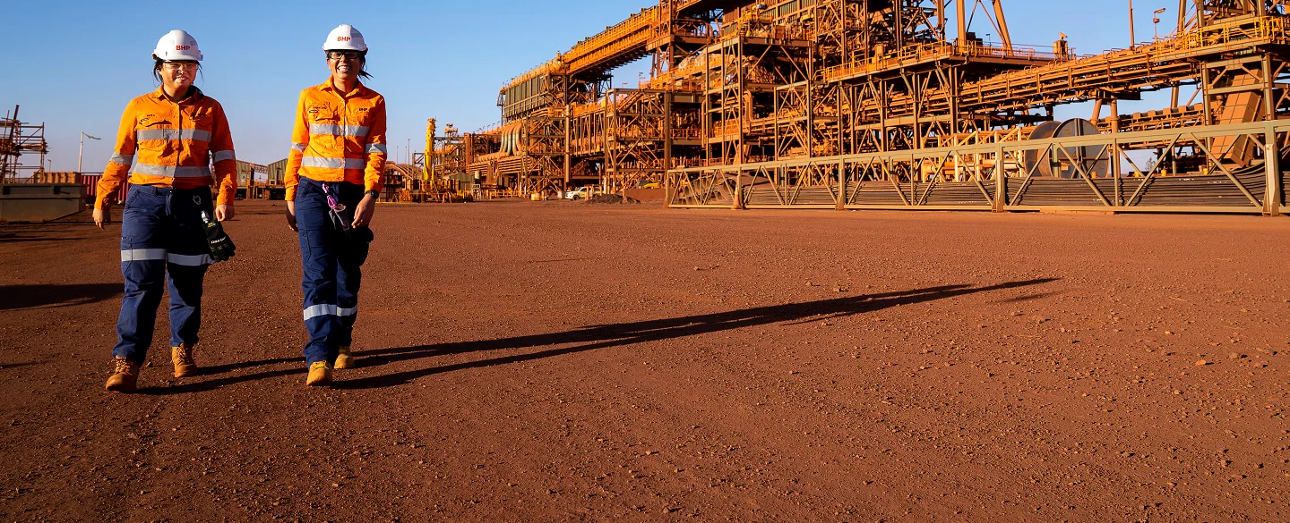

Figure 1: BHP
(Source: BHP, 2024)
To support its long-term net zero goals, BHP has put in place its Climate Transition Action Plan which includes investment in lower-carbon technologies. This report involves an analysis of the external marketing environment in which BHP operates, an external analysis of strategic growth opportunities using the Ansoff matrix, and a critical analysis of how BHP could gain sustainable competitive advantage as it progresses towards a lower carbon business model.

2. Task 1: Marketing Environment Analysis

2.1 Company Selection and Context
BHP is one of the world's largest diversified mining companies, and a world leader in the production of iron ore, copper, metallurgical coal and potash. Based in Melbourne, Australia, it has operations throughout Australia, Chile, Canada, and other countries around the world, providing raw materials that are crucial for infrastructure construction, steel manufacturing and the global energy transition. BHP's approach to going "into the future" with certain commodities has also helped to make it competitive, with demand for minerals to support renewable energy technologies rising alongside that for electric vehicles.
BHP's FY2024 revenue was US$55.7 billion, underlying EBITDA, US$28.3 billion and attributable profit, US$7.9 billion, indicating that BHP was resilient in the face of commodity price volatility. Production of the company's iron ore was also record level at 287 million tonnes, and copper at approximately 1.87 million tonnes was excellent out of its Australian and Chilean mines. BHP also had a total economic contribution of 91,587 employees and contractors worldwide and US$49.2 billion (Ernst and Young, 2021). These results prove this company will have the funds required to invest in sustainability measures and carbon reduction technologies.
Sustainability is an important component of BHP's policy. The company has targets for decarbonising its operations (Scope 1 and Scope 2) by 30% by FY2030 from the baseline of FY2020 and targets to help customers decarbonise steelmaking and other industrial processes. The commitments provide added confidence that the long-term competitive advantage will be maintained and that BHP will be a more attractive investment and regulator and a better customer (BHP, 2024).
The global operations map reveals that BHP's mining business is very spread out and has a strong presence in Australia, Chile and Canada. Australia remains the main site for BHP's iron ore business and BHP's excellent copper business is based in Chile. BHP's FY2024 Annual Report indicates that on a global level, BHP's contribution to the economy was US$49.2 billion, of which BHP made a contribution of US$34.7 billion in Australia alone (Sec.gov, 2024).

2.2 External Marketing Environment Actor 1 – Natural Environment
The natural environment is the most critical external factor influencing BHP's marketing environment as the impacts and risks of climate change, carbon emissions, resource scarcity and environmental regulations are becoming more significant in influencing what stakeholder expectations and market competitiveness are (Lee et al., 2020). Demand from governments, investors and industrial customers for lower-carbon minerals is accelerating as the world moves towards renewable energy and zero carbon emissions. There is growing demand for lower-carbon minerals from government, investors and mineral-using industrial customers, as the world transitions to renewables and zero carbon. This has led BHP to include sustainability in its corporate strategy, investing in renewable electricity, electrification technologies and improving operational efficiency. BHP continues to progress towards reducing its Scope 1 and Scope 2 GHG emissions by at least 30% by 2030 as outlined in its Climate Transition Action Plan and to become net-zero by 2050 through operational emissions.
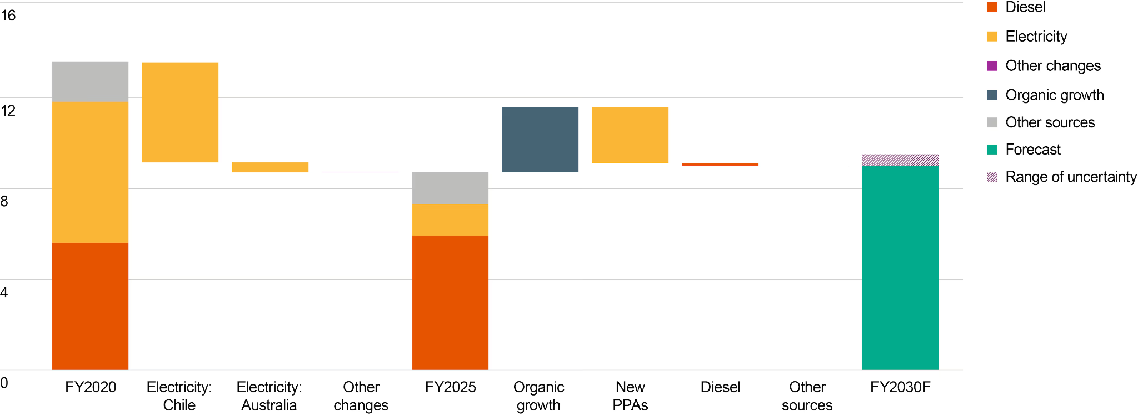

Figure 2: BHP Operational Greenhouse Gas (Scope 1 and Scope 2) Emissions (FY2020–FY2024)
(Source: BHP, 2024c)
The figure shows BHP's progress towards its goal of meeting its baseline reductions in operational GHG emissions from its FY2020 target. The company has been active in the area of renewable electricity procurement, energy efficiency programmes, and trials of battery-electric mining equipment, among other actions to support decarbonisation. BHP is on track to meet its medium term goal to cut operational emissions by at least 30% until FY2030, and aims to be a net zero operational emissions company by FY2050. By lowering emissions, the trajectory increases BHP's environmental performance, and provides greater confidence with its stakeholders.

2.3 External Marketing Environment Actor 2 – Political and Regulatory Environment
The political and regulatory environment significantly influences BHP's strategic decisions, investment priorities and marketing environment. BHP Billiton is one of the biggest mining companies in Australia and as such is subject to national climate legislation, environmental regulations and international sustainability frameworks. The Australia's Climate Change Act 2022 is the first statute to create a legally binding obligation for the Australian Government to achieve net zero emissions by 2050 and to cut emissions by 43% below 2005 levels by 2030 (DCCEEW, 2025). The national goals have driven high expectations of large mining companies to decarbonise their operations without compromising on their competitiveness.
The Safeguard Mechanism is a key policy influencing BHP, and is a regulatory framework for the highest-emitting industrial facilities in Australia. The mechanism is applicable to facilities that emit over 100,000 tonnes of CO₂-equivalent per year, and is based on a decreasing emission base. The policy has been updated since 2023, and now aligns with Australia's climate goals and promotes investment in decarbonising technology and increasing the competitiveness of Australian industries in the world. The scheme achieved coverage of 219 large facilities in 2023–24, covering around 31% of Australia's total greenhouse gas emissions (DCCEEW, 2025). Therefore, BHP is committed to ongoing investment in renewable electricity, electrification and operational efficiency to meet these regulatory obligations and ensure that BHP continues to have social licence to operate.
Globally, BHP is also being impacted by the Paris Agreement, which has raised disclosure expectations around ESG and new financial reporting requirements relating to climate change. Renewable energy incentives and funding for industrial decarbonisation are among the government's actions that can help mining companies move towards low carbon innovation. It is no longer only a legal requirement; regulatory compliance has become a corporate reputation-building exercise and a way to attract responsible investors and to build BHP's competitive edge in markets where customers are increasingly looking for sustainably produced minerals.
The timeline shows how Australia has been moving closer to a low-carbon economy by progressively tightened climate policy and emissions regulations. The Climate Change Act 2022, the Safeguard Mechanism reform in 2023 and the national 2030 emission reduction target of 43% below 2005 levels to reach the 2050 net zero target are key milestones (DCCEEW, 2025). The policies have a direct impact on mining companies like BHP, driving them to continuously lower their operational emissions and increase their transparency in reporting environmental, social and governance (ESG) data. Since the Safeguard Mechanism was expanded to 219 large industrial facilities, including large mining facilities, it has provided increased incentives to invest in renewable energy and energy efficiency and low carbon technologies.

3. Task 2: Strategic Growth and Competitive Positioning

3.1 Strategic Growth Recommendation Using Ansoff Matrix
The Ansoff Matrix (Ansoff, 1957) is a strategic planning matrix which offers four growth strategies for existing or new markets and products: market penetration, market development, product development, and diversification. It helps organisations assess growth opportunities without compromising on risk and long-term competitiveness.
For BHP, market penetration is the strategy of trying to boost sales of the current commodities, such as iron ore and copper, in their current markets by involving in more relationship-building activities and by being more efficient. This approach results in short-term revenue growth, but is not very effective for meeting rising expectations for environmental impacts or shifting customer expectations for reduced carbon products.
Market Development refers to the extension of existing products into new geographical markets, specifically into emerging economies of increasing interest in minerals for infrastructure and renewable energy. This can lead to market share growth, but also place BHP at risk from geopolitical challenges, trade restrictions and regulatory uncertainty.
Product development is the most suitable strategy, which supports the BHP long-term sustainability goals and the energy transition in the world. BHP is committing more resources towards commodities of the future and working with customers to apply lower carbon steel-making technologies and minimize value chain emissions. BHP is also committed to investing in renewable electricity, electrification, battery electric mining equipment and decarbonisation technologies as part of its Climate Transition Action Plan 2024, to help decarbonise its operations (BHP, 2024b). The programs result in products that are more valuable, improved ESG performance and customer demand for sustainably produced minerals.
Diversification is when companies enter into very new markets with new products (Cherepovitsyn et al., 2023). Diversification would diminish risk to business in the long-term, but would be more risky than product development and would take a significant amount of money to implement.
Hence, product development is the most appropriate approach to growth for BHP as it can be used to drive both the global transition to lower carbon economy and the competitive advantage. The growing demand for copper, nickel and potash in renewable energy systems and electric vehicles offers good long-term growth potential. In addition, BHP's innovation investment and sustainable mining technologies help the company deliver increased value to customers, enhance regulatory compliance and strengthen its responsible mining stewardship (BHP, 2024b).
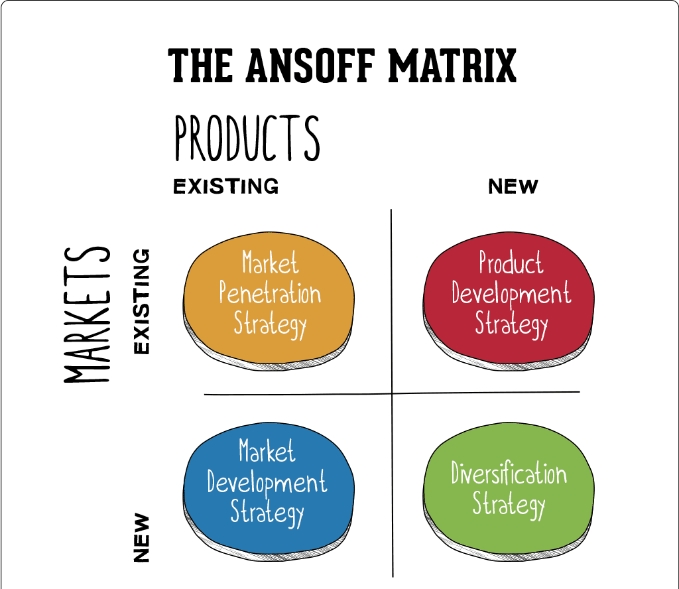

Figure 3: Ansoff Matrix
(Source: Hanlon, 2021)
As shown in the Ansoff Matrix, product development would provide a moderate level of risk with a good chance of long-term value creation opportunities, which is the most balanced growth strategy for BHP. BHP is focused not just on producing more of current commodities, but also on investing in products and technologies which will enable decarbonisation of the world, such as copper and potash partnerships, and low carbon steelmaking. BHP's Climate Transition Action Plan 2024 states that BHP is continuing investments in renewable electricity, electrification and emissions reduction technology and is proceeding on track to achieve the goal of reducing operational emissions by at least 30% from the FY2020 baseline level by FY2030 (BHP, 2024b). These investments deliver sustainability benefits, enhance BHP's ESG profile and align BHP's supply with increasing customer requests for responsibly sourced minerals. This means that product development also contributes to BHP's global competitiveness and profitability in the long term, while also supporting environmental goals.

3.2 Competitive Advantage through Lower-Carbon Business Model
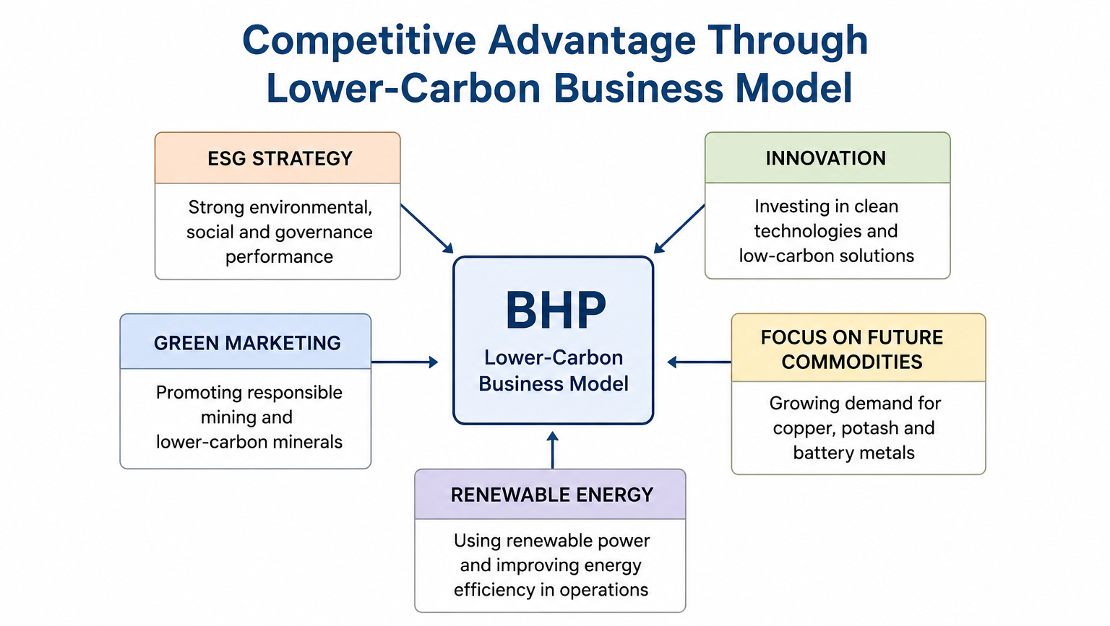

Figure 4: BHP Lower-Carbon Business Model
(Source: Self-Created)
BHP is gaining a competitive edge in the ability to embed sustainability into its business model, and in responding to global demand to meet the energy transition's critical mineral requirements. Porter's Generic Strategy: Organisations can outperform other organisations by using a cost leadership, differentiation or focus strategy. The strategy selected by BHP is a combination of cost leadership and differentiation based on investments in lower carbon technology and sustainable mining practices, while efficiently operating on a large scale. This plan will help reduce production costs, increase operational efficiency and differentiate itself with strong Environmental, Social and Governance (ESG) reporting (Rosário and Cruz, 2025).
BHP's ESG strategy is closely aligned with its Climate Transition Action Plan (CTAP) 2024 that was approved by 92 per cent of shareholders at the 2024 Annual General Meeting. The company is ongoing to purchase renewable electricity, electrification, battery electric haul trucks and partnerships to reduce emissions across the steelmaking value chain. BHP is also investing in its portfolio with a focus on future commodities vital for electric vehicles, renewable energy infrastructure and global food security such as copper and potash. The investments reinforce BHP's commitment to responsible resource generation and climate action, bolstering its green marketing strategy.
The other significant source of competitive advantage is innovation. BHP is stepping up its renewable electricity use by entering into a number of long-term power purchase agreements, including several power purchase agreements to develop new renewable electricity generation projects (Antony Jose et al., 2024). Meanwhile, the company is helping to speed up the shift away from diesel-based mining equipment to battery electric powered technology that will cut the emissions from operations.
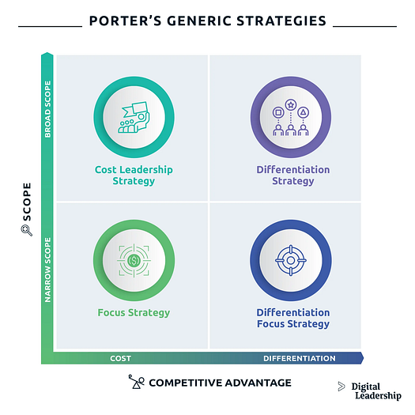

Figure 5: Porter's Generic Strategy
(Source: Dieffenbacher, 2024)
The BHP's competitive advantage is achieved through both cost leadership and differentiation (Porter's Generic Strategy). The company's wide-ranging operations enable large-scale economies and investments in renewable electricity, digital mining technologies and operational efficiency reduce costs. Meanwhile, BHP differentiates itself by excellent ESG behaviour, transparency in climate disclosures and investments in low carbon products. This realigns the two strategies to cater for the increasing demand of customers for responsibly sourced minerals and to keep BHP profitable.
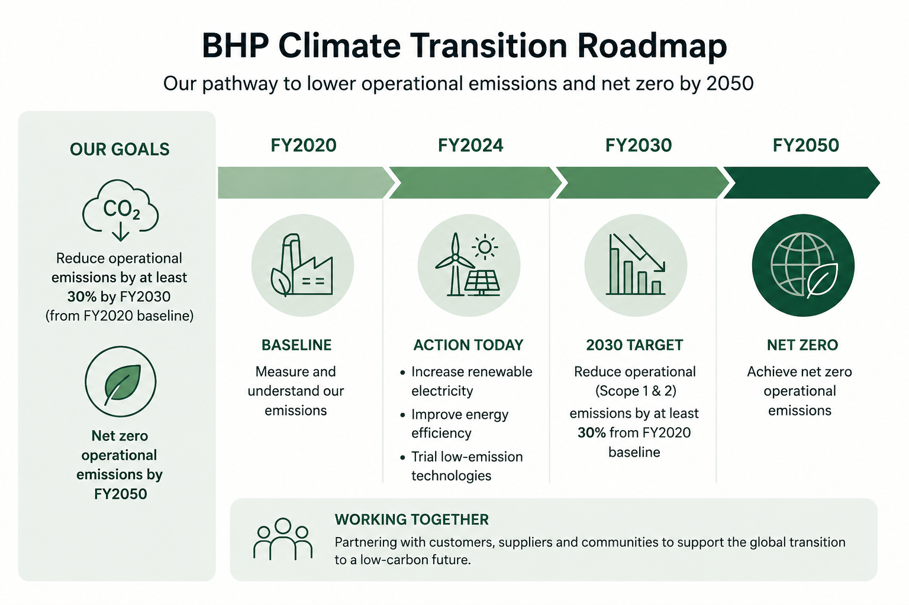

Figure 6: BHP Climate Transition Roadmap
(Source: Self-Created)
The Climate Transition Roadmap provides a blueprint for BHP's transition to decarbonise its operations and to become a net-zero company. Renewable electricity investments, electrification of mining fleets, investments in battery-electric haul trucks and investments in energy efficiency and energy value chain participation with customers to reduce value chain emissions are part of the roadmap. BHP's 2024 CTAP also reinforces BHP's commitment to a 30% target for reductions to its operational Scope 1 and 2 emissions by FY2030 and a future goal of becoming ‘operational net zero' by 2050. There is also a need for continuing technological innovation and collaboration, as some of the technologies for decarbonisation are not commercially available today, the roadmap notes.

4. Task 3: Critical Reflection on AI Usage

4.1 Tool Disclosure
Only as a tool for a literature search to identify relevant academic work, to summarise background information and to improve the grammar and organisation of the work was Generative AI used. The final report, critical analysis and evaluation, interpretation of evidence and conclusions were independently reviewed, edited and verified with appropriate academic and industry sources.

4.2 Critical Evaluation of AI Output
Although AI enhanced the research process, some answers were found not to be contextually relevant, with information that was outdated or lacking in academic references, requiring verification. Prior to inclusion in this report, each numerical statistic, company performance indicator and sustainability claim has been reviewed in BHP Annual Reports, the Climate Transition Action Plan, government publications and peer-reviewed literature. The suggestions that are generated by AI were thus not treated as definitive advice. This verification process resulted in the report being more reliable, accurate, and with a better academic standard, and excluded unsupported information.

4.3 Contribution Analysis
The most common applications of AI were brainstorming, identifying topics, clarifying sentences, and proposing appropriate report structures. The critical evaluation of BHP's marketing environment, the use of the Ansoff Matrix and Porter's Generic Strategy, interpretation of the sustainability data, choosing academic sources and the creation of recommendations were completed independently of judgement and analysis. The figures, numerical evidence and Harvard references have not been selected solely based on what AI generated but have been selected from official reports or academic sources where they are found as reliable sources of information. The report was, in this manner, more of a personal understanding with AI acting as a learning support tool than when it is doing an academic task for the student.

4.4 Ethical and Professional Reflection
Using AI in higher education should be done transparently and ethically, while adhering to the principles of academic honesty, which aligns with the university's academic integrity policy. AI was employed in a way that was strictly within its bounds and any findings were crosschecked and referenced appropriately throughout this assignment. This was to foster honesty, responsibility and critical thinking and research.

5. Conclusion
The marketing environment of BHP has been critically evaluated in this report and it was discovered that the most critical external factors affecting the BHP long-term competitiveness are the sustainability of the marketing environment and the regulatory change. The analysis showed that BHP has a major spur in the future as the global need for future-oriented commodities such as copper and potash is expected to increase, and because of technological advancement and the adoption of renewables. However, climate change, stricter environmental policies and requirements, carbon cuts and geopolitical unpredictability remain as major strategic challenges. The product development strategy used by BHP based on the Ansoff Matrix is the most appropriate path towards the long-term development of BHP because it is more aligned to the lower-carbon transition being undertaken by BHP and the increasing demand of their products based on those minerals to be developed in a sustainable way by its customers. Moreover, Integration of Porters Generic Strategy, ESG programs and BHP Climate Transition Action Plan 2024 also help to increase the competitive edge of BHP by promoting innovation, operational efficiencies and sustainability leadership. To sum up, the capacity of BHP to create long-term value to stakeholders depends on its continuing quest to decarbonise, renewable energy and responsible mining, as well as its response to the evolving regulatory and environmental environment across the world.

References
Ansoff, H.I. (1957) ‘Strategies for diversification’, Harvard Business Review, 35(5), pp. 113–124. https://www.casrilanka.com/casl/images/stories/2017/2017_pdfs/sab_portal/course_material/strategies_for_diversification.pdf
Antony Jose, S., et.al. (2024). Promoting a Circular Economy in Mining Practices. Sustainability, 16(24), p.11016. doi: 10.3390/su162411016
BHP (2024a). 2024 Annual Reporting Suite. [online] Bhp.com. Available at: https://www.bhp.com/news/media-centre/reports-presentations/2024/08/2024-annual-reporting-suite [Accessed 14 July 2026a].
BHP (2024b). Climate Transition Action Plan | BHP. [online] Bhp.com. Available at: https://www.bhp.com/sustainability/climate-change/climate-transition-action-plan [Accessed 14 July 2026b].
BHP (2024c). Operational GHG emissions (Scopes 1 and 2 emissions from our operated assets) | BHP. [online] Bhp.com. Available at: https://www.bhp.com/sustainability/climate-change/operational-ghg-emissions [Accessed 14 July 2026c].
BHP (2024d). Our businesses. [online] Bhp.com. Available at: https://www.bhp.com/about/our-businesses [Accessed 14 July 2026d].
Cherepovitsyn, A., Kazanin, A. and Rutenko, E. (2023). Strategic Priorities for Green Diversification of Oil and Gas Companies. Energies, 16(13), pp.4985–4985. doi: 10.3390/en16134985
DCCEEW (2025). Safeguard Mechanism. [online] Dcceew.gov.au. Available at: https://www.dcceew.gov.au/climate-change/emissions-reporting/national-greenhouse-energy-reporting-scheme/safeguard-mechanism [Accessed 14 July 2026].
Dieffenbacher, S. (2024). Porter’s Generic Strategies: Cost Leadership, Differentiation and Focus. [online] Digital Leadership. Available at: https://digitalleadership.com/blog/porters-generic-strategies/ [Accessed 14 July 2026].
Ernst and Young (2021). ANNUAL REPORT PURSUANT TO SECTION 13 OR 15(d) OF THE SECURITIES EXCHANGE ACT OF 1934 . [online] Sec.gov. Available at: https://www.sec.gov/Archives/edgar/data/811809/000119312524210297/d812514d20f.htm [Accessed 14 July 2026].
Hanlon, A. (2021). The Ansoff Model. [online] Smart Insights. Available at: https://www.smartinsights.com/marketing-planning/create-a-marketing-plan/ansoff-model/ [Accessed 14 July 2026].
Lee, J., Bazilian, M., Sovacool, B. and Greene, S. (2020). Responsible or reckless? A critical review of the environmental and climate assessments of mineral supply chains. Environmental Research Letters, 15(10), p.103009. doi: 10.1088/1748-9326/ab9f8c.
Rosário, A.T. and Cruz, R.N. (2025). Environment, Social, and Governance Business: Challenges and Opportunities. Information Systems Engineering and Management, pp.73–102. doi: 10.1007/978-3-031-86079-9_4
sec.gov (2024). REPORT OF FOREIGN PRIVATE ISSUER PURSUANT TO RULE 13a-16 OR 15d-16 UNDER THE SECURITIES EXCHANGE ACT OF 1934. [online] Sec.gov. Available at: https://www.sec.gov/Archives/edgar/data/811809/000119312524207407/d886704d6k.htm [Accessed 14 July 2026].

