
MODULE NAME: INTERNATIONAL FINANCIAL MANAGMENT
MODULE CODE: LCBB6002

TOPIC: IMPORTANCE OF INTERNATIONAL FINANCIAL MANAGEMENT (IFM) TO THE CORPORATION (1500 words)

STUDENT NAME: MARTINA CHORLOVA
STUDENT NUMBER: 2028046

LECTURER NAME: DR. TAYE OSADIYA

DATE: 25/08/2023

TABLE OF CONTENTS

- INTRODUCTION……………………………………………………………………...3

- ANALYSIS OF DIVIDEND DISTRIBUTION POLICY ……………………….3

- ANALYSIS OF EFFICIENT MARKET HYPOTHESIS THEORY …………4

- ANALYSIS OF APPRAISING PROJECTS……………………………………….5

- CONCLUSION…………………………………………………………………………..6

- REFERENCES………………………………….………………………………………..7

- INTRODUCTION
Today’s world has made widespread use of the term International Financial Management, which more commonly goes by the name International Finance. It refers to the management of financial resources within an international context of business. The study of the changes in exchange rates, foreign investments, and the ways in which these factors influence international trade is the focus of the field of economics known as international finance. Not only is it essential for large multinational corporations (MNCs) with a large number of overseas subsidiaries to have an understanding of international financial management, but it is also essential for small businesses that are engaged in exporting or importing.
The retail industry on a worldwide scale is one of the most important industries in the world since it supplies a wide variety of product categories to end users. Tesco is a worldwide corporation that has its operations based in the United Kingdom and manages a wide variety of grocery and general goods products. This company was founded in 1919, and its shares have been traded on the London Stock Exchange (Rosnizam et al., 2020). The company operates in several nations throughout continental regions, encompassing multiple business units. Notably, it offers financial services primarily through its subsidiary, Tesco Financial Services. This subsidiary effectively administers the accounts of 4.6 million clients, which are categorised into segments such as vehicle insurance, credit cards, and policies. In this report will be analysed the dividend distribution policy, efficient market hypothesis and methods of appraising projects of the company.

- ANALYSIS OF DIVIDEND DISTRIBUTION POLICY
The definition of 'dividend policy' states that it is "the practise that management follows in making dividend payout decisions or, in other words, the size and pattern of cash distributions over time to shareholders" (Lease et al., 2000, p. 29). Since the beginning of the modern commercial corporation, managers have been struggling with the question of how they should approach dividend policy. It should come as no surprise, then, that dividend policy continues to be one of the subjects of greatest discussion in finance. There are three primary theories of dividends, all of which are in direct opposition to one another. There are those who maintain that a rise in dividend payments results in an increase in the value of a company. According to a different point of view, high dividend payouts have the opposite effect on the value of a company, more specifically, they have a negative impact on the value of the company. The third theoretical approach contends that dividends should not be considered important, and that any work that is put into determining whether or not to pay dividends is wasted. These points of view are reflected in the following three hypotheses and theories about dividend policy: the high dividends raise share value theory (also known as the 'bird-in-the-hand' argument), the low dividends increase share value theory (also known as the tax-preference argument), and the dividend irrelevance hypothesis (also known as Modigliani and Miller (M&M) theory).
As per the most recent information available as of the month of August 2023, Tesco had distributed dividends amounting to 0.14 USD per share over the course of the preceding 12 months. This equates to a dividend yield of 4.32% based on the current price of the stock, which is 3.21 USD a share. Dividends are distributed by Tesco twice yearly. The months of June and November are reserved for payments. The figure below displays Tesco’s cumulative dividend for each fiscal year.

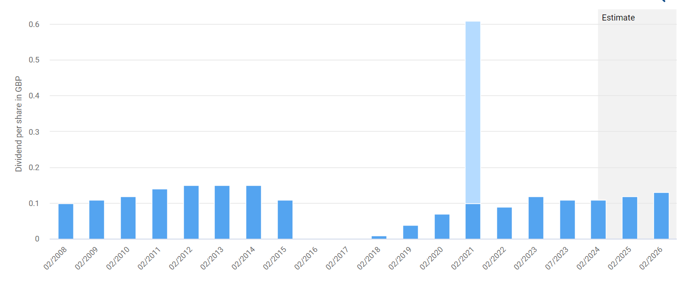
Source: dividendstocks.cash (2023)

The previous year did not see an increase in the dividend paid by Tesco. In the past decade, Tesco has managed to bring this number down by an average of -3.24% every year. The dividend went risen by 25.71% during the course of a period of 5 years. In the event that the standard of the company's shares does not change, the presence of an unusually high dividend yield is indicative of an undervaluation. When viewed from the opposite perspective, a stock that has a historically low dividend yield despite constant increases in the dividend payout looks to be overvalued. What exactly is going on with Tesco? Tesco has had a dividend yield of 4.66 percent on average over the course of the last 12 months. It currently stands at 4.32%, which is 0.34 percentage points lower than its previous value. A favourable purchasing opportunity for Tesco shares has not presented itself as a result of the decline in the dividend yield. However, the amount of the dividend is not sufficient evidence to determine whether the stock is priced reasonably or generously on its own. As a consequence of this, one may argue that dividends do in fact have the potential to influence the wealth of shareholders, both positively and negatively. Because of this, Modigliani and Miller (M&M) theory is not applicable to Tesco.

- ANALYSIS OF EFFICIENT MARKET HYPOTHESIS THEORY
This hypothesis relates to the fact that the share price reflects all of the information about the company. It makes the assumption that stock prices are listed on stock exchanges in a manner that is both transparent and accurate. It is an indication that the value of monetary securities reflects all of the market data in its entirety. Using this method, investors can realise greater profits by accepting appropriate levels of risk. In relation to Tesco, there are three distinct types of efficient market theory, namely:
Weak form: It requires that all share price data is available to market participants. Only the information that the corporation wishes to share with the public is disclosed. The difficulty with weak efficiency theory is that historical price information is unrelated to the approaching future cost of the assets. This corporation does not use technical analysis to forecast stock values in the future (Muraina & Dandago,2020).
Semi-strong form: This idea holds that any positive or negative information about the company will have an immediately impact on the share price. The company is unaware of any price modifications. For measuring the current value of a company share, the organisation must look to the future. The corporation does not employ technical or basic assessment for any illegal purpose in modest study of efficiency theory.
Strong Form: This indicates that the only individuals who are aware of the current stock price are the board of directors and the chief executive officer of the company. It incorporates the information gathered from firm management as well as information gathered from outside sources. In this particular business, the share price of the company is determined using both historical and current data. According to Rugman (2019), it is difficult to earn riches in the market over longer time periods.

- ANALYSIS OF APPRAISING PROJECTS
Business organisations often use one of four distinct approaches to investment assessment in order to analyse any proposal for capital investments and determine which fixed assets to buy. Accounting Rate of Return, also known as ARR, Payback, Net Present Value, or NPV, and Internal Rate of Return, also known as IRR, are four methodologies that are frequently employed. After perusing the most recent annual report and financial statement published by Tesco, it is clear from reading this report that the corporation employs practically all of the strategies. Let me briefly examine one of the methodologies used by Tesco and that is NPV. The company’s plan to open new 65 Tesco Express stores across the country. Before coming to this conclusion, the management team should have given some thought to how well this industry has performed over the course of the years and assessed how the company is currently trending in this regard. This would have allowed them to estimate the amount of money they would bring in thanks to this investment. Once the amount of money that is going out is deducted from the total amount of cash flows that are coming in after they have been discounted, the net present value of the investment needs to be positive in order for it to be deemed a valuable investment. Before making any decision on the investment of capital, an appropriate appraisal is required. Before beginning work on any new project, it is important to first do a thorough analysis of the project using the process that is more commonly known as strategic planning. The procedure is of such critical importance that it can go a long way towards determining whether a particular capital investment will be successful or unsuccessful.

- CONCLUSION
In conclusion, can be observed that Tesco’s dividend distribution policy indicates undervaluation. The statistics as a whole demonstrates that Tesco's operational efficiency and profitability have increased and are currently at a higher level than they were in the years prior. The projections indicate that this pattern will continue as it has been. This is a result of Tesco's strong strategic alignment and its membership card policy, both of which allow the company to make more effective use of its resources. Tesco has been able to maintain its leadership position and increase its market share as a result of this. On the other hand, Tesco had a few problems, such as a low liquidity ratio. Despite this, Tesco remains a potential investment option for individuals looking for reliable returns on their capital because the corporation can give such returns.

- REFERENCES

Bernhard S., et al. (2014) “Preferences and Performance of International Strategies in Retail Sectors: An Empirical Study”, Long Range Planning 47, pp. 319-336

Dayananda, D., et al. (2002) “Capital Budgeting Financial Appraisal of Investment Projects”, Cambridge, Cambridge University Press

Frankfurter, M. & Wood, G. (2002) “Dividend policy theories and their empirical tests”, International Review of Financial Analysis, Vol. 11, Is. 2, pp. 111 – 138

Lease, C., et al. (2000) “Dividend Policy: Its Impact on Firm Value”, Boston: Harvard Business School Press, pp. 29

Miller, M.H. & Modigliani, F. (1961) “Dividend Policy, Growth, and the Valuation of Shares”, Journal of Business, Vol. 34, Is. 4, pp. 411 – 433

Muraina, A. & Dandago, I., (2020) “Effects of implementation of International Public Sector. Accounting Standards on Nigeria's financial reporting quality”, International Journal of Public Sector Management

Parker, M. (2005) “Retail Multinational learning: a case study of Tesco”, International Journal of Retail & Distribution Management, Vol. 33, Is. 1, pp. 23-48

Rafferty, M. et al. (2010) “Dividend Policy: A Review of Theories and Empirical Evidence”, International Bulletin of Business Administration, Issue 9, pp. 171 – 187

Rosnizam B., et al. (2020) “Market opportunities and challenges: A case study of Tesco” Journal of the Community Development in Asia (JCDA), Vol. 3, No 2, pp. 18-27

Rugman, M., (2019) “From globalisation to regionalism: The foreign direct investment
dimension of international finance. In Shaping a new international financial system”,
Routledge, pp. 203-219

Tesco Annual Report (2022) online source, available at: https://www.tescoplc.com/media/759057/tesco-annual-report-2022.pdf (accessed on 14/08/2023)

Tesco Dividend (2023) online source, available at: https://dividendstocks.cash/dividend-profile/Tesco-Dividend#:~:text=Tesco%20pays%20a%20dividend%202,income%20for%20the%20whole%20year. (accessed on 15/08/2023)

