Student name: | Zunaira Mushtaq
Programme: | Certificate of Higher Education Skills for the Workplace (Health & Social Care)
Module: | Introduction to Health and Social Care
Module code: | LCHS4003
Assignment Title: | Written Assignment – Component 1: Coursework Portfolio (Task 1 and Task 2)

Table of Contents
Task 1: Report on the Shortage of Community Mental Health Services 3
1. Introduction 3
2. The Council’s Duties under the Care Act 2014 3
3. Impact of the Issue on the Community 4
4. Recommended Response 4
5. Conclusion 5
Task 2: Essay on Ambulance Services in the UK 6
2.1 Introduction 6
2.2 Origins and Historical Context 6
2.3 How the Service Functions Today 6
2.4 Significance for Quality of Life 8
2.5 Conclusion 9
Reference List 10

Task 1: Report on the Shortage of Community Mental Health Services
To: Councillor, Cabinet Member for Health and Social Care, Birmingham City Council
Address: Victoria Square, Birmingham, B11 1B
From: Zunaira Mushtaq
Subject: Addressing the shortage of community mental health services in Birmingham

1. Introduction
Community mental health services allow people with mental health problems to stay safe at home (Sartorius, 2023). These types of services include community mental health teams, crisis care, supported housing, day centres and peer group programs. There currently is not enough provision for such services in Birmingham.
The need for mental health provision is growing across England. The number of new referrals to secondary mental health services per month stood at approximately 454,000 in 2024/25 (CQC, 2025). Birmingham is a big and diverse city with a population of over one million people. Mental health provision locally is provided by Birmingham and Solihull Mental Health NHS Foundation Trust. However, local provision has failed to keep up with the growing demand, leading to long waiting times for patients.
This report outlines the effects of the shortage in our community and makes recommendations on how the Council can act. This is done within the framework of its duties under Part 1 of the Care Act 2014.

2. The Council’s Duties under the Care Act 2014
The Council’s core duties in care and support are detailed in Part 1 of the Care Act 2014, and from the list below, it is evident that this service is needed in our community:
- Section 1 (Well-being): the Council must improve the well-being of individuals. Well-being encompasses physical, mental and emotional health.
- Section 2 (Prevention): the Council must arrange and provide services for the prevention or reduction or delay of care needs.
- Section 3 (Integration): the Council must collaborate with the NHS to integrate health and social care.
- Section 4 (Information and advice): the Council must provide individuals with information regarding care and support in the council’s area.
- Section 5 (Market Shaping): The Council is expected to provide an array of quality local services.
- Sections 9 and 10 (Assessment): The Council is expected to carry out assessments on adults and their carers who may require care.
- Section 18 (Meeting Needs): The Council should satisfy the person’s eligible needs.
In the absence of adequate community mental health services, the Council will be unable to meet these obligations (Care Act 2014; Department of Health and Social Care, 2014).

3. Impact of the Issue on the Community
Longer waits make people worse off. Long waiting times for CMHTs have been noted. The typical waiting time for the second appointment is slightly above seven weeks, while there are services that take even longer periods (Centre for Mental Health, 2025). CQC (2026) has found that those who had to wait longer were more likely to report deterioration of their mental health state.
More people reach crisis. Without early intervention, some individuals become in crisis in terms of their mental wellbeing. They may then attend A&E, require police assistance, or get themselves hospitalised.
Unequal access. Certain groups have had to wait for longer periods than others. For instance, younger people, the disabled, and autistic individuals were more prone to report longer waiting times and unsuitable services (CQC, 2026).
Pressure on unpaid carers. Relatives step in to fill that void. This could be detrimental to their own well-being and even employment. They, too, might need some assistance.
Wider social effects. The link between poor mental well-being and loneliness, unemployment, debt, and homelessness is clear. This affects the entire community and puts additional pressure on other services of the Council, like housing.

4. Recommended Response
The Council should undertake the following six actions:
- Mapping need for services using the NHS. Collaborate with NHS Birmingham and Solihull ICB on assessing the needs gap. This can be done by using JSNA in partnership planning (section 3).
- Investing in prevention and early intervention. This includes funding well-being hubs, peer support services, and voluntary sector services. Also, offer help during the waiting time for treatment (section 2).
- Improving information and advice. Create an easily accessible website and telephone directory for local mental health services (section 4).
- Shape the local market. Increase the number of supported housing and community support providers. Increase the recruitment and training of social workers and support workers (section 5).
- Make assessments quicker. Ensure that needs assessments and carers’ assessments are carried out for adults and their carers, with independent advocacy as required (sections 9, 10 and 67).
- Keep track of progress. Monitor waiting times and feedback from service users. Publish the findings at six-monthly intervals to the Birmingham Health and Wellbeing Board.
These actions would increase early help. The resources available to the Council are very stretched, making early help the most effective way to spend limited money.

5. Conclusion
There is a lack of mental health support services within the community in Birmingham. This results in delays, increased crisis situations, inequitable access, and additional burden on carers. There are clear statutory responsibilities laid out in the Care Act 2014 which outline the responsibilities of the Council to promote well-being and prevent need. It is possible for the Council to meet these responsibilities through working with the NHS and by making early help investments and assessing progress.
Yours sincerely,
Zunaira Mushtaq

Task 2: Essay on Ambulance Services in the UK

2.1 Introduction
Ambulances provide immediate and urgent care to those who are ill or injured. They respond to 999 calls, provide treatment on the spot, and transfer the casualties to hospitals. In this essay, the background behind the development of ambulance services is examined and evaluated. The essay also looks into the impact of ambulance services in improving the lives of the service users.

2.2 Origins and Historical Context
The concept of an ambulance developed during wars. In the 1790s, Dominique-Jean Larrey, the army surgeon, introduced horse-drawn "flying ambulances" which transported wounded soldiers quickly from the scene of battlefields to hospitals.
In the UK, civilian ambulance services have been officially developed since the late nineteenth century. In 1877, the St John Ambulance Association was founded to teach civilians about first aid skills. The Metropolitan Asylums Board used horse-drawn ambulances to take patients with infectious diseases in the 1880s in London (Pollock, 2013). Nevertheless, the ambulance services across the country were irregular.
The turning point in the history of the development of ambulances is related to the creation of the National Health Service. The National Health Service Act of 1946 obliged the local health authorities to ensure ambulance provision for those who required their services. Since 1948, the services were free of charge for all patients. Initially, ambulance personnel were considered mainly as drivers transporting patients to hospitals.
Their role has developed over time. In 1966, paramedics in Belfast established the mobile coronary care unit. This revealed that there were better chances of survival for heart attack patients when treated before arriving at hospitals (Pantridge and Geddes, 1967). Following this, there was an improvement in training for the staff. In the 1980s and 1990s, the paramedic role evolved. Paramedics are now health practitioners who work independently.

2.3 How the Service Functions Today
Currently, there are ten NHS ambulance trusts in England. The calls are categorised according to their severity. The first category includes cases of life-threatening urgency like cardiac arrest, where the goal is a seven-minute average response time. The second category comprises emergencies like stroke or chest pain. The goal set for the second category is 18 minutes, although, temporarily, it is 30 minutes, to aid recovery (NHS Providers, 2025).
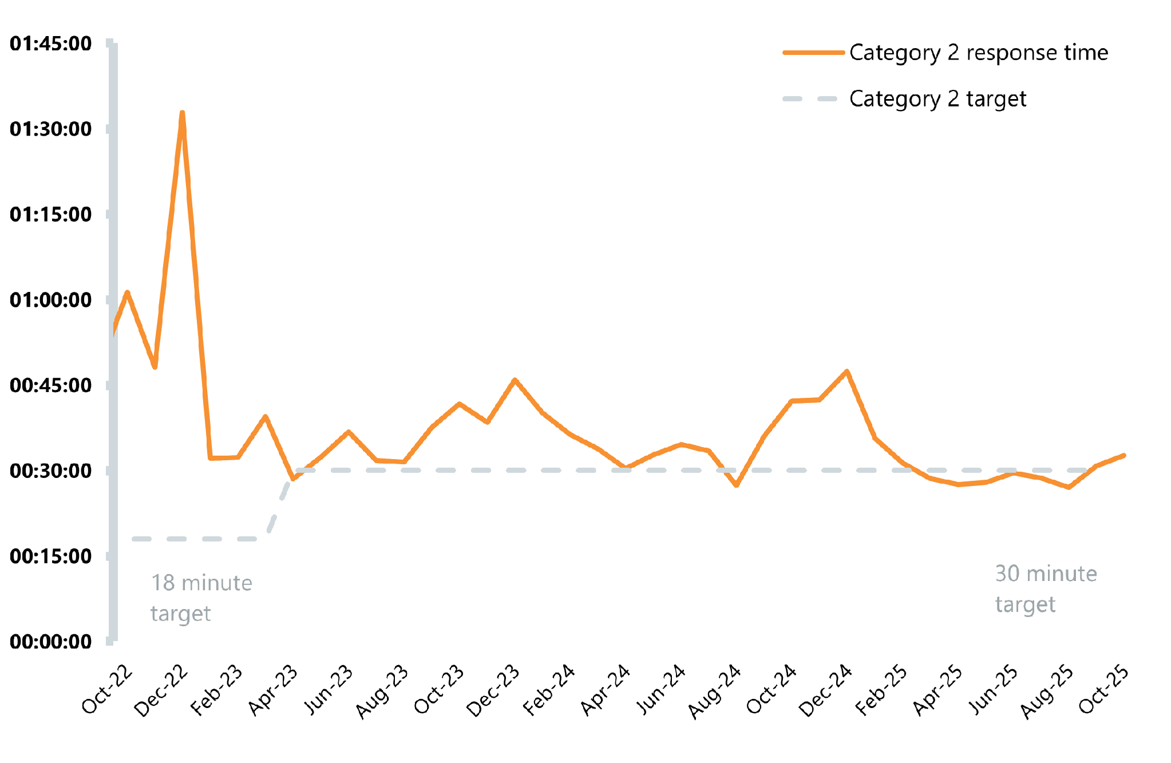
Figure 1: Ambulance response times for category 2 incidents
Source: (NHS Providers, 2025).
This service has several advantages. The personnel do far more than merely transport the patients. Patients are treated over the phone ("hear and treat") or even at home ("see and treat"). It helps reduce unnecessary visits to the A&E. The ambulance service cooperates with NHS 111, GPs and mental health professionals.
Nevertheless, there are several major challenges the service has to cope with. Demand is extremely high. October 2025 saw almost 800,000 ambulance incidents, which was a monthly record (NHS Providers, 2025). Response times are often too long. In 2024/25, the average Category 2 response time was 35 minutes 11 seconds, exceeding the target of 30 minutes (Nuffield Trust, 2025).
The main reason for this situation is that hospital stays are too long and ambulances have to wait while passing patients to the A&E department. In December 2025 (fig 2), the average handover time exceeded 30 minutes (NHS Providers, 2026). While waiting, ambulances cannot answer calls. There is an evident trend of improvement. In December 2025, the average Category 2 response time was 32 minutes 43 seconds, compared to 47 minutes 26 seconds a year ago (NHS Providers, 2026).
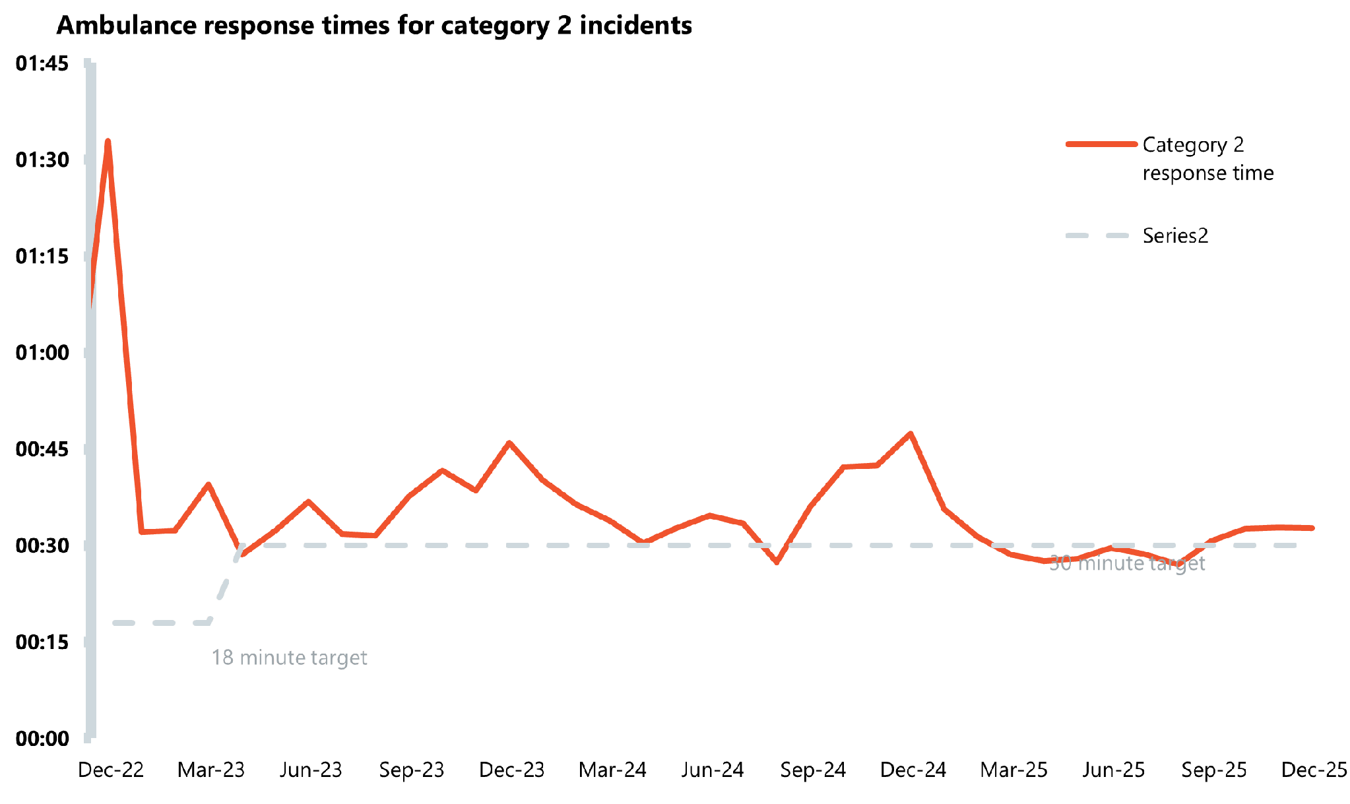
Figure 2: Ambulance response times for category 2 incidents
Source: (NHS Providers, 2026).

2.4 Significance for Quality of Life
Ambulances contribute positively to the quality of life of service users. Firstly, timely reaction saves lives. The faster the reaction time, the more lives can be saved from cardiac arrest, stroke, or heart attack. Timely treatment can also reduce possible complications that will lead to chronic diseases, therefore increasing people's independence.
Secondly, treatment in place can be beneficial to many patients. For instance, an elderly person who falls down can be examined and helped in the same place. This way, one can avoid hospitalisation, which causes stress and increases the risk of infections.
Thirdly, this service provides additional comfort. Elderly persons, disabled persons, or persons with chronic illnesses feel safe in case something happens. It allows people to live independently because of the constant availability of help. In addition, non-emergency patient transportation helps people to visit medical institutions regularly, like dialysis.

2.5 Conclusion
Ambulance services originated from battlefields and evolved into an important service within the NHS. Currently, these services provide specialised care through telephone consultations, visits to patients’ homes and during transfers to hospitals. They experience challenges such as high demand for their services, long response times and poor handover processes at hospitals. Despite these challenges, ambulance services play an important role in saving lives and promoting independent living among individuals.

Reference List
Care Act 2014, c. 23. Available at: https://www.legislation.gov.uk/ukpga/2014/23/contents (Accessed: 13 October 2026).
Care Quality Commission (CQC) (2025) The state of health care and adult social care in England 2024/25: mental health. Available at: https://www.cqc.org.uk/publications/major-report/state-care/2024-2025/access/mh (Accessed: 13 October 2026).
Care Quality Commission (CQC) (2026) Community mental health survey 2025. Available at: https://www.cqc.org.uk/publications/surveys/community-mental-health-survey (Accessed: 13 October 2026).
Centre for Mental Health (2025) Mental health services in the UK in 2025: what the latest NHS Benchmarking survey tells us. Available at: https://www.centreformentalhealth.org.uk/mental-health-services-in-the-uk-in-2025-what-the-latest-nhs-benchmarking-survey-tells-us/ (Accessed: 13 October 2026).
Department of Health and Social Care (2014) Care and support statutory guidance. Available at: https://www.gov.uk/government/publications/care-act-statutory-guidance/care-and-support-statutory-guidance (Accessed: 13 October 2026).
National Health Service Act 1946, c. 81. Available at: https://www.legislation.gov.uk/ukpga/Geo6/9-10/81/contents (Accessed: 13 October 2026).
NHS Providers (2025) NHS Activity Tracker: November 2025 – ambulance sector. Available at: https://nhsproviders.org/resources/nhs-activity-tracker-november-2025/ambulance-sector (Accessed: 13 October 2026).
NHS Providers (2026) NHS Activity Tracker: January 2026 – ambulance sector. Available at: https://nhsproviders.org/resources/nhs-activity-tracker-january-2026/ambulance-sector (Accessed: 13 October 2026).
Nuffield Trust (2025) Ambulance response times. Available at: https://www.nuffieldtrust.org.uk/resource/ambulance-response-times (Accessed: 13 October 2026).
Pantridge, J.F. and Geddes, J.S. (1967) ‘A mobile intensive-care unit in the management of myocardial infarction’, The Lancet, 290(7510), pp. 271–273.
Pollock, A. (2013) ‘Ambulance services in London and Great Britain from 1860 until today: a glimpse of history gleaned mainly from the pages of contemporary journals’, Emergency Medicine Journal, 30(3), pp. 218–222.
Sartorius, N. (2023). Community care for people with mental illness: Challenges emerging in the 2020s and consequent recommendations. World Psychiatry, 22(3), 388–389. https://doi.org/10.1002/wps.21112

