

Postgraduate/Distance Learning
Assignment coversheet & feedback form

THIS SHEET MUST BE THE FIRST PAGE OF THE ASSIGNMENT YOU ARE SUBMITTING (DO NOT SEND AS A SEPARATE FILE)

For completion by the student:
Student Name: Andrea Hofmann

Student University Email: 2324045@student.uwtsd.ac.uk
Module code: HPCA7028  Module title: Sacred Skies | Student ID number:  2324045 |  |  | Educational support needs:  Yes/No  No
Assignment title: A Critical Examination of the Sky in Relation to Material Culture

Assignment due date: 2 May 2024
This assignment is for the 1st X 2nd 3rd 4th 5th 6th module of the degree
I confirm that this is my original work and that I have adhered to the University policy on plagiarism.
Signed ……………………………………………………………
Email submission:if you are submitting this form via email, please tick this box X □
(as a substitute for your signature) to confirm that you agree to the above declaration.
Assignment Mark
1st Marker’s Provisional mark
2nd Marker’s/Moderator’s provisional mark
External Examiner’s mark (if relevant)
Final Mark

NB. All marks are provisional until confirmed by the Final Examination Board.

For completion by Marker 1 :
Comments:

Marker’s signature: |  |  | Date:
For completion by Marker 2/Moderator:

Comments:

Marker’s Signature: |  | Date:
External Examiner’s comments (if relevant)

External Examiner’s Signature: |  | Date:

A Critical Examination of the Sky in Relation to Material Culture

The Megalithic Site of Yverdon-Les-Bains

Introduction
This essay aims to measure the Yverdon-Les-Bains megalithic site in Switzerland and understand it as a cultural expression of the people who built it. The site is located on the southwestern shore of Lake Neuchâtel, situated in the western region of the Swiss Plateau. Built by the Cortaillod culture, whose presence can be traced all throughout the plateau, along the base of the Jura mountain range, the megalithic monument is about 6000 years old and was in use for at least 3000 years. As the most notable and ancient megalithic building in the alpine region of Middle Europe, the Yverdon site showcases two main stone rows and three separate clusters of individual stones, altogether adding up to 45 menhirs, some very large and weighing nearly five tons, some very small. (Fig. 1)
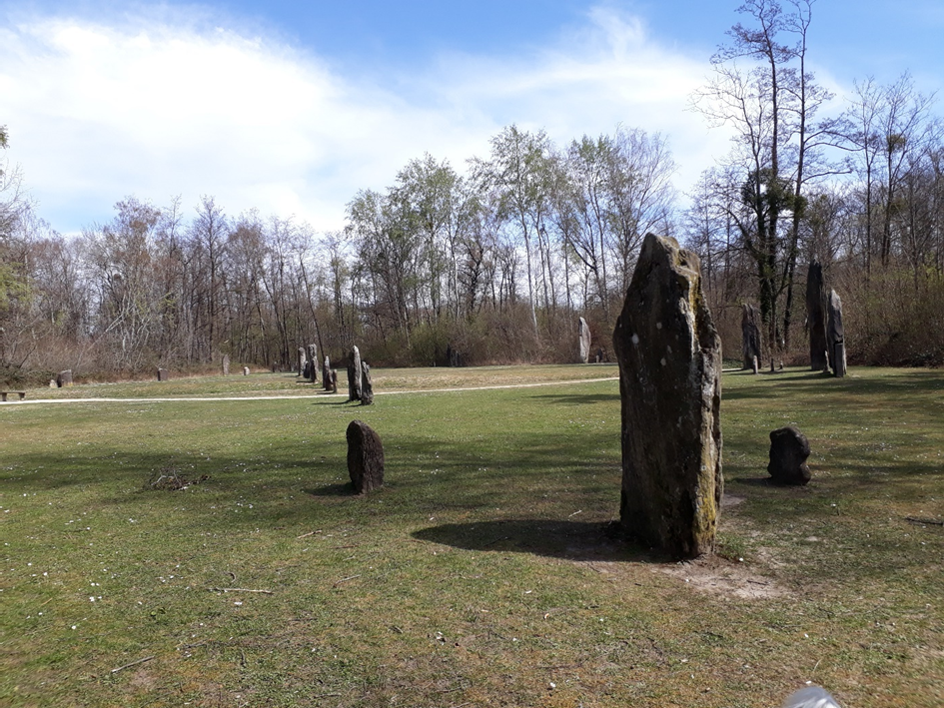
Fig. 1: Photo of the megalithic monument in Yverdon-Les-Bains, Switzerland, dated to 4500 BC to 4000 BC, facing northeast. The northern row is to the left, the central row in the middle of the photo, and two of the three separate clusters can be seen on the right. (Photo A. Hofmann)

The people of the Cortaillod culture were pile-dwellers who built their houses on stilts on lake shores. Much is known about their cultural diversity thanks to scientific dating methods and detailed analyses of the finds. However, very little is known about the purpose of the complex and the original culture’s cosmology. Matters are complicated if no written records are available, as Stanisław Iwaniszewski points out. In this instance, gaining meaningful evidence will require much more interpretation. Fabio Silva argues that ‘the sky is a natural phenomenon that is turned into a cultural skyscape through human agency’. Keeping that in mind, the astronomical orientations, including the site’s landscape characteristics, will be explored and their interpretation enriched with interdisciplinary studies, as Liz Henty suggests. It is, therefore, my intention in this essay to let the sky become ‘a link between us and our remote ancestors’, as Iwaniszewski writes so aptly.

The Megalithic Site
The megalithic site in Yverdon has an eventful history. It was built around 4500 BC to 4000 BC by the Cortaillod culture and was used for over 3,000 years before it was flooded in 850 BC and sank into the lake. It remained underwater for almost 3,000 years and was only discovered on the lake shore in 1887. Due to a river correction, the level of the lake suddenly dropped in 1887, and large boulders lying on their sides appeared on the shore. The engineer, Charles de Sinner, noticed them and saw that they were trimmed and facing certain orientations. He thought they could belong to a megalithic monument. Remarkably, though, his idea did not meet with more interest at the time, as there was a veritable "pile-dwelling fever" in Switzerland in the mid-19th century. When the lowered lake level brought countless prehistoric artefacts to light, fishermen in Lake Neuchâtel no longer fished for fish but for ancient pots and everyday objects. The alpine region was unspeakably proud of its newfound ancestors. All delighted to finally have access to an imaginable prehistoric past. Common people collected and traded the artefacts, while artists and newspapers eagerly painted a romanticised image of the pile-dwellers. Things were only settled when it was regulated by the government in 1884. Because de Sinner concluded in his report that the stones were possibly just erratic blocks left behind by the glacier after all, the megaliths were forgotten for nearly a century again. It was not until the geologist Jaques Henry Gabus rediscovered them in the now dense undergrowth. Six years later, Jean-Louis Voruz of the archaeological service investigated the site and identified 45 menhirs, some up to 4.5 metres long and weighing around five tonnes. Through stylistic comparisons with Carnac in Brittany, the dating of the megalithic structure could be derived from indirect chronological references to 4500 to 4000 BC. In the 1980s, the smaller stones were taken to the museum and replaced by cement blocks so they could not be stolen from the site, and the other megaliths were strung in two very straight rows or arranged in three smaller groups on the side. Despite the possibility of an original reconstruction based on the partially existing traces in the ground, horticultural considerations were prioritised when rebuilding the monument.
The Cortaillod Culture
The builders of the megalithic site in Yverdon belonged to the classical Cortaillod culture, which was originally from Southern France. The area where the site was built was regularly flooded by the Orbe and must therefore have been quite marshy. The megaliths, however, were put on a slightly elevated ground by one or two meters above lake level. The people who built the monument had just become farmers. Their settlements were found mainly on lakesides and riverbanks, always close to the water and cultivatable land. It remains uncertain why the Cortaillod culture did not settle further away from the flood-prone areas but rather began to build settlements on stilts after having lived on solid ground for millennia. One assumption is that the settlements on piles on the lakeshore protected them from enemies, another is that the fishing was so good that it gave them a reason to build their houses on stilts directly on the shore. Due to the fluctuating lake level, some settlements may not have been inhabited all year round but merely served as seasonal residences. It is assumed that the new lifestyle required fertile land near the water for farming and livestock breeding. The fish the lake provided was certainly a good reason for at least a seasonal dwelling near the lake. Residing in the liminal space between land and water, overlooking the lake, while feeling nourished and protected from high water and enemies, seems quite a good reason to build in such a way. Several pile-dweller settlements were found near the Yverdon megalithic site, with at least five small ones to the northeast. Their dating was uncertain due to erosion and uncontrolled mining in the mid-19th century. Archaeological dating was more reliable in the southwest, facing away from the lake. Settlements from about 3850 BC up until the Early Bronze Age were found there.
The Cosmology of the Cortaillod Culture
The Cortaillod buried their dead unburnt in narrow stone cist graves, preferably on sunny slopes facing east. Few grave goods were found, but ochre, the colour of life, was present in the graves. The dead were buried in a squatting position as if it were only a temporary state of rest. This could hint at concepts of resurrection, Ernst Probst notes. Concerning the Yverdon monument, ethnographic comparison further suggests that the site must once have had a socio-religious significance. Voruz and his team considered it to be a religious gathering place due to its obvious spatial organisation, taking the stones to be statues, which could be interpreted as ancestors, heroes, or gods to be remembered. Directly at the megalithic site, there were only two finds attributed to the Neolithic period. A stone hammer and a perforated axe sheath made of deer antlers were found in the northeast where the two stone rows intersect. What’s more, archaeological investigations at two smaller megalithic sites nearby showed that prehistoric visitors seemed to have been very careful not to leave any vessels or waste at the sites. According to Marie-Hélène Grau Bitterli, this allows the conclusion that the area must have been consecrated and certain codes of conduct were maintained. She writes that the construction of the megalithic monument may have served as a foundation act, a regular honouring of the ancestors, and/or as a place to celebrate fertility festivals. In Saint-Aubin near Lake Neuchâtel, a small gynaicomorphic vessel was also found, indicating a mother goddess worship. (Fig. 2) Such vessels with moulded female breasts were associated with ancestors or fertility cults.
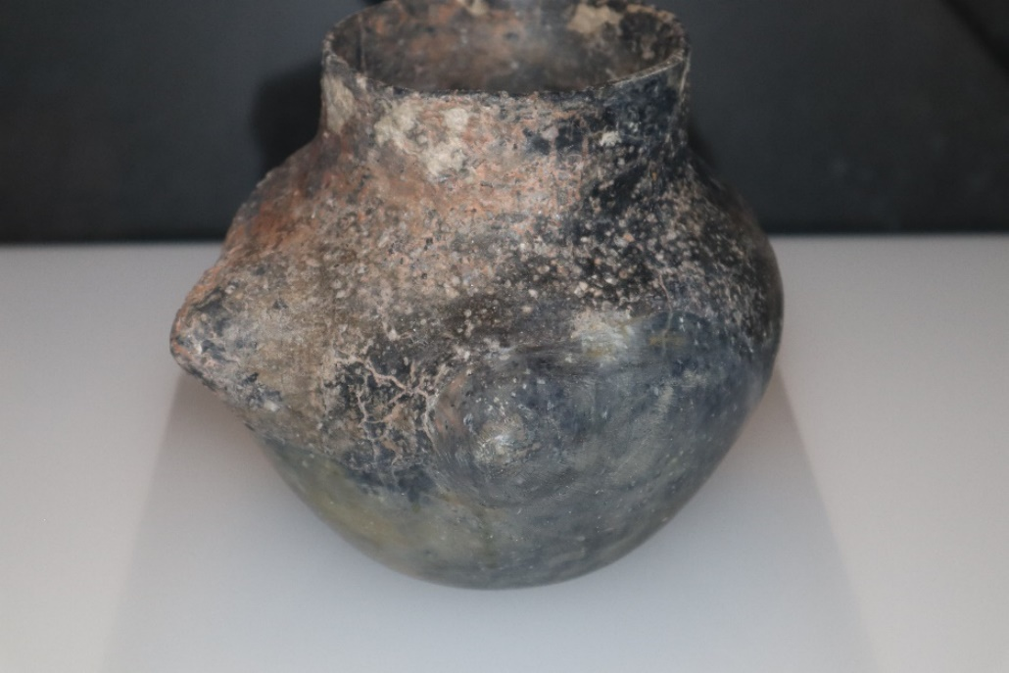
Fig. 2: Vessel with modelled breasts found in Saint-Aubin near Yverdon, exhibited in the Laténium, the archaeological museum in Hauterive, Neuchâtel (Photo A. Hofmann)

Similar clay vessels from the same time period appeared in Germany, where the most important discovery of all was made, concerning the cosmology of the pile-dwellers. In Ludwigshafen-Seehalde, right across the Swiss border at Lake Constance, wall panels from around 3850 BC were retrieved from the water. After being very well conserved underwater, following a fire, these wall panels give insights into the cosmological concepts of the pile-dwellers. Helmut Schlichtherle reports that once restored, a seven-metre-long picture frieze with at least seven figures was revealed. The figures were women, all equipped with sculpturally modelled breasts. Their bodies were portrayed abstractly, only hinted at with a rectangular shape and white line outline. Little arms stretched upwards on the sides as if praying. On top, shoulders and a small half-round seemed to indicate a head and shoulders section. Schlichtherle interpreted the rays around their heads as sunbeams. (Fig. 3)
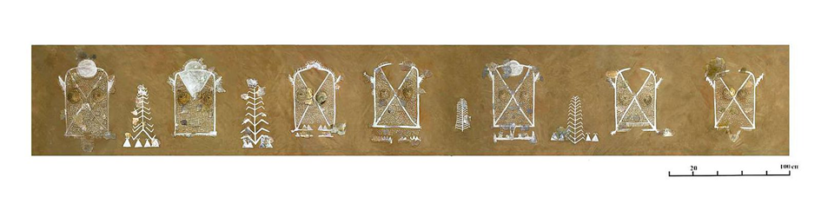
Fig. 3: The seven-metre-long picture frieze with at least seven figures, all with sculpturally modelled breasts.
(Image: © Landesamt für Denkmalpflege Baden-Württemberg)
Iwaniszewski argues that several theoretical perspectives exist when it comes to archaeological evidence. These perspectives normally lead to conclusions that can vary depending on the interpreters' viewpoints and the weightings of the found material. In this sense, some see the wall panels as standing for mother goddess worship, others think the female figures could be pointing at fertility goddesses due to the emphasis on the breasts. Schlichtherle later corrected his initial interpretation of mother goddess worship to suspecting that it might rather have been ancestor worship. This conclusion was reached partly due to engraved tree-like motifs between the seven figures, which he believed to be family trees. According to him, these motifs indicate ancestral lines and genealogical connections. ‘We can, therefore, ask ourselves whether mothers and grandmothers who were still remembered by name were depicted here, ancestral women who had already been transported into the realm of myth, or perhaps even ancestral mothers who had already been deified’ (translated by A. Hofmann), Schlichtherle argues. Due to the female figures and the gynaicomorphic vessels, he sums up the pile-dwellers’ cosmological belief to be that of a female primordial goddess or ancestress, representing at the same the Sun, because of the heliocephalous head.
The clay vessels with the moulded breasts found at Lake Constance and near Lake Neuchâtel allow the connection of the two finding places and draw conclusions about the cosmology of the Cortaillod culture, especially since the two cultures lived side by side in the same period and area.
The Measuring
Various approaches were required to measure the megalithic site in Yverdon. When measuring online, using Google Earth Pro, the photograph does not show all the stones because some are in the shadow of the trees. Added to this is that the stones visible in the photograph are not standing in their original positions and, therefore, cannot provide accurate results. The choice in the 1980s to prioritize horticultural considerations over a faithful reproduction of the original megalithic site made measuring quite difficult. The site nowadays features two main stone rows: the northern row, which is oriented from northwest to northeast, and the central row, which is oriented from southwest to northeast. Sometimes, the three scattered groups of individual stones in the south are also regarded as a loose row and called the southern row. Thanks to Sylvain Pittet, who transferred the find positions of the menhirs according to Voruz's plan onto an official map, the original orientations can be verified. So I went to the site twice with a map, a tape measure and ski poles to locate and measure the position of the original stones. I intended to focus on the two rows, the northern and the central row, as these showed clear orientations. Afterwards, their eastern and western declinations should be determined to see whether there were any solar or lunar alignments. The group of stones 9 to 13 on the original plan seemed very important, as both rows cross there. (Fig. 4)
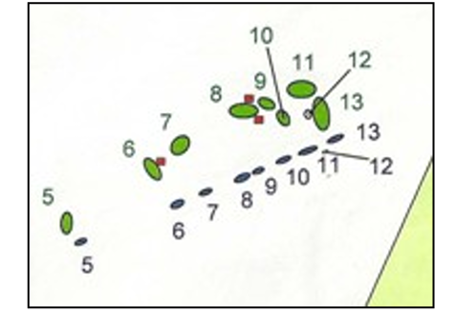
Fig. 4: The stones 9 to 13 at the megalithic site of Yverdon. This is where both rows come together. The menhirs 5 to 13, coloured in green, are no longer standing in their original position but were moved by some meters or even replaced. The grey markings show today's positions. (Credit: Richard Walker, ‘Megalithanlage Yverdon-Les-Bains-Clendy, Analyse Des Designs Und Möglicher Archäoastronomischer Aspekte’, Version 4.7, 05/2014)

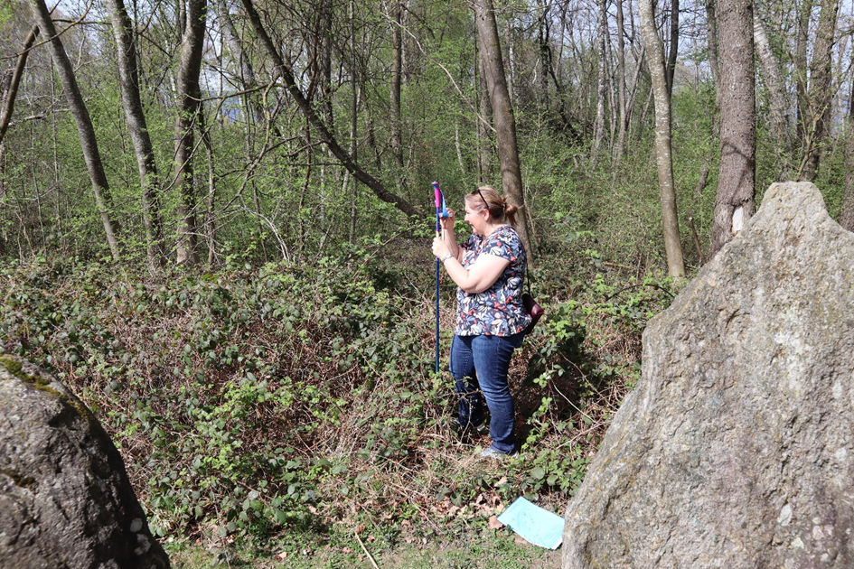
Fig. 5: A. Hofmann at the megalithic site of Yverdon, measuring the northern row with a ski pole,
standing at the original position of stone 13 (Photo: Hansjürg Hofmann)

The megaliths 1 and 2, as well as 15 and 17, must have once stood at the beginning of the rows, probably as visor stones. They are also no longer in their original positions. (Fig. 5)
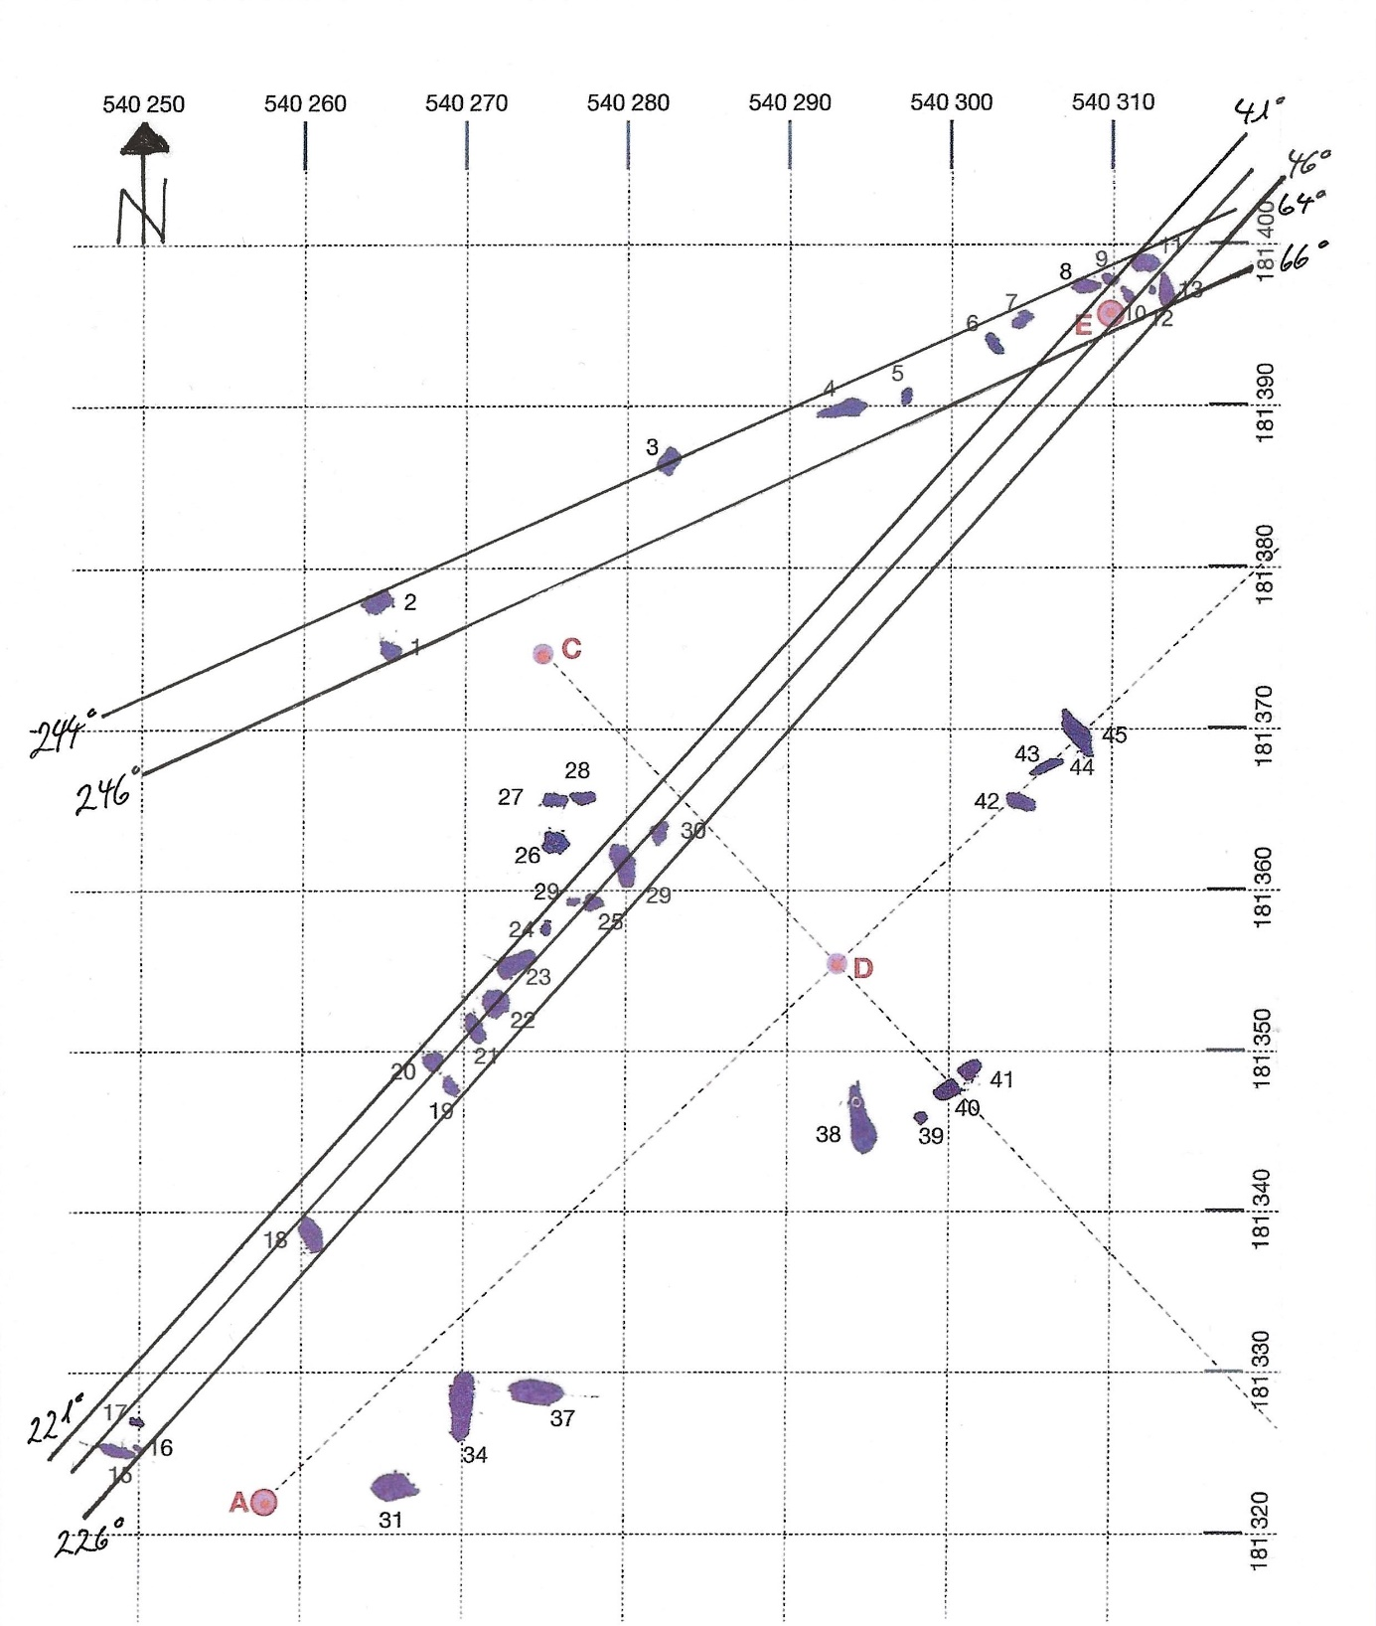
Fig. 6: Map by Sylvain Pittet of the original stone positions at the megalithic site in Yverdon,
marked by A. Hofmann for verification and documentation of the measurement.

After the fieldwork, I compared all the results with a final measurement on Pittet’s map
(Fig. 5) and with the results of the two archaeoastronomers, Born and Walker.

The northern row
Northern row | West T.Az | East T.Az | Stones used | Dec West | Dec East
Hofman on computer | 246 | 66 | 2 – 5  (reduced visibility on Google Earth) | -14.43 | 16.46
Hofman in the field | 243.98 | 63.98 | 1 - 13 | -15.73 | 17.67
Hofmann on Pittet’s map with original stone positions | 246 | 66 | 2 – 11  (outer edges) | -14.48 | 17.56
Hofmann on Pittet’s map with original stone positions | 245 | 65 | 1 – 13  (outer edges) | -15.13 | 18.22
Born | 241.03 | 62.77  (unable to reproduce his numbers) | 5-11 | -18.85 | 18.85
Walker | 246 | 66 | 2-11 | -17.1 | +17.1

The central row
Central row | West T.Az | East T.Az | Stones used | Dec West | Dec East
Hofmann on computer | 219 | 39 | 18 - 27  (reduced visibility on Google Earth) | -31.18 | 33.24
Hofman in the field | 225.98 | 45.98 | 15 – 11/13  (through their centre) | -27.05 | 28.85
Hofmann on Pittet’s map with original stone positions | 222 | 42 | 24 - 11  (outer edges) | -30.20 | 31.37
Hofmann on Pittet’s map with original stone positions | 221 | 41 | 15 – 13  (outer edges) | -30.16 | 31.77
Born | 223.03 | 46.06 | 15 to 13 | -29.15 | 29.15
Walker | 222 | 42 | 15 to 11 | -29.2 | 29.2

The figures show some deviations due to the stones selected for the measurement and the altitude resulting from the azimuth. Those from Born and Walker are mean values documented in detail. Because of the variable hills and peaks around the site, some closer, some further away, the altitude changes rapidly with an azimuth change of only a few degrees. (Fig. 7)

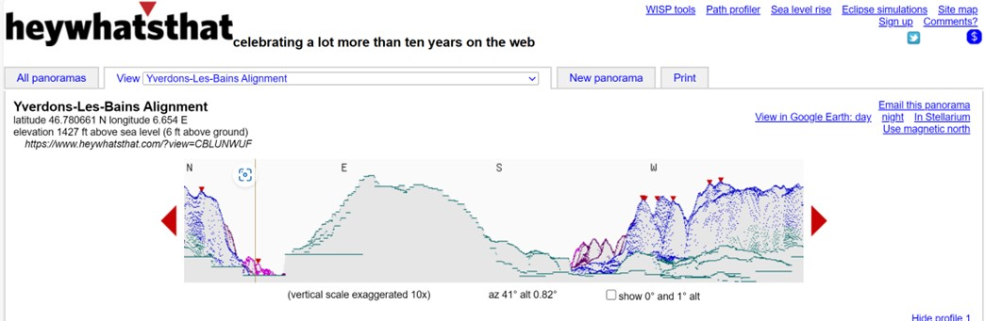
Fig. 7: The 360° panorama around the megalithic site of Yverdon. (Screenshot from Heywhatsthat.com)

Because the numbers vary due to the different altitudes, a window where both rows come together, seemed to be best suited for calculating the declinations. This window comes up with an azimuth range of 41° to 66°. It is quite impressive that this range covers the entire lake. (Fig. 8 and 10)

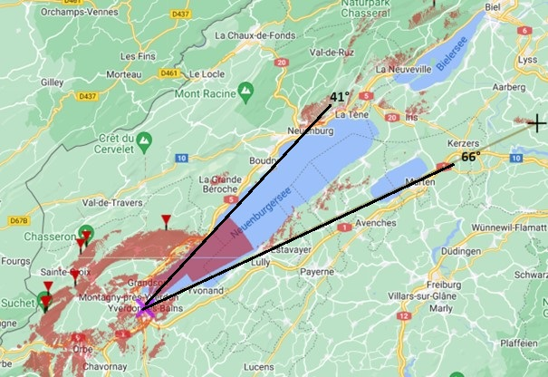
Fig. 8: When working with the window of an azimuth range of 41° to 66°, a full view of the lake is given.
(Screenshot from Heywhatsthat with my markings)
The Astronomical Orientations
The lunar standstills
The measurement comes up with a clear indication that the rows were oriented towards the lunar standstills. The northern row was oriented towards the minor lunar standstill, and the central row towards the major lunar standstill. Clive L. N. Ruggles calculated that when, in 4000 BC, the lunar declination reached a minimum monthly limit at around 18.95° north and south, a minor lunar standstill occurred, and when it reached a maximum monthly limit at around 29.25° north or south, a major lunar standstill took place. The measurement for the northern row came up with a declination range between 14.43° south and 18.85° north, depending on which stones were taken into account. Therefore, the azimuth range 64° to 66° (Fig. 6) shows an orientation towards the minor lunar standstill, when in 4000 BC, the Moon reached a minimum monthly limit at around 18.95° north respectively south. The central row has a declination between 27.05° south and 33.24° north, again depending on the stones taken into account. Its azimuth range of 41° to 46° (Fig. 6) displays an orientation to the major lunar standstill when in 4000 BC, the Moon reached a maximum monthly limit at around 29.25° north or south.
The lunar standstills explained
Judith S. Young describes the lunar standstills as ‘a compound pendulum system’. Due to the gravity of the Sun, the orbital plane of the Moon is not at a fixed address in the sky. Rather, while upholding the 5.1° tilt in relation to the ecliptic, it precesses in a cycle of 18.6 years. Therefore, the Moon can be seen to rise further north and further south than the Sun. The Moon’s monthly range of rises and sets increases within 9.3 years and shrinks again within the following 9.3 years. When the monthly range of lunar risings and settings are at their outermost extreme, it is called “the major lunar standstill”; when it is at their innermost extremes, it is called “the minor lunar standstill”. Even though the name might imply that the Moon is standing still at a certain time and position in the sky, this is not the case. Over many months, the Moon gradually approaches an extreme position, goes no further, changes direction, and then gradually moves towards the other extreme position again.
A combined lunar and solar alignment
In addition to the orientation towards a lunar event, the northern row also appears to have a solar orientation. When the measurement is taken from the outer edges of stones 1 – 13, the declination 15.13° south roughly points to the solar alignment on the solar cross-quarter days February 8 and November 4, and the declination 18.22° north points to those of Mai 13 and Juli 31. As such, the northern row is possibly a combination of lunar and solar orientation. An archaeoastronomical examination by Clive L. N. Ruggles revealed that some short megalithic rows in Scottland were also not only oriented towards the lunar standstill but could include a solar alignment as well. In contrast to Yverdon, however, it was a "largely solstitial" alignment in Scotland, whereas the stones in Yverdon were aligned to the cross-quarter days.
Accentuating the northeast
The junction of the northern and central rows accentuates the northeast. Yverdon shares this feature with the famous Stonehenge site, where the entrance of the ditch-and-bank enclosure lies in the northeast when seen from the centre. According to Clive L. N. Ruggles, there is no obvious reason for this other than an extreme lunar position. If the builders of Stonehenge viewed the northeast as an entry point, then the gate-like junction in Yverdon may have served as an entrance as well.
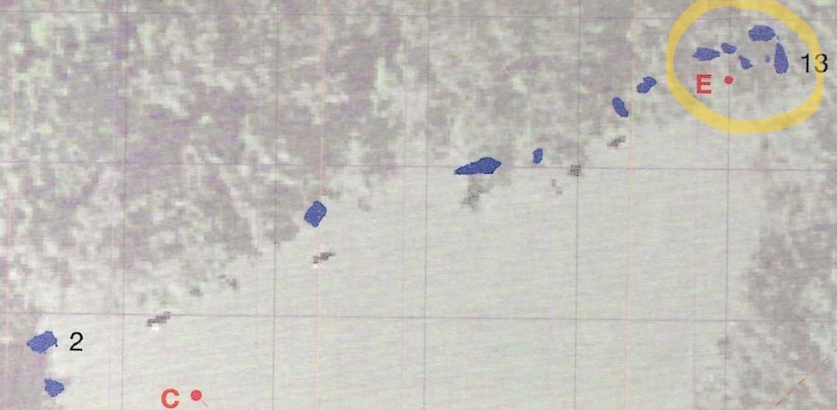
Fig. 9: The stones 9 to 13 at the northeastern end of the megalithic site in Yverdon seem to shape a gate. (Image: Map with original stones by Born in ‘Die Megalithen Von Yverdon-Les-Bains, Archäologische Analysen Der Steinreihen Und Steinkreise’ (Basel: ambripress, 2017) marked by A. Hofmann)

The Purpose and Function
Building a stone monument required so much effort and wealth that it must become obvious why it was constructed and why it was built in that particular place, J. McKim Malville argues. The only archaeological find on the site of Yverdon was made at the exact point where the gate-like junction, which may have served as an entrance to the Yverdon site, is situated. A stone hammer and a perforated axe sheath made of deer antlers were excavated there. Applying the logic that the northeast azimuth window is very important due to three features, the lake takes on a special significance. The extreme positions of the Moon, the marking of the solar cross-quarter days, and the only archaeological find made on the site come together in this gate-like part of the monument. This azimuth window, therefore, emphasises the lake's importance to the site's builders. (Fig. 10)
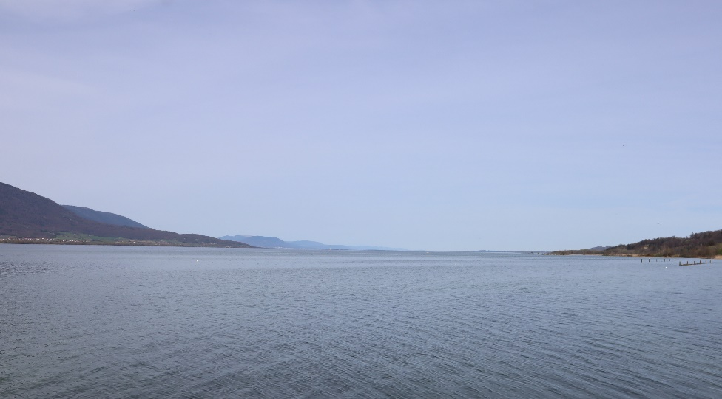
Fig. 10: A full view of the lake is given when working with an azimuth range of 41° to 66°.
(Photo: A. Hofmann)
The lake as a mirror of the sky
The Cortaillod culture's houses were built on stilts on lakeshores, indicating the significance of the lake to their way of living. Besides serving protection and nourishment, the lake could also have been a bridge to the mother goddess or ancestresses, or in case the gate-like junction was an entry, also as an entry point for ancestral or divine powers. Looking at water can ‘serve as a reflecting surface by which to gaze into heaven’, Geoffrey W. Dennis remarks, therefore, it can trigger a visionary trance. In the Hebrew Bible, water is ‘a primeval force’ and the first words are ‘a wind of God hovered over the waters (Genesis 1:2)’. There was an idea prevalent that water is ‘the matrix of heaven’, Dennis argues. As a potential place of revelation, water is the means through which a numinous force can be met. Dennis calls on religious practices from around the world when stating that after an initial purification with water, a connection to a divine being can be made by ritual immersion into a body of water or by looking at its surface. Nicholas Campion suggested that the image of ancient astronomers using prehistoric monuments simply to observe celestial movements should be replaced by ‘concepts of ritual, shamanistic participation in a living cosmos composed of undistinguished sky and land’. This seems consistent with what Dennis states, referring also to hydromancy, as the form of ritual clairvoyance using a water surface is called. It is a widespread practice in different cultures of the world. Looking at a surface of water has a mesmerizing effect, its brilliance and the flickering alter the concentration and can bring on change in brain wave patterns. When looking at the sky reflected in a body of water clear definitions of identity dissolve and ‘a subsequent merging in the unity of the world’ happens, Ilaria Cristofaro states her personal experiment. She suddenly sensed that harmony manifested itself, and ‘empathy, meaningfulness, wholeness, balance and the unity of opposites’ took possession of her. She felt that where sky and land met, the surface of the water could become a gateway to another sphere. Considering that the astronomical alignments at the site in Yverdon point to the lunar standstills, the rituals of the Cortaillod culture must have included the Moon. According to Radcliffe G. Edmonds, there were rituals of drawing down the Moon in the ancient Greco-Roman world. As controversial as they may have been, one of their aims was to collect the concentrated power of the Moon during its closeness to the earth. In their eyes, it created “moonfoam”, which was ‘gathered from the dew of plants and the rays of Moonbeams’ and considered extra potent. Edmonds also states that water was put into a bowl to contact various divinities.
Lunar cycles in agriculture
When considering the scientific evidence regarding the site of Yverdon, a gap can be identified concerning the interpretation of the pile-dwellers’ cosmology. There are conclusions about the importance of the Sun, but none about the Moon. However, given that the megalithic site of Yverdon so impressively points at the lunar standstills, the question can be raised as to why there are no depictions of the Moon on the wall panels. If the heads of the female figures represented the Sun, and further evidence could be seen in the incised drawings of the Sun on clay pots, as Schlichtherle suggests, then the bodies could indirectly have implied the Moon. It might have been self-explanatory for the pile-dwellers that the moulded breasts on walls and vessels symbolized the Moon, as breasts naturally stand for feeding and food. Pedro Jovchelevich states that ‘when dealing with complex systems, the direct and consistent causal relationship that science seeks is not always detectable’. Having found a practical confirmation of the relationship between lunar cycles and plant growth, he underlines the significance of the Moon's cycles for sustainable farming practices. The use of lunar rhythms to enhance plant growth in biodynamic farming is an ancient indigenous agricultural management approach that knows of the importance of ethno-astronomy. According to Jovchelevich, the farm is viewed as a unique entity composed of soil, plants, animals, and humans. If this is also true of the pile-dwellers, their apparent knowledge of the astronomical cycles of the sun and moon would suggest that they relied on a benevolent influence of the mother goddess or ancestresses for themselves, their soil, their crops and their livestock.
Conclusion
This essay measured the Yverdon-Les-Bains megalithic site in Switzerland and aimed to understand it as a cultural expression of the Cortaillod culture who built it. The results of the measurement were cross-checked with archaeological evidence and enriched with studies from other disciplines. The effects of the surrounding landscape and orientation were included, and special attention was paid to the lake in the northeast. The builders had the lunar standstills and possibly the solar cross-quarter days in mind when they hauled the large boulders to the lake shore. They erected them in two rows, the northern row aligned with the minor lunar standstill and the central row with the major lunar standstill. The northern row seems to include a solar alignment to the cross-quarter days. At the site of Yverdon, two cycles could be therefore observed: the 18.6-year cycle of the Moon and the Sun's annual cycle, which determines the seasons. As new farmers, the Cortaillod culture seemed to have included the Moon in their agricultural practice, possibly viewing it as a force that brought extra power to their plant growth. Their cosmology revolved around feminine figures, either a mother deity or ancestresses who had become deified over time, possibly representing both, the Sun and the Moon. Different tribes might have visited the consecrated area of the megalithic site in Yverdon over the millennia in order to visit their ancestral mothers or mother goddess. The builders of the site placed special emphasis on the junction of the northern and central rows in the northeast of the alignment. There, the stones were arranged like a gate that opens up towards the lake. A comparison to Stonehenge suggests that it could have been the entrance to the site. People might have come by boat and stepped onto the consecrated space, or they could have invited the deity or the ancestresses to step in from across the lake. In either case, the liminal space of the water seems to have invited various kinds of rituals. Every 9.3 years, when one of the lunar extremes occurred, or during the year at the cross-quarter days, cleansing and fertility rituals might have been made to connect to the ancestral line or the mother-like deity. Where the sky touched the surface of the lake, they were seen as being present, and contact could be made by entering a trance state when looking at the flickering light of the Sun or Moon on the surface of the water. The feeling of unity and harmony between the living and the divine could thus be regularly reinforced.

Bibliography

Bleicher, Niels, Steinzeit Im Parkhaus, Moderne Archäologie Und Das Unsichtbare Welterbe Der Pfahlbauten, (Zürich: NZZ Libro, 2018)

Born, Ernst, Die Megalithen Von Yverdon-Les-Bains, Archäologische Analysen Der Steinreihen Und Steinkreise (Basel: ambripress, 2017)

Campion, Nicholas, ‘Locating Archaeoastronomy Within Academia’ in Skyscapes: The Role and Importance of the Sky in Archaeology (Oxford: Oxbow Books, 2015)

Cristofario, Ilaria, ‘Harmony And A Phenomenology Of Liquid Skies’ in The Harmony Debates: Exploring a practical philosophy for a sustainable future, ed. by Nicholas Campion, (Lampeter: Sophia Centre Press, 2020)

Dennis, Geoffrey W., ‘The Use Of Water As A Medium For Altered States Of Consciousness In Early Jewish Mysticism: A Cross Disciplinary Analysis’ in Anthropology of Consciousness, American Anthropological Association, Vol. 19, Issue 1, 2008

Edmonds , Radcliffe G., Drawing Down The Moon Book Magic In The Ancient Greco-Roman World, (Princeton University Press, 2019)

Gonzalez-Garcia, A.César, ‘Lunar Alignments – Identification and Analysis’ in Handbook of Archaeoastronomy and Ethnoastronomy, ed. by Clive L.N. Ruggles (Springer Nature, 2015), pp. 493-505

Grau Bitterli, Marie-Hélène and others, ‘Zwei neue Fundgebiete mit Megalithen am Nordufer des Neuenburgersees’, in as. Archäologie der Schweiz, Vol. 25.2002.2, pp. 20-30

Hafner, Albert and others, ‘Ufer- und Moorsiedlungen’ in 4.000 Jahre Pfahlbauten, Archäologisches Landesmuseum Baden-Württemberg und Landesamt für Denkmalpflege im Regierungspräsidium Stuttgart, (Ostfildern: Jan Thorbecke Verlag, 2016) pp. 59-64

Heitz, Caroline and Stapfer, Regine, ‘ Fremde Keramik = Fremde Menschen?’ in 4.000 Jahre Pfahlbauten, Archäologisches Landesmuseum Baden-Württemberg und Landesamt für Denkmalpflege im Regierungspräsidium Stuttgart, (Ostfildern: Jan Thorbecke Verlag, 2016) pp. 150-151

Henty, Liz, ‘An Examination of the Divide Between Archaeoastronomy and Archaeology’ in The Role and Importance of the Sky in Archaeology. ed. by Fabio Silva and Nicholas Campion, (Oxford: Oxbow Books, 2015)

Honegger, Matthieu and Michel, Robert, ‘Neue Aspekte Der Cortaillod-Kultur Im Neuenburgerland’, in as. Archäologie der Schweiz, Vol. 25.2002.2, pp. 31-39

Iwaniszewski, Stanisław, ‘Cultural Interpretation of Archaeological Evidence Relating to Astronomy’ in Handbook of Archaeoastronomy and Ethnoastronomy, ed. by Clive L.N. Ruggles (Springer Nature, 2015), pp. 315-321 (p. 316).
Jovchelevich, Pedro, ‘Astronomical Rhythms In Biodynamic Agriculture’ in Subtle Agroecologies, Farming with the Hidden Half of Nature, ed. by Julia Wright (Boca Raton: CRC Press, 2021), pp. 123-130

Kaeser, Marc-Antoine, ‘Gemeinsame Wurzeln’ in 4.000 Jahre Pfahlbauten, Archäologisches Landesmuseum Baden-Württemberg und Landesamt für Denkmalpflege im Regierungspräsidium Stuttgart, 4.000 Jahre Pfahlbauten (Ostfildern: Jan Thorbecke Verlag, 2016), pp. 22-26

Loubier, Jean-Christoph and Burri, Elena Maria Elisabeth, ‘Räumliche Modellierung der Besiedlungsdynamik des Schweizer Mittellandes im Neolithikum’ in M@ppemonde, vol. 101, No 04 (Université de Genève, 2011)

Malville, J. McKim, ‘Meaning And Intent In Ancient Skyscapes – An Andean Perspective’ in Skyscapes: The Role and Importance of the Sky in Archaeology, ed. by Fabio Silva and Nicholas Campion, (Oxford: Oxbow Books, 2015) p. ix.

Ottaway, Barbara and Strahm, Christian, ‘Swiss Neolithic Copper Beads: Currency, Ornament or Prestige Items?’ in World Archaeology, Vol. 6, No. 3 (Feb 1975), pp. 307-321

Pétrequin, Pierre, ‘An Der Grenze Zwischen Land Und Wasser’ in 4.000 Jahre Pfahlbauten, Archäologisches Landesmuseum Baden-Württemberg und Landesamt für Denkmalpflege im Regierungspräsidium Stuttgart, (Ostfildern: Jan Thorbecke Verlag, 2016) pp. 65-67

Probst, Ernst, Die Cortaillod-Kultur, Eine Kultur der Jungsteinzeit vor etwa 4.000 bis 3.500 v. Chr., (Leipzig: Amazon Distribution, 2020)

Röder, Brigitte, ‘Alles So Schön Vertraut Hier’ in 4.000 Jahre Pfahlbauten, Archäologisches Landesmuseum Baden-Württemberg und Landesamt für Denkmalpflege im Regierungspräsidium Stuttgart, (Ostfildern: Jan Thorbecke Verlag, 2016) pp.137-142

Ruggles, Clive L. N., ‘Long-Term Changes In The Appearance Of The Sky’ in Handbook of Archaeoastronomy and Ethnoastronomy, ed. by Clive L.N. Ruggles (Springer Nature, 2015), pp. 473-482
Ruggles, Clive L. N., ‘Scottish Short Stone Rows’ in Handbook of Archaeoastronomy and Ethnoastronomy, ed. by Clive L.N. Ruggles (Springer Nature, 2015), pp. 1287-1296

Ruggles, Clive L. N., ‘Stonehenge and its Landscape’ in Handbook of Archaeoastronomy and Ethnoastronomy, ed. by Clive L.N. Ruggles (Springer Nature, 2015), pp. 1223-1238

Schlichtherle, Helmut, ‘Mitten im Leben’ in 4.000 Jahre Pfahlbauten, Archäologisches Landesmuseum Baden-Württemberg und Landesamt für Denkmalpflege im Regierungspräsidium Stuttgart, in 4.000 Jahre Pfahlbauten (Ostfildern: Jan Thorbecke Verlag, 2016)

Seidel, Ute, ‘Frühe Bauern Auf Besten Böden’ in 4.000 Jahre Pfahlbauten, Archäologisches Landesmuseum Baden-Württemberg und Landesamt für Denkmalpflege im Regierungspräsidium Stuttgart, (Ostfildern: Jan Thorbecke Verlag, 2016) pp.52-58

Silva, Fabio, ‘An Introduction’ in Skyscapes: The Role and Importance of the Sky in Archaeology, ed. by Fabio Silva and Nicholas Campion, (Oxford: Oxbow Books, 2015)
Suter, Peter, ‘Das Leben Am See – Wirtschaft, Haus, Handwerk, Verkehr, Austausch’ in Die Pfahlbauer Am Wasser Und Über Den Alpen, ed. by Daniel Gutscher, Archäologischer Dienst des Kantons Bern (Bern: Rub Media, 2013)
Voruz, Jean-Louis, ‘Hommes et Dieux du Néolithique Les statues-menhirs d'Yverdon’, Annuaire de la Société Suisse de Préhistoire et d'Archéologie, 75 (1992), pp. 37-64

Walker, Richard, Megalithanlage Yverdon-Les-Bains-Clendy, Analyse des Designs und möglicher archäoastronomischer Aspekte, Version 4.7 (05/2014) p. 3. <https://www.ursusmajor.ch/downloads/megalithanlage-yverdon-clendy-v-4_7.pdf> [accessed on Feb 18, 2024]

Young, Judith S., Moon Teachings For The Masses At The Umass Sunwheel & Around The World: The Major Lunar Standstills Of 2006 & 2024-25, Dept. of Astronomy, University of Massachusetts, Amherst, Updated December 2010, <https://www.umass.edu/Sunwheel/pages/Moonteaching.html> [accessed April 23, 2024]

Jean-Louis Voruz, ‘Hommes Et Dieux Du Néolithique Les Statues-Menhirs D'Yverdon’, Annuaire de la Société Suisse de Préhistoire et d'Archéologie, 75 (1992), pp. 37-64 (p. 37).
Albert Hafner and others, ‘Ufer- Und Moorsiedlungen’ in 4.000 Jahre Pfahlbauten, Archäologisches Landesmuseum Baden-Württemberg und Landesamt für Denkmalpflege im Regierungspräsidium Stuttgart, (Ostfildern: Jan Thorbecke Verlag, 2016) pp.59-64 (p. 59).
Stanisław Iwaniszewski, ‘Cultural Interpretation Of Archaeological Evidence Relating To Astronomy’ in Handbook of Archaeoastronomy and Ethnoastronomy, ed. by Clive L.N. Ruggles (Springer Nature, 2015), pp. 315-321 (p. 316).
Fabio Silva, ‘An Introduction’ in Skyscapes: The Role and Importance of the Sky in Archaeology, ed. by Fabio Silva and Nicholas Campion, (Oxford: Oxbow Books, 2015 ) p. 2.
Liz Henty, ‘An Examination of the Divide Between Archaeoastronomy and Archaeology’ in The Role and Importance of the Sky in Archaeology. ed. by Fabio Silva and Nicholas Campion, (Oxford: Oxbow Books, 2015), p. 30.
Iwaniszewski, Cultural Interpretation of Archaeological Evidence, p. 315.
Voruz, Hommes Et Dieux, p. 42.
Marc-Antoine Kaeser, ‘Gemeinsame Wurzeln’ in 4.000 Jahre Pfahlbauten, Archäologisches Landesmuseum Baden-Württemberg und Landesamt für Denkmalpflege im Regierungspräsidium Stuttgart, 4.000 Jahre Pfahlbauten (Ostfildern: Jan Thorbecke Verlag, 2016), pp. 22-26 (p. 24).
Voruz, Hommes Et Dieux, p. 46.
Voruz, Hommes Et Dieux, p. 37.
Richard Walker, Megalithanlage Yverdon-Les-Bains-Clendy, Analyse Des Designs Und Möglicher Archäoastronomischer Aspekte, Version 4.7 (05/2014) <https://www.ursusmajor.ch/downloads/megalithanlage-yverdon-clendy-v-4_7.pdf> [accessed on Feb 18, 2024], p. 11.
Matthieu Honegger and Robert Michel, ‘Neue Aspekte Der Cortaillod-Kultur Im Neuenburgerland’, in as. Archäologie der Schweiz, Vol. 25.2002.2, pp. 31-39, (p. 32).
Jean-Christoph Loubier and Elena Maria Elisabeth Burri, ‘Räumliche Modellierung Der Besiedlungsdynamik Des Schweizer Mittellandes Im Neolithikum’ in M@ppemonde, vol. 101, No 04 (Université de Genève, 2011), p. 11.
Voruz, Hommes Et Dieux, p. 42.
Marie-Hélène Grau Bitterli and others, ‘Zwei Neue Fundgebiete Mit Megalithen Am Nordufer Des Neuenburgersees’, in as. Archäologie der Schweiz, Vol. 25.2002.2, pp.20-30, (p. 27).
Barbara Ottaway and Christian Strahm, ‘Swiss Neolithic Copper Beads: Currency, Ornament Or Prestige Items?’ in World Archaeology, Vol. 6, No. 3 (Feb 1975), pp. 307-321, (p.307).
Ute Seidel, ‘Frühe Bauern Auf Besten Böden’ in 4.000 Jahre Pfahlbauten, Archäologisches Landesmuseum Baden-Württemberg und Landesamt für Denkmalpflege im Regierungspräsidium Stuttgart, (Ostfildern: Jan Thorbecke Verlag, 2016) pp. 52-58 (p. 52).
Pierre Pétrequin, ‘An Der Grenze Zwischen Land Und Wasser’ in 4.000 Jahre Pfahlbauten, Archäologisches Landesmuseum Baden-Württemberg und Landesamt für Denkmalpflege im Regierungspräsidium Stuttgart, (Ostfildern: Jan Thorbecke Verlag, 2016) pp. 65-67 (p. 67).
Brigitte Röder, ‘Alles so schön vertraut hier’ in 4.000 Jahre Pfahlbauten, Archäologisches Landesmuseum Baden-Württemberg und Landesamt für Denkmalpflege im Regierungspräsidium Stuttgart, (Ostfildern: Jan Thorbecke Verlag, 2016) pp. 137-142 (p. 140).
Caroline Heitz and Regine Stapfer, ‘ Fremde Keramik = fremde Menschen?’ in 4.000 Jahre Pfahlbauten, Archäologisches Landesmuseum Baden-Württemberg und Landesamt für Denkmalpflege im Regierungspräsidium Stuttgart, (Ostfildern: Jan Thorbecke Verlag, 2016) pp 150-151 (p. 150).
Voruz, Hommes Et Dieux, p. 42.
Ernst Probst, Die Cortaillod-Kultur, Eine Kultur der Jungsteinzeit vor etwa 4.000 bis 3.500 v. Chr., (Leipzig: Amazon Distribution, 2020), pp. 43 and 49.
Voruz, Hommes Et Dieux, p. 37.
Voruz, Hommes et Dieux, p. 45.
Marie-Hélène Grau Bitterli and others, Zwei neue Fundgebiete, p. 21.
Marie-Hélène Grau Bitterli and others, Zwei neue Fundgebiete, p. 26.
Peter Suter, ‘Das Leben Am See – Wirtschaft, Haus, Handwerk, Verkehr, Austausch’ in Die Pfahlbauer Am Wasser Und Über Den Alpen, ed. by Daniel Gutscher, Archäologischer Dienst des Kantons Bern (Bern: Rub Media, 2013), p. 85.
Helmut Schlichtherle, ‘Mitten Im Leben’ in 4.000 Jahre Pfahlbauten, Archäologisches Landesmuseum Baden-Württemberg und Landesamt für Denkmalpflege im Regierungspräsidium Stuttgart, (Ostfildern: Jan Thorbecke Verlag, 2016), p. 182.
Iwaniszewski, Cultural Interpretation of Archaeological Evidence, p. 317.
Niels Bleicher, Steinzeit Im Parkhaus, Moderne Archäologie Und Das Unsichtbare Welterbe Der Pfahlbauten, (Zürich: NZZ Libro, 2018) pp. 152-153.
Schlichtherle, ‘Mitten im Leben’ [‘Wir können uns also fragen, ob hier Mütter und Grossmütter dargestellt waren, an die man sich noch namentlich erinnerte, oder bereits ins Mythische entrückte Ahnfrauen, vielleicht aber auch bereits vergöttlichte Stammmütter.’ translated by A. Hofmann] p. 185.
Schlichtherle, ‘Mitten im Leben’, p.186.
Hafner and others, ‘Ufer- und Moorsiedlungen’, p.60.
Ernst Born, Die Megalithen Von Yverdon-Les-Bains, Archäologische Analysen Der Steinreihen Und Steinkreise (Basel: ambripress, 2017) p. 14.
Ernst Born, Die Megalithen von Yverdon-Les-Bains, Archäologische Analysen der Steinreihen und Steinkreise (Basel: ambripress, 2017) and Richard Walker, Megalithanlage Yverdon-Les-Bains-Clendy, Analyse des Designs und möglicher archäoastronomischer Aspekte, Version 4.7 (05/2014) <https://www.ursusmajor.ch/downloads/megalithanlage-yverdon-clendy-v-4_7.pdf> [accessed on Feb 18, 2024]
Clive L. N. Ruggles, ‘Long-Term Changes In The Appearance Of The Sky’ in Handbook of Archaeoastronomy and Ethnoastronomy, ed. by Clive L.N. Ruggles (Springer Nature, 2015), pp. 473-482 (p. 480).
Judith S. Young, Moon Teachings For The Masses At The Umass Sunwheel & Around The World: The Major Lunar Standstills Of 2006 & 2024-25, Dept. of Astronomy, University of Massachusetts, Amherst, Updated December 2010, <https://www.umass.edu/Sunwheel/pages/Moonteaching.html> [accessed April 23, 2024]
A.César Gonzalez-Garcia, ‘Lunar Alignments – Identification And Analysis’ in Handbook of Archaeoastronomy and Ethnoastronomy, ed. by Clive L.N. Ruggles (Springer Nature, 2015), pp. 493-505 (p. 494).
Clive L. N. Ruggles, ‘Scottish Short Stone Rows’ in Handbook of Archaeoastronomy and Ethnoastronomy, ed. by Clive L.N. Ruggles (Springer Nature, 2015), pp. 1287-1296 (pp. 1292).
Clive L. N. Ruggles, ‘Stonehenge and its Landscape’ in Handbook of Archaeoastronomy and Ethnoastronomy, ed. by Clive L.N. Ruggles (Springer Nature, 2015), pp. 1223-1238 (p. 1234).
J. McKim Malville, ‘Meaning And Intent In Ancient Skyscapes – An Andean Perspective’ in Skyscapes: The Role and Importance of the Sky in Archaeology, ed. by Fabio Silva and Nicholas Campion, (Oxford: Oxbow Books, 2015) p. ix.
Voruz, p. 45.
Geoffrey W. Dennis, ‘The Use Of Water As A Medium For Altered States Of Consciousness In Early Jewish Mysticism: A Cross Disciplinary Analysis’ in Anthropology of Consciousness, American Anthropological Association, Vol. 19, Issue 1, 2008, p. 89.
Dennis, ‘The Use Of Water’, p. 93.
Nicholas Campion, Skyscapes: ‘Locating Archaeoastronomy Within Academia’ in Skyscapes: The Role and Importance of the Sky in Archaeology (Oxford: Oxbow Books, 2015), p. 11.
Dennis, ‘The Use Of Water’, p. 97.
Ilaria Cristofario, ‘Harmony And A Phenomenology Of Liquid Skies’ in The Harmony Debates: Exploring a practical philosophy for a sustainable future, ed. by Nicholas Campion, (Lampeter: Sophia Centre Press, 2020), pp. 276 and 285.
Radcliffe G. Edmonds, Drawing Down The Moon Book Magic In The Ancient Greco-Roman World, (Princeton University Press, 2019), p. 23.
Edmonds, Drawing Down The Moon, p. 211.
Schlichtherle, ‘Mitten Im Leben’, p.186.
Pedro Jovchelevich, ‘Astronomical Rhythms In Biodynamic Agriculture’ in Subtle Agroecologies, Farming with the Hidden Half of Nature, ed. by Julia Wright (Boca Raton: CRC Press, 2021), pp. 123-130 (p. 124).
Jovchelevich, ‘Astronomical Rhythms In Biodynamic Agriculture’, p. 123.
Jovchelevich, ‘Astronomical Rhythms In Biodynamic Agriculture’, p. 126.

