University of Wales Trinity Saint David
London

Module Name: Management Economics
Module Number: LCBB5003
Name of the Lecturer: Emad Elkhashen

Title of the Assignment: Assessment 2 - Resit

Student Name: Rumyan Zarankov
Student Number: 1913489

Submission Date: 11/05/2022

Table of Contents
Adidas History and Its Products 3
The Market Structure under which Adidas Operates in 3
Did Adidas operate in a different market structure in its history? 8
Will it be more optimal for Adidas to operate in a different Market Structure? 8
Government Intervention 10
References 12

Adidas History and Its Products
Adidas is a multinational firm that deals with designing and manufacturing sportswear and apparel. Adidas produces shoes, clothing, and other sports apparel. The company was founded in Herzogenaurach, Germany, by Adolf Dazzler. Adidas began as a small business where Dassler used to make shoes at their home. After some time, his brother Rudolf joined him, and they started what was known as Dassler Brothers Shoe Factory (Adidas, 2022). In the beginning, the brothers made sports boots using heavy metal spikes. The innovation was appreciated by many, although the shoes were heavy and not entirely friendly to the athletes. Later on, they transitioned from the metal spikes and started using lightweight rubber spikes. Germany's national football team was the first to use the Adidas lightweight soccer boots. In the 1954 world cup final, they won against an inform Hungarian team, and Adidas became popular globally (Adidas, 2022).
The brothers split up in 1947, and Rudolf formed his own shoe company named RUDA, the modern PUMA. Adidas acquired its signature three stripe logo in 1952 from Karhu Sports, a footwear brand based in Finland. The founder Adi Dassler died in 1978, and the company was left in the care of his wife Kathe and the son Horst. The wife and son died in 1984 and 1987, respectively, and shortly after the son's sudden death, there was trouble at Adidas, and the daughter, who was the only one left, sold the company to French industrialist Bernard Tapie (Ind et al., 2015). Tapie failed to pay the loan he took to purchase the company, and he mandated the Credit Lyonnais bank to sell the company. Adidas was put under new management with a new CEO, Mr. Robert Louis-Dreyfus, who helped turn Adidas's fortunes. In 1997, Adidas acquired Salomon Group and its brands. This was followed by a series of new acquisitions and partnerships, including partnerships with Yohji, Stella McCartney, Reebok, and many more. Adidas also partners with major sports clubs and countries and with top athletes (Adidas, 2022).

The Market Structure under which Adidas Operates in
Adidas is a multinational firm that deals with the designing, manufacturing, marketing, and worldwide selling of sportswear and accessories. Adidas operates in an oligopoly market structure. An oligopoly is a market structure where there are few numbers of firms that produce similar products, and none of the firms has the absolute power to prevent the other firms from having a significant influence (Head and Spencer, 2017). Adidas competes with several different sportswear and apparel industry producers who produce differentiated goods that are perfect substitutes. The sportswear industry is dominated by ten big companies, which take almost 95% of the total market. The firms include Adidas, Nike, Puma, Under Amour, New Balance, Asics, Fila, Hanesbrands, Foot Locker, Li Ning, and Anta (Farooq, 2022). The sports apparel market in the United States as of 2021 was valued at approximately 103 billion dollars. Adidas and Nike accounting more than 50 percent of that revenue.
Although Adidas and Nike stand out as the dominant brands in the global sports apparel market, none has the monopoly power. The other firms also pose competition as significant players in the market. The sportswear market is estimated to be worth over 379 billion in 2022, according to Statista. The market was valued at more than 366 billion euros in 2021. Nike remains the most successful sportswear brand, while Adidas comes second. Adidas was valued at 16 billion euros as of 2021, with Nike valued at 42 billion euros (Camarão, 2021). As of 2019, Adidas was the most popular sportswear brand in the UK, with over 6.4 million customers opting for Adidas and around 5.7 million preferring Nike. Adidas and Nike have had a competitive advantage over other sportswear brands worldwide, with the two firms taking over a market share of over 60 percent (Statista, 2022).
The large market share and domination by the two firms are attributed to their revenue and asset size, which allow them to have more variety of products and reach more expansive areas. The firms also lead in the amount spent on advertising and marketing, which gives them a competitive advantage in popularity (Team, 2022). Few firms still dominate the global sales of sportswear and apparel. According to Statista, Nike and Adidas accounted for over 70 percent of total sales of clothing and sportswear. In 2021 the Adidas AG annual report indicated that Adidas net sales were about 21 billion euros. The sales revenue was raised from the sale of Footwear, hardware, and Apparel, with Footwear contributing the largest share of the sales (Adidas, 2022).
A few large firms have also dominated marketing expenditure in the sportswear industry. Enormous spending on marketing and advertisement is typical in an oligopoly market as each firm tries to gain more popularity over the other (Singh and Zhu, 2008). Like with other factors, Nike and Adidas are the leading spenders in marketing. According to Statista, Adidas AG has been steadily increasing its spending on marketing and advertisement, reaching an all-time high of over 3 billion euros in 2019. Nike also spent over 3 billion euros on marketing in the same period. The two companies combined spent almost 70 percent of the total marketing expenditure in the sportswear industry (Statista, 2022).
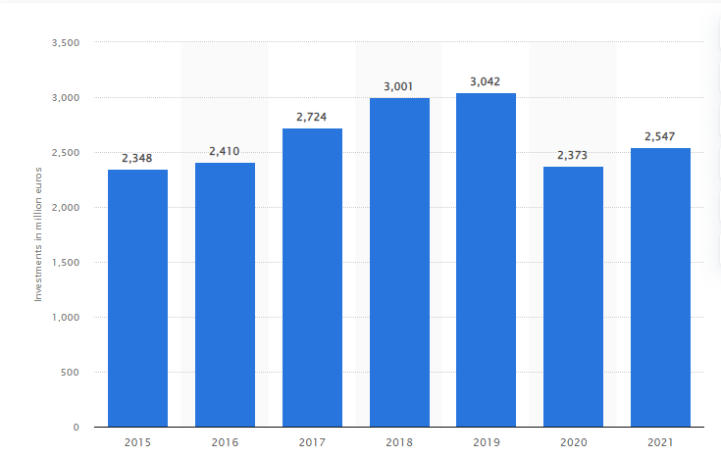
Adidas Spending on Marketing
Figure 1: Amount spend by Adidas group on marketing from 2015 to 2021
(Statista, 2022)
Another characteristic that makes the sportswear industry an oligopoly is the high number of employees employed by a few firms in the industry. The sportswear industry employs over 200 thousand employees globally. The employees are distributed in the manufacturing factories, distribution stores, and the marketing department worldwide. Sportswear firms have opened many distribution stores in many parts of the world to increase popularity and reach more customers. This has contributed to the high number of employees employed in the industry. Sourcing of raw materials has also forced firms to open several manufacturing companies near the source of raw materials. Like other factors we have listed above, the number of employees employed in the sportswear industry work for the top ten sportswear firms. Nike and Adidas combined use over 60 percent of the total employees working in the industry. As of 2020, Nike was the leading employer in the sportswear industry, having employed over 75 thousand employees globally. Adidas came second with over 62 thousand employees worldwide. Puma came further third with around 15 thousand employees (Statista, 2022).
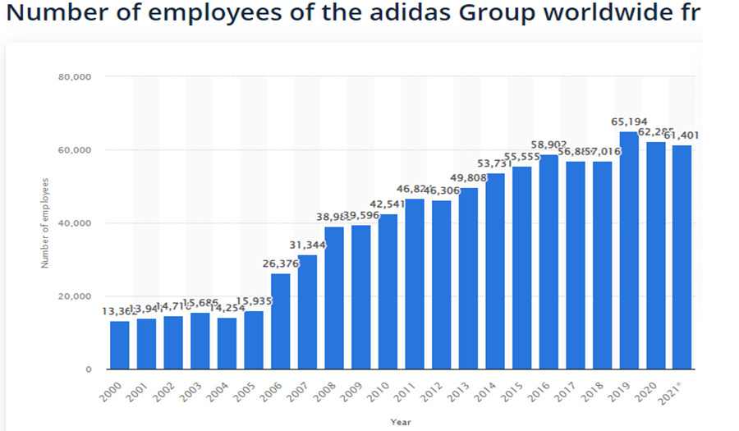
Figure 2: Graph showing the number of employees employed by Adidas worldwide (Statista, 2022)
The production in the sportswear industry has been characterized by many factories owned by a few large firms. Several firms have spread their factories worldwide, thus taking all the manufacturing markets for sportswear (Mahdi et al., 2015). This is an evident characteristic of an oligopoly market structure. The top ten owns all the manufacturing factories worldwide. Although these firms have their roots in specific countries, they have not limited themselves to only producing in the home country. The majority of them have established many factories across the borders, which helps them meet the increasing demand for sportswear and apparel. As of 2020, Nike had over 523 factories distributed in over 40 countries. The majority of its shoe production is from China and Vietnam. Like Nike, Adidas has placed manufacturing factories in different parts of the world in what seems like competing for law materials among the oligopoly firms and a marketing strategy to create rapport with the local consumers by acting like they are local firms. The move also aims to reduce the cost of transport and reduce the total cost of production. Adidas has more than 500 manufacturing factories distributed in over 55 countries globally. Majority of their shoes are manufactured in Asian countries. All other firms have few factories globally (Polderman, 2020).
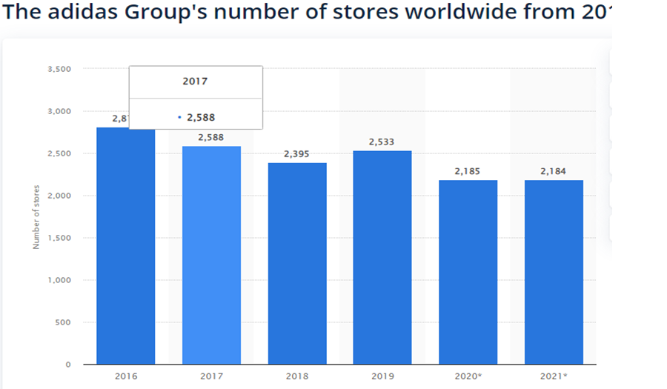
Figure 3: A bar graph indicating the number of Adidas stores worldwide from 2016 to 2021 (Statista, 2022)
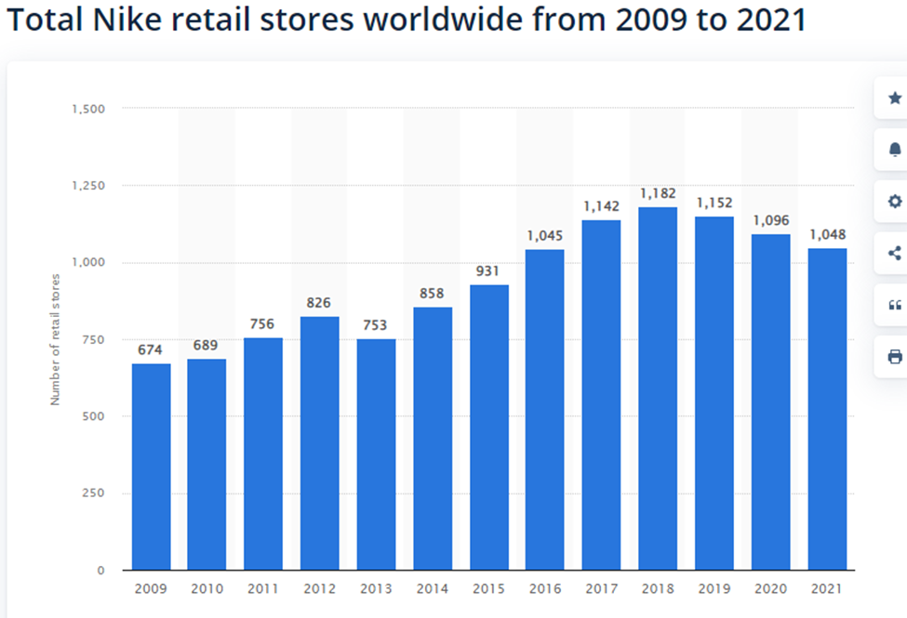
Figure 4: Graph showing the number of stores owned by Nike between 2009 and 2021 (Statista, 2022)

Did Adidas operate in a different market structure in its history?
Adidas has operated in one other market structure before becoming an oligopoly. Adidas began as a monopolistic competition in the sportswear market. Although other firms were manufacturing shoes and clothing, no firm had specialized in producing sportswear and sports apparel. Adidas became the first company to manufacture spiked running shoes. This was the first of Adidas's many innovations to separate itself from its competitors. Adidas focused more on producing outfits that were specifically friendly for sports activities. By doing so, they ensured there was no perfect substitute for their products which gave them the monopolistic competition character (Dhingra and Morrow, 2019). However, the competitive advantage in the sportswear market was short-lived. When the two brothers split, Rudolf started his own company (the modern Puma), a direct competitor of Adidas. Puma started producing sportswear that was a direct substitute for what Adidas was making. That's when the sportswear market structure changed from monopolistic competition to oligopoly.
The monopolistic competition nature of the sportswear market made it easy for other firms to enter the market. The sportswear industry was becoming a lucrative business that attracted other firms. Nike was established in 1964 and became a real competitor for Adidas. The establishment of several firms specializing in the production of sportswear led to Adidas losing its privilege as the only firm specializing in sportswear. The entry of the new firms changed the dimension and characteristics of the market. Since now there were several firms producing sportswear that are a perfect substitute for each other, the market structure in which Adidas operates changed from being monopolistic competition to being an oligopoly.
The industry has grown and has become one of the highest revenue-generating initiatives. However, despite the huge revenue collected from the industry, a limited number of firms have made a breakthrough in the industry. There are no barriers to entry, but the huge investment needed has limited other players from entering the market. The competition has remained among the top ten firms, with each firm coming up with innovations to outshine the other. Nike and Adidas are way over the other firms, with the two having over 60 percent of the market share (Statista, 2022). This has made the market remain an oligopoly.

Will it be more optimal for Adidas to operate in a different Market Structure?
It could be more optimal if Adidas operated in a different market structure. Probably in monopolistic competition or a monopoly. Currently, Adidas is running in an oligopoly market structure, resulting in it losing its market share to competitors. Although the trend indicates an increase in revenue over the years and the quantity produced and sold, the rate could have been higher if Adidas was the only firm specializing in sportswear manufacturing.
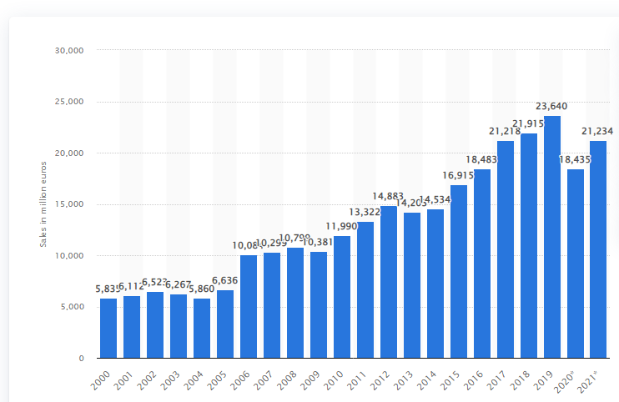
Adidas Sales revenue in million euros
Figure 5: The Adidas Group’s net sales worldwide from 2000 to 2021 (Statista, 2022)

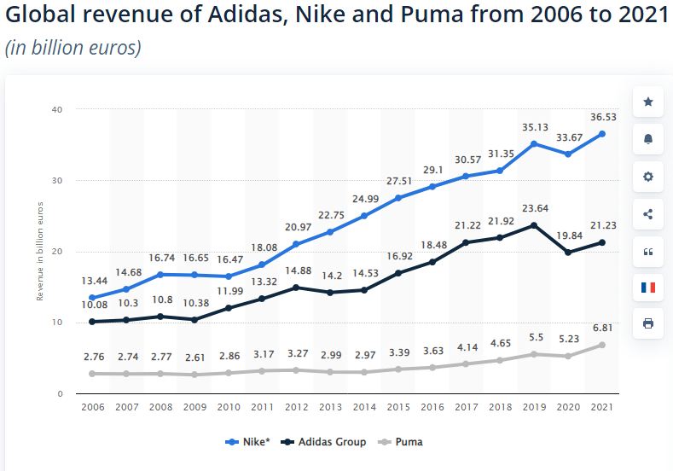
Figure 6: Global Revenue of Adidas, Nike and Puma from 2006 to 2021 (Statista, 2022)
The oligopoly nature of the market exposes Adidas to stiff competition from other several firms operating in the market. Despite Adidas being the oldest in the market and the company that introduced the sportswear designs. It has failed to keep up with the market share it enjoyed in the initial stages. Adidas has lost the pole position as the most preferred sportswear brand to North America-based Nike (Statista,2022). Other firms such as Puma, Reebok, and Under Armour are also closing down on Adidas, and soon Adidas may struggle to maintain the number of sales they make. Figure 7 below indicates the footwear market share between Nike and Adidas. Sports Footwear has gained popularity in recent times due to its lightweight.
Majority of the population has resulted in the wearing of sports shoes since they are light and comfortable. Diet, obesity, and weight-related illnesses and complications have forced many people to engage in gym activities and fitness. This has significantly increased the number of customers purchasing sports footwear. However, due to the increase in the number of firms offering the Footwear, Adidas has not been able to reap very high profits or make large sales volumes. This is basically because it has lost a market share to other firms. Figure 7 below indicates the footwear market share between Nike and Adidas. The data demonstrate that Nike controls the largest market share in all the regions covered, while Adidas comes second. This is a market that probably Adidas could have held if operating in a monopolistic competition market. The nature of an oligopoly market ensures that no firm can prevent the other from having an absolute advantage. And Nike has created a sneaker culture that is not easy to compete with, giving the company a competitive advantage in the Footwear market. This competition highlights why it could have been more appropriate for Adidas to operate in a monopolistic competition rather than an oligopoly.
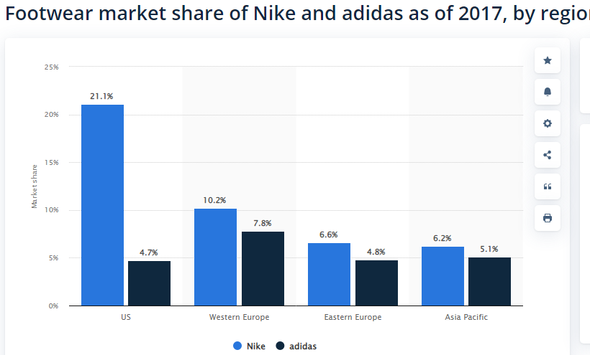
Figure 7: Footwear market share between Nike and Adidas in four regions (Statista, 2022)

Government Intervention
It's difficult to tell whether government intervention is suitable for society or bad. History has shown that government intervention has benefits and limitations. It benefits some people and hurts others (Barr, 2020). However, I believe the benefits of government intervention outweigh its limitations, and therefore I could advocate for more significant government intervention. Government intervenes in the economy in many ways that are beneficial to society. The following are some ways in which government intervention benefits society.
Government intervention creates equality: In a free market, some people would likely have an advantage over others. People will probably act for their selfish gain without caring about society's well-being (Droste et al., 2016). This could lead to wealth accumulation within a particular group of people and poverty in others. Government intervention plays a part in the redistribution of resources through taxation and other policies such as unemployment benefits and minimum wage. Although this affects businesses, the benefits to society are much more significant than the effect on businesses.
Provision of Public goods: public goods are usually not provided in the free market. There is no profit incentive for private entities to offer goods that people can enjoy freely. However, the government is not a profit-oriented entity and provides public goods without expecting profits. The areas in which government intervenes in delivering public goods include defence, health care, education, etc. (Anomaly, 2015). Although this affects business by competing with the private entities that provide some of those services, society's benefits from the government's provision of public goods are higher.
Control of Monopoly power. Government intervention to prevent mergers and price control helps prevent some firms from having monopoly power and charging higher prices than the equilibrium price. In a free market, prices are determined by the forces of demand and supply. However, merges and collaboration among sellers can lead to monopoly power, enabling them to set prices as they wish. This will likely hurt the consumers as they may be forced to pay higher than the average. Therefore, although the free market is more attractive to businesses and promotes business growth, it's dangerous to the consumers and may lead to artificial inflation.
In conclusion, we can say that although government intervention has its negativity, such as discouraging business and preventing investments in the economy. It has more significant benefits to society as it creates equality through redistribution of wealth, provides public goods that private entities are not interested in providing, and protects consumers from extortion by sellers. Therefore, I would advocate for more significant government intervention.

References
Adidas, 2022. Adidas History. [online] Available at: https://www.adidas-group.com/en/ [Accessed 5 May 2022].
Adidas.com, 2022. [online] Adidas.com. Available at: https://www.adidas-group.com/en/investors/financial-reports/ [Accessed 24 April 2022].
Anomaly, J., 2015. Public goods and government action. Politics, Philosophy & Economics, 14(2), pp.109-128.
Barr, N., 2020. Economics of the welfare state. Oxford University Press, USA.
Camarão, R.P., 2021. The evolution of the direct-to-consumer model in the sportswear industry: an assessment of the model’s application by top industry leaders (Doctoral dissertation).
Dhingra, S. and Morrow, J., 2019. Monopolistic competition and optimum product diversity under firm heterogeneity. Journal of Political Economy, 127(1), pp.196-232.
Droste, N., Hansjürgens, B., Kuikman, P., Otter, N., Antikainen, R., Leskinen, P., Pitkänen, K., Saikku, L., Loiseau, E. and Thomsen, M., 2016. Steering innovations towards a green economy: Understanding government intervention. Journal of Cleaner Production, 135, pp.426-434.
Farooq, U., 2022. Top 10 Adidas Competitors - Competitors Analysis of Adidas | Marketing Tutor. [online] Marketing Tutor. Available at: https://www.marketingtutor.net/adidas-competitors/ [Accessed 5 May 2022].
Head, K. and Spencer, B.J., 2017. Oligopoly in international trade: Rise, fall and resurgence. Canadian Journal of Economics/Revue canadienne d'économique, 50(5), pp.1414-1444.
Ind, N., Iglesias, O. and Schultz, M., 2015. How Adidas found its second wind. Strategy+ Business, 80, pp.1-5.
Mahdi, H.A.A., Abbas, M., Mazar, T.I. and George, S., 2015. A Comparative Analysis of Strategies and Business Models of Nike, Inc. and Adidas Group with special reference to Competitive Advantage in the context of a Dynamic and Competitive Environment. International Journal of Business Management and Economic Research, 6(3), pp.167-177.
Polderman, M., 2020. Responsiveness, Cost-Efficiency and Sustainability in The Global Apparel Supply Chain: Towards an Integral Approach on Manufacturing Location Decisions A Nike Inc. Case study (Doctoral dissertation, University of Groningen. Faculty of Economics and Business).
Singh, V. and Zhu, T., 2008. Pricing and market concentration in oligopoly markets. Marketing Science, 27(6), pp.1020-1035.
Statista, 2022. Topic: Adidas Statistics and Facts. Available at: https://www.statista.com/topics/1257/adidas/#dossierKeyfigures [Accessed 1 May 2022].
Statista, 2022. Revenue from footwear segment of Nike, Adidas and Puma from 2010 to 2021. Available at: https://www.statista.com/statistics/278834/revenue-nike-adidas-puma-footwear-segment/ [Accessed 1 May 2022].
Statista, 2022. Point-of-sale (POS) marketing investments of the Adidas Group from 2015 to 2021. Available at: https://www.statista.com/statistics/540836/adidas-marketing-spend/ [Accessed 2 May 2022]
Statista, 2022. Number of employees of the Adidas Group worldwide from 2000 to 2021. Available at: https://www.statista.com/statistics/268427/number-of-employees-of-the-adidas-group-worldwide-since-2000/ [Accessed 2 May 2022]
Statista, 2022. The Adidas Group’s number of stores worldwide from 2016 to 2021. Available at: https://www.statista.com/statistics/268435/adidas-group-number-of-stores-worldwide/ [Accessed 03 May 2022]
Statista, 2022. The Adidas Group’s net sales worldwide from 2000 to 2021. Available at: https://www.statista.com/statistics/268416/net-sales-of-the-adidas-group-worldwide-since-2000/ [Accessed 4 May 2022]
Statista, 2022. Global Revenue of Adidas, Nike and Puma from 2006 to 2021. Available at: https://www.statista.com/statistics/269599/net-sales-of-adidas-and-puma-worldwide/ [Accessed 4 May 2022]
Statista, 2022. Footwear market share of Nike and Adidas as 2017, by region. Available at: https://www.statista.com/statistics/895136/footwear-market-share-of-nike-and-adidas-by-region/ [Accessed 04 May 2022]
Team, T., 2022. Adidas Is Giving Nike A Run For Its Money. [online] Forbes. Available at: https://www.forbes.com/sites/greatspeculations/2019/08/06/adidas-is-giving-nike-a-run-for-its-money/ [Accessed 5 May 2022].

