BLOG POST ON: “AIR JORDAN”


By: Vladimir Stoyanov
Module: Marketing Fundamentals
Module number: (LCBB4004)
Lecturer’s name: Tushara Balendran



blog
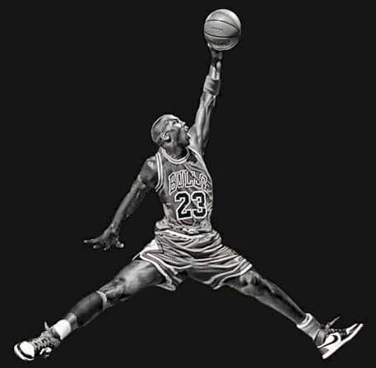

The story behind the air Jordans

According to: Holmes, (2020) The first “Air Jordan” shoe was produced for “MJ” while he was playing for the Chicago Bulls in 1984 and they released to the public on April 1,1985. At that time, Converse were the official shoes for the NBA. The company told MJ they could not put him above the other athletes they were sponsoring, which included players like Magic Johnson and Larry Bird, so they said that they did not want to change the official NBA shoes, so Jordan decided to let go. His favourite shoe at that time were actually “Adidas”, so he tried with them, but the owners of Adidas told him they could not make the shoe work at that time. Jordan’s agent, David Falk, told him to try with “Nike”, which at that time was known more for a track shoe, but Jordan said he was not interested. So, Falk talked to Jordan’s mother, Deloris. Jordan said, “My mother said,’ You are going to go listen, you may not like it, but you are going to listen, “’ They offered him an amazing deal, one that was like a dream for a rookie so, Jordan of course accepted the offer. And from there, the process of making the shoes began. At that time Nike have just created a new technology for their footwear called “Air Soles” and when Jordans manager thought about it he has said Michael is the best in the air, and after that it all came to him, and he got the name for the shoes which is still the same to this day “Air Jordan”.
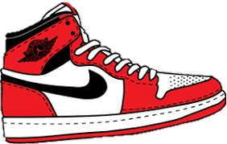
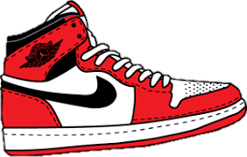
history of Michael Jordan
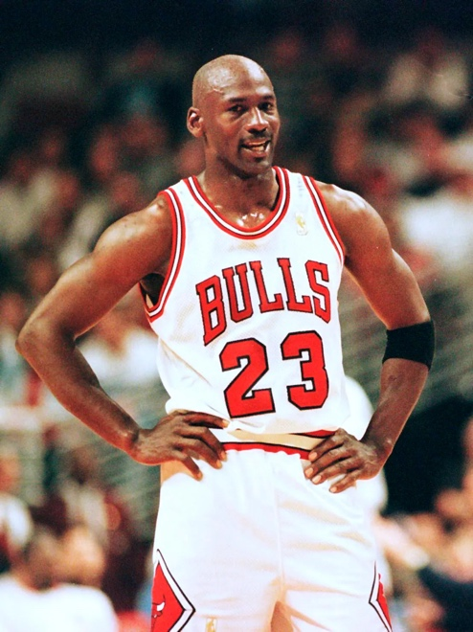
Michael Jordan is born on the 17th of February ,1963 is an American businessman and a former professional basketball player. Jordan has four more siblings two brothers and two more sisters. Michael married his wife Juanita Vanoy on the second of September 1989 they have two sons and one daughter. Jordan and Juanita divorced two times. Since he was young his dream was to be a basketball player and over anything to be the best. In 1968 his family moved to North Carolina and Jordan started going to “Emsley A. Laney High School” where he played three sport such as: football, basketball and baseball. During his sophomore year MJ was 1.80 cm tall that’s 5 feet 11 inches he tried to get in the basketball varsity team but unfortunately, he did not get accepted, from the whole school only one person made it into the team his name is Harvest Smith, but he was a lot taller than Michael Jordan. But Jordan got even more motivated and really wanted to prove how good he is so, tried for the Laney’s junior varsity team where he was on top and had games with 40 points, he became the star of the team. The next year was good for Jordan he grew 10cm in hight he trained like he was already in the NBA and not long after that he earned his place in the varsity roaster Jordan was scoring from 20 to 25 points each game after that many college basketball programs wanted to recruit him, and he accepted the basketball scholarship to the University of North Carolina.

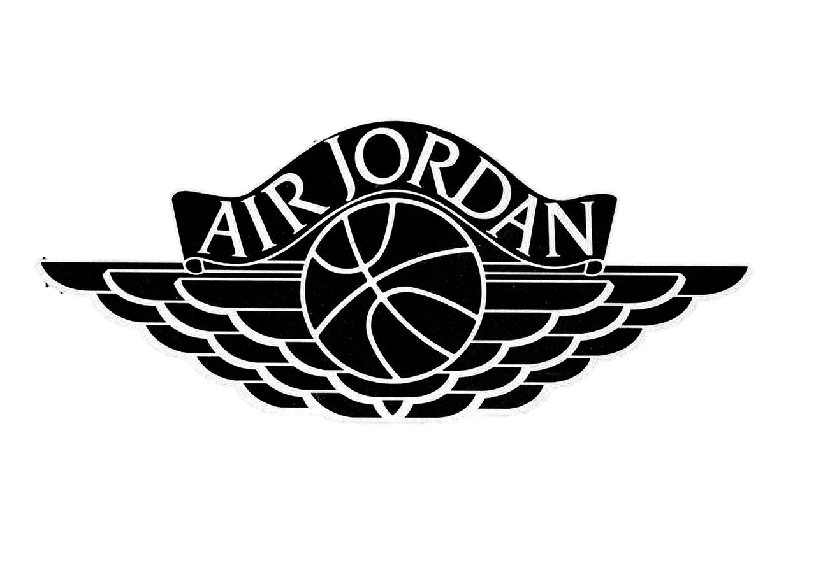
Air Jordan PRODUCTS
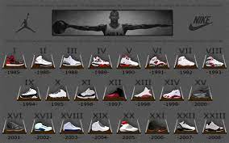
1.Footwear
The Air Jordans are made with extremely high-quality materials like full-grain calfskin and best quality leather upper. Also, an amazing look, amazing apparel, approach, many different colours, big collection which leads to customers being able to choose the perfect sneaker for them.

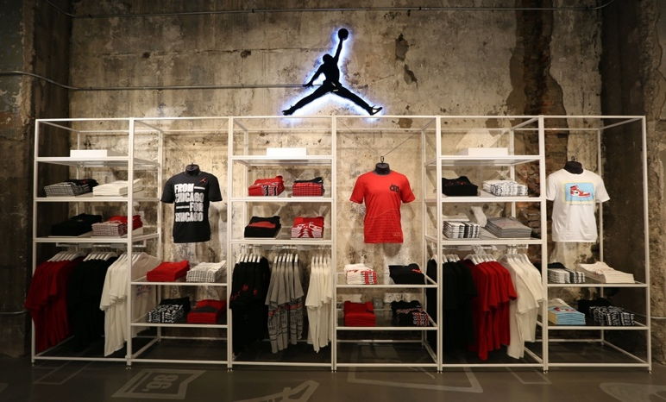
2.Clothing
The clothing of Air Jordan is comfy, soft, smooth and stylish everything from hoodies to sports tank tops, t-shirts and underwear. Jordan is taking actions for a better future for the company and sports in general. Protect the planet on the way and just continue rising. Together with Nike, Jordan is developing sustainable products with new materials it is “Move to Zero” initiative is a journey aiming for zero-carbon and zero-waste future.

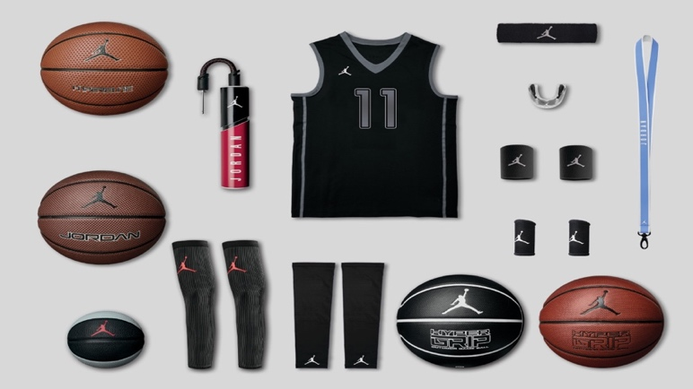
3. Accessories
Jordan has one of the best sports and
gym equipment such as: basketball balls,
headbands, wristbands and many more.
Also, accessories like phone cases,
bracelets, chains, keychains and more.
According to Curcic (2022), The Air Jordan V (5) is inspired by a World War 2 fighting plane, that was meant to be an a fearless soldier on the court, ready to head into a fight with the enemy. But like other retro Jordans (like the Air Jordan 1 Retro High and Air Jordan 6), their main goal has changed from being a sports shoe to an iconic fashion sneaker.
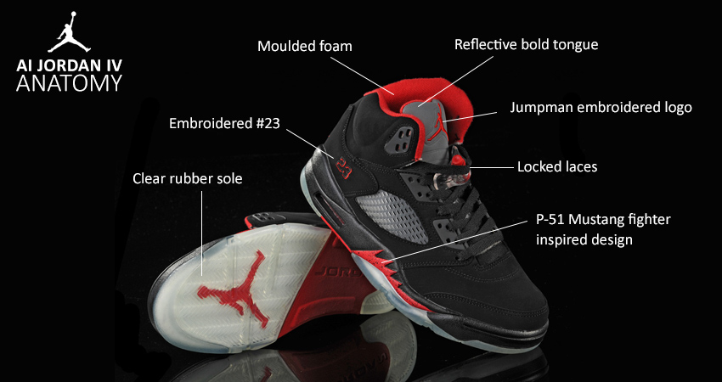

PROS: CONS:
-Well-cushioned -Loose forefoot
-Excellent court feel section
-Attractive details -Loses upper
-Appealing style rigidity after
-Sturdy midfoot to rearfoot several uses
support -Somewhat
-Good airflow weighty
-Luxurious look
-Customizable look

Air Jordan logo

Information from 1000logos.net (2022), the brand Air Jordan is known for its contribution to the design of basketball footwear. It is owned by NIKE
The creation of the “Jumpman” logo can be tracked back to a photoshoot for Life magazine that was a little before the 1984 Olympic Games. The photoshoot was before MJ signed with NIKE.
There are two people claiming to be the creators of the logo.
The most famous is Jacobus Rentmeester, the photographer who made the shot for Life magazine, with Jordan in a team USA Olympic outfit. The shot was staged it is not taken from a real basketball game. The pose looked more like a ballet move
(Grand jeté) than a movement from MJ’s jumping style. People even said it didn’t look like a basketball move.
In 1985, Jordan did the same jump but this time he was with a pair of NIKE sneakers. Rumour has it that the designer of the Air Jordan 1, Peter Moore, was going to use the Life magazine version for the logo but was not able to due to copyright. So, he licensed the shot for $150 before NIKE recreated the pose and turned it into a poster.

Interesting fact is that the rappers Drake and Future made a song called “Jumpman” that takes the name from the Jumpman logo, and they do mention the brand many times in their lyrics.
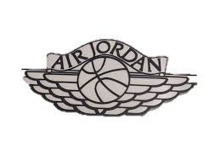

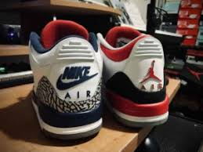

price

Air Jordans are using high-quality materials for all of their products and that makes them expensive and both Nike and Jordan are pricing their products high enough to cover the price of producing them.
Another reason for the price is the Air Max technology.
The Air Max technology brought a new type of cushioning to the shoe which helped to support the foot. It was rigid enough to keep its shape but still soft enough to keep providing comfort. The Air Jordans are considered a luxury brand that is because they technically qualify as designer shoes, they are not mass-produced court sneakers a lot of thought and good engineering goes into every single release, each one is different from the other even some buyers have their shoes made just for them and of course customers expect everything considered luxury to be expensive.
Another thing that is making them more expensive is that Air Jordans are collectible there are people that spend millions on their shoe collection and some of them are not even going to wear their shoes ever even though they paid for them. Air Jordan has some celebrity collaborations for example with Travis Scott who was his “Air Force 1” shoes also “Air Jordan 4”, “ Air Jordan 6” and more every single one of them are even more expensive than the normal models because of Travis’s name involved. Some shoes from the Air Jordan collections are rare and hard to find which makes them even more expensive. They even did a collaboration with the big fashion brand “DIOR” and the shoes turned out to be on of the best decisions they have ever made with a lot of success.

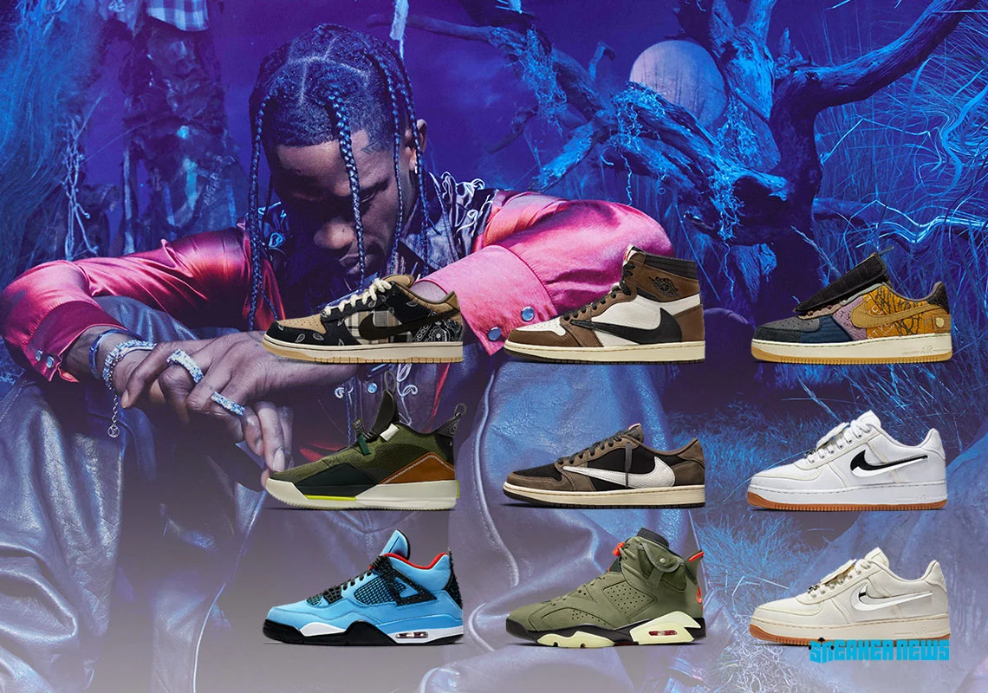
These are some of the Travis Scott Shoes they are some of the best sneakers ever made and the people love them.

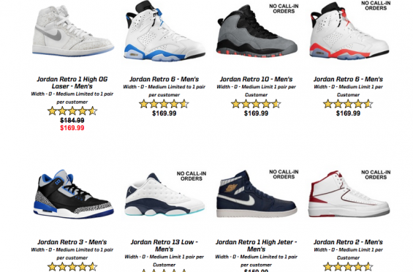

These are some Air Jordan with 5-star reviews.

WHERE YOU CAN FIND AIR JORDAN

You can find Air Jordans in the official NIKE website:
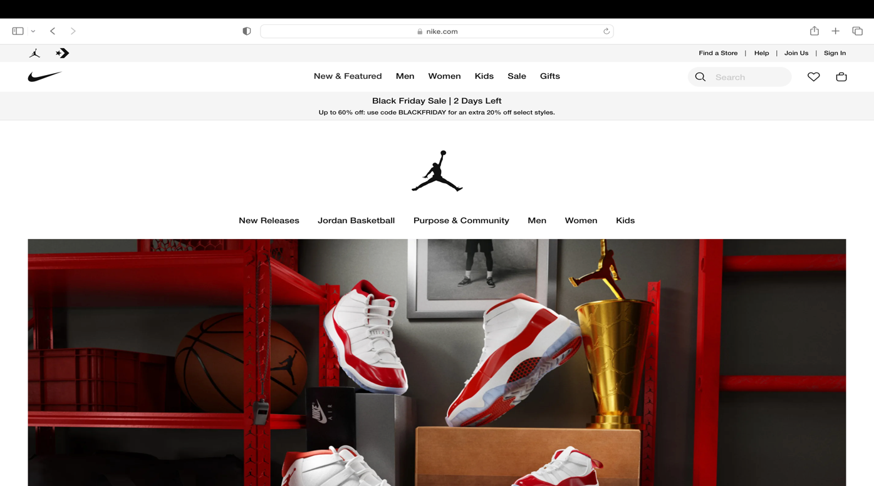
https://www.nike.com/jordan

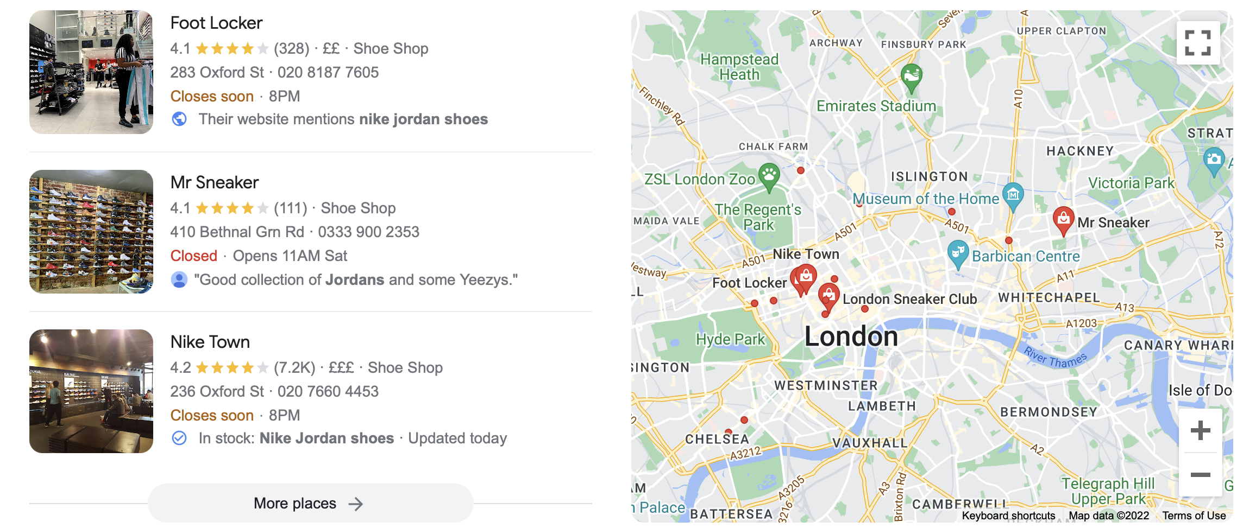
Also, in stores too. Such as:

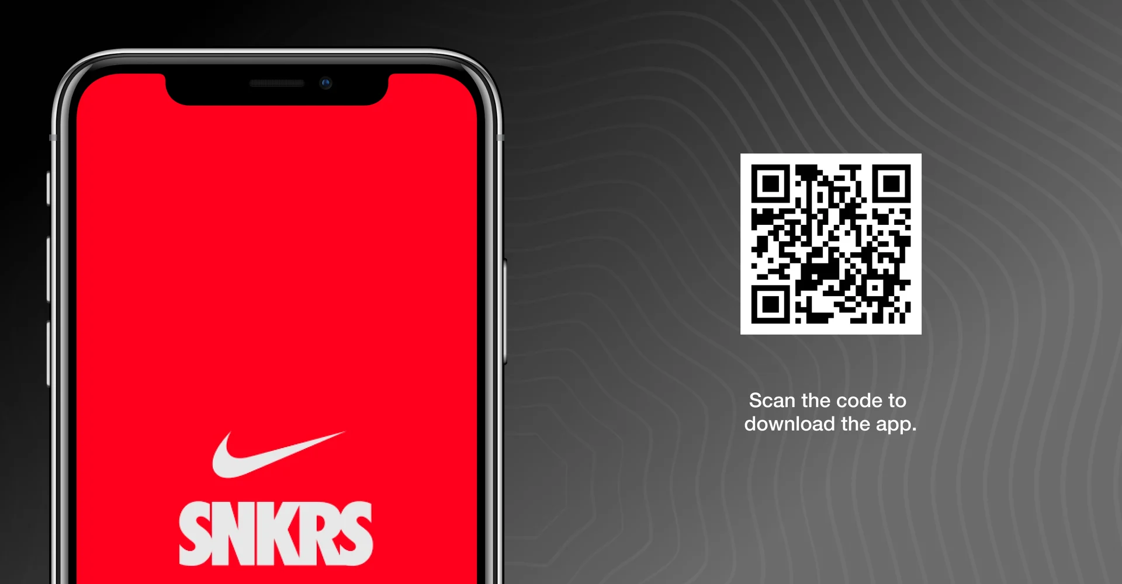
They also can be found it the official NIKE app, it can be downloaded on “Android” and “IOS” devices.

With the app you can get information on new releases and when you sign up and create an account you get discount for the first purchase also when using the app you can browse through all the clothing, accessories and footwear which may be not in stock when you visit the real life stores.

Promotion
Air Jordan are using promotions like:
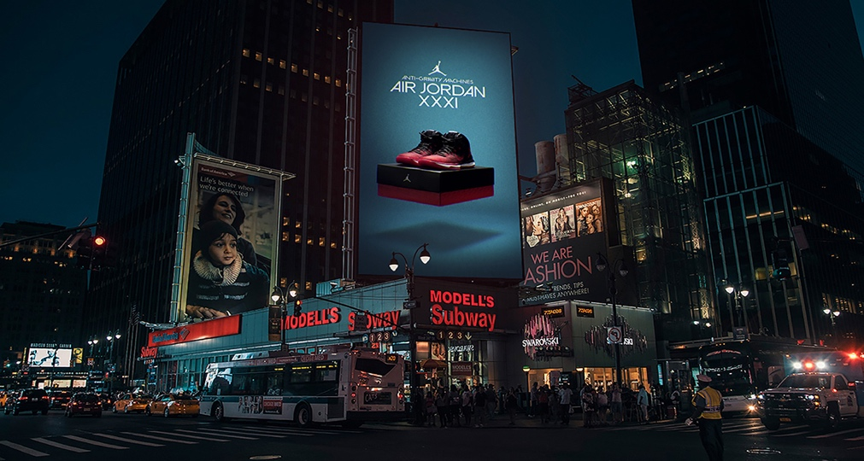
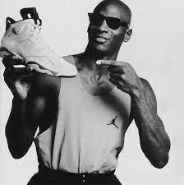
Commercials on TV: Billboards:

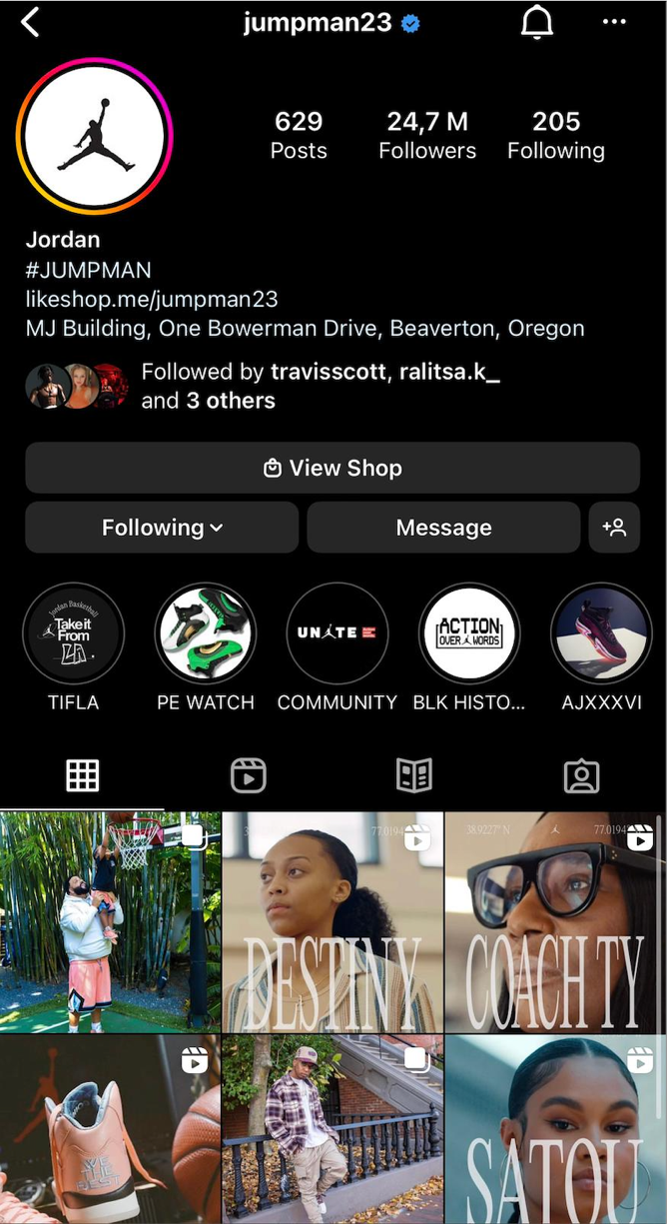



Social Media:


Referencing
https://www.footy.com/blog/gear/nike-air-jordan-history
https://1000logos.net
https://www.marieclaire.com/fashion/a32555197/air-jordans-history/
https://www.britannica.com/biography/Michael-Jordan
https://www.nba.com/news/history-nba-legend-michael-jordan
https://thesporting.blog/blog/the-rise-of-air-jordan
https://blog.klekt.com/jordan/a-brief-history-of-air-jordans/
https://en.wikipedia.org/wiki/Air_Jordan
https://runrepeat.cohttps://www.footy.com/blog/gear/nike-air-jordan-history
m/uk/air-jordan-5-retro

