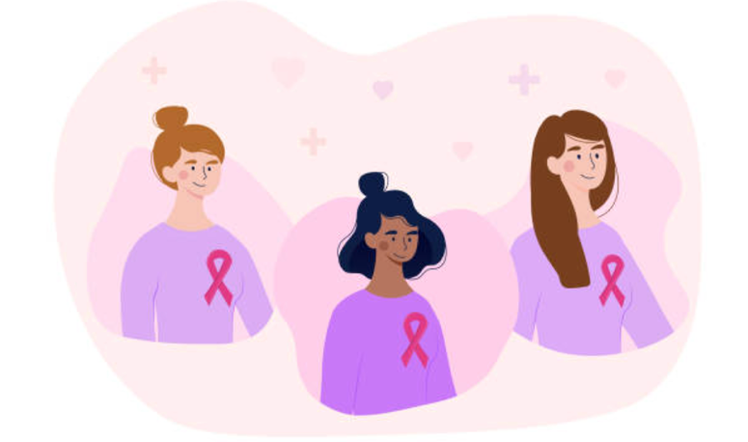
Introduction

This report concerns breast cancer in women.

Breast cancer is a disease in which cells in the breast grow out of control and divide in a way that eventually form a growth which is known as a tumour.

A breast is made up of three main parts: lobules, ducts and connective tissue. The lobules are the glands that produce milk. The ducts are the tubes that carry milk to the nipple. The connective tissue surrounds and holds the breast together. Breast cancer can begin in different parts of the breast including these mentioned.
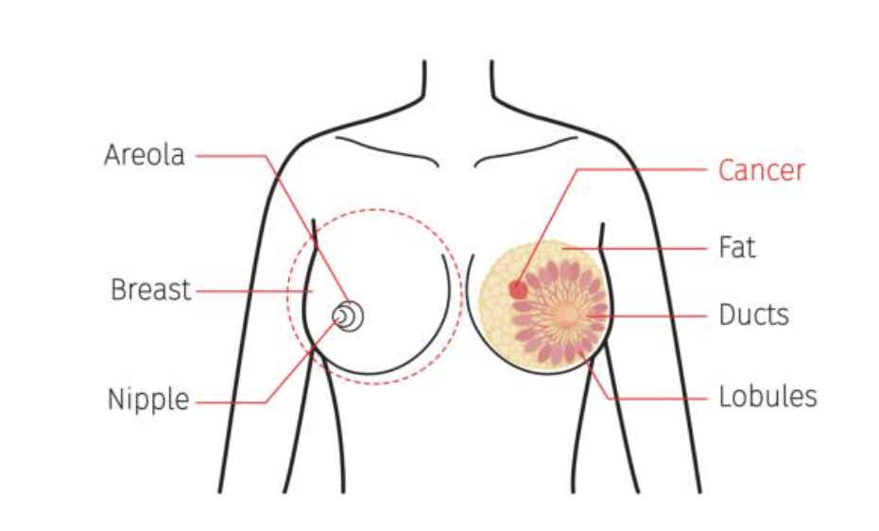
There are different types of breast cancer, and the kind of breast cancer depends on which cells in the breast turn into cancer. The less common types of breast cancer are pagets disease, medullary, mucinous and inflammatory breast cancer. However, the most common types of breast cancer are ductal carcinoma and lobular carcinoma. Invasive ductal carcinoma occurs when cancer cells begin in the duct and then grow outside the ducts into other parts of the breast. Lobular carcinoma occurs when cancer cells begin in the lobules and then spread from the lobules to the breast tissue that are close by. Both types of breast cancer can be invasive which means that the cancer cells can start in part of the breast and then spread to other parts of the body.

Breast cancer affects women in the United Kingdom. Cancer Research UK states that there are 55,920 new cases of breast cancer each year and of these cases 23% of them are preventable. Cancer Research UK also states that 76% of the women that suffer from breast cancer survive for 10 or more years. However, breast cancer causes the death of 11,499 women each year demonstrates that the disease is a severe health issue which provides a reason as to why, in 2021/22, Cancer Research UK committed £443 million to cancer research that will fund new projects that will run for years in an effort to combat the disease as well as spending £28 million on information and influencing work.

Furthermore, breast cancer does not just affect women in the United Kingdom. World Cancer Research Fund International states that breast cancer is the most common cancer worldwide. The World Cancer Research Fund International states that in 2020, there were more than 2.26 million new cases of breast cancer; Belgium had the highest rate of breast cancer in 2020 followed by the Netherlands, Luxembourg, France, Demark, Australia, New Zealand, Finland and finally, the United States of America. The World Cancer Research Fund International also states that in 2020, Barbados had the highest rate of breast cancer mortality in 2020 followed by Fiji, Jamaica, Bahamas, Papua New Guinea, Somalia, Mali, Dominican Republic, Syria and finally, Samoa. These findings indicate that women from countries where there is poor healthcare and little access this type of healthcare are more likely to die of breast cancer than those women from countries that have quality health care and access to it too.

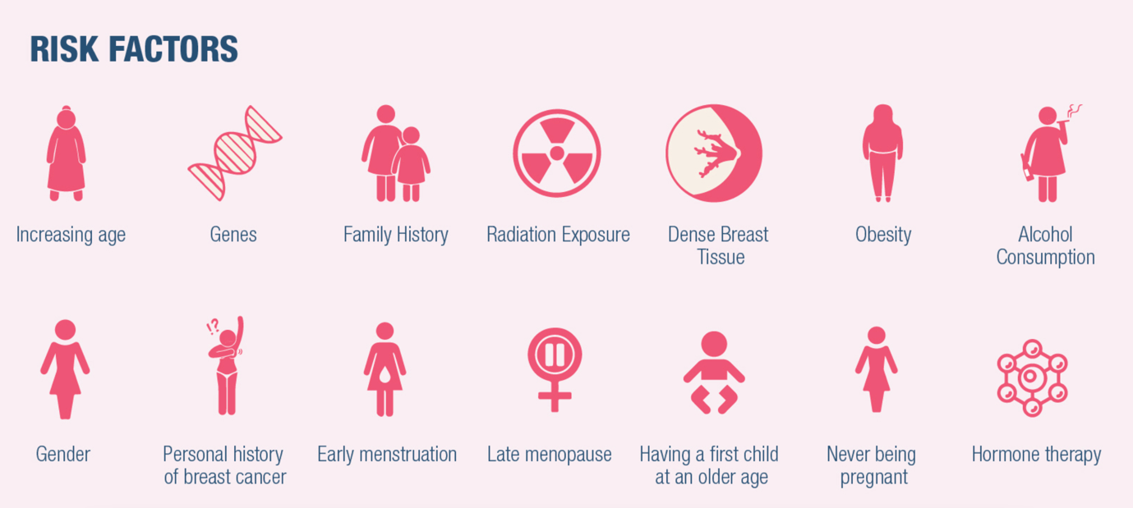
Main body
The NHS states that the causes of breast cancer are not fully understood making it difficult to say why one woman may develop breast cancer and another may not. However, the NHS also states that there are known factors that increase the risk of developing breast cancer. Some of these a woman cannot do anything about, but there are some risks that a woman can reduce or remove; both of which will be discussed below.

Firstly, a risk factor that a woman cannot do anything about is family history. The risk of developing breast cancer increases if a woman has a strong family history of breast cancer. For example, the American Cancer Society have stated that having a first degree relative such as a mother, sister or daughter with breast cancer almost doubles a woman’s risk and having 2 first degree relatives increases the risk by about 3-fold. The risk of developing breast cancer also increases if a woman has inherited the genes known as BRCA1, BRCA2, TP53, CHEK2, PALB2, ATM, PTEN, CDH1 and STK11. BRAC1 and BRCA2 are the most well-known breast cancer related genes. This is because BRCA1 and BRCA2 are genes that help make protein that repair damaged DNA, but, mutated versions of these genes can lead to abnormal cell growth, not just repair which can lead to breast cancer cancer. For example, the American Cancer Society have stated that a woman with a BRCA1 or BRAC2 gene mutation has up to a 7 in 10 chance of getting breast cancer by age 80.
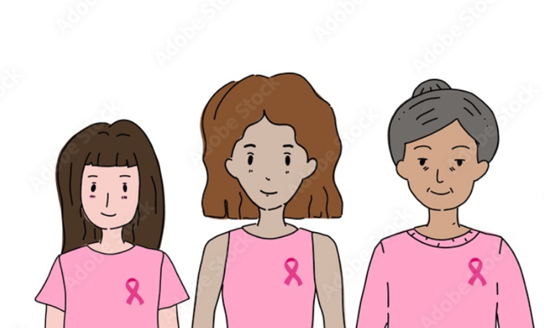
Secondly, a risk factor that a woman cannot do anything about is increasing in age. This is because science has not found a way to prevent aging and a new study suggests that stopping or even reversing the aging process is impossible due to biological constraints. The risk of developing breast cancer increases with age because as a woman gets older, there are more opportunities for genetic damage and are less capable of repairing the genetic damage. For example, the according to the American Cancer Society, about 1 out of 8 invasive cancers develop in women younger than 45 and the NHS confirmed this by stating that breast cancer is most common in women over age 50, especially in those that have been through menopause.

Thirdly, a risk factor that a woman cannot do anything about is dense breast tissue. This is because women with dense breast tissue have a higher risk of developing breast cancer because they have more breast cells and so, they have more cells that can become cancerous.

Lastly, a risk factor that a woman cannot do anything about is the exposure to the drug diethylstilbestrol (DES). DES is a synthetic form of the female hormone oestrogen. It prescribed to women in the United States between 1940 and 1971 in order to prevent miscarriage and premature labour. The use of DES declined after studies in the 1950’s showed that it was not effective in preventing these problems mentioned previously. Although, it continued to be used to stop lactation, for emergency contraception and to treat menopausal symptoms in women. In 1971, researchers linked prenatal DES exposure to a type of cancer found in the cervix and vagina called clear cell adenocarcinoma in a small group of women. The Food and Drug Administration soon notified health care providers throughout the United States that DES should not be prescribed to pregnant woman. But it continued to be used in Europe until 1978. A study found that females exposed to DES in utero, otherwise known as DES daughters, have an increased risk of breast cancer. For example, after age the 40, DES daughters have approximately twice the risk of breast cancer as unexposed women of the same age and with similar risk factors.
Alternatively, there a risk factors that women can do something to reduce them.

Firstly, drinking alcohol increases the risk of getting breast cancer as 8% of breast cancer cases in the UK are caused by alcohol drinking..Therefore, if a woman wants to reduce the risk of getting breast cancer, she should reduce her alcohol intake or alternatively, stop drinking alcohol all together.

Secondly, smoking tobacco increases the risk of getting breast cancer as studies have shown this. Specifically, the risk is 7-13% higher in current smokers and 6-9% higher in former smokers especially those who started at adolescent or peri-menarcheal ages. Therefore, if a woman wants to reduce the risk of getting breast cancer, she should endeavour to never smoke or to stop smoking as soon as possible which is difficult as it is considered an addiction.

Lastly, insufficient physical activity increases the risk of getting breast cancer as breast cancer risk is 13% lower in women with high levels of physical activities when compared to women with low level. Therefore, if a woman wants to reduce her risk of getting breast cancer, she should ensure that she exercises in line with NHS recommendations or alternatively, in line with recommendations from the Mayo Clinic.

In the United Kingdom, there are public health measures available to women that help reduce the risk of breast cancer, measures available to help those who have a higher risk of breast cancer and measures available to help women spot breast cancer early i.e., before the breast cancer spreads to other areas of the breast and other areas of the body too.

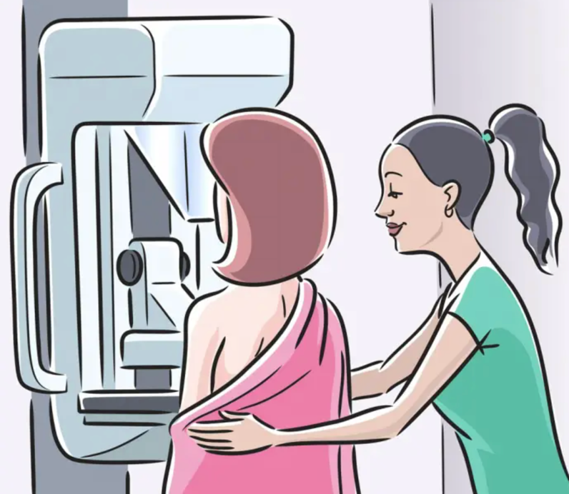
For women between the ages of 50 and 70, the NHS offers a free x – ray breast screening every 3 years called a mammogram in an endeavour to spot breast cancer early. However, women of a younger age that have a higher-than-average risk of cancer, such as having a family history or one of the breast cancer related genes, can have screening from a younger age. Mammograms are efficient in finding breast cancer because they can spot growths/tumours when they are too small to see or feel. This means that each year more than 2 million women have breast cancer screening. The mammogram programme finds cancer in 9 out of every 1,000 women that have screening. These small growths/tumours are much easier to treat than larger ones because they usually need less treatment which means they are more likely to be cured. This is shown in the fact that current evidence suggests that breast screening reduces the number of deaths from breast cancer by 1,300 a year. Although, it is important to note that there are risks of undergoing a mammogram. For example, each mammogram exposes a woman to a small amount of radiation but having them every 3 years for 20 years only very slightly increases the chance of getting cancer due to the exposure to radiation.

For women that have an increased risk of breast cancer, there are 3 medicines available that can be prescribed by the NHS. The medicines are called tamoxifen, anastrozole, raloxifene. These medicines are usually taken once a day for a period of 5 years. During this period of 5 years, the risk of breast cancer is reduced and even after this period of 5 years, the risk of breast cancer can be reduced. Although, it is important to note that there are side effects of these medicines that can include hot flushes, sweating, nausea and tiredness.

For women than have an increased risk of breast cancer or women that have breast cancer, the NHS offers mastectomy’s which is a surgery to remove a breast or both breasts. By removing the breast or breasts, there is a reduction in the risk of getting breast cancer and if a woman has breast cancer, there is a reduction in the risk of it spreading because there is less cells that can become cancerous. As a mastectomy can have a signification effect on a woman’s body image and sexual relationships, the NHS offer breast reconstructions where a woman’s original breast shape is recreated by using breast implants or tissue from other parts of the body.

Regardless of the public health measures available within the United Kingdom, women still suffer from breast cancer. Breast cancer has a physical consequence on a women’s body. In the most cases, women will likely suffer from fatigue, pain, lymphoedema, lowered bone density, changes in weight, changes in mood, hair loss and the side effects associated with early menopause. This means that some women suffering from breast cancer may have to stopping working, hire help to ensure that the family home keeps running and are in constant pain. In some cases, as previously mentioned, women die from breast cancer which has an effect on their family, friends, work colleagues and so on that can last for years after their death.


Furthermore, once a woman is diagnosed for breast cancer, appointments will be made at her local GP and hospital. As so many women are affected by breast cancer each year, there are long be long waiting lists which causes increased amounts of stress for those suffering from the disease. This is because long waiting lists delay the treatment of the cancer in the breast which inevitably worsen it as cancerous cells are given the opportunity to multiply and spread. Normally, this results in doctors having to prioritise breast cancer patients and those appoints which means that other individuals suffering from different diseases and illnesses are forced to wait longer for their appointments. Therefore, breast cancer has a short-term consequence in a health and social care setting.

Similarly, breast cancer has a consequence on the metaphorical body of the NHS as it is currently costing the NHS over £700 million a year and it is predicted to rise. This means that the NHS are being forced to have make decisions based on finite resources which is otherwise known as ‘resource allocation’. This means that some patients will not be provided with treatment that they feel they deserve which can lead to litigation which is an added cost for the NHS. For example, roughly £5 million was spent on breast cancer litigation in the year of 2021. Therefore, breast cancer has a long-term consequence in a health and social care setting.

Conclusion

Breast cancer is a disease that affects women globally and nationally. The United Kingdom has a variety of public health measures in place. Nonetheless, women still suffer from breast cancer. When they do, the consequences are not only felt by them as well as their family and friends if they die from it but also by the NHS as breast cancer has short- and long-term effects on it. Ultimately, these consequences effect people’s view on the NHS and create strong opinions. However, it is important to remember that the surgeons, doctors, nurses, and other medical individuals are doing what they can with the resources that they are given which inevitably leads to some tough decision making.


Reference List

What is breast cancer? (2022) Centers for Disease Control and Prevention. Centers for Disease Control and Prevention. Available at: https://www.cdc.gov/cancer/breast/basic_info/what-is-breast-cancer.htm#:~:text=Breast%20cancer%20is%20a%20disease,different%20parts%20of%20the%20breast. (Accessed: November 20, 2022).
Anatomy of the breast (no date) Memorial Sloan Kettering Cancer Center. Available at: https://www.mskcc.org/cancer-care/types/breast/anatomy-breast (Accessed: November 20, 2022).
Breast anatomy (2022) National Breast Cancer Foundation. Available at: https://www.nationalbreastcancer.org/breast-anatomy (Accessed: November 20, 2022).
Breast anatomy (2022) National Breast Cancer Foundation. Available at: https://www.nationalbreastcancer.org/breast-anatomy (Accessed: November 20, 2022).
Types of breast cancer: Common, rare and more varieties (2022) Cancer Treatment Centers of America. Available at: https://www.cancercenter.com/cancer-types/breast-cancer/types (Accessed: November 20, 2022).
What is breast cancer? (2022) Centers for Disease Control and Prevention. Centers for Disease Control and Prevention. Available at: https://www.cdc.gov/cancer/breast/basic_info/what-is-breast-cancer.htm#:~:text=Breast%20cancer%20is%20a%20disease,different%20parts%20of%20the%20breast. (Accessed: November 20, 2022).
What is breast cancer? (2022) Centers for Disease Control and Prevention. Centers for Disease Control and Prevention. Available at: https://www.cdc.gov/cancer/breast/basic_info/what-is-breast-cancer.htm#:~:text=Breast%20cancer%20is%20a%20disease,different%20parts%20of%20the%20breast. (Accessed: November 20, 2022).
What is breast cancer? (2022) Centers for Disease Control and Prevention. Centers for Disease Control and Prevention. Available at: https://www.cdc.gov/cancer/breast/basic_info/what-is-breast-cancer.htm#:~:text=Breast%20cancer%20is%20a%20disease,different%20parts%20of%20the%20breast. (Accessed: November 20, 2022).
Breast cancer risk (2019) Cancer Research UK. Available at: https://www.cancerresearchuk.org/health-professional/cancer-statistics/statistics-by-cancer-type/breast-cancer/risk-factors#heading-Thirteen (Accessed: November 20, 2022).
Breast cancer risk (2019) Cancer Research UK. Available at: https://www.cancerresearchuk.org/health-professional/cancer-statistics/statistics-by-cancer-type/breast-cancer/risk-factors#heading-Thirteen (Accessed: November 20, 2022).
How we spend your money (2022) Cancer Research UK. Available at: https://www.cancerresearchuk.org/about-us/our-organisation/how-we-spend-your-money (Accessed: November 20, 2022).
Breast cancer statistics: World cancer research fund international (2022) WCRF International. Available at: https://www.wcrf.org/cancer-trends/breast-cancer-statistics/ (Accessed: November 20, 2022).
Breast cancer statistics: World cancer research fund international (2022) WCRF International. Available at: https://www.wcrf.org/cancer-trends/breast-cancer-statistics/ (Accessed: November 20, 2022).
Molyneux, E., Israels, T. and Howard, S.C. (2020) “Cancer treatment in low- and middle-income countries,” Oxford Textbook of Cancer in Children, pp. 90–96. Available at: https://doi.org/10.1093/med/9780198797210.003.0012.
NHS choices. NHS. Available at: https://www.nhs.uk/conditions/breast-cancer/causes/ (Accessed: November 20, 2022).
NHS choices. NHS. Available at: https://www.nhs.uk/conditions/breast-cancer/causes/ (Accessed: November 20, 2022).
NHS choices. NHS. Available at: https://www.nhs.uk/conditions/breast-cancer/causes/ (Accessed: November 20, 2022).
NHS choices. NHS. Available at: https://www.nhs.uk/conditions/breast-cancer/causes/ (Accessed: November 20, 2022).
Breast cancer risk factors you can't change (no date) American Cancer Society. Available at: https://www.cancer.org/cancer/breast-cancer/risk-and-prevention/breast-cancer-risk-factors-you-cannot-change.html (Accessed: November 20, 2022).
Breast cancer risk factors you can't change (no date) American Cancer Society. Available at: https://www.cancer.org/cancer/breast-cancer/risk-and-prevention/breast-cancer-risk-factors-you-cannot-change.html (Accessed: November 20, 2022).
NHS choices. NHS. Available at: https://www.nhs.uk/conditions/predictive-genetic-tests-cancer/ (Accessed: November 20, 2022).
Breast cancer risk factors you can't change (no date) American Cancer Society. Available at: https://www.cancer.org/cancer/breast-cancer/risk-and-prevention/breast-cancer-risk-factors-you-cannot-change.html (Accessed: November 20, 2022).
Spencer, C. (2021) New study says humans cannot slow the process of aging, The Hill. The Hill. Available at: https://thehill.com/changing-america/well-being/longevity/559061-huge-new-study-says-humans-cannot-slow-the-process-of/ (Accessed: November 20, 2022).
Age. Available at: https://www.breastcancer.org/risk/risk-factors/age (Accessed: November 20, 2022).
Breast cancer risk factors you can't change (no date) American Cancer Society. Available at: https://www.cancer.org/cancer/breast-cancer/risk-and-prevention/breast-cancer-risk-factors-you-cannot-change.html (Accessed: November 20, 2022).
Breast cancer risk (2019) Cancer Research UK. Available at: https://www.cancerresearchuk.org/health-professional/cancer-statistics/statistics-by-cancer-type/breast-cancer/risk-factors#heading-Thirteen (Accessed: November 20, 2022).
What are the risk factors for breast cancer? (2022) Centers for Disease Control and Prevention. Centers for Disease Control and Prevention. Available at: https://www.cdc.gov/cancer/breast/basic_info/risk_factors.htm (Accessed: November 20, 2022).
Diethylstilbestrol (DES) exposure and cancer (no date) National Cancer Institute. Available at: https://www.cancer.gov/about-cancer/causes-prevention/risk/hormones/des-fact-sheet#:~:text=Breast%20cancer.&text=A%202006%20study%20from%20the,similar%20risk%20factors%20(6). (Accessed: November 20, 2022).
Diethylstilbestrol (DES) exposure and cancer (no date) National Cancer Institute. Available at: https://www.cancer.gov/about-cancer/causes-prevention/risk/hormones/des-fact-sheet#:~:text=Breast%20cancer.&text=A%202006%20study%20from%20the,similar%20risk%20factors%20(6). (Accessed: November 20, 2022).
Diethylstilbestrol (DES) exposure and cancer (no date) National Cancer Institute. Available at: https://www.cancer.gov/about-cancer/causes-prevention/risk/hormones/des-fact-sheet#:~:text=Breast%20cancer.&text=A%202006%20study%20from%20the,similar%20risk%20factors%20(6). (Accessed: November 20, 2022).
Diethylstilbestrol (DES) exposure and cancer (no date) National Cancer Institute. Available at: https://www.cancer.gov/about-cancer/causes-prevention/risk/hormones/des-fact-sheet#:~:text=Breast%20cancer.&text=A%202006%20study%20from%20the,similar%20risk%20factors%20(6). (Accessed: November 20, 2022).
Diethylstilbestrol (DES) exposure and cancer (no date) National Cancer Institute. Available at: https://www.cancer.gov/about-cancer/causes-prevention/risk/hormones/des-fact-sheet#:~:text=Breast%20cancer.&text=A%202006%20study%20from%20the,similar%20risk%20factors%20(6). (Accessed: November 20, 2022).
Diethylstilbestrol (DES) exposure and cancer (no date) National Cancer Institute. Available at: https://www.cancer.gov/about-cancer/causes-prevention/risk/hormones/des-fact-sheet#:~:text=Breast%20cancer.&text=A%202006%20study%20from%20the,similar%20risk%20factors%20(6). (Accessed: November 20, 2022).
https://www.cancerresearchuk.org/health-professional/cancer-statistics/statistics-by-cancer-type/breast-cancer/risk-factors#heading-Ten
https://www.cancerresearchuk.org/health-professional/cancer-statistics/statistics-by-cancer-type/breast-cancer/risk-factors#heading-Ten
Jones, M.E. et al. (2017) “Smoking and risk of breast cancer in the generations study cohort,” Breast Cancer Research, 19(1). Available at: https://doi.org/10.1186/s13058-017-0908-4.
https://www.cancerresearchuk.org/health-professional/cancer-statistics/statistics-by-cancer-type/breast-cancer/risk-factors#heading-Ten
Edward R. Laskowski, M.D. (2021) How much exercise do you really need?, Mayo Clinic. Mayo Foundation for Medical Education and Research. Available at: https://www.mayoclinic.org/healthy-lifestyle/fitness/expert-answers/exercise/faq20057916#:~:text=As%20a%20general%20goal%2C%20aim,your%20risk%20of%20metabolic%20problems. (Accessed: November 20, 2022).
Breast screening (2020) Breast screening | Breast cancer | Cancer Research UK. Available at: https://www.cancerresearchuk.org/about-cancer/breast-cancer/getting-diagnosed/screening/breast-screening (Accessed: November 20, 2022).
Breast screening (2020) Breast screening | Breast cancer | Cancer Research UK. Available at: https://www.cancerresearchuk.org/about-cancer/breast-cancer/getting-diagnosed/screening/breast-screening (Accessed: November 20, 2022).
Breast screening (2020) Breast screening | Breast cancer | Cancer Research UK. Available at: https://www.cancerresearchuk.org/about-cancer/breast-cancer/getting-diagnosed/screening/breast-screening (Accessed: November 20, 2022).
Breast screening (2020) Breast screening | Breast cancer | Cancer Research UK. Available at: https://www.cancerresearchuk.org/about-cancer/breast-cancer/getting-diagnosed/screening/breast-screening (Accessed: November 20, 2022).
Breast screening (2020) Breast screening | Breast cancer | Cancer Research UK. Available at: https://www.cancerresearchuk.org/about-cancer/breast-cancer/getting-diagnosed/screening/breast-screening (Accessed: November 20, 2022).
NHS choices. NHS. Available at: https://www.nhs.uk/conditions/breast-cancer/treatment/ (Accessed: November 20, 2022).
NHS choices. NHS. Available at: https://www.nhs.uk/conditions/breast-cancer/treatment/ (Accessed: November 20, 2022).
NHS choices. NHS. Available at: https://www.nhs.uk/conditions/breast-cancer/treatment/ (Accessed: November 20, 2022).
NHS choices. NHS. Available at: https://www.nhs.uk/conditions/mastectomy/ (Accessed: November 20, 2022).
NHS choices. NHS. Available at: https://www.nhs.uk/conditions/mastectomy/ (Accessed: November 20, 2022).
NHS choices. NHS. Available at: https://www.royalfree.nhs.uk/services/services-a-z/breast-surgery/breast-cancer-faqs/ (Accessed: November 20, 2022).
Physical Wellbeing, Breast Cancer Network Australia. Available at: https://www.bcna.org.au/health-wellbeing/physical-wellbeing/ (Accessed: November 20, 2022).
Cancer waiting times (2022) Cancer waiting times | Cancer information | Cancer Research UK. Available at: https://www.cancerresearchuk.org/about-cancer/cancer-in-general/cancer-waiting-times (Accessed: November 20, 2022).
MS;, M.R.S.M.S. (no date) Economic Analysis of the breast cancer screening program used by the UK NHS: Should the program be maintained?, Breast cancer (Dove Medical Press). U.S. National Library of Medicine. Available at: https://pubmed.ncbi.nlm.nih.gov/28392714/ (Accessed: November 20, 2022).
O’Connell, R.L. et al. (2021) “Litigation in breast surgery: Unique Insights from the English National Health Service experience,” BJS Open, 5(3). Available at: https://doi.org/10.1093/bjsopen/zraa068.

