Contemporary Challenges
Ashanti Taylor / 2304545
Automation of jobs and the impact on future job opportunities / A.I.

The automation of jobs through artificial intelligence is a phenomenon that is happening all around us, constantly. It infers the takeover of machines in the workspace through artificial intelligence. The phrase “Artificial Intelligence” or, as we most commonly see it abbreviated as, AI, is software created to mimic aspects of human intelligence. Due to how vast and widespread the internet is, Language Models, image and video generative AIs and deepfake technology have more data than ever to input into their neural networks, and output as a computer-generated combination of its source data.

Contrary to certain beliefs that are portrayed in fictional media, AI does not think for itself, but is essentially a neural network. Inputs work through this network, to come up with the most appropriate output. We have already seen how ATMs and self-checkout machines are dominating their respective fields, especially within our day and age where face-to-face socialising is at an all-time low. In current times, AI is not only dominating manual labour work, but also cognitive, creative jobs that were once considered ‘too human’ to be accomplished by a machine. Whilst not technically classed as general artificial intelligence, Large Language Models (also known as LLMs) take data from the internet and use it to ‘converse’ or ‘write creatively’ in open-ended conversations with a user. ChatGPT is the most popular example of this. Most LLMs use a specific neural network architecture called a transformer (the ‘GPT’ in ChatGPT stands for Generative Pretrained Transformer [1]), which can read vast amounts of text on the internet and use the knowledge it ‘learns’ to take the patterns in texts that it analyses to converse as naturally as possible. One downfall is that Chatbots synthesise so much data from pre-existing texts, that most of its responses are unremarkable, basic answers. LLMs may also digest controversial opinions or content, and when prompted can churn out unsettling or offensive messages. They can be biased and gullible [2], as they do not actively think for themselves like we humans do.

AI was initially created to mimic basic human reasoning, in the hopes that it would make life easier for humanity; that it would take over manual, repetitive jobs such as material handling, assembly of parts, costumer service and analyst work. For example, AI could be used in healthcare to diagnose patients by viewing their data and spot patterns in the information. It has the potential to be even more accurate than humans, since it does not experience the fatigue a human doctor may with their long working hours to meet the demands of healthcare. The use of generative AI also stems from the desire to have what we don’t, or perhaps cannot, achieve. We are currently seeing this with image generation AIs, like Midjourney, Adobe Firefly and Stable Diffusion— something as human as art itself has started to see an uprise in the usage of AI. Most arguments in favour of AI generated art comes from how efficient and easily accessible it is, in just a matter of seconds you can generate a piece of art from a few typed-out prompts. This makes art more viable to people who have disabilities, or those who cannot draw to the standard they want to achieve.

As aforementioned, LLMs can exhibit bias and generate offensive content when prompted by a user, if their training data is flawed or incomplete, or via a prompt injection. A prompt injection, as described by Stephen Henry, an infrastructure engineer, is ‘a technique that allows attackers to bypass safety measures of an LLM by carefully crafting a prompt that the model will interpret in a way the attacker desires.’ [3] Their ability to process and generate sensitive information can be exploited shockingly easily, therefore both the security and ethical implications are of significant concern. Job displacement [4] is also a defining factor of all AIs, with LLMs at the forefront. They are already used to replace human writers in online articles, as the vast majority of companies strive for more work output with less expense. With image generation AIs, younger artists who hope to enter their respective industries may be discouraged due to how art-based companies are beginning to embrace this type of artificial intelligence. Wacom, a high-end digital art tablet brand, recently used an AI generated piece of art to advertise their product [5]. AI renders art tablets and other digital art supplies near useless, so there was evidently an uproar on social media when an actual art tablet brand used AI instead of paying an artist for a promotional image instead. Similarly to image generation AIs, we are beginning to see the uprise in video generation AIs, the most popular example is OpenAI’s ‘text-to-video’ artificial intelligence, Sora [6]. A user can input a text prompt, and the AI will create a video up to 60 seconds in accordance with the prompt. OpenAI themselves state that ‘the model understands not only what the user has asked for in the prompt, but also how those things exist in the physical world’ [7]. At first, it sounds like a cause for concern, however recent evidence has been released that OpenAI have a partnership with Shutterstock, and most of Sora’s videos are simply compiling real videos and images from their partner platform.

There is no one way to solve the problems AI is starting to cause, but most people are rooting for some form of regulation or law when it comes to AI generation. A solution that has been proposed to combat AI threats of job displacements is the concept of a Universal Base Income (UBI) [8]. Hypothetically, a UBI would act as a form of safety net for those who’s jobs may be taken over by automation— it would also act as a tool to combat inequality, ensuring a stable consumer rate for a functioning economy. A commonly posed argument against the idea of a UBI is that people would no longer want to work at all; who would work the jobs that AI is currently unable to do? Surgeons, litter-pickers, lifeguards, what would motivate them to continue pursuing their careers if AI is bound to take over their respective sectors anyway, and if there is a base income for them, so even if they were to quit, they would still be able to pay to live in this economy? A more current call for regulation has to do with deepfakes. Deepfakes are a type of image that has been AI generated to represent or imitate someone’s appearance and are particularly being urged by the public to potentially criminalise. In the United Kingdom, the creation and publication of explicit deepfake images became illegal as a part of the Online Safety Act in 2023 [9]. There are currently no federal laws against deepfake image creation, however. With the rise of doctored images, there is a growing call and need for regulation in at least this aspect of generative artificial intelligence.

Overall, the automation of jobs is a very real and current threat of AI. As well as automation of labour, jobs in creative fields are also at risk, AI offers an easier, more efficient and more accessible alternative to devoting years of people’s lives toward their respective professions. AI also poses threats to society as we know it, LLMs can spread falsified and harmful information, whilst deepfakes can incriminate and commit defamation against innocent people. Whilst these tools can be useful, most people believe that the downsides of AI outweigh the benefits and have already placed a stigma on it. Regulation and appropriate action with job displacements are imperative for a functioning society to work with the growing integration of AI.

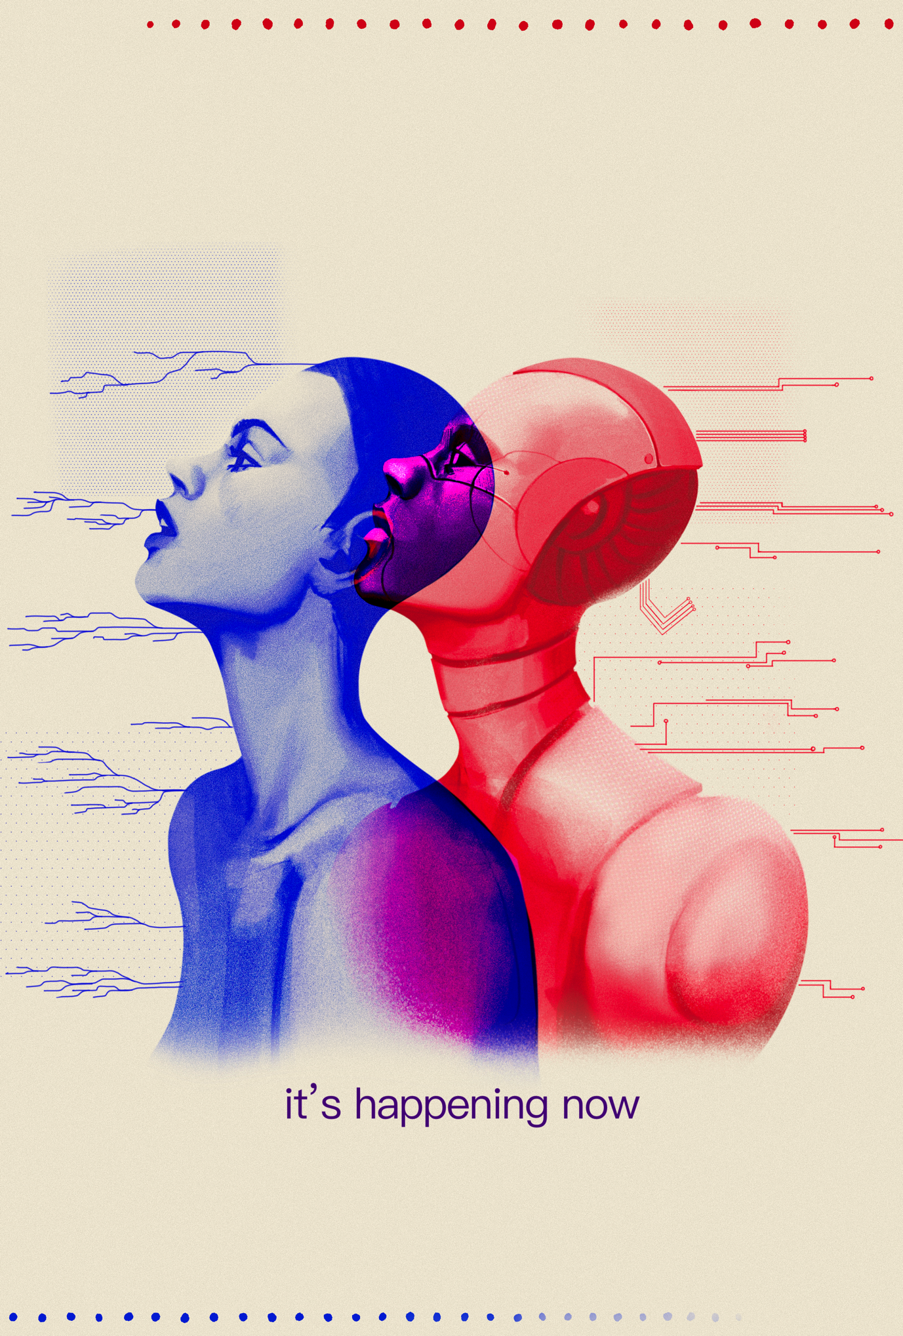
Poster Design:
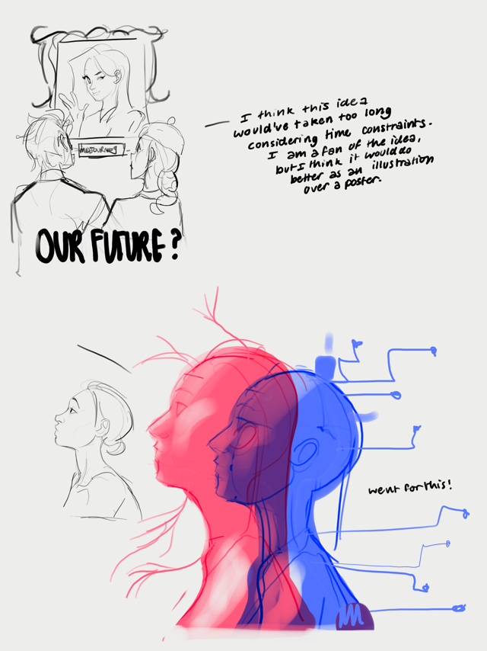
Sketch:

Bibliography:

[1] D. Nield, “How ChatGPT and other LLMs work-and where they could go next,” WIRED UK, https://www.wired.co.uk/article/how-chatgpt-works-large-language-model (accessed Feb. 22, 2024).
[2] David C, Paul J, “ChatGPT and Large Language Models: What’s the risk?” NCSC, https://www.ncsc.gov.uk/blog-post/chatgpt-and-large-language-models-whats-the-risk (accessed Feb. 22, 2024).
[3] S. Henry, “Prompt injection: A new threat to CHATGPT and Bard,” LinkedIn, https://www.linkedin.com/pulse/prompt-injection-new-threat-chatgpt-bard-stephen-henry (accessed Feb. 24, 2024).
[4] B. Hoffman, “Council post: 14 Ways Automation will affect the job market, and how leaders can prepare,” Forbes, https://www.forbes.com/sites/forbescoachescouncil/2023/02/24/14-ways-automation-will-affect-the-job-market-and-how-leaders-can-prepare/ (accessed Feb. 24, 2024).
[5] G. Levine, “Wacom explained its AI-generated images after backlash,” 80lv, https://80.lv/articles/wacom-explained-its-ai-generated-images-after-backlash/ (accessed Feb. 24, 2024).
[6] J. Hsu, “Realism of OpenAI’s Sora Video Generator raises security concerns,” New Scientist, https://www.newscientist.com/article/2417639-realism-of-openais-sora-video-generator-raises-security-concerns/ (accessed Feb. 24, 2024).
[7] OpenAI, “Creating video from text,” Sora, https://openai.com/sora (accessed Feb. 24, 2024).
[8] T. Moody, “Embracing the future: How UBI can transform our AI-driven world,” LinkedIn, https://www.linkedin.com/pulse/embracing-future-how-ubi-can-transform-our-ai-driven-world-moody-gxl2c (accessed Feb. 24, 2024).
[9] I. Rahman-Jones, “Taylor Swift Deepfakes spark calls in Congress for new legislation,” BBC News, https://www.bbc.co.uk/news/technology-68110476 (accessed Feb. 24, 2024).

