Human Development ECEY4001
Sara Elisabeth King (2105395)

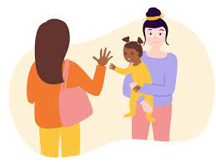
(Source: Famly.Co., 2020)
EARLY YEARS TRANSITIONS:
A Guidance Handbook for Practitioners
Contents

Introduction

Aims
This handbook aims to assist Early Years workers when supporting children during the transitioning process. It will explore in detail the importance of communication during transitions for the Early Years Foundation Stage, specifically focusing on children aged 0-2years who are entering a creche environment for the first time. Not only can this be an extremely anxious and distressing time for the child, but also for the parent(s)/guardian(s). Hence the reason why the support and skills demonstrated by the childcare professional is vital to enabling a child to transition successfully into their new environment. Lindon (2012) states that increasing knowledge and research with regards to child developmental facts and theories gives practitioners (and parents too) the tools to adapt and possibly enhance their own performance, providing high-quality care and support for the child. The over-all aim of this handbook is to support practitioners in providing the best possible outcomes for the child during the transitioning process.

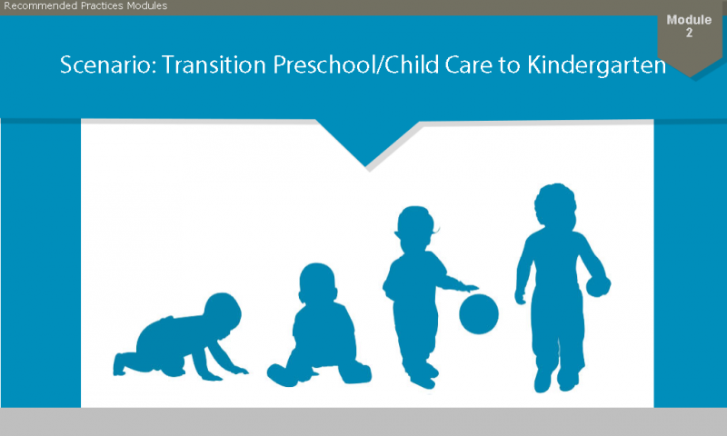
Transitions – what are they?
(Source: Early Childhood Recommended Practices Modules, 2021)

It is not possible to summarise the term ‘transitions’ into one singular definition as it can be used in a range of contexts. However, it is commonly described as a particular period in one’s lifetime where significant events occur and is usually associated with alterations and/or developments to a variety of aspects, including personal appearance, roles and relationships, professional status, social involvement and physical surroundings. Transitions can impact on an individual’s cognitive, social and emotional well-being and therefore can include the need for psychosocial and cultural adjustments (Vogler, Gina, and Woodhead, 2008)
The Novak Djokovic Foundation (2016) explains that transitions in the early years can refer to the new experience of a child having to attend and adjust to an unfamiliar setting/environment. Similarly, Early Years Matters (2021) points out that transition “is always about change; particularly adjusting to change” and describes it as an on-going process rather than a singular occurrence that requires input from the practitioner, parent/guardian and the child, if they have the capacity to do so. Clarke (2020) says that there are many common examples of transitions for children, including:
- Weaning onto solid food
- Advancing from crawling to walking
- Progressing from nappies onto toilet-training
- Starting a new setting (for example nursery or school)
- Arrival of a new sibling
- Moving house
- Parents separating
- Illness or death within the family.

It is a well-known fact that transitions play a significant role in modern societies when considering children’s learning and education. All children in the care and education system will have experienced transitions in some such way, and the effects of transitions can be instrumental to the child’s learning and over-all well-being (Brooker, 2008). A thoughtful and sensitive approach to managing transition can be extremely reassuring for children and their parents/carers, alleviating the anxiety of being separated from one another. A smooth transition will provide comfort for parents/carers and children, setting a foundation that will encourage trust and confidence in the care of the child (Patel, 2021).

The Needs of The Child

Having access to a good education system that is suitable to the needs of the child is not only a legal right for all children but is also consequential to providing the best possible opportunities for children to achieve their full potential (Gov.UK, 2021). Considering each child as an individual is vital for their development as “every child is a unique child, who is constantly learning and can be resilient, capable, confident and self-assured” (EYFS, 2021, p.6). Studies into child development are still on-going; however, acquiring knowledge and understanding of research that has already been conducted will help professionals understand and pinpoint the specific needs of a child.

Brain Development
Disciplines within the social and natural sciences such as biology, psychology, medicine and (more recently) neuropsychology have exerted influence over suggested theories and ideas regarding the development of children (Lindon and Brodie, 2016). In recent times, neuropsychological findings and approaches have become apparent in trying to understand and treat psychiatric, psychosocial, developmental and learning issues in children and young people (Semrud-Clikeman and Ellison, 2009). In the first few years of a child’s life, their brain develops at a rapid pace and early experiences can affect its construction. A young child’s brain will make over one million neural connections every second, and research has proven that positive interactions during these early years is crucial in helping the brain to develop. The brain of a child that has experienced neglect or inappropriate/unreliable care does not develop as efficiently and can cause the child to experience issues regarding learning and behaviour (Harvard University, 2021). Recognising that communication plays a key role in brain development, the NSPCC (2021) have launched a ‘Look, Say, Sing, Play’ campaign to promote regular and appropriate communication/interaction between carers and children, both professionally and at home, in order to encourage ‘brain-building.’

Maslow’s Hierarchy of Needs
Maslow (1943) developed The Hierarchy of Needs Model based on his theory that everyone has five levels of ‘needs’, where the first level needs to be achieved before the second, and so on. He argued that if his model was used as the basis for further research, it should provide a greater insight of how we are able to meet the needs of individuals (Milheim, 2012). The five levels are:
- Physiological needs – these are the basic requirements needed to exist such as air, food, water and warmth.
- Safety needs – a safe, secure environment that provides structure and protection from harm.
- Love and belonging needs – to be socially accepted and have meaningful, significant relationships with family members, peers and life-partner.
- Self-esteem – the desire for dignity and achievement, as well as acquiring recognition and respect from others and an over-all positive reputation.
- Self-actualization – Realising own potential and seeking personal growth for
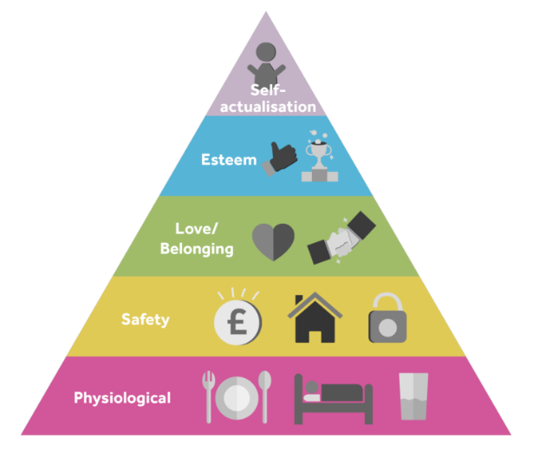

(Source: Future Learn, no date)

From a child developmental view, children must have their needs met in order to achieve their full potential in all areas of development and learning including physical, emotional, social, communication, creative and cognitive development (Future Learn, no date).

Attachment Theory
According to Bowlby (1969), “attachment is characterized by specific behaviours in children, such as seeking proximity to the attachment figure when upset or threatened.” He argued that children are pre-programmed from birth to form attachments and are instinctively driven to find one main attachment figure – known as monotropy, he suggests that the primary caregiver is usually the mother, but that is not necessarily always the case (McLeod, 2017). A significant period in attachment theory is from birth to one years old, as three out of four of the proposed phases of attachment occurs during this time (Wilson-Ali, Barratt-Pugh, Knaus, 2019). Ainsworth et al. (1979, 2014) describe the four phases as:
- Pre-attachment (birth to three months old) – Baby does not display preference or attachment to a particular carer but enjoys looking at human faces and listening to voices. The baby encourages bonding with caregivers through grasping, sucking, babbling and crying.
- Attachment in the making (three to six months old) – Baby will begin to differentiate between people and will start to show preference for one person.
- Clear-cut attachment (six months to three years old) – their attachment towards a specific person becomes more obvious and intense, and separation anxiety occurs. They feel uneasy and possibly distressed around strangers, particularly when in an unfamiliar environment.
- Goal-corrected partnership (three years+) – Children begin to understand that carers cannot be always with them and become less distressed when carer leaves for a short period of time (Vinney, 2019).

Similarly, Erikson (1982) also points out the need for infants to feel secure, as he introduced his theory on the Eight Stages of Human Development. His bio-psychosocial approach was built of Freud’s theory of psychosexual development and suggests that an individual will experience conflict in each stage of development. He believed that identity strengths or ‘virtues’ can be achieved when an individual acquires both perspectives (Batra, 2013).
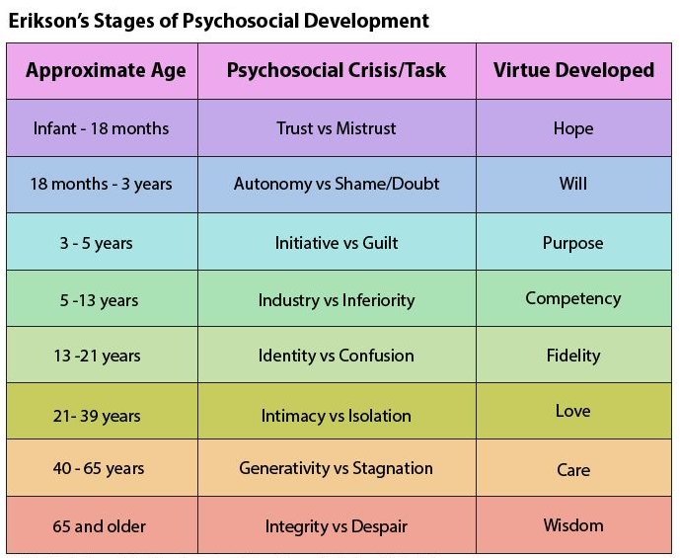

(Source: The Psychology Notes HQ, 2019)

For the target age group of this handbook (0-2years), Erikson believes that children will experience two of the above stages:

- Stage 1 – Trust vs. Mistrust – Erikson suggests that between the ages of 0-18months, infants learn to trust the caregiver (usually the mother) to provide their basic needs, provided these needs are adequately met. The virtue ‘Hope’ emerges as a direct result of the child being attended to in a loving, caring manner. However, if the infant is deprived of these fundamental needs, or the caregiver is unreliable in providing them, infants will develop feelings of mistrust which can negatively affect their ability to form relationships in future. Erikson describes this as ‘Withdrawal’, an inveterate state which is the total opposite of the virtue ‘Hope.’
- Stage 2 – Autonomy vs. Shame/Doubt – From 18months to 3years old, a child develops greater physical abilities enabling them to be more independent (for example, the ability to walk, use the toilet, play with toys, to feed and dress themselves). Erikson’s theory claims that the way in which caregivers respond to children during this stage can either encourage or delay their development. If caregivers are too restrictive and don’t allow children the opportunity to learn self-control and independence, this can lead to the child having feelings of shame and doubt, especially if they recognise that they are less able than their peers. Therefore, finding the correct balance between encouraging independence and protecting children from failure and harm during this stage is crucial to supporting healthy development. Displaying patience and explaining possible consequences to their actions will gradually lead the child to experience autonomy in a way that is socially acceptable. As a result, children will achieve a sense of Will, developing self-confidence in their own capabilities (Batra, 2013).
The Role of The Adult

The first aspect to note is that adults play a significant lead role when facilitating transitions, particularly for children aged 0-2 years. Winnicott (1960) recognised the extreme vulnerability of an infant child and points out its fragile psychological state, lacking understanding of the world around them and incapable of communicating effectively. He claimed that without the environment on which it depends, the baby cannot exist (Mitchell, 2009).

There is no such thing as an infant… If you set out to describe a baby, you will find that you are describing a baby and someone. A baby cannot exist alone but is essentially part of a relationship.
(Winnicott, 1966)

It is important to take into consideration the vulnerability of a child when they are going through any sort of transition.
All adults that are involved in the care of the child need to work together to facilitate a well-supported transition. A positive partnership between parents and early years practitioners can result in great benefits for a child’s cognitive development and academic achievement (Lamb-Parker, 2001). The UK Government has recognised the significance of parental involvement in children’s education and have issued ‘The Children’s Plan’ (DCSF 2007), a Policy paper that emphasises the importance of this. In working effectively with one another, issues are more likely to be identified early (or possibly prevented) and strategies can be put into place that can help meet the needs of the child. An effective partnership will also allow the opportunity to advocate for the child (Hornby, 2011).
Notably, positive partnerships cannot be established without effective communication. Rogers (1980), as cited by Hornby (2011), suggests that in order to work effectively with parents, professionals need to communicate the attitudes of “genuineness, respect and empathy.”

Early years practitioners are required to take a holistic approach when caring for and educating children. Both Froebel and Montessori recognised the need for knowledgeable and qualified practitioners that could adopt a holistic approach to the care and education of children (Dyer, 2017). According to the EYFS, a holistic approach requires practitioners to positively encourage a child in all areas of development including physical, social, emotional, intellectual and spiritual well-being. Inclusion needs to be considered and respected in order to adopt a holistic approach into practice. Booth, Ainscow and Kingston (2006) defined the term inclusion as “the unified drive towards maximal participation in and minimal exclusion from early years settings, from schools and from society.”

