Rahela Begum
1809413
Professional Career Development
BMSK4005
Mary March

Introduction
The purpose of this report is to produce a portfolio of evidence which demonstrates an understanding of the skills and knowledge which contribute towards working effectively, their readiness for employment, an understanding of personal strengths and areas for further development as well as establishing employment goals and developing a personal development/ action plan.
Having not been in education it has taken a lot for me to personally get back into education. My original plan was to go into university straight after having done my A Levels. This plan was going well until a personal set back took place which meant I had to leave university, this was only supposed to be for a year but due to personal circumstances I never went back to finish off my degree in Media and Cultural studies. After leaving university I have always wanted to go back and complete my studies but never managed to build up that confidence which I once had.
I then went on to looking for work and entered the world of work in retail. Although I was happy to start work I have always deep down inside felt regret that I wasn’t able to complete my studies. Nine years later I applied here at the University of Wales. I was extremely happy that I got through the interview process and managed to secure a place at the University. Although I was happy I was still in two minds about attending. This was due to the fact that I was unsure that I would be able to make time for my studies due to work and my two children. After a lot of deep thought I found that my children are my motivation and I want to be someone that they look up to.
I decided to get back in to education and study not only because I would like a different career but because I want the qualification and knowledge in this field. I also choose this university and this course because of its flexibility and I have the options on what I could do next for example finish at level 4 or continue further on to level 5 and 6. I also felt that it was suitable for me as I studied Business at A Levels.
I have chosen to study now to prove to myself that I can do it. I have also chosen to study now as I feel that it would help me to improve my skills and make me more employable, I feel that it will also help me go up the employment ladder at work because not only will I have the knowledge I will also have the skills.

Self-Evaluation Review
I will be doing a Self-evaluation review, this process will highlight my strengths, weaknesses and help me to develop any unused skills and abilities. The self-evaluation review will help me to identify skills and qualities which I need to improve and develop on. This will be an opportunity for me to do a self-assessment which not only is important to my growth as an employee but as an individual. The self-evaluation process will include self-motivation, learning styles and a reflective review of my self-evaluation using the DIEP model (Boud, D Keogh & Walker, 1985).

What is self–motivation?
According to (BusinessDictionary.com, 2019) self-motivation is the ‘ability to do what needs be done, without influence from other people or situations’. Having self-motivation to me means having a reason, a passion and the strength to complete a task although you may find it challenging at times.
There are many things which inspire and motivate me to achieve my goals and targets. Things which motivate me are my family who are always supportive and helpful with the decisions I make, this helps me to push my limits to try and get further in to reaching my goals weather it is at home, work or with study. To stay motivated I tend to look at the positives instead of the negatives this helps me to not lose morale as I know that if I do not achieve my goals now there is nothing wrong with me trying over again and again. Having this kind of mind frame I believe has helped and helping me to better myself, as a parent, at work and also as a student.
Self-motivation is very important as it helps you to learn and grow irrespective of the specific situation. Self-motivation is also important as I believe that without it, it tends to take away the determination and ambition that you may have. Without self-motivation a person may feel that they do not have a purpose to achieve a target or a goal. The lack of self-motivation may be what is needed to help them boost their morale to help achieve targets.
To find out if I am self-motivated I have taken a ‘The Self-Motivation Quiz’ (Mindtools.com, 2019). By completing this quiz it will tell me how I am doing when it comes to self-motivation. The quiz consists of 12 questions and the scores are interpreted in three sections, the level of self-motivation is calculated by the total you score on the quiz.
Having done the quiz I scored a total of ‘43’. Therefore my score interpretation was ‘You’re doing OK on self-motivation. You’re certainly not failing – however, you could achieve much more’ (Mindtools.com, 2019). I agree with my score interpretation as I believe that I could/ could have achieved many things, but due to personal setbacks I was not able to achieve my original goals.
I have identified self-motivation as being a strength which pushes us to keep on going, this is an internal drive to keep moving forward and to develop and achieve. Another way which self-motivation can be identified is when you think you are ready quit or you are unsure about how to start – this is when your self-motivation drives you do carry on or keep on going. Self-motivation is important to me as I feel that without it, it eliminates the determination and ambition one should have.

Learning Styles
‘Learning styles communicates to the understanding that everyone learns differently’ (Teach.com, 2019). There are various types of learning styles, such as Visual, Auditory and Kinaesthetic.
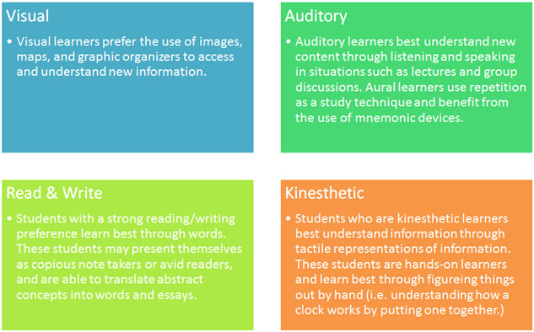
(Teach.com, 2019)

Visual learners tend to take in information by using images such as graphs, charts, diagrams etc. Using images is the best way to reach a visual learner. As for Auditory learners they learn best through listening and speaking, this may be done through group discussions, carefully listening to information which is being delivered by speech. And lastly kinaesthetic learners. Kinaesthetic learners understand information well through tactile representation.
To find out what type of learner I am I have taken a VAK Test (Businessballs.com, 2019). The VAK test is a self-assessment questionnaire where I will be answering questions that mostly represent how I generally behave. The test consists of 30 questions and scores are divided in to three categories Visual, Auditory and Kinaesthetic learning style.
After completing the test I scored 17, 10 and 2. This interprets that I am a Visual learner an explanation of this would be ‘Someone with a Visual learning style has a preference for seen or observed things, including pictures, diagrams, demonstrations, displays, handouts, films, flip-chart, etc. These people will use phrases such as ‘show me’, ‘let’s have a look at that’ and will be best able to perform a new task after reading the instructions or watching someone else do it first. These people will work from lists and written directions and instructions’ (Businessballs.com, 2019).
I both agree and disagree with the interpretation as I believe that I am both a visual and an auditory learner. I am able to absorb information through listening and spoken word, I am also able to follow spoken instructions, whether it is at face value or through the phone. Therefore I believe that I have a mixture of the two learning styles.

DIEP Reflective Model
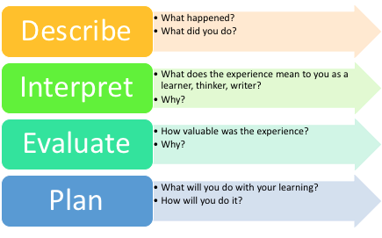
(courses.lumenlearning.com, 2019)

To carry out my reflective self-evaluation review, I will be using the DIEP model. Reflective writing helps you to think about and understand your on learning and experiences, it also helps to plan out what you would like to do in the future. The DIEP model (Boud, D Keogh & Walker, 1985) is a framework which uses emphasis on significance and future action. The model consists of four steps, Describe, Interpret, Evaluate and Plan.

Describe
I am currently working in the retail industry as a customer service assistant. I am usually working on tills and therefore I tend to deal with customers on the main check outs as well as self- service checkouts. There came a time when my manager asked me to help out my team members with delivery on the shop floor.
At first I was nervous and anxious about doing this as I had very little experience on dealing with delivery and thought that I would not be able to handle the pressure as deadlines have to be met in order to meet customer needs. This meant that I had to ask other colleagues for help and they would have to explain and show me how work on the shop floor needs to be done.
Interpret
Having being asked to help out on the shop floor came across to me as an opportunity to gain a new experience and skills which I have not acquired. This meant that I would have to work as a part of a team and deliver my best.
I saw this situation as being an opportunity although I felt that I was not ready to learn or take on the work load. I had to motivate myself and take the opportunity as this would mean that I will now have experience both doing delivery on the shop floor, on the check out and also carrying out a few admin jobs at the store.
I found the staff members working on the shop floor really helpful as they were considerate to my lack of experience. I saw that they all had an assigned/ designated area which they were working in which meat that the work load was being shared out fairly. This also shows that the leader of the shift had everything under control.
Working on the shop floor has helped me to associate with other team members whom I have not previously worked with. This also gave me the opportunity to learn of other team members and build up on skills and experience which I have not previously had a change to work on.
Evaluate
I found this experience to be extremely valuable as this has made me more productive at work as I have learnt new skills which now make me more effective in the way I work. I am now able to do many things which I wasn’t able to do before and therefore I am now seen as a reliable and effective team worker who my managers are able to rely on if they are ever in need of any extra help.
Having learnt the different job roles of different staff member in the store, means that I now have the basic knowledge of what it is to become a shift leader in the near future if I was to go up the employment ladder in this job field. This has also helped me find out whether I was an effective team member or not.
Plan
With the skills and knowledge which I have learnt while agreeing to undertake the different roles which are required to run the store, I have now decided to take on more training at work. Undertaking more training at work would give me the chance to learn things which I do not know and would also help me to implement my learning while I am working.
I will now be able to work on my weaknesses as I have now identified in which areas my strengths are for example I am a good/ efficient team worker, I am reliable and attentive. This would help me to become experienced and trained as practice makes perfect.

Personal Development Planning
A personal development plan is a process which is constantly reviewed, this aims to assist ongoing employability by improving skills and knowledge required by the workplace. According to Morgan P. (2017, p27 -41) ‘personal development plans intend to develop those skills that are seen as peripheral or unnecessary for working life’ and ‘professional development plans are seen as important for working life, particularly within organisation’.
This process will help me to reflect on my learning and, performance and achievement for my personal, educational and career development. I believe that it is important to have a development plan in place as this will help me to set new targets and goals which will help me to develop as an individual as well as an employee.
For the personal development plan I will be doing a Personal SWOT Analysis and I will also be setting SMART Objectives
Personal SWOT Analysis
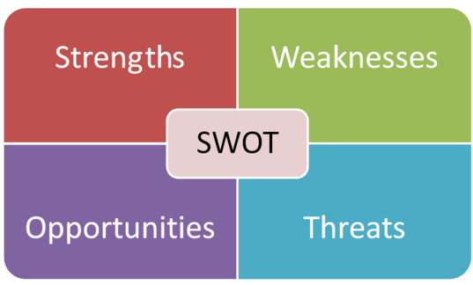
(Google.com, 2019)

SWOT Analysis is a useful technique for understanding Strengths and Weaknesses and for identifying both Opportunities and Threats (Mindtools.com, 2019). It is important that my SWOT analysis is clear so that I can go back to it to reflect or change it if required.
(S)trengths - I have good team work and organizing skills. I am able to build on ideas with other member of the team. When allocated to take the lead within a team I am able to clearly identify and allocate tasks to my group members while being fair so that everyone enjoys the task and the shift runs smoothly.
I am also good at time management and am able to identify which tasks are important and need to be done first. I would usually write up a list of things to do and carry out the tasks according to their importance while managing my time effectively.
(W)eakness – My communication skills are weak as I am not able to express myself at all times and tend to get shy sometimes. It is important to have good communication skills as I will me dealing with people face-to-face on a daily basis.
Problem solving is another weakness that I have. When facing problems sometimes I am not able to see all sides and also tend to worry and panic a little which causes delay in coming up with a solution.
(O)ppertunities – I already know how to carry out some important tasks such as till checks/ counts and price changes (increases and decreases). This can also be seen as a strength as I already have knowledge of a few managerial tasks.
I have the opportunity of getting in house training by team/ shift leaders who will be able to teach me what I do not know yet for example stock count, promotion changes.
(T)hreats – As a mother of two children under the age of 5, it may be difficult to take part in progression training if I am not able to find reliable and trustworthy child care for my children.
Another threat will be that there may be other candidates who are more knowledgeable and have more experience than me.

SMART Objectives
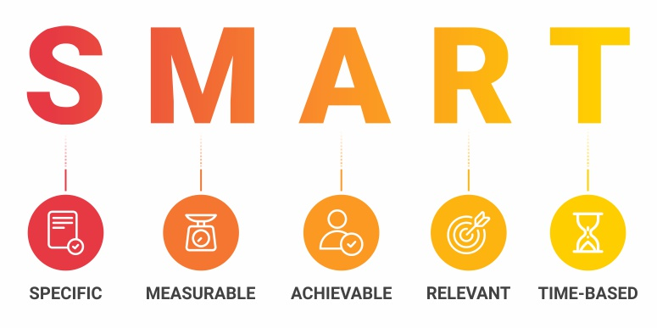(Google.com, 2019)
SMART Goals are a guide to set objectives, this is a statement that describes what an individual or an organisation would like to achieve. These objectives are SMART if they are Specific, Measurable, Achievable, Relevant and Time related, ‘good goals, should be SMART’ (Morgan, P. 2017, p38-40)

(S)pecific – I will need to be clear in what it is I want to achieve and have set deadlines.
(M)easurable – To make sure that the goal which I have set myself is trackable.
(A)Achievable/ Attainable – Although my goal may be challenging I need to make sure that it is possible for me to accomplish it.
(R)ealistic/ Relevant – I will need to be realistic and honest with myself about the knowledge that I have, what I need to improve on and if I am capable of it.
(T)ime Related/ Sensitive – It is important that I set deadlines to meet my goals as this will help me achieve one goal at a time and will stop me from procrastinating and allow me to be stress free and concentrate on what is most important.
A goal which I have set myself is to be more assertive and so I will set goals for assertive behaviour. I will need to practice both verbal and non-verbal assertive characteristics. An example of verbal assertive characteristic would be to practice speaking in a relaxed and clear voice and not hesitate while speaking, an example of non-verbal assertive characteristic would be to make eye contact, receptive listening and to have clear expressive emotions. Using this method would help me as my goals will be specific and so I will be clear in what it is that I need to do and when it needs to be done by, it will also be realistic which means I have set goals which I am capable of achieving.

Expectations and understanding of employment
Recruitment Process
The recruitment process is the procedure of recognising a job vacancy. This also includes analysing the requirements of the job, reviewing the applications, the interview process which then leads to shortlisting and then selecting the right candidate for the job.
The recruitment process is the first step an organisation takes in acquiring staff members, this maybe for many reasons such as to attain new skills, to get more staff or to replace staff who maybe leaving due to various reasons.
Companies have the recruitment process as it helps them to minimize the time needed to search, interview, hire and train new members of staff. This helps downsize the process and makes the search for viable candidates more effective. Companies will find ‘good, qualified, reliable employees if they have a successful hiring process’ (Lucaspsg.ca, 2019), this shows that if organizations follow an organised recruitment path they will find candidates who will be a great asset to they business.
Contracts
Organizations have contracts as it is a legally binding agreement between the employer and employee. This is important because it outlines the expectation of both parties. The contract also protects both parties if expectations are not met. The contract is a written document which summaries the understanding of the specific job role, so that there are no misunderstandings.
Organizations also have contracts are they also work as a dispute resolution mechanism. This is because the purpose of the contract is to create an agreement to both parties stating their rights and duties in accordance to the agreement.

Career ambitions and aspirations
At this current moment I would first like to finish off my studies as I believe that having this qualification would not make me more employable but give me an insight on the knowledge of the business world. Having done this course it I believe it will help me to have an insight on what other options these are for me which I may want to consider, if one does not go well for me.
I believe that I have what it takes to become effective leader. Although I am passionate about this I would need a lot of on the job training as there are many things which need to be learnt.
My career ambition and aspirations would be to go up the employment ladder at my current workplace. I would like to become a team leader in the near future and then go on to becoming a manger where I will be running my own store. After having become manager I would not want to stop there and if there is an opportunity for me to go further I would like to pursue that and maybe go on to working in the head office of the company.

Personal Development Plan
A personal development plan will help me to identify the main areas of learning and development activity which will allow me to either acquire new or develop on existing skills. The purpose of this is to help me to enhance my performance in my current job role so that I am ready to step up to the next level in the near future.

 | Short-Term Time Frame  What do I want to  accomplish in the next  three to six months? | Mid-Term Time Frame  What do I want to  accomplish in the next  six months to two years? | Long-Term Time Frame  What do I want to  accomplish in the next  two to three years?
Section 1 - My Goals  What are my overall goals that I want to accomplish in this time period?  Example: become a Student Affairs Officer; learn computer graphics | Improve customer service skills | Improve communication and leadership skills | Improve on leadership/management skills
Section 2 - Skills and Knowledge to be  Learned  What specifically do I need to learn? What project do I need to work on?  Example: Student advising;  Banner; Dreamweaver; develop a procedures manual | Work towards improving customer service, by remaining friendly and professional at all times. Listen to customers and help to meet their needs. | Undertake training, for both communication and leadership. | Take on more responsibilities on shifts carrying out procedures such as cash, price integrity etc.
Section 3 - Next Steps  How am I going to acquire the skills and knowledge? How am I going to do this project?  Example: take Dreamweaver class; do an  informational interview; set up a project outline | Take on customer facing shifts for example tills, customer service desk. | Carry out leadership tasks by shadowing a former team leader and also relevant training required. | Feedback from management on how I am currently doing and what needs to be done to better myself.
Adapted from: http://www.hr.ucdavis.edu/sdps/forms/IDP%20Final%2010.14.11.pdf

 | Short-Term Time Frame  What do I want to  accomplish in the next  three to six months? | Mid-Term Time Frame  What do I want to  accomplish in the next  six months to two years? | Long-Term Time Frame  What do I want to  accomplish in the next  two to three years?
Section 4 - Resources  What resources do I need?  Example: free time; funding | Customer feedback, customer satisfaction feedback for my services. | Review of updated training. Completing leadership training. | Feedback from shift/ store manager. More training if required.
Section 5 - Time Schedule  What is my time schedule? | Ongoing, as I will need to face customers on a daily basis. | One year | Two years
When will I start? | As soon as possible | 01/2020 | 06/2020 or 01/2021
When do I expect to finish? | N/A | 01/2021 | 01/2022
Section 6 - Completion  When have I completed each  step? | □__________  Date  □__________  Date  □__________  Date | □__________  Date  □__________  Date  □__________  Date | □__________  Date  □__________  Date  □__________  Date
Adapted from: http://www.hr.ucdavis.edu/sdps/forms/IDP%20Final%2010.14.11.pdf

Conclusion
In this report we have seen the overall process of recruitment and the employability skills what are needed by me in order to achieve my goals. This is important because these are the key skills and knowledge needed by me in order to achieve my target and become the leader which I aspire to be.
Knowing the recruitment process of a company has given me an insight of what to look for when completing a job application form. It has also given me an insight of what happens in the HR department of an organization before they advertise a job role.
Having done the SWOT analysis, setting SMART goals and also doing the Personal development plan has helped me to understand myself better as I am now more clear on what it is that I need to improve on, what I would like to do and when I need to do this by. By sticking to my personal development plan it will help me to climb up the competitive employment ladder and get the job which I want.

References
- Boud, C.; Keogh, R.; Walker, D. (Eds) (1985) Reflection: turning experience into learning. London: Kogan
- Advancement Courses Blog. (2019). 4 Types of Learners in Education | Advancement Courses. [online] Available at: https://blog.advancementcourses.com/articles/4-types-of-learners-in-education/ [Accessed 01 Aug. 2019].

- Businessballs.com. (2019). VAK Learning Styles Self Assessment Questionnaire - BusinessBalls.com. [online] Available at: https://www.businessballs.com/self-awareness/vak-learning-styles-self-test/#vak-indicators-and-self-test [Accessed 04 Aug. 2019].

- BusinessDictionary.com. (2019). What comes after those ellipses?. [online] Available at: http://www.businessdictionary.com/definition/self-motivation.html [Accessed 20 Aug. 2019].
- Google.com. (2019). what is swot analysis - Google Search. [online] Available at: https://www.google.com/search?q=what+is+swot+analysis&source=lnms&tbm=isch&sa=X&ved=0ahUKEwjii7K5wLrkAhVOh1wKHWVMBm8Q_AUIEigB&biw=1821&bih=868#imgrc=FOyT0vPQ-SGMzM: [Accessed 13 Aug. 2019].

- Google.com. (2019). what are smart objectives - Google Search. [online] Available at: https://www.google.com/search?biw=1821&bih=868&tbm=isch&sa=1&ei=cnJxXfGZJNLDxgOdtpBg&q=what+are+smart+objectives&oq=what+are+SMART+&gs_l=img.3.0.0l10.554428.560438..563148...0.0..0.1717.10103.2-1j5-1j0j2j4......0....1..gws-wiz-img.....0..0i67.GdnP1Kw2U4E#imgrc=J1rkaKXFnC_72M: [Accessed 13 Aug. 2019].

- Lucaspsg.ca. (2019). The Importance of a Strong Recruitment Process - Lucas Professional Search Group. [online] Available at: http://www.lucaspsg.ca/the-importance-of-a-strong-recruitment-process/ [Accessed 21 Aug. 2019].

Mindtools.com. (2019). How Self-Motivated Are You?:. [online] Available at: https://www.mindtools.com/pages/article/newLDR_57.htm [Accessed 3 Aug. 2019].

- Mindtools.com. (2019). SWOT Analysis: – Discover New Opportunities, Manage and Eliminate Threats. [online] Available at: https://www.mindtools.com/pages/article/newTMC_05.htm [Accessed 5 Sep. 2019].

- Morgan, P, 2017, The Business Student’s Guide To Study And Employability.

- Teach.com. (2019). Learning Styles. [online] Available at: https://teach.com/what/teachers-know/learning-styles/ [Accessed 14 Aug. 2019].

- Teach.com. (2019). Learning Styles. [online] Available at: https://teach.com/what/teachers-know/learning-styles/ [Accessed 14 Aug. 2019].

