
Program: BA (Hons) Developing Leadership and Management
Module Title: Creativity and Innovation
Module Code: BMSW5031_Card

Student Name: Abdul Rukshan
Student ID: 2412468

Executive Summary
A small, independent, community-based café located near Cardiff docks, Seren Coffi is a hospitality enterprise and cultural hotspot. Changing Customer Demand, peak customer traffic, underused off-peak capacity, and skyrocketing energy and supply costs are key challenges the organisation is experiencing. This can be solved by the need for a more structured approach that can make it efficient without losing its strong ethical values and community identity.
It is proposed that Seren Coffi transform into a participative ecosystem in which the value is co-created by staff, customers and the community through the establishment of Seren Circle: A Community Co-Creation and Resilience Model. The model is tested and explored in practice using the 4Ps approach: Product Innovation through improved cultural products/services, Process Innovation with a structured and voluntary approach to participation, Position Innovation as a location where innovation can be experienced as a Welsh community innovation hub and Paradigm Innovation with a transformation to relational value creation.
Based on Lewin's Force Field Analysis: 21 driving forces vs 16 restraining forces, the net (positive) force is 5, and the model is viable but should be piloted carefully. The overall innovation is recommended for implementation in a controlled pilot framework for achieving balance, legal clarity and cultural integrity.

Table of Contents
Executive Summary 2
Part 1: Organisational Context and Operational Challenges 1
1. Introduction 1
1.1 Organisational Background 1
1.2 Core Issue 1
2. Critical Analysis of Creativity and Innovation in Capitalist Growth 2
2.1 Creativity and Innovation in Capitalist Systems 2
2.2 Limitations for Small and Value-Driven Organisations 3
2.3 Seren Coffi Context 3
3. Detailed Innovation and the 4Ps Framework 4
3.1 Product Innovation 4
3.2 Process Innovation 5
3.3 Position Innovation 5
3.4 Paradigm Innovation 5
4. Creativity Process and Development of the Idea 6
5. Viability Evaluation Using Lewin’s Force Field Analysis 7
5.1. Driving Forces: Support for the Innovation 7
5.2. Restraining Forces: Barriers to Implementation 8
5.3. Net Force and Overall Feasibility 9
5.4 Implementation Plan and Actions 10
6. Organisational Climate for Innovation 10
7. Conclusion 11
Part 2: Supplementary Reflection on the Use of AI to Develop the Innovation Concept 13
Introduction 13
AI (ChatGPT) Recommendations for Part 01 13
Critical Appraisal of the AI Recommendations 14
Issues Experienced When Applying AI 15
Successes Achieved Through AI Use 16
Conclusion 17
References 18
Appendixes 23
A1. Initial Prompts to AI (ChatGPT) 23
A2. Response From AI (ChatGPT) 27
A3. 2nd Prompts to AI (ChatGPT) 30
A4. Response of AI (ChatGPT) to 2nd Prompts 31

Part 1: Organisational Context and Operational Challenges

1. Introduction

1.1 Organisational Background
Situated amongst a rich hospitality hub, the Seren Coffi is a small independent coffee shop in close proximity to the Cardiff docks. The café will be a community space, which will be indicated by the use of Welsh language signage, ethical reconstruction and reusing items, and its focus on ethical coffee sourcing (Barros et al., 2025).
It regularly offers as many poetry readings as it does informal cultural gatherings and much community activity, even a pay-what-you-can evening. In addition to coffee sales, Seren Coffi can be considered a cultural centre because its visitors are able to interact with the company, therefore having an active role in the space (Manners-Bell and Lyon, 2022).
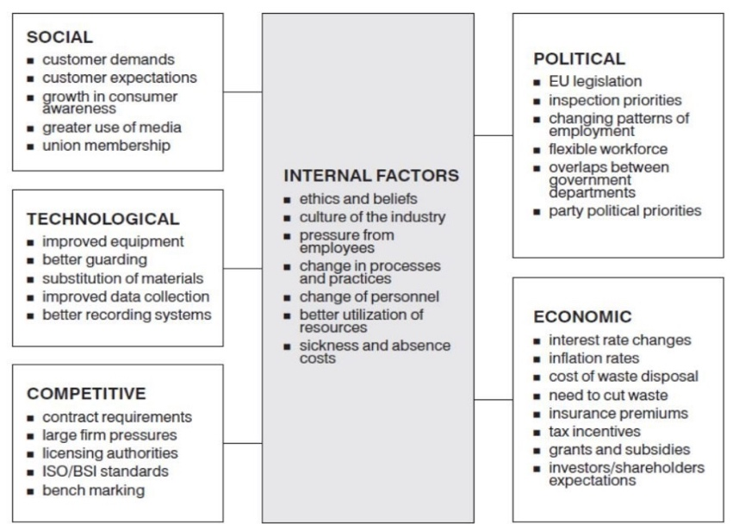
Figure 1: Internal and external pressure on business (Ismail, 2019)

1.2 Core Issue
Seren Coffi is definitely a community-based coffee shop, but at the moment is undergoing a lot of changes and issues in its workplace. The greatest issue with it is not so much that its community is against capitalism; it is that it has to account for the needs of the business model it runs on, while balancing it with the needs of capitalism. Although its services are participatory and value-adding, it is housed in the context of traditional concepts of hospitality and follows traditional operating models, including a standardised workforce, rapid response in busy periods, and economic awareness of the request to the host (Burgelman et al., 2004).
The café, as it is, is a bit underutilised, especially on busy days when the number of staff is higher, and during slow periods when staff and resources are minimised (Manners-Bell and Lyon, 2022). Also, high energy costs and related expenses associated with energy supply put additional financial strain (Nonaka and Takeuchi, 1995).
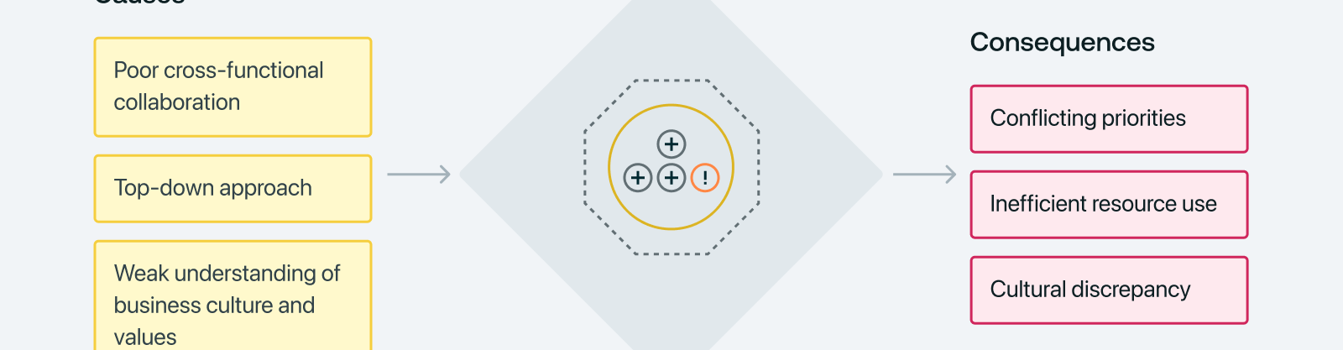
Figure 2: Strategic misalignment (Quantive, 2024)

2. Critical Analysis of Creativity and Innovation in Capitalist Growth

2.1 Creativity and Innovation in Capitalist Systems
Creativity is generating new and useful ideas; innovation is the application of the idea to grow into a result. In capitalist systems, there is more or less rivalry between organisations, and this competition is an important source for innovation. This system has a number of benefits. It helps to make things more efficient, increase technological progress and incentivise organisations that implement successful new and improved solutions (Garrett, 2020). The pressure of competition also results in the development of a need for improvement in the service offered- thereby driving cycles of innovation faster and enhancing the quality of service offered in industries (Schein, 2010).

2.2 Limitations for Small and Value-Driven Organisations
These limitations are more important for small businesses such as Seren Coffi. Larger companies are more likely to be at the top of innovation ecosystems due to the economies of scale, structured research and development systems and financial resources that they have. This leaves smaller organisations with a lack of formal innovation infrastructure because they must do the same thing as bigger organisations – be creative but do it informally, at a low cost and with experience (Burgelman et al., 2004).
Also, under capitalism there is a tendency to commercialise creativity - ideas being valued primarily for their profitability (Hamel, 2000). This limits communities' ability to recognise social, cultural and emotional innovations - which, for many organisations involved in community life (Johns, 2006).

2.3 Seren Coffi Context
Aspect | Opportunities | Risks
Economic growth | Efficiency, innovation, and investment can improve operations | Over-commercialisation may reduce uniqueness (Osterwalder and Pigneur, 2010).
Cost structure | Economies of scale can reduce supply and operational costs | Pressure to standardise may increase long-term costs to identity
Market position | Expansion can strengthen competitiveness and purchasing power | Loss of independence if acquired by a hospitality group
Cultural identity | Broader reach can promote Welsh culture to wider audiences | Risk of dilution of Welsh cultural authenticity and local focus
Customer experience | Improved systems may enhance service efficiency. | Reduced personal and community-driven atmosphere (Kusmaningtyas and Rahmadania, 2025).

3. Detailed Innovation and the 4Ps Framework
The proposed innovation for Seren Coffi is a structured community co-creation process to create a more resilient community and a more culturally engaged and operationally sustainable process. This empowers a different view of the café as a participative ecosystem and generating value together with staff, customers and the community (Beig, 2020).
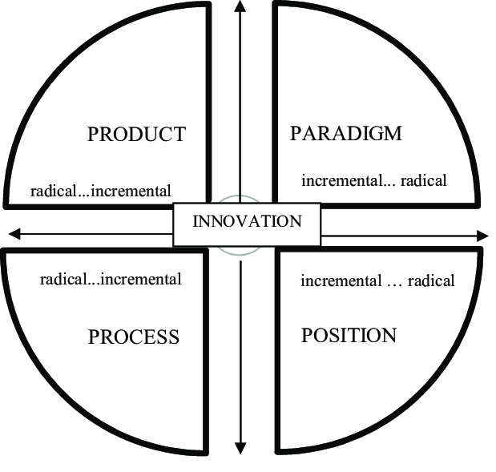
Figure 3: 4Ps of Innovation Framework (Zastempowski and Przybylska, 2016)
The innovation is called “Seren Circle – A Model for Co-Creation and Resilience of Communities.” This is due to the tendency of change towards a structured community network with a focus on social value creation and operational improvement (Zastempowski and Przybylska, 2016).

3.1 Product Innovation
Product innovation isn't limited to the mere innovation of the product; it's the enhancement of the experiential offering that's required. These encompass activities like opportunities to join in with the community, cultural events like Welsh language evenings, poetry sessions, music sessions and repair sessions, alongside themed events. Recipients also have opportunities to participate in supporter programs and pay-it-forward, further fostering emotional connection and loyalty. Such additions reinforce the cultural and social essence of the Seren Coffi as a space of pure transaction (Chesbrough, 2003; Beig, 2020).

3.2 Process Innovation
In process innovation, the key concept is structured participation and not operational labour. Customers are neither involved with the service delivery nor treated as de facto employees. The core operational responsibilities such as cooking, tidying, cash handling and customer service continue to be the duty of trained paid staff.
Community events not happening during peak times are organised under a structured booking system, ensuring voluntary participation and planned involvement of participants. Staff also gather customer suggestions on short feedback forms to ensure the services can be continually improved. Moreover, the demand data is applied to enhance the working schedules and resource utilisation for better resource management during working and non-working times (Villari, 2021).

3.3 Position Innovation
Position innovation is the way Seren Coffi is positioned in the market. Seren Coffi could be seen as a place where the whole community finds innovation, to set itself apart from everyone else and stand out in the crowds of passionate customers of support to more or less commercialised café chains, which seek to distinguish themselves mainly by offering quick, convenient and standardised services. In this positioning, the importance is given to culture, creation and community identity instead of mass-market efficiency (Crossan and Apaydin, 2010).
This method sets Seren Coffi apart from national and international café chains and strengthens its sense of the cafe as a “creative and collaborative space” (Zavratnik et al., 2020) where a scope of social interactions and cultural engagements is created. This improves its strategic positioning, as well as the resonance and authenticity of its role as a unique organisation focused on the community (Global Business, 2024).

3.4 Paradigm Innovation
Paradigm innovation is a transition from a “transactional” to a “relational”/value-based business model. It is a social place that is co-created by Seren Coffi, in which the notions of economic sustainability, ethical sourcing, community in the ownership of ideas, Welsh cultural identity and social connection are put into one system. But the café can still be a business and will need to be financially sustainable in order to run for the long term. Profitability and efficiency are not sacrificed, but rather, along with social and cultural productivity creation. This allows Seren Coffi to sustain its identity and continues to produce community impact, while maintaining its resiliency (Amabile and Pratt, 2016).

4. Creativity Process and Development of the Idea
After analysis of the operational patterns and the behaviour of the users of SerenCoffi, the innovation concept was conceived (Robra et al., 2023).
Stage | Description
Observation | Identification of queues during peak hours, staffing pressure, and unused capacity during off-peak periods.
Problem Definition | Seren Coffi requires greater operational resilience while maintaining its community identity and ethical values.
Problem Reframing | Customers are not considered replacement workers but potential co-creators of cultural and community experiences.
Idea Generation | Development of solutions such as community membership, cultural events, feedback systems, transparent pricing, and off-peak engagement activities.
Idea Evaluation | Assessment of feasibility based on cost, legal considerations, alignment with café values, and operational practicality.
Selection | The “Seren Circle: Community Co-Creation and Resilience Model” was selected as the most suitable innovation (Salim and Khorsheed, 2025).
Pilot Testing | A proposed three-month pilot phase to test effectiveness before full implementation.

The idea came as a result of observation and a lateral approach. Customer involvement was no longer seen as an informal or symbolic factor; rather, it was introduced as a factor which can be structured into something used by the company to do operations (Sethibe, 2018).
The concept later developed into a developed sharing model, in which the customer works within certain areas of interest, is involved in the organisation of the events and offers ideas for improvement. In exchange, they get social interaction, learning experiences and recognition in the community without any financial benefits (Sethibe, 2018). This transformation codifies on a formal basis behaviours that are already informal and adjusts them to meet the operational requirements (Villari, 2021). This establishes a system of shared responsibility, one in which both staff and customers contribute ideas, attend events, support cultural activities and provide feedback, while paid staff remain responsible for operational duties (Robra et al., 2023).

5. Viability Evaluation Using Lewin’s Force Field Analysis
The model can be applied in determining the driving forces behind the innovativeness and the limiting forces that may be negative towards the implementation of the innovation (Lewin, 1951).
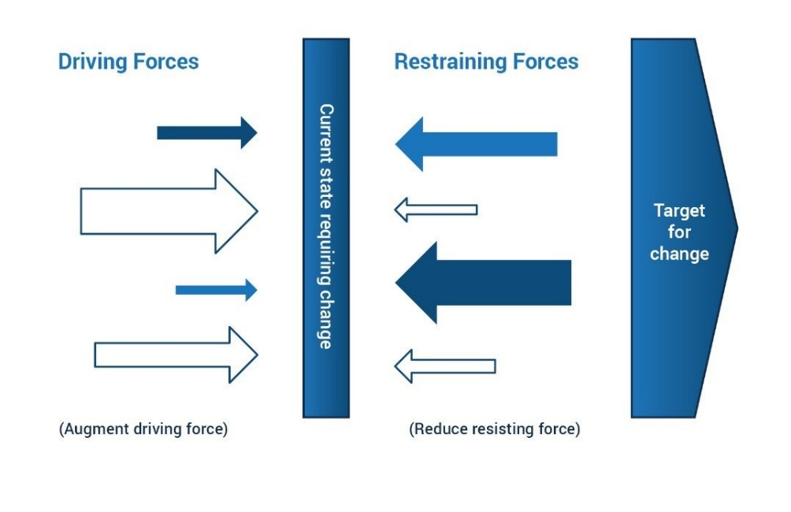
Figure 4: Lewin’s force field analysis (ILX, 2019)

5.1. Driving Forces: Support for the Innovation
The driving forces are aspects that favour the establishment of the community-based operational model. These are the current strengths and traits of the existing cafe, which are consistent with the new changes (Crossan and Apaydin, 2010).
Driving Force | Weight | Description
Strong Community Loyalty | 5 | Seren Coffi enjoys a loyal customer base that identifies with the café’s values. This loyalty is crucial, as it ensures active participation in the innovation (Goffee and Jones, 1998).
Existing Community Engagement | 4 | Customers have already shown interest in helping during events. This informal support can be formalised into a structured system of participation (Mumford, 2000).
Ethical Alignment with Values | 5 | The innovation fits seamlessly with Seren Coffi’s core values of ethical sourcing and community engagement, making it attractive to customers and employees alike (Amabile, 1996).
Low-Cost Pilot Potential | 4 | The proposed model doesn’t require significant financial investment. It relies on customer participation, reducing the need for additional staff or costly investments (Schumpeter, 1934).
Stable Demand Base | 3 | Seren Coffi has a consistent customer base, which ensures there is ongoing support for the innovation and helps maintain community involvement (de Barros et al., 2025).
The overall weight of the driving forces is 21, which means that the innovation is heavily supported. The fact that the ethical values of the cable, the high number of loyal customers, and the low cost of the proposal indicate that the chances of success are high, since these forces will automatically promote the innovation (Rahmadania and Kusmaningtyas, 2025).

5.2. Restraining Forces: Barriers to Implementation
Although there is a high level of support, the community-centred model can face restraining forces that could hinder the smooth implementation of the model. These forces involve such factors as organisational inertia, complexity of coordination, and staff resistance (Burgelman et al., 2004).
Restraining Force | Weight | Description
Governance Inertia | 4 | Seren Coffi’s decision-making process is slow due to its consensus-based structure, which could delay the implementation of new ideas (Tushman and O’Reilly, 1996).
Coordination Complexity | 4 | Integrating customer participation into daily operations may result in complex coordination challenges, such as managing schedules and workloads (Amabile, 1996).
Staff Skepticism | 3 | Some staff may be hesitant to embrace the new operational model, especially if it requires them to work with volunteers or shift responsibilities (Mumford, 2000).
Risk of Role Confusion | 3 | There may be concerns about the café taking advantage of customers by asking for work in exchange for non-monetary benefits, which could create a negative perception (Schein, 2010).
Legal Ambiguity | 2 | The legal implications of customer participation and value exchange might be unclear, especially regarding volunteering agreements and compensation (Tidd et al., 2005).

5.3. Net Force and Overall Feasibility
In order to find the net force, the weight of all the restraining forces is summed with the weight of all the driving forces, and then the difference between the resultant sum and the weight of the driving forces is taken (Amabile and Pratt, 2016). This computation is as follows:
Driving Forces: 21
Restraining Forces: 16
Net Force: 21 - 16 = 5
The net force of 5 shows that the proposed innovation is a viable one, whereby the driving forces exceed the restraining ones.
The steps that can be taken to deal with these restraining forces are:
1. Concise communication to make everyone in the staff and customers realise the worth of the new model (Fayol, 1949).
2. Drawing limits that prevent the idea of exploitation and make sure that the engagement is voluntary and of value (Kusmaningtyas and Rahmadania, 2025).
3. Streamlining the coordination efforts through developing a systematic model for customer involvement in a bid to make operations simpler (Zavratnik et al., 2020).
4. Legal issues can be solved through the hiring of legal professionals to make sure the system meets the regulations and that the roles and expectations are well defined (Goffee and Jones, 1998).

5.4 Implementation Plan and Actions
Action | Description
Three-month pilot | Test the Seren Circle model on a small scale before full rollout to evaluate feasibility and impact.
Project coordinator | Assign a named staff member to manage the pilot and oversee coordination between staff and community participants.
Participation boundaries | Develop clear written rules defining that customers cannot replace paid staff roles and participation is strictly voluntary.
Staff consultation | Involve staff in planning to ensure acceptance, reduce resistance, and improve operational design.
Monthly review meetings | Conduct regular evaluations to monitor progress, challenges, and required adjustments.

6. Organisational Climate for Innovation
The overall organisational climate is supportive and strong in relation to innovation for Seren Coffi. Trust, openness, and common values are cornerstones of café culture, supporting both staff and patrons to come up with ideas and to get involved in creative processes (Gupta et al., 2006). This fosters a sense of safety and soundness, enabling people to make recommendations without concern about rejection or negative judgment. Consequently, informal acts of innovation and generating ideas can already be seen as part of the everyday "chitchat" in the café (Turner, 2020).
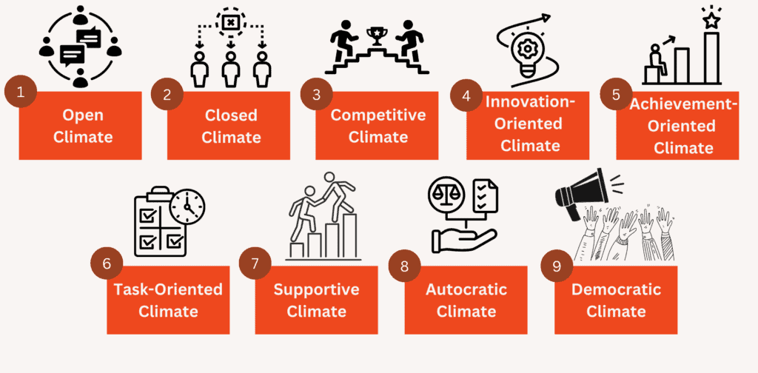
Figure 5: Types of organisational climate (Rosales, 2025)
There are also structural restraints that limit the implementation of innovation. Decision-making is very consensual and inclusive, but it decelerates the pace of action and diminishes the organisation's capacity and speed of action in operational challenges (West and Farr, 1990). Moreover, informal organisational processes also tend to prevent innovative practice from being scalable or standardised, particularly if sustainability is a priority (Van de Ven et al., 1999).
In sum, the climate of the organisation in Seren Coffi is an enabling and limiting situation to innovation. It encourages knowledge, understanding and skill acquisition to celebrate creativity, collaboration and community involvement while simultaneously stalling down the rate, coordination and structured implementation (Barros et al., 2025). The innovations in the proposed model are consistent with this, as they are based on values of participation and openness already present in the culture (Fischer and Riedl, 2020).

7. Conclusion
Clearly, the community is already very creative, participatory and informal in its culture of innovation, and Seren Coffi adds to it. Currently, the organisation does not have a consistent structure in place to exploit these areas fully as part of its daily procedures; there are some efficiencies emerging, for example, there is an uneven (or unequal) element of pressure on staffing, and using capacity efficiently and orderly is not always reflected in the quality of the services and their cost.
The Seren Circle model proposes a balance, a structured community co-creation, without losing the boundaries between participation by the customer and paid operational skills.
According to the analysis of the 4Ps framework, the innovation boosts product experience, optimises operational processes, refines the position in the market and facilitates a shift in the overall paradigm, focusing on the creation of value for the long term.

Part 2: Supplementary Reflection on the Use of AI to Develop the Innovation Concept

Introduction
This supplement is a critical appraisal of the use of the Artificial Intelligence Large Language Model (ChatGPT) to assist with the improvement of part 01 of this assessment. As per the requirement of the assessment, my Part 1 report looked at Seren Coffi, an independent café in the Welsh docks area, which has strong links with Welsh language, ethical sourcing, reclaimed materials, community events and a commitment to clear communication with customers.
I used ChatGPT after I did an initial version of my Part 1 report. I asked ChatGPT, “Can you make it better?” after providing the task requirements and my initial version of part 01. I gave the case study and the requirements for the module, and also gave my own report, and asked whether the work could be improved. The AI response identified strengths, weaknesses and areas for development (Hutchinson, 2020). Then, I made the changes as I seemed to me to be suitable. I uploaded this improved version and once again asked if it was OK. The second AI response affirmed that the second document was far more robust, but fortunately, there were still areas for improvement. I have done the corrections that I feel are needed before the submission.

AI (ChatGPT) Recommendations for Part 01
AI recommended several important improvements to strengthen my Part 1 report on Seren Coffi. First, it suggested that the report should be more relevant to the case study than to a general discussion of creativity, innovation and capitalism. It noted that my initial response was on the main areas of focus required by the question, such as introduction, discussion of capitalism, the 4Ps of innovation, the creativity process, Lewin’s Force Field Analysis and organisational climate, but that I needed to better reference the actual situation of Seren Coffi. AI proposed that I include the Welsh signage at the café, its ethical sourcing, used furniture, slow service, pay-what-you-can days, coffee bean prices, energy costs, and the fact that the group was interested in expanding their business (Ateeq et al., 2025).
Secondly, AI suggested that I reconsider the formulation and ethical foundations of my innovation concept. Initially, I referred to customers as “co-workers,” which could mean that they provide their time as a form of contribution, in exchange for non-financial rewards. AI stated this may pose a potential risk of exploitation or unpaid labour. It proved to be a helpful criticism as it demonstrated my idea required safeguarding Seren Coffi's moral principles. I thus modified it to “Seren Circle: a model of community co-creation and resilience”. This is a new edition where the customer is not regarded as a worker. Instead, they become co-creators and contributors of events, partners for feedback, members and supporters and paid staff will attend their operational tasks (Popkova et al., 2020).
Third, AI suggested enhancing the explanation of the 4Ps of innovation. My original idea was that it was a good idea for all 4 Ps, but AI told me to make the idea clearer for the Ps. It said that the change in the way the café runs events, satisfies capacity requirements outside of peak periods, takes customer feedback and engages with the community, is largely process innovation and can be addressed by Seren Circle. It's also highly paradigm in nature as it re-inflects Seren Coffi as a community value-creation platform rather than a regular coffee shop. Product innovation is also important as it sets the café apart from chain cafés, and positioning innovation is weaker unless it is accompanied by specific product innovations like supporter cups, Welsh language evenings and community memberships (Cooper, 2024).

Critical Appraisal of the AI Recommendations
The AI recommendations were helpful in enhancing the quality, clarity and viability of my Seren Coffi innovation. One of the strongest contributions was that AI helped me move away from a risky and unclear idea. This was a vulnerability that AI was able to detect and highlight to me that innovation must be responsible, ethical, viable and well communicated. Therefore, I adjusted my concept to ‘customers as co-creators'. This ensured the solution was more appropriate for Seren Coffi since the customer was able to make a contribution through events, feedback, membership and community activities and paid staff would continue to perform the operation (Popkova et al., 2020; Singal, 2025).
AI has also prompted me to make the report more case-specific. Rather than a general discussion about creativity, innovation and capitalism, AI suggested to me that I tie theory straight to Seren Coffi's context. This deepened my analysis since the true challenge for the café is the conflict between capitalist growth and moral character. Capitalist growth looks at speed, profit, scale and efficiency; while Seren Coffi is based on slowness, Welsh identity, ethical sourcing, transparency and community trust. Another area in my creativity process that was enhanced by AI was the one I created about identifying the problem, reframing the customers from buyer to supporter, brainstorming ideas, and then evaluating them against the values of the Seren Coffi to choose the most appropriate idea (Saba et al., 2020).
But the AI suggestions also came with drawbacks. Limitations included occasional repetition and inconsistency of feedback. Even when the report improved, AI still talked about the same areas of concern, including wording concerns, reference count and figure quality. Repetition was useful to establish critical weaknesses but also made it hard to distinguish if the report was truly better or if AI was just discovering additional issues (Ghorbani, 2024; Gama and Magistretti, 2023).
The second problem was that some advice was general. In this case, AI suggested including implementation costs, success factors and a pilot plan, but didn't know what Coffi's actual funds were, since the case study is fictional. So, I couldn't just make up fictional numbers and had to use my own sense of numbers. The third limitation was the danger of over-reliance. AI can help create good, polished writing, but it may diminish the student's critical voice if copied verbatim. I didn't use AI as a final editor or idea-refiner because, for this reason, I used it as an editor and idea-refiner. I took useful recommendations, modified and ignored suggestions that were not in line with Seren Coffi's ethical values (Tekic and Füller, 2023)..

Issues Experienced When Applying AI
However, a major challenge with the use of AI was that it actually added to the workload, instead of decreasing it. Once the initial response came in, significant rewriting was needed, such as elaborating and clarifying the concept of an innovation, adding more detailed information about the case studies, enhancing the 4Ps analysis and creating a more usable (and meaningful) Lewin Force Field Analysis. These recommendations were helpful but added another layer of critical review, selection and revision (Verganti et al., 2020).
Another challenge was that AI-generated answers sometimes seemed confident without even needing to be verified. For instance, the AI suggested reviewing the reference list, handbook stipulations, cover page and AI acknowledgement. These suggestions were useful, but it was up to me as the student to verify assessment needs and to guarantee academic correctness.
Another was the problem of academic honesty. AI was not always able to differentiate between creative development and directly submitted work. I then had to make sure that I only used AI as a learning and reflection tool. Screenshots of prompt and response should be provided in the Appendix, and the report should explicitly state the part AI played in assisting, not supplanting, my own judgment (Polamuri, 2025).

Successes Achieved Through AI Use
Even though this tool has some drawbacks, the results were a great help in making my innovation concept better and clearer. The key achievement was the development of Seren Circle into a more responsible and sustainable model. The last concept was based on the view that the customer is not an employee, but a participant in the event, with a cultural program, a system of participation and feedback, communication of costs, and events outside the peak hours in the community. This helped to further reinforce Seren Coffi's ethical and Welsh and community-based identity and helped to diminish the risk of exploitation (Ghorbani, 2024).
The other success was the enhancement of critical depth. With the support of AI, I gained the perspective that Seren Coffi's struggle was not just about the lack of funds, but also about the conflict between capitalist expansion and community value. This added to the strength of the report, reinforcing that innovation cannot and should not be measured by profit, scale and/or efficiency. Trust, cultural identity, ethical transparency, social belonging and social resilience are part of value creation in the case of Seren Coffi.
Another success was the enhancement of the viability analysis. AI helped me to add a pilot period, participation boundaries, staff consultation, legal clarity, review processes, and success indicators to make Lewin's Force Field Analysis more usable. This assisted in developing this innovation from an abstract concept to a more practical and viable suggestion (Verganti et al., 2020).

Conclusion
In summary, AI assisted me in improving my Part 1 report, albeit only as a critical tool. ChatGPT was most useful as an idea-refining and challenging tool, as well as a reviewer. It assisted me to spot areas that required improvement in the wording, ethics, case application, prioritisation of the 4Ps, the creative process and viability. It came with certain drawbacks, such as repetition, general guidance and dependency issues. The key takeaway from this is that whilst AI can aid in creativity and innovation, it is not a substitute for human judgment.

References
Amabile, T.M. (1996). Creativity in Context: Update to the Social Psychology of Creativity. Boulder, CO: Westview Press.
Amabile, T.M. and Pratt, M.G. (2016). The dynamic componential model of creativity and innovation in organisations: Making progress, making meaning. Research in Organisational Behaviour, 36, pp.157–183.
Ateeq, K., Masaeid, T.A., Selim, H., Oswal, N., Alkubaiusy, A.A.A. and Ajdoobi, S.M.G. (2025). Harnessing AI for Faster Innovation: How AI Concept Generation Impacts Development Timelines and Market Agility. Journal of Posthumanism, 5(2), pp.37–50.
Barros, R. de, Resende, L.M. and Pontes, J. (2025). Exploring creativity and innovation in organisational contexts: A systematic review and bibliometric analysis of key models and emerging opportunities. Journal of Open Innovation: Technology, Market, and Complexity, 11(2), p.100526. doi: https://doi.org/10.1016/j.joitmc.2025.100526
Beig, L. (2020). A Conceptual Framework for Innovation Assessment in Firms Based on 4Cs. Lecture notes in mechanical engineering, pp.801–811. doi: https://doi.org/10.1007/978-3-030-48021-9_88
Burgelman, R.A., Christensen, C.M. and Wheelwright, S.C. (2004). Strategic Management of Technology and Innovation. 4th ed. Boston, MA: McGraw‑Hill.
Chesbrough, H. (2003). Open Innovation: The New Imperative for Creating and Profiting from Technology. Boston, MA: Harvard Business School Press.
Cooper, R.G. (2024). The AI transformation of product innovation. Industrial marketing management, 119, pp.62–74. doi: https://doi.org/10.1016/j.indmarman.2024.03.008
Crossan, M.M. and Apaydin, M. (2010). A multi‑dimensional framework of organisational innovation: A systematic review of the literature. Journal of Management Studies, 47(6), pp.1154–1191.
Fayol, H., 1949. General and Industrial Management. London: Pitman.
Fischer, T. and Riedl, R. (2020). On the stress potential of an organisational climate of innovation: a survey study in Germany. Behaviour & Information Technology, pp.1–22. doi: https://doi.org/10.1080/0144929x.2020.1836258
Gama, F. and Magistretti, S. (2023). Artificial intelligence in innovation management: A review of innovation capabilities and a taxonomy of AI applications. Journal of Product Innovation Management, 42(1). doi: https://doi.org/10.1111/jpim.12698
Garrett, P.M. (2020). Getting ‘creative’ under capitalism: An analysis of creativity as a dominant keyword. The Sociological Review, 69(1), pp.21–36. doi: https://doi.org/10.1177/0038026120918991
Ghorbani, M. (2024). Thesis AI tools to support Design activities and Innovation processes Students Name Institution Politecnico di Torino Course Engineering and Management Date.
Global Business (2024). 4Ps marketing strategy innovation of fresh food e- commerce in the background of big data. An International Journal, 16(4s).
Goffee, R. and Jones, G. (1998). The Character of a Corporation: How Your Company’s Culture Can Make or Break Your Business. New York, NY: HarperBusiness.
Gupta, A.K., Smith, K.G., and Shalley, C.E. (2006). The interplay between exploration and exploitation. Academy of Management Journal, 49(4), pp.693–706.
Hamel, G. (2000). Waking up IBM: How a gang of unlikely rebels transformed Big Blue. Harvard Business Review, 78(4), pp.136–146.
Hutchinson, P. (2020). Reinventing Innovation Management: The Impact of Self-Innovating Artificial Intelligence. IEEE Transactions on Engineering Management, 68(2), pp.1–12. doi: https://doi.org/10.1109/tem.2020.2977222
ILX (2019). Change: a force to be reckoned with? [online] Ilxgroup.com. Available at: https://www.ilxgroup.com/india/blog/kurt-lewin-change-management [Accessed 12 Feb. 2026].
Ismail, K. (2019). E-Books: Risk Management 10. Principles. [online] HSSE WORLD. Available at: https://hsseworld.com/e-booksrisk-management-10-principles/#google_vignette [Accessed 12 Feb. 2026].
Johns, G. (2006). The essential impact of context on organisational behaviour. Academy of Management Review, 31(2), pp.386–408.
Kusmaningtyas, A. and Rahmadania, E.N. (2025). Organisational Innovation Climate to Improve Employee Innovative Behaviour Through Psychological Ownership in Employees in The Department of Marine Affairs and Fisheries of East Java Province, Indonesia. International Journal of Research and Innovation in Social Science, IX(I), pp.2745–2753. doi: https://doi.org/10.47772/ijriss.2025.9010222
Lewin, K. (1951). Field Theory in Social Science. New York, NY: Harper.
Manners-Bell, J. and Lyon, K. (2022). Logistics and Supply Chain Innovation: A Practical Guide to Disruptive Technologies and New Business Models. 2nd ed. London: Kogan Page.
Mumford, M.D. (2000). Managing creative people: Strategies and tactics for innovation. Human Resource Management Review, 10(3), pp.313–351.
Nonaka, I. and Takeuchi, H. (1995). The Knowledge‑Creating Company: How Japanese Companies Create the Dynamics of Innovation. New York, NY: Oxford University Press.
Oldham, G.R. and Cummings, A. (1996). Employee creativity: Personal and contextual factors at work. Academy of Management Journal, 39(3), pp.607–634.
Osterwalder, A. and Pigneur, Y. (2010). Business Model Generation: A Handbook for Visionaries, Game Changers, and Challengers. Hoboken, NJ: Wiley.
Polamuri, S. (2025). Beginner’s Guide to Large Language Models (LLM). [online] Dataaspirant. Available at: https://dataaspirant.com/llm/ [Accessed 18 Jun. 2026].
Popkova, E.G., Alekseev, A.N., Lobova, S.V. and Sergi, B.S. (2020). The Theory of Innovation and Innovative Development. AI Scenarios in Russia. Technology in Society, 63, p.101390. doi: https://doi.org/10.1016/j.techsoc.2020.101390
Quantive (2024). Common Pitfalls in Strategic Planning & How To Avoid Them. [online] Quantive.com. Available at: https://quantive.com/resources/articles/strategy-development-pitfalls [Accessed 12 Feb. 2026].
Robra, B., Pazaitis, A., Giotitsas, C. and Pansera, M. (2023). From creative destruction to convivial innovation - A post-growth perspective. Technovation, 125, p.102760. doi: https://doi.org/10.1016/j.technovation.2023.102760
Rosales, I. (2025). Organisational Climate: Meaning, Benefits, & Strategies. [online] Genius. Available at: https://joingenius.com/productivity/organizational-climate/ [Accessed 12 Feb. 2026].
Saba, D., Sahli, Y., Maouedj, R., Hadidi, A. and Medjahed, M.B. (2020). Towards Artificial Intelligence: Concepts, Applications, and Innovations. Enabling AI Applications in Data Science, pp.103–146. doi: https://doi.org/10.1007/978-3-030-52067-0_6
Salim, B. and Khorsheed, K.A. (2025). The role of psychological climate factors in stimulating creativity through workplace innovation in the service sector of a transitional economy. Discover Psychology, 5(1). doi: https://doi.org/10.1007/s44202-025-00482-w
Schein, E.H. (2010). Organisational Culture and Leadership. 4th ed. San Francisco, CA: Jossey‑Bass.
Schumpeter, J.A. (1934). The Theory of Economic Development. Cambridge, MA: Harvard University Press.
SETHIBE, T.G. (2018). TOWARDS A COMPREHENSIVE MODEL ON THE RELATIONSHIP BETWEEN LEADERSHIP STYLES, ORGANISATIONAL CLIMATE, INNOVATION AND ORGANISATIONAL PERFORMANCE. International Journal of Innovation Management, 22(02), p.1850021. doi: https://doi.org/10.1142/s1363919618500214
Singal, A. (2025). What is a Large Language Model (LLM) - Daily Dose Of AI. [online] Daily Dose Of AI. Available at: https://dailydoseofai.in/what-is-a-large-language-model-llm/llm/.
Tekic, Z. and Füller, J. (2023). Managing innovation in the era of AI. Technology in Society, 73, p.102254. doi: https://doi.org/10.1016/j.techsoc.2023.102254
Tidd, J., Bessant, J. and Pavitt, K. (2005). Managing Innovation: Integrating Technological, Market and Organisational Change. 3rd ed. Chichester: Wiley.
Turner, E. (2020). Be Less Zombie: How Great Companies Create Dynamic Innovation, Fearless Leadership, and Passionate People. Chichester: Wiley.
Tushman, M.L. and O’Reilly, C.A. III (1996). Ambidextrous organisations: Managing evolutionary and revolutionary change. California Management Review, 38(4), pp.8–30.
Van de Ven, A.H., Polley, D.E., Garud, R. and Venkataraman, S. (1999). Building an infrastructure for the innovation journey. The Innovation Journey, 149, p.180.
Verganti, R., Vendraminelli, L. and Iansiti, M. (2020). Innovation and Design in the Age of Artificial Intelligence. Journal of Product Innovation Management, 37(3), pp.212–227. doi: https://doi.org/10.1111/jpim.12523
Villari, B. (2021). Community-centred Design: A Design Perspective on Innovation In and For Places. The International Journal of Design in Society, 16(1), pp.47–58. doi: https://doi.org/10.18848/2325-1328/cgp/v16i01/47-58
West, M.A. and Farr, J.L. (1990). Innovation at work: Psychological perspectives. In M.A. West, J.L. Farr (eds.) Innovation and Creativity at Work. Chichester: Wiley.
Zastempowski, M. and Przybyłska, N. (2016). Cooperation in Creating Innovation in Polish Small and Medium-Sized Enterprises in the Light of Empirical Studies. Journal of Competitiveness, 8(2), pp.42–58. doi: https://doi.org/10.7441/joc.2016.02.04
Zavratnik, V., Podjed, D., Trilar, J., Hlebec, N., Kos, A. and Stojmenova Duh, E. (2020). Sustainable and Community-Centred Development of Smart Cities and Villages. Sustainability, 12(10), p.3961. doi: https://doi.org/10.3390/su12103961

Appendixes

A1. Initial Prompts to AI (ChatGPT)
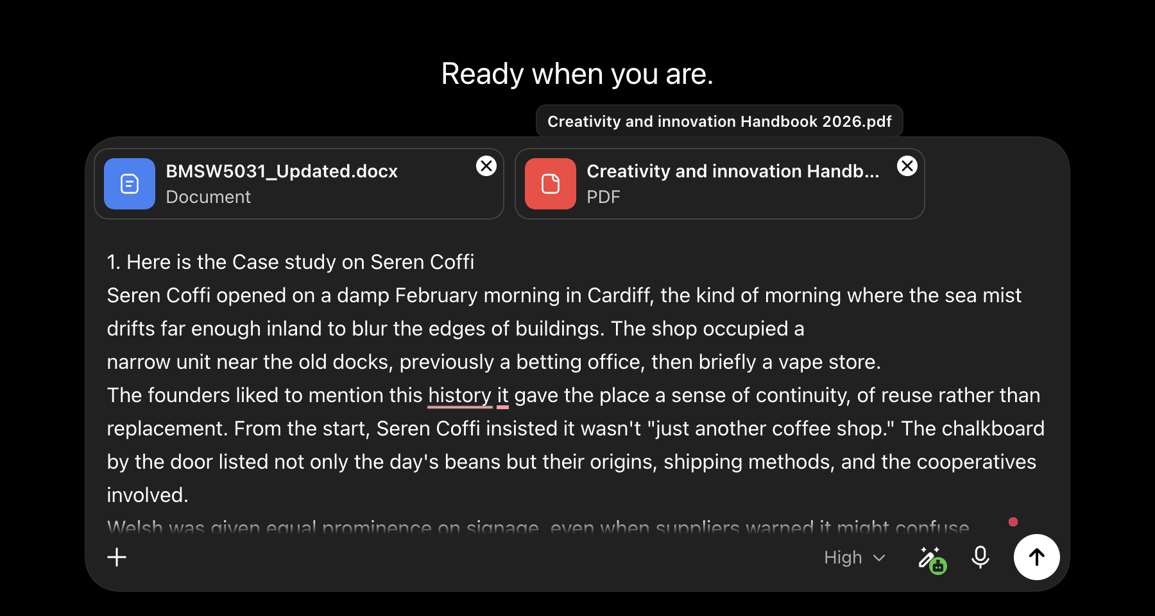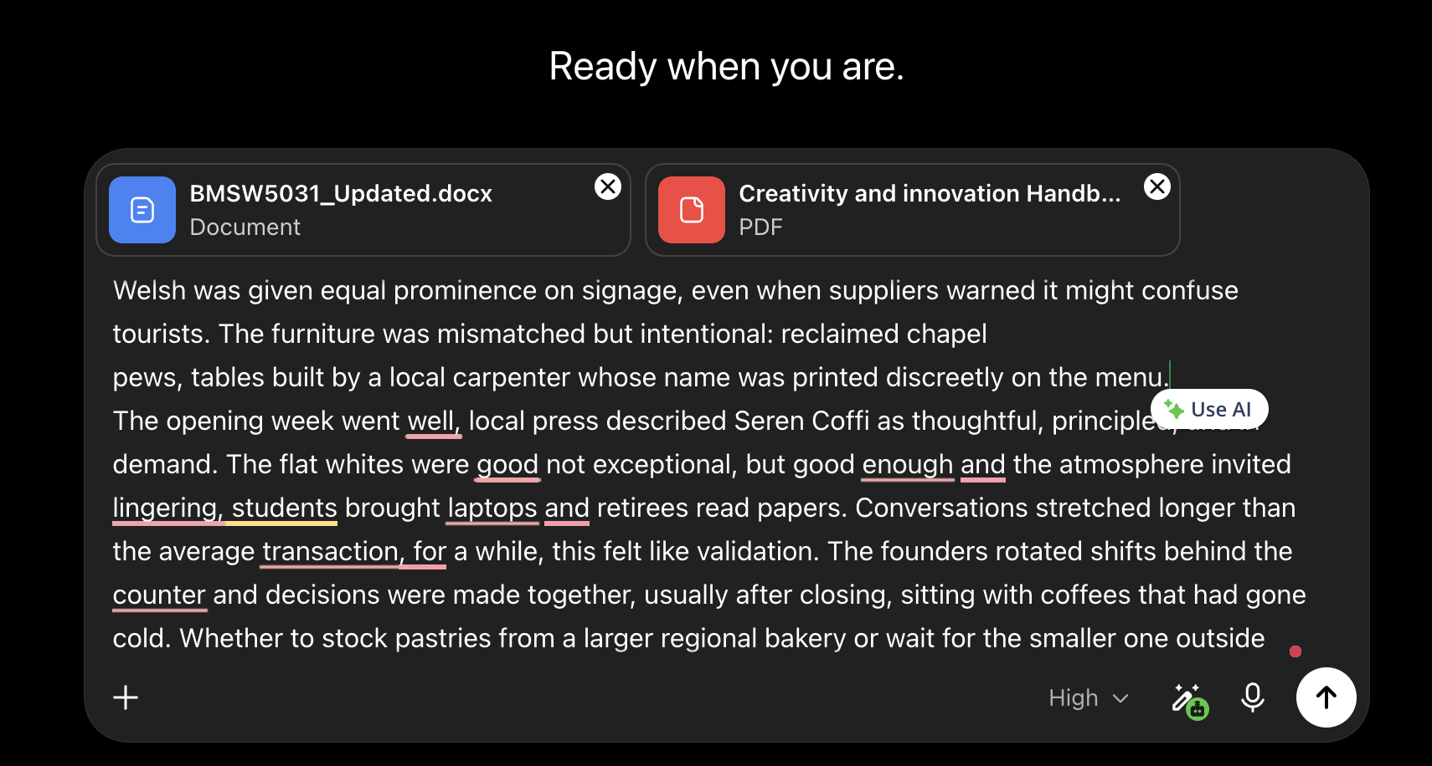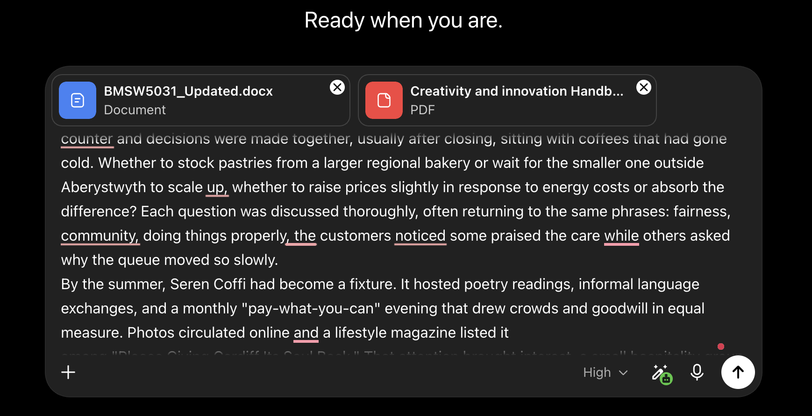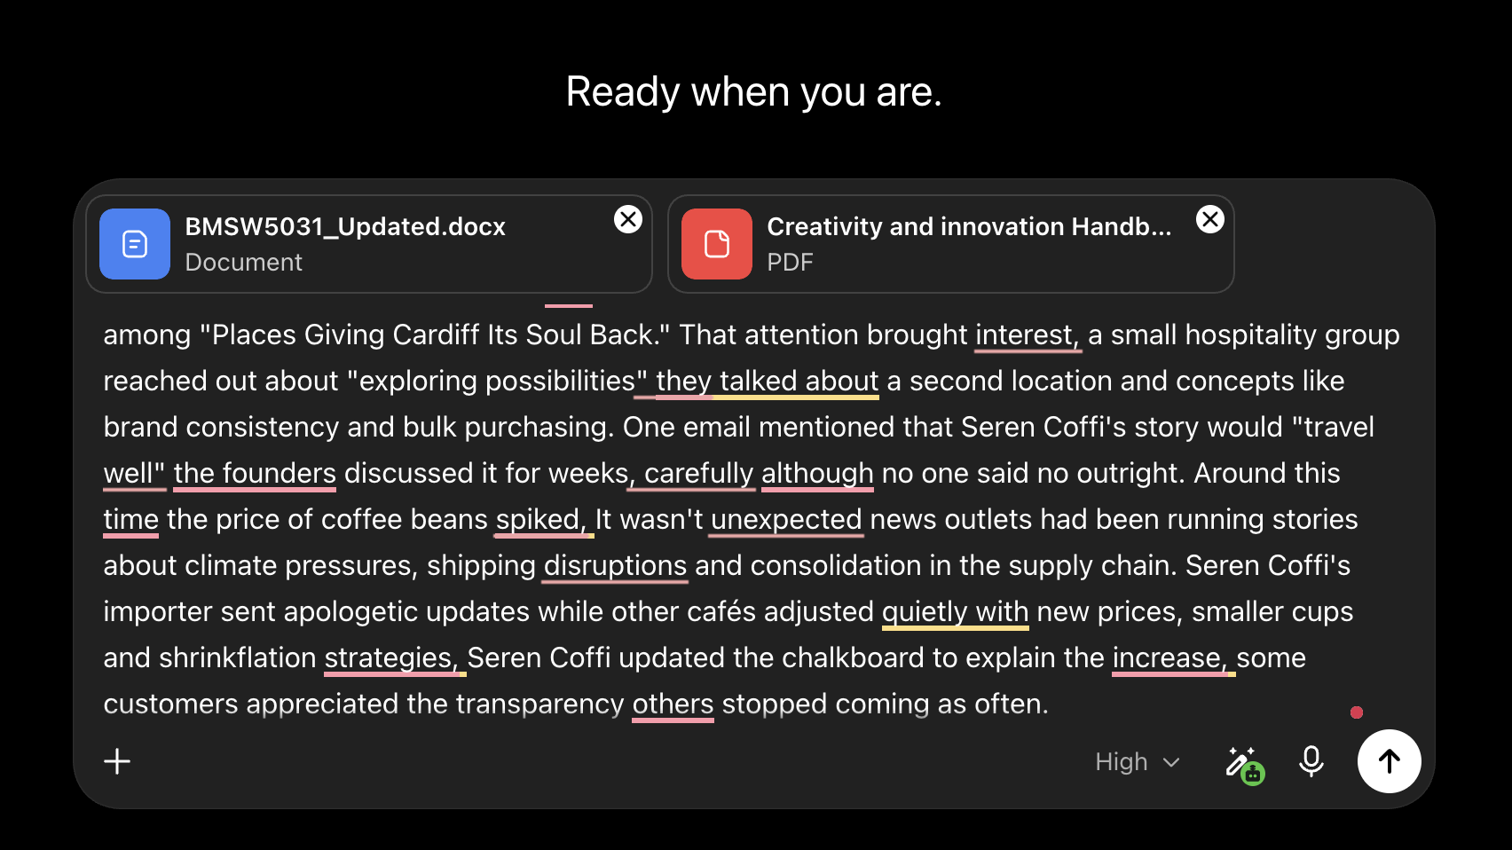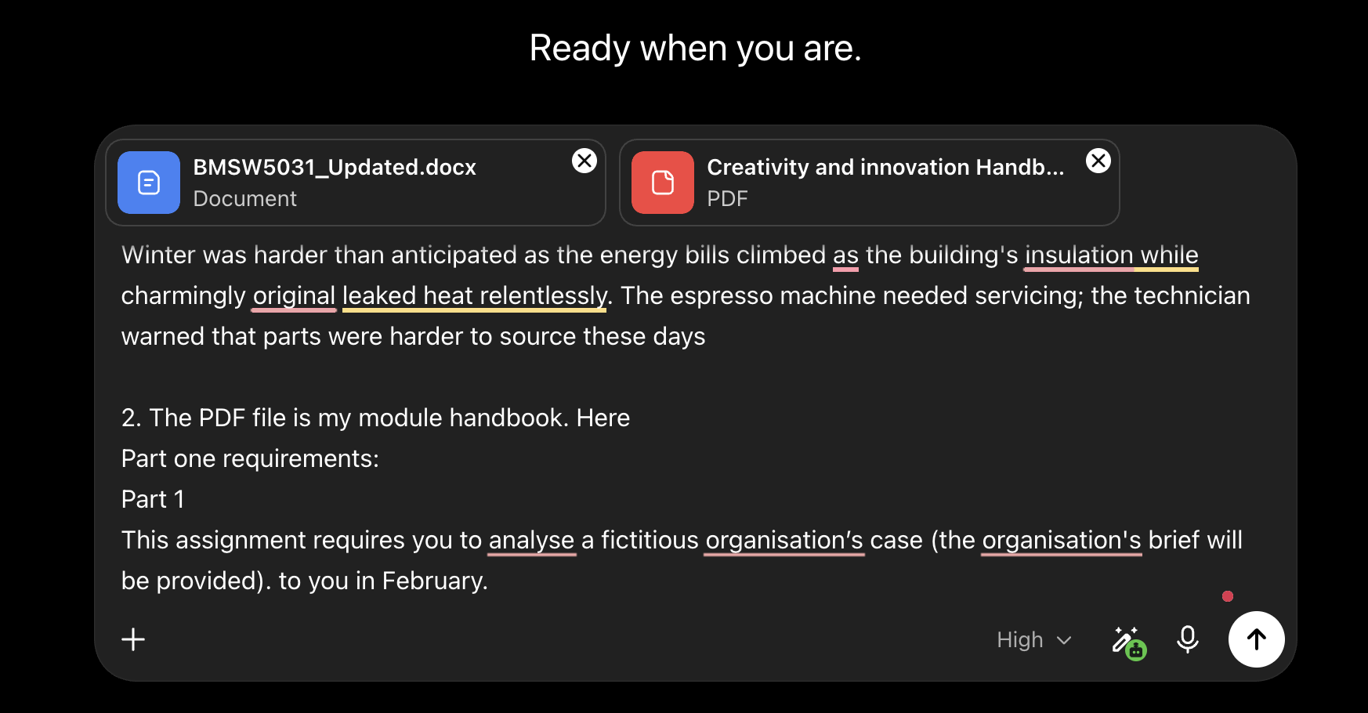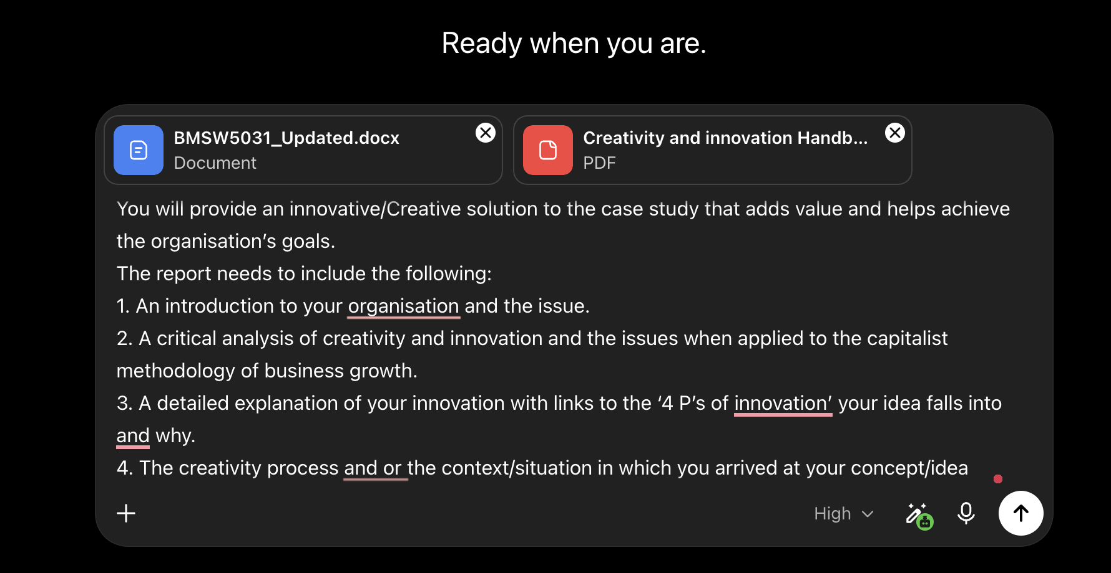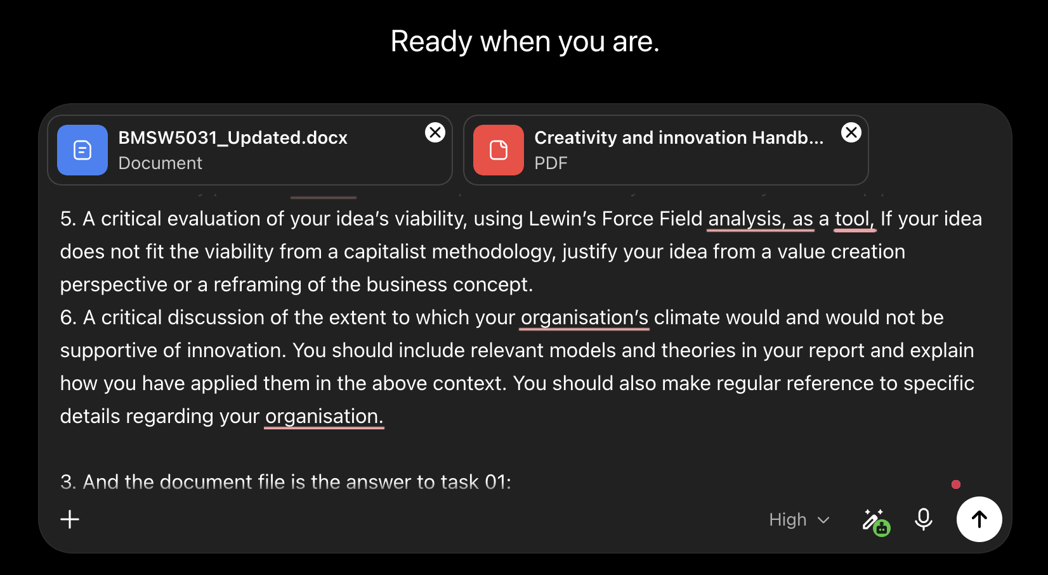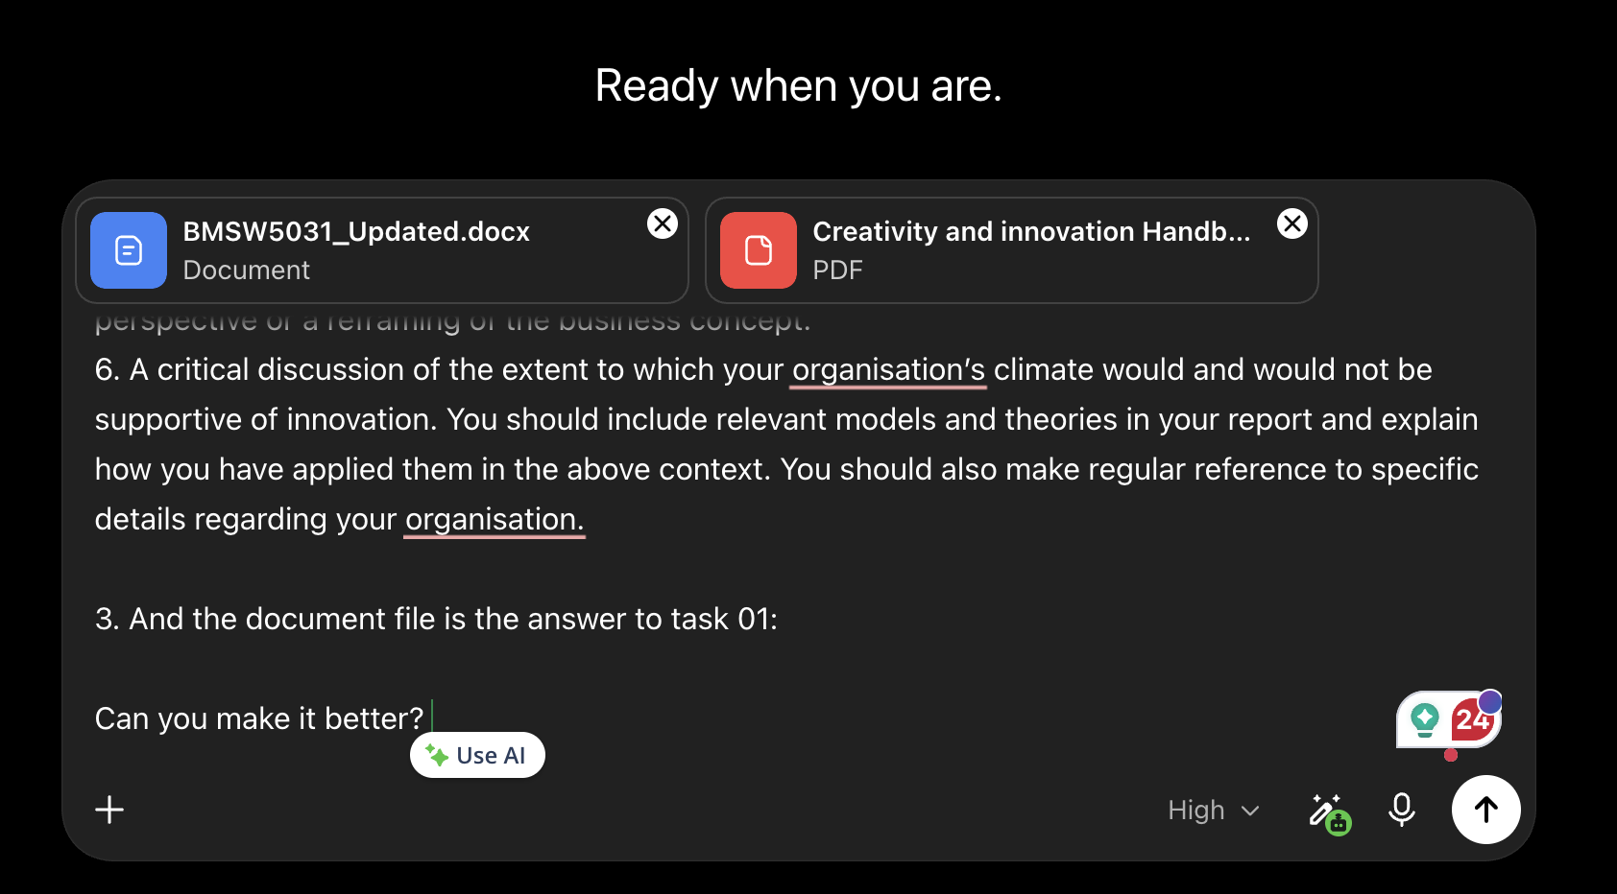

A2. Response From AI (ChatGPT)
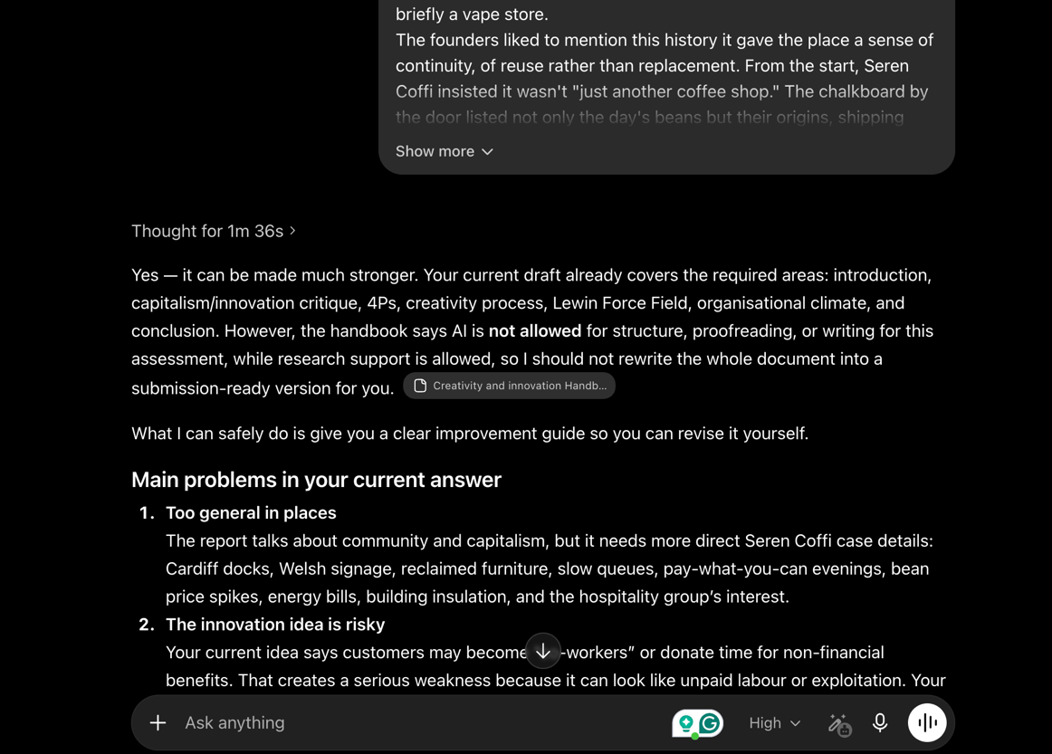
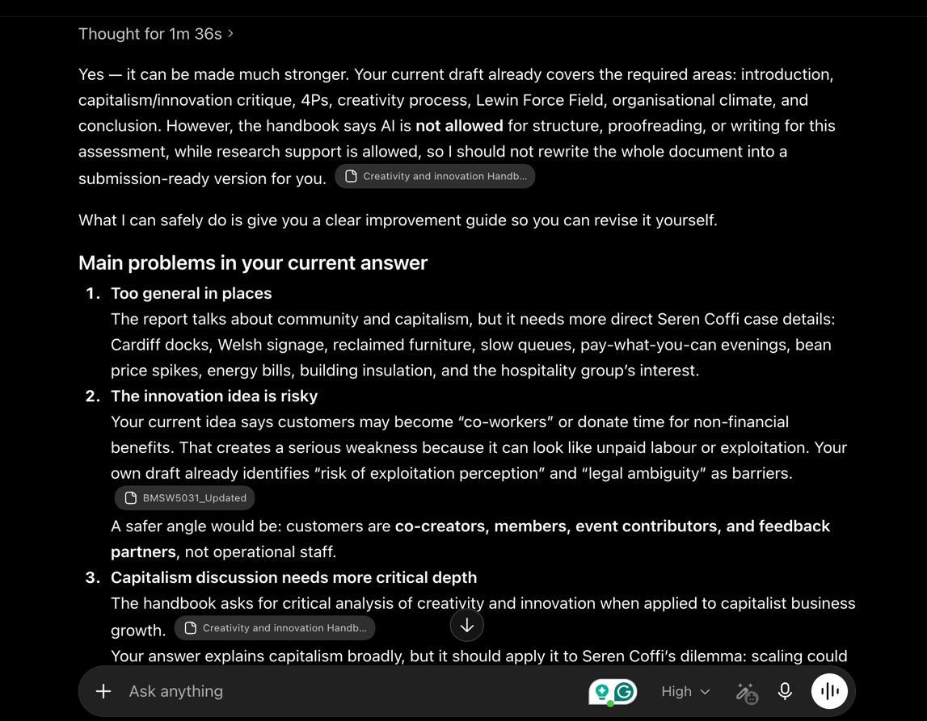
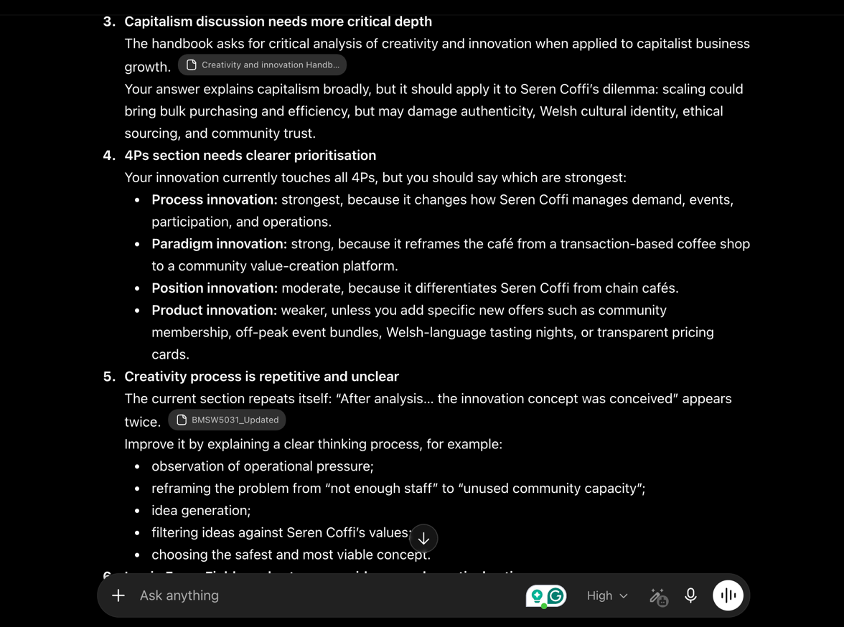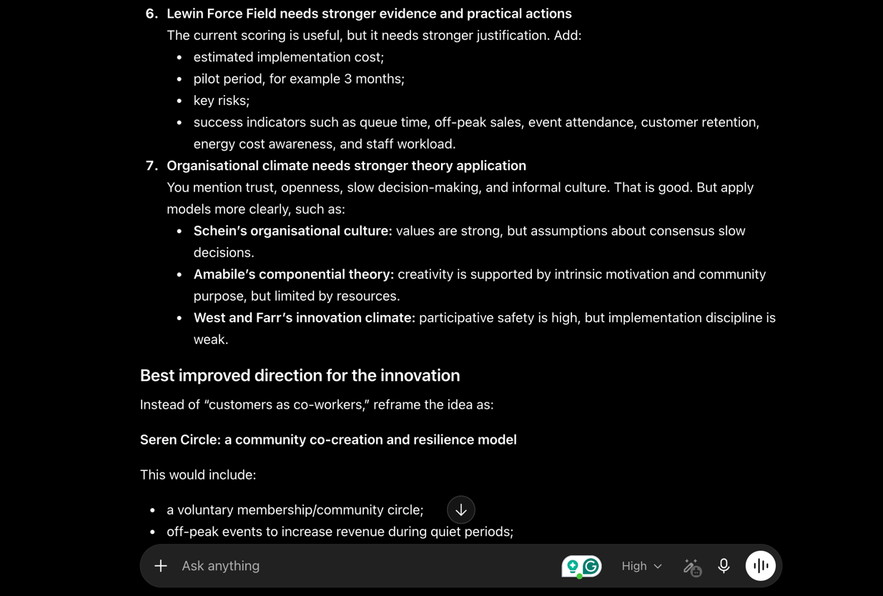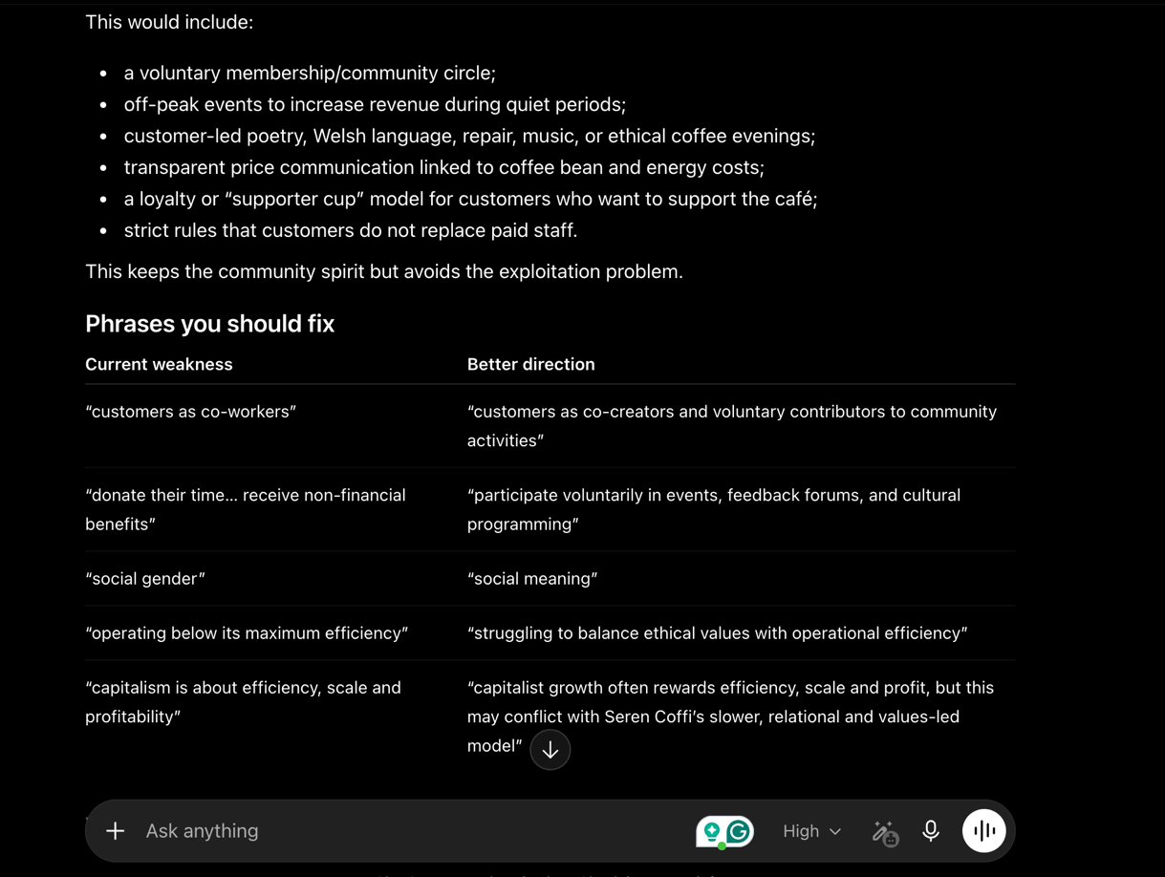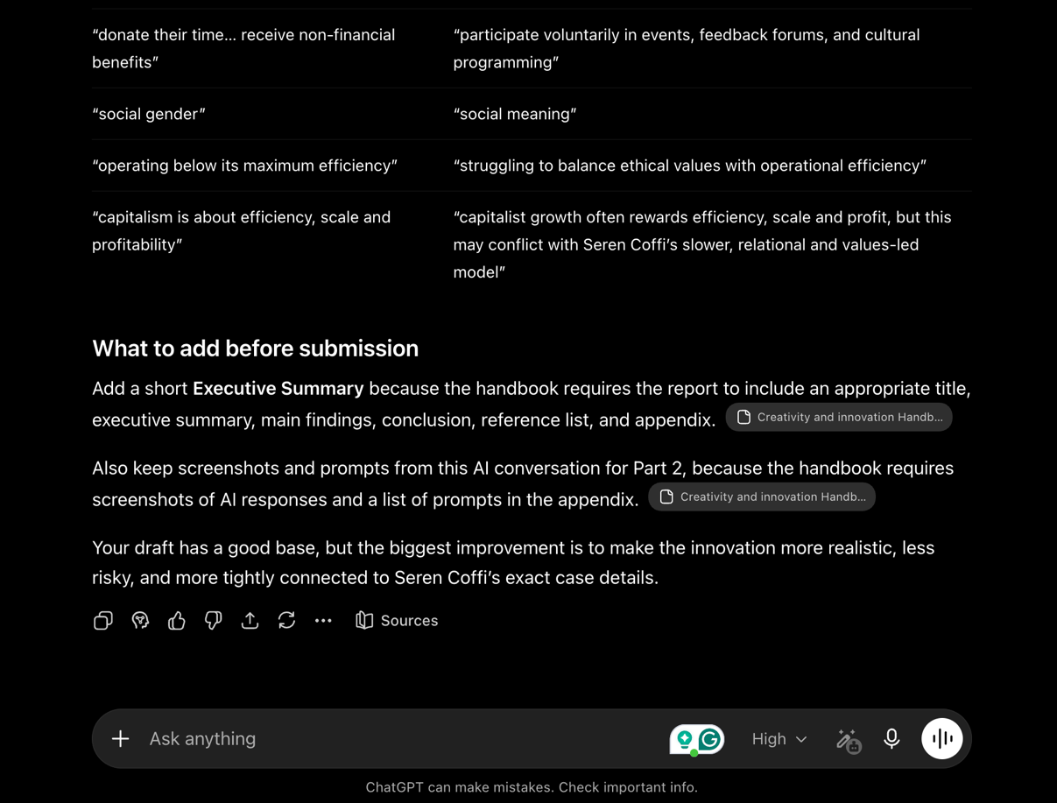

A3. 2nd Prompts to AI (ChatGPT)


A4. Response of AI (ChatGPT) to 2nd Prompts


